
THE UNIVERSITY OF ZAMBIA
SCHOOL OF ENGINEERING
DEPARTMENT OF ELECTRICAL AND ELECTRONC ENGINEERING

Name: : PETER MWALE

Comp no: : 2018202642

Course code: : MEC 3102

Task: : LABOLATORY NO ONE

Date: : 06th SEPTEMBER, 2021.

Due date: : 13th SEPTEMBER, 2021. ATTATION: : MR BOYD FADIGA
TITTLE: The basic logic (logical) gates operations.
OBJECTIVES
- To become familiar with the logical operations of the AND, OR, NOT, NOR and AND gates.
- To become familiar with the use of the truth tables.
INTRODUCTION:
Logic gates are the basic building blocks for forming digital electronic circuitry. A logic gate has one output terminal and one or more input terminals. Its output would be HIGH (1) or Low (0) depending on the digital level (s) at the input terminal (s). The logic gates can be used to design digital systems that will evaluate digital input levels and produce a specific output response based on that particular logic circuit design.
THEORY
Digital or logic circuits operate in the binary mode where each input and output voltage is either a 0 or 1. The 0 and 1 designations represent predefined voltage ranges. The characteristic of logic circuits allows us to use Boolean algebra as a tool for the analysis and design digital circuits. Boolean algebra is a relatively simple mathematical tool that allows us to describe the relationship between logic circuit output (s) and its inputs as an algebraic equation. This algebraic equation is known as Boolean expression or simply Boolean equation.

There three fundamental gates that are used in logic circuit namely the AND, NOT and the OR gate.
The INVERTER is also known as a NOT gate. It is a logic gate that performs inversion (also called complementation) operation. It only allows one input. It changes one logic level to the opposite logic level, i.e., from HIGH to LOW level or from LOW to HIGH level. In terms of bits, it changes a 1 to 0 and a 0 to 1.

The AND gate is one of the basic gates from which all logic functions are constructed. It is composed of 2 or more inputs and a single output. Fig 3-9(a) shows a logic symbol for a 2-input AND gate. Note that inputs are shown on the left (labelled as A and B) and the output is on the right (labelled as X).
Like AND gate, the OR gate, is another basic logic gate from which all logic functions are constructed. It is composed of two or more inputs and a single output. Fig-3-21(a) shows a logic symbol for a 2-input OR gate. Notice that the inputs are shown on the left labelled as A and B and the output is on the right (labelled as X).

Other gates are as a result of a combination of these three fundamental gates. For example, a NOR gates are a combination of a NOT and an OR. A NAND gates is a combination of an AND followed by a NOT GATE.
Equipment
Desktop Computer.
Simulation software.
Procedure
Practical 2.1
An inverter module 7404 was connected to a switch input and a lamp output. The power was switched on and the toggle switch operating while observing the lamp indications accordingly.

Practical 2.2
The 7404 modules were replaced with a 7400 module and connected from two switch inputs to one lamp output. The values of the output were taken down for all possible combinations of the inputs and shown in a table (Lamp on = 1, Off = 0)

Practical 2.3:
The output of the Practical 2.2 was taking to an inverter and a lamp output. Another column for Z bar was added to the truth table and the indications of the lamp taken down for all possible combinations of values of the two input toggle switches, A and B.
Practical 2.4
An OR gate was implemented on the INTIKIT using 7410 module three input NAND gates instead of inverters and a two input NAND gate and the lamp output values were checked against an OR gate truth table.
Practical 2.5
A NOR gate was implemented using three inverters from the 7404 module and one NAND from module 7410 for two switch inputs and a lamp output. A truth table was drawn for all possible combinations of A and B switches.
Practical 3.1
The circuit for Z = AB + AC was connected on the INTIKIT using only one 7400 module and a truth table for all possible combinations of A, B and C drawn up.
Practical 3.2
A circuit for Z = A (B + C) was set up on the INTIKIT for the same input switches in the previous experiment but a different lamp for the output. The lamp indications were checked against the lamp indications for the previous experiment.
Practical 3.3
Two circuits were set up on the INTIKIT, one satisfying the Boolean equation Z= (A+B)(A+C) with one 7400 and one 7404 and the other to satisfy the Boolean equation Z=A+BC.
Practical 3.4
Logic circuits were set up on the INTIKIT for (A(bar) + B(bar)) C and for AB + C(bar) and their output connected to adjacent lamps. The lamps were expected to be complementary for all settings of A, B and C.
Data collection and data analysis. (results)

Practical 2.1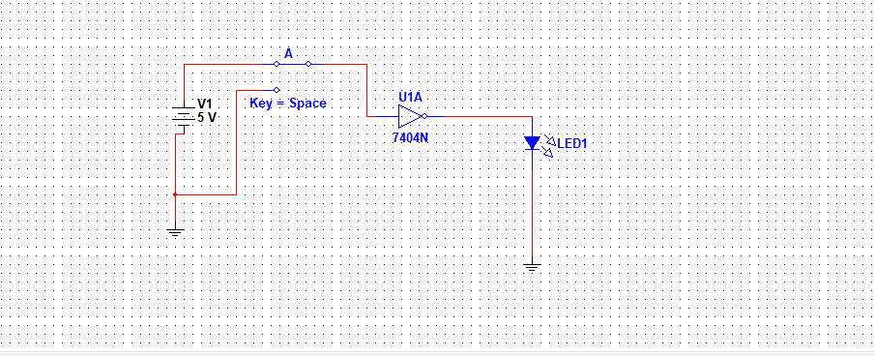

Truth Table
A | Ᾱ
1 | 0
0 | 1
Practical 2.1 was used to check the indications of the lamp for the operations of the toggle switch passed through the Inverter. The lamp was on when the toggle was down and off when the switch was up. An input of High produces a Low and an Input of Low produces a High for the Inverter.

Practical 2.2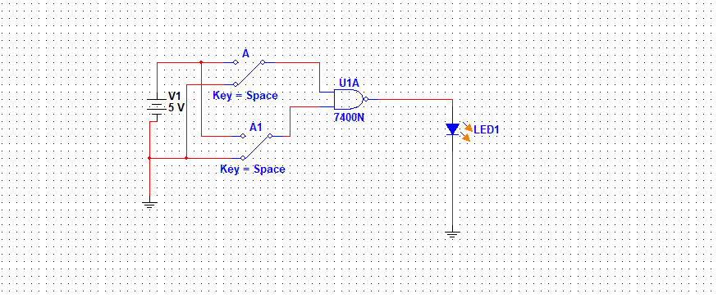
Truth Table
A | B | Z
0 | 0 | 1
0 | 1 | 1
1 | 0 | 1
1 | 1 | 0
Practical 2.2 was used to demonstrate the output of a NAND gate for two inputs A and B. A NAND gate produces an output opposite to that of an AND gate. It only produces a Low when both inputs are Highs and a High everywhere else.

Practical 2.3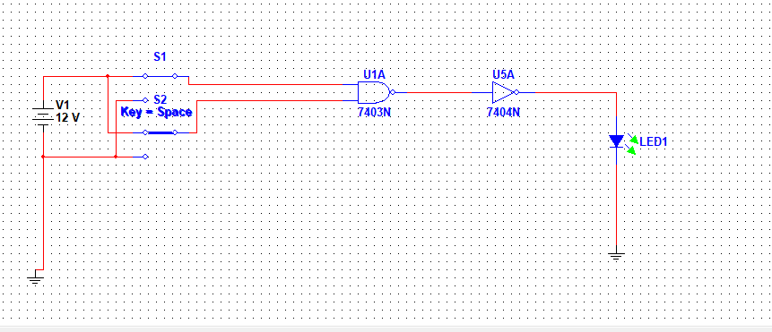
Truth Table
A | B | Z
0 | 0 | 0
0 | 1 | 0
1 | 1 | 1
1 | 0 | 0
Practical 2.3 demonstrated that a NAND output used as an input for a NOT gate produced the same effect an AND gate would produce, a HIGH only when both inputs are High.

Practical 2.4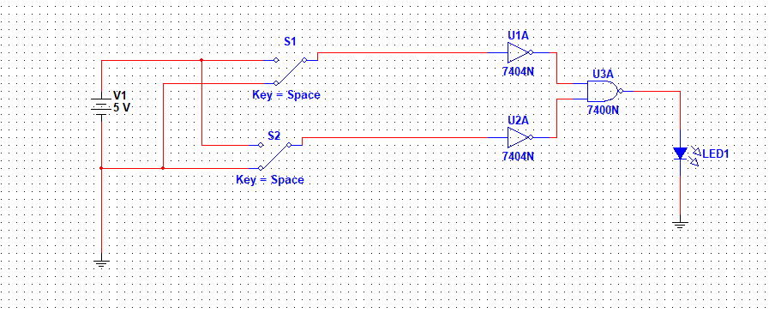

Truth Table
A | B | Z
0 | 0 | 0
0 | 1 | 1
1 | 0 | 1
1 | 1 | 1

Practical 2.5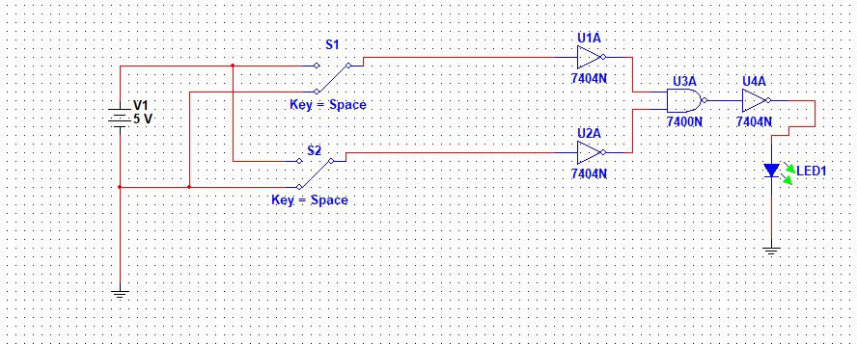
Truth table
A | B | Z
0 | 0 | 1
0 | 1 | 0
1 | 0 | 0
1 | 1 | 0
Practical 2.4 and 2.5 were used to demonstrate how NOR and OR gate can be implemented using two input NOT gates and a NAND gate using inverters .

Practical 3.1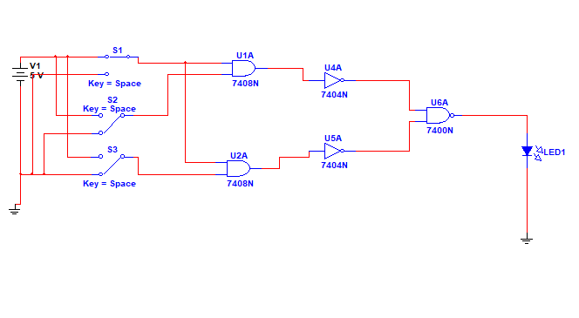
Truth Table
A | B | C | Z
0 | 0 | 0 | 0
0 | 0 | 1 | 0
0 | 1 | 1 | 0
1 | 1 | 1 | 1
0 | 1 | 1 | 1
0 | 0 | 1 | 1
1 | 0 | 1 | 0
0 | 1 | 0 | 0

Practical 3.2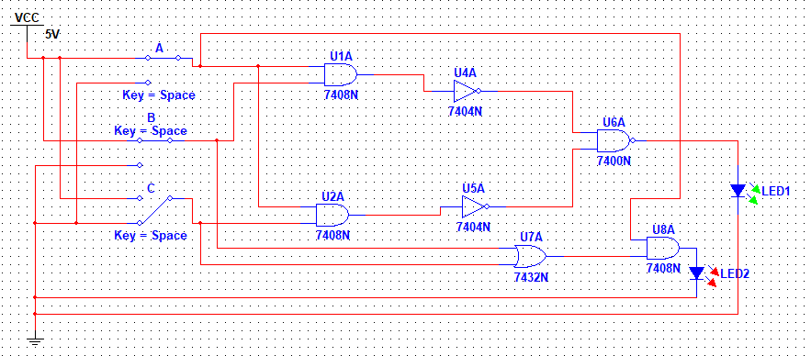
Truth Table
A | B | C | Z
0 | 0 | 0 | 0
0 | 0 | 1 | 0
0 | 1 | 1 | 0
1 | 1 | 1 | 1
0 | 1 | 0 | 0
1 | 0 | 1 | 1
1 | 1 | 0 | 1
1 | 0 | 0 | 0

Practical 3.3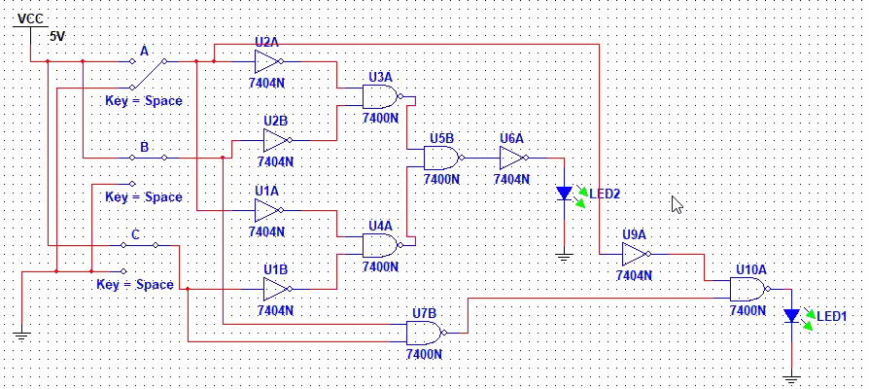
Truth Table
A | B | C | Z
0 | 0 | 0 | 0
0 | 0 | 1 | 0
0 | 1 | 1 | 1
1 | 1 | 1 | 1
0 | 1 | 0 | 1
1 | 0 | 1 | 0
1 | 1 | 0 | 0
1 | 0 | 0 | 0
Practical 3.1, 3.2 and 3.3were used to demonstrate and prove the distributive law of Boolean algebra and its implementation using logic gates.

Practical 3.4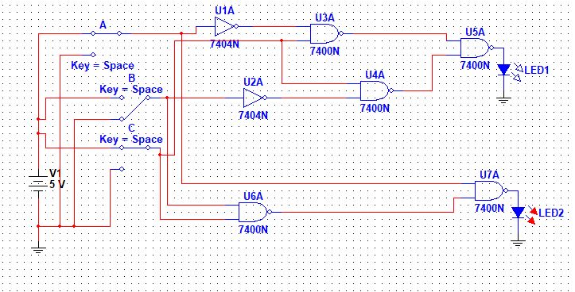

Truth Table
A | B | C | Z
0 | 0 | 0 | 0
0 | 0 | 1 | 0
0 | 1 | 1 | 0
1 | 1 | 1 | 1
0 | 1 | 0 | 0
1 | 0 | 1 | 0
1 | 1 | 0 | 1
1 | 0 | 0 | 1

Exercises
Exercise 2.1
(a)
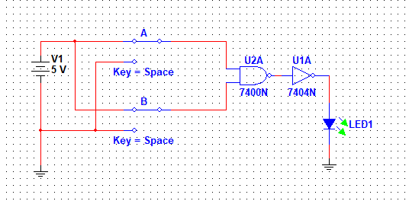
Truth table interpreting the operation of NAND followed by the NOT gate
A | B | Z
0 | 0 | 0
0 | 1 | 0
1 | 0 | 0
1 | 1 | 1
(b)
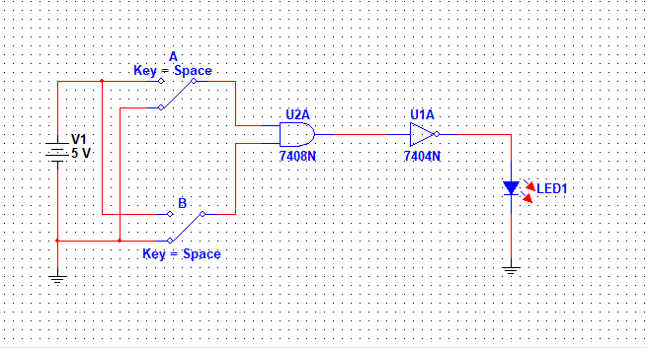
The Truth table note the revaluations with correspondence to the executions from the operation above in the practical
A | B | Z
0 | 0 | 1
0 | 1 | 1
1 | 0 | 1
1 | 1 | 0

Exercise 2.2
A | B | A’ | B | A’.B’ | A’’.B’’ | A+B
0 | 0 | 1 | 0 | 0 | 0 | 0
1 | 0 | 0 | 0 | 0 | 1 | 1
0 | 1 | 1 | 1 | 0 | 1 | 1
1 | 1 | 0 | 1 | 0 | 1 | 1

Exercise 2.3
Applying DE Morgan’s principle
Exercise 2.4
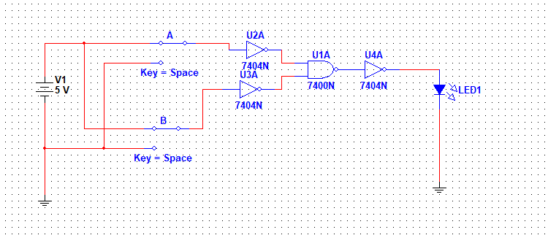
A-input B-input Z or (A + B)’ truth tables revaluates the executions
A | B | Z or (A+B)’
0 | 0 | 1
0 | 1 | 0
1 | 0 | 0
1 | 1 | 0

Exercise 2.5
The exclusive probable four identities for the OR gate are as highlighted below;
- 0 + 0 = 0
- 1 + 0 = 1
- 0 + 1 = 1
- 1 + 1 = 1
Exercise 3.1
Basing on truth table method will prove the groups of theorems
- 1 + A = 1
1-1=A=1-1
A=0 Hence when A=0 OR GATE is proved right form its results.
Equally A=0 is holding for 0.A=0 since when 0 is ANDED with 0 the product is absolutely 0. Hence fourth, answering 1.A=? Gives the answer 0 since 1.0 with respect to AND gate analysis equals to 0.

- A+A=A
A (1+1) = A
As per logical gate principle perspective, when 1 is ANDED WITH 1, 1+1=1 hence,
A (1) = A, A=A Hence proven.
Therefore, A.A=A is also logically proven since initially A WAS found to be 1,when 1 is ANDED with 1, 1.1 results to 1. Such that A ANDED A gives A.
(C) A+A’=? A.A’=0 Going across this will divide A’ into 0 to make a the subject
A=0/A=0 Hence A=0. To replace A & A’ we get 0+0=0 also 0.0=0 hence proven.

Exercise 3.2
When fig 3.1 and 3.2 of the independent circuit are combined together to form a logical circuit for Z=AB+AC, the notice is identified such that when A switch is turn OFF or opened with any one switch of either B or C is turned ON gives the LED light ON while it goes OFF when A is turned OFF regardless of turning ON any one or both of B and C switches. This concludes to mean switch A is the master switch.
Exercise 3.3
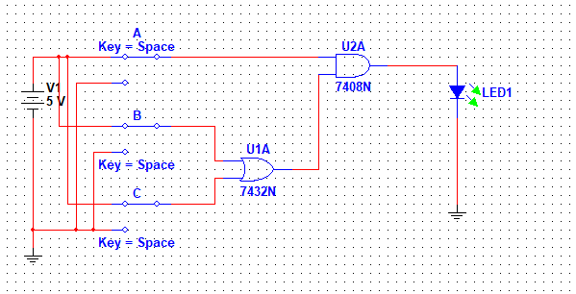

The truth table theoretically explaining the practical performed
A | B | C | B+C | Z or A(B+C)
0 | 0 | 0 | 0 | 0
0 | 0 | 1 | 1 | 0
0 | 1 | 0 | 1 | 0
1 | 0 | 0 | 0 | 0
1 | 0 | 1 | 1 | 1
1 | 1 | 0 | 1 | 1
0 | 1 | 1 | 1 | 0
1 | 1 | 1 | 1 | 1

Exercise 3.4 – Distributive Theorem
Consider the expression:
Z = A + BC
Which can be expressed as (A + B)(A + C). Therefore:
(A + B)(A + C) = A + BC
The logic circuits for both sides are as shown below:
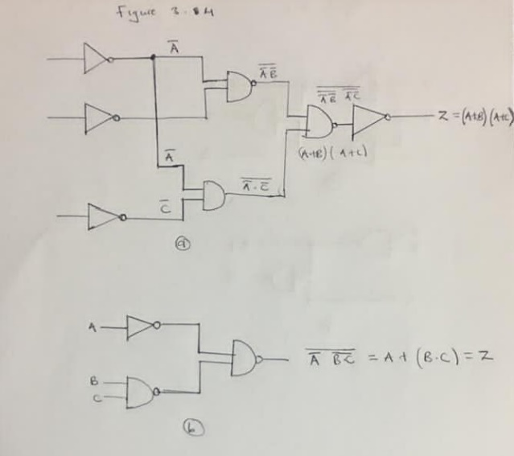
Figure 15 - Logic Circuit for Z = (A+B)(A+C

Exercise 3.5 – Writing expressions from logic circuit
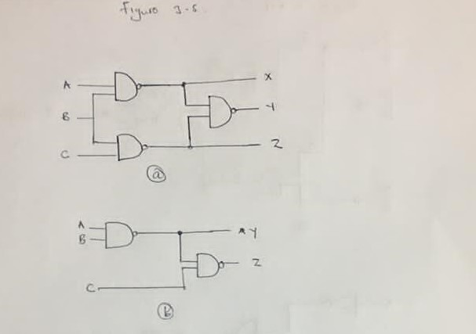
Expressions for X, Y, and Z were written from Figure 17 (a) and (b) below.
- From Figure 17 (a)
$X=\overline{A.B}$ $Y=\overline{B.C}$ $Z=A.B+B.C$
- From Figure 17 (B)
$Y=\overline{A.B}$ $Z=A.B+\overline{C}$

Exercise 3.6 – Writing sum of products expressions for complements

- $Y=\left(A+B\right)\left(C+D\right)\left(B+C\right)$ Then the complement is
$$\overline{Y}=\overline{\left(A+B\right)\left(C+D\right)\left(B+C\right)}$$
$$\overline{Y}=\overline{A}.\overline{B}+\overline{C}.\overline{D}+\overline{B}.\overline{C}$$

- $Z=\overline{\left(A+B\right)C}+\overline{\left(\overline{A}+\overline{B}\right)\overline{C}}$
$Z=\overline{\left(AC+BC\right)}+\overline{\left(\overline{A}\overline{C}+\overline{B}\overline{C}\right)}$ By Distributive Laws
$\overline{Z}=\overline{\overline{\left(AC+BC\right)}+\overline{\left(\overline{A}\overline{C}+\overline{B}\overline{C}\right)}}$ Complementing Z
$=\overline{\overline{\left(AC+BC\right)}}.\overset{̿}{\left(\overline{A}\overline{C}+\overline{B}\overline{C}\right)}$ By De Morgan’s theorem
$=\left(AC+BC\right).(\overline{A}\overline{C}+\overline{B}\overline{C})$
$=AC\left(\overline{A}\overline{C}+\overline{B}\overline{C}\right)+BC(\overline{A}\overline{C}+\overline{B}\overline{C})$ By Distributive Laws
Exercise 3.7
- $A+AB$
$=A.(1+B)$ But 1 + B = 1
$$Therefore A+AB=A$$

- $(A+B+C)(A+\overline{B})$
$=A\left(A+B+C\right)+\overline{B}(A+B+C)$ By Distributive laws
$=AA+AB+AC+A\overline{B}+B\overline{B}+\overline{B}C$ But AA = A and $B\overline{B}=0$
$$=A+AB+AC+A\overline{B}+\overline{B}C$$
$=A\left(1+B+\overline{B}+C\right)+\overline{B}C$ But 1 + X = 1
$$A.1+\overline{B}C=A+\overline{B}C$$
Therefore $\left(A+B+C\right)\left(A+\overline{B}\right)=A+\overline{B}C$
- $\left(A+BC\right)\left(B+AC\right)+\overline{A}B\overline{C}$
- $=A\left(B+AC\right)+BC\left(B+AC\right)+\overline{A}B\overline{C}$ By Distributive laws
- $=\left(AB+AAC\right)+\left(BBC+ABCC\right)+\overline{A}B\overline{C}$
- $=AB+AC+BC+ABC+\overline{A}B\overline{C}$
- $Therefore, \left(A+BC\right)\left(B+AC\right)+\overline{A}B\overline{C}=AB+AC+BC+ABC+\overline{A}B\overline{C}$

Discussion
The simulation was done without any difficulties. The modules given had NAND and NOT gate which were combined to come up with other gates. For example, the OR operation in practical 2.4 was achieved using two NOT gates and one NAND gate as opposed to use the actual OR gate, the modules were used. Thus, in the absence of an AND, OR gate, a NAND gate can be very handy in achieving the same operations. However, this means that we would use more modules. This in circuit design is costly. Simplifying Boolean expressions of a given logic circuit can also help simplify the logic circuit to be constructed thereby reducing the number of modules or gates used. The experiment was also used to verify some of the rules of Boolean Algebra.

Application
The NAND gate is almost universally used in integrated circuit logic although all types of operations can be obtained, usually at a greater cost. The design tools are mostly better adapted to the use of the three fundamental operations of AND, OR, NOT was connecting a NOT at the output of AND gives a NAND and adding a NOT to output of OR gives a NOR.
The sum of products for Boolean functions is the most useful for NAND logic but if the number of variables is large or if the number of product terms is large, either could exceed the number of inputs available on standard integrated circuit module.
Up to eight inputs are available on some types and in either input expanders can be connected to increase the number of available inputs.

Conclusion
The experiments the assignments were successful as the desired objectives were met. The experiments enhanced my understanding of basic logic operations, combinational logic equivalence, non-equivalence and other circuits.

- EEE 3131 – INTIKIT I.C. Logic Tutor Student Assignments Lab Manual.
- Hatilima J, EEE 3131 – Digital Electronics Notes, (2015), the University of Zambia, Lusaka.

