
THE UNIVERSITY OF ZAMBIA
DEPARTMENT OF MECHANICAL ENGINEERING

NAME : CHIMANGO NDHLOVU

COMPUTER NUMBER : 2019031892

SCHOOL : ENGINEERING

COURSE : MEC 3102

ASSIGNMENT : 02

LECTURER : MR. MUNKOMBWE

1. You are tasked to choose an appropriate method of electric power generation. What factor do you need to consider before presenting you best method? [10]
When coming up with a suitable method for electric power generation in a particular area a few factors are considered as outlined herein. The initial cost to set up the whole electric power plant and its subsidiaries from generation to supply, it is convenient to choose a method that is of a lesser cost. Once this is done the next thing is to consider the maintenance costs such as replacement of worn out components and servicing of other mechanical components and the amount of power to be generated. Limitations such as availability of the resource required to generate the power as well as how much resource is required to produce a unit amount of power, the availability of the resource and its social economical impact are to be considered.
2. What are the conventional and alternative methods of energy sources? [6]
Conventional sources of energy can be described as non-renewable sources of energy which have been used for quite a long time and the reserves are getting depleted to a great extent, some of the conventional methods are:
Hydro electric power where the potential energy of water at high altitudes is harnessed as the water falls over a height “H” where the potential energy is converted to kinetic energy and hits turbines at the bottom which spin and convert the mechanical energy to electrical energy by means of a generator.
Thermal power plants are also able to generate electric power by means of combustion, in a coal power plant coal is combusted in a boiler and the heat generated converts water into steam which passes through boiler tubes and turns the steam turbines which in turn generates electrical energy.
Alternative sources of energy can be described as renewable sources of energy meaning they can be used over and over again without depleting, studies in this field are vital to mankind as these sources will be able to meet the demands of when our natural resources are depleted. Some of the common renewable sources are Wind which generates energy using wind turbines and Solar energy (rays of the sun) which generates energy by means of voltaic cells converting the sun energy to electrical energy.
4. In a nuclear power generation, explain the importance of the control rods? [4]
In a nuclear reactor energy is released from U₂₃₅ atoms as they undergo the chain reaction and are bombarded by free neutrons which are also controlled by moderators such as heavy water or graphite, control rods usually made out of Cadmium or Boron are placed in the core of the reactors between the reaction rods. If they are placed in the reactor, the reaction speed is slowed and if they are removed, the reaction speed increases so the speed of the reaction can be controlled by the depth of the submerged control rods depending on how much energy is to be generated from the plant.

7. Differentiate between Primary and Secondary power distribution. [2]
PRIMARY POWER DISTRIBUTION
Distribution lines on the high voltage side of the distribution transformer of up to 132 kV, 220 kV or more. This type of transmission is high voltage transmission and uses a 3-phase 3-wire system.
SECONDARY POWER DISTRIBUTION
Distribution lines on the low-voltage side of the distribution transformer where voltage is stepped down to levels of up to 22 kV or 33 kV with the help of step down transformers
9. A three-phase delta-connected load, each phase of which has an inductive reactance of 40 Ω and a resistance of 25 Ω, is fed from the secondary of a three-phase star-connected transformer which has a phase voltage of 230 V. Draw the circuit diagram of the system and calculate: [12]
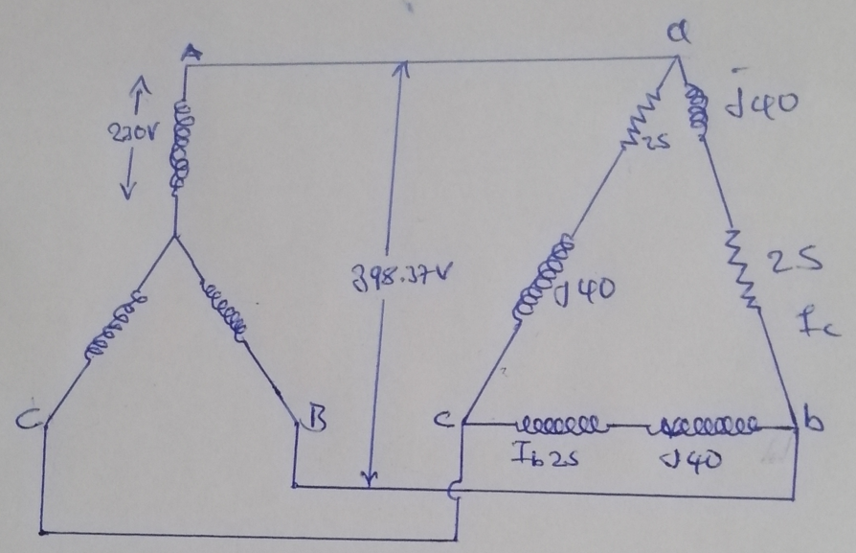
- The current in each phase of the load;
I_{a} = $\frac{398.37}{25+j40}$
I_{a} =8.445 -58⁰ A
I_{b} =8.445 -58⁰ - 120⁰
I_{b} =8.445 -178⁰ A
I_{c} =8.445 -58⁰ + 120
I_{c} =8.445 62⁰ A

8.44A
(b) The p.d across each phase of the load;
P.d = 230 x $\sqrt{3}$
398.37V
(c) The current in the transformer secondary windings;
I_{A} = I_{a}$\sqrt{3}$
= 8.445 x $\sqrt{3}$
I_{A} = 14.6272A
(d) The total active power taken from the supply and its power factor
Active power = $\sqrt{3}$ x V_{L} x I_{A} cosθ cosθ=0.53
= $\sqrt{3}$ x 398.37 x 14.627 x 0.53
= 5348W
= 5.349 Kw

11. Each phase of star connected load consists of non-inductive resistance of 50Ω in parallel with a capacitance of 63.6μF. Calculate:
V_{L} = 381
- The line current,
V_{L} = $\sqrt{3}$V_{P}
V_{P} = $\frac{VL }{ \sqrt{3}}$ = $\frac{381 }{\sqrt{3}}$ = 220 | 0⁰ = (220 + j0)V
Admittance of each phase is,
Y_{P} = $\frac{ 1 }{ R}$ + jwc
= $\frac{1}{ 50}$ + j 314 x 63.6 x 10⁻⁶
= (0.021 + j0.020)s
So,
I_{P} = V_{P}Y_{P}
= 220 x (0.021 + j0.020)
= 4.4 + j4.4
= 6.22 | 45⁰

- Total power absorbed,
P absorbed in 3 phases
3 x 968w = 2.904Kw

iii. Total kVA and
V_{P} = (220 + j0) V
I_{P} = (4.4 + j4.4) A
So complex power,
S = VI
S = (220 + j0) (4.4 - j4.4)
S = 968 - j 968
S = 1369 | - 45⁰ VA
= 3 x 1369
= 4.107KVA

- The power factor when this load is connected to a 381 V (line voltage), 3-phase, 50Hz supply.

P.f = cos 45 = 0.707 leading

13. Two wattmeters are used for measuring the power input and the power factor of an over-excited synchronous motor. If the reading of the meters are (-2.0 kW) and (+7.0 kW) respectively. Calculate the input power and power factor of the motor.
input = W₁ + W₂
= -2 + 7
= 5Kw

Relationship derived is,
tan θ = $\frac{(\sqrt{3}(W1-W2)}{W1+W2}$
W1 gives the ⁻ve reading, so
W₁ = -2Kw
tan θ = $\frac{-(\sqrt{3}(-2-7)}{(-2+7)}$
tan θ = $\sqrt{3}$ x $\frac{9}{3}$
tan θ = 3.1176
θ = tan ⁻¹ (3.1176)
= 71.2⁰ lead
cos θ = 71.2 = 0.3057 lead

