VANCOUVER ISLAND UNIVERSITY

DEPARTMENT OF ECONOMICS
ECON 211: Principles of MicroECONomics

Sample Final examination, APRIL 2013

Name (Last, First): ______________________________________________
ID#: ______________________________________________
Signature: _______________________________________________

This Exam has total 17 pages including the cover page

Instructions:

- Total marks 85. Duration: 2 Hours.

- Please answer your MCQs on the MCQ answer sheet by filling up required information fields

- You must show your all work to get full marks. If you do not show work, you may not get full marks even for a correct answer.

- Use the marks assigned to each question as a guide to allocating your time across questions.

Good Luck on Your Exam

PART A
(There are 50 MCQs in this section, worth 50 marks)

- David has an income (Y) of $50 with which he can purchase DVDs (D) at $10 each and haircuts (H) at $20 each. Which one of the following represents Guy's budget line?
    - Y = 10QD - 20QH
    - 50 = QD + QH
    - Y = 50 + QD + QH
    - 50 = 10QD + 20QH

- Real income in terms of a good is defined as
- income divided by the quantity consumed of a good.
- the income of a producer of that good.
- the price of one good divided by the price of another good.
- income divided by the price of a good.

- The price of a cup of coffee is $2.00. The price of a cup of tea is $1.20. The relative price of a cup of tea with respect to a cup of coffee is
- 0.6 cups of coffee.
- 1.67 cups of coffee.
- 1.0 cup of coffee.
- 1.25 cups of coffee.
- 0.75 cups of coffee.

- If income decreases, the budget line
- becomes steeper.
- becomes flatter.
- shifts leftward and parallel to the original budget line.
- shifts rightward and parallel to the original budget line.
- shifts parallel either leftward or rightward depending on whether the goods measured on the axes are normal or inferior.

- Sarah has an income of $100. She purchases 5 pizzas at $10 each and 10 subs at $5 each. Then the government taxes subs, and the price rises to $10 each. Simultaneously, the government gives Sarah a grant of $50 in income to make up for this change. As a result, Sarah's budget line
- becomes steeper.
- becomes flatter.
- shifts leftward and parallel to the original budget line.
- shifts rightward and parallel to the original budget line.
- swivels around the original consumption choice.

- The initial budget equation for pop (p) and movies (m) is Qp = 20 - 4Qm, and the price of a pop is $5. If the price of a pop falls to $4, what is the new budget equation?
- Qp = 25 - 2Qm
- Qp = 25 - 4Qm
- Qp = 25 - 5Qm
- Qp = 20 - 5Qm
- none of the above

- A change in the price of the good measured on the vertical axis changes ________ of the budget line.
- the slope and y-intercept
- the slope and x-intercept
- the x- and y-intercepts but not the slope
- only the slope
- only the y-intercept

- Junkfood Jill spends all of her income on jellybeans and Jolt cola. Suppose that Jill's income is $30, the price of a bag of jellybeans is $6, and the price of a bottle of Jolt cola is $2. Which of the following combinations of jellybeans and Jolt cola lies inside Jill's budget line?
- 2 bags of jellybeans and 8 bottles of Jolt
- 5 bags of jellybeans and 0 bottles of Jolt
- 4 bags of jellybeans and 4 bottles of Jolt
- 3 bags of jellybeans and 6 bottles of Jolt
- 5 bags of jellybeans and 15 bottles of Jolt

- An indifference curve is
- the boundary between what can be produced and what cannot be produced.
- the boundary between what a consumer can afford and what he cannot afford.
- a line that shows combinations of goods among which a consumer is indifferent.
- the boundary between normal goods and inferior goods.
- a line with a positive slope.

- The marginal rate of substitution
- is the amount of good Y substituted for good X as a consumer moves along his budget line.
- is the rate at which a person gives up the good measured on the y-axis to get an additional unit of the good measured on the x-axis while remaining on the same indifference curve.
- increases as a consumer consumes more of the good measured on the x-axis.
- is greater than the magnitude of the slope of the budget line.
- is equal to the slope of the budget line.

Use the figure below to answer the following two questions.

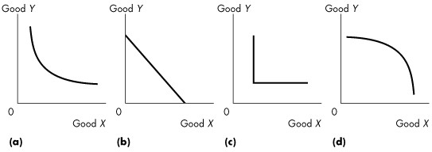

- Which one of the graphs in Figure shows perfect substitutes?
- (a)
- (b)
- (c)
- (d)
- (c) and (d)
- Which of the graphs in Figure 9.2.1 shows perfect complements?
- (a)
- (b)
- (c)
- (d)
- (c) and (d)

Use the figure below to answer the following question.

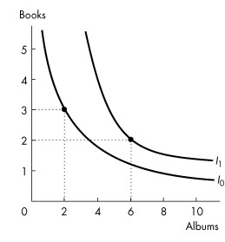

- Refer to the above Figure. Rashid buys only books and albums. The figure shows his preferences. Rashid's indifference curves ________ display diminishing marginal rate of substitution because ________.
- do; Rashid is indifferent between consuming 6 albums and 2 books and consuming 2 albums and 3 books
- do not; the magnitude of the slope of both indifference curves decreases as Rashid consumes more albums and fewer books
- do not; Rashid is indifferent between consuming 6 albums and 2 books and consuming 2 albums and 3 books
- do; the magnitude of the slope of both indifference curves decreases as Rashid consumes more albums and fewer books
- do; the price of an album decreases as Rashid increases the quantity he buys

- A consumer choosing between apples and oranges is at her best affordable point. Then the price of apples decreases. If both apples and oranges are normal goods, which one of the following statements is true about her new best affordable point?
- She will consume more apples and more oranges.
- She will consume more apples and fewer oranges.
- She will consume fewer apples and more oranges.
- She will consume fewer apples and fewer oranges.
- She will consume more apples, and we cannot tell whether she will consume more or less oranges.

Use the figure below to answer the following questions.
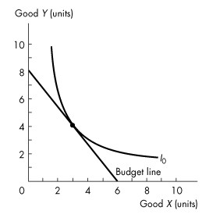

- Consider the budget line and indifference curve in the above Figure. At the best affordable point, the marginal rate of substitution is
- 1/2.
- 2.
- 4/3.
- 3/4.
- 4.

- What is a distinguishing characteristic of an inferior good?
- a negative price effect
- a positive income effect
- a positive substitution effect
- a negative income effect
- an upward-sloping demand curve

- Albert is consuming at a point where his budget line is not as steep as indifference curve. To reach consumer equilibrium, Albert
- consumes less of the good that is measured on the horizontal axis.
- consumes none of the good that is measured on the horizontal axis.
- must increase his income.
- must shop at stores that have lower prices.
- consumes more of the good that is measured on the horizontal axis.

- Which one of the following is included in the implicit rental rate of capital?
- economic depreciation
- the cost of electricity
- the cost of raw materials
- the cost of low-skilled labour
- the cost of heating

- Economic profit equals total revenue minus
- the cost of resources bought in the market.
- the implicit rental rate.
- the opportunity cost of production.
- the cost of resources supplied by the owner.
- the cost of resources owned by the firm.

- If economic profit is equal to zero then the firm is making
- a normal profit.
- zero profit as recorded by accountants.
- negative profit as recorded by accountants.
- zero taxable income.
- an amount equal to the implicit rental rate.

Use the table below to answer the following questions.

Table 1
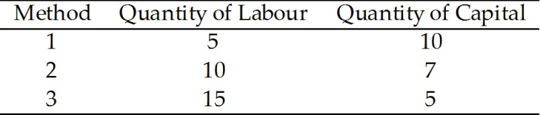

- Refer to Table 1, which shows three methods for making photon torpedoes. Which method is technologically efficient?
- 1 only
- 2 only
- 3 only
- all of the methods
- 1 and 3 only

- Some firms use large amounts of capital and small amounts of labour, while others use small amounts of capital and large amounts of labour to
  - use surpluses of labour and capital and eliminate unemployment of these resources.
  - use the best available technology.
  - use the resources that are most readily available.
  - maximize profit.
  - maximize production.

- A firm with one or more owners of limited liability is
  - a sole proprietorship.
  - a partnership.
  - a conglomerate.
  - a corporation.
  - a public company.

- One difference between oligopoly and monopolistic competition is
  - there is a smaller number of firms in a monopolistically competitive market than in an oligopoly.
  - in oligopolies firms make slightly different products whereas in monopolistic competition the products are identical.
  - monopolistic competition has barriers to entry, whereas oligopoly has none.
  - fewer firms compete in an oligopoly than in a monopolistically competitive market.
  - in oligopolies, firms are typically smaller in size.

Use the table below to answer the following questions.

Table 2
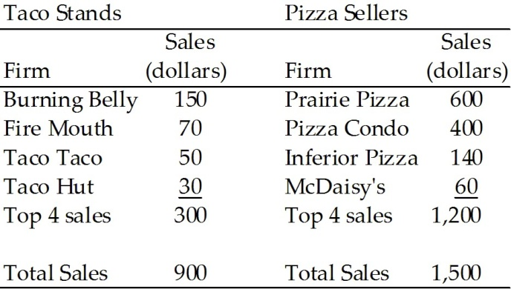

- Refer to Table 2. The four-firm concentration ratio for taco stands is
  - 15 percent.
  - 100 percent.
  - 80 percent.
  - 33 percent.
  - 30 percent.

- In a perfectly competitive market, the four-firm concentration ratio is
  - almost zero.
  - 50 percent.
  - 100 percent.
  - 75 percent.
  - 25 percent.
- Product differentiation is always a feature in
  - perfect competition.
  - monopolistic competition.
  - oligopoly.
  - monopoly.

- Which one of the following would not likely be a firm with economies of scale?
  - an electrical production plant
  - a telephone company
  - a firm that produces handmade cabinetry
  - a multi-store dry-cleaning firm

- A firm with a lower unit cost from producing a wider range of goods and services has economies of
  - transactions costs.
  - scale.
  - scope.
  - team production.

- When the demand for electricity peaks during the hottest days of summer, Hydro One can generate more electricity by using more fuel and increasing the working hours of many of its employees. The company cannot, however, increase electric power production by building additional generating capacity. This means that the company is operating in the
- market run.
- intermediate run.
- long run.
- short run.

- A firm's total product curve describes
- the minimum cost of producing a given amount of output.
- the maximum output that a given quantity of labour can produce.
- how the maximum attainable output varies as the size of the firm's plant varies, given the quantity of labour employed.
- how the management of the firm makes decisions over the short run.
- how the amount of labour varies as the amount of output varies.

Use the figure below to answer the following questions.

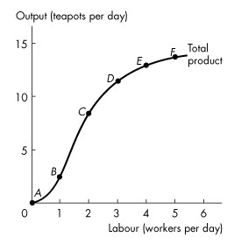
- Refer to the above Figure which illustrates Tania's total product curve. Which one of the following statements is false?
- All the points above the curve are unattainable.
- All the points below the curve are attainable.
- All the points below the curve are inefficient.
- The cost of producing at point B equals the cost of producing at point C.
- All the points on the curve are attainable.

- Marginal product of labour is the increase in total product that results from a
- one-unit increase in the quantity of labour employed, other inputs remaining the same.
- one-unit increase in the quantity of fixed inputs employed, holding the quantity of the variable inputs constant.
- one-unit increase in both the quantity of variable and fixed inputs.
- change in the cost of labour.
- 1 percent change in the quantity of labour and the quantity of capital employed.

Refer to the table below to answer the following questions.

Table 3

Labour  (workers per day) | Output  (teapots per day)
0  1  2  3  4  5 | 0  3  12  19  23  25

- Refer to Table 3 which gives Tania's total product schedule. The marginal product when the firm increases the number of workers from 3 to 4 per day is
- 6 teapots.
- 2 teapots.
- 9 teapots.
- 7 teapots.
- 4 teapots.

- Refer to Table 3 which gives Tania's total product schedule. The marginal product when the number of workers increases from 1 to 2 is
- 3 teapots.
- 12 teapots.
- 7 teapots.
- 9 teapots.
- 6 teapots.

Use the figure below to answer the following question.

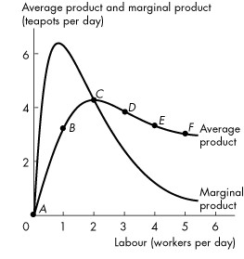

- Refer to the above Figure which shows Tania's average product curve and marginal product curve. The point of maximum average product is point
  - B.
  - C.
  - D.
  - E.
  - F.

- The law of diminishing marginal returns states:
  - As the size of a plant increases, marginal product eventually decreases.
  - As the size of a firm's plant increases, average cost eventually decreases.
  - As a firm uses more of a variable factor of production, with a given quantity of the fixed factor of production, the marginal product of the variable factor eventually diminishes.
  - As a firm uses more of a variable factor of production, its average cost eventually decreases.

Use the table below to answer the following question.

Table 4

Number of Workers | Total Product  (baskets of corn)
1  2  3  4  5 | 0  3  7  10  12

- Refer to Table 4. The table gives the total product schedule of workers who harvest corn. Diminishing marginal returns begin when the ________ is hired.
  - 1st labourer
  - 2nd labourer
  - 3rd labourer
  - 4th labourer
  - There are no diminishing marginal returns since total product always rises.

- The average product of labour equals
  - the slope of the total product curve.
  - the slope of the marginal product curve.
  - the increase in total product divided by the increase in labour employed.
  - total product divided by the quantity of labour employed.
  - the difference between the total product and the marginal product of labour.

Use the table below to answer the following questions.

Table 5
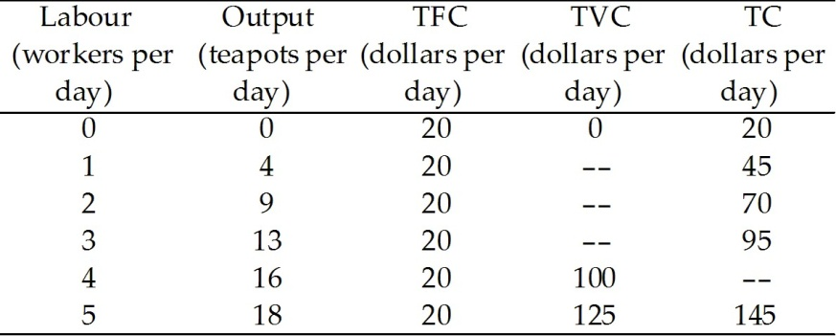

- Refer to Table 5, which gives Tania's total cost schedule. The average fixed cost of producing 9 teapots per day is
  - $2.22.
  - $1.25.
  - $10.00.
  - $1.11.
  - $1.54.

- Refer to Table 5, which gives Tania's total cost schedule. When output increases from 4 to 9 teapots, the marginal cost of one of the 5 teapots is
  - $4.25.
  - $4.
  - $25.
  - $6.25.
  - $5.

- Marginal cost is equal to
  - total cost divided by output.
  - the increase in total cost divided by the increase in output.
  - the increase in total cost divided by the increase in labour input, given the amount of capital.
  - total variable cost minus total fixed cost.
  - the increase in total cost divided by the increase in variable cost.

- Choose the correct equation.
- TFC=TC/Q
- TFC=TC-AVC
- TFC=TC-TVC
- TFC=TVC/Q
- TFC=TVC-TC

Use the figure below to answer the following question.

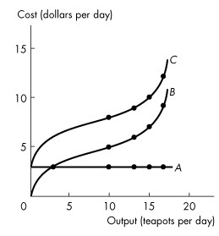

- Refer to the above Figure. Which one of the following statements is false?
- The total fixed cost curve A.
- Total variable cost and total cost both increase with output.
- The vertical gap between curves B and C is equal to total variable cost.
- Marginal cost is equal to the slope of curve C.
- Total fixed cost is constant.

Use the figure below to answer the following questions.

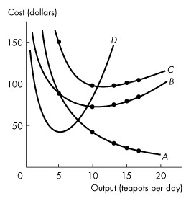
- Refer to the above Figure, which illustrates the short-run average and marginal cost curves. The average variable cost curve is curve
- A.
- B.
- C.
- D.

- As soon as diminishing returns set in, a firm's
- marginal product increases.
- average fixed cost decreases.
- marginal cost decreases.
- marginal cost increases.
- total cost decreases.

- The marginal cost (MC) curve intersects the
  - ATC, AVC, and AFC curves at their minimum points.
  - ATC and AFC curves at their minimum points.
  - AVC and AFC curves at their minimum points.
  - ATC and AVC curves at their minimum points.
  - TC and TVC curves at their minimum points.

- If ATC is falling, then MC must be
  - rising.
  - falling.
  - equal to ATC.
  - above ATC.
  - below ATC.

- The marginal cost curve slopes upward due to
- diminishing marginal utility.
- diminishing marginal returns.
- technological inefficiency.
- economic inefficiency.
- none of the above.

- Which type of cost does not change as the quantity of output produced changes?
  - average total cost
  - marginal cost
  - average fixed cost
  - total fixed cost
  - Both C and D are correct.

- Economies of scale are present when
  - the LRAC curve slopes downward.
  - average total cost remains constant as input increases.
  - average total cost rises as output increases.
  - the LRAC curve is horizontal.
  - total fixed cost increases.

Use the figure below to answer the following questions.
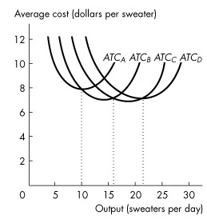

- Refer to the above Figure, which illustrates the short-run average total cost curves for four different plant sizes. Which curve represents the average total cost for the largest of the four plant sizes?
  - ATCA
  - ATCB
  - ATCC
  - ATCD
  - either ATCC or ATCD

Use the figure below to answer the following questions.

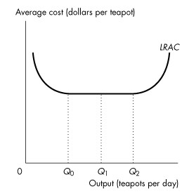
- Refer to the above Figure, which illustrates the long-run average total cost curve. Which one of the following statements is false?
  - Economies of scale exist between 0 and Q0 units of output.
  - Diseconomies of scale exist between 0 and Q1 units of output.
  - Constant returns to scale exist between Q1 and Q2 units of output.
  - Diseconomies of scale exist at quantities greater than Q2 units of output.
- A price-taking firm faces a
- perfectly inelastic demand.
- downward-sloping marginal revenue curve.
- downward-sloping supply curve.
- perfectly elastic demand.
- downward-sloping demand curve.

Use the figure below to answer the following questions.

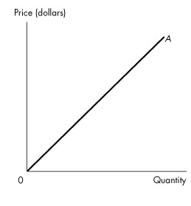
55. Refer to the above Figure. The firm competes in a perfectly competitive market. Curve A represents the firm's
- total fixed cost curve.
- average fixed cost curve.
- average variable cost curve.
- total revenue curve.
- marginal revenue curve.

    - A firm shuts down if price is
- above minimum average variable cost.
- below minimum average variable cost.
- above minimum average fixed cost.
- less than marginal cost.
- below average total cost.
    - A perfectly competitive firm's supply curve includes its marginal cost curve at all prices above minimum
  - average total cost.
  - average fixed cost.
  - total cost.
  - average variable cost.
  - total variable cost.
    - The maximum loss a firm will experience in the short run equals
  - zero.
  - its total fixed cost.
  - its total variable cost.
  - its total cost.
  - its marginal cost.

Use the figure below to answer the following question.

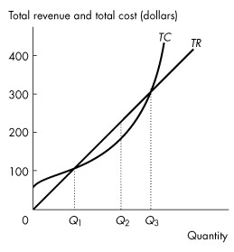
    - Refer to the above Figure, which shows a perfectly competitive firm's total revenue and total cost curves. Which one of the following statements is false?
  - At an output of Q1 units a day, the firm makes zero economic profit.
  - At an output greater than Q3 units a day, the firm incurs an economic loss.
  - At an output of Q2 units a day, the firm incurs an economic loss.
  - At an output less than Q1 units a day, the firm incurs an economic loss.

Use the figure below to answer the following questions.
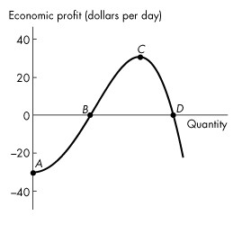
    - Refer to the above Figure, which shows a perfectly competitive firm's economic profit and loss. The firm is incurring a loss at
  - point A.
  - point B.
  - point C.
  - point D.
  - both points B and D.

    - If a perfectly competitive firm's marginal revenue is greater than its marginal cost, the firm
- cannot increase its economic profit.
- must be making an economic profit.
- will decrease its output to increase economic profit.
- will increase its output to increase economic profit.

    - In a perfectly competitive market, the market price is $8. An individual firm is producing the output at which MC = $8. AVC at that output is $10. What should the firm do to maximize its economic profit in the short run?
  - shut down
  - expand output
  - contract output
  - leave output unchanged
  - raise the price
    - A firm is producing the profit-maximizing amount of output when it is producing where its ________ curve intersects its ________ curve.
  - marginal cost; average total cost
  - marginal cost; average variable cost
  - marginal cost; marginal revenue
  - average total cost; average variable cost
    - In which one of the following situations will a perfectly competitive firm make an economic profit?
  - MR > AVC
  - MR > ATC
  - ATC > MC
  - ATC > MR
  - MC > AVC

Use the figure below to answer the following questions.
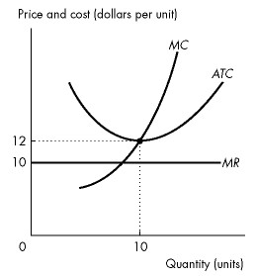
    - Refer to the above Figure, which shows the cost curves and marginal revenue curve of a firm in a perfectly competitive industry. In the short run, if the market price of the good is $10, the firm produces ________ units of output and ________.
  - 10; incurs an economic loss of $20
  - less than 10; incurs an economic loss of $20
  - 10; makes an economic profit of $20
  - less than 10; incurs an economic loss of less than $20
    - Long-run equilibrium occurs in a competitive market when
  - economic profit and economic loss have been eliminated.
  - no barriers to entry exist.
  - all firms are operating at their shutdown points.
  - price equals marginal cost.
  - none of the above.
    - If firms in a perfectly competitive market are incurring an economic loss, some firms will exit. This exit shifts the market
  - demand curve leftward, and the market price falls.
  - demand curve rightward, and the market price rises.
  - supply curve leftward, and the market price rises.
  - supply curve rightward, and the market price falls.

Use the figure below to answer the following question.
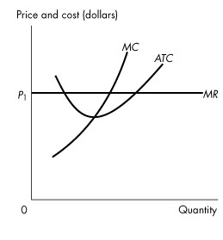
    - Refer to the above Figure, which shows the cost curves and marginal revenue curve of a firm in a perfectly competitive industry, The firm is
  - making an economic profit.
  - incurring an economic loss.
  - breaking even.
  - not maximizing economic profit.
  - going to close down temporarily.

Use the figure below to answer the following questions.
    - Refer to the above Figure, which shows the cost curves and marginal revenue curve of a firm in a perfectly competitive market. In the long run, market
  - demand will increase.
  - demand will decrease.
  - supply will increase.
  - supply will decrease.
  - supply and market demand will decrease.

    - If a market experiences external economies, the long-run market supply
  - is perfectly inelastic.
  - is perfectly elastic.
  - curve has a positive slope.
  - curve has a negative slope.
  - has allocative inefficiency.

PART B

(The section contains short answer questions, worth 50 marks. Please note that answers with necessary explanation will receive full marks only.)
Question 01
Plot $AFC$, $AVC$, $ATC$ and $MC$ curves on a scale diagram with dollars on the vertical axis and the level of output on the horizontal axis. Now identify the capacity of the firm, and name the before and after regions of the “capacity” point.
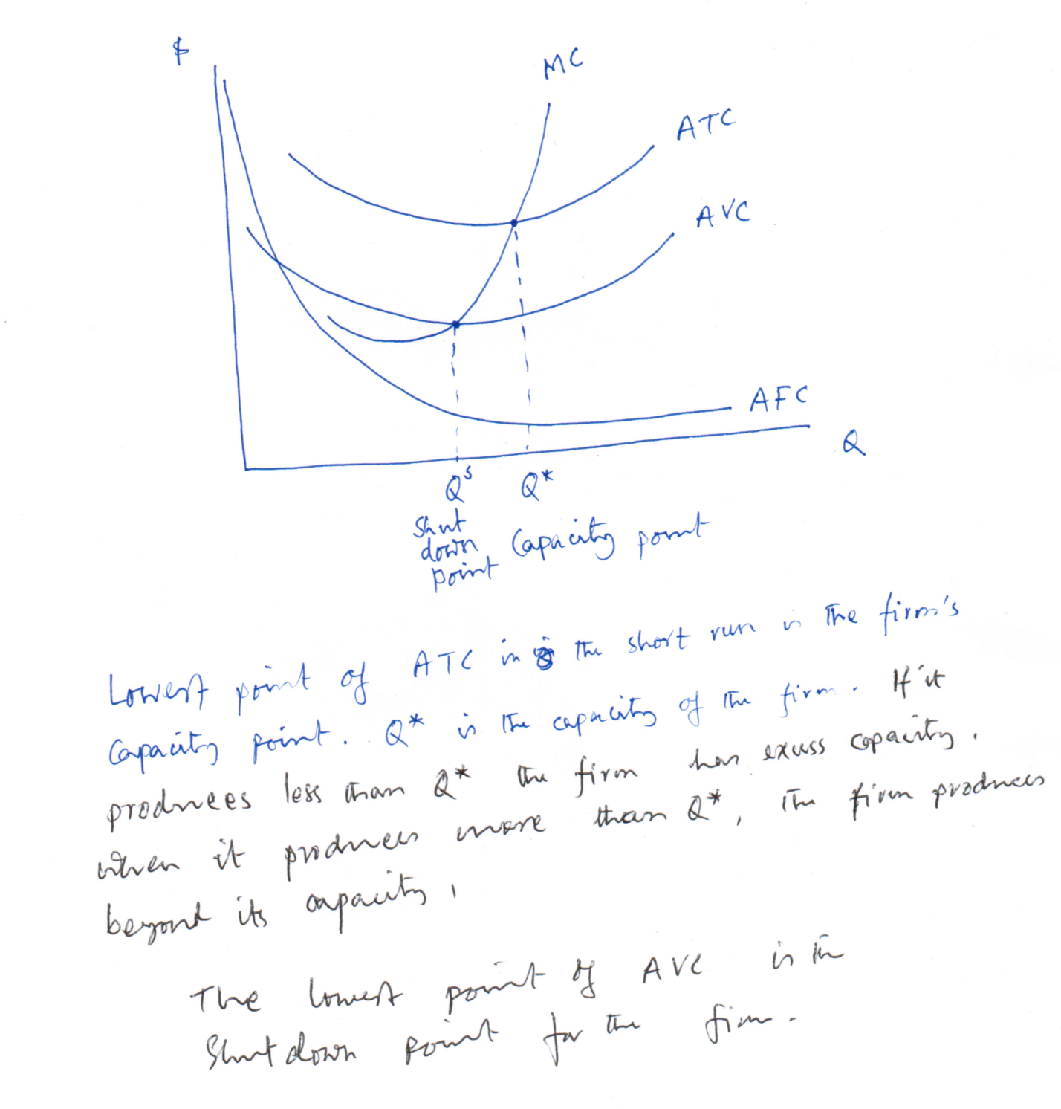

Question 02

Consider the market for gasoline. Suppose the market demand and supply curves are as given below. In each case, quantity refers to millions of litres of gasoline per month; price is the price per litre (in cents)
$$Demand:p=75-4Q^{D}$$
$$Supply:p=15+2Q^{S}$$

- Plot the demand and supply curves on a scale diagram with necessary labeling.

Price

$$p=75-4Q^{D}$$
$$Slope=\frac{∆p}{∆Q^{D}}=-4$$
75

$$p=15+2Q^{S}$$
$$Slope=\frac{∆p}{∆Q^{S}}=+2$$

35

15

Quantity
10
18.75

- Compute the equilibrium price and quantity for this gasoline market.
The equilibrium condition is:
$$Q^{D}=Q^{S}$$
and there is single price in the equilibrium, such that
$$75-4Q^{*}=15+2Q^{*}$$
$$Q^{*}=10$$
Plug-in the equilibrium quantity either in the demand or supply function, we get
$$p^{*}=75-4×10=35$$
Equilibrium price and quantity: $\left(p, Q^{*}\right)=(35, 10)$

Question 03
Consider the perfectly competitive market is initially in short-run equilibrium at quantity Q₀ and price P₀. Draw a supply-and-demand diagram for this market, showing equilibrium price and quantity. Using this equilibrium price, draw a typical competitive firm’s demand function. To find the equilibrium quantity for the firm draw the supply function. Please state clearly, how the supply function of a competitive firm is derived.

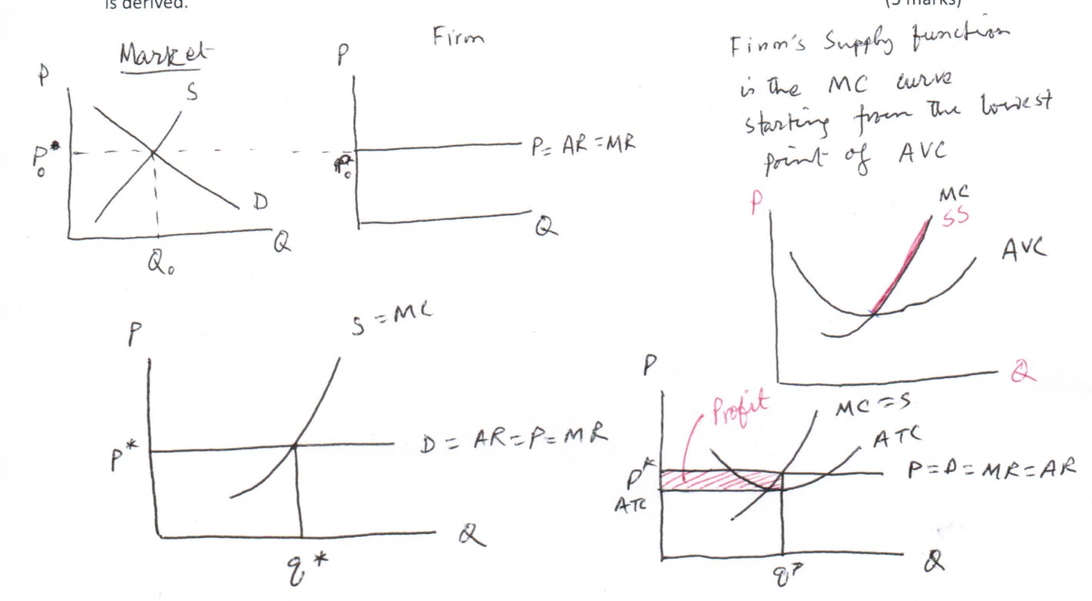

Question 04
Explain what happens over time if some of the firms in a competitive market make positive economic profits in the short run.

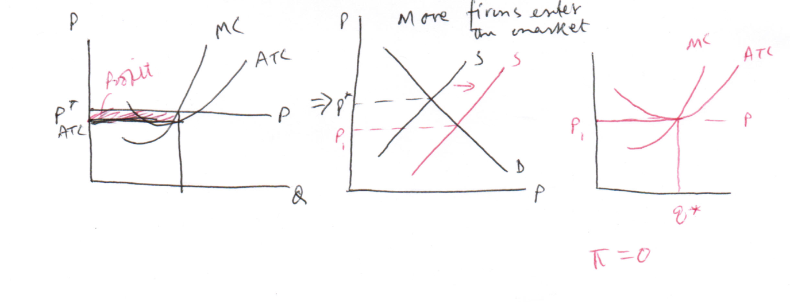
If one or more firm(s) in a competitive market make(s) profits in the short run, new firms enter the market because of free entry/exit assumption. Then the market supply function shifts to the right. For a given demand curve the new equilibrium offers a lower price, for which firms that were making positive profit now find themselves with zero economic profit over time.

Question 05
- What are the basic assumptions of a perfectly competitive market?

- Derive the competitive firm’s profit maximization condition ($MC=MR)$.

- Draw the demand curve for a competitive firm and market

- For a price-taking firm draw a diagram that illustrates the short-run equilibrium situation. Also state the equilibrium condition.

Your equilibrium point will have $MC=MR=P$, where firms make zero profit. Entry/exit stops. (p. 282, figure 12.8 (a))

- How the long-run equilibrium of a firm differs from its short run equilibrium?

In longrun no fixed cost. Firms make zero economic profits and operate at MES. Please re to figure 12.12 (p. 191)

Question 06
Consider the following table showing the various revenue concepts for DairyTreat Inc., a perfectly competitive firm that sells milk by the litre. Suppose the firm faces a constant market price of $2 per little

Price | Quantity | Total revenue  (TR) | Average Revenue  (AR) | Marginal revenue  (MR)
$2 | 150 | 300 | 2
2 | 175 | 350 | 2 | 2
2 | 200 | 400 | 2 | 2
2 | 225 | 450 | 2 | 2
2 | 250 | 500 | 2 | 2

- Compute TR, AR and MR for each level of output. Fill in the table

- Explain why for a perfectly competitive firm, AR = MR = p.

Competitive firms are price takers. A firm calculates its TR based on unit sold at the given market price, p. In above table you see p=AR=MR

- Plot the TR, MR, and AR curves on a scale diagram. What is the slope of the TR curve?

Please re to figure 12.2 & 12.3
The slope of TR is the MR function

Question 07
Consider the perfectly competitive barley industry. It is initially in long-run equilibrium at quantity Q₀ and price p.
- Draw a supply-and-demand diagram for the barley market, showing the initial longrun equilibrium.

- Draw a diagram for a typical form where the industry is in its initial LR equilibrium, showing its MC, ATC, and LRAC curves. Are any profits being earned the typical barley farmer?

- Now suppose there is an increase in demand for barley. Price rises to p₁. In your diagram show the response of the typical firm to the increase in market price from p₀ to p₁. Show the typical firm’s profit at this new price.

The market demand function shift to the right and market quantity and price increase. Firms take the price from the market and start to earn positive economic profit. ( you can use figure 12.10 (for opposite analysis) to answer the question)

- Explain how the industry adjusts to its new long-run equilibrium. Illustrate this adjustment both in the demand-and-supply diagram and in the diagram of the typical firm.
Use entry/exit concept to reach at the equilibrium in the LR

Question 06
Ex. 3-5 based on the table provided on p. 269

Question 07
Ex. 18, p. 249
- The opportunity cost (OC) of buying a watch is the loss of whatever else would have been purchased with the funds
- The OC of owning a watch is the annual foregone return, such as the forgone interest from buying a watch rather than placing the funds in a saving account, and the depreciation of the watch
- Yes, owning a watch creates an economic profit opportunity. If the watch appreciate at a rapid clip, so that the gain in the value of the watch over time exceeds the normal profit from the funds used to purchase the watch, then owning the watch has lead to an economic profit
Question 08
Ex. 4, p. 247
- Many Indian farmers use oxen-pulled plow because the cost of tractors is too high. Using oxen-pulled plows allows farmers to produce at lower cost than if they used tractors. Because of the lower cost, Indian famers may well be economically efficient
- The presence of JD in the Indian market will increase the supply of tractors and lower their price. By lowering their cost so that using a tractor is now economically efficient, Indian farmers will switch production methods. Their technology constraint will change as a result of using the additional capital equipment and the farmers will be able to produce more output than before

** END OF EXAM **

