IMPROVING MINING PRODUCTIVITY AND EFFICIENCY THROUGH APPROPRIATE MINING TECHNOLOGY.

Course Objective: To provide an intense and intimate practical training to production managers, Mine Captains, Shift Bosses, Production and Planning Engineers, Rock Mechanics Engineers, Mine Contractors Drilling and Blasting Engineers and Allied Mine Professionals.

RESPONSE OF ROCK TO SUB – CRITICAL STRESS LEVELS
  - Stress and Strain
Sir Isaac Newton – gravitational forces forces.

Gravity not the only one, other sources include tectonic processes, isostacy, previous temperature and loading history, effects of weathering and ground water and changing local conditions.

Basis Rheology - is study of the response of materials to stress application. The terms “elastic” and “plastic” are two familiar rheological models; others are more complex.

Rheology – Science of the study of the deformation and flow of matter. Rheologist, rheometer e.t.c.

Typical Stress Strain Curve for large rock mass
a = closing of flaws
c b = Linear Dortion
b c = Micro fracturing begins up to
yield point
a

Application of Stress – rock mass yields at rate characteristics of a non – rigid material. As stress is increased, the rate of deformation decreases and becomes constant. If stress is removed, some of the strain will be immediately recovered, some will be recovered on a time dependent basis and some will be irrecoverable.

ROCK MECHANICS

SOME DEFINITIONS

- MECHANICS: is the study of the effects of forces on bodies. The effects may be acceleration, velocity and displacement; or the forces may produce changes in volume and shape; finally fracture or flow may occur.

ROCK MECHANICS: is the study of the effects of forces on rocks. The principal effects of interest for the geologist are the changes in shape that occur. Those of interest for the geophysists are probably the dynamic aspects of changes in volume and shape i.e. seismic waves. The Engineer is primarily concerned with the phenomena influencing the predictability of fracture and flow and to some extent with changes in the volume and shape of rocks.
- DEFORMATION: is the absolute or relative movement of a point on a body or the change in a linear dimension e.g.

p
$∆l$ $∆l$ = DEFORMATION
L

- STRAIN: is the unit deformation or the deformation per unit length or width.
p
$∆l$ $∆l$ = DEFORMATION
L
Strain=∆l
L

P p
In engineering work, it is common practice to use the original unstrained length L, for calculating any strain.
- NORMAL STRAIN: ϵ is the deformation per unit length in the direction of the deformation. Strain is dimension less.
- SHEAR STRAIN: Commonly described as the relative change in the angle defining the sides of an infinitesimal element.

Y

γ = ∆X
Y
Length over which the deformation occurs is at right angles to the direction of the deformation.
- MODULUS OF DEFORMATION: E is the ratio of normal stress to normal strain for a particular material where the increase in strain is caused by the increase in stress.
For elastic bodies the term “modulus of elasticity” is used for this property.
- POISSONS RATIO : Is the ratio for a particular material, of the transverse normal strain to the longitudinal normal strain under uniaxial stress in the longitudinal direction.

- POISSONS EFFECT: Term used to describe the lateral deformation resulting from longitudinal stress.

- ELASTIC: Describes a material or state of a material where strain or deformation is recoverable, nominally instaneously but actually within certain tolerances and within some arbitrary value.

- Plastic describes a material or a state of a material where strain or deformation is partially irrecoverable within certain tolerances and within some arbitrary time.

- VISCOUS: Describes a material whose strain is dependent on time.
SOME MORE DEFINITIONS

STRESS: The force per unit area acting on a body, in the limit as the area approaches
zero.

BIAXIAL STRESS: The state of stress where either the intermediate or the minor principal stress is equal Zero.
EFFECTIVE STRESS: (effective Pressure, intergranular pressure (FL ⁻²)
The average normal force per unit area transmitted from grain to grain in a granular mass. It is the stress that is effective in mobilizing internal friction.
FIELD STRESS: The stress existing in a rock mass independent of any man made works.

RESIDUAL STRESS: Stress that exists in a formation owing to previously applied forces or deformations.

TRIAXIAL STRESS: A state of stress where the 3 principal stresses have finite magnitudes, or simply a three dimensional state of stress.

NEUTRAL STRESS: (Pore Pressure) (p.w.p.u (FL⁻²)
Stress transmitted through the pore water (water filling the voids of the mass).

NORMAL STRESS: (FL²) The stress component normal to a give plane.
PRINCIPAL STRESS: σ₁ σ₂ σ₃ (FL ⁻²) Stress acting normal to three mutually perpendicular planes intersecting at a point in a body on which the shear stresses are zero.
MAJOR PRINIPAL STRESS: σ₁ (FL ⁻ ²)
The largest (with regard to sign) principal stress
MINOR PRINCIPAL STRESS: σ₃ (FL ⁻ ²)
The smallest (with regard to sign) principal stress.
INTER MEDIATE PRINCIPAL STESS: σ₂ (FL ⁻ ²)
The principal stress whose value is neither the largest nor the smallest (with regard to sign) of the three.
SHEAR STRESS: (Shearing Stress) (Tangential Stress τ(FL⁻²) The Stress component tangential to a given plane.
TOTAL STRESS: σ₂ (FL ⁻ ²) The total force per unit area acting within a granular mass. It is the sum of the neutral and effective stresses.
σ = σ₁ ₊ μ σ₁ = Effective Stress
μ = Neutral Stress
STRESS DIFFERENCE: The algebraic difference between the major and minor principal stresses.

MI 313 LECTURE 2
FUNDAMENTAL PRINCIPLES OF ROCK MECHANICS
DO THE DEFINITIONS
Then the fundamentals of Solid Rock Mechanics from Budavari.
Identification and classification of rock
Intact – rock
Geological Identification – visual examination
- Igneous, Metamorphic or Sedimentary
- Core examination – optical or television borehole camera especially for non – coring rocks.
Mechanical property determinations - intact rock strengths
- deformation moduli
- frictional characteristics
Use above to mechanically classify intact rock.
e.g. Utilize uniaxial compressive strength (C_{o)} and the tangent modulus of elasticity at 50% C_{o}, E_{t50}.
Deere and Miller Rocks are classified as BM. AH, BL etc.
REFERENCE: Deere D. U, and Miller, R. P., “Engineering Classification and Index Properties for Intact Rock “AFWL TR , pp65 – 116 , 1966.
In situ Rock
Mechanical Evaluation and Classification
- examine exploratory drill cores
- examine in-situ rock if underground access possible.
Common mechanical defects
Fracture - break in a body of rock may or may not be attended by a displacement.
- geological origin or man made – e.g. blasting.
Fault - fracture of geological origin – attended by shear displacement
- may contain usually, gouge, decomposition or alternation products.
Joint - Fracture of geological origin in body of rock – attended by displacement.
- Usually occur in sets or systems
- alternation or decomposition products in joint surfaces
Parting - A thin decompositional layer, often organic separating thicker rock strata.
Bedding Plane - Surface that separates each successive layer in a stratified body of rock.

ENGINEERING CLASSIFICTION FOR INTACT ROCK
- Strength Basis

Class | Description | Uniaxial Compressive  Strength Psi (u.c.s)
A | Very high Strength | $>$32,000 psi 220 MN/m²
B | High Strength | 16,000 – 32000 110 -220 MN/m²
C | Medium Strength | 8000 – 16000 55 – 110 MN/m²
D | Low Strength | 4000 – 8000 28 – 55 MN/m²
E | Very Low Strength | $<$4000 $<28 MN/m$²

- On Modulus Ratio
Class | Description | Modulus Ratio
H | High Mod. Ratio | $>$ 500
M | Ave. (Med) Mod. | 200 - 500
L | Low Mod. Ratio | $$>200$$

lll. Deformation Properties
- Elastic | - Plastic
No creep or swelling tendencies Large amount of stored strain Energy | More than 25% total strain at any stress level is irrecoverable
Brittle fracture failure with Explosive energy releases | Some material will creep or swell on exposure and some will fail by yielding or rupture.  Includes viscous or time – dependent strain material (at contact stresses).

bonds across faults negligible.
bonds across joint – zero high, some…………………. $≪$ strength of host rock
bond across parting or bedding planes variable but generally $<$ that of the host rock.
Classifying ……………………….. rock
RQD – rock quality designation based on core logging
- In ratio of length of core recovered, counting only those pieces of intact core 4” or longer to the total length of the core run.
e.g.
RQD % | DESCRIPTION OF ROCK QUALITY
0 - 25 | Very poor
25 - 50 | Poor
50 - 75 | Fair
75 - 90 | Good
90 - 100 | Excellent

Descriptive Terminology for Joint Spacing and Bed Thickness
Joint Spacing | Bed Thickness | Spacing
Very close | Very thin | $<$ 2” 5.08 cm
Close | Thin | 2” – 1 Ft 5.08cm 30……
Moderately Close | Medium | 1ft – 3ft 30.8 cm 91.44cm
Wide | Thick | 3ft – 10fr 0.91cm 3.05m
Very wide | Very think | $>$ 10fr. $>$ 3.05 m

CLASSIFICATION OF……………….. ROCK
I Strength II Continuity
Description | Unconfined Strength PSC | Description | Joint Spacing
Very Strong | 725000 | Massive | $>$ 6 fr 1.8m
Strong | 1000 - 25000 | Blocky | 1 – 6 ft .3m – 1.8m
Weak | 5000 – 10 000 | Broken | 3” – 1 fr 0.08m – 0.304m
Very weak | $<$ 5000 | Very broken | $<$ 3” $<$ 0.08m

Classification from …………………… measurements:
Determine elastic moduli of ………………….. and intact rock.

Rock soundness = E _{intact}
E _{in – situ}

E intact - E…………………… = Crack coefficient of the …………… rock

 | Soundness | Crack Coefficient | Geological Diagnostic of Rock Grade
- Excellent | 0.75 – 1.00 | $<$ 0.25 | Fresh, no joints,
- Good | 0.50 – 0.75 | 0.25 – 0.56 | Less jointed, joints slightly open
- Available | 0.35 – 0.50 | 0.50 – 0.65 | Parted by joints minor clay filling
- Deficient | 0.20 – 0.35 | 0.65 – 0.80 | Wide joints, clay, water in joints rock more weathered
- Bad | $<$ 0.20 | $<$ 0.80 - 100 | Advanced weather conspicuously jointed cracked or crushed

LECTURE 3

HOOKEN SOLID

Ε = $σ/E$
σ Various Ε s
Ε
Rheological Model of a perfectly elastic material model is sping and is referred to as a Hooken solid it obeys Hookins Law which simply states that: The strain produced is linearly proportional to the acting stress level. The constant of proportionality is known as Youngs Modules (E) and the mathematical relationship of this model is E = $σ/ϵ$.
If stress – strain relationship is not perfectly linear, then the elastic model does not fully explain the observed behavior. Sometimes use a straight line which approximate the actual stress – strain relationship.
Common ways of specifying Young’s Modulus when the stress – strain curve is non – linear.

$σ$ $σ$
$σ$

Ε Ε Ε
- Secant Modulus (b) Tangent Modulus (c) Initial Modulus

NEWTON FLUID
σ

Ε ΛΕ 3m
Λt dash-pot
Various ή S
0 T
$\frac{∆ϵ}{∆ϵ}$ = $\frac{σ}{Zn}$ $⟹$ ϵ = $\frac{σ}{Zn}$
Strain increases linearly with time in proportion to the stress applied and immensely proportional to the viscosity 𝑛. The graphical representation in the strain time plane is a straight line that passes through the origin and was a slope of $\frac{σ}{Zn}$
Plastic Material
σ
σ₀

ϵ

There is a threshold stress level below which no strain occurs. The material cannot support stress beyond this threshold value. Strain in the form of plastic Haw results.

Elastic Plastic Material on St Venant Material
σ Ε
σ₀
∑₀ δ=con
T
ϵ
A stress equipment to the threshold for plastic flow results in an instaneous elastic deformation plus an exponentially decreasing rate of strain. To completely describe ……………….. behavior, a rather complex rheological model is required. To simulate elastic behavior and permanent time – dependent deformation, a Hookean solid and a Newtonian Fluid are joined in series:-
Maxwell Solid
Ε 3m σ Ε. ϵ₀

σ₀/Ε t
Constant Stress Constant Strain Behavior of Maxwell Solid under constant Strain
The equation relating strain to time for a fixed stress level is
ϵ = ${σo}/E$ + $σo t /Zn$
To represent time-dependent time – recoverable deformation the Hooken and Newtonian models are joined in parallel viz. Combine Maxwell and Kelvin Solids in series to Form a Burgers Solid which is a valid rheological model for rock.
BURGERS SOLID Load removed
E time dependent plus
E 3ή permanent deformarion
time dependent deformation Elastic recovery
Elastic defor
permanent deformarion
t
Shows the strain behavior of model in response to a constant stress level.
Involved: Instantaneous elastic deformation time dependent and permanent deformation. All this is typical of rock behavior. The strain equation for the model is as follows:
ϵ = $\frac{σo}{EM}$ + ${σo t}/{3n }$+ ${σo t}/{3n }$_{m +} ${σo t}/{3Ek }$ (l – e -E_{k} $t/{3m}$ _{k} )
“M” refers to Maxwell Solid
“K” refers to Kelvin Solid
Inelastic Theories – many
Rock – brittle limited plastic angel /show plastic range only in triaxial loading conditions. Ductile materials – long plastic range. Engineering materials metals, plastics, rubber, synthetic fibres, paints ………………………….The dependant and permanent deformation are generally much lower in magnitude than the elastic deformations. For most practical purposes elastic (Hookean Model) can be used alone to approximate rock behavior.
Poissons Effect
Poissons Effect unconfined
When an elastic material is compressed in one direction, it tends to expand at 1 to that direction e.g. image a square rubber eraser expanding as it is squeezed. The amount of liberal strain (𝜺₃) is less than the axial strain (𝜺₁) Poisons ratio is defined simply as the ratio of the lateral strain to the longitudinal strain.
Μ = ${ε3}/{ε…}$
For most rocks poisons ratio is in the 0.20 to 0.30 range. The lateral expansion in unconfined axial compression causes the normal stress in the lateral direction to remain at zero.
However consider situation in following figure. σ

v
Rigid σ= 0 Abutments x
∑$1/2$
Poissons Effect unconfined
Lateral expansion is prevented by rigid confinement and so a stress will be generated in the lateral direction. This is similar to the situation existing in virgin ground below the earth’s surface where neck is confined in all directions by the adjoining rock as shown below.

Earth’s surface
σ2
σX
H Vertical stress =γH σY

The following approach can be used to determine the magnitude of t he lateral (horizontal) stresses generated by the vertical gravity stress field. The strain in the X direction due to σ_{x} acting alone
𝜺_{x} _{(x)} would be
𝜺_{x} _{(x)} = σx/$E$
Similarly 𝜺_{x} _{(y)} = ⁻ $\frac{σy}{ME}$
𝜺 x (z) =⁻ $\frac{σz}{ME}$
Due to the confinement, the net resultant strain must be zero.
Assuming rock is isotropic (having the same properties in all directions)
σ_{x =} σ_{y}
Therefore 𝜺x= 𝜺x(x) + 𝜺x(y) + 𝜺x (Z) = 0
M σ_{x} - σ_{x –} σ_{z} = 0
ME
Therefore σ_{x =} σ_{z/(M – 1)}

Now since for most rocks Poissions Ratio is close to 0.25, a horizontal compressive stress, approximately equal to ⅓ of the gravity generated vertical stress will be present in the earth’s crust.
Important to realize that there may not be the only stresses present.
Viz past geological history
Present tectonic activity
May super impose additional stress.
Often the horizontal stress is greater than the vertical stress. The only way to know the magnitude and direction of the net resultant stress field is to measure it.
Techniques for measuring in – situ stress levels will be discussed later
𝜺_{x =} $\frac{1}{E}$ $[ σx- μ ( σy-σz ) ]$
𝜺_{x =} $\frac{1}{E}$ $[ σy- μ ( σx-σz ) ]$
𝜺_{x =} $\frac{1}{E}$ $\left[ σz- μ \left( σx-σy \right)\right]$
Derive ay and 𝜺_{z} from basic principles
therefore 𝜺𝑛 = $\frac{σx}{E}$ - $\frac{σy}{ME}$ - $\frac{σz}{ME}$
𝜺_{x =} $\frac{1}{E}$ $[ σx- μ ( σy-σz ) ]$
Strain in x – dir ₌ 𝜺_{x (x) =} ${σx}/E$
Youngs Modulus
Stain in the Y – direction due to $σy$ acting alone is due to confinement the net resultant strain must be zero assuming that the rock is iso tropic $σx-σy$
therefore = 𝜺_{x (x) +} 𝜺_{x (y) +} 𝜺_{x (z) = 0}
𝜺 x = 𝜺_{x} (x) + 𝜺_{x} (y)+ 𝜺_{x} (z) = 0
$\frac{σx}{E}$₊ $\frac{σy}{ME}$ – $\frac{σ2}{ME}$ ₌ ₀
_{M} $σx$ ₋ $σx- σx$–$σ$₂ ₌ 0
ME

But σ_{x =} σ_{y}
Therefore $M$ σ_{x -} σ_{y -} $σ$₂ ₌ 0
ME

σμ (M -1) - $σ$₂ ₌ 0
𝜺y The strain in the y direction due to σ_{y} acting alone is 𝜺y (y) = $\frac{σy}{E}$
Similarly y (x) = - $\frac{σx}{ME}$
𝜺y (Z) = - $\frac{σz}{ME}$
𝜺_{Z} The strain in the Z direction due to $σ$₂ acting alone is 𝜺z (_{z}) = $\frac{σ}{E}$²
Similarly 𝜺_{z} (x) = -$\frac{σx}{ME}$
𝜺_{z} (x) = -$\frac{σy}{ME}$

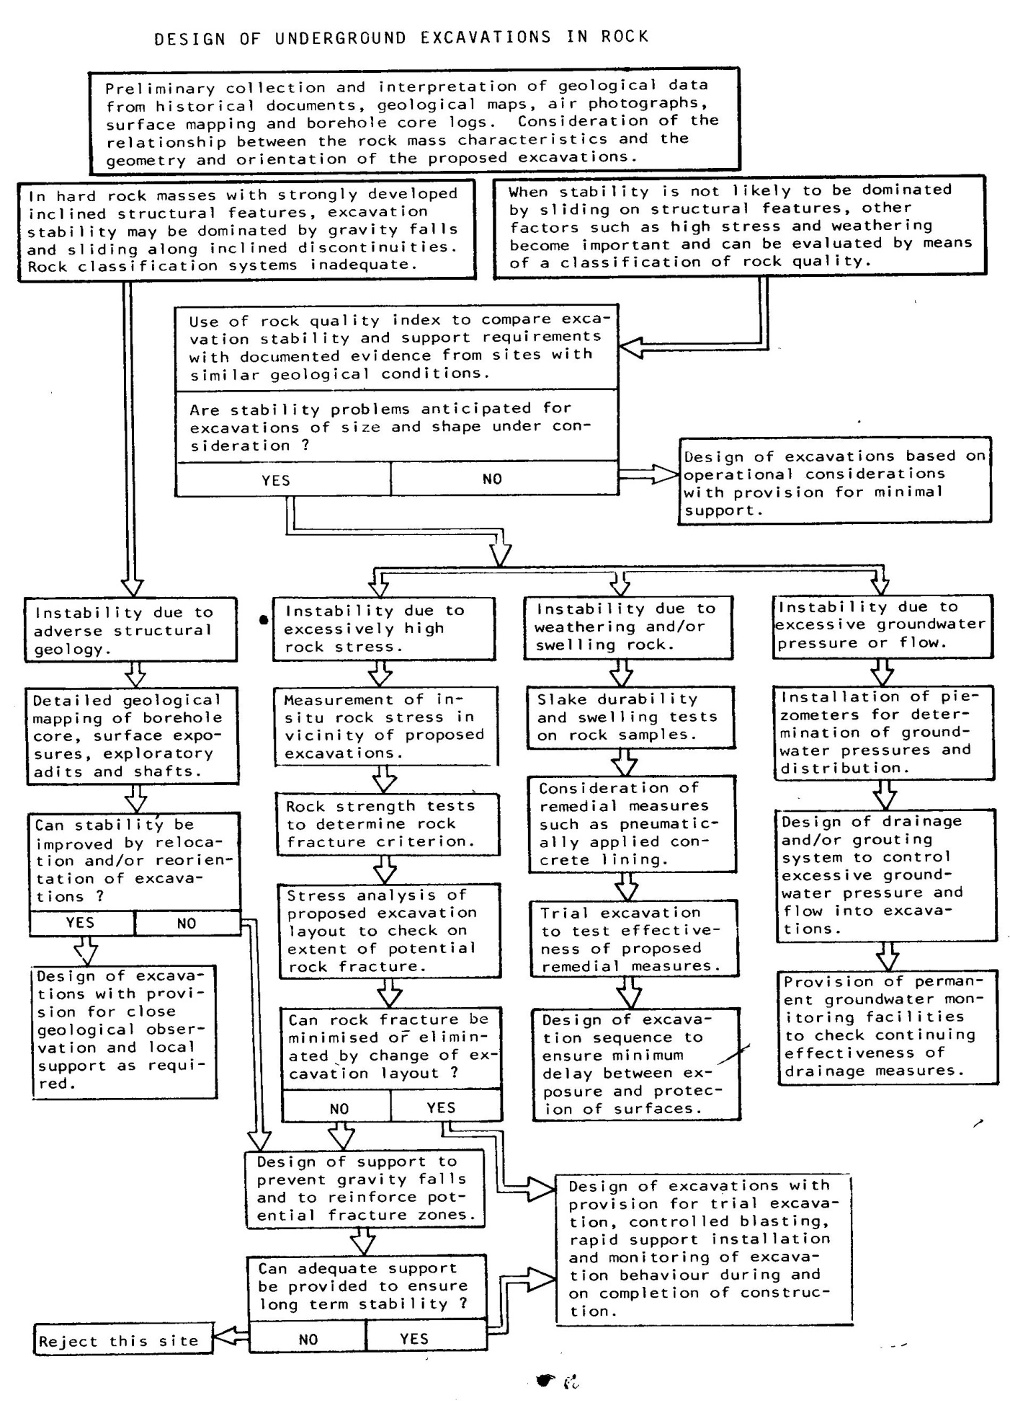
A vertical, circular, unlined shaft, 4.88m in diameter, extends to a depth of 609.6m where the stresses are examined; the density of the overburden is 170pcf, poison’s number is 4; assume the horizontal stress in the undistributed ground is due only to the horizontal restraint of the overburden pressure; (a)calculate the horizontal field stress (b) calculate the stresses at the surface of the shaft and plot on one Mohr’s diagram the three stress circles for radial, tangential and horizontal planes; (c) what is the stress concentration factor (d) repeat (b) for a point 1.524m into the rock from the face of the shaft; (e) repeat (d) if a lining pressure of 1 ksf is applied.
A circular, unlined tunnel, 4.88m in diameter, is driven at a depth of 609.6m; the horizontal stress in the undisturbed ground is due only to horizontal restraint of the overburden pressure; (a) calculate using plate theory equations the stress at the surface of the rock at the crown of the tunnel and plot on one Mohr’s diagram the three stress circles for the radial, tangential and horizontal planes; (b) what is the stress concentration factor in (a) (c) repeat (a) for a point on the surface of the rock at the mid height of the wall of the tunnel ; (d) what is the stress concentration factor in (c)? (e) repeat (a) for a point on the vertical centerline 1.524m into the rock from the surface of the tunnel; (f) repeat (a) for a point on the horizontal centerline 1.524m in from the surface of the rock , (g) calculate the unit strain energy stored in the rock at the surface of the tunnel shown in the figure below.

