

THE UNIVERSITY OF ZAMBIA
SCHOOL OF ENGINEERING
DEPARTMENT OF MECHANICAL ENGINEERING

TITLE: ORTHOGONAL CUTTING ANALYZED WITH A TWO COMPONENT LATHE TOOL DYNAMOMETER

COURSE: MEC 3102

LABORATORY EXPERIMENT NO: 3

NAME: DANIEL OGAH

COMPUTER NUMBER: 2020905124

FOR THE ATTENTION OF: DR MUSONDA

DATE OF EXPERIMENT: 5/10/2023

DUE DATE :10TH , OCTOBER ,2023

ABSTRACT: This laboratory investigates the cutting process in precision machining using a specialized two-component lathe tool dynamometer. This research aims to enhance our understanding of the forces and dynamics involved in orthogonal cutting, a fundamental process in manufacturing. By employing a two-component lathe tool dynamometer, the study offers a comprehensive analysis of cutting forces in both the tangential and radial directions. The findings from this research will contribute to the optimization of machining processes, enabling more efficient and accurate manufacturing in various industries.
OBJECTIVES:
i. To measure the cutting forces 𝑭𝒄, and 𝑭𝒂, in two perpendicular directions, (ii) ii. To determine the influence of:
- Depth of cut 𝒅
- Feed rate 𝒇
- Cutting velocity 𝑽𝒄
- Rake angle 𝜶 of the cutting tool on the cutting forces iii. To compare the practical results with the theoretically obtained values of 𝑭𝒄 and
𝑭𝒂.

EQUIPMENT
Lathe tool dynamometer , metal bars
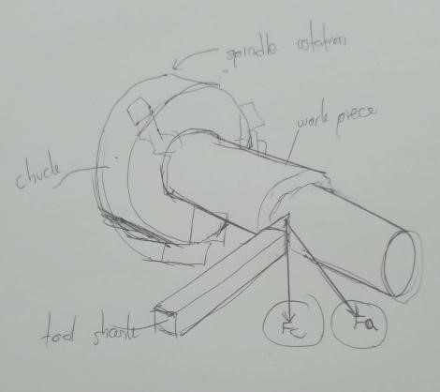
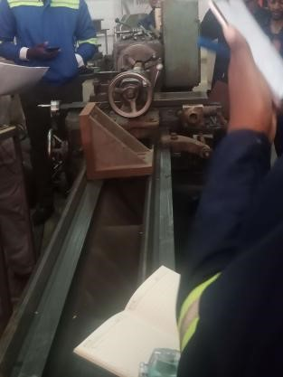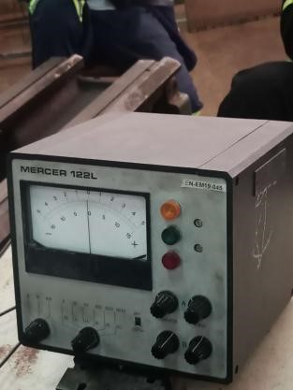

LATHE DYNAMOMETER
A lathe dynamometer is an instrument designed to measure the forces and torques exerted on a cutting tool during the machining or turning process on a lathe machine. It is an essential tool for research and manufacturing processes in industries such as metalworking and precision engineering. Lathe dynamometers are used to gather data on cutting forces and tool performance, helping engineers and researchers optimize machining processes.
Key features of a lathe dynamometer include:
- Force and Torque Sensors: Lathe dynamometers are equipped with sensors capable of measuring both axial (tangential) and radial forces, as well as torque, allowing for a comprehensive understanding of the cutting forces at play.
- Data Acquisition System: These instruments are typically connected to data acquisition systems that record and analyze the real-time force and torque data. This information is crucial for optimizing cutting parameters and tool geometry.
- Mounting Interface: A lathe dynamometer is designed to be securely attached to the lathe machine's tool post or tool holder. It must be rigidly connected to accurately capture the forces generated during cutting.
- Calibration: Precise calibration is essential to ensure accurate force and torque measurements. Calibrations are usually performed regularly to maintain the accuracy of the dynamometer.
The setup for a lathe dynamometer is as follows
Mounting: The lathe dynamometer is securely mounted to the lathe machine's tool post or tool holder. The dynamometer should be aligned with the cutting tool and workpiece to accurately measure the forces and torques.
Calibration: Before the experiment, the dynamometer must be calibrated to ensure accurate measurements. This calibration involves applying known forces and torques to the dynamometer and adjusting its sensitivity or gain settings to match the expected values.
Tool Installation: The cutting tool is installed in the lathe's tool holder, and the dynamometer's tool holder is positioned next to it. The tool and dynamometer should be aligned properly to ensure that they share the same cutting path.
Workpiece Preparation: A workpiece material is securely mounted on the lathe's spindle, ready for machining. The material choice and dimensions should be well-documented for the experiment.
Finally, data is collected and presented by the dynamometer

THEORY
Orthogonal cutting is a fundamental process in machining, where a cutting tool removes material from a workpiece. Understanding the forces and dynamics involved in this process is crucial for optimizing machining operations, tool selection, and workpiece material handling. In this experiment, a two-component lathe tool dynamometer is employed to measure and analyze the forces acting on the cutting tool during orthogonal cutting. This section provides the theoretical background and key equations relevant to the experiment.
1. Orthogonal Cutting Forces:
In orthogonal cutting, there are two primary cutting forces: the axial cutting force (Fc) and the radial cutting force (Fr). These forces can be defined using the following equations:
- Axial Cutting Force (Fc): Fc=T/R Where:
- T is the cutting torque measured by the dynamometer.
- R is the effective radius of the workpiece being machined.
- Radial Cutting Force (Fr): Fr=Fz−Fa Where:
- Fz is the resultant force along the cutting direction.
- Fa is the feed force, which is the force acting in the feed direction.
  - Cutting Power:
Cutting power (Pc) can be calculated using the following formula:
Pc=Tω Where:
- T is the cutting torque.
- ω is the angular velocity of the workpiece in radians per second.
  - Specific Cutting Force:
The specific cutting force (Kc) is a material property that represents the resistance of a material to cutting. It can be calculated as follows:
Kc=Fc/Ap Where:
- Fc is the axial cutting force.
- Ap is the uncut chip cross-sectional area.
  - Merchant's Circle Diagram:
Merchant's circle diagram is a graphical representation of cutting forces and chip formation during orthogonal cutting. It provides insights into the relationships between cutting parameters and forces. The diagram includes the following components:
- Cutting Force (Fc)
- Thrust Force (Ft)
- Cutting Velocity (Vc)
- Cutting Speed (V)
- Chip Thickness (t)
The diagram can be used to analyze chip formation, predict cutting forces, and optimize machining parameters.
  - Tool Wear and Tool Life:
The experiment can also investigate the relationship between cutting forces, tool wear, and tool life. Increased cutting forces can lead to accelerated tool wear and reduced tool life. The Taylor Tool Life Equation can be used to relate tool life (T) to cutting speed (V), tool material properties, and cutting forces:
Tn=C Where:
- n is an exponent typically determined experimentally.
- C is a constant.

4. PROCEDURE
Firstly, the lathe dynamometer was calibrated for both directions. Calibrating the force sensors of the lathe dynamometer involved preparing the instrument, applying known and precise forces, recording sensor outputs, and adjusting the sensor settings to match the expected values. This process ensured that the sensor provided accurate measurements of cutting forces during the machining experiments, enhancing the reliability and quality of the collected data. Regular documentation and verification checks helped maintain the sensor's accuracy over time. The compound slide was then removed and the dynamometer was aligned
The tool was mounted and set to an overhang L which was 10.16mm+/- ½. The electronic gauge working was checked and actual tests were done, recording deflections which were to be converted to forces for the conditions set for the conditions below

4.1. Variable depth of cut 𝒅
Speed: 𝐧 = 𝟏25/𝐦
Feed 𝐟 = 𝟎. 13mm/𝐫ev
Rake angle 𝛂= +𝟏0°
Work piece diameter D=65 mm (measure actual diameter workpiece)
Depth of cut 𝒅 = 𝟏,𝟏. 𝟕5, 𝟐. 𝟓, 𝟑.𝟐5, 𝟒 m𝒎

4.2. Variable tool feed 𝒇 Speed: 𝒏 = 𝟏25rev/min
Depth of cut 𝒅 = 𝟐.𝟓 𝒎m
Work piece diameter 𝑫 = 𝟔5𝒎𝒎 (measure actual work piece diameter)
Rake angle 𝛂 = +𝟏0°
Feed 𝒇 = 𝟎. 𝟏3, 𝟎.𝟏𝟏; 𝟎.097; 𝟎.084; 0.07𝒎𝒎/𝒓ev

4.3. Variable Cutting Speed 𝑽𝒄
Depth of cut 𝒅 = 𝟐. 𝟓 m𝒎
Work piece diameter 𝑫𝑫 = 𝟔5 𝒎𝒎 (measure actual diameter)
Rake angle 𝛂 = +10°
Speed: 𝒏 = 𝟖0, 125,160,200,315,400rev/min
Feed 𝒇𝒇 = 0.070 m𝒎/𝒓ev

4.4. Variable rake angle a Speed: 𝒏 = 𝟏25 𝒓ev/𝒎𝒎 Feed 𝒇 = 𝟎. 𝟏4 𝒎𝒎/𝒓ev
Depth of cut d = 2.5 mm
Workpiece diameter 𝑫=65𝒎𝒎 (measure actual workpiece diameter)
Rake angle 𝜶 = 𝟎°, 𝟓°, 𝟏0°, 𝟏5°, 𝟐0°, 𝟐5° Collect sample chips for known cutting parameters for
use in Section 4.5. The chip thicknesses should be measured using a dial type vernier caliper.

DATA COLLECTION

Feed rate =0.12 rev/min Rake angle =10degrees
Diameter =58

4.1 Varying depth
Depth of cut | a |  | b
Depth of cut | Force | Magnification | Force | Magnification
1 | 0.2 | 5 | 2.6 | 15
1.75 | 0.1 | 5 | 1.5 | 50
2.5 | 0.2 | 5 | 2 | 50
3.25 | 0.2 | 5 | 2.4 | 50
4 | 0.2 | 5 | 2.8 | 50
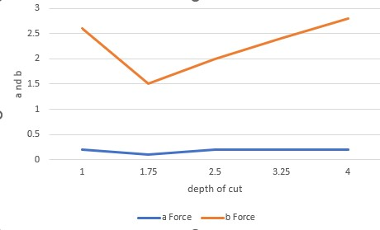

4.2

Var
ying Feed
rate

Feed rate: 0.14
Speed=125rpm
Depth=2.5
Diameter=58mm
Rake angle=10 deg

Feed rate | a |  | b
Feed rate |  | Magnification |  | Magnification
0.14 | 0.1 | 5 | 2.1 | 50
0.12 | 0.1 | 5 | 1.8 | 50
0.11 | 0.2 | 5 | 2 | 50
0.09 | 0.1 | 5 | 1.8 | 50

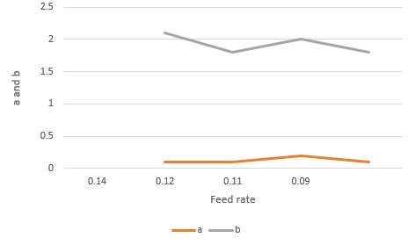

4.3) Varying speeds

Speed | a |  | b
Speed |  | Magnification |  | Magnification
90 | 0.2 | 5 | 2 | 50
125 | 0.1 | 5 | 2 | 50
180 | 0.1 | 5 | 2.3 | 50
250 | 0.1 | 5 | 0.9 | 50
355 | 0.3 | 5 | 0.4 | 15
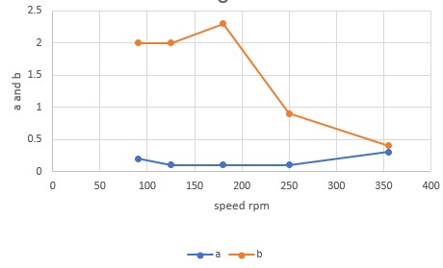

VARYING RAKE ANGLE
Rake angle | a |  | b
Rake angle |  | Magnification |  | Magnification
0 | 0.1 | 5 | 0.3 | 15
5 | 0.1 | 5 | 0 | 5
10 | 0.2 | 5 | 0.3 | 15
15 | 0.1 | 5 | 0.1 | 5
20 | 0.2 | 5 | 0.1 | 5
25 | 0.1 | 5 | 0.05 | 5
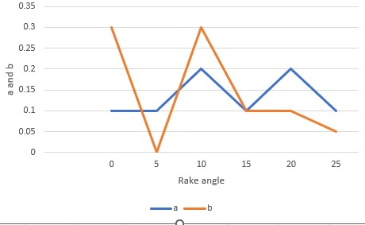

CHIP THICKNESS

Rake angle degrees | Original thickness mm
0 | 0.04
5 | 0.04
10 | 0.06
15 | 0.05
20 | 0.04
25 | 0.04
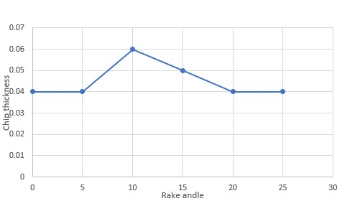
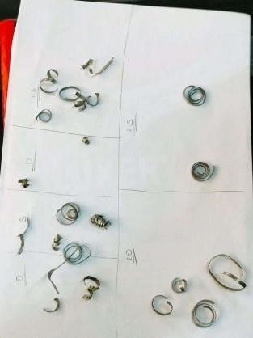

DATA ANALYSIS

ii) Fc = UtoD

U for steel = 2084.9N/mm^2

This was done for all depths but only the first depth of 2.5mm was calculated Fc= 2084.9 x 0.06 x 2.5 = 312.735N
Depth of cut | Fc | Fa
2.5 | 312.7 | 156
3.25 | 407 | 204
4 | 500 | 250

iii)
Power consumption = pi x n x d x fc/60
Power consumption based off rake angle is shown below
Rake angle | Power consumption
0 | 133030
5 | 121560
10 | 110830
15 | 99730
20 | 88630
25 | 77540

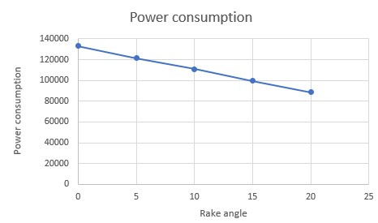
iv) Sample Calculations:
Power expended in overcoming friction 𝑷_{𝒇} = 𝑭_{𝒇}𝑽_{𝒇}
𝑽_{𝒄}𝑺𝒊𝒏Ф 𝟎. 𝟑𝟗𝟑𝑺𝒊𝒏 𝟏𝟔. 𝟕
𝑽_{𝒇} = = = 𝟎. 𝟏𝟏𝟖𝒎/𝒔
𝑪𝒐𝒔(Ф − 𝜶) 𝑪𝒐𝒔 (𝟏𝟔. 𝟕 − 𝟎)
𝑭_{𝒇} = 𝑭_{𝒄}𝑺𝒊𝒏𝜶 + 𝑭_{𝒂}𝑪𝒐𝒔𝜶
𝑭_{𝒇} = 𝟕𝟑𝟔𝐒𝐢𝐧 𝟎 + 𝟒𝟏𝟓𝐂𝐨𝐬 𝟎 = 𝟒𝟏𝟓 𝐍

𝑷𝒇 = 𝑭𝒇𝑽𝒇
𝑷_{𝒇=}𝟒𝟏𝟓 ∗ 𝟎. 𝟏𝟏𝟖 = 𝟒𝟖. 𝟗𝟕𝑱/𝒔

𝑵 = 𝑭_{𝒄}𝑪𝒐𝒔 𝜶 − 𝑭_{𝒂}𝑺𝒊𝒏 𝜶
𝑵 = 𝟕𝟑𝟔𝐂𝐨𝐬 𝟎 − 𝟒𝟏𝟓𝐒𝐢𝐧 𝟎 = 𝟕𝟑𝟔 𝐍

𝑭_{𝒇}
𝑻𝒂𝒏 𝜷 = 𝝁 =
𝑵
𝑭^{𝒇}
𝜷 = 𝑻𝒂𝒏^{−𝟏} ( )
𝑵
𝜷 = 𝑻𝒂𝒏^{−𝟏} (^{𝟒𝟏𝟓}) = 𝟐𝟗. 𝟒𝟏𝟔
𝟕𝟑𝟔
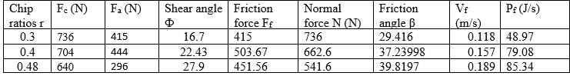

v)
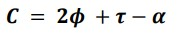
Rake angle | Merchants constant
0 | 74
5 | 60
10 | 54
15 | 48
20 | 39
25 | 31

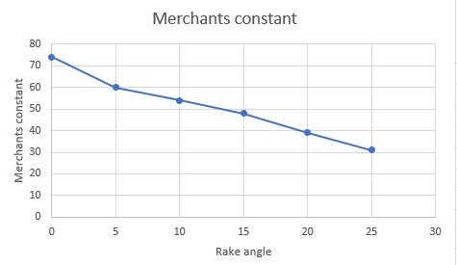

Discussion
From the data collected and analyzed from 4.1 it was clear to see that depth of cut had no significant effect on the deflection of the material as both factors of deflection a and b remained constant however a change in the depth of cut reveals a direct increase in the change in cutting and axial forces Fc and Fa
From the data collected and analyzed from 4.2 it was clear to see that feed had no significant effect on the deflection of the material as both factors of deflection a and b remained constant
In 4.3 the change in speed had varying effects on deflection where a would remain constant with slight changes while b would generally decrease throughout the changes
For the test 4.4 similar to test 4.2 showed a change in the rake angle did not have a significant effect on the deflection of a but lead to the decrease in the deflection of b
In the test 4.5 allowed us to understand that friction and chip ratio plays roles in the consumption of power
For the case of verification of merchants hypothesis from the lab has been seen to be proven from the graph showing its inverse proportionality with the rake angle. The accuracy and consistency of the model in various cutting conditions validate its usefulness. However, it's essential to consider factors like machine dynamics and model limitations, such as idealized assumptions. In cases of deviation, advanced analysis and computer simulations can provide a deeper understanding of the machining process. Ultimately, verification relies on the model's alignment with real-world observations.

CONCLUSION
From the performed lab experiment on using a Two-Component Lathe Tool Dynamometer for Orthogonal Cutting has deepened our understanding of machining dynamics accomplishing the aims of the lab. We can conclude the following based off the results obtained from the results . Rake Angle: The rake angle is inversely proportional to cutting and axial forces. Increasing the rake angle reduces these forces.
Feed Rate: The feed rate is directly proportional to cutting and axial forces. Increasing the feed rate increases these forces.
Depth of Cut: The depth of cut is directly proportional to cutting and axial forces. A deeper cut leads to higher forces.
Speed: The cutting speed is directly proportional to cutting and axial forces. Higher speeds result in increased forces.

REFERENCES
- Schonberger, R. J. (2007). "World Class Manufacturing: The Lessons of Simplicity Applied." Free Press.
- Groover, M. P. (2018). "Fundamentals of Modern Manufacturing: Materials, Processes, and Systems." Wiley.
- ElMaraghy, H. A. (2018). "Product Lifecycle Management: Volume 1: 21st Century Paradigm for Product Realisation." Springer.

