THE UNIVERSITY OF ZAMBIA
SCHOOL OF MINES
DEPARTMENT OF GEOLOGY

Name; Sikasukwe Aron
Computer No; 2018202006
Couse; Ggy4070
Ass No; Three (3)
Title; METAMOPHISM OF CALCAEREOUS ROCKS
Due Date: 09/10/2022
ATTN; Dr. A. Ahmed

METAMORPHISM OF CALCAREOUS ROCKS

Metacarbonates form by metamorphism of sedimentary protoliths that contain significant amounts of carbonate minerals. These protoliths are mostly limestones or dolostones.
The metamorphic reactions that occur, and the metamorphic minerals that form, in metacarbonates depend on overall protolith composition.
Mineral reactions in metacarbonate rocks commonly depend on the composition of H2O-CO2 fluids present during metamorphism.
Mapping regional isograds based on minerals in metacarbonates can be problematic because, besides pressure and temperature, fluid composition affects the minerals that are present.
The most common minerals in metacarbonates are Ca-, Mg-, or CaMg-silicates. Other minerals, including garnets and phlogopites, are also common.
Key reactions that occur during carbonate metamorphism include decarbonation reactions, dehydration reactions, mixed-volatile reactions and, less commonly, solid-solid reactions. We commonly depict these reactions on T-X phase diagrams.
Contact aureoles, with concentric zones containing different mineral assemblages, often develop when an igneous intrusion causes contact metamorphism of a carbonate sedimentary rock.
Calcsilicates, metacarbonate rocks dominated by silicate minerals, are produced by metasomatism during metamorphism of carbonate sedimentary rocks.
Calcsilicates may be in zoned skarns that develop adjacent to or around igneous intrusions.
Metacarbonates are not as common as metabasites or metapelites, but we are going to give them extra attention in this chapter. We do this for two related reasons. First, the reactions that occur during metamorphism of carbonate-rich rocks often depend on the compositions of fluids present during metamorphism. This is untrue of most other rock compositions. Second, discussion of the role of fluids leads naturally to discussion of T-X phase diagrams, an important kind of diagram that we
Metacarbonate protoliths may be clastic or chemical sedimentary rocks. They are mostly limestones and dolostones, dominated by carbonate minerals. Less commonly, the protoliths are calcareous shales and mudstones (both often called marls), or calcareous siltstones or sandstones. We call metacarbonates made entirely, or mostly, of carbonate minerals, marbles.
If a protolith contains significant amounts of non-carbonate minerals, many intriguing silicate minerals may form during metamorphism. These include tremolite, diopside, forsterite, Ca-rich garnet (grossular or andradite), wollastonite, and others. The metamorphic minerals that develop depend on the protolith composition, but most are calcium-, magnesium-, or calcium-magnesium-silicates.
If silicate minerals make up most, or a significant amount of a metacarbonate rock, we call the rock a calcsilicate rock, or just a calcsilicate. Some calcsilicate rocks contain neither calcite nor dolomite because these minerals were entirely consumed by decarbonation reactions during metamorphism. Metamorphism of siliceous dolomites, in particular, has been the focus of much investigation because of all the fascinating minerals that may be created.
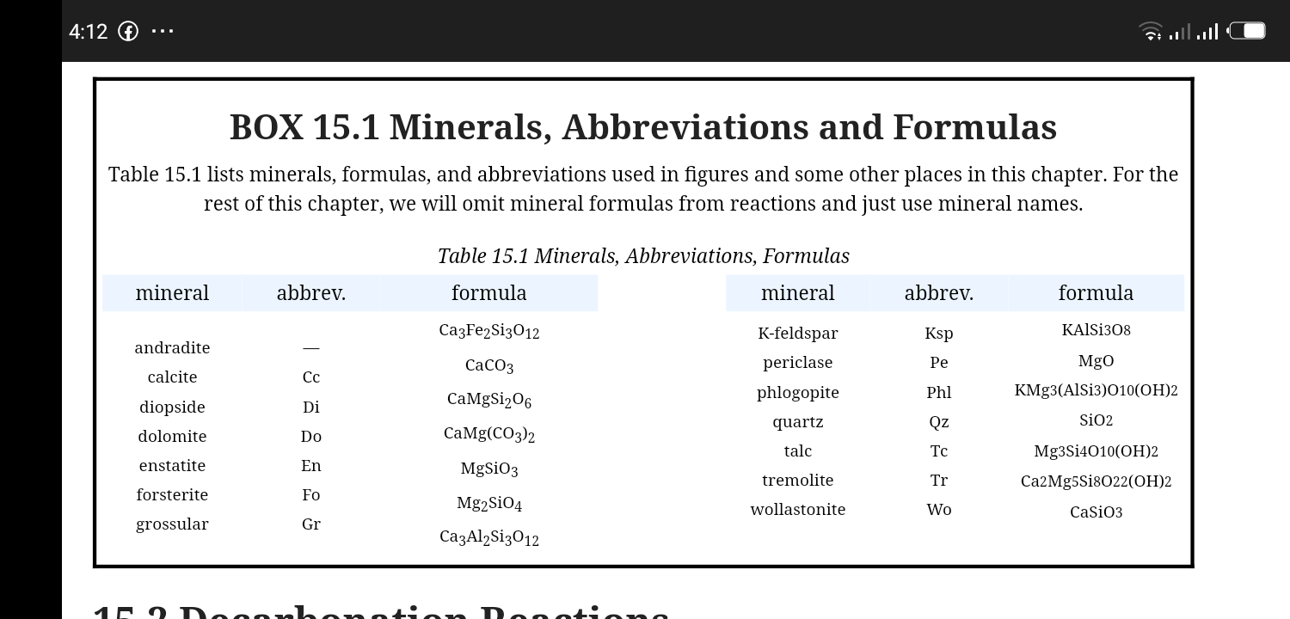
INDEX MINERALS IN METACARBONATES
Studies by N.L Bowen and C.E. Tilley in the 1940s, updated and modified subsequently by others, have established that, depending on protolith composition, metamorphic minerals appear in predictable order as carbonate rocks are metamorphosed to higher grades. These minerals, like index minerals in pelitic rocks, are stable over different temperature ranges and allow us to compare metamorphic grades of different rocks based on mineralogy.
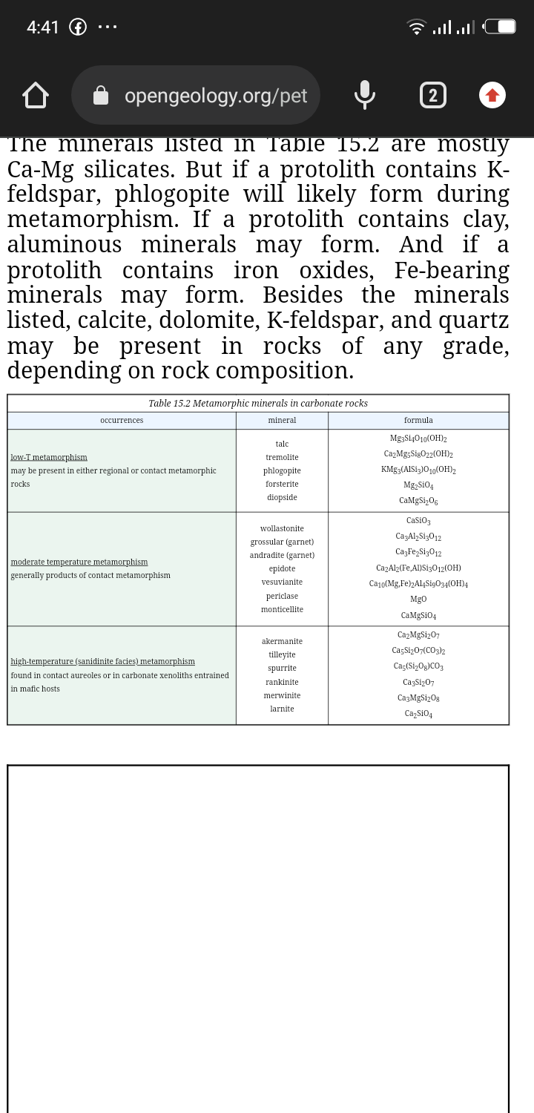
METAMORPHISM AT DIFFERENT SCALES
Regional Metamorphism
Lower-grade rocks, depending on composition, may contain talc. With increasing grade tremolite, diopside, and perhaps forsterite or wollastonite may develop. However, the rock composition greatly affects the minerals that are present. Different composition rocks may plot in different 3-phase triangles, meaning that a different assemblage will be stable.
Contact Metamorphism
involve rocks metamorphosed at low pressure and shallow depths in Earth. So, the effects of contact metamorphism may be profound. It is certain that heat from magmas contributes to regional
Skarns
A special kind of calcsilicate rock, a skarn, sometimes called a tactite, develops by hydrothermal metamorphism in contact aureoles around igneous intrusions. Fluids from the intrusion may enter the surrounding country rock, causing metasomatism that introduces significant Si, Al, Fe, or Mg, and perhaps removes other elements. This can lead to a variety of new metamorphic minerals. These minerals, mostly Ca-Mg-Fe-Al silicates, may include any of the minerals listed in Table 15.2.
REFFERNCE:
Dr. A. Ahmed 4070 (Metamorphic PETROLOGY) lecture notes.
https//opengeology.org

