EXPLORATION GEOCHEMISTRY PART II
SOME ASPECTS OF GEOCHEMICAL DATA
-BY-
B.M. MUSONDA
(MSc Geochemistry)

DETERMINATION OF ELEMENT CONTENTS IN SAMPLES
The analytical methods that are employed in geochemical surveys depend on the following factors:
- The nature of elements that are required to be determined
- The mode of occurrence of the elements of interest in the samples
- The cost of analytical work
- The desired contrast
- The desired precision and accuracy of the analytical data
- Access to analytical equipment
- The nature and type of samples
- The detection limit of the equipment
The analytical methods that are employed in the determination of the chemical composition of the geochemical samples are given in table 1.
Colorimetry is based on the formation of coloured compounds in solution by reaction of atoms of a given element with a specific chemical reagent. Quantitative estimation of an element is possible if the intensity of absorption is proportional to the concentration of the colored compound. Dithizone is a common colorimetric reagent which can be used to separate and estimate many elements by varying the pH of extraction and adding complexing agents for unwanted elements. Colorimetric methods are available for nearly all the elements of interest in exploration geochemistry. The serious challenges that are associated with this method is the inability to determine more than one element at a time and the sensitivity of many reagents to interferences. The major advantages of this method are its simplicity, low cost, and portability of the equipment.
Emission spectrometry is based on the measurement of intensity of characteristic radiation which elements in geochemical samples emit when they are exposed to intense heat of an electric discharge or other sources of energy. Sources of heat energy in these systems include d.c. arc and plasma. The advantage of this method is the large number of elements that can be analysed silmutaneously, low unit cost and the low detection limits for most elements. The major disadvantages of this method are the high cost of the equipment, high maintenance cost and the need for a highly trained operator. The reproducibility of results is also a challenge when using the d.c arc equipment.
Atomic Absorption is based on the absorption of radiation of characteristic wavelength by uncharged atoms in a vapour state. The absorption of energy by atoms of a given element leads to excitation of the outer electrons in the outer shells of these atoms. The proportion of light absorbed is proportion to the concentration of atoms of a given element in the light path. In atomic absorption a sharp spectral line of the element to be analysed is generated in a source lamp and passed through the vaporized sample. The atomic vapour is formed by aspirating dissolved samples into a flame or by heating solids and liquids in a furnace. The analysis of sample solutions by AAS is the most widely used analytical method in exploration geochemistry. The popularity of this method may be attributed to the low detection limits for elements of interest, the specificity for individual elements, the opportunity to determine several elements on one solution, and the relatively inexpensive and simple equipment required. The arrangement of components on a typical Atomic Absorption Spectrometer is given in figure 1.
X-ray Fluorescence Spectrometry is based on the absorption of an x-ray beam by inner electrons of atoms which in turn emit fluorescent X-rays of a wavelength characteristic of the element activated. The advantages of XRF include multi-element capability, high precision, and low cost per determination. The disadvantages are high cost of equipment and high detection limits. X-ray tubes are used on normal XRF units as sources of x-ray radiation. The most commonly used tubes include copper, chromium and tungsten. Radioactive sources of radiation are also commonly used in portable instruments.
Radiometric methods involve the use of radiation produced during radioactive decay of radiogenic nuclides of elements such as K, U and Th. Non-radioactive elements may be converted into radioactive elements by bombardment with neutrons or other atomic particles (neutron-activation analysis). The energy of the emitted gamma rays and their intensity are used to identify the elements present and to estimate their content in the samples. The advantage of this method is the multi-element capability and the low detection limits for many elements of interest in exploration geochemistry. The disadvantages of neutron activation are the high cost of the equipment, and general unavailability of a neutron source, the hazards of dealing with radiation, and the need for highly trained operators.
The electronic energy changes that take place in methods which involve absorption and emission of radiation are illustrated in figure 2.

EVALUATION OF THE QUALITY OF DATA
The evaluation of the quality of data that are generated in geochemical surveys is a very important activity in mineral exploration programmes. Every data set should be examined for possible errors in the reported analytical values. If the reliability of the geochemical analyses is very high then the quality of the data is considered to be good. The quality of geochemical data is determined on the basis of its precision and accuracy. Accuracy is a measure of how close the reported values are to the actual contents of the elements in the samples being investigated. Precision is the degree or extent to which the reported values can be reproduced in replicate analyses. Precision is much more important in exploration geochemistry than accuracy. A cheap analytical method which produces in accurate data of very high precision is more likely to be employed in exploration geochemistry at a reconnaissance stage than one which produces accurate data at a very high cost. The generation of data of very high quality is required in detailed surveys in order for exploration personnel to make the right interpretation of data. The effect of precision and accuracy of the geochemical analyses on the quality of data is given in figure 3.
It is the responsibility of the exploration and laboratory personnel to ensure that the analytical systems that are employed in geochemical surveys generate data of acceptable quality. The survey team should always put in place procedures which should enable them to monitor the quality of the routine processes that the laboratories to which they submit samples have put in place. All accredited and good laboratories always monitor the quality of analytical systems that are employed in routine production of geochemical data.
The survey team can monitor the quality of the data set by including duplicate samples and reference materials in each batch of samples that are submitted to the laboratory. The duplicate samples are for monitoring the analytical precision while the reference materials are for establishing the accuracy of the data values. There should be one duplicate sample for every 10 or 20 samples that are submitted to the laboratory. Two to four reference materials should be included in every batch of geochemical samples which are submitted to a laboratory. The reference materials provide the means for assessing the accuracy of the analytical system that is employed in the determination of the concentrations of the elements in the geochemical samples.
The strategy employed by laboratory personnel to ensure the production of high quality data is usually very similar to the one described above for the survey personnel. The production of high quality data in any given laboratory depends on how well the instruments used in the analysis are calibrated, the accuracy of the intermediate analytical measurements that are made in the analytical process and the extent to which contamination of samples is prevented in the analytical process.

Evaluation of the precision
The precision of an analytical method can be determined by multiple analyses of a single sample or by multiple analyses of many samples from the area being investigated. Using multiple determinations of a single sample the standard deviation of an analytical method is calculated as follows:
S_{a}² = 1/ (n-1).[∑(x_{i})²-(∑x_{i})²/n
The standard deviation of a mean value is known as the standard error. The value of the standard error is given by
S_{mean}= S_{a}/√n
The precision of duplicate measurements is much higher than that of individual measurements
The standard deviation of the mean of duplicate analyses is 0.7S_{a}.
The analytical error varies with concentration. Therefore replicate determinations for several samples of differing concentrations are desirable in the estimation of the precision.
For normally distributed populations of data values 68 % and 96 % of the data values fall within the range of mean value ± one or two standard deviations respectively.
The precision can also be measured using the coefficient of variation (CV) which is defined as follows:
C.V. = 100 S_{a}/Mean value
The standard deviation for duplicate determinations is given by the following equation:
S_{a}² = 1/k∑((X_{1i}-X_{2i})²/2)
The total analytical standard deviation is a sum total of precision values that are associated with individual stages in the entire analytical process.
S_{t}²= S₁²+S₂²+S₃²+…S_{n}²
In some geochemical work C.V. values of 10- 50 % are common. But AAS method can give C.V. values in the range of 3 to 10 %.
Evaluation of Accuracy
The evaluation of the accuracy of a geochemical analysis requires one to know the true content of an element in some samples that are submitted together with samples collected in the survey. The samples with known contents of the elements of interest are usually certified reference materials whose chemical constituents have been determined accurately by different laboratories or analysts. The sources of reference materials that are used in geochemical exploration surveys include British Geological Survey, USGS, BRGM in France and other mineral research laboratories in developed countries, Canadian mineral research laboratories and the IAEA. The IAEA and the USGS are very good sources of reference materials such as rocks, sediments and soils. If the percentage deviation of the values obtained in the analysis of elements of interest is very low then the accuracy of the analytical data generated on the samples is likely to be good and acceptable. Synthetic samples and spiked samples can also be used to determine the accuracy of geochemical data sets.
It is important for laboratories and geochemical exploration teams to put in place systems for routine monitoring of the quality of analytical determinations.

Validation of values in the data sets
All the values reported by the laboratory should be examined and validated prior to processing and interpretation of data. Any data values which fall outside the expected range of concentration should be removed from the data set unless it is proved beyond doubt that the values are outliers. Samples where the concentrations of the elements of interest are below the detection limit should have the contents reported as a percentage of the detection limit. If the detection limit of the method for a given element is 5 ppm then the content should be reported as 2.5 ppm and not <5 ppm.

Table 1 Methods of analysing geochemical samples and minor elements for which they are commonly used (Source: Rose, 1979)
ELEMENT | COLORIMETRY | EMISSION SPECTROMETRY  D.C. ARC PLASMA |  | RADIO-METRY | AAS | XRF
Antimony | × |  | ×
Arsenic | × |  | ×
Barium | × |  | × |  | ×
Beryllium | × | × | × | ×
Bismuth | × |  | × |  | ×
Boron |  |  | × | ×
Cadmium | × | × | × |  | ×
Chromium | × | × | × |  | × | ×
Cobalt | × | × | × |  | ×
Copper | × | × | × |  | ×
Fluorine | ×
Gold |  |  |  |  | × | ×
Iron | × |  | × |  | ×
Lead | × | × |  |  | ×
Lithium |  | × | × |  | ×
Manganese | × | × | × |  | × | ×
Mercury | × |  |  |  | ×
Molybdenum | × | × | × |  | ×
Nickel | × | × | × |  | × | ×
Niobium | × |  |  |  |  | ×
Platinum | × | ×
Rare earths |  | × | × |  |  | ×
Rubidium |  |  |  |  | × | ×
Selenium | × |  | ×
Silver | × | × | × |  | ×
Strontium |  | × | × |  | × | ×
Sulphur | × |  |  |  |  | ×
Tantalum | × |  |  |  |  | ×
Thorium |  |  |  | × |  | ×
Tin | × | × | × |  |  | ×
Titanium | × | × | × |  | × | ×
Tungsten | × |  |  |  |  | ×
Uranium |  |  |  | ×
Vanadium | × | × | × |  | × | ×
Zinc | × |  | × |  | × | ×

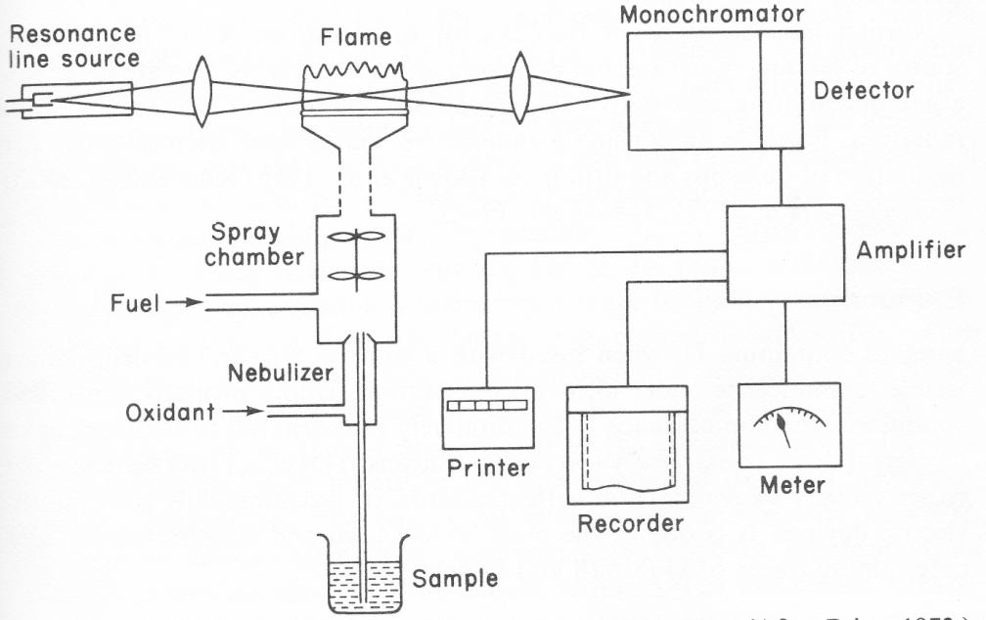
Figure 1 The basic components of an Atomic Absorption Spectrometer

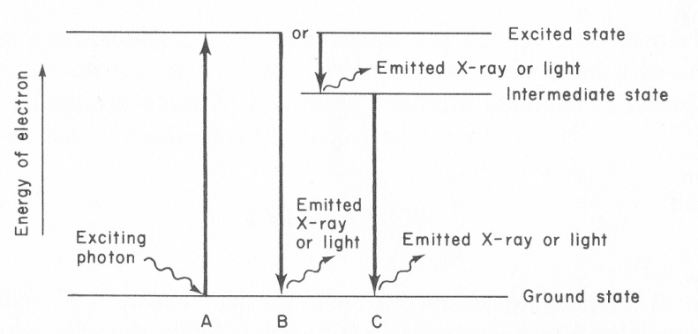
Figure 2 The electronic energy changes that take place in methods which involve absorption and emission of radiation by the atoms of elements present in the samples.

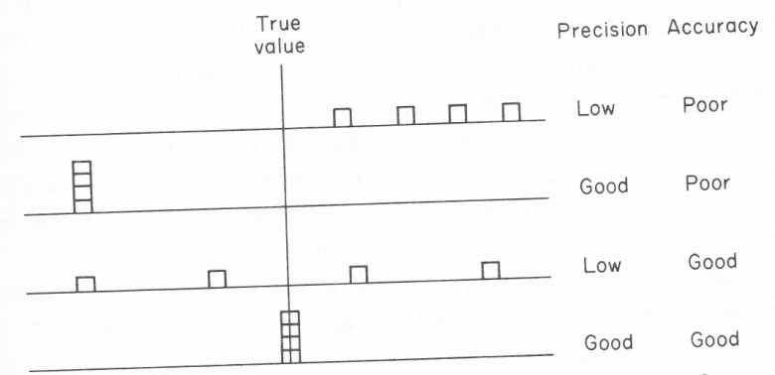
Figure 3 Possible combinations of precision and accuracy based on four analyses of 1 sample

STORAGE OF GEOCHEMICAL DATA
After the validation of data it is usually stored in a worksheet or database file on a computer storage device such as a hard disk or removable disk. The format of the files containing geochemical data is normally similar to the one illustrated in table 2.
Table 2 The Distribution of Some elements in stream sediments of St. Francis Mission Area in Solwezi District
AREA CODE | S.NO | X-COORD. | Y-COORD. | CU | CO | NI | MN | FE | PB | ZN
05EB | 1 | 448800 | 8634900 | 100 | 40 | 40 | 140 | 1850 | 10 | 30
05EB | 16 | 447000 | 8630000 | 60 | 15 | 45 | 260 | 5830 | 10 | 10
05EB | 43 | 447500 | 8627400 | 35 | 15 | 60 | 40 | 720 | 10 | 30
05EB | 44 | 447300 | 8626700 | 35 | 20 | 50 | 170 | 3070 | 10 | 25
05EB | 45 | 446600 | 8626000 | 40 | 15 | 65 | 120 | 2080 | 10 | 30
05EB | 46 | 446700 | 8625700 | 40 | 20 | 65 | 220 | 4200 | 10 | 30
05EB | 47 | 446700 | 8624800 | 60 | 20 | 85 | 110 | 6100 | 10 | 15
05EB | 48 | 446200 | 8623900 | 15 | 10 | 40 | 90 | 1110 | 0 | 20
05EB | 49 | 446900 | 8623300 | 35 | 15 | 65 | 210 | 3360 | 10 | 30

PRESENTATION OF GEOCHEMICAL DATA
Geochemical data can be presented in one of the following ways:
- Tabular form
- Profile form
- Map form
Tables are commonly used to present data that is obtained during geochemical surveys. The tables may contain raw data (table 2) or data that has been processed to generate summary statistics. Table 3 is an illustration of summary statistics for the geochemical data set in table 2.

Table 3 Summary statistics for stream sediment data from St. Francis mission area in Solwezi district
Element number of samples Minimum Maximum Mean Variance
Value (ppm) value (ppm) (ppm)
Cu 9 10 100 46.7 24.2
Co 9 5 40 18.9 8.6
Ni 9 15 85 57.2 14.8
Mn 9 40 260 151.1 70.1
Fe 9 720 6210 3146 1934
Pb 9 0 10 8.9 3.3
Zn 9 10 30 24.4 7.7

A geochemical profile is a graph that shows the distribution of an element in samples collected on a given traverse. A geochemical traverse is illustrated in figure 4.
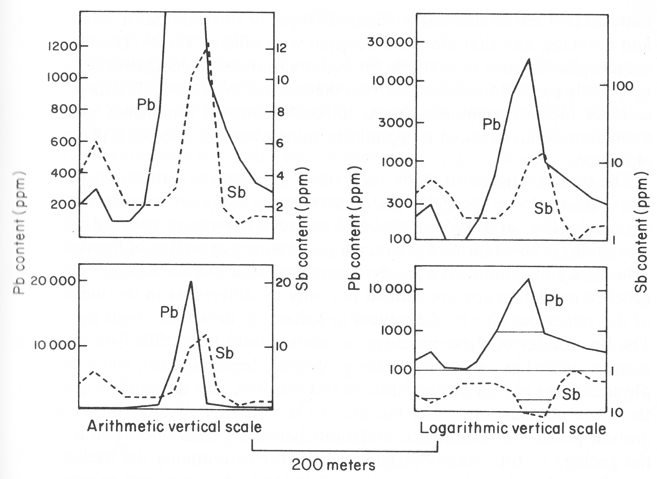
Figure 4 The geochemical profile curves for distribution of Pb and Sb in soil.

A geochemical map is the most appropriate way of presenting data on the distribution of an element in a survey area. A well plotted geochemical map provides a good summary on the spatial distribution of an element in the survey area. The types of maps used in exploration geochemistry include the following:
- Element value maps
- Symbol maps
- Gray scale maps
- Colour maps
- Isoline maps
- Moving average maps
These maps are plotted using appropriate computer packages such as Geosoft, Surfer and Excel. The different types of maps are given in figures 5 to 9.

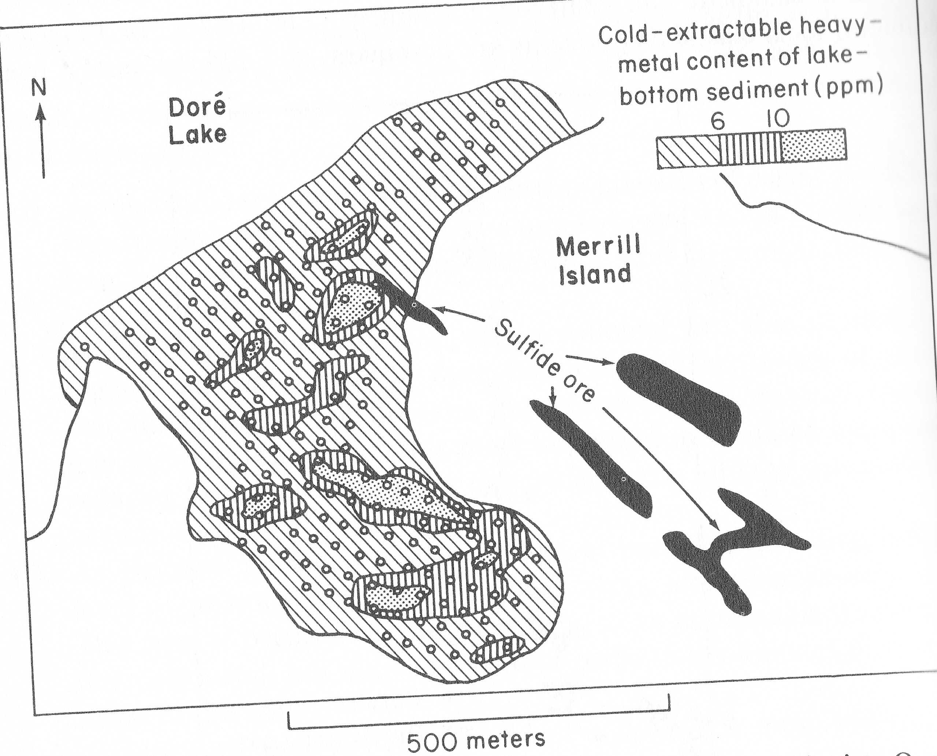
Figure 5 Grey scale map showing the distribution of heavy metals in the sediments of Dore Lake in Canada. (After Schmidt, 1956)

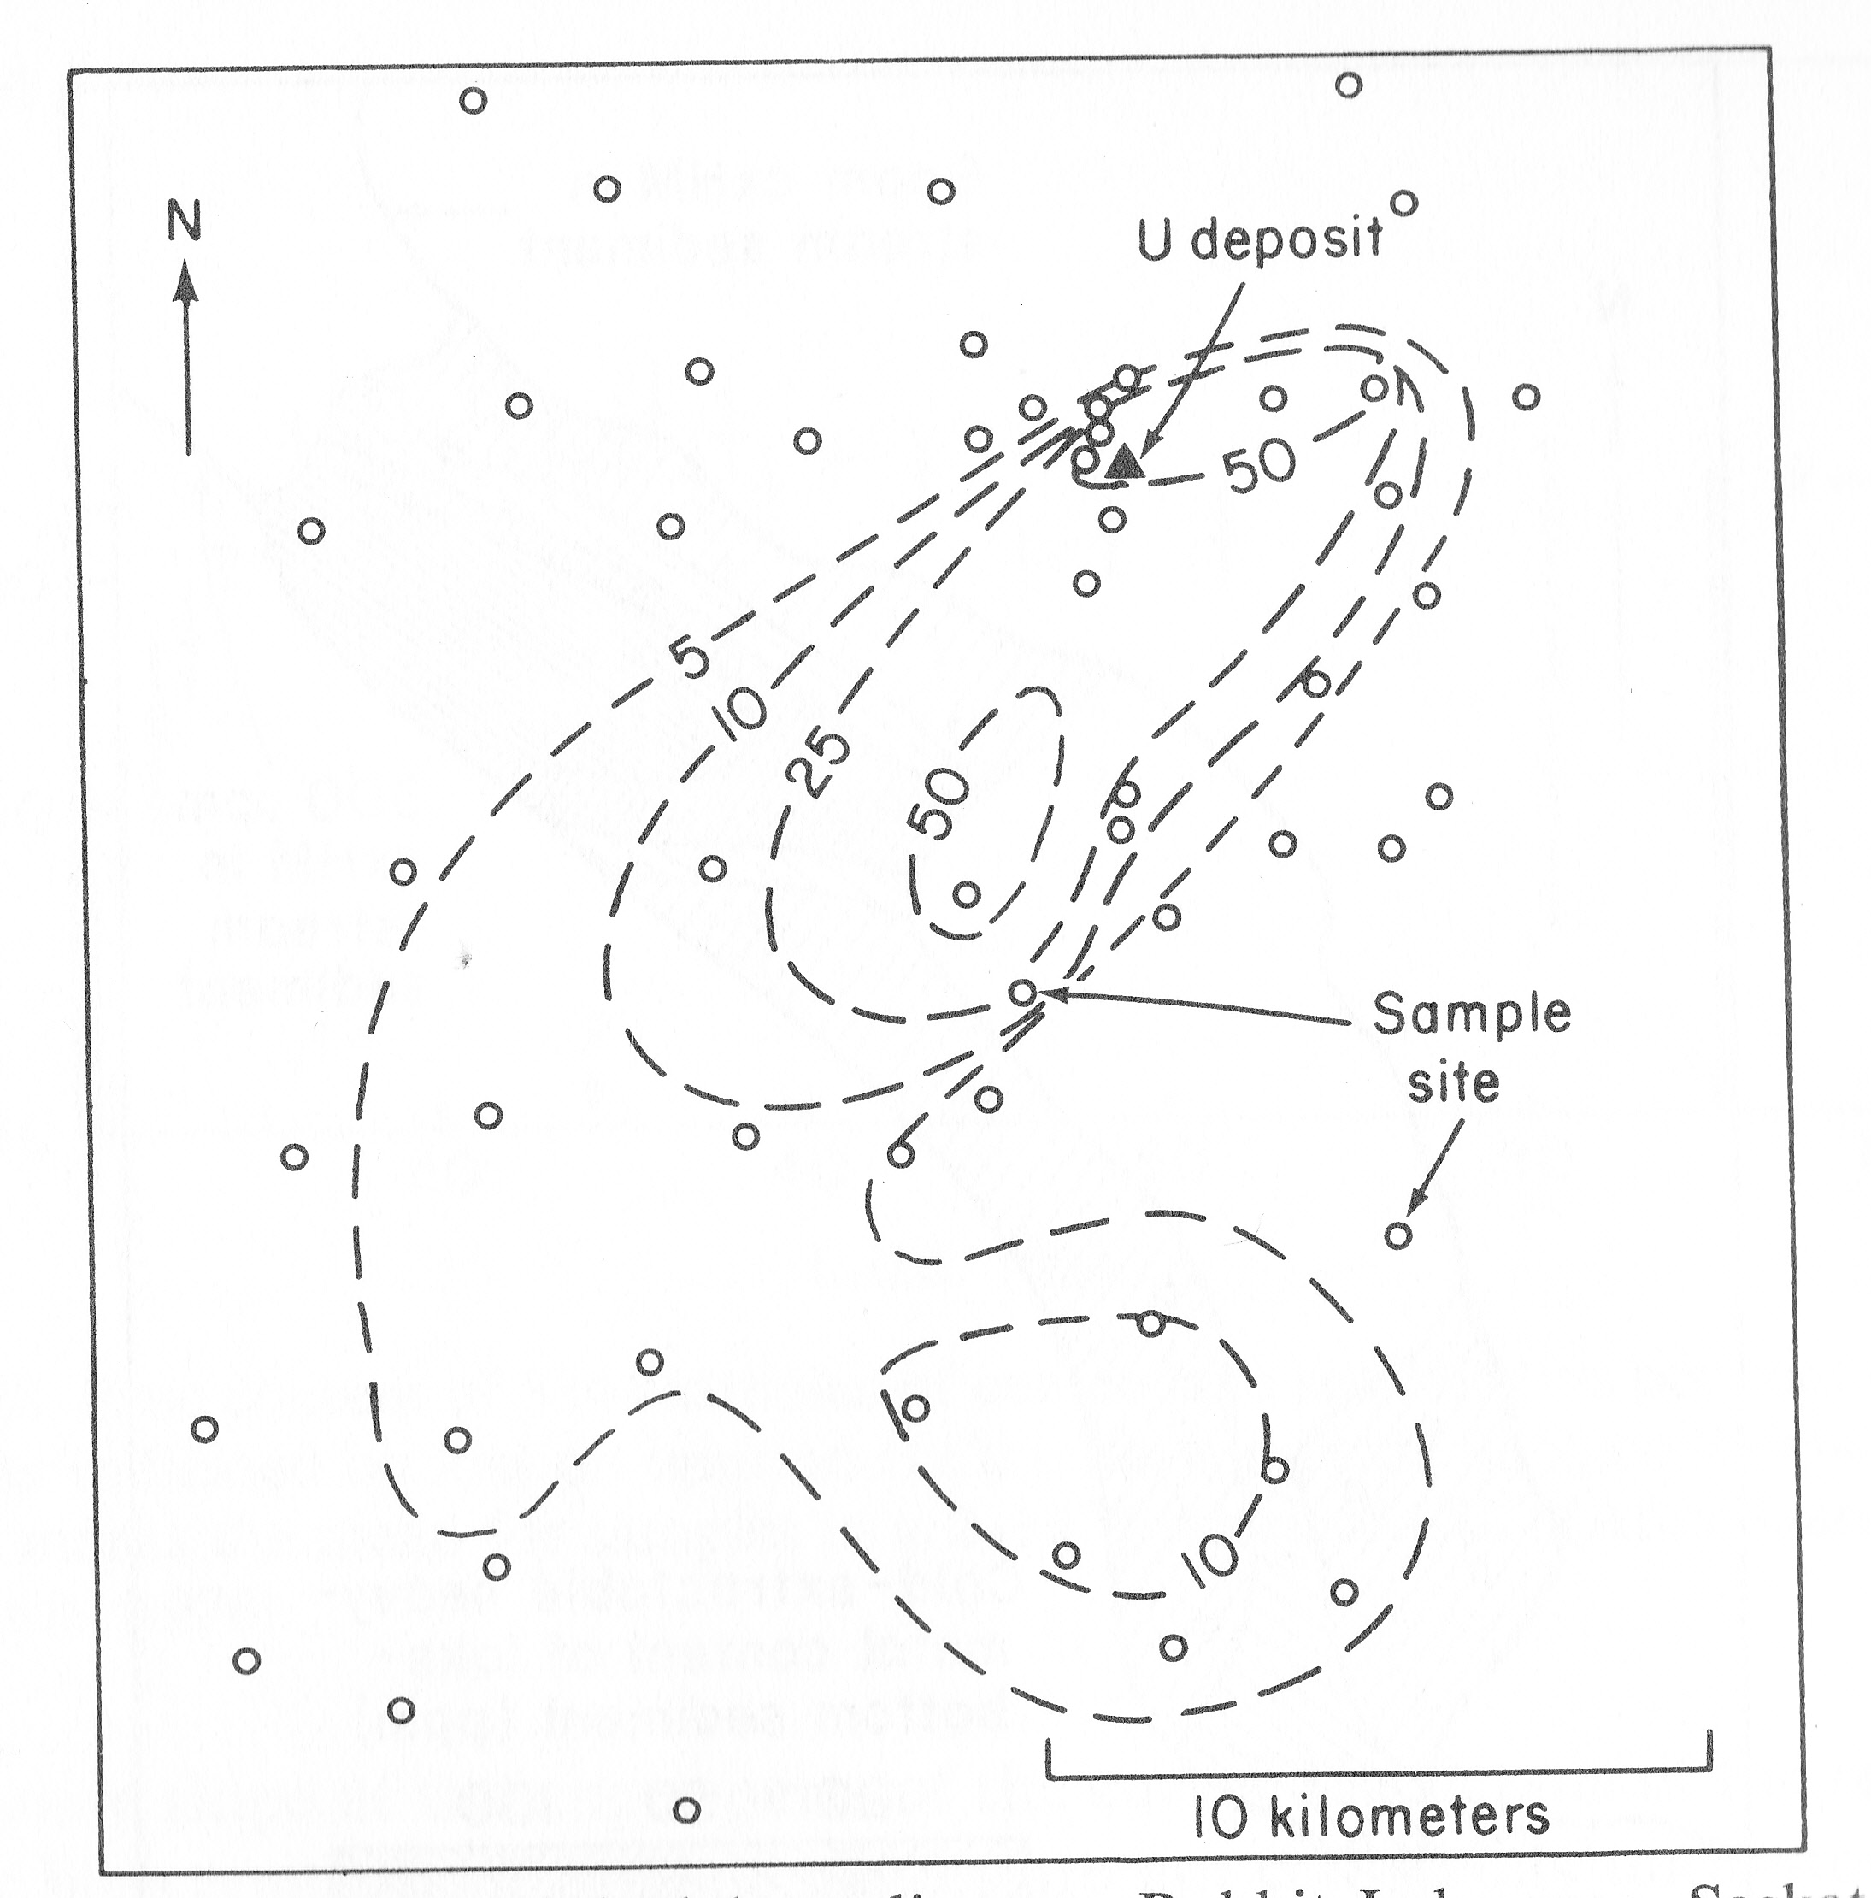
Figure 6 Uranium (ppm) in lake sediments, Rabbit lake area, Saskatchewan. (after Cameron, 1976)

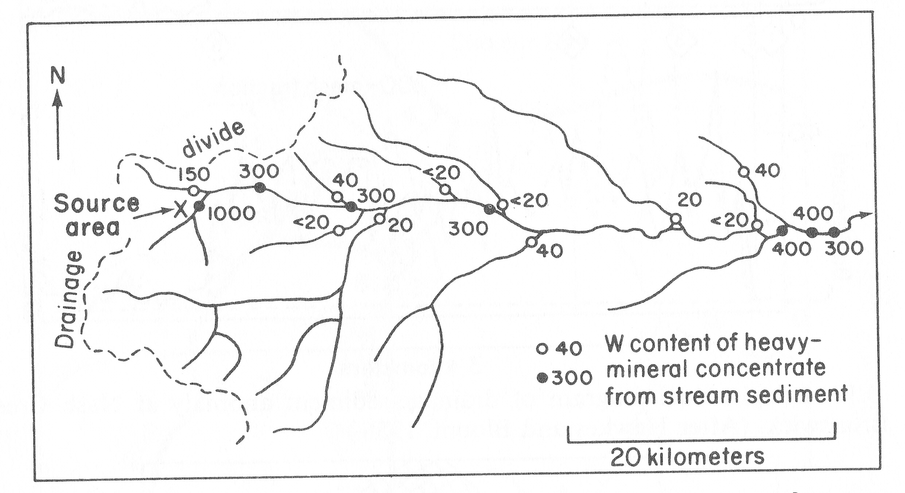
Figure 7 Tungsten content (ppm) of heavy mineral concentrates of stream sediments, Clear Creek, Colorado. (After Theobald and Thompson, 1959)

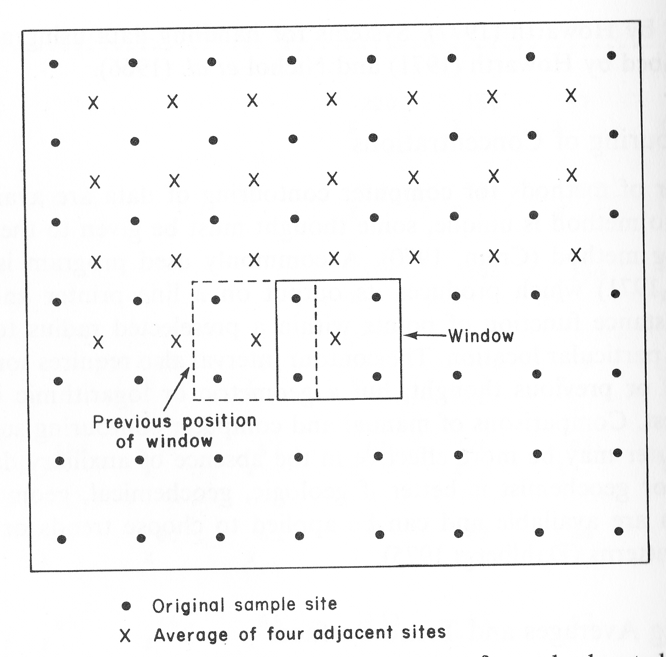
Figure 8 An illustration of how a moving average map may be prepared through the use of a window with four sampling sites. (After Rose et al, 1979)

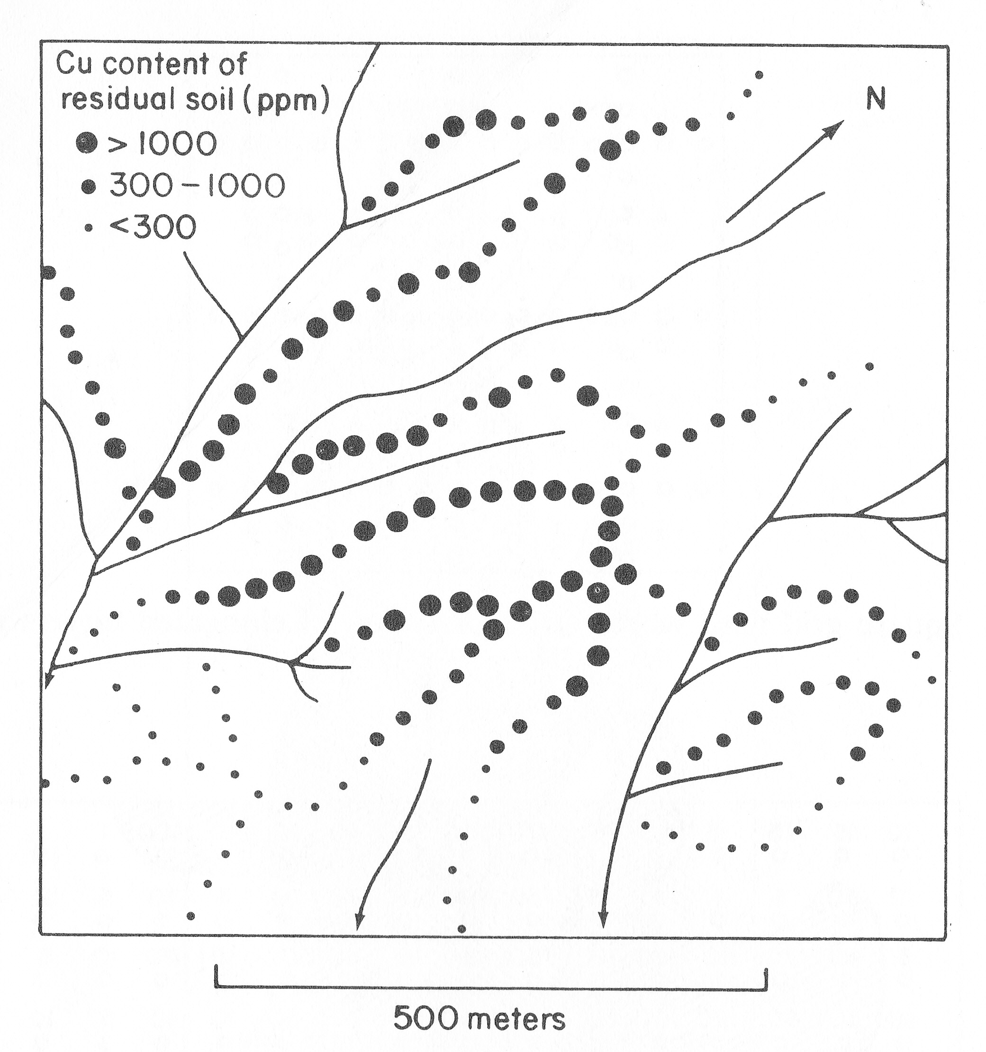
Figure 9 The distribution of Cu in soils of the Cebu Project area in the Philippines. (After Rose et al, 1979)

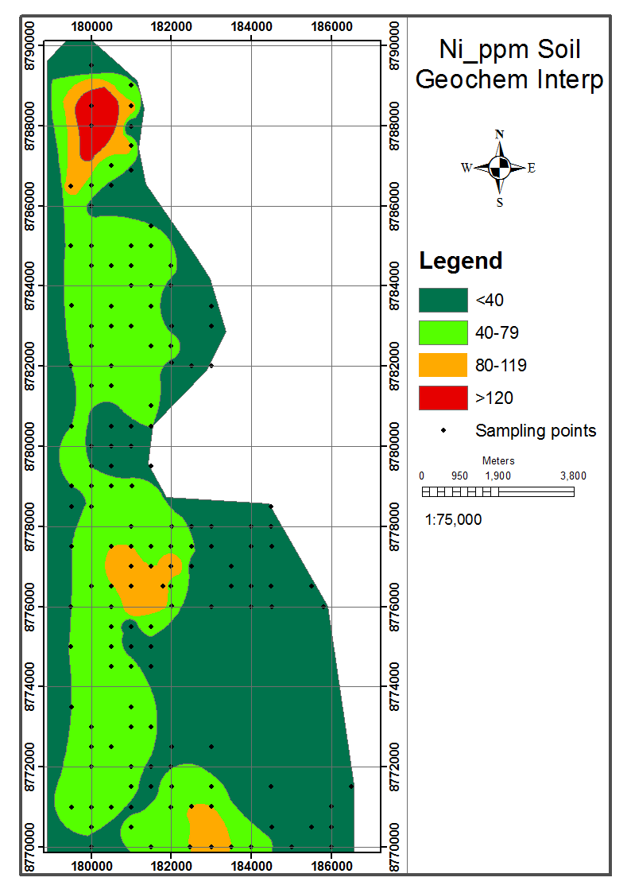
Figure 10 The distribution of Nickel in the soils of Mwinilunga district in NW Zambia. (After Mukube, 2012)

The element value maps, grey scale maps, and Symbol maps maps are very easy to plot. The values or appropriate symbols are posted on the map adjacent to corresponding sample sites. Where there is a large number of sampling sites it is more appropriate to plot an isoline or contour map. The isoline map is sometimes called the geochemical relief map. Three to five contours are necessary. The contour levels may best be determined from a cumulative frequency curve so that discontinuities in the data set may be represented by contour levels. One of the contour levels should correspond to the threshold so that anomalous areas may be highlited on the map. It is normal to have analytical values and contours on the same map.
Colour maps are widely employed today to show the distribution of elements in areas covered by geochemical surveys. Moving average maps are not as widely used today as in the past fifty years .
INTERPRETATION OF GEOCHEMICAL DATA
Statistical Analysis of data
The essence of carrying out statistical analysis of data is to distinguish between anomalous values and background values. The analytical value that separates these two populations in a data set is called the threshold. There are several methods which can be used to determine the threshold value of an element of interest. The methods used depend on the amount of data, purpose of the survey, knowledge of the area surveyed, and economic consequences of the selection. Methods for selection of a threshold include the following :
- Comparison with data from the literature.
- Graphical discrimination of the numerous background values from the smaller proportion of anomalous values in an upper tail or second peak on a histogram of the data.
- Calculation of the threshold from the mean plus 2 or 3 standard deviations.
- Plotting the cumulative frequency and using the discontinuities in the curve to partition the data set into anomalous and background populations.
- Recognition of clusters of anomalous samples when the data are plotted on a map.
- Comparison with the results of an orientation survey.

According to the rule of thumb the threshold for a population of analytical values which are normally distributed is taken to be the mean value plus two or three standard deviations. The selection of two or three standard deviations depends upon an individual. The major disadvantage of this method is that it does not take into consideration the distribution of values in the data set. This method is not recommended and should be avoided at any cost. It should only be used in cases where one is sure that there is no natural break in the distribution of values in a data set. In other words it can only be used where there is no evidence for the existence of more than one sub population.
The most appropriate way of determining the threshold is by examining the data set for breaks in the distribution of values which could mark the boundary between the anomalous values and the background values. Two graphical methods are available for examination of a data set for discontinuities in the distribution: The histogram method and the cumulative frequency curve method.
The Histogram method involves the construction of a histogram using the values in a data set and determining a value which corresponds to a major break in the distribution and that best represents the boundary value between anomalous values and background values (figure 11). The more the populations overlap and the more numerous the individual populations among the samples, the greater is the difficulty in selecting an effective threshold.
The cumulative frequency curve is perhaps the best method of splitting a data set into two sub-populations of background values and anomalous values (Sinclair, 1976; Stanley, 1987). Some data sets may have more than two sub populations and using this method it is possible to split any data set into the actual number of sub-populations present. In geochemical exploration we are interested in the subset of the data set which contains anomalous values. This method is applied to data sets which contain a relatively large number of values such as 100 or above. For smaller number of values use the histogram method or just observe the values and select the anomalous values from the background values. The data set is split into twelve or more classes. The cumulative frequency for each class is determined and the cumulative frequency value is plotted against the concentration of an element of interest on a special graph paper. The most commonly used plot is one where logarithms of concentrations are plotted against probability or cumulative frequency. The line of best fit is drawn using the data points. The significant breaks in the gradient of the plotted line are noted and the middle part of one of them is selected and the concentration corresponding to this is taken to represent the threshold value. The segment of the curve above this value represents the anomalous population while that below it represents the background population (figure 12 ).

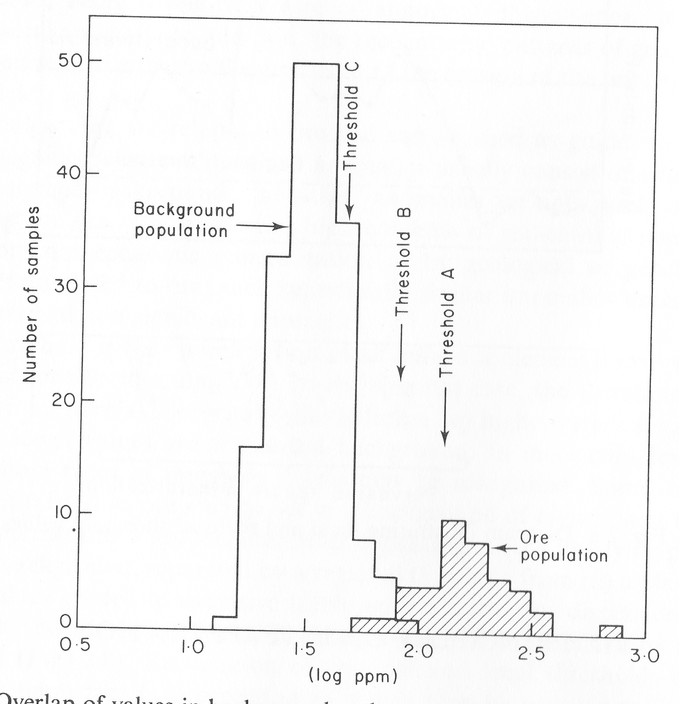
Figure 11 Using a Histogram to determine the threshold of an element

Where computer facilities are readily available one can use multivariate and other sophisticated statistical techniques such as factor analysis, trend surface analysis, moving average analysis, cluster analysis, discriminant analysis etc. It may also be necessary for the data to be transformed into logarithms prior to statistical treatment. This transformation generally applies to data sets in which the trace elements are lognormally distributed (Ahrens, 1954, 1957).

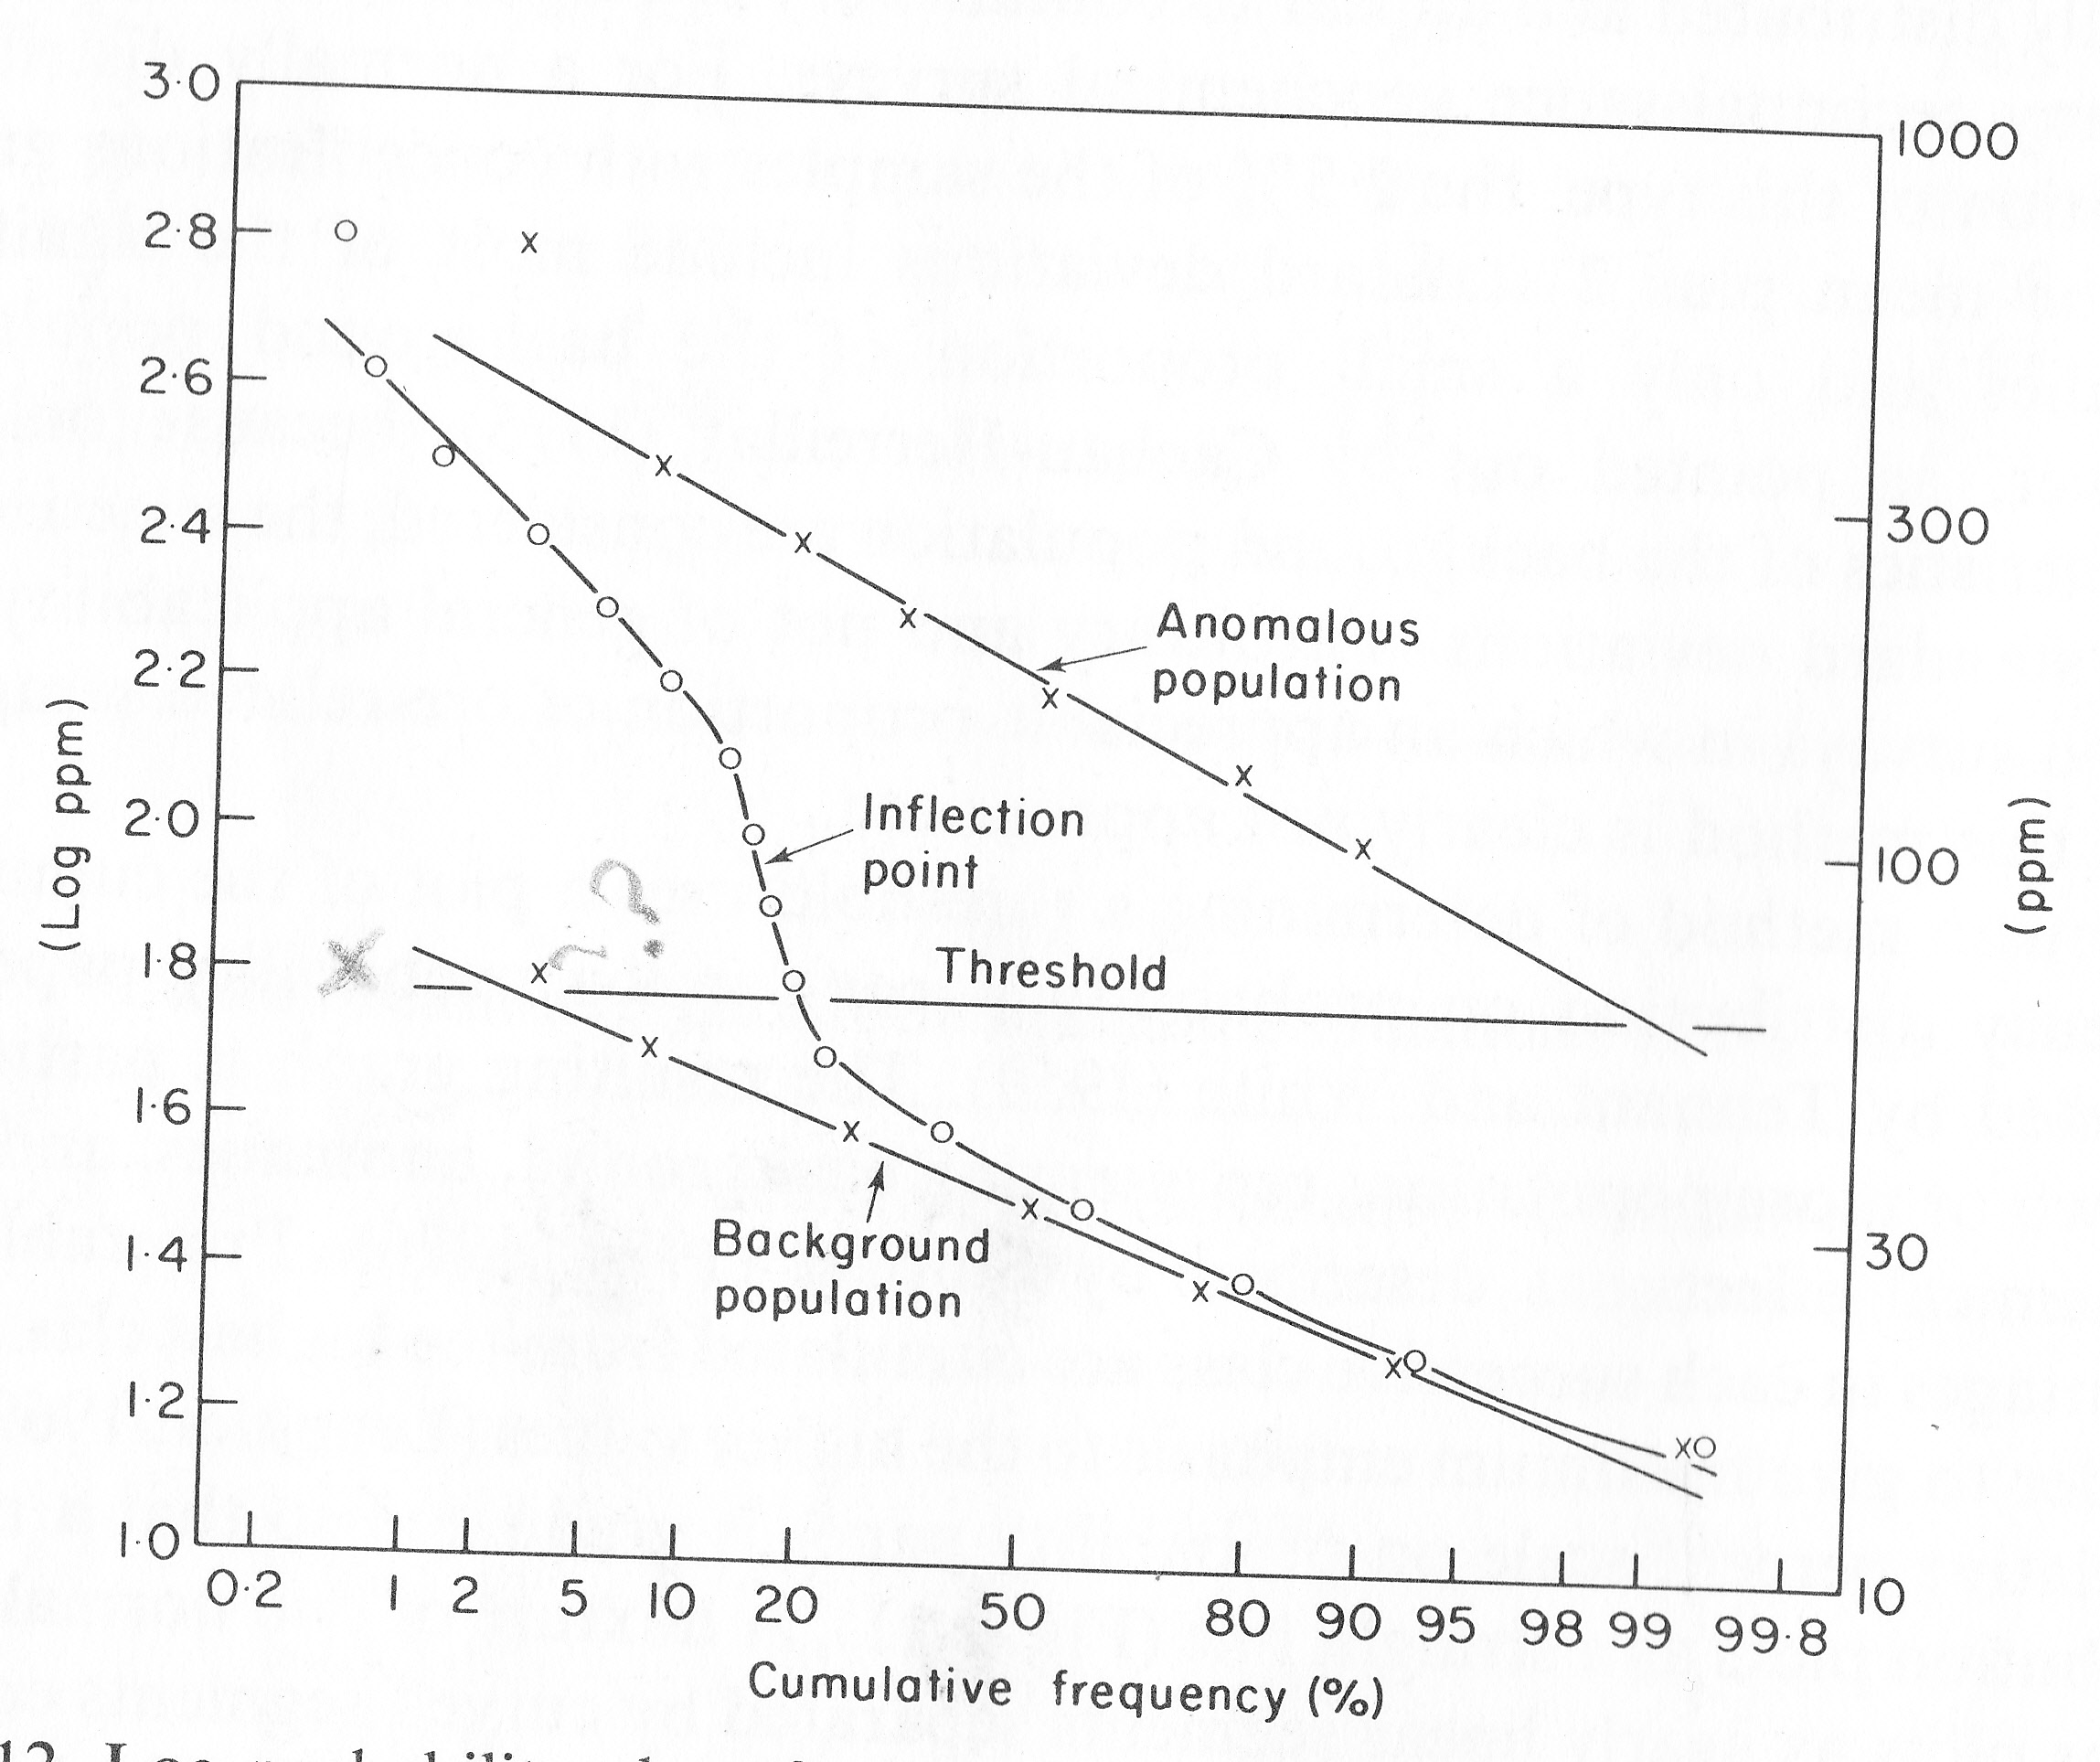
Figure 12 Illustration of the splitting of geochemical data into background and anomalous values

Evaluation of data
Once the data has been plotted it is easy to see the dispersion patterns of elements which are present in a given area and to identify significant anomalies. The anomalies are ranked on the basis of their significance. The anomalies are normally appraised according to the order of significance. The presence of element associations in the surveyed areas may be established through the use of spatial distribution analysis and statistical correlation analysis. The correlation matrix is a very important tool in the determination of associations of elements in the study area.
It is important to establish the relationship between distribution patterns of elements and the geological features. Dispersion patterns may spatially be associated with geological features such as specific lithological units or structures such as faults and folds. The geochemical dispersion patterns may also be associated with topographic features. The correct interpretation of geochemical data requires one to use an integrated approach that requires the application of GIS techniques.

Follow - Up Surveys
These surveys are organised in order to follow up the anomalies identified in the previous surveys. The purpose of these surveys is to establish if the anomalies are related to mineralisation and to identify mineralised areas. These surveys may involve detailed stream sediment sampling, soil sampling, trenching, pitting and mapping.
Once mineralised ground is located the geochemist may handover to the exploration Geologist whose function will be to establish the economic value of the mineralisation through a drilling programme.

SOME SHORT EXERCISES ON INTERPRETATION OF GEOCHEMICAL DATA
Q1. The composition of water samples collected from three natural sources is given in table i. Discuss the mineralization potential of the areas from which the samples were collected.
Table i Water chemistry
Constituent | Zambezi river | Burra-Burra area | water in a coastal town (UK)
pH | 6.7 | - | 4.87
Conductivity (μS/cm) | 97 | 4000 | 55
Ca | 9.7 | 68 | 1.1
Mg | 2.2 | 41 | 1.5
Na | 4.0 | 23 | 11.4
Sulphate | 3 | 6600 | 6.4
Nitrate | 0.1 | 0.1 | 1.8
Cl | 1 | 0.1 | 20.1
Al | 0.01 | 433 | <0.01
Fe | 0.1 | 2178 | <0.01
Cu | 0.01 | 312 | <0.01
Zn | 0.02 | 200 | <0.01

Q2. The chemical composition of soils derived from granite gneiss in Minnesota (1), dolerite in England (2), dolerite in India (3), residual clay from limestone in Virginia (4), and laterite from a gabbro in Zambia (5) are given in table ii. Discuss the base metal mineralization potential of the underlying rocks.

Table ii (in %) The composition of soils developed on different rock types
Oxide | 1 | 2 | 3 | 4 | 5
SiO₂ | 55.07 | 47.0 | 0.7 | 55.9 | 6.24
TiO₂ | 1.03 | 1.8 | 0.4 | 0.20 | 0.14
Al₂O₃ | 26.14 | 18.5 | 50.5 | 19.92 | 0.73
Fe₂O₃ | 3.72 | 14.6 | 23.4 | 7.3 | 88.48
FeO | 2.53 | - | - | 0.39 | 0.95
MnO | - | - | - | - | 0.01
MgO | 0.33 | 5.2 | - | 1.18 | 0.23
CaO | 0.16 | 1.5 | - | 0.50 | 0.15
Na₂O | 0.05 | 0.3 | - | 0.23 | 0.12
K₂O | 0.14 | 2.5 | - | 4.79 | 0.04
P₂O₅ | 0.7 | 0.7 | - | 0.10 | 0.001
Pb | 0.0008 | 0.0004 | 0.0003 | 0.0025 | 0.0045
Cu | 0.0003 | 0.0010 | 0.0025 | 0.0035 | 0.18
H₂O | 9.75 | 7.2 | 25.0 | 8.40 | 3.05

Q3. The data obtained in a stream sediment survey for copper anomalies is
given in figure i.Use the data in figure i to do the following:

  - Use an appropriate statistical method to split the data set into background values and anomalous values
  - Outline a rectangular block for a follow-up soil survey and design a sampling pattern for a detailed soil survey.

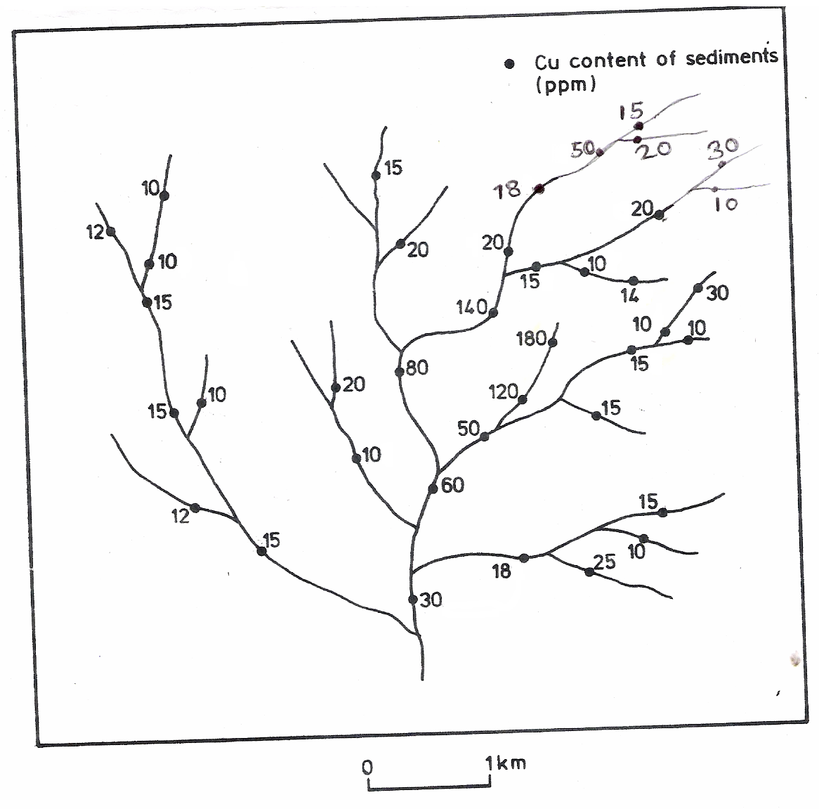
Figure i. The distribution of copper in stream sediments

REFERENCES

Adriano, D.C. (1986): Trace elements in the terrestrial Environment. Springer verlag, New York.

Ahrens L.H. (1954): The lognormal distribution of the elements. Geochimica Et Cosmochimica Acta, 5, 49 – 73.

Ahrens, L. H. (1957): Lognormal-type distributions, Geochim. Cosmochim. Acta, 11, 205-212.

Anderson, J.M. and Ingram, J.S.I., eds. (1993): Tropical Soil Biology and Fertility. A Handbook of Methods, C.A.B. International, Willingford, UK. Pp 88-95.

Armour-Brown, A. (1971): Provincial and regional geochemical studies in Zambia, PhD.
Thesis, Imperial College, London

ASTM Standards (1964): American Society for Testing Materials, Philadelphia, USA.

Baas Becking L.G.M., Kaplan, I.R., Moore, D (1960): Limits of the natural environment in terms of pH and oxidation-reduction potential. J. Geol. 68: 243- 284.

Brady, C.N., (1999): The nature and properties of soils, Prentice-Hall, New Delhi.

Brookins, D.G. (1978): Eh-pH diagrams for elements from Z = 40 to Z = 52, Application to the Oklo natural reactor. Chem. Geol 23:324-341.

Brookins, D.G. (1988): Eh-pH diagrams for geochemistry (Berlin Heidelberg: Springer-Verlag, 176 pp.).

Brownlow, A. H., 1979. Geochemistry. Prentice Hall, New Jersey.

Cameron, E.M. and Hornbrook, E.H.W. (1976). Current approach to geochemical reconnaissance for uranium in the Canadian shield. Exploration for Uranium ore deposits , 241-266. IAEA, Vienna.

Connor, J. J. and Shacklette, H. T. (1975): Background geochemistry of some soils, plants,
and vegetables in the conterminous United states. U.S. Geol. Survey Prof. Paper574-F,
164 pp.

Donahue, L.R.; Miller, W.R., and Shickluma, C.J., (1983): Soils: An Introduction to soils and plant growth, Prentice-Hall, Inc., Englewood Cliffs, New Jersey.

FAO (1990): Guidelines For Soil Profile Description, FAO, Rome, p. 70.

Faure, G., (1991): Principles and Applications of Inorganic Geochemistry (New York: MacMillan, 626 p).

Fitzpatrick, E. A. (1986): An Introduction to soil science (Singapore: Longman Publishers, 255 p).

Govett, G.J.S. 1958. Geochemical prospecting for Copper in Northern Rhodesia. PhD. Thesis, Imperial College, London.

Hem, J.D. (1977): Reactions of metal ions at surfaces of hydrous iron oxides. Geochim Cosmochim Acta 41:527-538.

Hem, J.D. (1981): Redox processes at surfaces of manganese oxides and their effects on aqueous metal ions. Chem. Geol 21:199-218.

Johnson, D.M. (1989): Probability and Statistics. South western Publishing Co., Cincinnati, Ohio.

Kinniburgh, D.G., Jackson, M.L. and Syers, J.K. 1976. Adsorption of alkaline earths, transition, and heavy metal cations by hydrous oxide gels of iron and aluminium. Soil Sci. Soc. Am. J., 40, 796-799.

Lepeltier, C.I. (1969): A simplified statistical treatment of geochemical data by graphical representation, Econ. Geol.,64: 538-550.

Little, P. and Martin, M.H. (1974): Biological monitoring of heavy metal pollution, environ. pollut., 6, 1-19.

Mason, B. and Moore, C.B. (1982): Principles of Geochemistry, New York: John Wiley & Sons, 344 p.

McBride, M.B., Sauve, S., and Hendershot, W. (1997): Solubility control of Cu, Zn, Cd, and Pb in contaminated soils. Eur. J. Soil Sci. 48: 337-346.

Mitchell R.L. (1964): Trace element contents in normal soils: In Chemistry of the soil, Bear, F.E. (ed.), New York, Reinhold Publishing Corp., 515 p.

Mukube, P. (2012). Multi-element Geochemical Soil Survey of the Jimbe Area in Mwinilunga district of Zambia. BSc. Thesis, University of Zambia.

Peters, W.C. (1978): Exploration and Mining Geology (New York: John Wiley and sons, 696 p).

Rose, A.W., Hawkes, H.E., & Webb J.S. (1979): Geochemistry in Mineral Exploration (London: Academic Press, 657 p).

Schmidt, R.c. (1956). Adsorption of copper, lead and zinc on some common rock forming minerals and its effect on lake sediments. Ph.D. Thesis, McGill University, Montreal.

Skoog, D.A. and West, D.M. (1985):Analytical Chemistry: An Introduction.Saunders College Publishing, Philadelphia.

Sinclair, A.J. (1976): The application of probability plots to mineral exploration. Special Vol. 4, Ass. Of Expl. Geoch., 95p.

Stanley, C.R. (1987). PROBPLOT, Assoc. Expl. Geochem.; Special Vol. 14.

Taylor, S.R. (1964): Abundance of Chemical elements in the Continental Crust, Geochim. et Cosmochim. Acta., 28, 1280-1281.

Theobald, P.K. and Thompson, C. E. (1959). Geochemical prospecting with heavy mineral concentrates used to locate a tungsten deposit. U.S. Geol. Survey Circ. 411, 13 pp.

Vogel, A.I. (1977): Textbook of quantitative inorganic analysis. London, Longman. 925 p.

Webb, J.S. and Tooms, J.S. 1959. Geochemical drainage reconnaissance for copper in Northern Rhodesia. Inst. Min. Met. Trans. 68, 125-144.

Zumkley H.and Spieker C (1988): The bioavailability of trace elements and age-specific trace element metabolism: In trace elements In Environmental History, eds., G. Grupe and B. Herrmann (Berlin Heidelberg: Springer-Verlag).

