CHEMICAL PROCESSES AT THE SURFACE OF THE EARTH
Most chemical processes of interest to the Geochemist which occur at the surface of the earth involve chemical reactions in which minerals interact with chemical species in water and gases in the atmosphere. These chemical reactions are represented by chemical equations.
Natural chemical reactions have a tendency to progress towards equilibrium. For a chemical reaction at equilibrium the activities of the products and reactants do not change with time. Consider the dissolution of halite in pure water under controlled laboratory conditions. As the crystals of salt are added to the water the solution will get stronger and stronger until it is saturated with respect to halite. When one considers the reactions that occur at the surface of the earth in open systems it is most likely that equilibrium may not be achieved due to the tendency for soluble products to be transported away from the sites where the reactions are taking place. Some reactions in nature fail to reach equilibrium due to the slow rates at which these reactions take place.
Reactions in geochemical environments are caused by changes in physicochemical conditions such as pressure, temperature and chemical composition.
CHEMICAL WEATHERING
Chemical weathering is the decomposition of rocks and minerals in the secondary geochemical environment that is caused by interaction of these solids with agents of weathering such as water and gases. The type of reactions that are involved in weathering include the following:
- Solution of minerals (congruent solution)
- Hydration
- Ion exchange
- Redox reactions
- Organic reactions
- Hydrolysis
These reactions may take place above the ground surface, in soils and sediments, in surface water bodies and below the groundwater table.
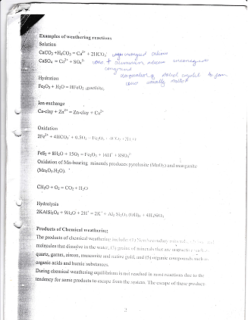
Examples of chemical weathering reactions:
Solution
CaCO₃ + H₂CO₃ H⁺ + 2HCO₃⁻ + Ca²⁺
CaSO₄ Ca²⁺ + SO₄²⁻
Hydration
Fe₂O₃ + H₂O 2HFeO₂
Ion exchange
Ca-Clay + Zn²⁺ Zn-Clay + Ca²⁺
Oxidation
4FeS₂ + 14H₂O +15O₂ 4Fe(OH)₃ + 8SO₄²⁻ + 16H⁺
2Fe²⁺ + 4HCO₃⁻ + 0.5O₂ Fe₂O₃ + 4CO₂ + 2H₂O
Oxidation of Mn bearing minerals produce pyrolusite (MnO₂) and manganite (Mn₂O₃.H₂O)
CH₂O + O₂ CO₂ + H₂O

Hydrolysis
2KAlSi₃O₈ + H₂O + 2H⁺ 2K⁺ + Al₂Si₂O₅(OH)₄
2NaAlSi₃O₈ + H₂O + 2H⁺ 2Na⁺ + Al₂Si₂O₅(OH)₄
CaAl₂Si₂O₈ + H₂O + 2H⁺ Ca²⁺ + Al₂Si₂O₅(OH)₄
2KAl₃Si₄O₁₀(OH)₂ + 72KAlSi₃O₈ + H₂O + 2H⁺ 2K⁺ + Al₂Si₂O₅(OH)₄
H₂O + 2H⁺ 2K⁺ + 3Al₂Si₂O₅(OH)₄ + 2H₄SiO₄

PRODUCTS OF CHEMICAL WEATHERING
- New secondary minerals such as clays, oxides etc
- Ions and molecules that occur in dissolved state
- Grains of resistant minerals that are liberated e.g. magnetite, zircon, quartz, garnet etc
- Organic compounds such as organic acids and humic substances
During chemical weathering in open systems equilibrium is not reached due to the tendency for some weathering products to escape from the systems.
The escape of these products allows the reactions to go to completion. Weathering reactions are promoted by high water flow rate, high temperature and acidic conditions. Attainment of equilibrium during weathering depends on the water/rock ratio. The higher the water rock ratio the more likely it would be for the reaction to run to completion than to reach equilibrium.
The fate of atoms released during weathering may be considered as follows:
- May become a structural part of a secondary mineral
- May get adsorbed by clay minerals, organic matter or Fe/Mn oxides
- Taken up by living organisms
- Removed in solution as simple ions, complex ions or adsorbed ions on colloidal particles.
RATE OF CHEMICAL WEATHERING
This is determined by the rate of water flow and temperature. The intensity of chemical weathering is greater in tropical regions than in subtropical, hot deserts and cooler regions. The high degree of weathering in the tropical regions is reflected in the production of laterites from country rocks. (Table 1, column 3).
Some Important products of Chemical weathering are:
- Soils
- Sediments
- Clay deposits
- Mineral deposits (bauxite, oxide copper deposits, Placer deposits, supergene enrichment deposits).
- Gossans
- Laterites
- Mineral water

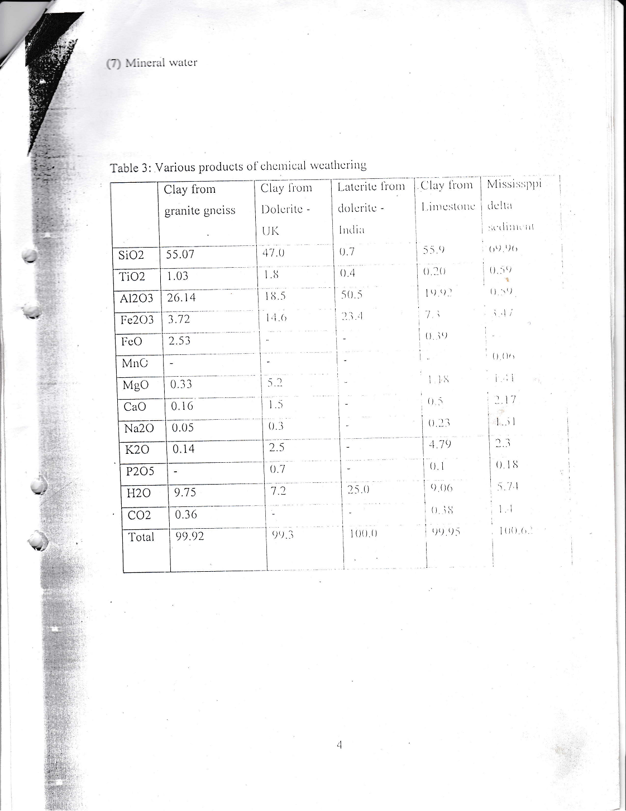
Stability of minerals in weathering environments
High susceptibility Mafic minerals Felsic minerals
Olivine Calcic plagioclase
Pyroxene Interm. Plg
Amphibole Sodic plg
Biotite K – feldspar
Muscovite
Low susceptibility Quartz
Changes produced by chemical weathering can be studied in different ways:
- Comparing the composition of rocks and their products
- Calculation of loss or gain of oxides assuming no change in Al₂O₃
- Plotting oxide ratios in rocks and soils
- Calculating normative minerals
Clay Minerals
Important products of chemical weathering are clay minerals. The nature of clay minerals formed depend on the rainfall/water flow rate, mineralogical composition of the rocks and the chemistry of the weathering solutions. In areas with very high rainfall kaolinite is mainly derived from K-feldspar. Illite is derived from micas. Montmorrilonite is derived from Mg-rich rocks. Magnesium- rich weathering solutions result in development of illite. Intermediate water flow rate favour development of kaolinite while, low flow rates favour formation of montmorrilonite. So the nature of the clay minerals that are produced during chemical weathering depend upon the following factors:
- Amount of rainfall
- Topography
- Mineralogy of bedrock or parent material
- Chemical composition of the weathering solutions
Stability relations of the clay minerals, feldspar and gibbsite can be calculated from equilibrium constants of appropriate reactions. The stability diagrams may be plotted in the Log([K⁺]/[H⁺]) vs –log [H₄SiO₄] space. Stability relations in system such as Al-OH-Si-H-Na and Al-O-Si-H-K can be plotted or determined under physicochemical conditions that normally exist in the secondary environment.
Clay minerals can be classified on the basis of chemical composition and crystal structure. An important property of clays is their cation exchange capacity (mEq/100g). Due to extensive ionic substitution in montmorrilonite its ion exchange capacity is very high.
SOILS
These are very important products of weathering. Soils are important in agriculture and applied geochemistry.

SEDIMENTS
The chemical composition of sediments depend upon the processes that are taking place in the source regions. Sediments in drainage channels tend to be enriched in carbonate minerals and organic matter. The composition of sediments may change due to a number of processes such as ion exchange, Adsorption, solution, precipitation, oxidation and reduction.
The destruction of organic matter during sulphate reduction is illustrated below.
1/53 (CH₂O)₁₀₆(NH₃)16H₃PO₄ + SO₄²⁻ + 15/53H⁺ = 1/53H₃PO₄ + 2HCO₃⁻ + 16/35NH₄⁻ + H₂S

The composition of some sediments from different environments is given below.
Table showing composition of sediments
Oxide | Mississippi Delta | Deep Sea red clay (Pacific) | Black sea | Carbonaceous shale | Sediments
SiO₂ | 69.96 | 53.93 | 48.9 | 51.03 | 84.14
TiO₂ | 0.59 | 0.96 | 0.58 | - | 0.22
Al₂O₃ | 10.52 | 17.46 | 12.8 | 13.47 | 5.79
Fe₂O₃ | 3.47 | 8.53 | 5.51 | 8.06 | 1.21
FeO |  | 0.45 | - | - | -
MnO | 0.06 | 0.78 | 0.103 | - | -
MgO | 1.41 | 4.56 | 2.48 | 1.15 | 0.41
CaO | 2.17 | 1.56 | 9.79 | 0.78 | 0.31
Na₂O | 1.51 | 1.27 | 1.57 | 0.41 | 0.99
K₂O | 2.30 | 3.65 | 2.52 | 3.16 | 0.0
P₂O₅ | 0.18 | 0.09 | 0.12 | 0.51 | -
H₂O+ | 1.96 | 6.3 | 0.26 | 0.81 | -
H₂O- | 3.78
CO₂ | 1.4 | 0.4 | 7.3 | - | -
Organic carbon | - | 0.13 | 1.32 | 13.11 | -
S | - | - | 1.63 | 7.29 | -
Total | 100.62 | 100.09 |  | 100.7 | 100.03

The major minerals of common sedimentary rocks and sediments include the following:
Quartz, orthoclase, microcline, plagioclase, muscovite, biotite, kaolinite, montmorrilonite, illite, chlorite, calcite and dolomite.

PRECIPITATION OF MINERALS IN BASINS
The precipitation of minerals in the sedimentary basin depends on the composition of water and prevailing Eh-pH conditions. Oxides form under oxidising conditions. Sulfides form under reducing conditions. Carbonates form under alkaline conditions. Silica precipitates under acidic conditions. Sulphates precipitate under oxidising conditions. Organic matter is only preserved under reducing conditions.
Evaporites
Evaporites form due to precipitation from water bodies that have lost water as a result of excessive evaporation. Minerals in evaporate deposits include NaCl, Na₂SO₄, Na₂CO₃, MgSO₄, CaSO₄, NaNO₃ and KNO₃. Evaporite minerals only form in water bodies where the aqueous solutions are supersaturated with respect to the given salts.
The condition for precipitation is satisfied if the value of the saturation index for a given salt is greater than 0.
S.I. = log (I.A.P/K_{sp})
Where S.I. is the saturation index, I.A.P is the ion activity product and K_{sp} is the solubility product constant of the salt or evaporate mineral.
If S.I. < 0 then the solution is undersaturated with respect to a given salt
If S.I. = 0 then the solution is saturated with respect to a given salt
If S.I. > 0 then the solution is supersaturated with respect to a given salt

The K_{sp} values for some minerals that may form in the environment are given below.
The I.A.P for NaCl is [Na] [Cl], where [Na] = γ. (Na⁺) and γ is the activity coefficient calculated using appropriate chemical data and equation (Debye-Huckel , Davies).

Table of solubility product constants
Mineral K_{sp}
NaCl 38
CaCO₃ (calcite) 10^{-8.35}
CaSO₄ (anhydrite) 10^{-4.5}
PbS (galena) 10^{-27.5}
Cu₂(OH)₂CO₃ 10^{-33.8}
CaMg(CO₃)₂ (dolomite) 10^{-16.7}
Fe(OH)₃ (amorphous) 10^{-38.7}

Oxidation of mineral deposits
Sulfide mineral deposits
PbS + 2O₂ PbSO₄
ZnS +O₂ + H₂O + 2CaCO₃ ZnCO₃ + 2Ca²⁺ + 2HCO₃⁻ + SO₄²⁻
2ZnS + 4O₂ + 2HCO₃⁻ 2ZnCO₃ +2SO₄²⁻ +2 H⁺

The oxidation of sulphide rich bodies at the surface of the earth produces iron rich yellowish to reddish brown material known as gossans. The secondary minerals that may be present in the gossans include:
Hydrated oxides
Carbonates (smithsonite, cerussite)
Sulfates (anglesite)
Chlorides (cerargyrite)
Phosphates (pyromorphite)
Silicates (chrysocolla, hemimorphite)
Native metals (silver, mercury)
The solubilities of these secondary minerals determine the extent to which the contained minerals may be mobilised from the outcrops of mineral deposits. Fe and Mn form insoluble oxides that remain at the outcrops. Ag is precipitated as the chloride or reduced to the metal. Hg is reduced to the metal. Pb and Cd form insoluble carbonates. Pb also forms an insoluble sulphate. Cu and Zn form carbonates. Cu forms insoluble oxides under low acidity conditions. Ni and co may be mobilised. In the presence of arsenic these minerals may form insoluble arsenates. Ni can also form an insoluble silicate.
Supergene sulphide enrichment
This process is caused by migration of copper in the oxidising environment followed by reaction of copper ions with other sulphides under reducing conditions resulting in replacement of these sulphides by copper sulphides as shown in the equations below:
Cu²⁺ + ZnS Zn²⁺ + CuS
8Cu²⁺ + 5ZnS + 4H₂O 4Cu₂S + 5Zn²⁺ + SO₄²⁻ + 8H⁺
14 Cu²⁺ + 5FeS₂ + 12H₂O 7Cu₂S + 5Fe²⁺ + 3SO₄²⁻ + 24H⁺

OXIDATION OF URANIUM ORES
Oxidation of uranium may result in its mobilisation in the form of UO₂²⁺. This form of U is highly mobile. The mobility of U may be enhanced in the presence of carbonate ions through the formation of highly soluble carbonate complexes as shown below:
UO₂²⁺ + 2CO₃²⁺ UO₂(CO₃)₂²⁻
UO₂(CO₃)₂²⁻ + CO₃²⁻ UO₂(CO₃)₃⁴⁻
PRECIPITATION OF URANIUM ORES
Uranium –rich ions may be immobilised under reducing conditions to precipitate uraninite.

