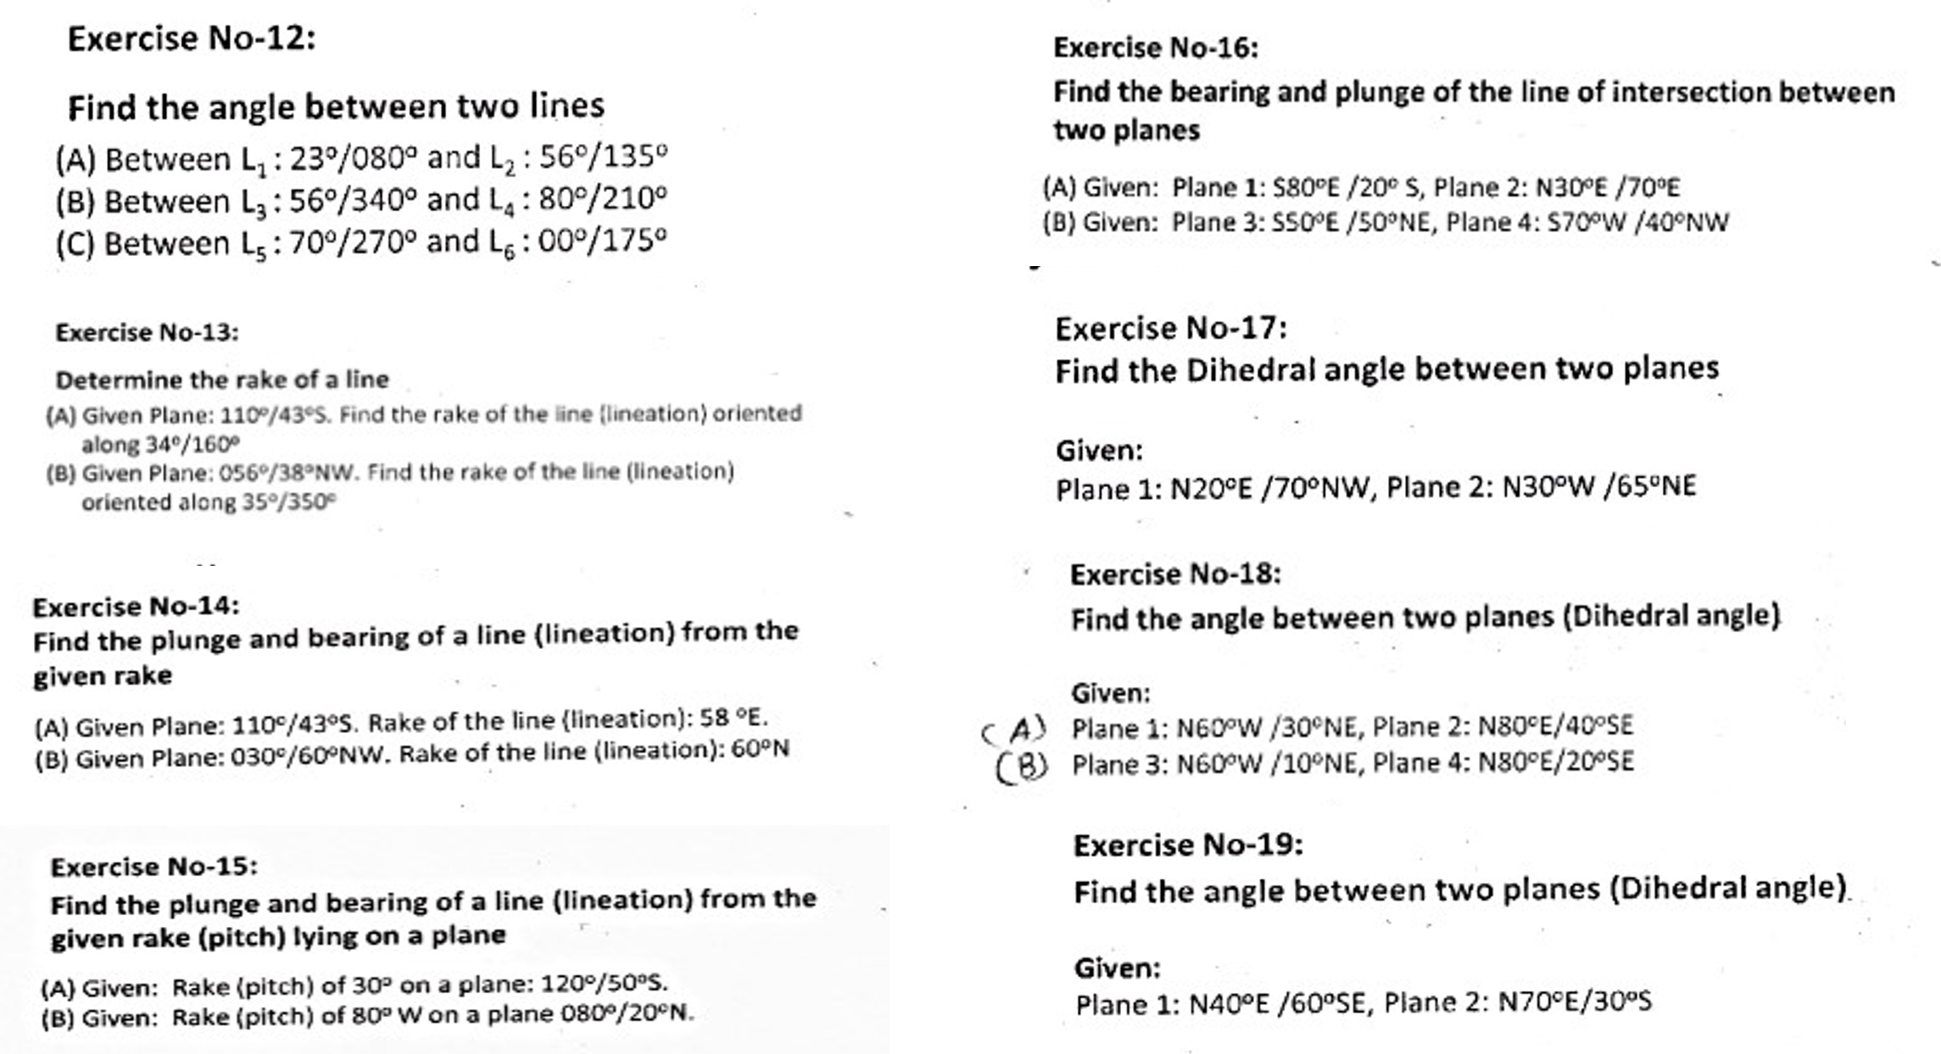
Stereographic Projection Exercises (12-19)

