MECHANICAL BEHAVIOR OF ROCKS

Main Topics
- Elastic, plastic and viscous behavior of rocks
- Rock Strength and Triaxial Tests
- Controlling factors on rock mechanics

Elastic, Plastic and viscous behavior of rocks
To determine whether a test specimen of rock has responded to axial compression in brittle, semibrittle, or ductile manner, all we need to know is the percentage of shortening before failure by fracturing.
Ductile rocks tend to accommodate the shortening (that is deform) without loss of cohesion; they do this by distributing the deformation throughout the body, or at the very least within broad zones.
Brittle rocks (brittle- bryttian = to shatter), on the other hand, accommodate shortening with pronounced loss of cohesion along through-going fractures.
Instead of being distributed, the deformation is highly concentrated in narrow zones.
As useful as the terms “brittle” and “ductile” may be, they fundamentally emphasize strain.
What we need at this point is a set of models that helps us envision the full interplay of stress and strain, helps us envision the fundamental ways in which rocks have been found to respond to stress.
Indeed, there are three basic models;

1. Elastic behavior 2. Plastic behavior and, 3. Viscous behavior
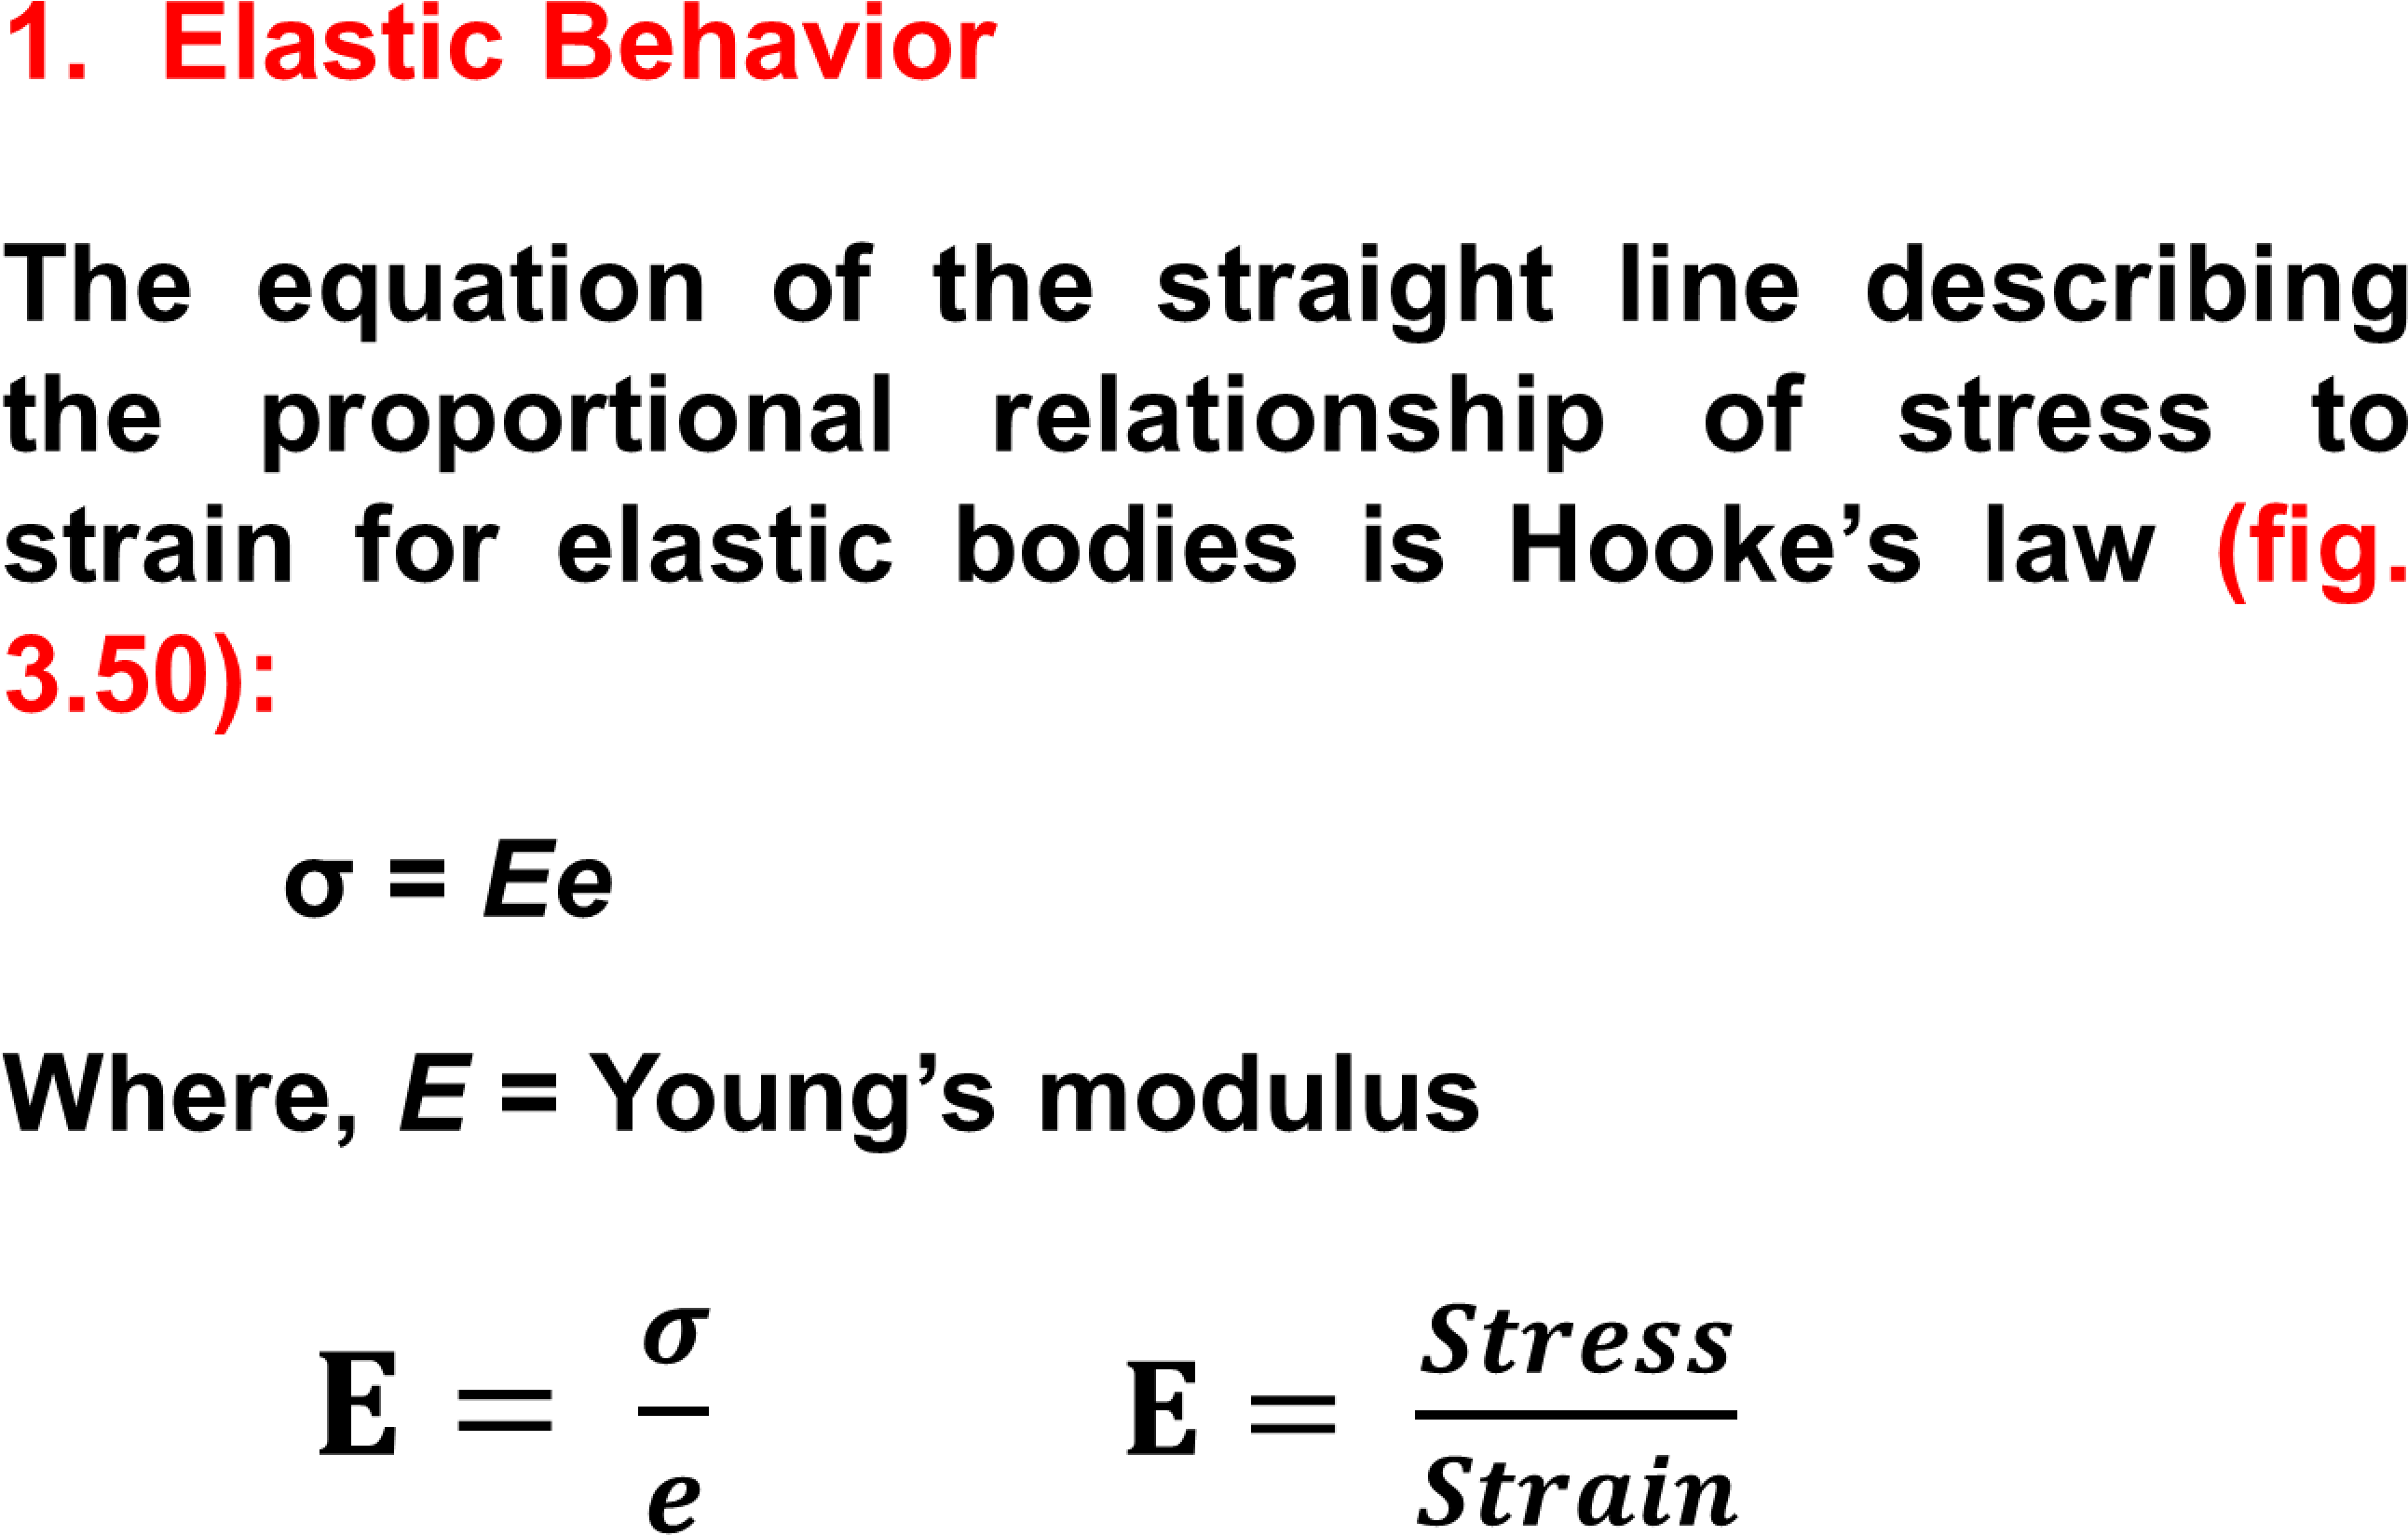
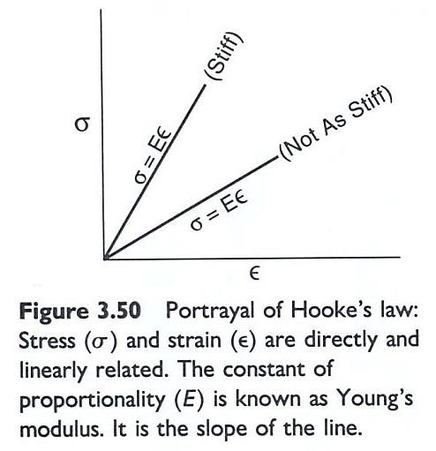
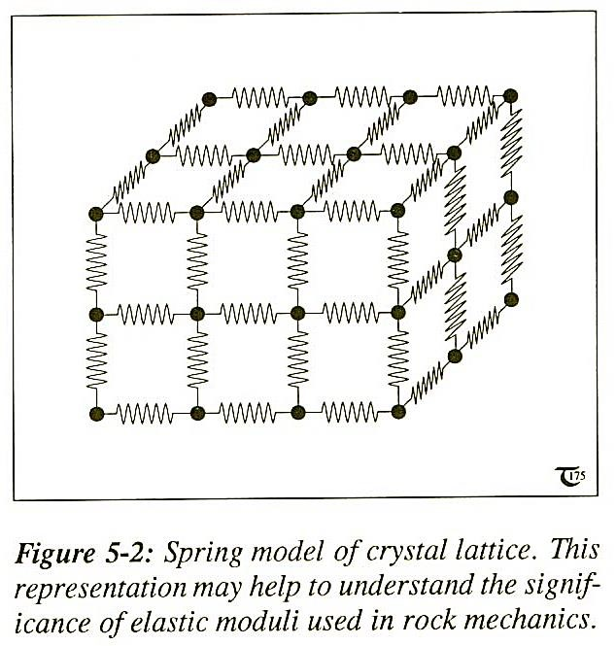
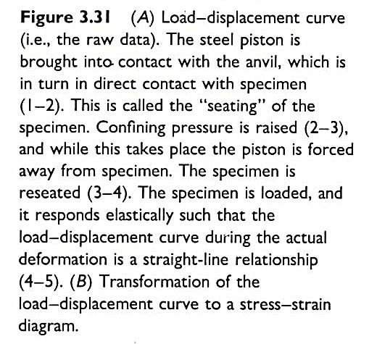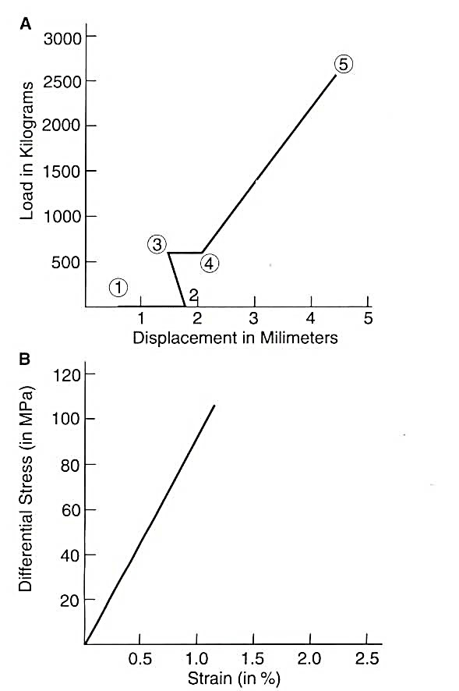
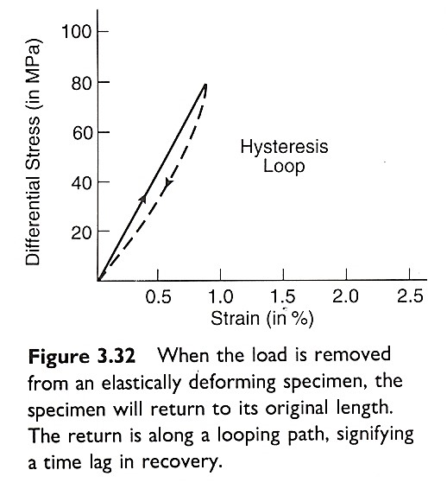
rupture
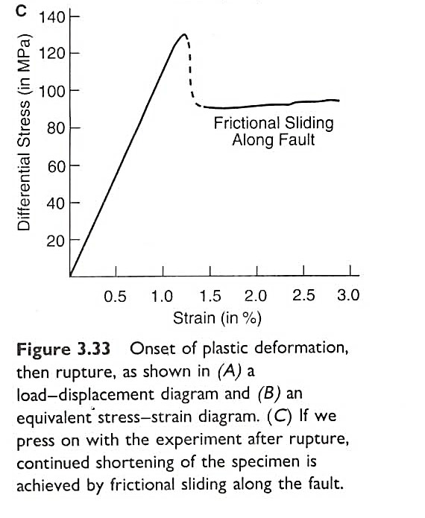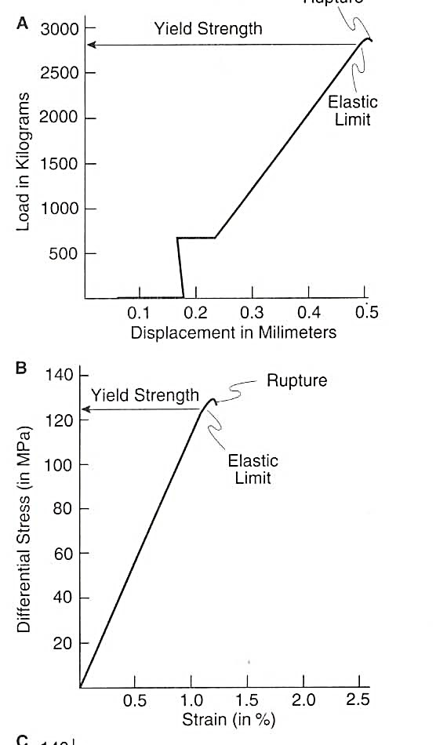
The value of E, Young’ modulus, describes the slope of the straight line stress-strain curve. Even under the same conditions of deformation, the value of E will vary from rock to rock, reflecting natural differences in the resistance of rock to elastic deformation.
Thus the slope of a straight line stress–strain curve is a major of the stiffness of the rock.
Typical values of Young’s modulus are presented in table 3.4: the higher the values, the stiffer the rock. Because extension is unitless, Young’s modulus is given in units of stress (e.g., MPa).
If stress is compressive, and therefore positive (+), extension will be negative (-), and thus Young’s modulus will be negative as well.
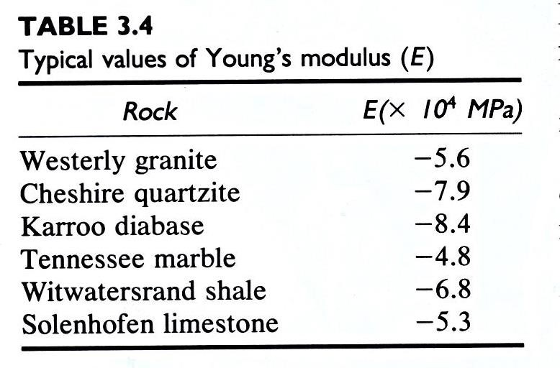
In the context of our experimental work, Young’s modulus E can be thought of as an elastic modulus that describes how much stress is required to achieve a given amount of lengthparallel elastic shortening of a core of rock.

Poisson’s ratio
A second elastic modulus, known as Poisson’s ratio and represented by a Greek letter ν (pronounced nu), describes the degree to which a core of rock bulges as it shortens.
Poisson’s ratio describes the ratio of lateral strain to longitudinal strain:

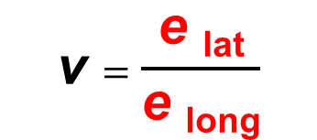 (3.6)
Poisson’s ratio is unitless, for it is a ratio of extension. Values of Poisson’s ratio are presented in table 3.2

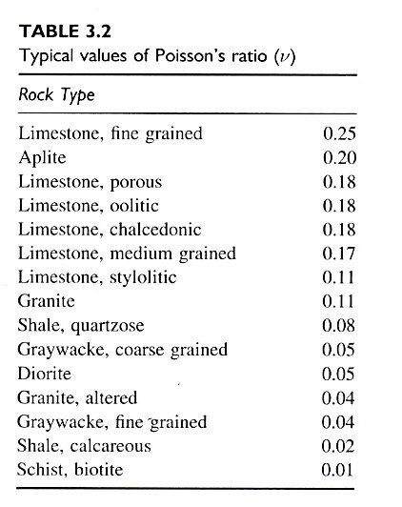
The generation of horizontal stresses by vertical loading is known as the Poisson effect.
The magnitude of such horizontal stresses (σ₂ = σ₃) is related not only to the vertical stress (σ₁), but also to Poisson’s ratio (v):
σ₂ = σ₃ = v σ₁
1- v
Since Poison’s ratio for common rocks is approximately 0.25, the magnitude of stress generated by the elastic phenomenon described here as the poisson effect is approximately one-third of the greatest principal stress.
σ3 = 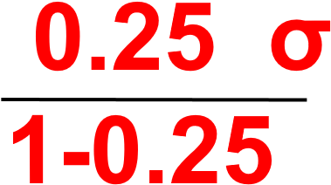1 = 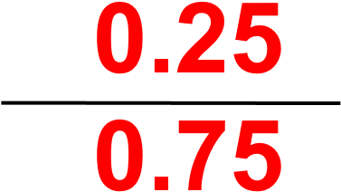 σ1 =  σ1

2. Plastic behavior
An ideally plastic body undergoes no strain whatsoever below the yield stress, and this would be represented on a stress-strain curve by a vertical line that terminates at the value of yield stress (fig. 3.53).
When the yield stress is achieved, the plastic body will strain as long as the yield stress magnitude is maintained (horizontal line).
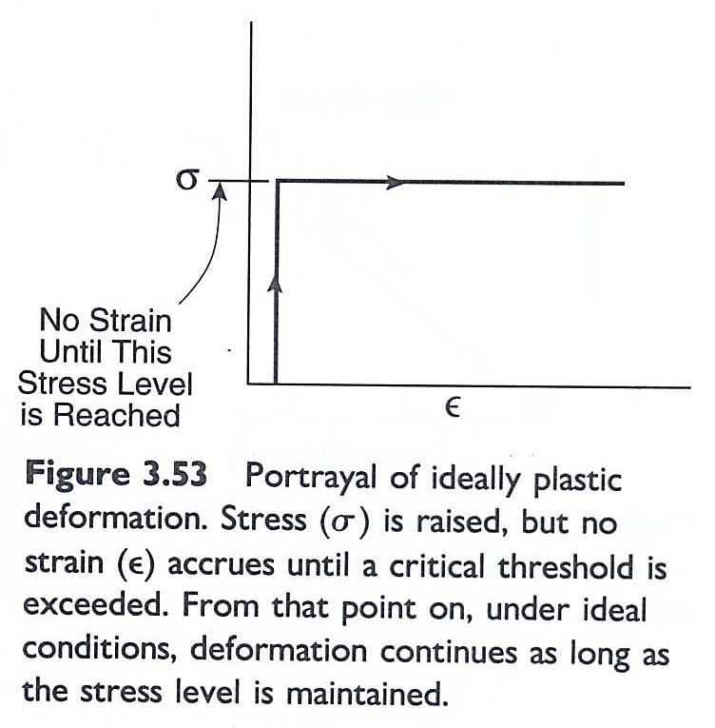
3. Viscous behavior
Viscosity is a measure of resistance to flow
(fig. 3.55), just as Young’s modulus can be thought of as a measure of resistance to elastic distortion.
The greater the viscosity, the greater the internal friction of the fluid.
Viscosity is measured in poises: “if a shear stress of one dyne/cm² acts on a liquid and gives rise to a strain rate of 1.0 sec⁻¹, the liquid has a viscosity of 1 poise (..where 10 poise=1 Pa sec)”.
Viscosities for common fluids are presented in Table 3.6.
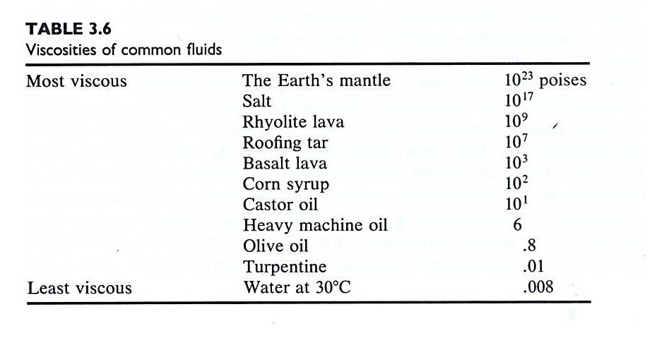
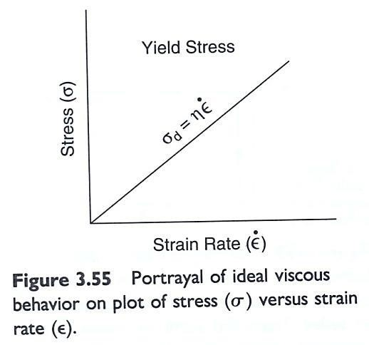
DEFORMING ROCKS
IN
THE LABORATORY

Rock Strength Uniaxial and Triaxial Tests
The mechanical properties of rocks are explored in rock mechanics laboratories, where samples are exposed to various stress fields that relate to different depths and stress regimes in the crust.
Uniaxial rigs can be used to test the uniaxial compressive or tensile strength of rocks.
Triaxial tests, where (σ₁ > σ₂= σ₃) are more common, where rock cylinders are loaded in the axial direction while the sample is confined in fluid that can be pumped up to a certain confining pressure.
A typical triaxial rig can build up an axial stress of 2-300 MPa and a confining pressure of up to 50-100 MPa or more.

Objectives
The thrust of dynamic analysis goes beyond force and stress. Of ultimate interest is a specific knowledge of the relationships between stress and strain.
This is the subject of rheology, the study of the response of rocks to stress.
Rheology: It is the science of flow and deformation of matter under controlled and specified conditions of testing.
Flow is a special case of deformation.
Deformation is a special case of flow.
We want to know how a rock of a given lithology responds when it is subjected to forces and stresses under different sets of conditions of:
- temperature,
- confining pressure,
- pore fluid pressure,
- rate of loading, and the like.
It would be ideal if we could predict the amount of strain any rock body would be forced to accommodate in the presence of any known stress under any given set of geologically reasonable conditions.
Structural geologists, physicists, and engineers have approached this challenge both experimentally and theoretically.
By subjecting rocks to forces and stresses under controlled conditions in the laboratory, we can observe, and describe mathematically, the nature of the deformation and the specific relationships between stress and strain.

The Value of Laboratory Deformational Experiments
We find it useful to create in the laboratory the very stresses whose impact we wish to examine.
We do this by subjecting rock specimens to controlled loading under known, prescribed conditions in a deformation apparatus.
The nature and origin of structural deformation of rocks becomes clearer through images and experiences in experimental deformation.
We place an undeformed cylindrical core of limestone into a thick-walled steel pressure vessel, squeeze the rock by hydraulic loading, and
then remove a conspicuously deformed specimen bearing structural characteristics identical to those of faulted rocks seen in natural outcrops
(Figure 3.26).
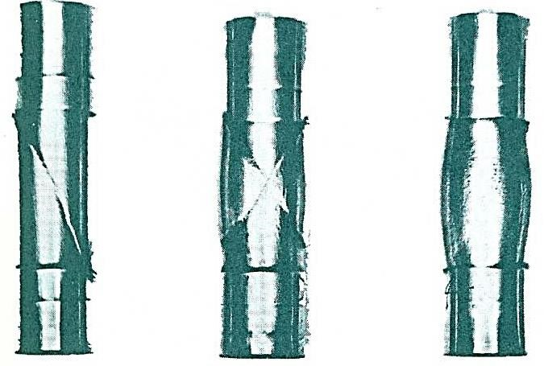
Figure 3.26. Deformation of experimentally deformed cylinders of rocks. Structure is reflected in the thin-walled copper jacket that envelops each rock specimen. Left to right: fault in slate, conjugate fault in sandstone, ductile flow in limestone. (from Donath (1970a). Published with permission of National Association of Geology Teachers, Inc.)

Sample Preparation for deformation experiment
A small core of rock is extracted from a rock through the use of a drill press and a diamond drill coring device. The ends of the cylinder of rock are polished on a grinding wheel.
After the specimen has been thus prepared, a micrometer is used to measure length (lₒ) and diameter (dₒ) of the specimen, preferably to three significant figures.
The specimen is then placed in a jacket of a thin-walled cylinder of copper or some other material of negligible strength.
The jacket serves to seal the rock from whatever fluid (e.g., kerosene) occupies the pressure vessel to avoid the fluid entering the sample and changing its mechanical properties.
For porous rocks or sediments it may be possible to control the pore pressure (e.g. up to 50 MPa).
Once all this has been done, the jacketed specimen is fitted with an anvil at its base and an upper piston specimen holder at its top (Figure 3.27A).
Both these components are made of stainless steel and equipped with O-rings to prevent entry of fluids into the jacket from above or below.
Then the specimen and its trimmings are screwed into the pressure vessel (Figure 3.27B), a steel vessel of sufficient wall thickness and inherent strength to resist fracturing under conditions of very high pressure.
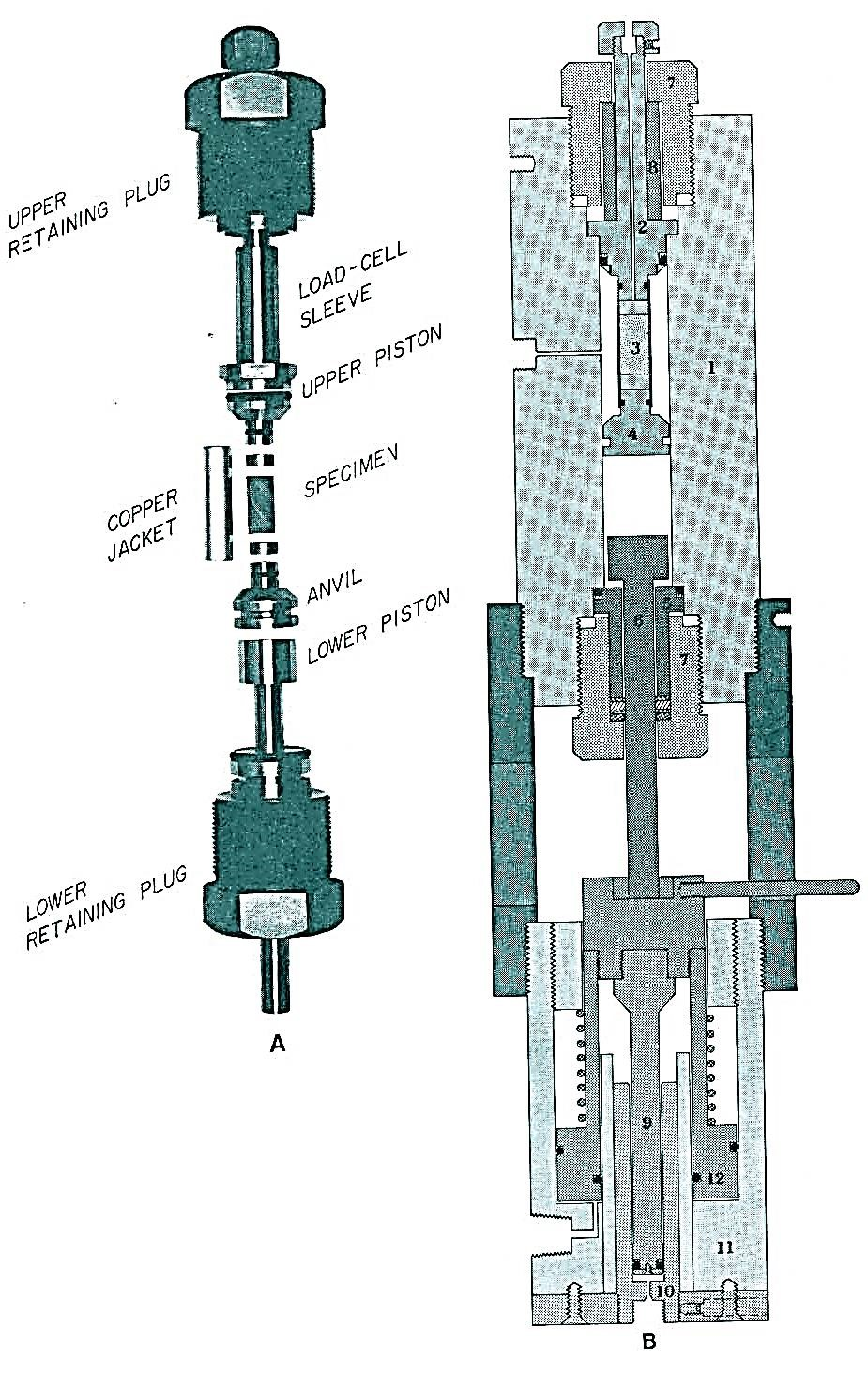
Figure 3.27 (A). Internal parts of pressure vessel, showing the relation of the cylindrical rock specimen (and copper jacket) to pistons and anvil. (From Donath, 1970a). Published with permission of National Association of Geology Teachers Inc.). (B) Schematic drawing of the vessel-press assembly in the Donath apparatus: 1. Pressure vessel; 2. upper piston and seal; 3. specimen; 4. anvil; 5. gland and lower seal; 6. lower piston; 7. retaining plug; 8. load cell; 9. equalization piston; 10. equalization cylinder; 11. ram body; 12. ram piston; 13. collar (from Donath, 1970a). Published with permission of national Association of Geology Teachers Inc.
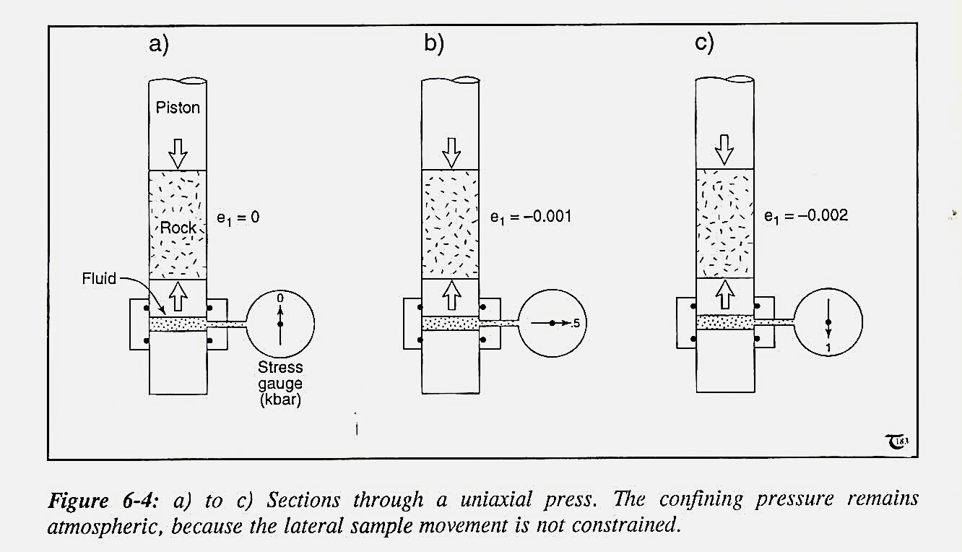

Types of Tests
There is more than one way to squeeze a rock. In the most common procedure, the cylindrical sample is subjected to axial compression (Figure 3.28A).
Vertical axial compressive stress (σ1) parallel to the length of the core is taken to higher levels than the horizontal radial compressive stress - that is, the confining pressure (σ2 = σ3) acting on the body of the rock cylinder.
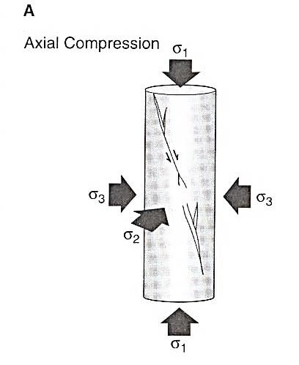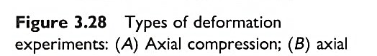
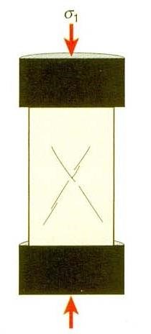
Uniaxial deformation rig, used to find the uniaxial strength of rocks.
Experiments show that, in general, the fine-grained rocks are stronger than coarse grained ones, and the presence of phyllosilicates lowers the strength.
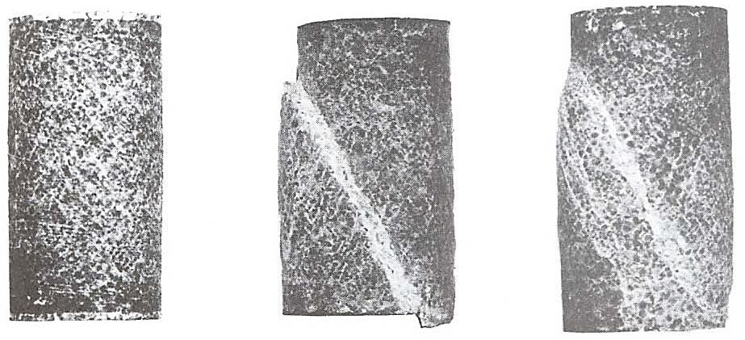
Figure 3.34: Faulted specimens of limestone. (Reprinted by permission. “Some Information Squeezed Out of Rocks”. By F.A. Donath. American Scientist. 58, Fig. 7, pp. 54-72 (1970b)
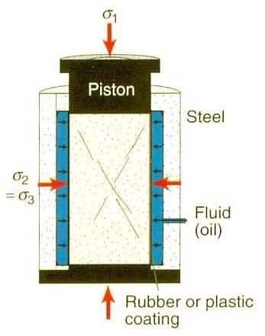
Triaxial rig. Oil pressure is pumped up in a chamber around the sample to increase the confining pressure.
Because the axial stress is the greatest principal stress and the radial stress is the least principal stress, the specimen undergoes length-parallel shortening.
A less common procedure is one in which the core is subjected to axial extension (Figure 3.28B).
In this case, horizontal radial compressive stress, the confining pressure (σ₁ = σ₂) acting on the body of the rock cylinder, is greater than the vertical axial compressive stress (σ₃) parallel to the length of the sample. As a result, the specimen undergoes length-parallel extension.
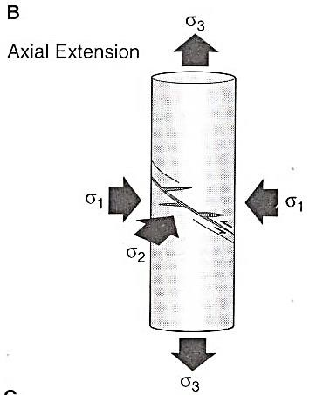
Fig. 3.28: Types of deformation experiments. B: Axial extension
Axial compression and axial extension tests carried out in this manner are referred to as triaxial deformation experiments.
In some tests the rock samples are not squeezed at all; rather they are pulled apart (i.e., stretched). Most commonly these are unconfined tensile strength tests (Figure 3.28C), which aim to determine the smallest amount of stress that will cause a rock to fail in tension. Rocks are much, much weaker in tension than in compression,
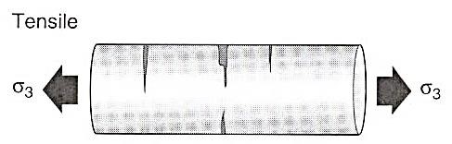
Fig. 3.28: Types of deformation experiments. C: Tensile

Orientation of failure planes
Failed rock contains discontinuity planes, termed fissures, ruptures, cracks, or fractures, if no significant shear displacement has taken place along the separation plane.
Regularly spaced and subparallel sets of fractures in nature are termed joints.
It is important to infer the orientation of the principal stress axes with respect to the fracture planes from laboratory tests in rock mechanics.
True fractures without fault displacement, or tension joints, are formed perpendicular to the least principal stress axis, σ₃ and parallel to the σ₁– σ₂ plane (Fig. 6-11a).
Movement over the fracture is impossible under the prevailing stress field responsible for its creation, because the critically resolved shear stress for this fracture orientation is zero.
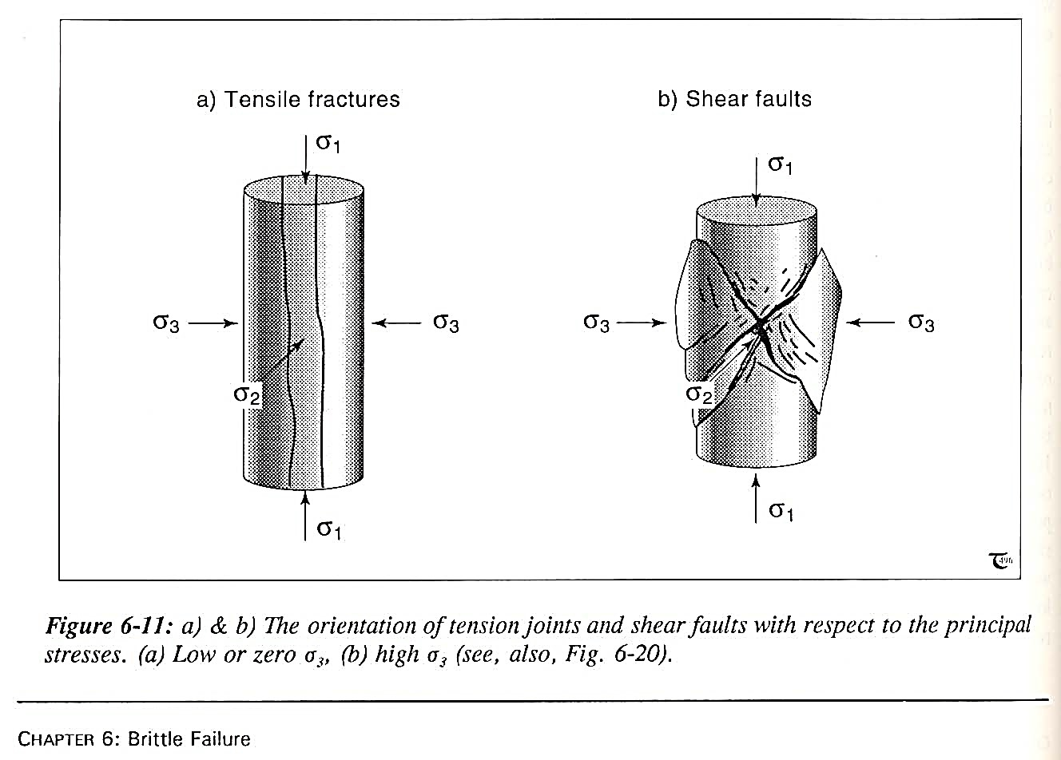
σ
1
–
σ
2
plane
In contrast, shear joints form close to the direction of maximum shear stress, which is in two conjugate planes at 45° to σ₁ and σ₃
(Fig. 6-11b).
The angle of internal friction of most rocks is closer to 30° to 40° rather than 45°. So the angle between σ₁ and shear fracture is above 30°
The Mohr-Coulomb criterion, does not predict that the planes of shear failure follow the maximum shear stress planes; failure planes are predicted to follow planes at an acute angle to σ₁ as observed.
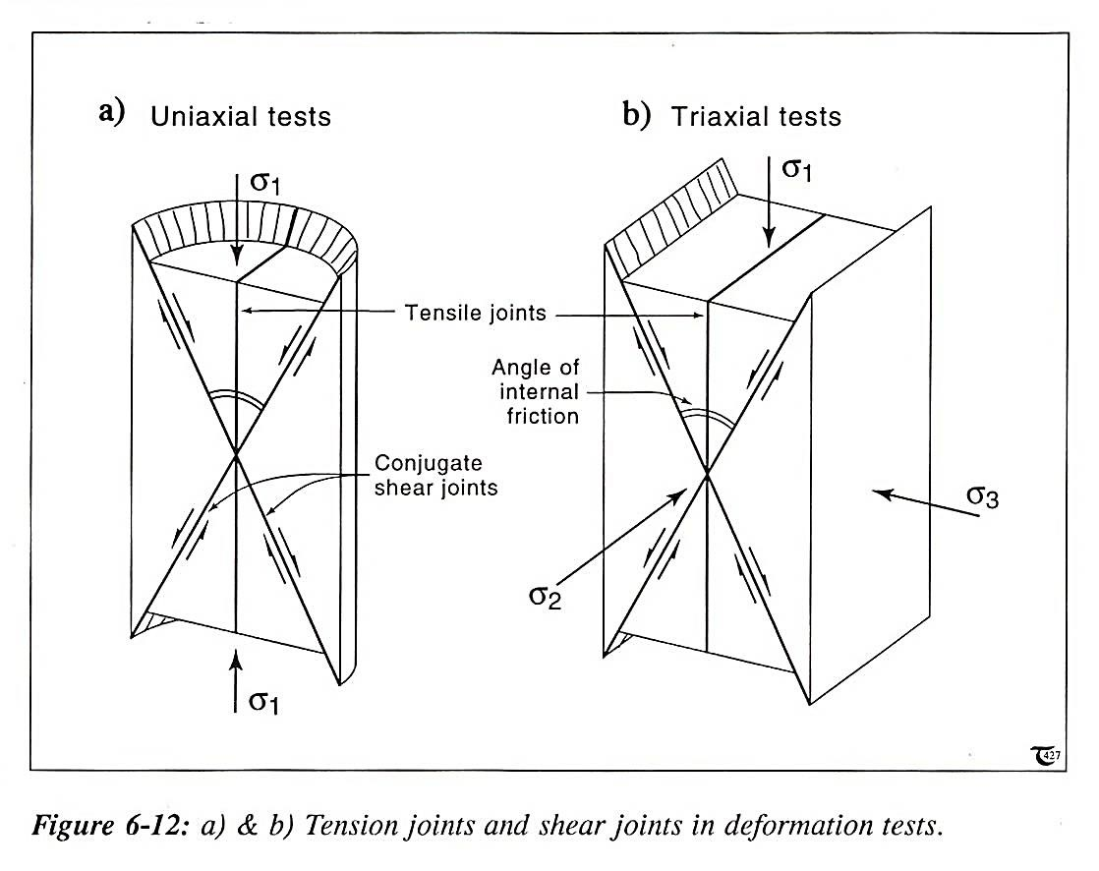
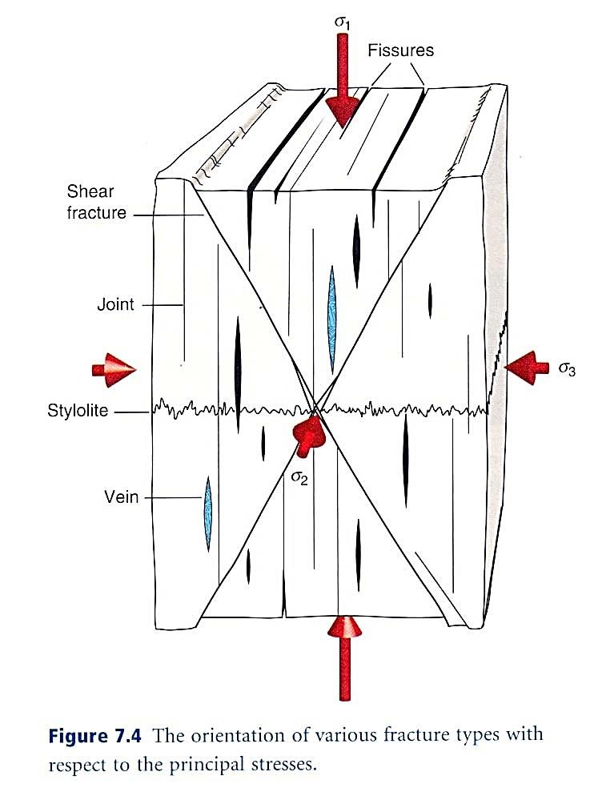
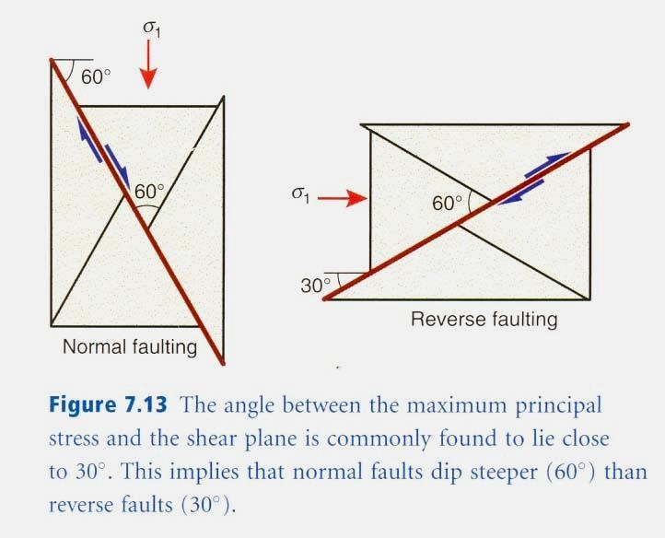

Controlling factors on rock mechanics

Strength and Ductility
The mechanical response of rocks to stress is different for different conditions.
If we were to examine hundreds of stressstrain diagrams generated during laboratory testing of every rock imaginable under every conceivable set of conditions, we would see significant differences in strength and ductility from graph to graph.
One of the chief conclusions that can be drawn from experimental compression tests is that measurements of rock strength and ductility are almost meaningless unless the conditions under which the deformation was achieved are also given.
Furthermore, each variable such as temperature or strain rate, has a different effect on the rheology of the rock being tested.
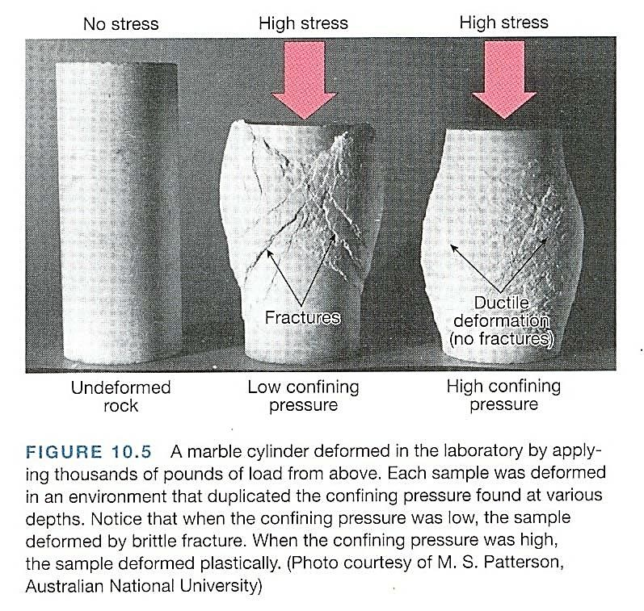

Strength and ductility
The mechanical response of rocks to stress is different for different conditions.
- Lithology
- Confining pressure and pore fluid pressure
- Temperature
- Strain rate
- Time
- Preexisting weakness
- Size

1. Lithology
All other things being equal, it is possible to arrange the common rock lithologies in order of increasing strength for specific conditions, such as confining pressure, temperature, or rate of loading.
Stress-strain diagrams provide the basis for the rankings.
The rankings are only approximate, being strongly influenced by the:
- composition,
- texture, and
- general condition of the rocks that happened to serve as "representative" test specimens for each lithology.
Moreover, the nature and orientation(s) of mechanical heterogeneity -that is, anisotropy, resulting from fractures, layers, foliations, and the like -profoundly influence rock strength.
Table 3.3 lists lithologies according to strength based on stress-strain diagrams summarizing compressional tests of rocks at room temperature under low levels of confining pressure.
Rocks like salt, anhydrite, shale, and mudstone are seen to be weak (and ductile) compared to rocks of intermediate strength like limestone or calcitecemented sandstone.
Quartzite, granite, and quartz-cemented sandstone are brittle and very strong by comparison.
Fig. 3.3: General ranking of lithology according to strength, based on tests at room temperature and low confining pressure
Strength of rocks | Rock types
Strongest  Weakest | Quartzite
Strongest  Weakest | Granite
Strongest  Weakest | Quartz-cemented sandstone
Strongest  Weakest | Basalt
Strongest  Weakest | Limestone
Strongest  Weakest | Calc-cemented sandstone
Strongest  Weakest | Schist
Strongest  Weakest | Marble
Strongest  Weakest | Shale/Mudstone
Strongest  Weakest | Anhydrite
Strongest  Weakest | Salt
Competent and incompetent rocks:
In a sequence of different lithologies, the rocks that are likely to behave in the most ductile manner when subjected to stress are commonly referred to as incompetent.
Rocks that are likely to deform in a brittle manner, with no obvious ductile deformation, are described as competent.

2. Confining Pressure and Pore Fluid Pressure
Increasing the confining pressure on a rock specimen in a compression test has the effect of increasing the strength and ductility of the rock. This has been firmly documented through experimental testing.
For any given lithology, the yield strength, ultimate strength, rupture strength, and ductility attain greater and greater values with increasing confining pressure (Fig. 3.38)
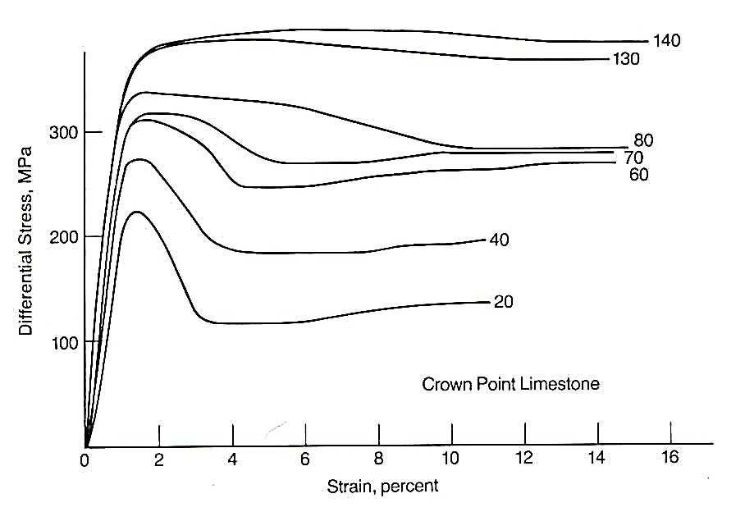
Confining pressure)
Fig. 3.38. Stress – strain diagram for limestone deformed at a variety of confining pressure. Tests conducted at room temperature. The magnitude of confining pressure (in MPa) for each run is shown next to each curve. Both strength and plasticity increase with greater confining pressure
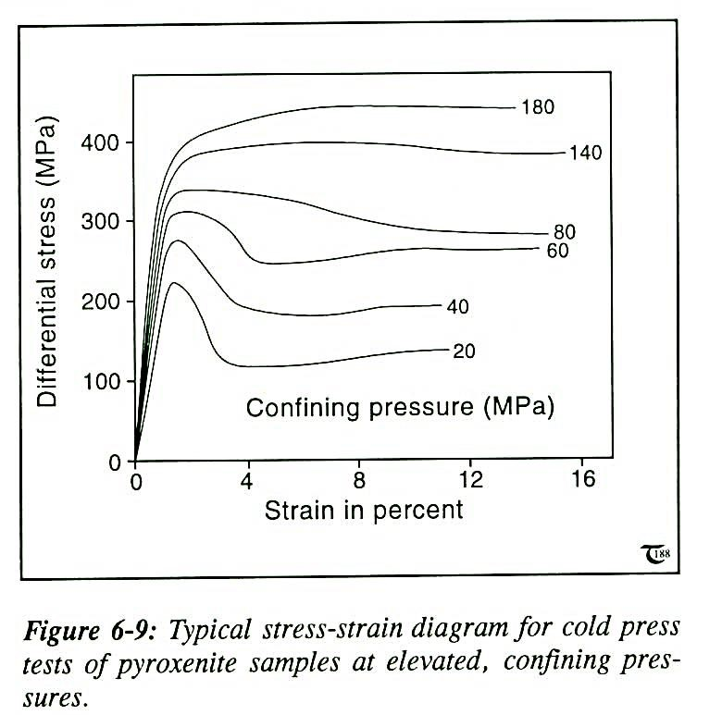
Compression test at higher confining pressure
Summary of compressional testing of limestone under confining pressure conditions of 27.6 MPa, 103 MPa, and 207 MPa
 | Specimen 1 | Specimen 2 | Specimen 3
Confiningpressure | 28MPa | 103MPa | 207MPa
Differential stress at  failure | 124MPa | 318MPa | 552MPa
σ₁ atfailure | 152MPa | 421MPa | 759MPa
σ₃atfailure | 28MPa | 103MPa | 207MPa
Angle θ between fault andσ | 25° | 30° | 33°
1

Pore fluid pressure
The effect of confining pressure can be partially or completely offset by the presence of elevated pore fluid pressure in the rock (or test specimen) undergoing deformation.
Figure 3.39 shows this nicely by means of graphs constructed by Handin and others (1963) on the basis of a series of compressional tests on Berea sandstone.
The graphs reveal that elevated fluid pressure can dramatically decrease ultimate strength, rupture strength, and ductility.
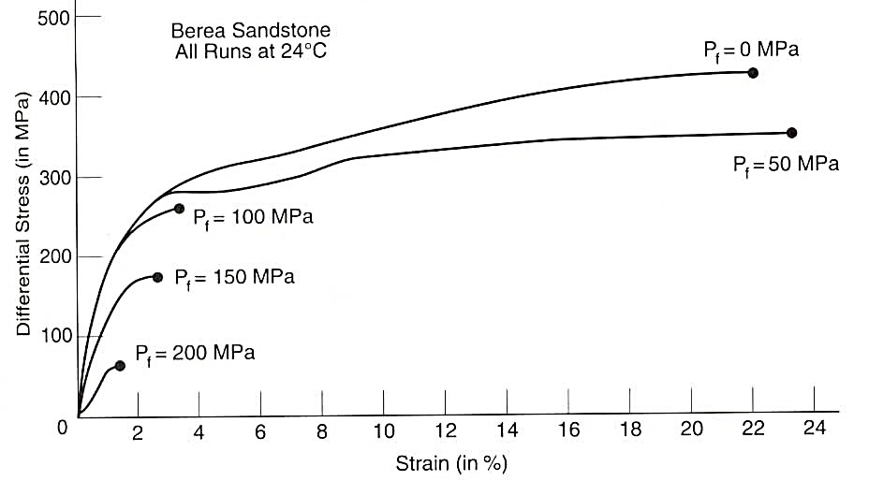
Fig. 3.39. laboratory derived stress-strain curves showing the influence of pore fluid pressure on the strength and ductility of rocks. All tests were carried out at 200 MPa confining pressures. Fluid pressure (Pf) for each run is hown next to each curve.
Elevated hydrostatic pore fluid pressure conditions counteract the effects of confining pressure on strength and ductility.
A measure of the net effect of confining pressure and fluid pressure is effective stress: effective stress equals confining pressure minus fluid pressure.

3. Temperature
An increase in the temperature of a rock generally depresses yield strength, enhances ductility greatly, and lowers ultimate strength.
Some rocks are more responsive to the effects of temperature than others. Igneous rocks are less affected by modest increases in temperature than sedimentary rocks.
Figure 3.40 presents a typical example of the influence of temperature on strength and ductility.
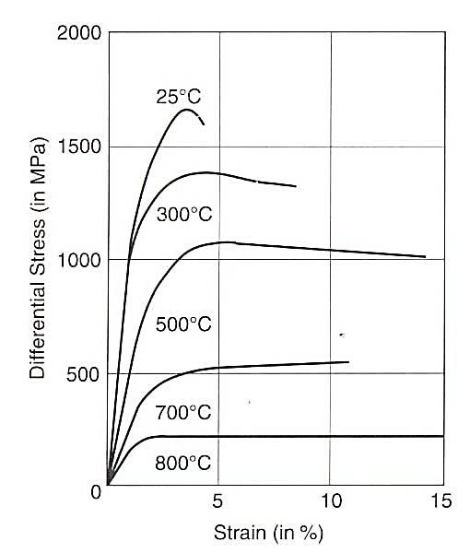
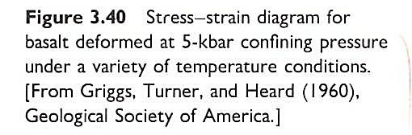

4. Strain Rate
Rock strength as measured in deformation experiments is partly a function of the rate at which the stress is applied. A rock can be forced to deform plastically at comparatively low levels of stress if the rate of loading is slow.
Heard (1963) helped to verify this principle quantitatively through deformational experiments in which conditions were identical in every way except for the rate of deformation (Figure 3.41).
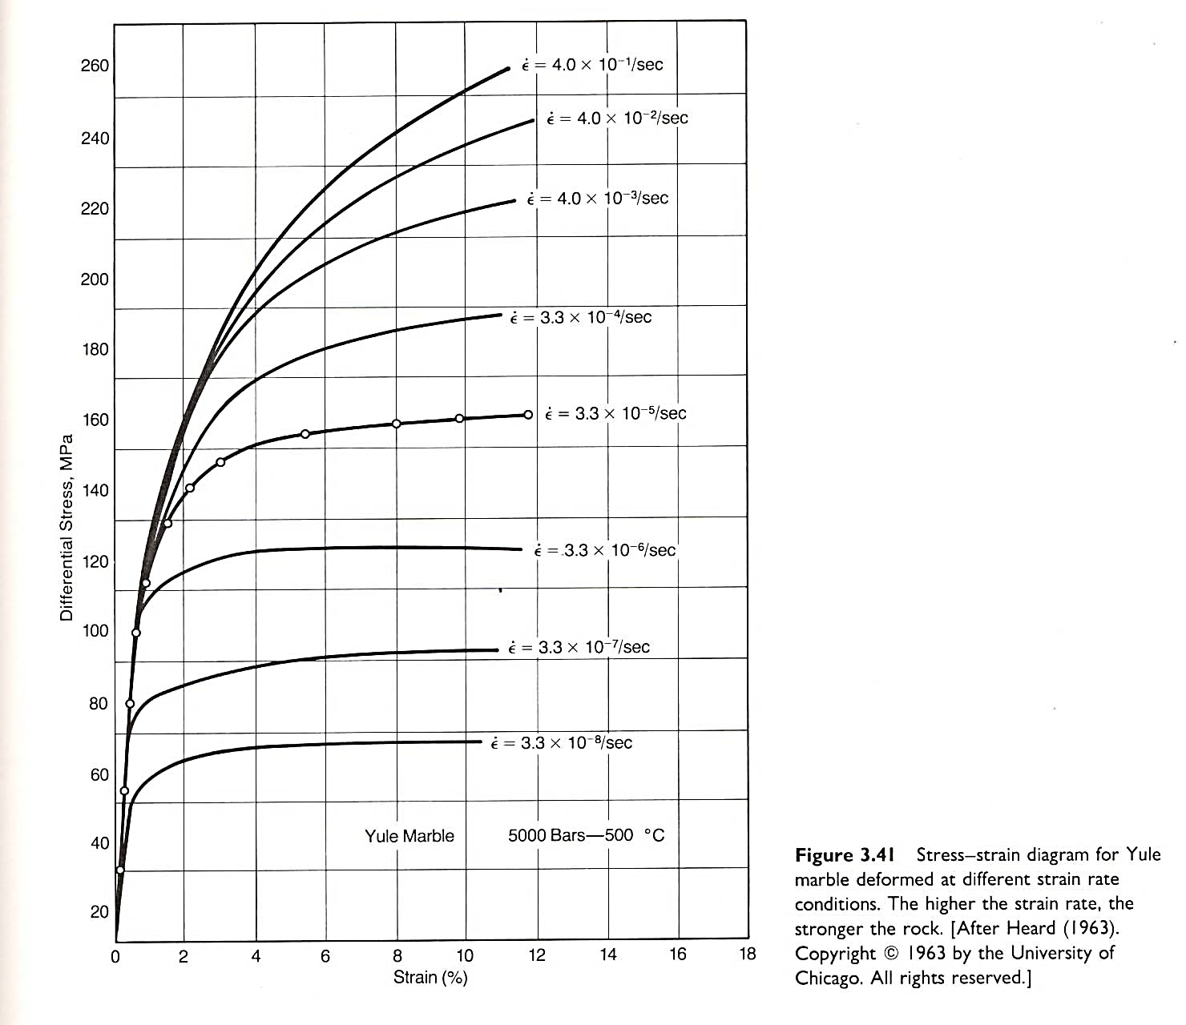
In testing the influence of "time" on rock strength, we can compare values of yield strength, ultimate strength, and rupture strength as a function of the rate of loading.
But normal practice is to carry out a constant strain test, wherein the rate of strain is held constant.
When the strain rate is relatively low, the amount of stress required to produce plastic deformation and ultimate failure is smaller than for experiments with higher strain rate.
5. Time:
Salt and ice behave like rheids, but what about "real rocks"? Marble is a real rock, one we usually think of as rigid. Yet look at the marble bench in Figure 3.46. It is behaving like a rheid after times that are short even by human standards.
One key factor that researchers are unable to duplicate in the laboratory is how rocks respond to small stresses applied gradually over long spans of geologic time.
However, insights into the effects of time on deformation are provided in everyday settings. For example, marble benches have been known to sag under their own weight over a span of 100 years or so.
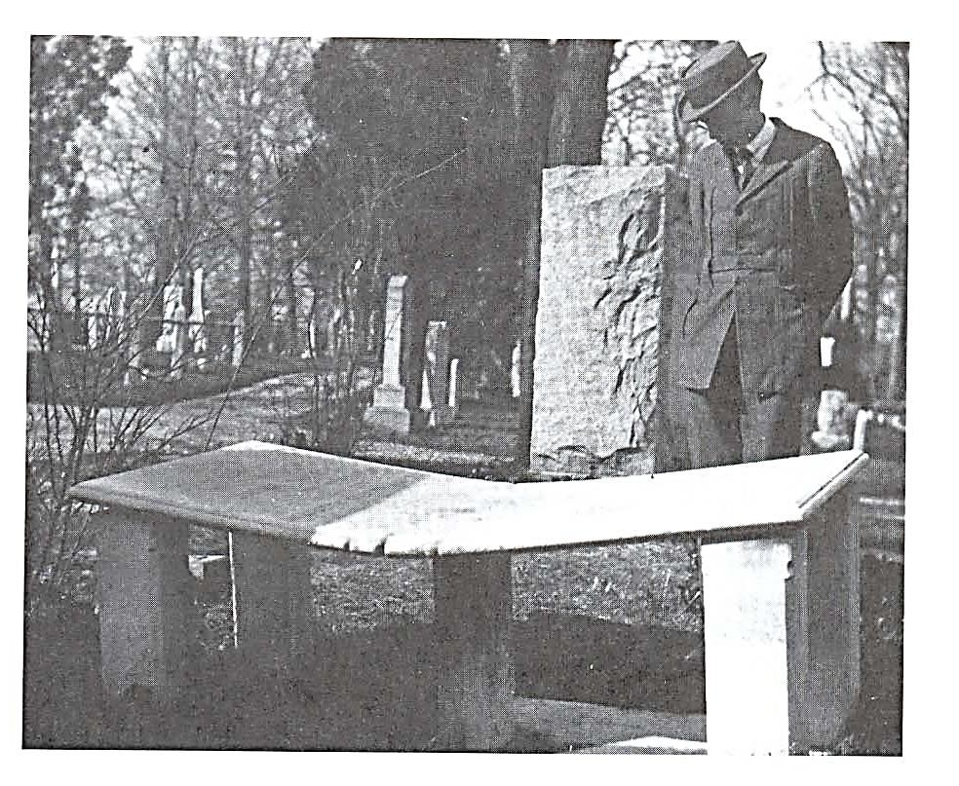
Figure 3.46. Marble bench bent downward by its own weight and that of the occasional occupant. The marble rheid is located is located in cemetery north of Soldier’s Home, Washington, D.C.
(Photograph taken in 1925 by W.T. Lee. Courtesy of United States Geological Survey)
In general, when tectonic forces are applied slowly over long time spans, rocks tend to display ductile behavior and deform by flowing and folding.
These same rocks may fracture if the stress increases suddenly. As a consequence, folding and faulting may occur simultaneously in the same rock body.

6. Preexisting Weaknesses
In preparing samples for rock deformation experiments, structural geologists are normally meticulous about using pristine, fresh rocks that have no visible cracks or other flaws. It is thought that the presence of a crack or fracture will ruin the experiment.
And yet we know that outcrop-scale bodies of rock, and regional-scale bodies of rock, are absolutely pervaded by flaws, at all scales: from spaced, through-going faults, fractures, and bedding surfaces; to pervasive joints and veins and stylolites; to webs of microscopic hairline cracks and voids.
Larger bodies of rocks are weaker than smaller bodies of rock, in part because of preexisting internal flaws and weaknesses.
The influence of the presence of such weaknesses will be greater when the conditions of deformation are fundamentally brittle. When the conditions are ductile, the influence of individual preexisting weaknesses like fractures and faults and bedding surfaces will not be as great.
Thank you
Rheology

Rheology
Rheology is the science of flow and deformation of matter under controlled testing conditions .
Flow is a special case of deformation.
Deformation is a special case of flow.
Rheology: The study of deformation and flow of matter at specified conditions. Range of material behaviour:
Solid Like --------- Liquid Like
(Ideal Solid ------------- Ideal Fluid)
Classical Extremes
Rheology is the study of the flow of matter, primarily in the liquid state, but also as 'soft solids' or solids under conditions in which they respond with plastic flow rather than deforming elastically in response to an applied force.
In practice, rheology is principally concerned with extending continuum mechanics to characterize flow of materials, that exhibits a combination of elastic, viscous and plastic behavior by properly combining elasticity and
(Newtonian) fluid mechanics.

Measuring shortening
Shortening of the core of the rock at any stage of an experiment can be described in terms of its extension (e) or stretch (S). Suppose that original specimen length was 2.3 cm and shortening was merely 0.02 cm:
e = Δl = - 0.02 cm = - 0.0087

l_{o} 2.3 cm

= 0.87 % shortening
S = l_{f} 2.28 cm = 0.99
l_{o} 2.30 cm
Notice that “centimeters” cancel out, and both extension (e) and stretch (S) are unit less.

Measuring Strain Rate
The rate at which a rock is shortened or stretched has a very important bearing on how it deforms. Thus we keep track of strain rate έ during deformational experiments. Strain rate is determined by dividing extension (e) by time (t).
Strain rate = έ = e/t
Strain rate is calibrated in units of reciprocal seconds (s⁻¹). For example, a strain rate of 10⁻⁵ s⁻¹ means that the amount of extension per second is 0.00001.
Describing strain rate in these units (s⁻¹) gives the impression, at first, that something is missing, but this is only because extension (e) is unit less.

Standard axial compression test
Load-displacement curve
Differential stress σ_{d} = σ₁ – σ₃
% strain = (% shortening) = = Δl l_{o} X 100
Elastic deformation Plastic deformation
Elastic limit: the point of departure from elastic behavior to plastic behavior. Its value known as yield strength is measured in stress.

Strength and ductility
The mechanical response of rocks to stress is different for different conditions.
- Lithology
- Confining pressure and pore fluid pressure
- Temperature
- Strain rate
- Time
- Preexisting weakness
- Size
Thank you

