FACULTY | SCIENCE
DEPARTMENT | GEOLOGY
SUBJECT | STRUCTURAL GEOLOGY I
SUBJECT CODE | GLY3712
PAPER | PAPER 2 PRACTICAL
DATE | OCTOBER 2018
DURATION | 180 min (3 hours) | MARKS | 100


REGULAR EXAMINATION
Examiner: Prof BS Mapani
Internal Moderator: Prof AF Kamona
This question paper consists of 4 pages (including this one)

Instructions
- Closed book examination
- Answer any five (5) questions
- Read questions carefully
- Start each question on a separate page
- Appropriate sketches will receive credit.
Requirements
Requirements: Graph paper for question 1 and tracing paper for questions 2

UNIVERSITY OF NAMIBIA EXAMINATIONS
- Study the Map given below in figure 1(after Bolton, Map 13). The unshaded units are mudstones.
- Draw a cross-section from A to B using the given profile. [40]
- Draw a stratigraphic column for the area. [5]
- Write the geological history of the area beginning with sedimentation of the oldest rocks. [15]

- In the Twyfelfontein area of Namibia, the Damaran sequence of turbidites and carbonates is overlain by the Permian Verbrandeburg Formation of Burnt Mountain. The Damaran carbonates have a sub-horizontal folded foliation, with fold axes plunging at 20° towards 340° and the steeper limb is oriented 018° dipping at 30° towards the west. The western limb has turbidites with preserved ripples that plunge 02° towards 120°. The other limb is known to have a strike of 300°. The Verbrandeburg Formation has been found to have an attitude of 030°, 20°W, and ripple marks in the sandstone horizons within the formation are oriented at 12° towards 258°.
  - Deduce the orientation of the foliation in the folded Damaran Carbonates, and orientation of both limbs during the deposition of the sandstone horizons within the Verbrandeburg formation. [20]
  - If the Damaran sequence were to be un-plunged, and unfolded, to simulate conditions around 900 million years, deduce the current direction that deposited the sandstone rich layers within the turbidites. [10]
  - Give an account of the Geological history in the area, with respective deformation events that happened. [10]

END OF EXAMINATION

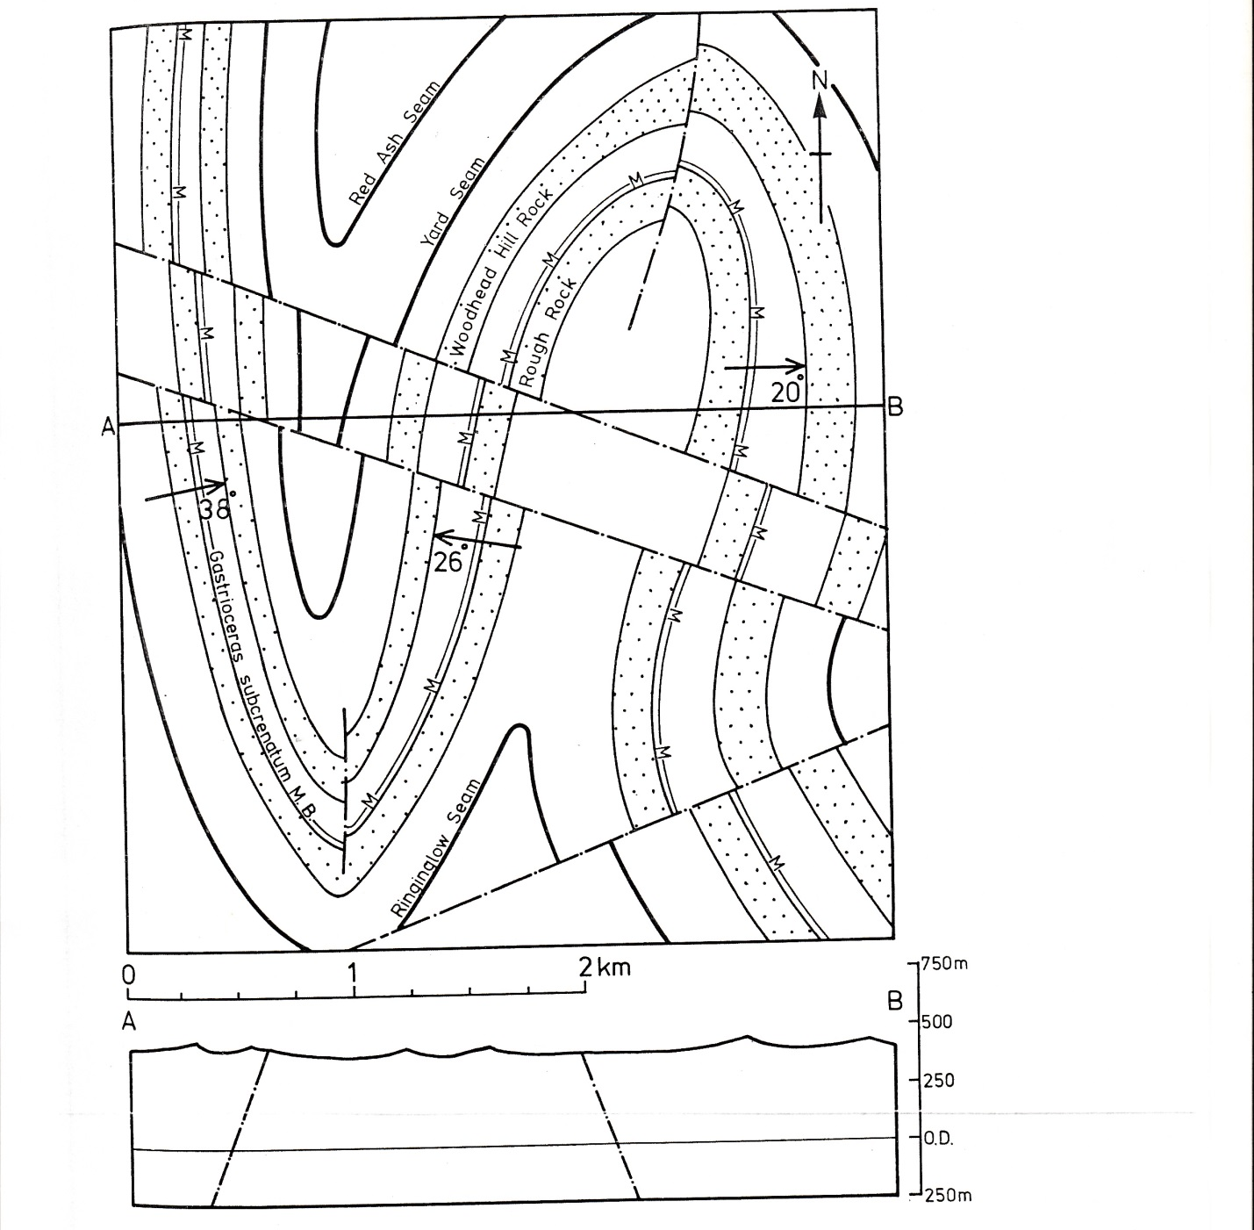
Figure 1, for question 1.

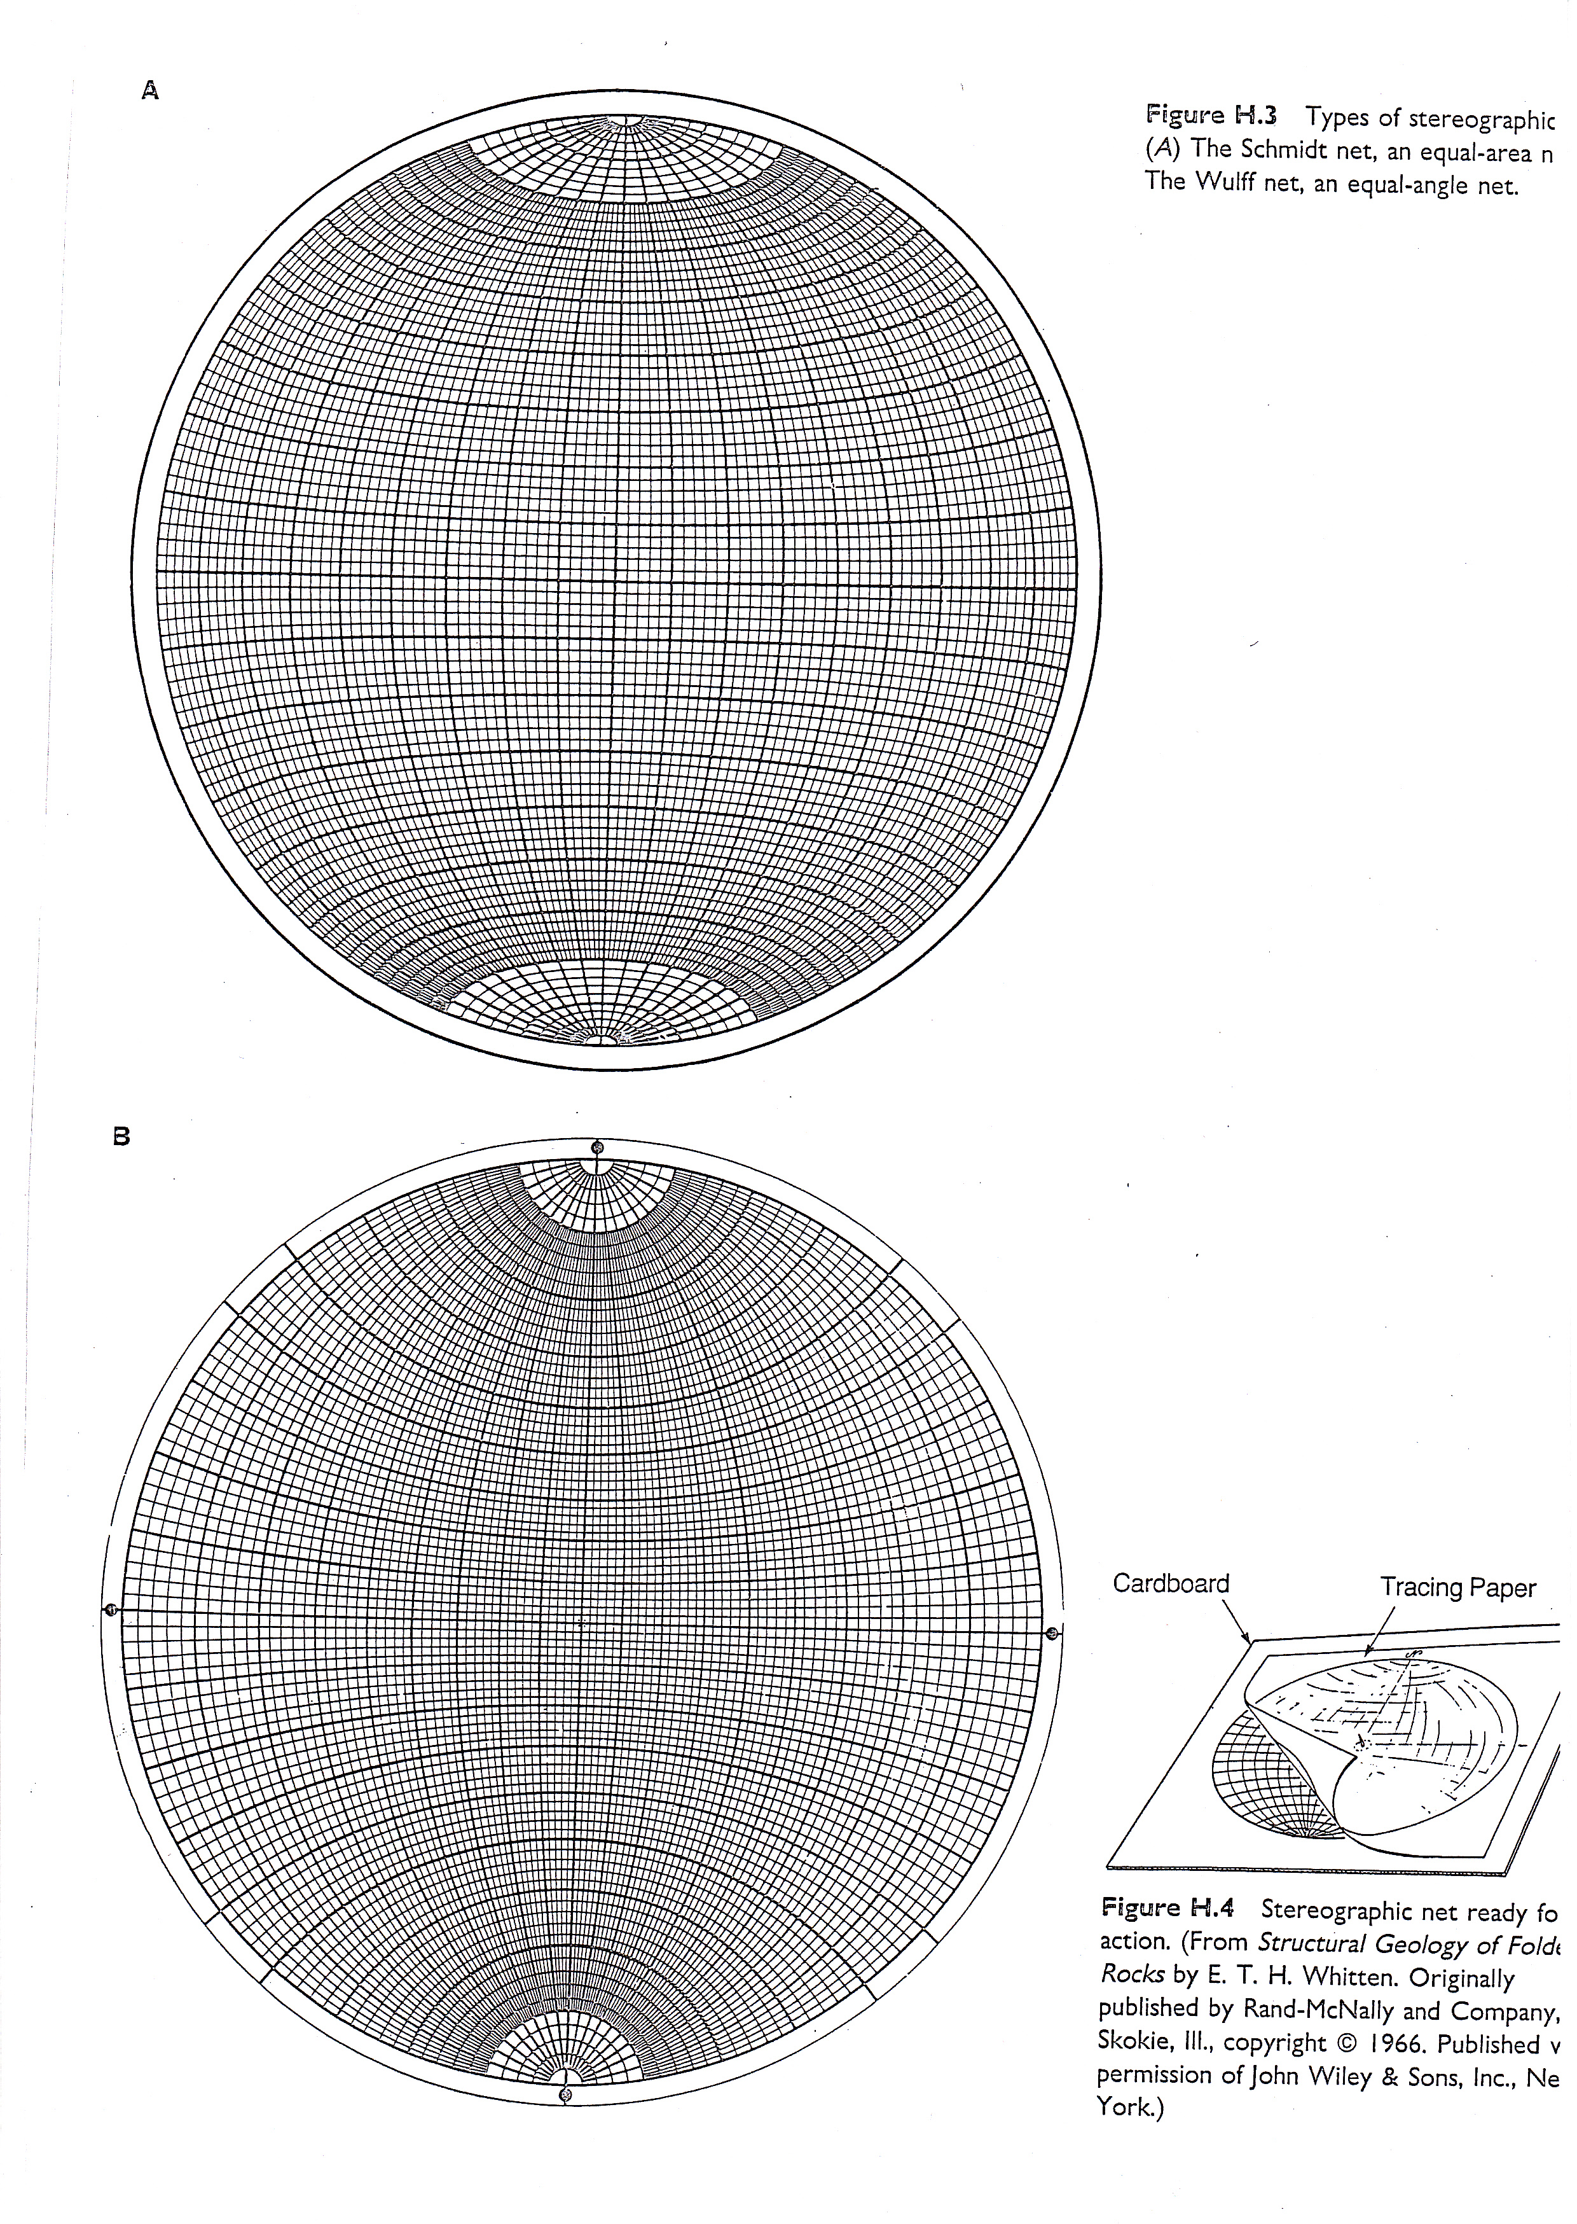
END OF THE EXAM

