FACULTY | SCIENCE
DEPARTMENT | GEOLOGY
SUBJECT | STRUCTURAL GEOLOGY I
SUBJECT CODE | GLY3712
PAPER | PAPER 2 -PRACTICAL
DATE | OCTOBER 2018
DURATION | 180 min (3 hours) | MARKS | 100


MODEL ANSWERS
SUPPLEMENTARY EXAMINATION
Examiner: Prof BS Mapani
Internal Moderator: Prof AF Kamona
This question paper consists of 5 pages (including this one)

Instructions
- Closed book examination
- Answer all questions
- Read questions carefully
- Start each question on a separate page
- Appropriate sketches will receive credit.
Requirements
Requirements: Graph paper for question 1 and tracing paper for questions 2

UNIVERSITY OF NAMIBIA EXAMINATIONS

1. Study the given map below, in figure 1 and answer the following questions:
  - Draw strike lines to determine the dip, strike and thickness of the rocks. Write the attitude of the beds. (5)
  - Draw a cross-section from the NW corner of the map to the SE corner of the map. (20)
  - Draw a stratigraphic succession of the rocks, starting with the oldest at the bottom and the youngest at the top. (5)
  - Write the geological and structural history of the area, beginning with the oldest rocks. (10)

Solution:
Given at the end of the paper

- Mr Ilonga Nawa, a geologist working for a gold exploration company made the following measurements in the younger Oshikandela Formation that had a lithology of sandstone. These younger rocks dip at 30° to 270° (000°, 30° W), and contain ripple marks oriented 14° towards 206°. The older folded and deformed Omaere Group lies below the unconformity, and possesses gold bearing quartz veins, that are axial planar to the folds. The veins are vertical, and the fold axis of the folded Omaere Group is oriented at 25° towards 290°. One limb of the Omaere Group, is oriented at 312°, 50°E and contains flute marks oriented 36° towards 171°. If the east dipping limb of the Omaere Group has the same dip as the west dipping limb, find:
  - The attitude of the east dipping limb (4)
  - The direction of the current that was responsible for the deposition of the Oshikandela formation (8)
  - The attitude of the fold axis, axial plane, east and west dipping limbs during the deposition of the Oshikandela formation (8)
  - The orientation of the flute marks and hence the current direction responsible for the deposition of the Omaere Group (20)

Solution
- First draw a great circle of the unit above the unconformity. Plot a pole to these rocks. Then plot the fold axis as given using the single limb and orientation of the west dipping limb. Then draw in the corresponding limb with the same dip
- Mark the orientation of the ripple marks, then rotate the oshikandela to horizontal, read the number, then add or subtract 90°
- Read off the fold axis. Axial plane =orientation of quartz veins; read off west and east dipping limbs
- First rotate the fold axis to horizontal(unplunge); then unfold; then take the plane to horizontal; read off the flute makrs and current direction

Q1. Solution
We have a refolded fold in the area. We should have crenulation cleavage.
L1 appears to have been down dip lineations of F1. They are parallel to F2
F1 plunges towards NE and SW

Solution to Question 1.
- Draw strike lines in a NNE-SSW direction
- Stratigraphic section starts with the oldest rock at the bottom, (as observed from your section) to the youngest at the top
Sandstone is at the botton, then mudstone, then shale, then limestone with an interbedded basalt, then fine sandstone with a chert band
3. Geological History- follow the stratigraphy that shows a platform sequence- sandstone, then mudstone due to quiet conditions or flooding, followed by shale as conditions remained more or less quiescent, finally carbonates. Carbonates were interrupted by a volcanic event of basalt. Finally sandstone again meaning incrasing energy that quietened as chert was deposited, then sandstone again.

Student Number:…………………………..
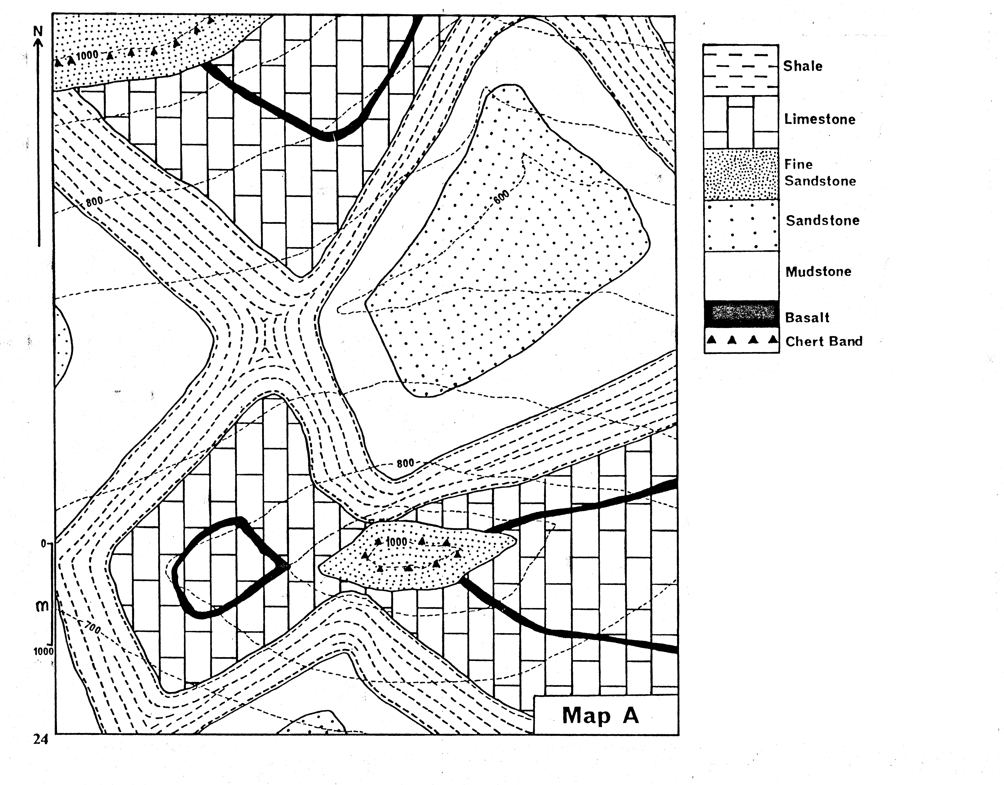
Figure 1. Must be handed in with your answers.
Solution: The strike lines must be in a NNE-SSW direction
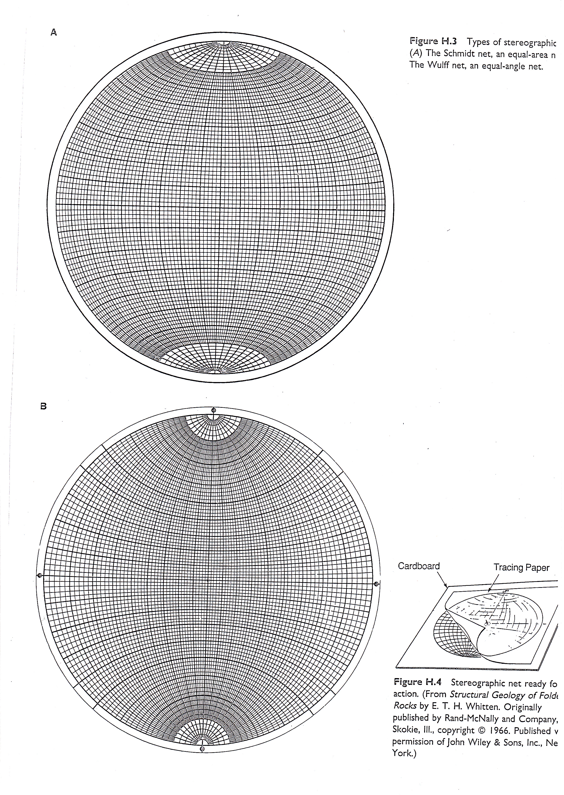
END OF THE EXAM

