FACULTY | SCIENCE
DEPARTMENT | GEOLOGY
SUBJECT | STRUCTURAL GEOLOGY I
SUBJECT CODE | GLY3712
PAPER | PAPER 1 THEORY
DATE | OCTOBER 2018
DURATION | 180 min (3 hours) | MARKS | 100


SUPPLEMENTARY EXAMINATION
Examiner: Prof BS Mapani
Internal Moderator: Prof AF Kamona

This question paper consists of 3 pages (including this one)

Instructions
- Closed book examination
- Answer any four (4) questions
- Read questions carefully
- Start each question on a separate page
- Appropriate sketches will receive credit.

UNIVERSITY OF NAMIBIA EXAMINATIONS
- (i) Discuss the concepts of simple shear and pure shear with respect to the production of folds. State the cardinal points of simple shear, as opposed to pure shear? [10]
(ii) Study the diagram below, and answer the questions that follow:
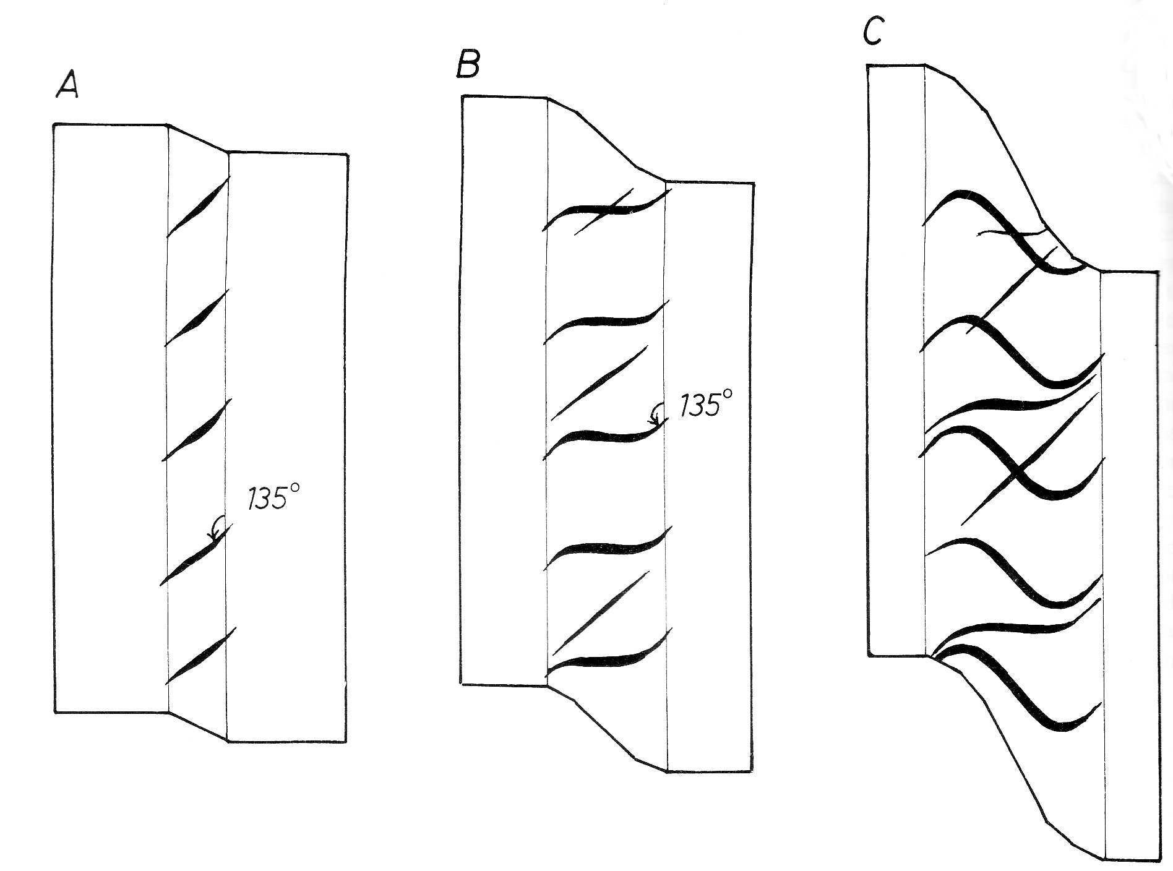
- what deformation process and mechanism has brought about the formation in the quartz veins observed in the diagram? Estimate the depth and nature of the confining pressures at the level at which they form. (5)
- Estimate the shear strain accommodated by the sheared rock. [5]
- Comment why they are three vein sets in the deformed rock. [5]

- Discuss how strain varies with:
- Temperature. [9]
- Confining pressure. [9]
- Strain rate. [7]

- Discuss the conditions required for grain aggregates to deform under superplastic creep. [25]

- The Okanjato area zone has experienced four deformation episodes, D1-D4. D2 is characterised by refolded folds, whose F2 axes plunge to the NE at 30° and F1 folds plunge to the NW and SE at 40°. D3 is a crenulation cleavage forming event, with hinge lines of microfolds that are parallel to the F1 folds. D4 is a faulting event.

- What was the nature of D1? [5]
- What is the orientation of the crenulation lineations? [5]
- If down dip lineations had developed during F1, what is the orientation of L1 after the D2 episode? [10]
- Deduce the orientation of the principal stresses, σ1, σ2 and σ3 during D2 and D3. [5]

- Discuss the generalised stratigraphy of the Archean. Your discussion must take into account important events that can be observed in the rock history. [25]

END OF THE EXAM

