FACULTY | SCIENCE
DEPARTMENT | GEOLOGY
SUBJECT | STRUCTURAL GEOLOGY I
SUBJECT CODE | GLY3712
PAPER | PAPER 1
DATE | OCTOBER 2018
DURATION | 180 min (3 hours) | MARKS | 100


MODEL ANSWERS
SUPPLEMENTARY EXAMINATION
Examiner: Prof BS Mapani
Internal Moderator: Prof AF Kamona

This question paper consists of 5 pages (including this one)

Instructions
- Closed book examination
- Answer any five (5) questions
- Read questions carefully
- Start each question on a separate page
- Appropriate sketches will receive credit.

UNIVERSITY OF NAMIBIA EXAMINATIONS
- (i) Discuss the concepts of simple shear and pure shear with respect to the production of folds. State the cardinal points of simple shear, as opposed to pure shear? (10)
(ii) Study the diagram below, and answer the questions that follow:
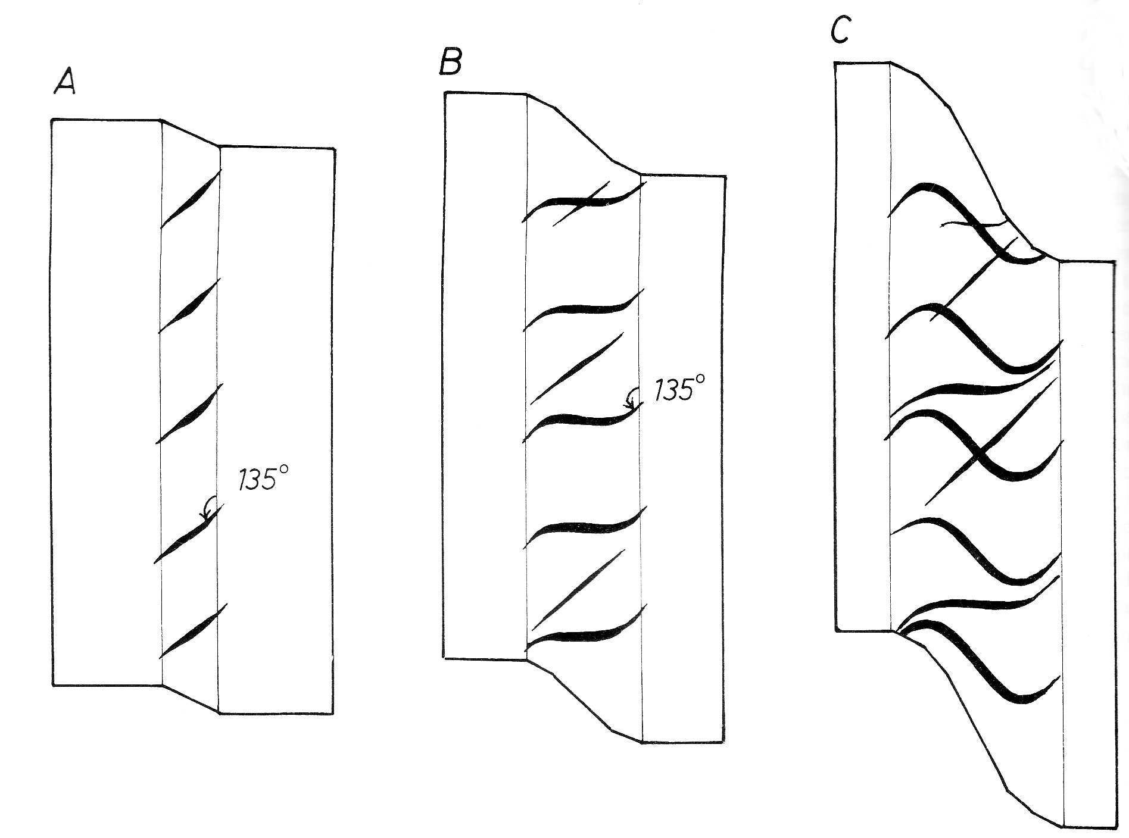
- what deformation process and mechanism has brought about the formation in the quartz veins observed in the diagram? Estimate the depth and nature of the confining pressures at the level at which they form. (5)
- Estimate the shear strain accommodated by the sheared rock. (2.5)
- Comment why they are three vein sets in the deformed rock. (2.5)
Solutions:
- First, simple shear must be contrasted with pure shear. In simple shear there is generated an angular shear as deformation proceeds. The shear strain incurred is much higher along the x-axis than on the y axis, except at extremely high shear strains where the difference becomes minimal. Simple shear is a non-coaxial deformation, as opposed to pure shear which is coaxial. The shear strain in pure shear is much higher on the y-axis as compared to the x-axis in an ordinate system. (10)
(a) Veins occur at 135 in the brittle ductile regime, the deformation mechanism at these depths is a combination of fracture and cataclasis and dislocation creep to grain boundary diffusion. (5)
(b) Shear strain is gamma, which can be calculated from the angle given, i.e., tan 135 = gamma; tan 135 is negative, therefore we obtain 135-90=45. Tan 45=1. Therefore the shear strain, gamma =1 (2.5)
(c) Three separate deformation events occurred. (2.5)

- Discuss how strain varies with:
- Temperature. [10]
- Confining pressure. [8]
- Strain rate. [7]
Solution
- At high temperatures, rocks under go lower strains compared to deformation at lower temperatures.
- At lower confining pressures in the crust, the rocks under go higher strain values to incur a minimal deformation. At higher confining pressure we need less strains during deformation.
- Strain rates are highest at shallow levels in the crust and lowest in the deeper part of the crust. In general we need higher strain rates to deform the rock in a short time near the surface and lower strain rates at depth. However if we deform the rocks very slowly, we can achieve the same results but we need a much longer time to do it.

- This is constriction zone, we obtain lineated elongate and cylindrical structures such as folds, lineations
- Discuss the conditions required for grain aggregates to deform under superplastic creep.
Solution
Superplastic creep is a sub-deformation mechanism under grain boundary diffusion. It is favoured by small grain aggregates that allow diffusion paths to be shorter. Superplastic creep occurs when grains begin to slide as they are being deformed, as diffusion of molecules, species, components and atoms from grain boundaries into lattice structure is accelerated. This happens at relatively higher strain rates than grain boundary diffusion at moderate temperatures and intermediate differential stresses.

- The Muwelewele area zone has experienced four deformation episodes, D1-D4. D2 is characterised by refolded folds, whose F2 axes plunge to the NE at 30° and F1 folds plunge to the NW and SE at 40°. D3 is a crenulation cleavage forming event, with hinge lines of microfolds that are parallel to the F1 folds. D4 is a faulting event.

- What was the nature of D1? [5]
- What is the orientation of the crenulation lineations? [5]
- If down dip lineations had developed during F1, what is the orientation of L1 after the D2 episode? [10]
- Deduce the orientation of the principal stresses, σ1, σ2 and σ3 during D2 and D3.

Solution
- D1 was a folding episode of So to produce S1
- L1 is oriented NW at a 40° plunge and SE at a 40° plunge
- L1 is parallel to F2
- In D2: σ1= NW and SE at 40°, σ2= -30° to the SW and σ3= 60° to the SW
In D3 =σ1= SW and NE at 60°, σ2= parallel to F1; and σ3= more or less vertical at 60° to the NW

- Discuss the generalised stratigraphy of the Archean. Your discussion must take into account important events that can be observed in the rock history. [25]

Solution
The Archaen was dominated by basic volcanism, which dominated; followed by intermediate volcanism and finally minor felsic volcanism. The volcanic rocks were later intruded, first by TTGs (tonalitite-trondjemite- Granitoids); reflecting the minor subduction and rifting that occurred. Above these igneous rocks, occurred minor sedimentary rocks. These rocks increased in the mid Archean (sediments) from the erosion of volcanic and plutonic rocks. Thus the presence of volcanosedimentary units dominates the sedimentary sequence. The oceans had carbonate rocks that accumulated when the oceans evolved. Towards the end of the Archaen, quartzites and BIFs increased, indicating a change of atmospheric conditions from an oxygen poor(nitrogen rich) to oxygen rich conditions that favoursed much more sedimentation in the Paleoproterozoic.

END OF THE EXAM

