UNIVERSITY OF NAMIBIA EXAMINATIONS

SOLUTIONS
EXAMINATION QUESTION PAPER

FACULTY | SCIENCE
DEPARTMENT | GEOLOGY
SUBJECT | STRUCTURAL GEOLOGY
SUBJECT CODE | GLY 3712
PAPER NUMBER | 2-PRACTICAL
DATE | OCTOBER-NOVEMBER 2018
DURATION | 3 HOURS
MARKS | 100
REQUIREMENTS | TRACING PAPER-A4 SIZE, STEREONETS AND GRAPH PAPER

REGULAR EXAMINATION

EXAMINER: PROF. B.S. MAPANI

INTERNAL MODERATORS: PROF. A.F. KAMONA (University of Namibia)

INSTRUCTIONS
- CLOSED BOOK EXAMINATION.
- READ QUESTIONS CAREFULLY.
- ANSWER ALL QUESTIONS.
- START EACH QUESTION ON A SEPARATE PAGE.
- TOTAL MARKS = 100.
- ALL MARKS ARE INDICATED IN BRACKETS.
- THIS QUESTION PAPER CONSISTS OF 3 PRINTED PAGES INCLUSIVE OF THE TITLE PAGE.

- Study the Map given below in figure 1(after Bolton, Map 13). The unshaded units are mudstones.
- Draw a cross-section from A to B using the given profile. [40]
- Draw a stratigraphic column for the area. [5]
- Write the geological history of the area beginning with sedimentation of the oldest rocks. [15]

SOLUTIONS:
Draw a section using strike lines or structural contours.
From the structural contours use their relative heights to come up with a section as shown below.
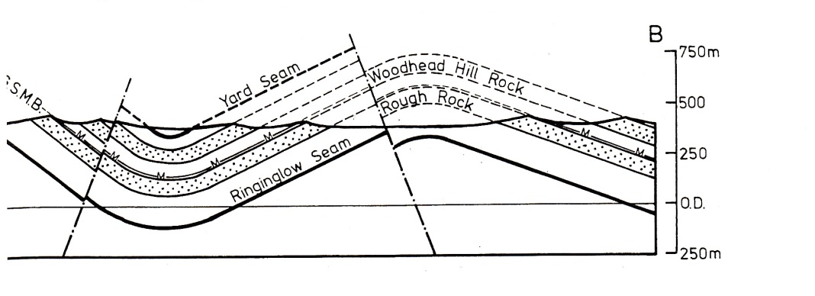
- In the Twyfelfontein area of Namibia, the Damaran sequence of turbidites and carbonates is overlain by the Permian Verbrandeburg Formation of Burnt Mountain. The Damaran carbonates have a sub-horizontal folded foliation, with fold axes plunging at 20° towards 340° and the steeper limb is oriented 018° dipping at 30° towards the west. The western limb has turbidites with preserved ripples that plunge 02° towards 120°. The other limb is known to have a strike of 300°. The Verbrandeburg Formation has been found to have an attitude of 030°, 20°W, and ripple marks in the sandstone horizons within the formation are oriented at 12° towards 258°.
  - Deduce the orientation of the foliation in the folded Damaran Carbonates, and orientation of both limbs during the deposition of the sandstone horizons within the Verbrandeburg formation. [10]
Plot all the structures on the stereonet, and poles for all planar features, ensuring that they are in the right positions.
Next rotate back the unconformity to horizontal, and all the structures will move in the same direction by the same amount of degrees.
Read out the new positions of the limbs using the poles and counting back 90 degrees.

  - If the Damaran sequence were to be un-plunged, and unfolded, to simulate conditions around 900 million years, deduce the current direction that deposited the sandstone rich layers within the turbidites. [10]
Since the Unconformity is now horizontal, the next task is to ensure that the two limbs go to horizontal. The first step is to unplunge the fold; so that the fold axis goes to horizontal.
Next rotate the limbs to horizontal and note where the ripple marks will rest.
Count 90 degrees away from the ripple mark direction as they are always perpendicular to the direction of current.
  - Give an account of the Geological history in the area, with respective deformation events that happened. [5]
Use the equal area net to rotate the unconformity. Review the rotation and go back to the original setting to check the orientation.
END OF EXAMINATION

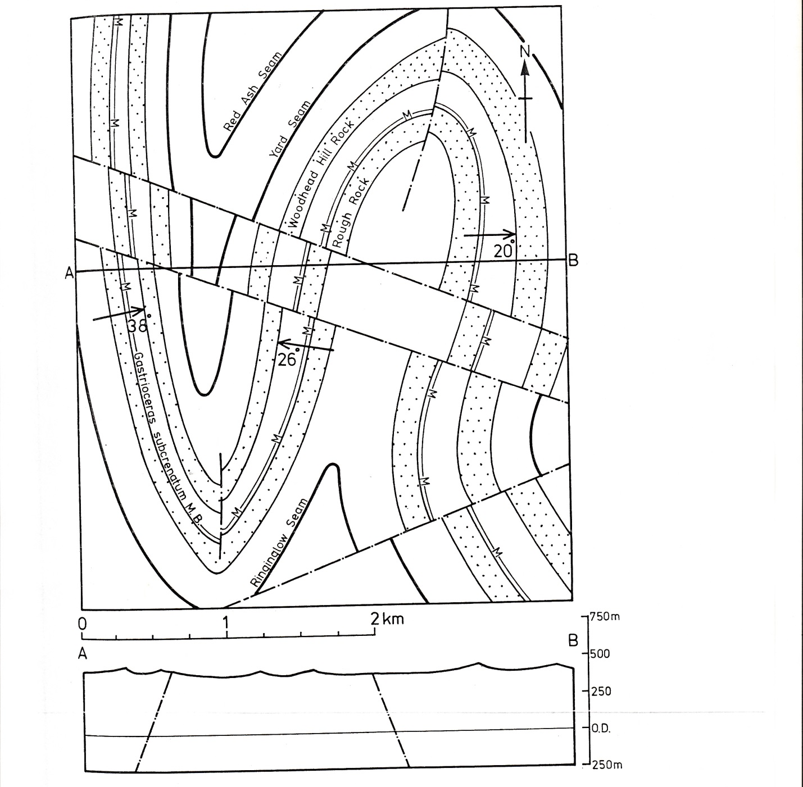
Figure 1, for question 1.
