
UNIVERSITY OF NAMIBIA EXAMINATIONS

EXAMINATION QUESTION PAPER
OCTOBER-NOVEMBER EXAMINATIONS 2017

FACULTY | SCIENCE
DEPARTMENT | GEOLOGY
SUBJECT | GLY 3712- STRUCTURAL GEOLOGY I -THEORY
SUBJECT CODE | GLY 3712-PAPER 1
DATE | NOVEMBER 2017
DURATION | 3 HOURS
MARKS | 100

EXAMINER: PROF. B.S. MAPANI

MODERATOR: Prof. A.F. KAMONA

INSTRUCTIONS
- CLOSED BOOK EXAMINATION
- READ QUESTIONS CAREFULLY
- ANSWER FIVE (5) QUESTIONS ONLY
- START EACH QUESTION ON A SEPARATE PAGE
- CALCULATORS ALLOWED AND A STEREONET

- The mylonites at Farm Nauzerus have been tested in a laboaratory and found to be quite strong. A differential stress of 700 MPa is required to fracture it when σ₁ is 750 MPa. The coefficient of friction at failure is 0.4123.
- Calculate the normal stress in the Bamba Zonke mylonites that induces failure. (10)
- What is the shear stress, at failure in the mylonites? (5)

- Calculate the cohesiveness of the mylonites and comment on its competence. (5)

- (i) Discuss the concepts of simple shear and pure shear with respect to the production of folds. State the cardinal points of simple shear, as opposed to pure shear? (10)
(ii) Study the diagram below, and answer the questions that follow:
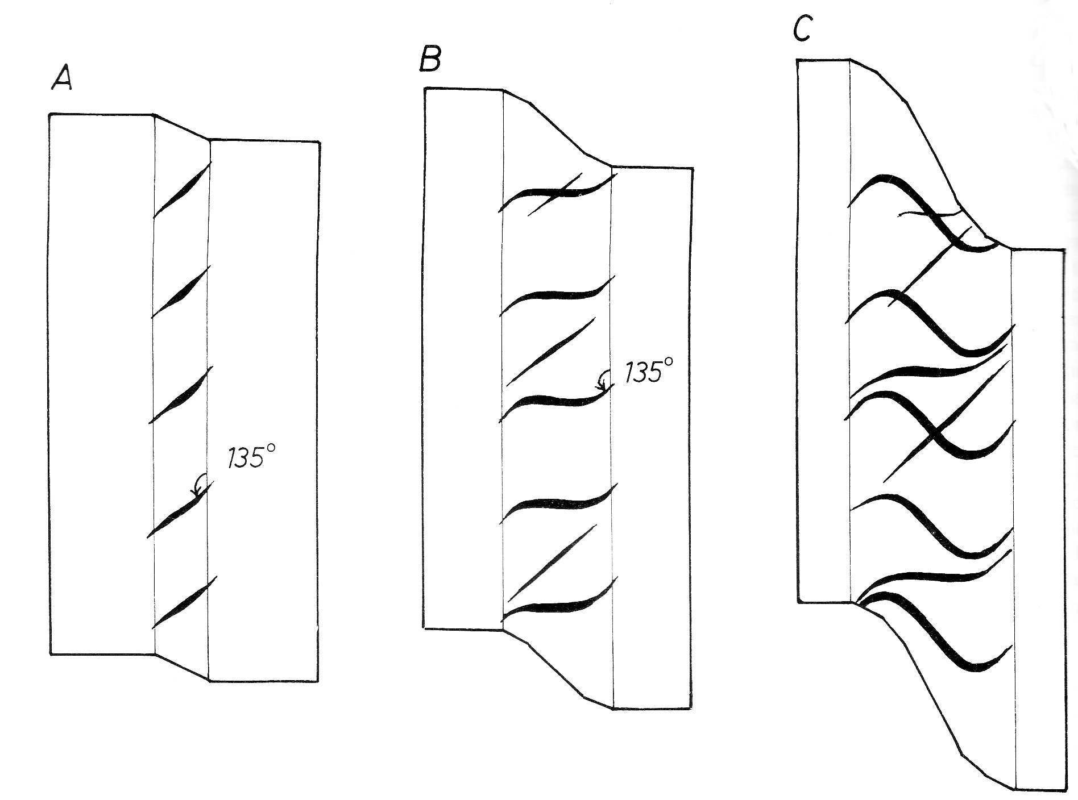
- What deformation process and mechanism has brought about the formation in the quartz veins observed in the diagram? Estimate the depth and nature of the confining pressures at the level at which they form. (5)
- Estimate the shear strain accommodated by the sheared rock. (2.5)
- Comment why there are three vein sets in the deformed rock. (2.5)

- Given that a deformed ooolite in the Ombombo carbonates in Opuwo has the form of an ellipse, with a long and short axis having been measured by one observant fourth year student for which he obtained the following averages long axis=1.8 cm, short axis =0.9 cm. He also carefully recorded the angle of bedding from which the oncoliths were displaced in several cores as follows: θ = 30°. Calculate the values of ψ, λ_{f} and γ in the Kombat carbonate units and comment on its strength. (20)
- Examine the diagram below, and answer the questions that follow:
A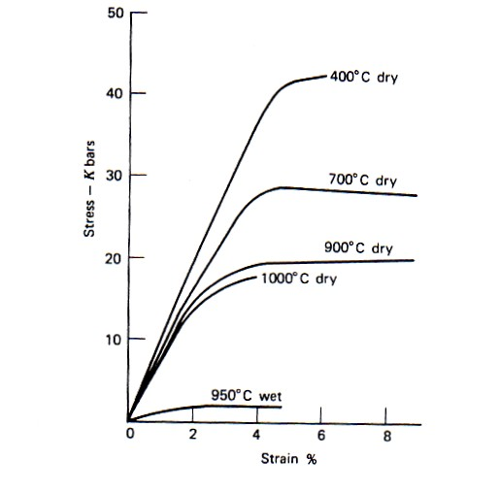 | B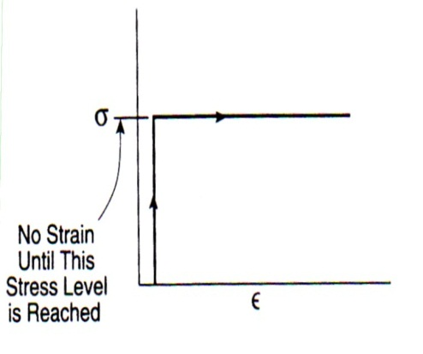

- What kind of rock behavior is being depicted in diagram A? Explain why the rock stressed at 1000°C supports a higher value of stress that the one at 950°C, even if the temperature is higher and must have a higher ductility. Why do rocks at higher temperatures, support less stress than those at lower temperatures? (14)
- Examine the diagram in B above. What type of response is depicted in this diagram? Why is the stress constant once it reaches the optimum point? (6)

5. A sandstone-shale-mudstone succession in the Kaoko belt is folded and deformed by two episodes, D₁ and D₂. D₁ produced F₁ folds that were plunging shallowly to the north, whereas F₂ folded the F₁ folds about E-W axes, and plunging to the east at about 30°.
(i) What is the orientation of the crenulation lineation formed during D₂ and in which units would they occur? (8)
(iii) What was the orientation of the cleavage formed in D₁, (S₁) if the folds (F₁) were not verging, before the onset of D₂? (5)
(iv) What would be the attitude of the down dip lineations formed during D₁ in the D₂ episode? (7)

6. (i) How does pore fluid pressure influence the strength of a rock. Draw a sketch with a Mohr circle and Mohr-Coulomb envelope. (12)
(ii) How can you get information about the existing stress fields by use of borehole data? (8)

END OF EXAM

