FACULTY | Science
DEPARTMENT | Geology
SUBJECT | Structural Geology I
SUBJECT CODE | GLY3712
PAPER | PAPER 1- THEORY
DATE | November 2016
DURATION | 180 min (3 hours) | MARKS | 90


UNIVERSITY OF NAMIBIA EXAMINATIONS
MODEL ANSWERS
SUPPLEMENTARY EXAMINATION
Examiner: Prof. BS Mapani
Moderator: Prof AF Kamona

This question paper consists of 3 pages (including this one)

Instructions
- Closed book examination
- Answer any four (4) questions. All questions carry equal marks
- Recommendation: read first all subordinate questions before you answer.
- Calculators and stereonets are allowed.

- A rock is under compression without failure in the first experiment; in the second it is under compression but fails. Given that the diameter of the Mohr circle is 2R, and the distance from the origin to the centre of the Mohr circle is C and that the angle between σ1 and the plane is θ;
- Derive the expression for the value of the normal stress in both the first and second experiments in terms of R, C and θ ( do not use σ1 and σ3). [8]
- Derive the expression for the shear stress in terms of R, C and θ. [5]
- If we are to introduce fluid pressure, Pf in your expression in (i); write down the expression in terms of R, C, θ and Pf. [12]

Solution
- σ_{n} = C + R Cos 2θ and σn = C -R Cos 2θ
- τ = R Sin 2θ
- σ_{n} = C + 0.5 {(C+R-Pf)-(C-R-Pf)} Cos 2θ and σ_{n} = C - 0.5 {(C+R-Pf)-(C-R-Pf)} Cos 2θ
- Mr Kapenasha Omapulo with his colleague Mr Omaere Ashikandela performed strain analyses on some deformed Gammsberg granites. Their results are summarized as follows: Semi-major axis was 1.87, and the Semi-minor axis was 0.85. Lines were estimated to have moved about 25° in a clockwise manner from the undeformed to the deformed state. Find the combined quadratic elongation (λf), the corresponding shear strain (γ) and the angular strain (ψ). [20]
From your value of strain in (a) Suggest what kind of structures are likely to be present in this area? [5]

Solution
S1 =1.87; S3 = 0.85;
S1* S1 = 3.4969 = λ1 and similarly S3* S3 = 0.7225 =λ3
Therefore 1/λf = 0.5{(3.4969+0.7225)/(0.7225*3.4969)}- 0.5{(3.4969-0.7225)/(0.7225*3.4969)}Cos 50° =0.48207
λf =2.07438
γ/λ = 0.5{(3.4969-0.7225)/(0.7225*3.4969)}Sin 50° = 0.4206
Therefore γ = 0.8725;
ψ = tan⁻γ = 41.1°

- Discuss how strain varies with:
- Temperature. [10]
- Confining pressure. [8]
- Strain rate. [7]
Solution
- At high temperatures, rocks under go lower strains compared to deformation at lower temperatures.
- At lower confining pressures in the crust, the rocks under go higher strain values to incur a minimal deformation. At higher confining pressure we need less strains during deformation.
- Strain rates are highest at shallow levels in the crust and lowest in the deeper part of the crust. In general we need higher strain rates to deform the rock in a short time near the surface and lower strain rates at depth. However if we deform the rocks very slowly, we can achieve the same results but we need a much longer time to do it.

- Examine the diagram given below in figure 1 and answer the following questions;
- What type of deformation and strain is experienced between A and C? [5]
- Discuss the type of strain experienced between D and E. [10]
- Plot a graph of stress versus strain rate and strain versus time for the portion of the graphs between C and D and D and E. [10]
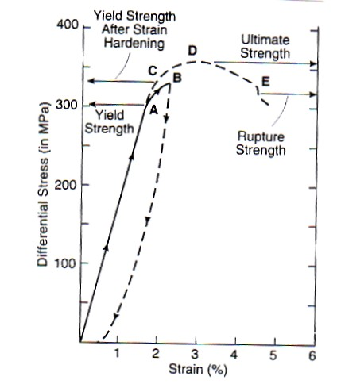
Figure 1- for question 3.
Solution:
- Permanent plastic strain from strain hardening to ultimate strength.
- D to E is accelerated strain, also known as tertiary strain.

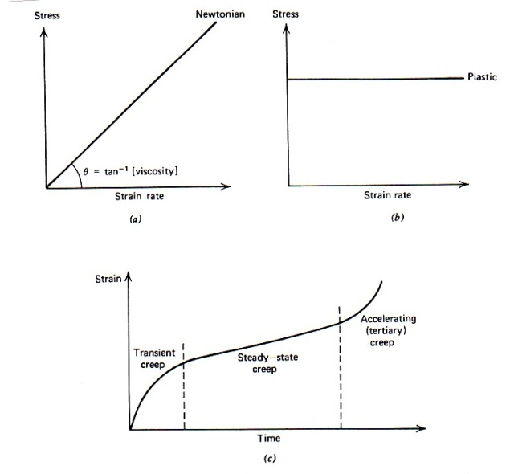
- No stress vs strain rate curves for elastic strain and accelerated strain

- Compare and contrast Grain boundary diffusion creep and Diffusive mass transfer deformation mechanism. [25]

Solution
Grain boundary diffusion (GBD) occurs at intermediate differential stresses and medium temperatures. In diffusive mass transfer (DMT) the conditions of deformation occur at low temperatures and low differential stresses. GBD requires that material (atoms, ions and radicles) be transported between grain boundaries from regions of higher stresses to regions of low stresses. The presence of fluid is not required during deformation. In DMT we require the presence of fluid in the rock. Material is dissolved at places of high stress and deposited at sites of low stress. The structures produced by GBD are normally serrated grain boundaries, mica fish, undulose extinction while DMT produces stylolites, beard structures, truncated fossil structures crystal embayments and accumulation of dark undissolved material.

- The Muwelewele area zone has experienced four deformation episodes, D1-D4. D2 is characterised by refolded folds, whose F2 axes plunge to the NE at 30° and F1 folds plunge to the NW and SE at 40°. D3 is a crenulation cleavage forming event, with hinge lines of microfolds that are parallel to the F1 folds. D4 is a faulting event.

- What was the nature of D1? [5]
- What is the orientation of the crenulation lineations? [5]
- If down dip lineations had developed during F1, what is the orientation of L1 after the D2 episode? [10]
- Deduce the orientation of the principal stresses, σ1, σ2 and σ3 during D2 and D3.
Solution
- D1 was a folding episode of So to produce S1
- L1 is oriented NW at a 40° plunge and SE at a 40° plunge
- L1 is parallel to F2
- In D2: σ1= NW and SE at 40°, σ2= -30° to the SW and σ3= 60° to the SW
In D3 =σ1= SW and NE at 60°, σ2= parallel to F1; and σ3= more or less vertical at 60° to the NW

END OF EXAM

