FACULTY | Science
DEPARTMENT | Geology
SUBJECT | Structural Geology I
SUBJECT CODE | GLY3712
PAPER | PAPER 2 –PRACTICAL
DATE | November 2014
DURATION | 180 min (3 hours) | MARKS | 90


REGULAR EXAMINATION
Examiner: Prof. BS Mapani
Moderator: Prof AF Kamona
This question paper consists of 3 pages (including this one)

Instructions
- Closed book examination
- Answer all questions.
- Recommendation: read first all subordinate questions before you answer.
- Calculators, Computers with Processing Modflow and Excel necessary.

UNIVERSITY OF NAMIBIA EXAMINATIONS

- Given the Map below in Figure 1, study it carefully and answer the questions that follow.

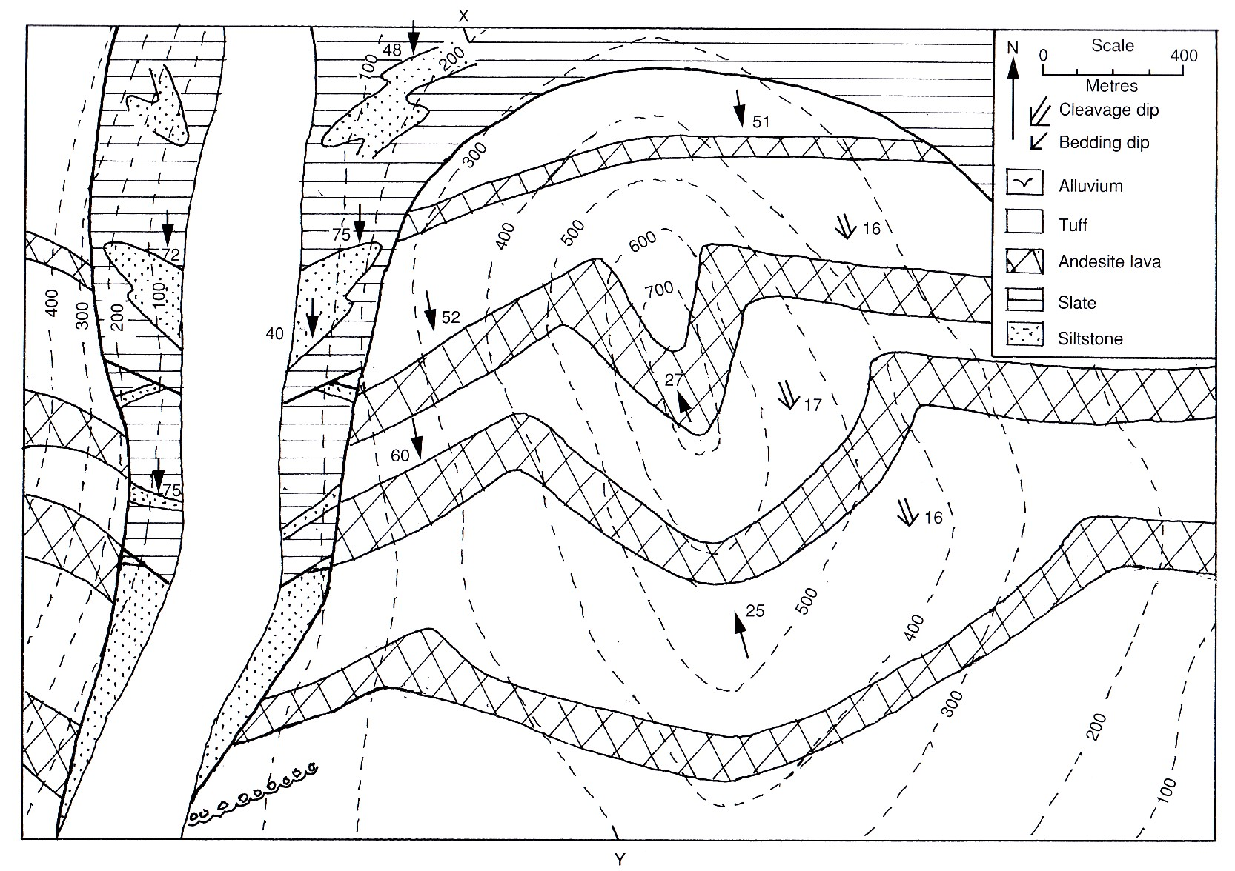

Figure 1.

- Draw a cross-section X-Y across the map (25)

- Plot all the structures present on a stereonet, and clearly separate the F₁ from the F₂ structures, including the unconformity (10)

- What is the attitude of the unconformity, F₁ and F₂ structures? (10)
- What was the orientation of the unconformity and F₁ folds before the F₂ folding? (20)

- Given that there are ripple marks that parallel the F1 fold in the lower sandstones beds, deduce the current direction that deposited the sandstones. (15)
- Write the geological history of the area, mentioning all the events that occurred. (20)
END OF EXAM

