FACULTY | Science
DEPARTMENT | Geology
SUBJECT | Structural Geology I
SUBJECT CODE | GLY3712
PAPER | PAPER 1- THEORY
DATE | November 2014
DURATION | 180 min (3 hours) | MARKS | 90


UNIVERSITY OF NAMIBIA EXAMINATIONS
REGULAR EXAMINATION
Examiner: Prof. BS Mapani
Moderator: Prof AF Kamona

This question paper consists of 3 pages (including this one)

Instructions
- Closed book examination
- Answer any four (4) questions. All questions carry equal marks
- Recommendation: read first all subordinate questions before you answer.
- Calculators and stereonets are allowed.

- A rock is under compression without failure in the first experiment; in the second it is under compression but fails. Given that the diameter of the Mohr circle is 2R, and the distance from the origin to the centre of the Mohr circle is C and that the angle between σ1 and the plane is θ;
- Derive the expression for the value of the normal stress in both the first and second experiments in terms of R, C and θ ( do not use σ1 and σ3). [8]
- Derive the expression for the shear stress in terms of R, C and θ. [5]
- If we are to introduce fluid pressure, Pf in your expression in (i); write down the expression in terms of R, C, θ and Pf. [12]

- Mr Kapenasha Omapulo with her colleague Ms Omaere Ashikandela performed strain analyses on some deformed Gammsberg granites. Their results are summarized as follows: Semi-major axis was 1.87, and the Semi-minor axis was 0.85. Lines were estimated to have moved about 25° in a clockwise manner from the undeformed to the deformed state. Find the combined quadratic elongation (λf), the corresponding shear strain (γ) and the angular strain (ψ). [20]
From your value of strain in (a) Suggest what kind of structures are likely to be present in this area? [5]

- Discuss how strain varies with:
- Temperature. [10]
- Confining pressure. [8]
- Strain rate. [7]

- Examine the diagram given below in figure 1 and answer the following questions;
- What type of deformation and strain is experienced between A and C? [5]
- Discuss the type of strain experienced between D and E. [10]
- Plot a graph of stress versus strain rate and strain versus time for the portion of the graphs between C and D and D and E. [10]
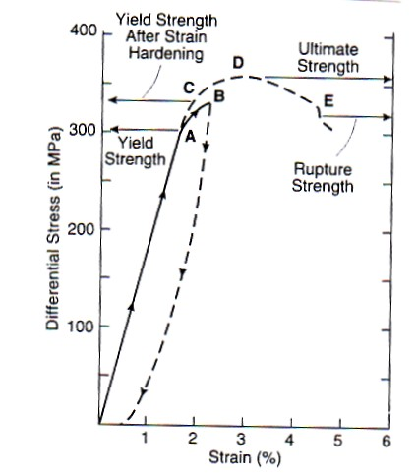
Figure 1- for question 3.

- Compare and contrast Grain boundary diffusion creep and Diffusive mass transfer deformation mechanism. [25]

- The Muwelewele area zone has experienced four deformation episodes, D1-D4. D2 is characterised by refolded folds, whose F2 axes plunge to the NE at 30° and F1 folds plunge to the NW and SE at 40°. D3 is a crenulation cleavage forming event, with hinge lines of microfolds that are parallel to the F1 folds. D4 is a faulting event.

- What was the nature of D1? [5]
- What is the orientation of the crenulation lineations? [5]
- If down dip lineations had developed during F1, what is the orientation of L1 after the D2 episode? [10]
- Deduce the orientation of the principal stresses, σ1, σ2 and σ3 during D2 and D3.

END OF EXAM

