FACULTY | Science
DEPARTMENT | Geology
SUBJECT | Structural Geology I
SUBJECT CODE | GLY3712
PAPER | PAPER 2 –PRACTICAL
DATE | November 2014
DURATION | 180 min (3 hours) | MARKS | 90


MODEL ANSWERS
SUPPLEMENTARY EXAMINATION
Examiner: Prof. BS Mapani
Moderator: Prof AF Kamona

This question paper consists of 3 pages (including this one)

Instructions
- Closed book examination
- Answer all three (3) questions.
- Recommendation: read first all subordinate questions before you answer.
- Calculators, graph paper and stereonets necessary.

UNIVERSITY OF NAMIBIA EXAMINATIONS

Study the map given in Figure 1 below. (b) Draw cross-section P-Q. Use the given legend (A, B, C, D) and cross-section to come up with a brief geological history of the area, beginning with the sedimentation. Hand in your map and write your student number on it

(60)

Solution

First draw strike lines across the whole map.

Then use the strike lines to construct the cross-section so that what lies underneath though not exposed can be seen.

The following data was obtained from the field by Mr. Ngeipi.

Dip-Dip direction of Foliation, S₁ | Dip-Dip direction of  Foliation, S₁ | Lineation, L₁
45, 045 | 40, 041 | 46, 320
29, 050 | 29, 045 | 38, 318
28, 048 | 32, 044 | 28, 138
30, 050 | 36, 042 | 28, 145
30, 240, | 39, 049
40, 244 | 38, 038
28, 238 | 35, 055
30, 242 | 27, 058
33, 246 | 31, 038
34, 248 | 29, 239
37, 230 | 30, 040
36, 233 | 40, 239

However, on his return, he was appointed to another department. As a new young geologist you have been requested to complete the structural analysis for Mr Ngeipi. Using the data above, what kind of structure is present in Mr Ngeipi’s field area? Discuss the significance of the L₁ in this area. [20]

Solution

Use your stereonet to plot the values of all the S1 foliation.

Then generate an average region through which you can estimate the regional dip or fold of the area.

Use the Lineations and fold axes to locate the regional fold in the area.

Obtain from the net, this average orientation.

The significance of the lineations is that they track regional fold axes and are parallel to the F1 axes.

3. Younger beds above an unconformity are oriented at 300°, 40° NE, whereas older beds below the unconformity are folded with one limb oriented at 045°, 30° NW and the other limb is 020°, 35° SE. The older turbidite beds preserve flute marks whose orientation is 30°→315°. What was the orientation of the older beds and the fold axis prior to the tilting of the unconformity? What was the current direction during the deposition of the older beds? [20]

Solution:

This requires you to rotate the structures.

First take the unconformity to horizontal; then unplunge and track the location of the flute marks on the other limb as you rotate them.

Flute marks must then be rotated to horizontal, and that is the paleodirection.

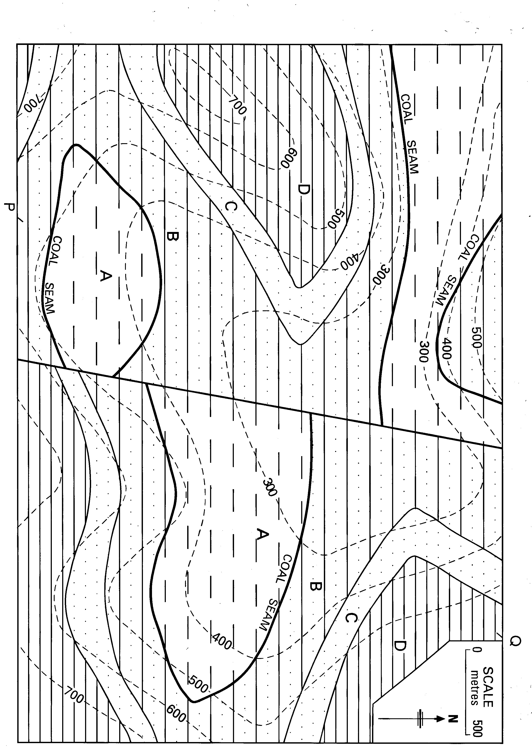
END OF EXAM

