FACULTY | Science
DEPARTMENT | Geology
SUBJECT | Structural Geology I
SUBJECT CODE | GLY3712
PAPER | PAPER 2 –PRACTICAL
DATE | November 2014
DURATION | 180 min (3 hours) | MARKS | 90


MODEL ANSWERS
REGULAR EXAMINATION
Examiner: Prof. BS Mapani
Moderator: Prof AF Kamona
This question paper consists of 3 pages (including this one)

Instructions
- Closed book examination
- Answer all questions.
- Recommendation: read first all subordinate questions before you answer.
- Calculators, Computers with Processing Modflow and Excel necessary.

UNIVERSITY OF NAMIBIA EXAMINATIONS

- Given the Map below in Figure 1, study it carefully and answer the questions that follow.

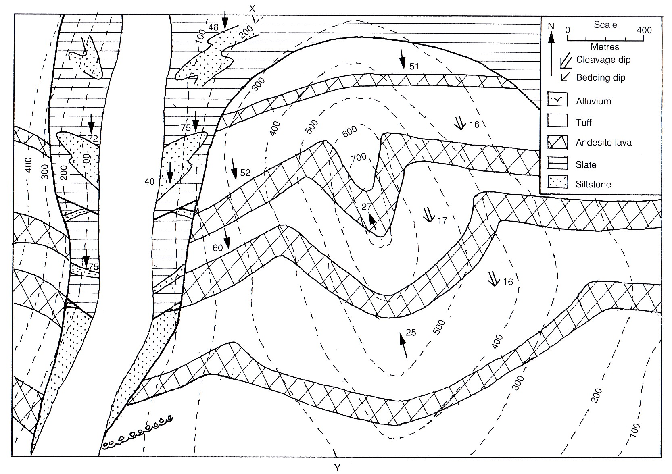

Figure 1.

- Draw a cross-section X-Y across the map (25)
In order to draw a cross-section first draw strike lines of the different lilthologies according to age.
The andesites have a different attitude from the sedimentary units.
The two types of strike lines should be used to draw the cross section on the map

- Plot all the structures present on a stereonet, and clearly separate the F₁ from the F₂ structures, including the unconformity (10)
The attitudes of the structures are already given on the map.
Plot the given plunge and use a protractor for the strike. The two types of structures should be plotted in two different symbols or colours. Steep structures and the shallow structures. Use your strike line to obtain a great circle of the regional fabrics.

- What is the attitude of the unconformity, F₁ and F₂ structures? (6)
You can get this from the map or from the stereonet. Read off the plane of the unconformity on the stereonet.F2= 27 towards 340; F1= 60 towards SW and SE
- What was the orientation of the unconformity and F₁ folds before the F₂ folding? (24)
This requires you to rotate the strata to original setting on a stereonet.
First, un-plunge the F2 folds, then track the movement of the F1 fold axis. The uncomfomity will move to horizontal.

- Given that there are ripple marks that parallel the F1 fold in the lower sandstones beds, deduce the current direction that deposited the sandstones. (20)
This is a continuation from the previous question. Unplunge the F1 fold, then rotate it to the horizontal. The fold axis tracks the ripple marks. Therefore the current direction is found 90 degrees away from where the fold axis rotated to horizontal intersect the horizontal surface.
- Write the geological history of the area, mentioning all the events that occurred. (15)
Geological history is as follows: 1. Deposition of siltstone; followed by shales. These shales and siltstones were deformed and folded; the shales became slates. 2. Volcanism, producing andesite and tuff. Then the volcaniclastics were deforme and folded mildly with the earlier strata , and eroded. Finally erosion to form alluvium
END OF EXAM

