UNIVERSITY OF NAMIBIA EXAMINATIONS

SOLUTIONS
EXAMINATION QUESTION PAPER
REGULAR EXAMINATIONS FOR 2015

FACULTY | SCIENCE
DEPARTMENT | GEOLOGY
SUBJECT | STRUCTURAL GEOLOGY
SUBJECT CODE | GLY 3712
PAPER NUMBER | 2-PRACTICAL
DATE | OCTOBER-NOVEMBER 2015
DURATION | 3 HOURS
MARKS | 100
REQUIREMENTS | TRACING PAPER-A4 SIZE, STEREONETS AND GRAPH PAPER

EXAMINER: PROF. B.S. MAPANI

INTERNAL MODERATORS: PROF. A.F. KAMONA (University of Namibia)

INSTRUCTIONS
- CLOSED BOOK EXAMINATION.
- READ QUESTIONS CAREFULLY.
- ANSWER ALL QUESTIONS.
- START EACH QUESTION ON A SEPARATE PAGE.
- TOTAL MARKS = 100.
- ALL MARKS ARE INDICATED IN BRACKETS.
- THIS QUESTION PAPER CONSISTS OF 3 PRINTED PAGES INCLUSIVE OF THE TITLE PAGE.

- Study the Map given below in figure 1(after Bolton, Map 13). The unshaded units are mudstones.
- Draw a cross-section from A to B using the given profile. [40]
- Draw a stratigraphic column for the area. [5]
- Write the geological history of the area beginning with sedimentation of the oldest rocks. [15]

SOLUTIONS:
Draw a section using strike lines or structural contours.
From the structural contours use their relative heights to come up with a section as shown below.
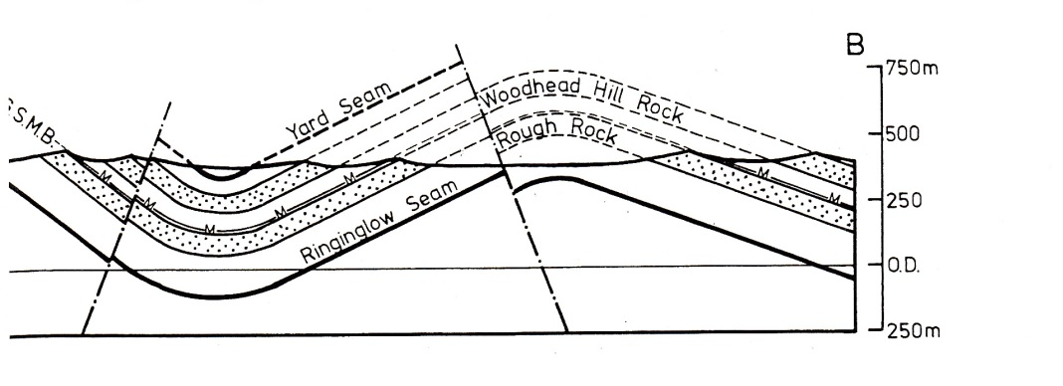
- In the Twyfelfontein area of Namibia, the Damaran sequence of turbidites and carbonates is overlain by the Permian Verbrandeburg Formation of Burnt Mountain. The Damaran carbonates have a sub-horizontal folded foliation, with fold axes plunging at 20° towards 340° and the steeper limb is oriented 018° dipping at 30° towards the west. The western limb has turbidites with preserved ripples that plunge 02° towards 120°. The other limb is known to have a strike of 300°. The Verbrandeburg Formation has been found to have an attitude of 030°, 20°W, and ripple marks in the sandstone horizons within the formation are oriented at 12° towards 258°.
  - Deduce the orientation of the foliation in the folded Damaran Carbonates, and orientation of both limbs during the deposition of the sandstone horizons within the Verbrandeburg formation. [10]
  - If the Damaran sequence were to be un-plunged, and unfolded, to simulate conditions around 900 million years, deduce the current direction that deposited the sandstone rich layers within the turbidites. [10]
  - Give an account of the Geological history in the area, with respective deformation events that happened. [5]
Use the equal area net to rotate the unconformity. Review the rotation and go back to the original setting to check the orientation.
- An outcrop in Gorob-Hope area of Namibia has an S1 foliation that formed during D1 and is oriented at 068°, 45°NW; whereas axial planar cleavage of the F2 folds is oriented at 040°, 60° NW.
  - Deduce the intersection lineation of S1 and S2. [10]
  - What type of interference folding occured during D1-D2? [5]
Plot the structures on an equal area stereonet. Find intersections and and read off the answers
The Two foliations are very close to each other. This appears to be a type 2 folding event.
END OF EXAMINATION

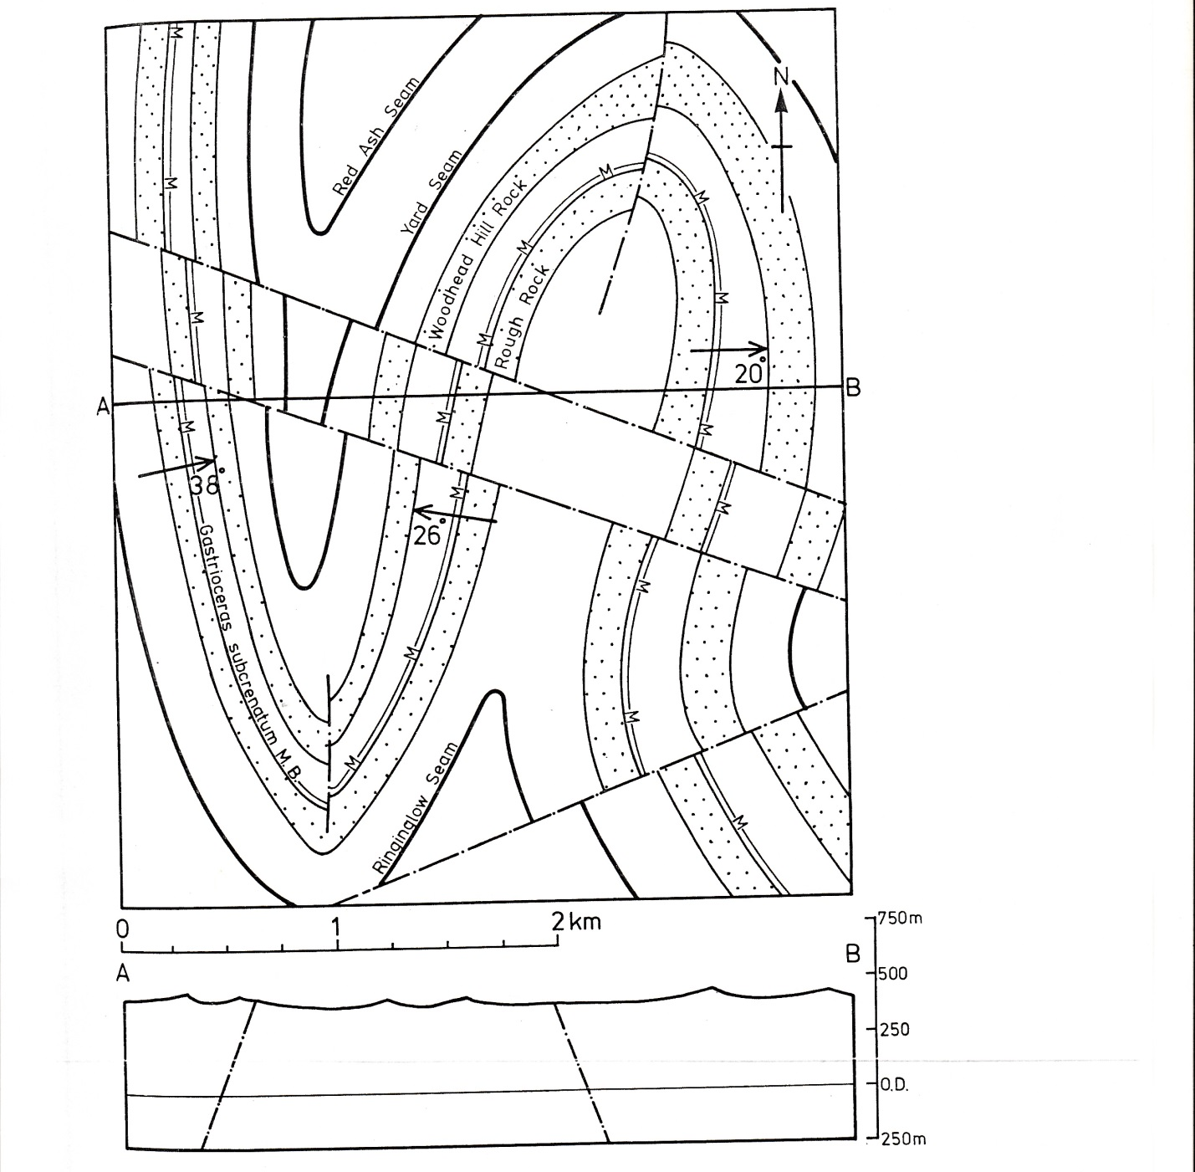
Figure 1, for question 1.
