

FACULTY | SCIENCE
DEPARTMENT | GEOLOGY
SUBJECT | STRUCTURAL GEOLOGY
SUBJECT CODE | GLY 3712
PAPER NUMBER | 2-PRACTICAL
DATE | OCTOBER-NOVEMBER 2015
DURATION | 3 HOURS
MARKS | 100
REQUIREMENTS | TRACING PAPER-A4 SIZE, STEREONETS AND GRAPH PAPER

SUPPLEMENTARY/SPECIAL EXAMINATION

MODEL ANSWERS
EXAMINER: PROF. B.S. MAPANI

INTERNAL MODERATORS: PROF. A.F. KAMONA (University of Namibia)

This question paper has three (3) printed pages including the cover page

INSTRUCTIONS
- CLOSED BOOK EXAMINATION.
- READ QUESTIONS CAREFULLY.
- ANSWER ALL QUESTIONS.
- START EACH QUESTION ON A SEPARATE PAGE.
- TOTAL MARKS = 100.
- ALL MARKS ARE INDICATED IN BRACKETS.
- THIS QUESTION PAPER CONSISTS OF 3 PRINTED PAGES INCLUSIVE OF THE TITLE PAGE.
- REQUIREMENTS: TRACING PAPER (A4) SIZE; STEREONETS AND GRAPH PAPER

UNIVERSITY OF NAMIBIA EXAMINATIONS

- Study the Map given below in figure 1(after Bolton, Map 25). The map is contoured at 10 m intervals. The area consists of a conformable sedimentary sequence.
- Complete the outcrop pattern by drawing strike lines for the rocks and the thrust fault. [10]
- Draw a cross-section from A to B. [35]
- Draw a stratigraphic column for the area. [5]
- Write the geological history of the area beginning with sedimentation of the oldest rocks. [10] Solution:
Section and completed outcrop:
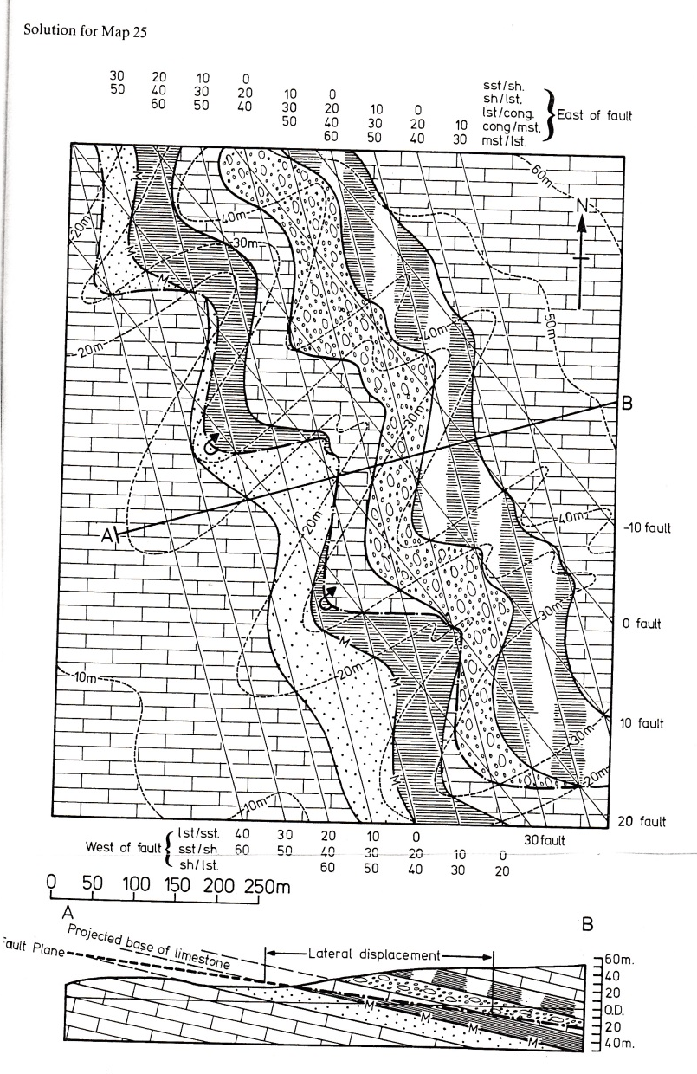
- In the Uis area of Namibia, the Damaran sequence of turbidites and carbonates is overlain by the Karoo Sequence. The Damaran turbidites have a sub-horizontal folded foliation, with fold axes plunging at 20° towards 340° and the western limb has a lineation oriented 28° towards 260°. The eastern limb has turbidites with preserved ripples that plunge 12° towards 120°. The The Karoo sequence has been found to have an attitude of 030°, 20°E, and ripple marks in the sandstone horizons within the formation are oriented at 12° towards 258°.
  - Deduce the orientation of the fold axis, lineation and ripple marks of the Damaran sequence during Karro. [9]
  - If the Damaran sequence were to be un-plunged, and unfolded, to simulate conditions around 700 million years, deduce the current direction that deposited the sandstone rich layers within the turbidites. [10]
  - Give an account of the Geological history in the area, with respective deformation events that happened. [5]

Solution: First plot all the structures. The eastern limb contains the lineation, draw a great circle through the lineation passing through the FA. Similarly draw a great circle through the ripple marks passing through the FA. The obtain poles for the two limbs for rotation.
    - To obtain this value, remove the U/C of Karoo by rotating the Karoo strata to horizontal. Then you obtain the following: FA =30° to 344°; lineation:46° towards 260°; ripple marks will be 0° to 120°
    - Ripples are 108°, therefore current direction is 108+90 = 198° or 108-90 = 018°.
    - Geological History: 1- deposition of the Damara sequence on deep marine environment, so as to get turbidites. Then deformation of the Damara involving folding of strata; followed by erosion, then deposition of the karoo followed by tilting.

- An outcrop in the Khan River area of Namibia has an S1 foliation that formed during D1 oriented at 068°, 45°NE; whereas axial planar cleavage of the F2 folds in D2 is oriented at 040°, 60° NE.
  - Deduce the intersection lineation of S1 and S2. [10]
  - What type of interference folding occurred during D1-D2? [5]
Solution:
Prepare your stereonet: Plot the S1 foliation and the axial planar cleavage. Where they intersect is the intersection lineation. Read it off.
  - The two foliations are very close in orientation. This is a type 2 folding event.

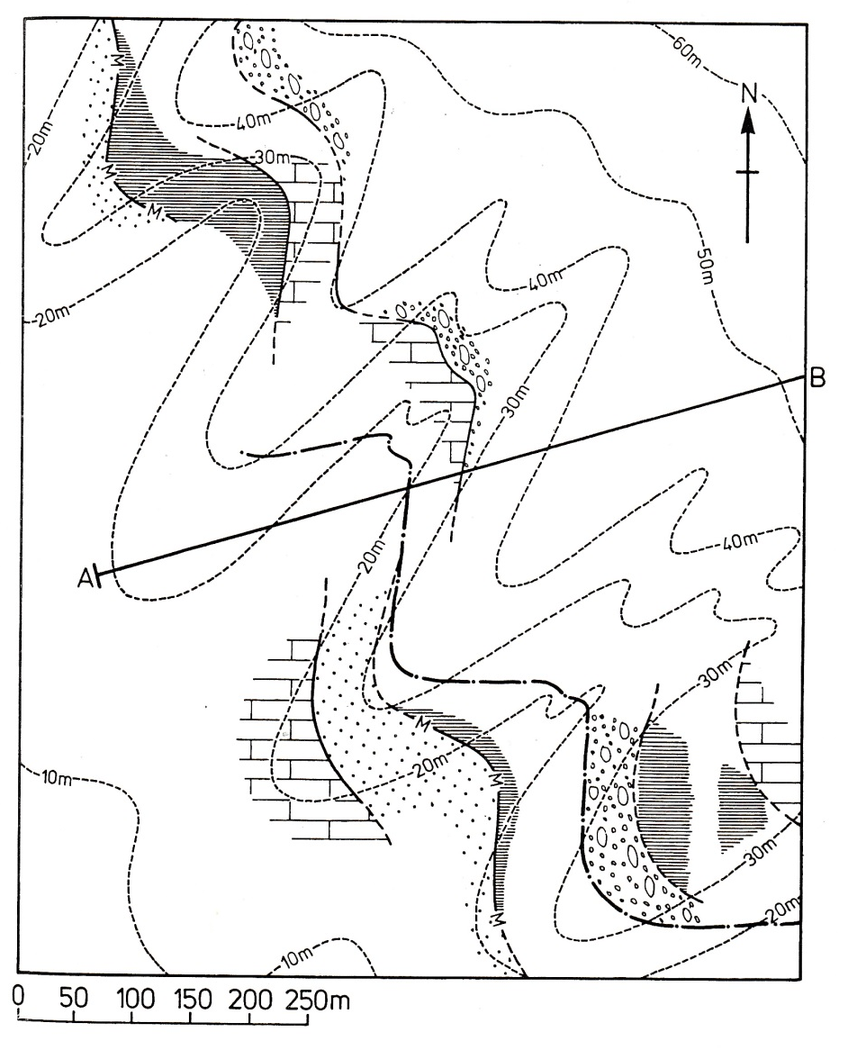
Figure 1, for question 1.
END OF EXAMINATION

