UNIVERSITY OF NAMIBIA EXAMINATIONS

EXAMINATION QUESTION PAPER
SUPPLEMENTARY EXAMINATIONS NOVEMBER/DECEMBER 2012

FACULTY | SCIENCE
DEPARTMENT | GEOLOGY
SUBJECT | STRUCTURAL GEOLOGY-PRACTICAL
SUBJECT CODE | GLY 3712-PRACTICAL
DATE | NOVEMBER/DECEMBER 2012
DURATION | 3 HOURS
MARKS | 100
REQUIREMENTS | TRACING PAPER-A4 SIZE AND GRAPH PAPER

EXAMINER: DR. B.S. MAPANI

MODERATOR: DR JODIE MILLER (Stellenbosch University)
INTERNAL MODERATOR: DR A.F. KAMONA (University of Namibia)

INSTRUCTIONS
- CLOSED BOOK EXAMINATION
- READ QUESTIONS CAREFULLY
- ANSWER ALL QUESTIONS
- START EACH QUESTION ON A SEPARATE PAGE
- TOTAL MARKS = 100

- Study the Map given below and answer the questions that follow:
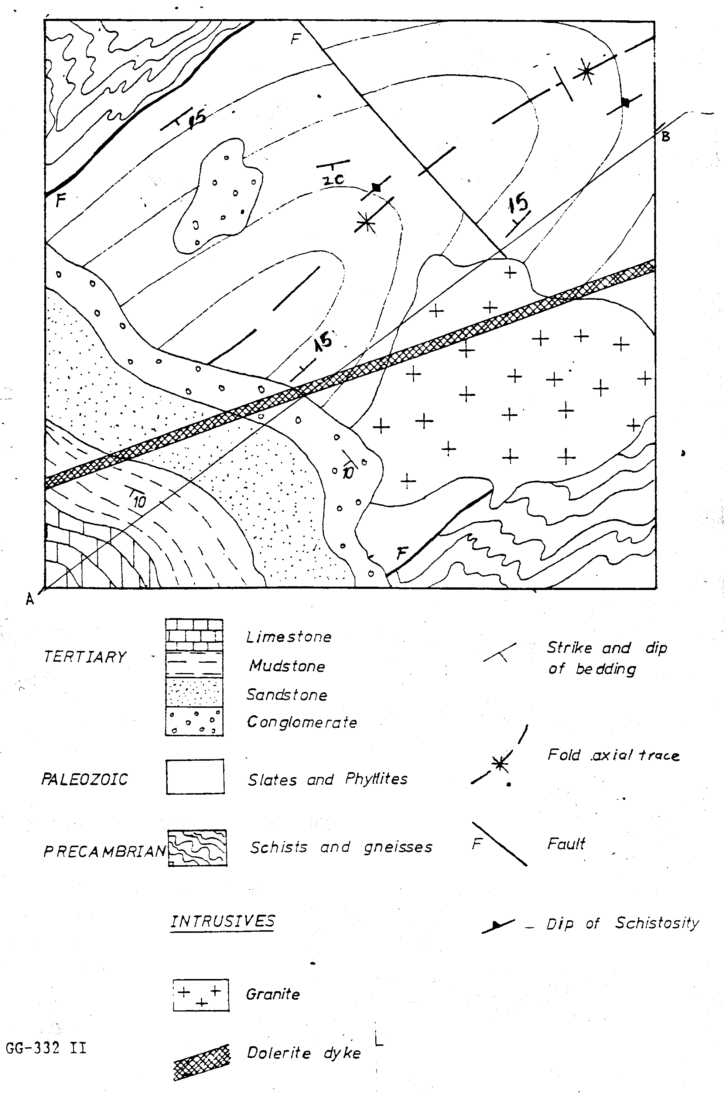The thick cross-hatched feature is a mafic dyke

- Draw a cross-section from A to B. (30)
- Draw a stratigraphic column for the area. (5)
- Write the geological history of the area beginning with sedimentation of the earliest geological units. (15)

- The Eland Reef Formation is oriented 020°, 30° E and overlies an older Buffalo Beans Formation. The Buffalo Beans Formation possesses plunging folds that have two limbs dipping 010° 50°E, and 350°30°W. Flute marks are preserved on the mudstone-sandstone contact of the Buffalo Beans Formation and are oriented 28° → 072°, and sole marks appear on the west dipping limb oriented 50°→ 272°.
(a) Calculate the interlimb angle for the fold. (10)
(b) what was the orientation of the fold axis before the unconformity? (25)
(c) what was the current direction that deposited the sandstone-mudstone sequence of the Buffalo Beans Formation? (15)



