UNIVERSITY OF NAMIBIA EXAMINATIONS

EXAMINATION QUESTION PAPER
SUPPLEMENTARY EXAMINATIONS NOVEMBER/DECEMBER 2012

FACULTY | SCIENCE
DEPARTMENT | GEOLOGY
SUBJECT | STRUCTURAL GEOLOGY
SUBJECT CODE | GLY 3712
PAPER NUMBER | 2- PRACTICAL
DATE | NOVEMBER/DECEMBER 2012
DURATION | 3 HOURS
MARKS | 100
REQUIREMENTS | TRACING PAPER-A4 SIZE AND GRAPH PAPER

EXAMINER: DR. B.S. MAPANI

MODERATOR: DR JODIE MILLER (Stellenbosch University)
INTERNAL MODERATOR: DR A.F. KAMONA (University of Namibia)

INSTRUCTIONS
- CLOSED BOOK EXAMINATION
- READ QUESTIONS CAREFULLY
- ANSWER ALL QUESTIONS
- START EACH QUESTION ON A SEPARATE PAGE
- TOTAL MARKS = 100
- ALL MARKS ARE INDICATED IN BRACKETS

- Study the Map given below and answer the questions that follow:
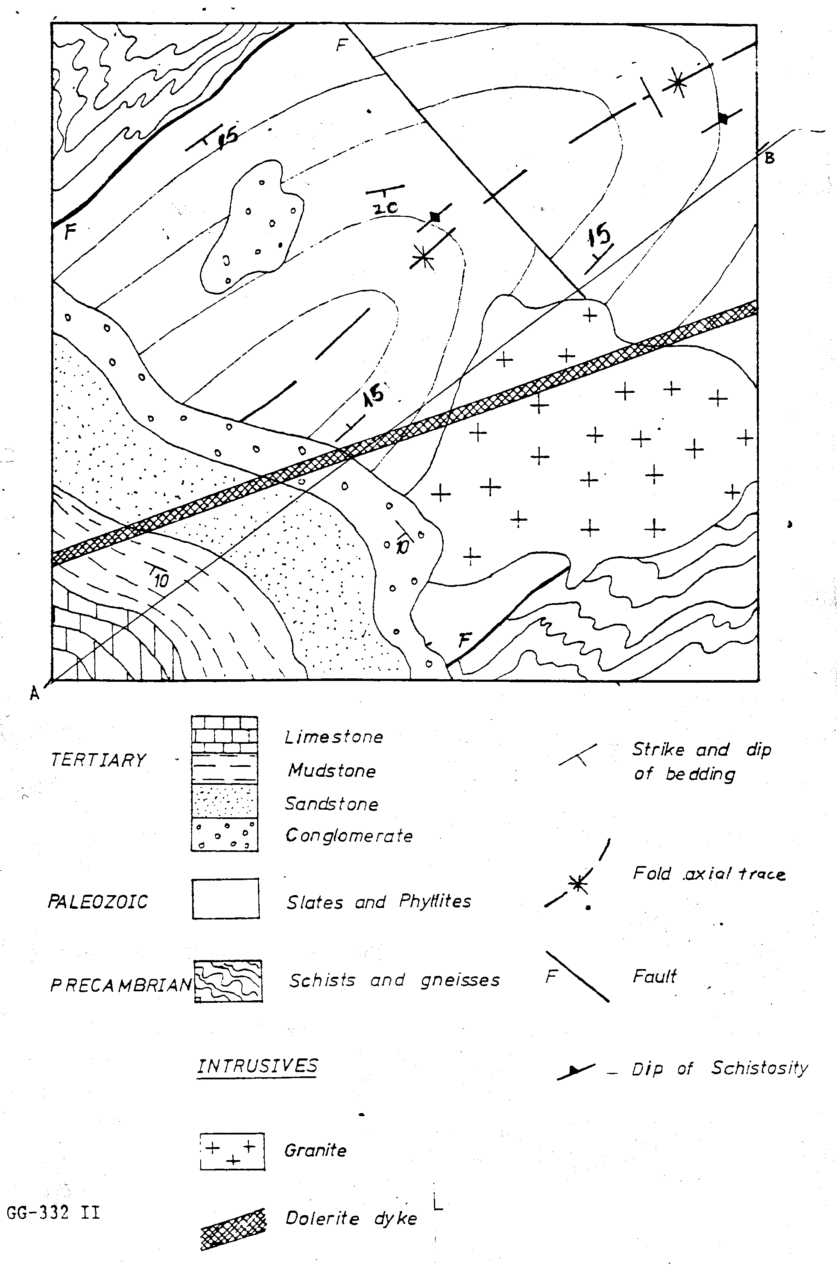The thick cross-hatched feature is a mafic dyke
Figure 1.

- Draw a cross-section from A to B. [30]
- Draw a stratigraphic column for the area. [5]
- Write the geological history of the area beginning with sedimentation of the earliest geological units. [15]

- The Eland Reef Formation is oriented 020°, 30°E and overlies an older Buffalo Beans Formation. The Buffalo Beans Formation possesses plunging folds that have two limbs dipping 010° 50°E, and 350°30°W. Flute marks are preserved on the mudstone-sandstone contact of the Buffalo Beans Formation and are oriented 28° → 072°, and sole marks appear on the west dipping limb oriented 50°→ 272°.
(a) Calculate the interlimb angle for the fold. [10]
(b) what was the orientation of the fold axis before the unconformity? [25]
(c) what was the current direction that deposited the sandstone-mudstone sequence of the Buffalo Beans Formation? [15]

END OF EXAMINATION
