UNIVERSITY OF NAMIBIA EXAMINATIONS

EXAMINATION QUESTION PAPER
1ST OPPORTUNITY EXAMINATIONS NOVEMBER/DECEMBER 2011

FACULTY | SCIENCE
DEPARTMENT | GEOLOGY
SUBJECT | GLY 3712- STRUCTURAL GEOLOGY-PRACTICAL
SUBJECT CODE | GLY 3712-PRACTICAL
DATE | NOVEMBER 2011
DURATION | 3 HOURS

EXAMINER: DR. B.S. MAPANI

MODERATOR: DR JODIE MILLER (Stellenbosch University)

INSTRUCTIONS
- CLOSED BOOK EXAMINATION
- READ QUESTIONS CAREFULLY
- ANSWER ALL QUESTIONS
- START EACH QUESTION ON A SEPARATE PAGE
- TOTAL MARKS = 100

REQUIREMENTS

The students will require graph paper and tracing paper

- Study the Map given below and answer the questions that follow:
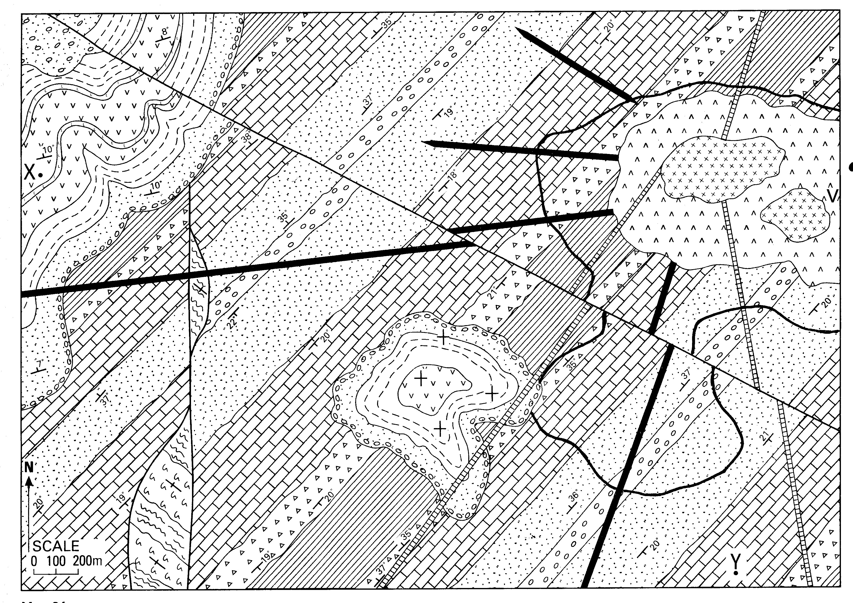

- Draw a cross-section from X to Y. (30)
- Draw a stratigraphic column for the area. (5)
- Write the geological history of the area beginning with sedimentation. (15)

- The Sable Reef Formation is oriented 020°, 30° E and overlies an older Springvalley Formation. The Springvalley formation possesses plunging folds that have two limbs dipping 010° 50°E, and 350°30°W. Flute marks are preserved on the mudstone-sandstone contact and are oriented 28° → 072°, and sole marks appear on the west dipping limb oriented 50°→ 272°.
(a) Calculate the interlimb angle for the fold. (10)
(b) what was the orientation of the fold axis before the unconformity? (25)
(c) what was the direction of the current that deposited the sandstone-mudstone sequence of the Spring Valley Formation? (15)

