UNIVERSITY OF NAMIBIA EXAMINATIONS

EXAMINATION QUESTION PAPER
1ST OPPORTUNITY EXAMINATIONS NOVEMBER/DECEMBER 2011

FACULTY | SCIENCE
DEPARTMENT | GEOLOGY
SUBJECT | GLY 3712- STRUCTURAL GEOLOGY I –PAPER 2
SUBJECT CODE | GLY 3712
DATE | JANUARY 2012
DURATION | 3 HOURS

EXAMINER: DR. B.S. MAPANI

MODERATOR: DR JODIE MILLER (Stellenbosch University)

INSTRUCTIONS
- CLOSED BOOK EXAMINATION
- READ QUESTIONS CAREFULLY
- ANSWER ALL QUESTIONS
- START EACH QUESTION ON A SEPARATE PAGE

REQUIREMENTS
Students will require tracing paper and graph paper for this examination

- Study the given Map carefully and answer the questions that follow:
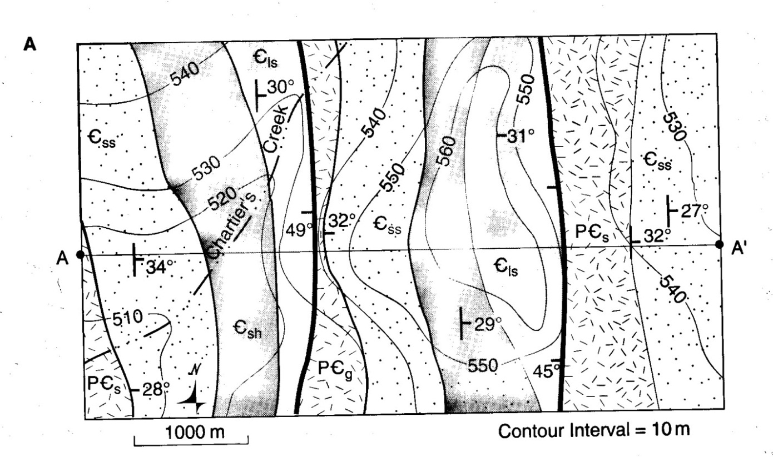
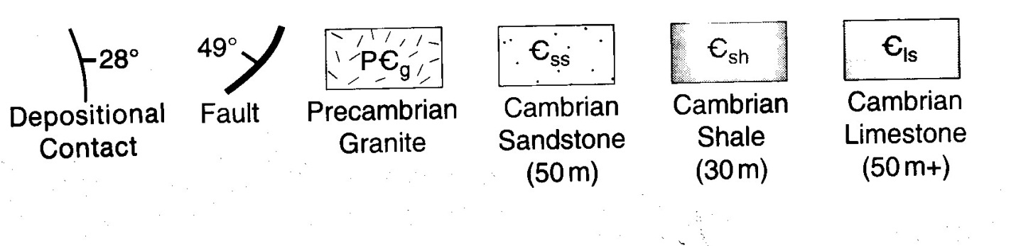

- Draw a cross-section A-A and write the geological history of the area. (40)
- Plot all the units on a stereonet and accompanying faults and folds, and interpret the structure. (15)

- The Twin Rivers Formation sediments have bedding oriented 305° 20° E, and below the unconformity older rocks contain a foliation oriented 020°15°W and 360° 30°W. The older psammite-schist- sequence preserves deformed ripple marks, measured as 14° towards 292°. A lineation that parallels the fold axis is ubiquitous in all regions.
(a) What was the orientation of the lineation before the tilting of the unconformity? (10)

(b) What was the orientations of the fold limbs and fold axis before the unconformity tilted? (15)
(c) what was the orientation of the ripple marks before the folding of the older rocks. A (10)
(d) deduce the current direction responsible for the deposition of the older folded rocks. (10)

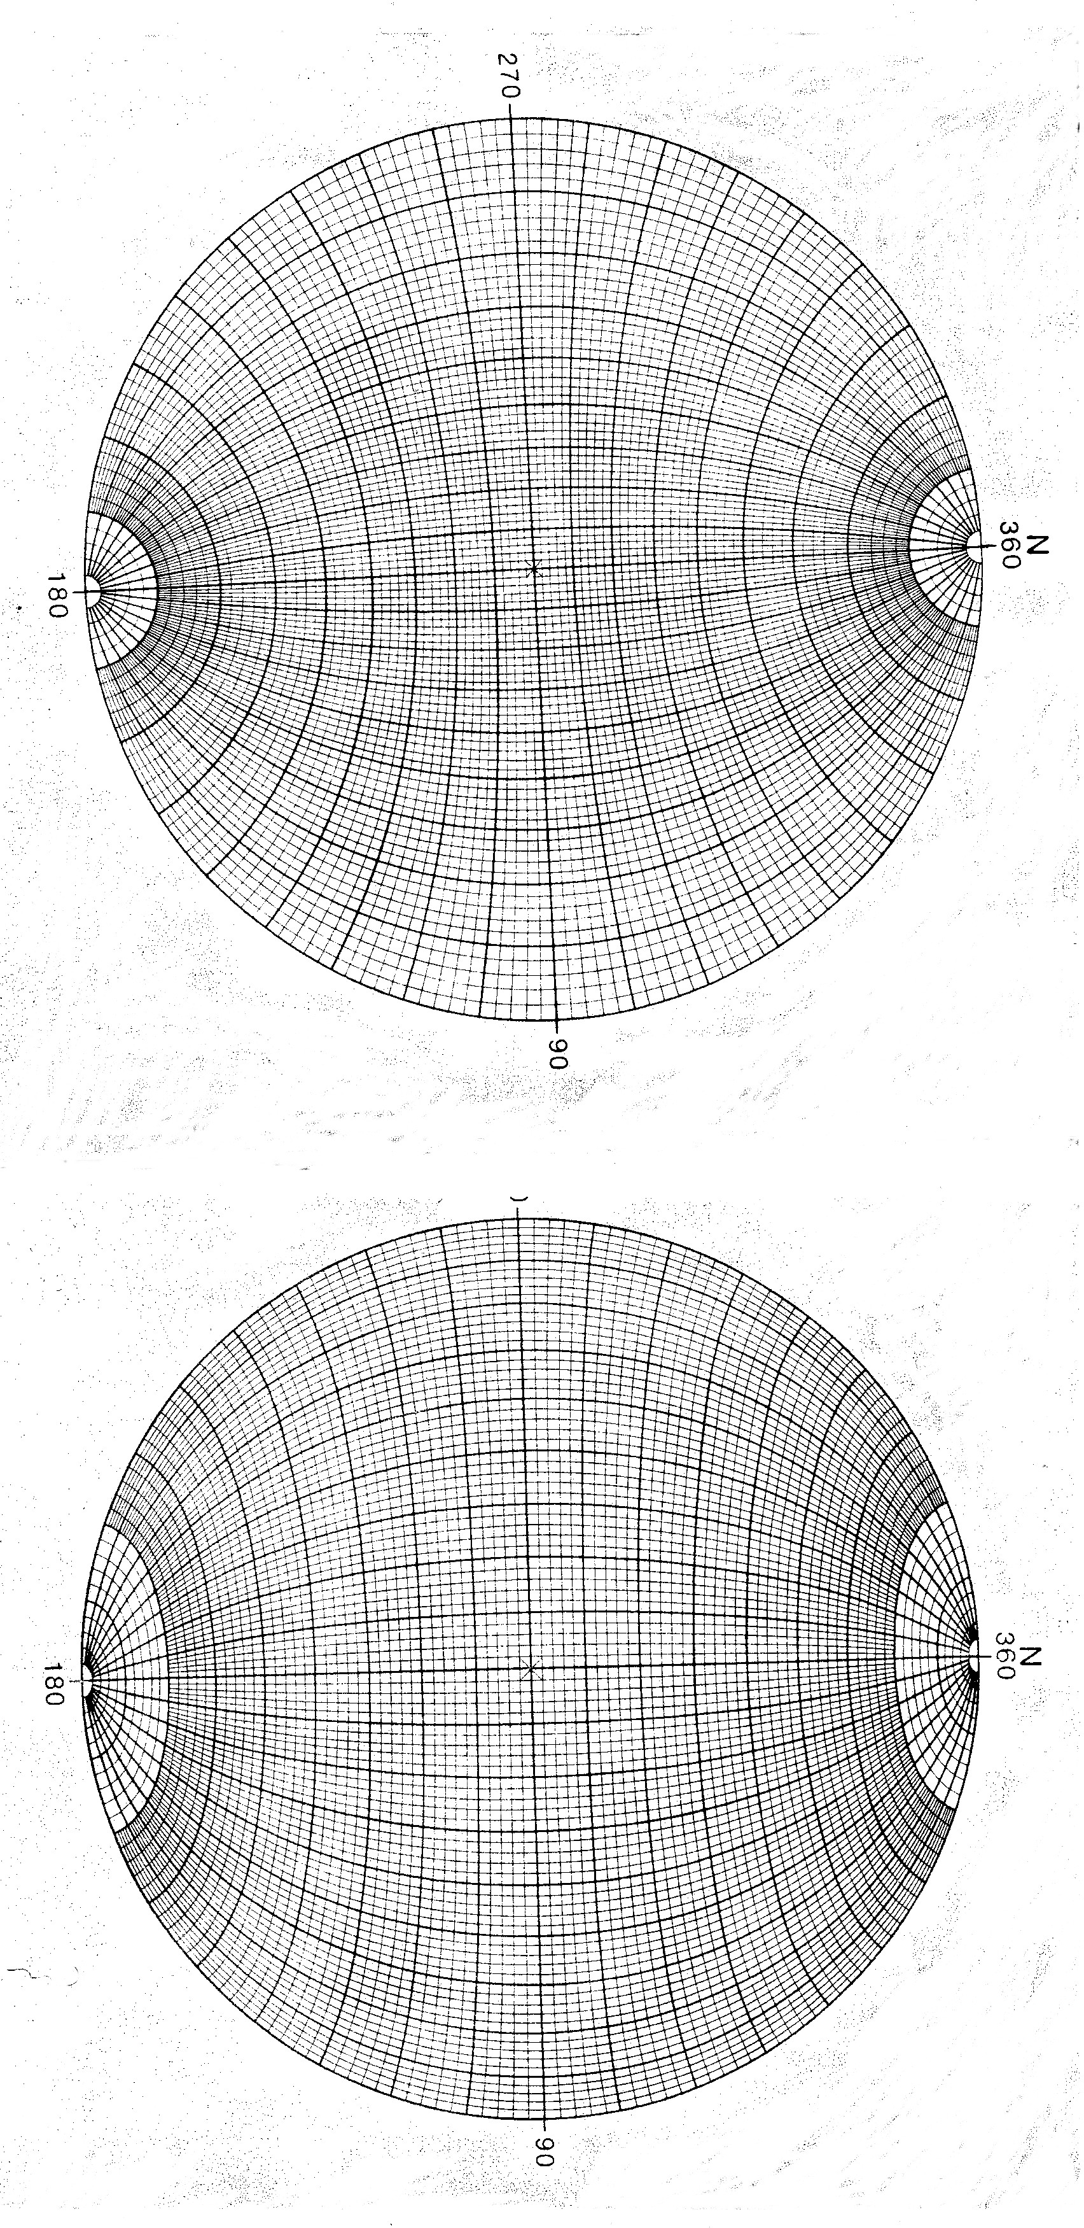
END OF EXAM

