UNIVERSITY OF NAMIBIA
FACULTY OF SCIENCE
DEPARTMENT OF GEOLOGY
STRUCTURAL GEOLOGY II: GLY 3862
NOVEMBER 2010 1ST OPPORTUNITY EXAMINATIONS.
Answer any four questions. Time allowed 2 hours.
- Discuss the concept of heterogeneous and homogeneous flow using scale as observed in nature. (25)
- During deformation in rocks, deformation mechanisms act at either molecular scale or grain scale, and particles may undergo displacement. Discuss and contrast deformation paths from displacement vectors. (25)
- Consider the photograph below in figure 1. Establish the following:
- The number of deformation episodes using evidence provided in the photograph (13)
- Consider whether the deformation was continuous or non continuous (12)
Figure 1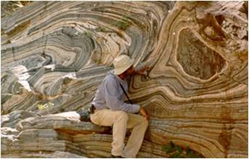
- Discuss the scenarios in the crust when its possible to have both ductile and brittle structures in the same rock. (25)
- Compare and contrast diagenetic foliation development and crenulation cleavage development. (25).
END OF EXAM

