UNIVERSITY OF NAMIBIA
GEOLOGY DEPARTMENT
FACULTY OF SCIENCE

GLY 3712 STRUCTURAL GEOLOGY

NOVEMBER 2010 1st OPPORTUNITY EXAMINATIONS

Paper 2: Practical

Time: Three (3) hours
Instructions: Answer all questions.
Total marks = 100

Study the map given in Figure 1 below. (b) Draw cross-section P-Q. Use the given legend (A, B, C, D) and cross-section to come up with a brief geological history of the area, beginning with the sedimentation. (60)

The following data was obtained from the field by Mr. Ngeipi.

Dip-Dip direction of Foliation, S₁ | Dip-Dip direction of  Foliation, S₁ | Lineation, L₁
45, 045 | 40, 041 | 46, 320
29, 050 | 29, 045 | 38, 318
28, 048 | 32, 044 | 28, 138
30, 050 | 36, 042 | 28, 145
30, 240, | 39, 049
40, 244 | 38, 038
28, 238 | 35, 055
30, 242 | 27, 058
33, 246 | 31, 038
34, 248 | 29, 239
37, 230 | 30, 040
36, 233 | 40, 239
40, 248 | 42, 242
43, 240 | 44, 244
34, 240 | 30, 046
36, 240 | 34, 034

However, on his return, he was appointed to another department. As a new young geologist you have been requested to complete the structural analysis for Mr Ngeipi. Using the data above, what kind of structure is present in Mr Ngeipi’s field area? Discuss the significance of the L₁ in this area. [20]

3. Younger beds above an unconformity are oriented at 300°, 40° NE, whereas older beds below the unconformity are folded with one limb oriented at 045°, 30° NW and the other limb is 020°, 35° SE. The older turbidite beds preserve flute marks whose orientation is 30°→315°. What was the orientation of the older beds and the fold axis prior to the tilting of the unconformity? What was the current direction during the deposition of the older beds? [20]

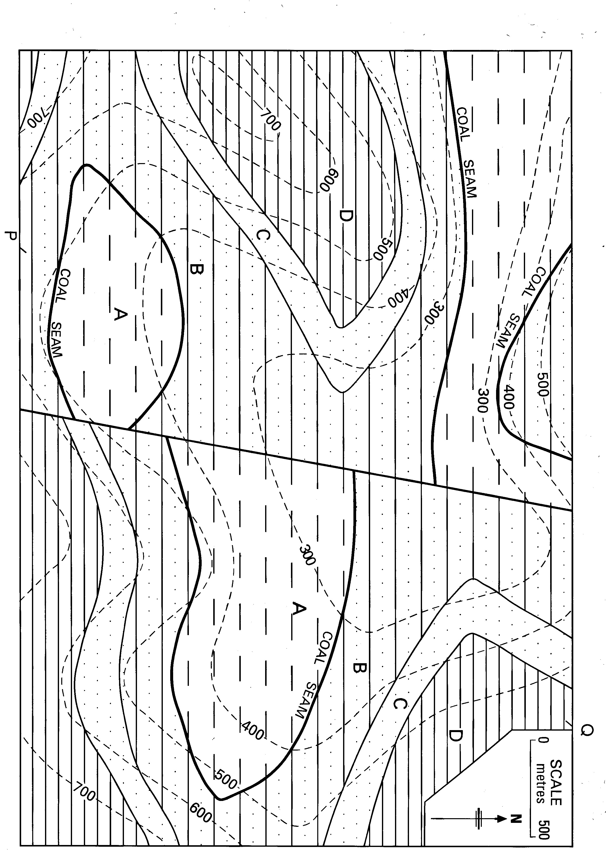

Figure 1. Map for Question 1

