UNIVERSITY OF NAMIBIA
GEOLOGY DEPARTMENT
FACULTY OF SCIENCE

GLY 3712 STRUCTURAL GEOLOGY

JANUARY 2011- 2nd OPPORTUNITY EXAMINATIONS

Paper 2: Practical

Time: Three (3) hours
Instructions: Answer all questions.
Total marks = 100

- Given the map with a sequence of sedimentary units, (a) draw structure contours for the upper and lower surfaces of the sandstone unit (stippled), and for the fault. (b) deduce the dip and strike of the units. What is the amount of throw on the fault and what type of fault is it? (c) Draw a cross-section X-Y in a NW-SE direction, such that the shale, sandstone and conglomerate will all appear. Write a short geological history of the area. If the sequence was deposited on a platform, state the geological events that led to its present geometry. Hand in the Map with your answer sheet. (60 marks)
- A fault plane is oriented at 330°, 80°NE and slicken fibres on the fault surface plunge 19° to 334°. The fault has a right lateral sense of shear. Estimate the principal stress directions which gave rise to this fault. Two fault systems are present in an area, forming two separate fault sets. Set A has shallow dips of 25° dipping towards the east, whereas set B has steeply dipping fault planes of 60° towards the northwest. Slicken fibres on the high angle faults show two generations of movement, one is down dip towards the NW and the up dip one has an easterly strike slip component to it. (a) Which fault formed first and why? What were the orientations of the three principal stresses during its formation? (b) During the formation of the second fault, what was the orientation of the principal stresses? If the low angle fault had formed last, what would have been the effect of the stress regime on the earlier high angle fault? (20 marks).
- Younger beds above an unconformity are oriented at 300°, 30° NE, whereas older turbidite beds below the unconformity are folded with one limb oriented at 045°, 30° NW and the other limb is 020°, 35° SE. The older turbidite beds preserve ripple marks, whose orientation is 30°→315°. What was the orientation of the older beds and the fold axis prior to the tilting of the unconformity? (10 Marks). What was the current direction during the deposition of the older beds? (10 Marks).

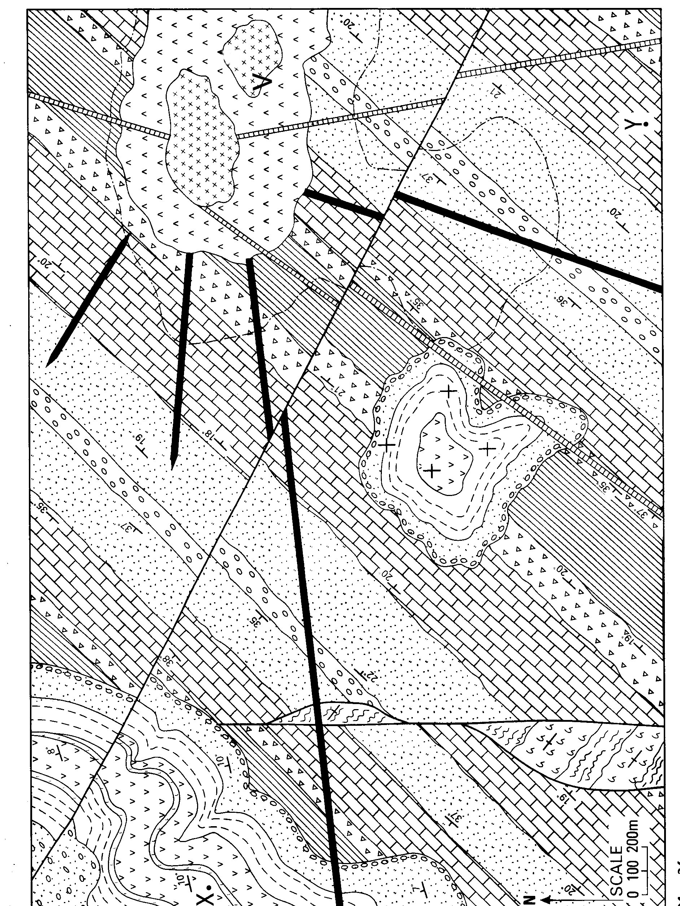
Figure 1 for Question 1.

