UNIVERSITY OF NAMIBIA
FACULTY OF SCIENCE
DEPARTMENT OF GEOLOGY
STRUCTURAL GEOLOGY II: GLY 3862
JANUARY 2011 2nd OPPORTUNITY EXAMINATIONS.
Answer any four questions. Time allowed 2 hours.
- Discuss why mountains may never be more than 8-10 km high on the continents. (25)
- Discuss dilatancy and how it comes about during deformation of rocks. Your discussion must include the deformation mechanism responsible. (25)
- Consider the photograph below in figure 1. Discuss how this type of foliation develops; in what type of rocks and what deformation mechanism may be responsible. (25)
Figure 1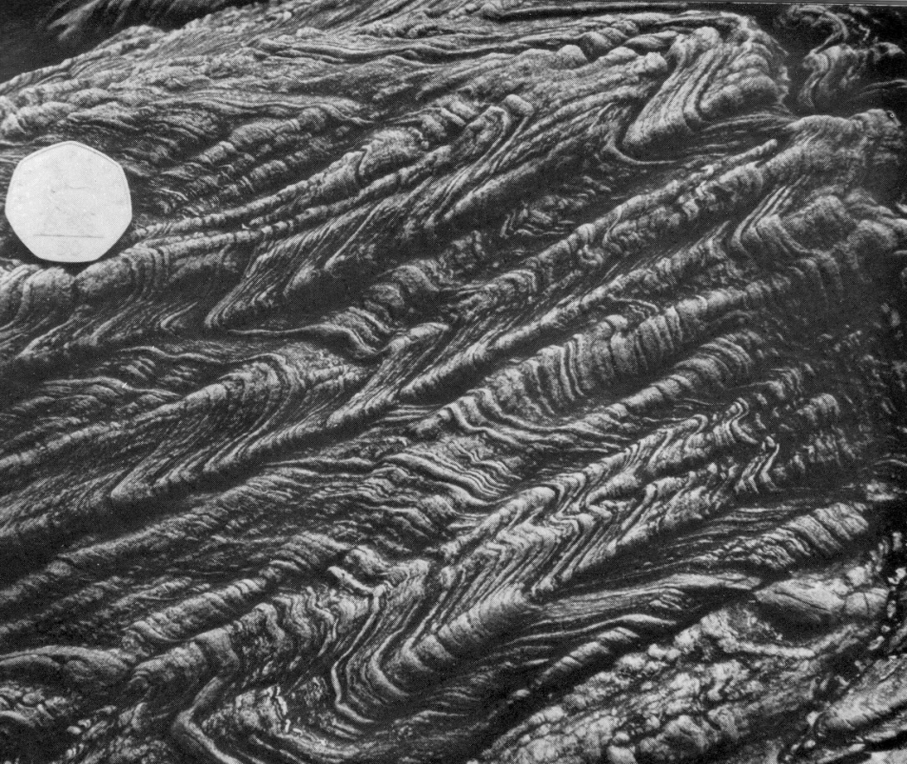
- Discuss the difference and significance of flow patterns and velocity vectors in deformed rocks. (25)
- You seek to date a metamorphic complex, in which deformed and metamorphosed dykes have intruded a banded gneiss. The gneiss is also intruded by granites that appear to be older than the mafic dyke. Discuss what dating methods, you will use, and what minerals will be utilized to date (i) absolute ages of all the rock units; (ii) metamorphic ages of the rock units and (iii) uplift ages. (25).

