TERMINOLOGY

Nomenclature of metamorphic rocks is not as systematic as that of
Igneous and sedimentary rocks. This is largely a result of the much greater range of chemical composition of metamorphic rocks and, moreover, that even one bulk chemical composition may give – depending upon the conditions of metamorphism-many rocks types with completely different mineralogies, textures and structures.

The names of most metamorphic rocks are based on three fundamental criteria:
1. textural and structural features (fabric) – e.g. granofels, gneiss,
slate, cataclasite etc.

2. mineralogy – putting the prefixed minerals names arranged in order
of their abundance. Thus, e.g. a rock with schistose structure and
composed of 50% biotite, 30% muscovite and 20% quartz is called “biotite muscovite schist”.

3. origin – if the premetamorphic nature of a metamorphic rock can be deduced. This may be indicated by the prefixes “meta”, “ortho-“ and “para-“. E.g. the term “metabasalt” denotes a metamorphosed basalt and “metapelite” – a metamorphosed argillaceous sediment. In general, if the parentage only can be determined, the prefix “ortho-“ indicates any igneous protolith (e.g. orthogneiss) and “para-“ any sedimentary protolith (e.g. paragneiss).

A complete rock name may, in theory, include all mentioned above parameters. In practice it never does and description used depends on the context and available information. It has led to a comparatively small number of commonly accepted rock names, listed below:
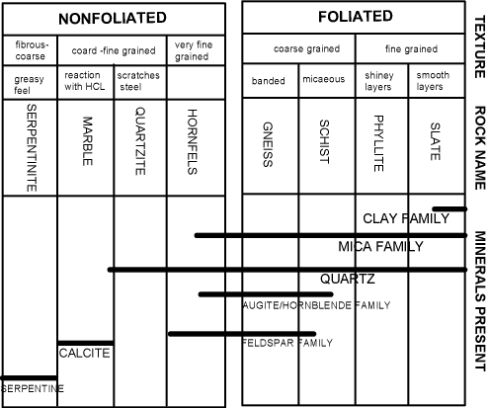

amphibolite – a medium- to coarse-grained, weakly foliated rock, consisting predominantly of hornblende and plagioclase
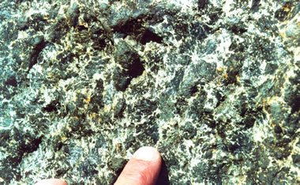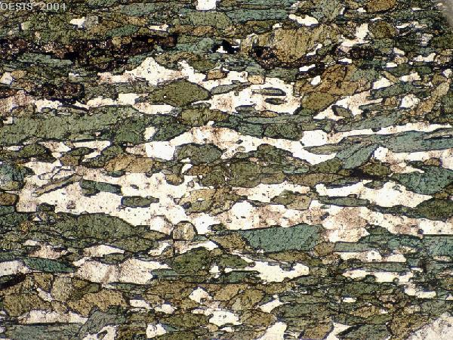

argillite – a very low-grade, aphanitic, dark-coloured, firmly indurated rock, derived from a mudstone.
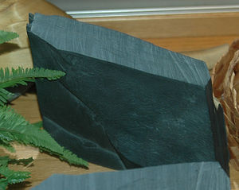
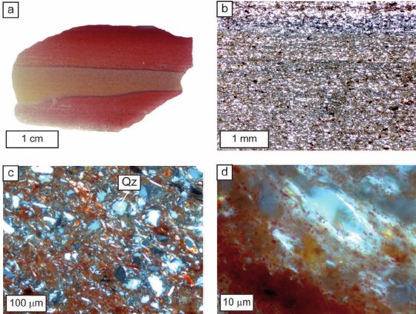

cataclasite – a rock built up of fine-grained crushed matrix, without banding or schistosity.
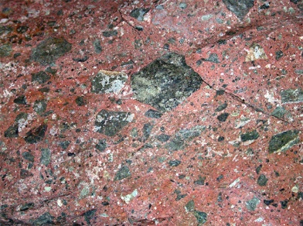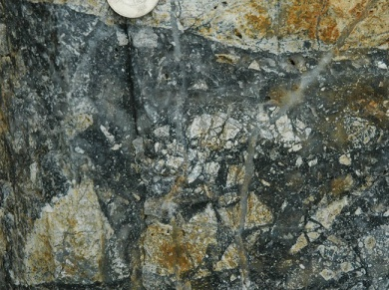
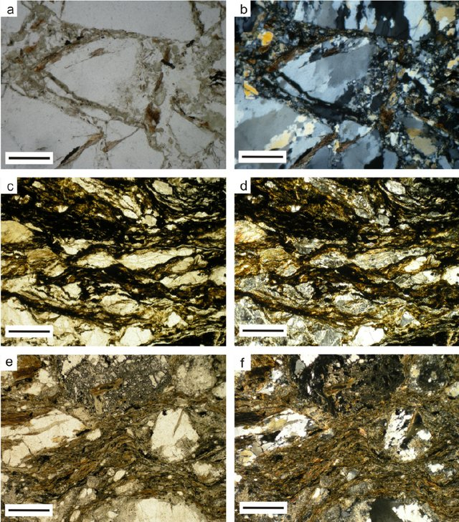
Thin sections in the fault zones. a, b) Coarse fault breccia with gneissic rock fragments (1N, +N) (well A-180). c, d) Oriented, elongated clasts in cataclastic fabric (1N, +N) (well A-180). e, f) Layers of comminuted gouge containing primarily crushed mono-crystals (1N, +N) (well A-180). The scale bars are 500 μm long.

eclogite – a medium-grained rock, composed of mphacitic pyroxene and pyrope-almandine garnet.
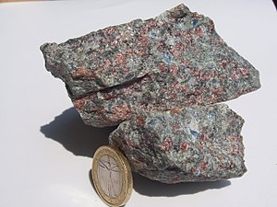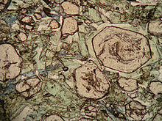
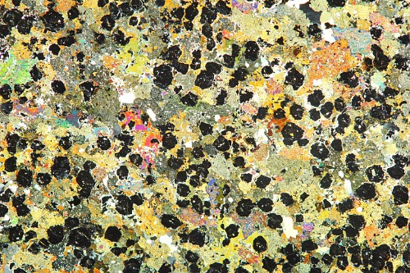

gneiss – with coarse-banded (gneissose) structure; layers relatively rich in quartz and feldspars alternate with those containing micas, hornblende, pyroxenes.
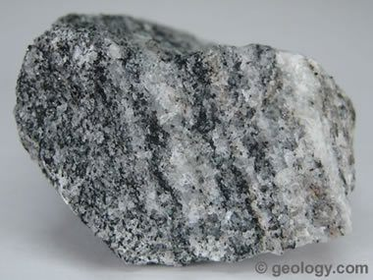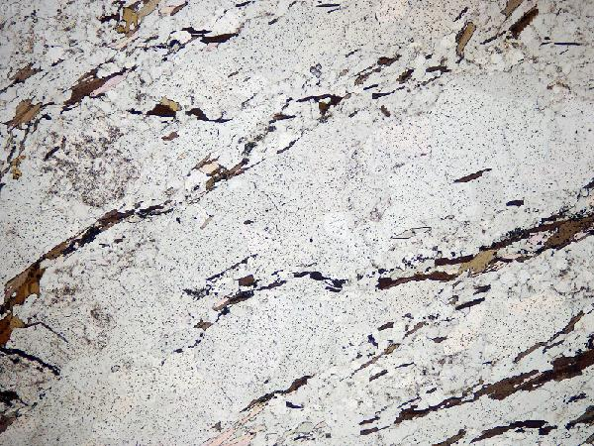

granulite – a rock of dominantly granulose structure, consisting mainly of quartz, feldspar, pyroxene and garnet.
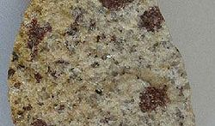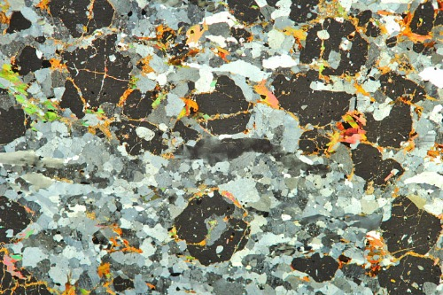

greenstone – an anphanitic, weakly metamorphosed mafic igneous rocks, epidotes, chlorites, actinolite, albite, sometimes carbonates are characteristic.
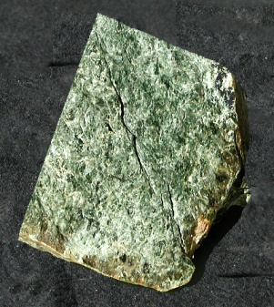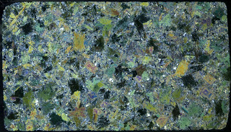
Subhedral pyroxene grains in greenstone. Specimen No. 48, cobble in glacial gravel, southeastern Michigan. Provenance likely northern Ontario. Macrophotograph in cross-polarized light. Imaged area 22mm by 38 mm

hornfels – a fine or medium-grained tough rock formed by thermal metamorphism, minerals in random orientation.
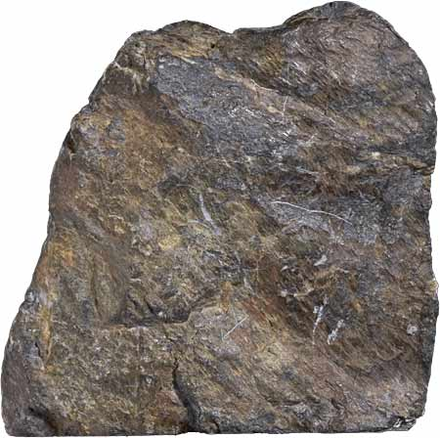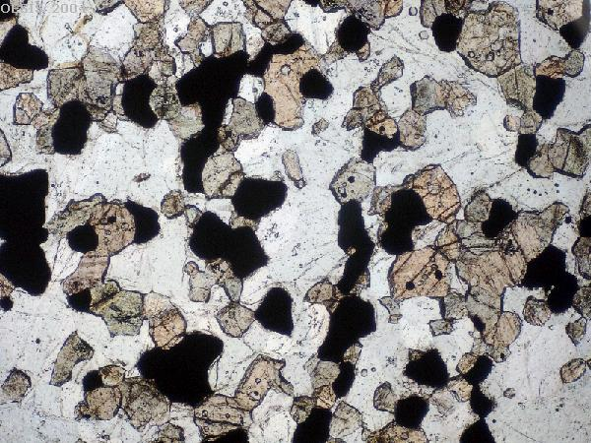

Hornfels is a metamorphic rock formed by the contact between mudstone / shale, or other clay-rich rock, and a hot igneous body, and represents a heat-altered equivalent of the original rock. This process is termed contact metamorphism. Because pressure is not a factor in the formation of hornfels, it lacks the foliation seen in many metamorphic rocks formed under high pressure and temperature regimes. Pre-existing bedding and structure of the parent rock is generally destroyed during the formation of hornfels. It is often difficult to identify hornfels without microscopic observation, or knowledge of its association with a magma body, as it is typically non-descript in hand specimen. Under a microscope the structure of hornfels is very distinctive, with small, generally equigranular, mineral grains fitting closely together like the fragments of a mosaic or a rough pavement

marble - a rock composed mainly of recrystallized calcite or dolomite, exhibiting granoblastic texture. Metamorphism of carbonate rocks with variable admixture of sandy or clay material gives calc-silicate schists or gneisses with diopside, tremolite, forsterite, wollastonite, grossular-andradite, occurring along with carbonates.
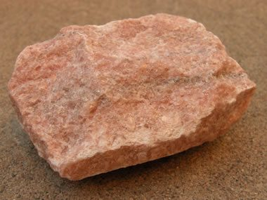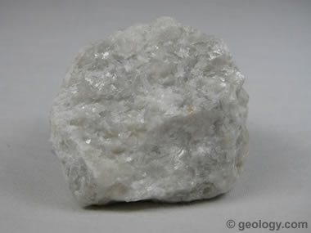
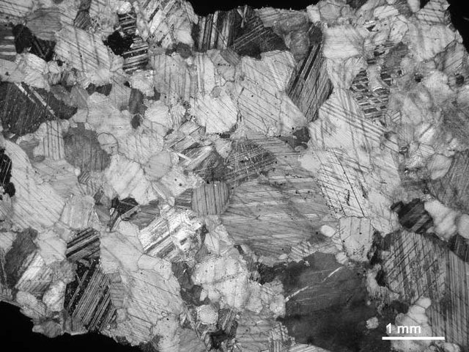
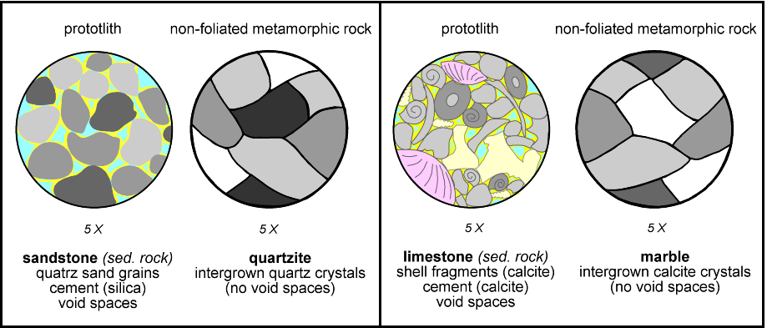

migmatite – a composite rock containing mafic metamorphic material mingled with leucocratic granitic rock, formed under conditions gradational to igneous processes.
the principal component is an aphanitic matrix, formed by crushing, showing banding and/or schistosity.
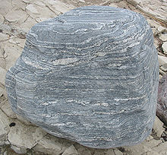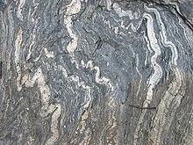
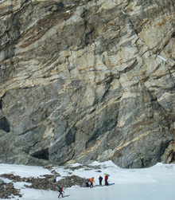
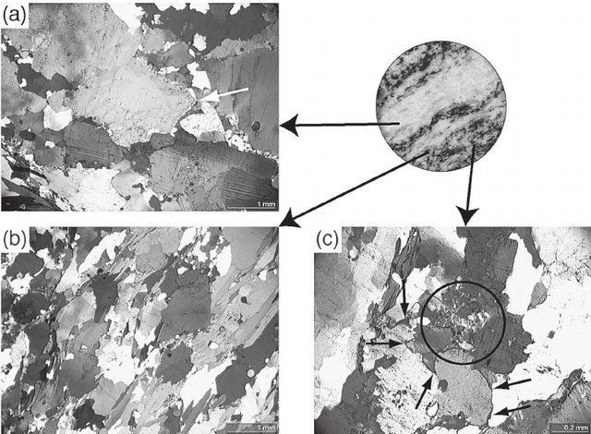
Migmatites in thin section (Bordoglio, Valle Onsernone; 696’980/116’975). Figures A–C depict different domains of the sample, as indicated on the slab (diameter 2.5 cm). (a) Photomicrograph of the wide leucosome band with euhedral feldspars; (b) Gneissic domain with abundant biotite; (c) Small triple point aggregates and thin films of forme

phyllite – similar to slate (see below), but with a silky sheen, slightly bigger porphyroblasts can be seen.
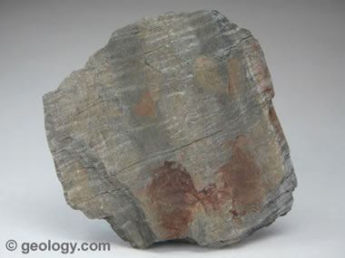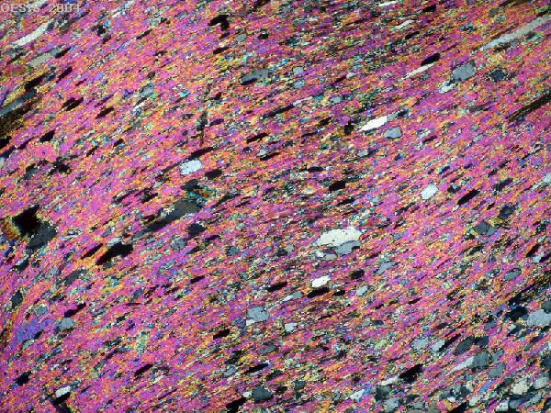

quartzite - a rock with granulose texture, composed of sutured quartz grains, formed by metamorphism of sandstones or cherts.
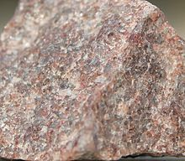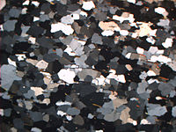

schist – any rock with strongly foliated schistose structure.
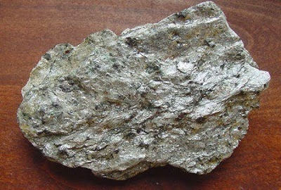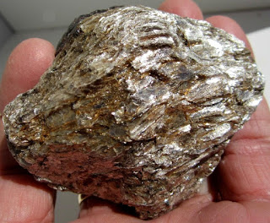
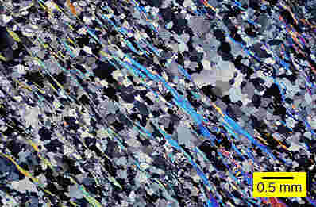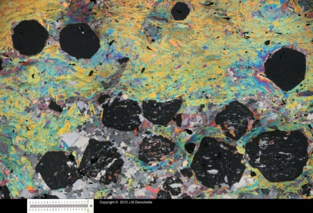

serpertinites - a rock composed of serpentines (antigorite, lizardite, chrysotile), may contain talc, chlorites, carbonates. Derived from rocks rich in olivines (peridotite family).
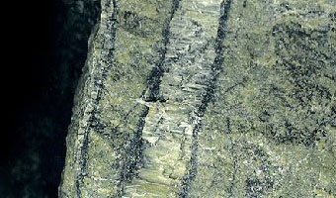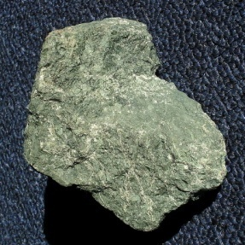
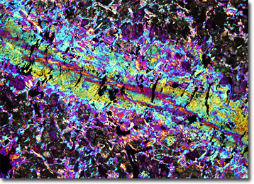

skarn (tactite) – a rock containing calc-silicate minerals (diopside, grossular, epidote, tremolite, forsterite), formed along contacts of a carbonate country rock and an intermediate igneous intrusion.
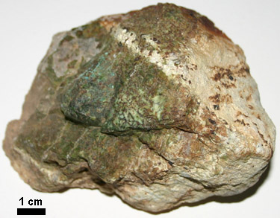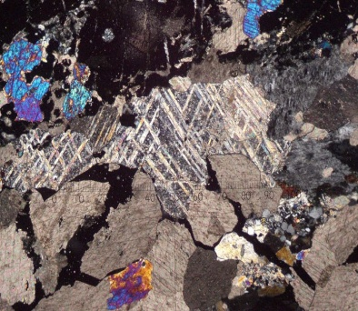

slate – an aphanitic rock with a good rock cleavage (slaty cleavage), tougher than shale; formed by regional metamorphism of mudrocks, also tuffs.
