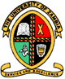

THE UNIVERSITY OF ZAMBIA
SCHOOL OF MINES
DEPARTMENT OF GEOLOGY

NAME : ANDREW SAKALA
COMPUTER NUMBER : 14055562
COURSE : GGY 4070
LECTURER : Dr. Ahmed
TASK : FELDSPAR GROUP OF MINERALS
DUE DATE : 05TH JUNE, 2018

INTRODUCTION
The name feldspar derives from the German Feldspat, aSpat, "a rock that does not contain
ore".^{[6]}The change from Spat to -spar was influenced by the English word spar,^{[7]} meaning a
non-opaque mineral with good cleavage.^{[8]} Feldspathic refers to rocks that contains feldspar.
The alternate spelling, felspar, has largely fallen out of use
Feldspar is the name given to a group of minerals distinguished by the presence of alumina and silica (SiO₂) in their chemistry.
This group includes aluminium silicates of soda, potassium, or lime. It is the single most abundant mineral group on Earth. They account for an estimated 60% of exposed rocks, as well as soils, clays, and other unconsolidated sediments, and are the principal components in rock classification schemes. The minerals included in this group are the orthoclase, microcline and plagioclase feldspars.

Type Mineral

Mineral Classification Silicate

Chemical Formula KAlSi3O8 – NaAlSi3O8 – CaAl2Si2O8

Streak White

Moh's Hardness 6-6.5

Crystal System triclinic, monoclinic

Color pink, white, gray, brown

Luster Vitreous

Fractur conchoidal, uneven

The feldspar group is a fairly large group with nearly 20 members recognized, but
only nine are well known and common. Those few, however, make up the greatest
percentage of minerals found in the Earth's crust. The following are some of the
more common feldspar minerals:

The plagioclase feldspars:
- Albite, (Sodium aluminum silicate)
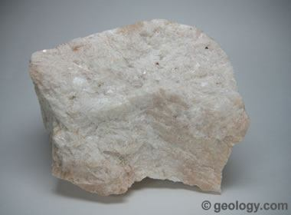
Albite: An igneous rock composed almost entirely of albite. This specimen is from the Petaca District of New Mexico and measures about 4 inches (10 cm) across
- Oligoclase, (Sodium calcium aluminium silicate)
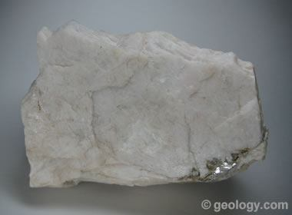
Oligoclase: A cleavage fragment of oligoclase. This specimen is from Mitchell County, North Carolina. It measures about 4 inches (10 cm) across

- Andesine, (Sodium calcium aluminium silicate)
Andesine was named after its original occurrence in the Andes Mountains of South America. Andesine belongs to the Plagioclase Feldspar group, an isomorphous solid solution series. Albite is one member, containing sodium and no calcium. The other end member, Anorthite, contains calcium and no sodium. Andesine is an intermediary member of this series. Andesine is considered by some authorities as a variety of Albite rather than a separate mineral. The acclaimed Dana's System of Mineralogy lists Andesine as an individual mineral, whereas the IMA does not recognize it as individual mineral species, but rather a calcium-rich variety of Albite. Andesine is the primary feldspar constituent of the igneous rock Andesite.
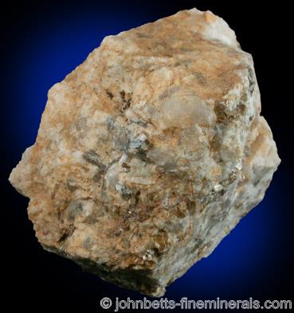
andesine

- Labradorite, (Calcium sodium aluminum silicate)
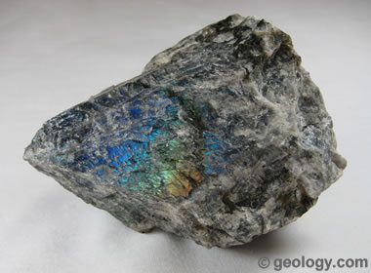
Labradorite: An igneous rock composed almost entirely of iridescent plagioclase. This specimen was found near the town of Nain in Labrador, Canada. It measures about 4 inches (10 cm) across.
- Bytownite, (Calcium sodium aluminum silicate)
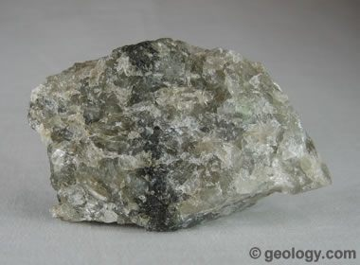
Bytownite: An igneous rock composed almost entirely of bytownite. This specimen is from Crystal Bay, Minnesota, and measures about 4 inches (10 cm) across.

- Anorthite, (Calcium aluminum silicate)
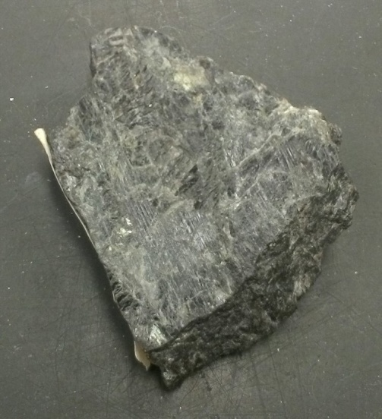
At the dark end of the plagioclase scale is this mineral. It has lots of calcium and little sodium. This is probably Anorthite
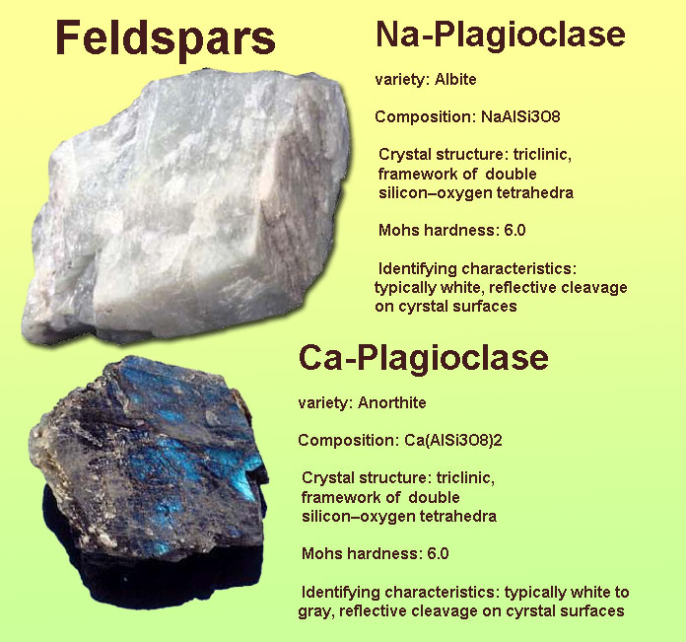

The K-feldspars or alkali feldspars:
- Microcline, (Potassium aluminium silicate)
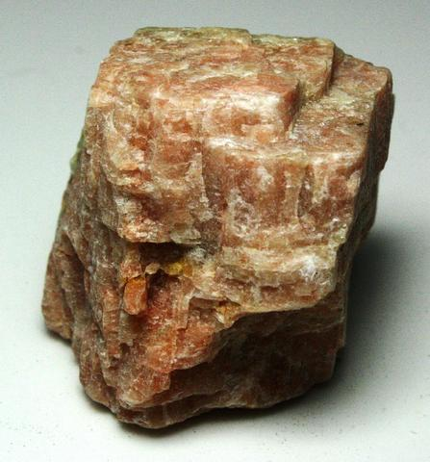
Microcline Feldspar
- Sanidine, (Potassium sodium aluminium silicate)
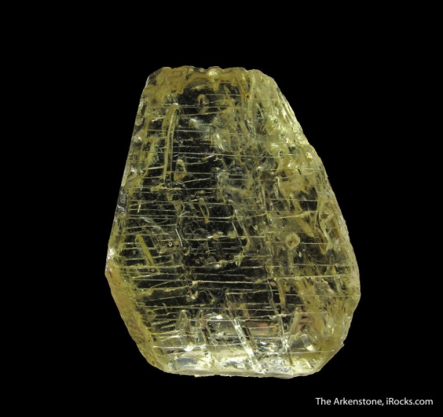
Sanidine
- Orthoclase, (Potassium aluminium silicate)
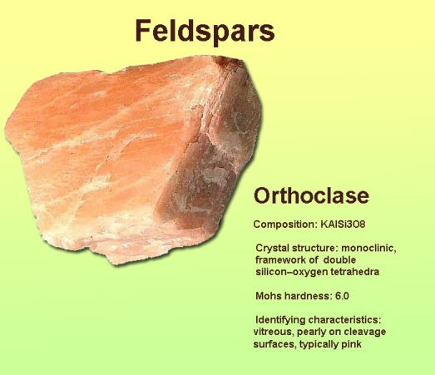
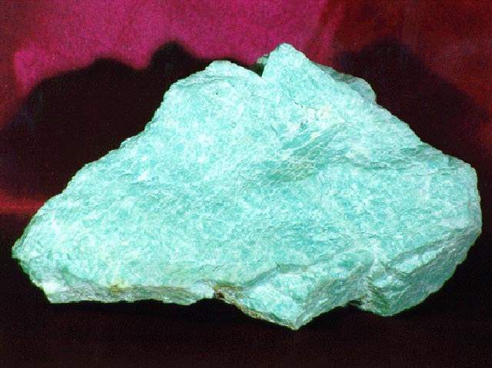
Amazonite is a blue-green variety of orthoclase. It is abundant in pegmatites in Amelia County

- The feldspars are a group of minerals that have similar characteristics due to similar structure. All feldspars have low symmetry, being only monoclinic, 2/m, to triclinic, bar 1. They tend to twin easily and one crystal can even be multiply twinned on the same plane, producing parallel layers of twinned crystals. They are slightly hard at around 6, and have an average density at 2.55 to 2.76. They have a rather dull to rarely vitreous luster. Crystals tend to be blocky. Some feldspars may be triboluminescent.
- They have two directions of cleavage at nearly right angles. Feldspars also tend to crystallize in igneous environments, but are also present in many metamorphic rocks.
- The general formula, for the common feldspars, is XAl(1-2) Si(3-2) O8 . The X in the formula can be sodium, Na and/or potassium, K and/or calcium, Ca. When the cation in the X position has a positive one (+1) charge such as with sodium or potassium, then the formula contains one aluminum and three silicons ions.
- If the formula contains the positive two (+2) cation calcium, then the formula will contain two aluminums and only two silicon ions. This substitution keeps the formula balanced, because aluminum has a charge of positive three (+3) and silicon has a charge of positive four (+4).
- Basically, the more calcium in the crystal, the more aluminum that will be needed to balance the charge. The silicons and aluminums occupy the centers of interlinked tetrahedrons of SiO4 and AlO4.
- These tetrahedrons connect at each corner to other tetrahedrons forming an intricate, three dimensional, negatively charged framework.
- The cations that represent the X in the formula sit within the voids in this structure.
- The different feldspars are distinguished by structure and chemistry. The potassium or K-feldspars are polymorphs, meaning they have the same chemistry, KAlSi3O8, but different structures and therefore are different minerals.
- The plagioclase feldspars are a set of minerals that are in a series from a sodium rich end member, albite, to a potassium rich end member, anorthite. The intermediate members of the series are given arbitrary boundaries based on their percentage of sodium or calcium.
- Often, feldspars are simply referred to as plagioclase and orthoclase (a K-feldspar) because identification to greater precision is difficult with ordinary methods. Once identified, however, some feldspar mineral varieties are found to have distinctive characteristics or originate from a classic locality and on these bases are recognized by mineral collectors as belonging to a specific feldspar mineral.

- STRUCTURE AND CHEMICAL COMPOSITION
The tectosilicates form 3 – dimensional lattices of (Si,Al)0₄- tetrahedra. Each tetrahedron has four corners in common with its neighbours; this lattice continues unrestricted in 3 dimensions. All modifications of Quartz possess this lattice. For the tectosilicates a partly replacement of S_{i +} Al) : 0 = 1:2, while the negative charge corresponds with the amount of Al-ions.
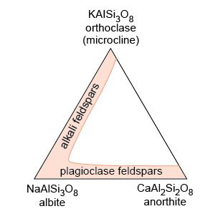
A ternary diagram showing the extent of solid solution in alkali and plagioclase feldspar at high temperatures.
The negative bonds that become available by this, attract alkali-elements into the structure. There are three pure end members:
KAISi₃ 0₈
NaAISi₃0₈
CaAI₂Si₂ O₈
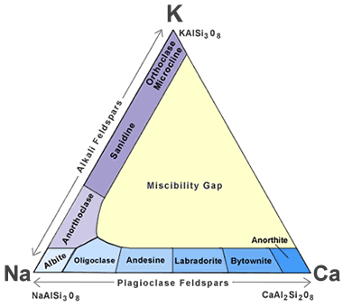
Feldspar mineral classification: This ternary diagram shows how feldspar minerals are classified on the basis of their chemical composition. The sequence of minerals along the left side of the triangle represents the solid solution series of the alkali feldspars. The sequence along the base is the solid solution series of the plagioclase feldspars. Triangular graph paper can be obtained from waterproofpaper.com, a GeoShops.com website.
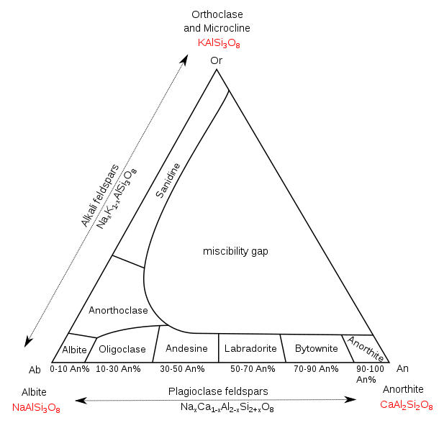
Compositional phase diagram of the different minerals that constitute the feldspar solid solution.

Compared to Quartz S_{i}O₂
In nature mostly the non-pure mixtures between these end members occur. In this the K – rich feldspars stand more or less apart, although usually a certain percentage NaAISi₃O₈ (10 – 25%) is present. It is recommended not to mention just K – feldspar, but rather mention K – rich feldspar. They are being divided according to structure and accordingly connected optical properties:
K – rich feldspars
Sanidine monoclinic (high temp. mineral; in lavas)
Orthoclase monoclinic (low temp. variety: adularia)
Microcline triclinic (low temp. variety: adularia)
Anorthoclase triclinic (high temp. mineral; Na > K)

Plagioclase The plagioclases form an almost perfect solid solution between the Na and Ca end members.
0 – 10% An albite
10 – 30% An oligoclase
Plagioclase 30 – 50% Andesine
50 – 70% labradorite
70 – 90% An bytowni
90 – 100% An anorthite

At high temperature the complete series is stable; at lower temperatures gradually a lower amount of Ca is possible, until at the lowest grade of metamorphosis only albite can be formed. Moreover a large part of the series occurs in both a high temperature and a low temperature form. The high temperature form is found mainly in vulcanites of the Na – rich end members the high-temperature form has practically only been obtained in synthetic ways.

Crystallographic axes
 | α | β | γ | (001)Λ(010)
Monoclinic | 90° | ±116° | 90° | 90°
K-rich feldspar; triclinic | ±90° | ±116° | ±90-92° | ±90°
Plagioclase; triclinic | ±94° | ±116° | ±87-92° | ±94°

The structures of the monoclinic and triclinic feldspars resemble one another strongly, especially within the group of K-rich feldspars.
The difference in situation of crystallographic axes amounts at most 4^{o.}
- CRYSTALSHAPE (Fig. 1)
Except from the difference in the angle (001) Λ.(010), the crystal shapes for the feldspars in the entire group are about the same.
- Microcline and Orthoclase Usually short prismatic and somewhat flattened crystals along (010) fig. 1Aa; also prismatic along the a- axis (pseudotetragonal, fig. Ab). Macroscopically usually translucent or untransparent, white pink or brownish.
- Adularia Often wedge shaped because of the lack of (010) fig. Ad. Often clear in veins. It is a low temperature form and can be hydrothermal.
- Sanidine Mostly plate shaped along (010) fig. Ac. Transparent and little
- = angle between b and c axis etc.
Altered and sometimes distinct cleavage. Beautiful occurrence in sanidine trachytes.
- AnorthoclaseLike orthoclase, but often elongated along c axis.
- Plagioclase Like orthoclase, but (001) Λ (010) = 94⁰. Besides mentioned shapes also elongated along b axis or platy along (010), however mainly different because of other twinning laws. With the handles sometimes, through shining in sunlight, lamellar twins may be seen, which are not present in K – rich feldspars, or in such a tiny structure, that they cannot be noticed. Macroscopically usually duller than K-rich feldspar. Often white, sometimes greenish due to alteration.
NB. In lavas small crystals occur (microlites). Mostly they form small plates along (010) or columns along the a axis. The plate and columnshape can be distinguished from each other by the size of their isometric section.
- CLEAVAGE
Feldspars have two cleavage planes that intersect at 90°. Fragments of pure feldspar crystals thus tend to form rectangular blocks with irregular ends. Feldspars have vitreous lusters and occur in opaque shades of white to gray to pink to very dark gray. Other rarer colors are also possible!
The feldspars are divided into two main groups: Potassium feldspar ("K-spar") and plagioclase ("plag"). Both display two cleavages and an overlapping range of colors, but only plagioclase displays tiny grooves on one cleavage known as striations. The photos below show several examples of feldspar. Click on any photo to enlarge!
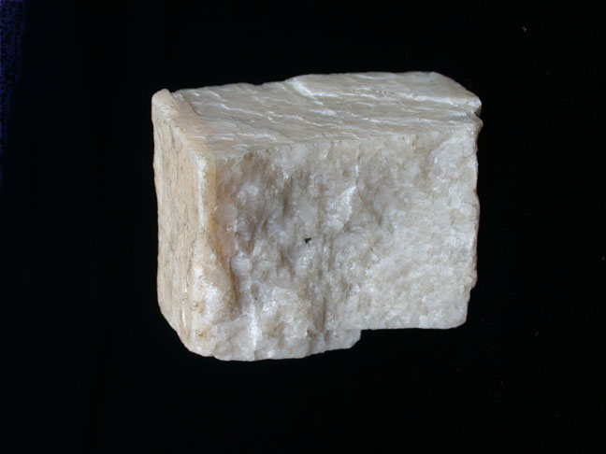
This white feldspar shows two cleavages (top/bottom and sides) plus the fracture surface (front).
Both plagioclase and K-spar are commonly white; the lack of striations suggests that this is K-spar.
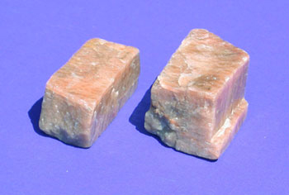
The salmon-pink colour is typical of K-spar. Note the two cleavage surfaces and one fracture surface. There are no striations.
Perfect cleavage along (010) and (001), although not always good visible. The cleavage planes are macroscopically used to distinguish from quartz which doesn’t show cleavage, and to check on possibly presence of twins. Microscopically cleavages are used to measure the extinction angles.

