KIMBERLITE
Kimberlite is a type of potassic volcanic rock best known for sometimes containing diamonds. It is named after the town of Kimberley in South Africa, where the discovery of an 83.5-carat (16.7 g) diamond in 1871 spawned a diamond rush, eventually creating the Big Hole.
Kimberlite occurs in the Earth's crust in vertical structures known as kimberlite pipes. Kimberlite pipes are the most important source of mined diamonds today. The consensus on kimberlites is that they are formed deep within the mantle. Formation occurs at depths between 150 and 450 kilometres (93 and 280 mi), from anomalously enriched exotic mantle compositions, and are erupted rapidly and violently, often with considerable carbon dioxide and other volatile components. It is this depth of melting and generation which makes kimberlites prone to hosting diamond xenocrysts.
Kimberlite has attracted more attention than its relative volume might suggest that it deserves. This is largely because it serves as a carrier of diamonds and garnet peridotite mantle xenoliths to the Earth's surface. Its probable derivation from depths greater than any other igneous rock type, and the extreme magma composition that it reflects in terms of low silica content and high levels of incompatible trace element enrichment, make an understanding of kimberlite petrogenesis important. In this regard, the study of kimberlite has the potential to provide information on the composition of the deep mantle, and melting processes occurring at or near the interface between the cratonic continental lithosphere and the underlying convecting asthenospheric mantle.

Kimberlites share certain chemical properties with highly potassic rocks yet have several distinctive aspects worth of special attention. Because they are the primary source of natural diamonds, their economic importance is considerable. Because of the presence of other high –P crystalline inclusions derived from depths in the mantle where diamond is stable, kimberlites provide an unparallel opportunity to investigate the actual composition and fabric of upper mantle rocks and inn themselves furnish a sample of the sort melts that are generated at these depths. For these reasons, much effort has been devoted to study of kimberlites (Boyd & Meyer, 1979a,b; Ahrens and others, 1975; Nixon, 1973).
Kimberlites have been sporadically emplaced into stable nonorogenic continental platforms especially in Africa and Siberia, since Proterozoic time.
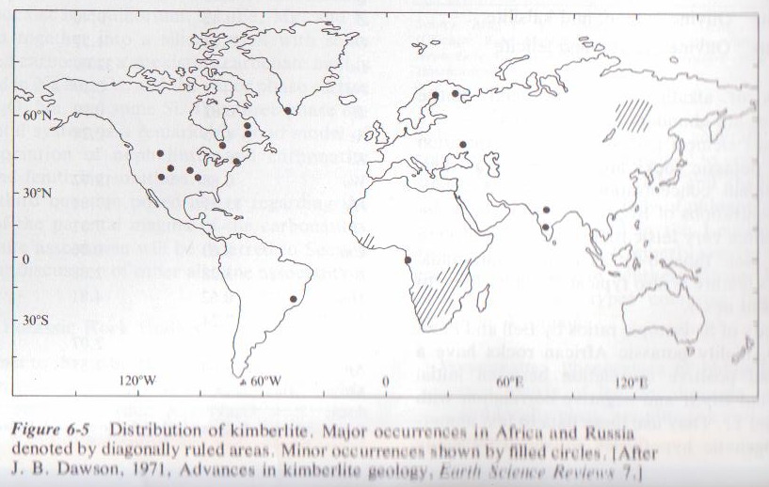
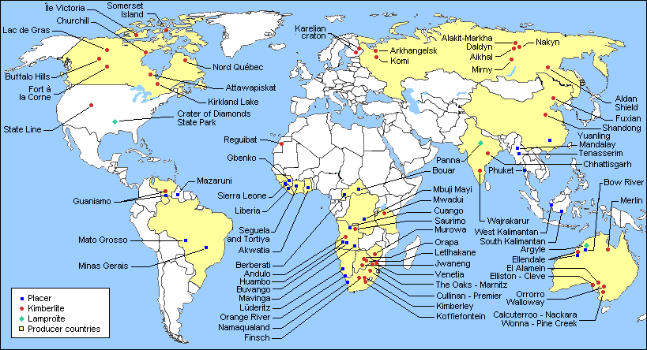
Generally, the significance of any structural control on the occurrence of kimberlite bodies is obscure at the surface, hidden deep crustal or upper mantle structures could govern their site of emplacement.
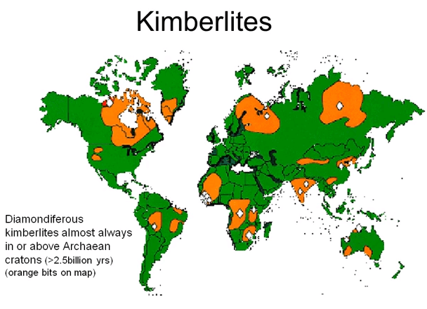
Characteristics
Kimberlites may be defined as a potassic ultrabasic hybrid ingneous rock containing large crystals (megacrysts) of olivine, enstatite, , Cr-rich diopside, phlogopite, pyrope-almandine, and Mg-rich ilmenite in a fine-grained matrix of serpentine, phlogopite, carbonates, perovskite, and other minerals. Not all kimberlites contain diamonds and in those that do, it is a very widely dispersed mineral. The minute concentrations of diamond are attested by the fact that in the famous Kimberly mine, 24 million tons of kimberlite yielded only 3 tons of diamond or one part in 8 million.
Most kimberlite near the surface occurs in pipe-like diatremes. Diatremes of kimberlite are small, generally less than one km² in horizontal area. They tend to occur in clusters and some can be demonstrated in deep mine workings to coalesce at depth with dikes of nonfragmental kimberlite.

Morphology and volcanology
Kimberlites occur as carrot-shaped, vertical intrusions termed 'pipes'. This classic carrot shape is formed due to a complex intrusive process of kimberlitic magma which inherits a large proportion of both CO₂ and H₂O in the system, which produces a deep explosive boiling stage that causes a significant amount of vertical flaring (Bergman, 1987). Kimberlite classification is based on the recognition of differing rock facies. These differing facies are associated with a particular style of magmatic activity, namely crater, diatreme and hypabyssal rocks (Clement and Skinner 1985, and Clement, 1982).
The morphology of kimberlite pipes, and the classical carrot shape, is the result of explosive diatreme volcanism from very deep mantle-derived sources. These volcanic explosions produce vertical columns of rock that rise from deep magma reservoirs. The morphology of kimberlite pipes is varied but generally includes a sheeted dyke complex of tabular, vertically dipping feeder dykes in the root of the pipe which extends down to the mantle. Within 1.5–2 km (0.93–1.2 mi) of the surface, the highly pressured magma explodes upwards and expands to form a conical to cylindrical diatreme, which erupts to the surface. The surface expression is rarely preserved, but is usually similar to a maar volcano. The diameter of a kimberlite pipe at the surface is typically a few hundred meters to a kilometer (up to 0.6 mile).
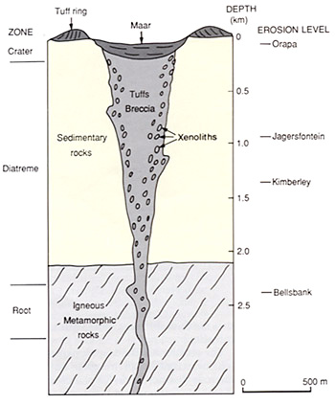

Two Jurassic kimberlite dikes exist in Pennsylvania. One, the Gates-Adah Dike, outcrops on the Monongahela River on the border of Fayette and Greene Counties. The other, the Dixonville-Tanoma Dike in central Indiana County, does not outcrop at the surface and was discovered by miners.^{[1]}

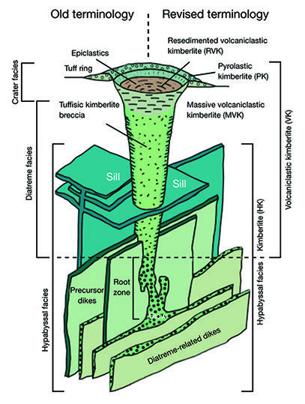

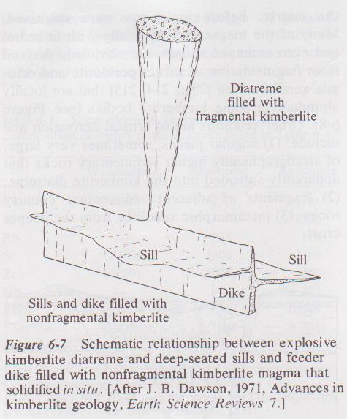
These dikes are thin, less than 10m, but may be as much as 14km long. Dikes and diatremes may be mutually cross-cutting. Flow and cumulate fabrics have been observed in thin sills formed from very fluid, carbonate-rich kimberlite melt.
The hybrid nature o kimberlite is manifest in the rock and mineral inclusions that are commonly present. Because of unquestioned chemical interaction between these inclusions and the matrix, it is difficult to be sure of the composition of the kimberlite melt, now represented essentially by matrix before inclusions were entrained. Many of the megacrysts, typically with anhedral and even embayed shapes are obviously derived from fragmentation of garnet peridotite and ecologite xenoliths that are locally abundant in some kimberlite bodies.

Petrology
Both the location and origin of kimberlitic magmas are areas of contention. Their extreme enrichment and geochemistry has led to a large amount of speculation about their origin, with models placing their source within the sub-continental lithospheric mantle (SCLM) or even as deep as the transition zone. The mechanism of enrichment has also been the topic of interest with models including partial melting, assimilation of subducted sediment or derivation from a primary magma source.
Historically, kimberlites have been subdivided into two distinct varieties termed 'basaltic' and 'micaceous' based primarily on petrographic observations (Wagner, 1914). This was later revised by Smith (1983) who re-named these divisions Group I and Group II based on the isotopic affinities of these rocks using the Nd, Sr and Pb systems. Mitchell (1995) later proposed that these group I and II kimberlites display such distinct differences, that they may not be as closely related as once thought. He showed that Group II kimberlites actually show closer affinities to lamproites than they do to Group I kimberlites. Hence, he reclassified Group II kimberlites as orangeites to prevent confusion.
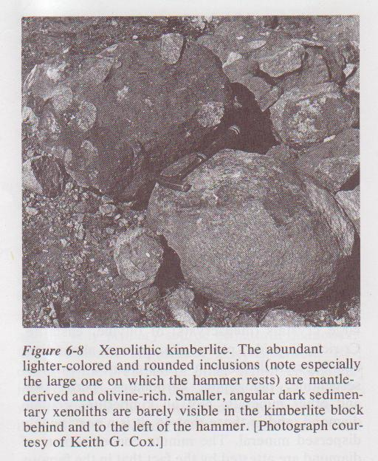
Petrology
Kimberlites are divided into Group I (basaltic) and Group II (micaceous) kimberlites. This division is made along mineralogical grounds.
The general consensus reached on kimberlites is that they are formed deep within the mantle, at between 150 and 450 kilometres depth, from anomalously enriched exotic mantle compositions, and are erupted rapidly and violently, often with considerable CO2 and volatile components. It is this depth of melting and generation which makes kimberlites prone to hosting diamond xenocrysts.
The mineralogy of Group I kimberlites is considered to represent the products of melting of lherzolite and harzburgite, eclogite and peridotite under lower mantle conditions. The mineralogy of Group II kimberlites may represent a similar melting environment to that of Group I kimberlites, the difference in mineralogy being caused by the preponderance of water versus carbon dioxide.

Group I kimberlites
Group-I kimberlites are of CO₂-rich ultramafic potassic igneous rocks dominated by a primary mineral assemblage of forsteritic olivine, magnesian ilmenite, chromium pyrope, almandine-pyrope, chromium diopside (in some cases subcalcic), phlogopite, enstatite and of Ti-poor chromite. Group I kimberlites exhibit a distinctive inequigranular texture caused by macrocrystic (0.5–10 mm, 0.020–0.39 in) to megacrystic (10–200 mm, 0.39–7.9 in) phenocrysts of olivine, pyrope, chromian diopside, magnesian ilmenite and phlogopite, in a fine to medium grained groundmass.
The groundmass mineralogy, which more closely resembles a true composition of the igneous rock, contains forsteritic olivine, pyrope garnet, Cr-diopside, magnesian ilmenite and spinel.

Group-II kimberlites (or orangeites) are ultrapotassic, peralkaline rocks rich in volatiles (dominantly H₂O). The distinctive characteristic of orangeites is phlogopite macrocrysts and microphenocrysts, together with groundmass micas that vary in composition from phlogopite to "tetraferriphlogopite" (anomalously Fe-rich phlogopite). Resorbed olivine macrocrysts and euhedral primary crystals of groundmass olivine are common but not essential constituents.
Characteristic primary phases in the groundmass include: zoned pyroxenes (cores of diopside rimmed by Ti-aegirine); spinel-group minerals (magnesian chromite to titaniferous magnetite); Sr- and REE-rich perovskite; Sr-rich apatite; REE-rich phosphates (monazite, daqingshanite); potassian barian hollandite group minerals; Nb-bearing rutile and Mn-bearing ilmenite.

Kimberlitic indicator minerals
Kimberlites are peculiar igneous rocks because they contain a variety of mineral species with peculiar chemical compositions. These minerals such as potassic richterite, chromian diopside (a pyroxene), chromium spinels, magnesian ilmenite, and garnets rich in pyrope plus chromium, are generally absent from most other igneous rocks, making them particularly useful as indicators for kimberlites.
These indicator minerals are generally sought in stream sediments in modern alluvial material. Their presence may indicate the presence of a kimberlite within the erosional watershed which produced the alluvium.
Geochemistry
The geochemistry of Kimberlites is defined by the following parameters:
- Ultramafic; MgO >12% and generally >15%
- Ultrapotassic; Molar K₂O/Al₂O₃ >3
- Near-primitive Ni (>400 ppm), Cr (>1000 ppm), Co (>150 ppm)
- REE-enrichment
- Moderate to high LILE enrichment; ΣLILE = >1,000 ppm
- High H₂O and CO₂

Economic importance
Kimberlites are the most important source of primary diamonds. Many kimberlite pipes also produce rich alluvial or eluvial diamond placer deposits. Only about 1 in 200 kimberlite pipes contain gem-quality diamonds.
The deposits occurring at Kimberley, South Africa were the first recognized and the source of the name. The Kimberley diamonds were originally found in weathered kimberlite which was colored yellow by limonite, and so was called yellow ground. Deeper workings encountered less altered rock, serpentinized kimberlite, which miners call blue ground.

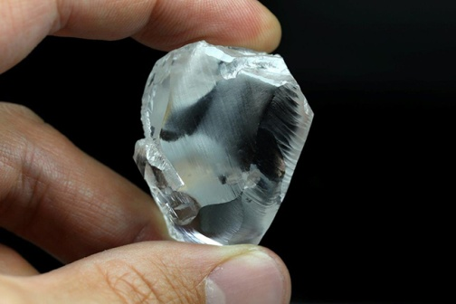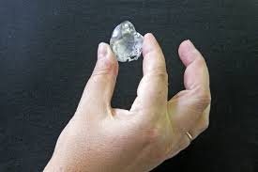

198carate diamond sells for 10.4 million 247 crate diamond

Other xenoliths are of crustal derivation and include: (1) angular pieces, sometimes very large, of stratigraphically higher sedimentary rocks that apparently subsided into the kimberlite diatreme (2) fragments of adjacent sedimentary country rocks (3) metamorphic xenoliths from the deeper crust.
The hybrid character of kimberlite is also reflected in the chemical composition of clean, inclusion-free kimberlite. Some elements such as Cr and Ni, have concentrations similar to typical mantal peridotite. Other constituents including H₂O, CO₂, P₂O, K, Ti, Rb, Sr and Nb – have concentrations similar to those in carbonatites and other highly alkaline rocks.
Emplacement of diatremes
Diatremes are pipes or narrow funnel shaped bodies filled with accidental and gas-charged juvenile magmatic material.
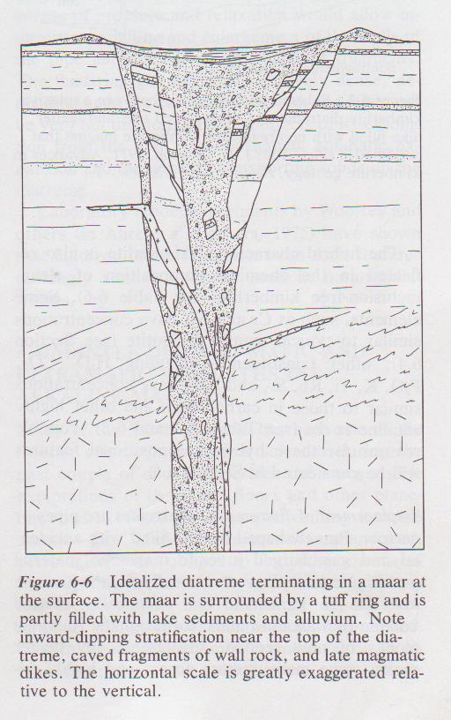
Characteristically, (1) the juvenile material is kimberlite or chemically related volatile-rich alkaline mafic to ultramafic rock (2) blocks of now eroded, stratigraphically higher rock some many metres across and highly friable, are found concentrated around the margin of the pipe, whereas well-rounded and apparently abraded xenoliths from deeper crustal or even upper mantle region tend to be concentration in the center (3) thermal contact metamorphic effects on xenoliths and wall rocks are weak or absent, even on highly susceptible coal and even though kimberlite diatremes in South Africa connect at depth to dikes emplaced as hot magma (4) where connections to the original surface are observable, diatremes terminate in maars and tuff rings (5) fragmental material, especially near the original top of the diateme, may be embedded with inward dips (6)ring faults and subsidence of the diateme filling maybe apparent (7) many diatremes are composite, showing multiple emplacement of fragmental material and of latter intrusion by fluid magma (8)swarms of Tertiary diatremes and maars in Europe and the Colorado Plateaus in Western North American are associated with lake sediments, testifying to abundant surface water during magmatic activity.
It is uncertain whether phreatomagmatic explosions producing the maar in some way trigger formation of an underlying diatreme due to propogation of a decompression wave down the magma column or whether the maar is secondary to the diatreme. Current thinking favours rapid rise of highly gas-charged (CO₂ + H₂O) kimberlitic magma into the crust. Somewhere en route, sufficient gas boils out of the decompressing magma to form an expanded fluidized column that cause upwarping of the overlying lid of rock and eventual rupture, allowing the fluidized mixture of gas and particulate material to erupt. Velocities of particles within the fluidized column may not be great but sufficient internal abrasion might occur to produce the observed rounding of fragments, a convecting and pulsating system with fragments surges of pressure and relaxation would allow intermittent spalling and enlargement of the walls of the pipe and subsidence of wall rock fragments. The fluidizing gas might be relatively dense, depending upon the confining pressure and might not be very hot due to the cooling effects of its exsolution from the melt and consequent adiabatic expansion and the work of transporting solids up the diatreme. Laboratory model experiments by Woolsey and others (in Ahrens and others, 1975) have shown that fluidized intrusive systems can form features strikingly similar to those seen in natural diatremes.
