GGY 4071 | Petrology
Igneous Rocks of the Ocean Basins

The Ocean Basins
The ocean basins cover the largest area of the Earth's surface. Because of plate tectonics, however, most oceanic lithosphere eventually is subducted. Thus the only existing oceanic lithosphere is younger than about Jurassic in age and occurs at locations farthest from the oceanic spreading centers. Except in areas where magmatism is intense enough to build volcanic structures above sea level, most of the oceanic magmatism is difficult to access. Samples of rocks can be obtained from drilling, dredging, and expeditions of small submarines to the ocean floor. Numerous samples have been recovered and studied using these methods. Most of the magmatism is basaltic. Still, few drilling expeditions have penetrated through the sediment cover and into the oceanic lithosphere. Nevertheless, we have a fairly good understanding of the structure of the oceanic lithosphere from seismic studies and ophiolites.
Here we will first look at ophiolites, then discuss basaltic magmatism in general, and then discuss the various oceanic environments where magmatic activity has occurred.
Ophiolites
An ophiolite is a sequence of rocks that appears to represent a section through oceanic crust. Ophiolites occur in areas where obduction (the opposite of subduction) has pushed a section of oceanic lithosphere onto continental crust. During this process, most ophiolite sequences have been highly deformed and hydrothermally altered. Nevertheless, it is often possible to look through the deformation and alteration and learn something about the structure of oceanic lithosphere.

An idealized ophiolite sequence shows an upper layer consisting of deep sea sediments (limestones, cherts, and shales), overlying a layer of pillow basalts. Pillow basalts have a structure consisting of overlapping pillow-shaped pods of basalt. Such pillow structure is typical of lavas erupted under water. The pillow basalts overly a layer consisting of numerous dikes, some of which were feeder dikes for the overlying basalts. Beneath the sheeted dike complex are gabbros that likely represent the magma chambers for the basalts. The upper gabbros are massive while the lower gabbros show layering that might have resulted from crystal settling. | 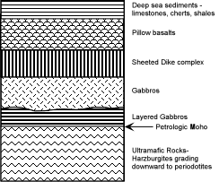

At the base of the layered gabbros there is a sharp increase in the density of the rocks, and the composition changes to ultramafic rocks. This sharp change in density is correlated with what would be expected at the base of the crust, and is thus referred to as the petrologic moho. At the top of the ultramafic sequence the rock type is harzburgite (Ol + Opx), a rock type expected to be the residual left from partially melting peridotite. The base of the ultramafic layer is composed of peridotite. Because most ophiolites have been hydrothermally altered, most of the mafic rocks have been altered to serpentinite. Note that ophiolite means "snake rock".
Volcanic Settings
Volcanism occurs at three different settings on the ocean floor.
- Oceanic Ridges - these are the oceanic spreading centers where a relatively small range of chemical compositions of basalts are erupted to form the basaltic layer of the oceanic crust. This chemical type of basalt is referred to as Mid Ocean Ridge Basalts (MORBs). In some areas, particularly Iceland, where there has been a large outpouring of basalts on the oceanic ridge, basalts called Enriched Mid Ocean Ridge Basalts (EMORBs) have been erupted.
- Oceanic Islands - these are islands in the ocean basins that generally occur away from plate boundaries, and are often associated with hot spots, as discussed previously. A wide variety of rocks occur in these islands, not all are basaltic, but those that aren't appear to be related to the basaltic magmas. In general these rocks are referred to as Oceanic Island Basalts (OIBs).
- Large Igneous Provinces (LIPs) - these are massive outpourings of mostly basaltic lavas that have built large submarine plateaus. Most are mid-Cretaceous in age. They are not well studied, but most have compositions similar to OIBs, and some may have once had oceanic islands on top, but most of these have since been removed by erosion.
Thus, most oceanic magmatism is basaltic, so we will first discuss basaltic magmas in general.

Basalts

Basalt (pronounced /bəˈsɔːlt/, /ˈbæsɔːlt/, or /ˈbeɪsɔːlt/)^{[1][2]} is a common extrusive volcanic rock. It is usually grey to black and fine-grained due to rapid cooling of lava at the surface of a planet. It may be porphyritic containing larger crystals in a fine matrix, or vesicular, or frothy scoria. Unweathered basalt is black or grey.
On Earth, most basalt magmas have formed by decompression melting of the mantle. Basalt has also formed on Earth's Moon, Mars, Venus, and even on the asteroid Vesta. Source rocks for the partial melts probably include both peridotite and pyroxenite (e.g., Sobolev et al., 2007). The crustal portions of oceanic tectonic plates are composed predominantly of basalt, produced from upwelling mantle below ocean ridges.
The term basalt is at times applied to shallow intrusive rocks with a composition typical of basalt, but rocks of this composition with a phaneritic (coarse) groundmass are generally referred to as diabase (also called dolerite) or g

On a chemical basis, basalts can be classified into three broad groups based on the degree of silica saturation. This is best seen by first casting the analyses into molecular CIPW norms (the same thing as CIPW norms except the results are converted to mole % rather than weight %). On this basis, most basalts consist predominantly of the normative minerals - Olivine, Clinopyroxene, Plagioclase, and Quartz or Nepheline.

These minerals are in the 4 component normative system Ol-Ne-Cpx-Qtz, shown here as a tetrahedron. In the tetrahedron, plagioclase plots between Ne and Qtz, and Opx plots between Ol and Qtz. The basalt tetrahedron can be divided into three compositional volumes, separated by planes.  - The plane Cpx-Plag-Opx is the critical plane of silica saturation. Compositions that contain Qtz in their norms plot in the volume Cpx-Plag- Opx-Qtz, and would be considered silica oversaturated. Basalts that plot in this volume are called Quartz Tholeiites. | 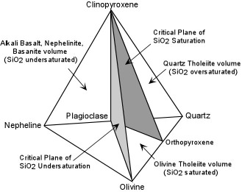

- The plane Ol - Plag - Cpx is the critical plane of silica undersaturation. Normative compositions in the volume between the critical planes of silica undersaturation and silica saturation are silica saturated compositions (the volume Ol - Plag - Cpx - Opx). Silica saturated basalts are called Olivine Tholeiites.
- Normative compositions that contain no Qtz or Opx, but contain Ne are silica undersaturated (the volume Ne-Plag-Cpx-Ol). Alkali Basalts, Basanites, Nephelinites, and other silica undersaturated compositions lie in the silica undersaturated volume.
Note that tholeiitic basalts are basalts that show a reaction relationship of olivine to liquid which produces a low-Ca pyroxene like pigeonite or Opx. Both olivine tholeiites and quartz tholeiites would show such a relationship and would eventually precipitate either Opx or pigeonite.
The critical plane of silica undersaturation appears to be a thermal divide at low pressure. This means that compositions on either side of the plane cannot produce liquids on the other side of the plane by crystal fractionation. To see this, look at the front two faces of the basalt tetrahedron. These are in the three component systems Ol-Cpx-Qtz and Ol-Cpx-Ne. These two faces are laid out side by side in the diagram below.

Experiments conducted on natural basalt compositions were run until liquids were found to be in equilibrium with at least Ol, Cpx, and Plagioclase. Such liquids would plot on a cotectic surface in the four component system represented by the basalt tetrahedron. These compositions were then projected from plagioclase onto the front two faces, shown here, to find the projection of the Ol-Plag-Cpx cotectic (the boundary curve along which Ol, Plag, Cpx, and Liquid are in equilibrium). | 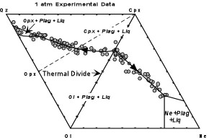

Experimental liquid compositions fairly well define the projection of this cotectic onto the two front faces as seen here.

Although some information is lost in the projection, we can still treat these two phase diagrams in the same way that we treat normal phase diagrams. Note that a composition projecting into the field of Ol + Plag + Liq in the Ol-Cpx-Ne part of the diagram would first crystallize Plagioclase and move onto the plane of projection. Next Ol would precipitate and the liquid composition would change in a direct path away from the Olivine corner of the diagram until it hits the Ol+Plag+Cpx+Liq cotectic. For compositions on this side of the diagram, the liquid composition would then change along the boundary curve until it eventually precipitated Nepheline.
A composition projecting into the Ol-Cpx- Qz triangle, on the other hand, would first crystallize plagioclase then crystallize Olivine. The liquid composition would then move in a direct path away from Olivine until it hit the Ol+Plag+Cpx boundary curve. But these compositions would then follow a path away from the Ol-Cpx join toward the Qz corner of the diagram and would eventually precipitate Opx.
As this experimental data shows, the join Ol-Cpx (which is the projection of the critical plane of silica undersaturation) is a thermal divide at low pressure. Thus, low pressure crystal fractionation of tholeiitic basalts cannot produce silica undersaturated basalts and low pressure crystal fractionation of silica undersaturated basalts cannot produce tholeiitic basalts.
Mantle peridotite, because it contains Opx, would plot in the Ol-Cpx-Opx part of the diagram. Note that at low pressure, only silica oversaturated liquids could be produced by melting such a peridotite. Furthermore, because of the low pressure thermal divide, silica undersaturated liquids could never be produced unless the peridotite had a silica undersaturated composition (i.e. it was Nepheline normative).
High pressure experiments reveal a solution to this problem. In these experiments basaltic material was placed in a sandwich between layers of peridotite. The peridotite sandwiches were then placed in an experimental apparatus at various high pressures and temperatures and then quenched. Compositions of the liquid in equilibrium with the peridotite at various pressures was then determined.

These results are plotted in a somewhat different projection shown here. This plots molecular norms in the triangle Qz-Ol - Ne. This is equivalent to the base of the basalt tetrahedron, where the critical plane of silica saturation is represented by the Opx - Plag join, and the critical plane of silica undersaturation is represented by the Ol - Plag join. All experimental liquid compositions are surrounded by a shaded field indicating the pressure at which the experiments were run. To see how this projection works, let's look at the experiments run at 30 kb pressure. | 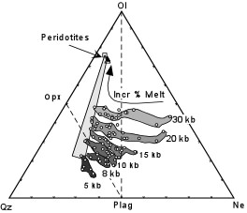

At 30 kb pressure the first liquids to form from melting of peridotite would be those farthest away from the peridotite. Note that these liquids would be highly silica undersaturated.

With increasing degrees of melting the liquid composition would change along a path toward the Ol - Plag join and eventually become silica saturated (they would enter the Opx - Plag - Ol compositional triangle). Eventually both Cpx and Opx in the original peridotite would be used up, leaving only Olivine, at which point the composition of the liquid would change along a direct path toward Olivine until the liquid composition reached the composition of the original peridotite at which point the peridotite would be 100% melted. Melting at other pressures would follow a similar path. With increasing degrees of melting they would change first toward silica saturation then towards the original peridotite.
Note that as pressure is reduced, the lowest degree of melting produces less silica undersaturated melts. In fact, at pressures of 8 and 10 kb the first liquids produced are silica saturated liquids, and at 5 kb the first liquids are silica oversaturated. These experimental results bring out two important points:
- The critical plane of silica undersaturation is a thermal divide at low pressures (less than about 10 kb) and is not a thermal divide at higher pressures.
- Silica undersaturated liquids are favored by high pressure of melting and low degrees of melting. Conversely, silica saturated to oversaturated liquids are favored by higher degrees of melting and low pressure.
We will refer to these two important points in the following discussion of the various oceanic settings.

Mid Ocean Ridge Basalts (MORBs)
Occurrence
The Oceanic Ridges are probably the largest producers of magma on Earth. Yet, much of this magmatism goes unnoticed because, with the exception of Iceland, it all takes place below the oceans. This magmatism is responsible for producing oceanic crust at divergent plate boundaries.

Magma is both erupted and intruded near the central depressions that form the oceanic ridges. Thus, both basalts and gabbros are produced. But, little is known of the gabbros since they are rarely exposed and most oceanic lithosphere eventually is subducted. The main melting mechanism is likely decompression melting as rising convection cells move upward through the mantle beneath the ridges. At most oceanic ridges the basalts that are erupted are tholeiitic basalts sometimes referred to as NMORBs (normal MORBs) | b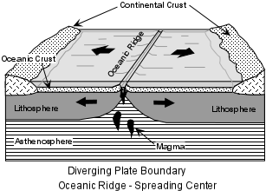

At Iceland, the rate of magma production is so high that volcanism has built the oceanic ridge above sea level. Most of the active volcanism occurs within two central rift zones that cut across the island. Again, the predominant type of basalts erupted are tholeiitic basalts, however, these are somewhat different from NMORBs, showing higher concentrations of incompatible trace elements. Thus, they are often referred to as Enriched MORBs (EMORBs). Unlike normal oceanic ridges, a significant volume of rhyolite is also erupted in Iceland. This was once thought to suggest that continental crust underlies Iceland, but it is more likely that the rhyolites are produced by either crystal fractionation of the basalts or partial melting of the oceanic crust beneath Iceland. | 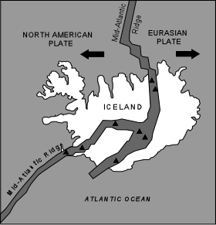

Small volumes of alkali basalt have also erupted in Iceland. This alkaline volcanism occurs on top of the tholeiitic basalts and erupts in areas to the east and west of the main rift zones that cut across the island.

Composition
- Major Elements - We here look at the general major element chemistry of both MORBs and EMORBs.

- At the oceanic ridges, the basalts erupted range in composition from Olivine tholeiites to Quartz tholeiites. The compositions are by and large restricted to basalt, i.e. less than about 52% SiO₂. The diagram shown here is called an AFM diagram. It is a triangular variation diagram that plots total alkalies at the A corner, total iron at the F corner, and MgO at the M corner. As shown, MORBs show a restricted range of compositions that fall along a linear trend extending away from the compositions of Mg-rich pyroxenes and olivines. | 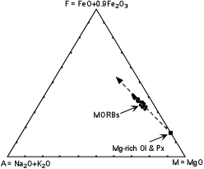

This is the trend that would be expected from fractional crystallization involving the removal of early crystallizing olivines and pyroxenes from a tholeiitic basaltic liquid. Note that the trend is often referred to as an Fe-enrichment trend.

- The rock suite erupted at Iceland shows a much broader range of chemical compositions. While EMORBs predominate, intermediate rocks like icelandites and siliceous rocks like rhyolites also occur. Plotted on an AFM diagram, we see that the EMORBs show a range of compositions that likely result from crystal fractionation of early crystallizing Mg-rich olivines and pyroxenes. With continued fractionation, the liquids follow an Fe enrichment trend to produce the icelandites. | 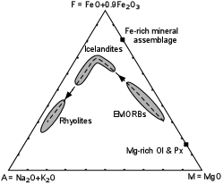

During this sequence the olivines and pyroxenes are expected to become more Fe enriched which would tend to cause the trend to bend somewhat. But at the peak of Fe enrichment it appears that the liquids have become so rich in Fe that an Fe-rich phase, like magnetite, joins the early crystallizing mineral assemblage. Fractionation of this Fe-rich mineral assemblage would then cause Fe to become depleted in successive liquids, driving the liquid compositions toward rhyolite. Thus, crystal fractionation appears to be responsible for the main variety of rocks found at Iceland.
The EMORBs and alkalic basalts found at Iceland are more akin to OIBs, and will be discussed further along with OIBs below. Here we turn our attention to what the major element chemistry of MORBs tells us about their origin.

The projected phase diagram shown here is the system Ol-Cpx-SiO₂, the front face of the basalt tetrahedron. Shown on the diagram is the projected cotectic along which Ol + Plag + Cpx + Liquid are in equilibrium as determined by 1 atmosphere experiments on numerous basalt compositions. Arrows on the boundary curve show direction of falling temperature. Also shown are parts of the Ol + Plag + Opx + Liq cotectic and parts of the Cpx + Plag + Opx + Liq cotectic. Note that these three boundary curves meet at a point on the diagram where Ol + Cpx + Opx would be in equilibrium with liquid. | 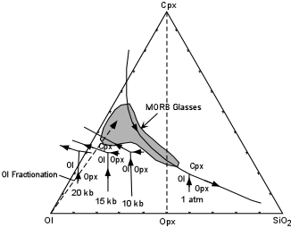

These intersecting boundary curves are also shown at pressures of 10, 15, and 20 kb. Partial melting of peridotite, containing Ol + Cpx + Opx at any of these pressures would first produce liquids with a composition at the intersection of the boundary curves. Note that the composition of the first liquid produced shifts away from the SiO₂ corner of the diagram with increasing pressure.
Since Cpx would be the first solid phase to disappear during melting, further melting of peridotite at any of these pressure would produce liquids with compositions that lie along the Ol - Opx boundary curve at each pressure.
Let's imagine that a liquid is produced at a pressure of 20 kb by partial melting of peridotite. Let's further specify that the melting produces a liquid with a composition at the tip of the arrow on the Ol-Opx phase boundary at 20 kb. If this liquid is then brought to low pressure, near 1 atm. and olivine fractionates, the liquid composition will now change along the dashed line in a direct path away from olivine. Olivine fractionation at low pressure will eventually cause the liquid composition to reach the Ol-Cpx boundary curve. Further fractionation involving the removal of olivine and Cpx will cause the liquid composition to change along the 1 atm boundary curve.
The composition of MORB glasses (likely representing MORB magmas) is shown as a shaded field on the diagram. The variation in the composition of MORB glasses is consistent with Olivine fractionation followed by Ol + Cpx fractionation at low pressure. But, note how the compositions of the most primitive (least fractionated) MORB glasses restrict the pressure conditions under which the primary (unfractionated) MORB glasses could have formed by melting of peridotite. Small degrees of melting at 15 kb could produce liquids that could fractionate by removal of olivine at low pressure to produce the primitive MORB glasses, and higher degrees of melting at pressures from 15 to 20 kb could produce such liquids as well. But, compositions of partial melts of mantle peridotite at pressures less than 15 kb are inconsistent with the composition of MORB glasses. Thus, it appears that primary MORB liquids can only be produced by melting of peridotite at pressures in excess of 15 kb.

- Trace Elements. MORBs typically show a depletion in highly incompatible elements relative to less incompatible elements. This suggests that MORBs are derived from a mantle source that is also depleted in highly incompatible elements. To see this, we here introduce a slightly different kind of trace element diagram.

On the diagram the concentration of each trace element in the rocks (MORBs in this case) is divided by the concentration estimated for the Bulk Earth. The trace elements are plotted in order of decreasing incompatibility, from most incompatible to less incompatible. | 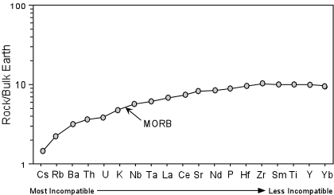

Note that this is similar to the REE diagrams we have discussed previously. In fact representative REEs are included in the diagram (La, Ce, Nd, Sm, & Yb). Note that the most incompatible trace elements are depleted relative to the less incompatible elements. For the REEs this is a LREE depleted pattern. To see why such a pattern suggests that these rocks were derived from a depleted mantle source, we must explore further.

Imagine that we start out with a mantle that has the composition of the Bulk Earth. Such a mantle will have trace element concentrations equal to the bulk earth, and therefore the normalized trace element concentrations will all plot at a value of 1.0 | 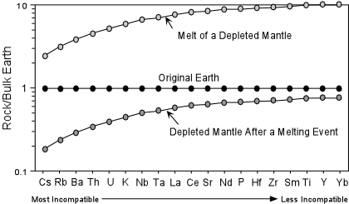

If we melt this mantle, for example to produce early crust, then the incompatible trace elements in the residual rock will show lower values than in the original bulk Earth. The most incompatible elements will show the most depletion. This would produce what we call a depleted mantle. If we melt this depleted mantle the incompatible trace elements will be preferentially partitioned into the melt. At higher degrees of melting, the trace element pattern of the liquid produced will be closely parallel to the depleted mantle source rock, but all concentrations will be higher.
Thus, MORBs, which show a depletion in the most incompatible elements likely formed by melting of a "depleted mantle", that is a mantle that had suffered a melting event sometime in the past. Furthermore, because the MORB pattern is nearly parallel to the depleted mantle, the degree of melting required to produce MORB magmas must have been relatively high (20 - 40%).

- Isotopes - Radiogenic isotopes offer further insight into the origin of MORBs. First consider Sr isotopes. Recall that the parent isotope for ⁸⁷Sr is ⁸⁷Rb. Note that in a depleted mantle the ratio of Rb to Sr will be low because Rb is more incompatible than Sr. Thus, over time a depleted mantle will produce less ⁸⁷Sr than would an undepleted mantle or a mantle that was enriched in Rb relative to Sr. Because of this, a depleted mantle would be expected to show relatively low ⁸⁷Sr/⁸⁶Sr ratios. A mantle with the composition of the Bulk Earth would be expected to have a ⁸⁷Sr/⁸⁶Sr ratio of about 0.7045. MORBs have ⁸⁷Sr/⁸⁶Sr ratios in the range between 0.7020 and 0.7025, all much lower than the Bulk Earth. Therefore, the Sr isotopes are consistent with the idea that MORBs represent melts of a depleted mantle.

Another isotopic system to consider is the Sm - Nd system. Note that both of these elements are REEs. In this system the parent radioactive isotope is ¹⁴⁷Sm. ¹⁴⁷Sm decays to ¹⁴³Nd with a half-life of 106 billion years. Note that in the incompatible element diagram above, the parent Sm isotope in a depleted mantle has higher concentrations than the daughter Nd isotope. Thus, in a mantle depleted in the most incompatible elements at some time in the past will produce more of the daughter ¹⁴³Nd isotope than the original undepleted Bulk Earth composition. Note that this relationship is just the opposite of the Rb-Sr system. ¹⁴⁴Nd is a stable, nonradiogenic isotope of Nd. Thus, the amount of ¹⁴⁴Nd in any rock does not change with time. So, in a depleted mantle, and any magmas derived from melting of such a depleted mantle the ¹⁴³Nd/¹⁴⁴Nd ratio will increase to higher values than in an undepleted mantle of Bulk Earth composition. The ¹⁴³Nd/¹⁴⁴Nd ratio of the Bulk Earth is expected to be about 0.51268.

But ¹⁴³Nd/¹⁴⁴Nd ratios of MORBs show higher values, ranging from 0.5130 to 0.5133. Thus, the ¹⁴³Nd/¹⁴⁴Nd ratios of MORBs are also consistent with their derivation from a depleted mantle.  The isotopic data is summarized in the ¹⁴³Nd/¹⁴⁴Nd vs. ⁸⁷Sr/⁸⁶Sr diagram. Bulk Earth values are shown, along with data for OIBs, continental crust, and oceanic sediments, which will be discussed later. | 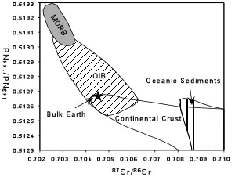

Origin
Here we summarize what we have discussed so far concerning the origin of MORBs.
- Melting is likely caused by decompression of the mantle as it rises beneath the oceanic ridges as a result of convection.
- Primary MORB magmas appear to be produced by partial melting of the mantle at pressures between 15 and 20 kb.
- Most MORBs erupted are not primary melts of the mantle, but instead appear to have suffered olivine fractionation.
- The small range in composition of MORBs can be explained by crystal fractionation of Olivine + Plagioclase + Cpx at low pressures near the surface.
- MORBs appear to be the result of melting of an incompatible element depleted mantle, both in terms of their incompatible trace element compositions and isotopic ratios of Sr and Nd.

Ocean Island Basalts (OIBs)
As discussed previously, the oceanic islands are, in general, islands that do not occur along the divergent or convergent plate boundaries in the ocean basins. Nevertheless, EMORBs, such as those that occur in Iceland, as well as the Alkalic basalts of Iceland have much in common with magmas erupted in the oceanic islands. In the Atlantic Ocean, which is a slow-spreading oceanic basin, as well as in the Galapagos Islands of the eastern Pacific Ocean, some of the islands occur close to oceanic ridge spreading centers.
In all cases we must keep in mind that the parts of these islands that are accessible for sampling represent only a fraction of the mass of the volcanic structures which rise from the ocean floor at depths up to 10,000 m. Thus, as with the ocean ridge volcanic rocks, there is a potential sampling problem.
Here we discuss not only the magmatism that has occurred recently at Oceanic Islands, but also the magmatism that produced massive submarine plateaus on the sea floor during the Cretaceous. The latter are often referred to as Large Igneous Provinces (LIPs).
Oceanic Islands
Most oceanic islands appear to be related to ascending plumes of hot mantle. These plumes must be relative narrow features because they appear to operate independent of the main convection cells that ascend beneath the oceanic ridges and descend at subduction zones. Still, in places like Iceland on the ocean ridge, magma production rates are high, and compositions of rocks are similar to those found in oceanic islands. So Iceland could also be considered an oceanic island.
If these rising plumes of hot mantle remain stationary in their positions in the mantle, they produce hot spots, as discussed previously. Hot spots are most recognizable when they occur beneath plates that move with higher velocities. Beneath faster moving plates, like the Pacific Plate, this results in linear chains of islands.

At the position directly over the hotspot, rising mantle melts to produce magma that erupts on the seafloor, eventually building a volcanic island directly over the hot spot. As the lithospheric plate moves over the hot spot the volcano eventually is cut off from its source of magma, and becomes extinct, and a new volcano forms on the plate at the location directly above the hot spot. | 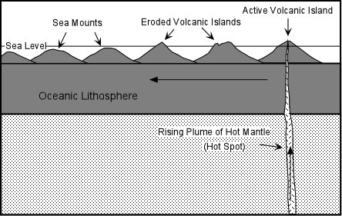

The volcanoes that have moved away from the hot spot eventually begin to erode until their elevations are reduced below sea level. At this point they are called seamounts.

Such linear chains of islands and sea mounts are most evident in the Pacific ocean. The largest of these is the Hawaiian - Emperor chain. The hot spot that produced this chain is currently located under the position of the big island of Hawaii, which has the only currently active volcanoes in the chain. The bend in the Hawaiian-Emperor chain must have resulted from a change in the direction of plate motion. Volcanic rocks dredged from the sea floor at the location of this bend are about 40 million years old. Thus, prior to 40 million years ago the Pacific Plate was moving in a more northerly direction. The most northerly seamount is dated at about 60 million years. Seamounts older than 60 million have apparently been subducted. | 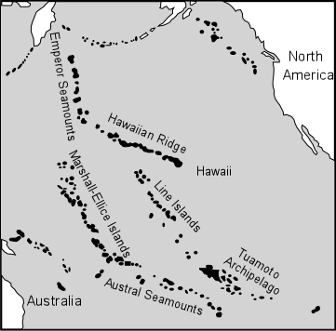

The reason such island/seamount chains are not as evident in the other oceans is because the plate velocity is lower and volcanoes tend to remain over the hot spots for longer periods of time, building elongated groups of islands rather than linear chains.

Large Igneous Provinces (LIP)s
Large igneous provinces are areas where large volumes of magma have been added to the Earth's crust over relatively short periods of time. Although here we discuss these in terms of the ocean basins, it should be noted that they also include the continental areas where large volumes of magma have been erupted as flood basalts. Eruption of large amounts of magma on the surface of the Earth can have drastic consequences. For example:
- The magmas may release large amounts of CO₂ gas into the atmosphere and force global warming.
- Large amounts of magma erupted on the seafloor change the volume of the ocean basins causing higher sea level and flooding large areas of the continents.
The mid Cretaceous Period was a time of higher than normal global temperatures and high stands of the oceans. Eruption of magma on the ocean floor at this time might have been the cause of these conditions. Evidence is preserved on the sea floor in the form of large submarine plateaus that were emplaced during this time period.

The map shows a plate tectonic reconstruction at 83 million years before the present. The dark shaded regions show the locations of submarine oceanic plateaus emplaced between 125 and 80 million years ago. Most of these were produced at the oceanic ridges, shown as dark lines, and moved outward from the ridges. These plateaus are numbered and listed in the table below. | 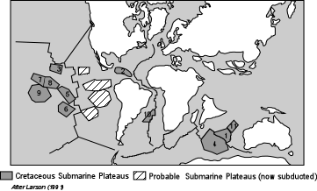

Number | Name | Age (my) | Volume (10⁶ km³)
1 | Broken Ridge | 90 - 110 | 5.19
2 | Caribbean | 75 - 90 | 20.41
3 | Hess Rise | 95 - 115 | 7.78*
4 | Kerguelen Plateau | 90 - 110 | 24.86
5 | Line Islands | 75 - 85 | 10.01
6 | Manihiki Plateau | 115 - 125 | 10.4*
7 | Macus Wake Seamounts | 90 - 115 | 30.85*
8 | Mid Pacific Mountains | 75 - 130 | 42.94*
9 | Ontong-Java Plateau | 100 - 125 | 101.35*
10 | Rio Grande Rise | 85 - 90 | 7.76
11 | Wallaby Plateau | 110 - 125 | 1.49
*Volumes doubled to account for possible twin plateaus that have been subducted.

In the Pacific Ocean, much of the oceanic lithosphere east of the position of the ridge 80 million years ago has been subducted. Thus, if the submarine plateaus formed at the ridge, then it would be expected that half of each plateau became separated at the ridge and have since been subducted. These probable plateaus are shown in the map, and if they were present would double the original size of the plateau. Thus, for example the largest of the plateaus is the Ontong-Java Plateau, now located in the southeastern Pacific, with a volume of about 50 million km³. But if the other half had been present, the total volume of magma erupted over a 25 million year period would have been over 100 million km³.
The few studies that have looked at the rocks in these submarine plateaus suggest that their compositions are similar to EMORBs and OIBs.

Composition
Unlike the ocean ridges, which have a rather limited range of rock compositions, the oceanic islands have produced a broader range. Basalts are still predominant, but other compositions are part of the series, and the types of rocks produced are variable from one island to the next. The table below shows that variety of rock types found at different oceanic islands. Some produce tholeiitic rocks similar to EMORBs and others produce alkalic basalts that are saturated to undersaturated with respect to silica.

Oceanic Island Rock Suites
Island or Group |  | Rock Types
Ascension |  | Oliv. Tholeiite (dominant) + Hawaiite + Mugearite + Trachyte + Peralk. Rhyolite
Azores |  | Alk. basalt + Hawaiite + Trachyte
Fernando de Noronha |  | Alk. Basalt + Nephelinite + Trachyte + Alkali Basalt + Trachyte + Phonolite
St. Helena |  | Alk. Basalt + Mugearite + Hawaiite + Trachyte + Phonolite
Trinadade |  | Nephelinite + Phonolite (dominant)
Tristan de Cunha |  | Alk. Basalt + Trachybasalt (dominant) + Trachyte
Gough |  | Alk. Basalt + Ol Tholeiite + Hawaiite + Trachyte
Réunion |  | Ol Tholeiite (dominant) + Mugearite
Mauritius |  | Alk. Basalt (dominant) + Mugearite + Phonolitic Trachyte
Hawaii |  | Tholeiite (dominant) + Alkali Basalt + Hawaiite + Mugearite + Trachyte
Tahiti |  | Alk. Basalt + Mugearite + Hawaiite + Trachyte
Galapagos |  | Tholeiite + Alk. Basalt + Icelandite (minor) + Qtz Trachyte (minor)
Jan Mayen |  | Alk. Basalt (dominant) + Trachyte
 | - Major Elements. For those islands that produce tholeiitic basalts, the range of compositions is similar to those that occur in Iceland. The more alkaline suites show a somewhat different range of rock types.

Shown here is the more common alkaline suite produced at oceanic islands. The most basic rocks are alkaline basalts that show a range of compositions and an Fe-enrichment trend that likely results from fractionation of Mg-rich olivines and pyroxenes. As these magmas become more enriched in iron, hawaiites are produced. The fractionating assemblage then becomes more Fe-rich, likely caused by the addition of magnetite to the crystallizing assemblage. This causes an Fe-depletion trend causing magmas to evolve to mugearites, benmoreites or trachytes, and eventually rhyolites and/or peralkaline rhyolites. | 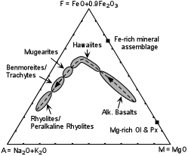

Perhaps not typical of all oceanic islands, but certainly the most well studied oceanic islands are the Hawaiian Islands. The main portion of each of the islands exposes tholeiitic basalts which appear to make up the most volume.

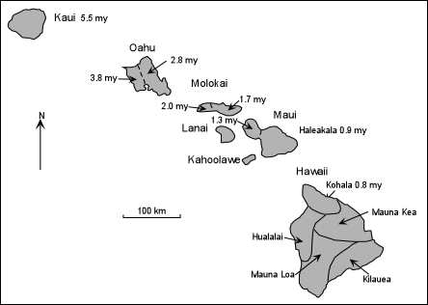

At the northwestern end of the island chain is the island of Kauai. Tholeiitic volcanism built Kauai about 5.5 million years ago. As one moves to southeast along the chain the age of tholeiitic volcanism becomes younger, occurring at 3.8 and 2.8 million years ago on Oahu, 2 and 1.7 million years ago on Molokai, and 1.3 and 0.9 million years ago on Maui.
The big island, Hawaii, is composed of 5 major volcanoes. The oldest is Kohala whose tholeiitic shield was built about 800,000 years ago. Hualalai and Mauna Kea are somewhat younger, and Mauna Loa and Kilauea are still actively erupting tholeiitic lavas.
Although the lower parts of Mauna Kea, on the big island, and Haleakala on Maui are composed of tholeiitic basalts, they are capped by steeper sided composite cones that consist of alkali basalts, hawaiites, mugearites, and trachytes. These alkaline caps are thought to have existed on top of the tholeiitic shields that make up the older islands, but the alkaline rocks have been eroded.
The island of Oahu is deeply eroded, but recent volcanism has occurred on the eroded shield. This post-erosional volcanism, as it is called, consists of highly alkaline basanites and nephelinites.
In terms of total alkalies and silica the three suites of rocks each show trends of increasing alkalies with increasing SiO₂.

In basic magmas the alkaline elements K and Na behave as incompatible elements, so crystallization of Mg & Fe- rich phases tends to cause both SiO₂ and alkalies to increase. Thus the general trends are consistent with crystal fractionation as a mechanism to explain chemical variation in each suite. | 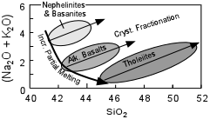

The least siliceous rocks of each suite show a trend of decreasing alkalies with increasing SiO. Again, because the alkali elements are incompatible in mantle mineral assemblages this could be explained by increasing degrees of partial melting. But, in the Hawaiian Islands, the tholeiitic magmas are produced first. During the tholeiitic stage the volcanoes are located directly over the rising mantle plume the forms the hotspot. In this area we might expect higher mantle temperatures and thus higher degrees of melting to produce tholeiitic magmas.
As the island moves away from a position directly over the hotspot the temperatures in the underlying mantle would be lower, but the rising plume at the hot spot could still drive the somewhat cooler mantle upward. Because the temperatures are lower, lower degrees of partial melting would be expected, and the slightly more alkaline magmas would be produced and erupt to form the alkalic caps such as seen at Mauna Kea and Haleakala.

Finally, after the passage of several million years the volcano has moved farther away from a position above the hotspot, and thus temperatures are even lower. Melting of the mantle at this lower temperature would result in lower degrees of melting to produce the very alkali-rich basanite magmas.
If this is the case we might expect a symmetrical distribution of magma types being produced on both sides of the hotspot. The difference, of course, would be that volcanism on the plate before it has reached the hotspot would only occur on the seafloor, because the volcanic island will not yet have been built. The only evidence presently available to support this idea is that just to the southeast of the big island there is currently an active submarine volcano called Loihi seamount. Chemical compositions of lavas erupted from Loihi are alkali basalt.
- Trace Elements. In comparison to MORBs, the OIBs and EMORBs show generally higher concentrations of the most incompatible elements. Consistent with the discussion above concerning the alkali elements, alkaline basalts have higher concentrations of incompatible elements than do the tholeiitic basalts erupted at the oceanic islands.

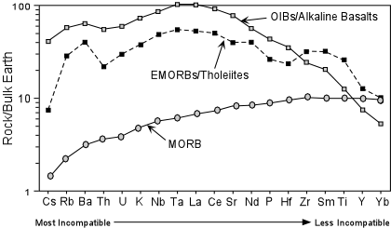

Two factors could account for these observations.
  - The mantle source of the EMORBs and OIBs is apparently enriched, or at least not as depleted, in incompatible trace elements than the depleted mantle source of MORBs.
  - Lower degrees of partial melting of the mantle would produce higher concentrations of the highly incompatible elements. The more alkali and incompatible element rich alkaline magmas would result from lower degrees of melting than the less alkali- and incompatible element rich OIBs/Alkali Basalts.

- Isotopes. Isotopic ratios of OIBs (including EMORBs and lavas forming the LIPs in the oceans) show higher values of ⁸⁷Sr/⁸⁶Sr and lower values of ¹⁴³Nd/¹⁴⁴Nd than MORBs. This indicates that the mantle source for the OIBs is enriched in Rb relative to Sr and enriched in Nd relative to Sm. Such a mantle source is often termed an "enriched mantle source". This isotopic data is consistent with the trace element data we looked at above.

Note that on the diagram OIBs lie on a mixing trend between MORBs and continental crust or oceanic sediment (most oceanic sediment is derived from continental crust). This suggests that continental crust may somehow be involved in mixing with the depleted MORB magmas to produce the more enriched OIB magmas. One possibility would be that the magmas originally start out as depleted MORB-like magmas and assimilate continental crust or oceanic sediment before reaching the surface. But, direct assimilation of continental crust can be ruled out because the OIBs are erupting through oceanic crust where no continental crust is present. Similarly contamination with oceanic sediment is unlikely because, even though ocean sediment exists in the deep ocean basins, the OIB magmas are not likely to come in contact with much sediment because they are passing through large volcanic structures to reach the surface of the island. Another alternative is that the mantle source of OIBs is mixture of a depleted mantle a mantle that has been enriched in some way by interaction with continental crustal material. How this could happen will be considered below in our summary discussion of OIBs.

Origin
Here we summarize the data we have discussed so far concerning the origin of OIBs.
- Melting is caused by decompression of the mantle as it rises in narrow plumes beneath the oceanic islands.
- Melting probably takes place at relatively low pressure to produce silica saturated tholeiitic magmas, but at high pressure to produce the silica undersaturated varieties such alkali basalts, basanites and nephelinites

- These basic magmas evolve by crystal fractionation to produce a wide variety of other rock types including hawaiites, mugearites, trachytes, and rhyolites. The more silica undersaturated basanites would fractionate to produce nephelinites and phonolites.
- Lower degrees of melting produce the most incompatible element rich magmas, like basanites, while successively higher degrees of melting could produce the alkali basalts and tholeiitic basalts.
- OIBs (including EMORBs) appear to be the result of melting of an incompatible element enriched mantle, both in terms of their incompatible trace element compositions and isotopic ratios of Sr and Nd.

One recent theory on how the enriched OIB mantle source could be generated suggests that oceanic sediment (derived from the continents) is carried deep into the mantle by the subduction process. Because subducted lithosphere is cold and dense it may continue to sink into the mantle and eventually reach the core/mantle boundary. In doing so, the subducted material carries some oceanic sediment that is enriched in incompatible trace elements and has high ratios of ⁸⁷Sr/⁸⁶Sr and low ratios of ¹⁴³Nd/¹⁴⁴Nd. | 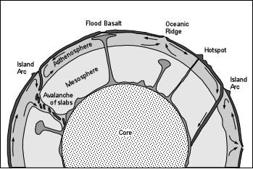

This enriched component mixes with the mantle near the core/mantle boundary to produce an enriched mantle. The enriched mantle eventually heats up as a result of heat released from the Earth's core. When it is sufficiently hot it begins to rise in narrow plumes that channel the enriched mantle upward and produce hotspots as they rise through the asthenosphere, eventually melting to produce the variety of OIBs and EMORBs erupted from oceanic islands..

Examples of questions on this material that could be asked on an exam
- Define the following: (a) ophiloite sequence, (b) ocean ridge, (c) oceanic island (d) Large Igneous Province.
- Draw the basalt tetrahedron and lable all planes and volumes within it.
- What conditions favor generation of silica undersaturated magmas from melting of the mantle?
- Which suites of volcanic rocks would you expect to find in each of the following settings (a) oceanic ridge, (b) oceanic island, (c) LIP?
- Compare MORBS and OIBS in terms of their trace element and isotopic composition (draw diagrams if necessary).
- What is the difference between an "enriched" mantle and a "depleted" mantle?
- Which suites of volcanic rocks occur in the Hawaiian Islands and how are they
- explained (draw diagrams if necessary).

