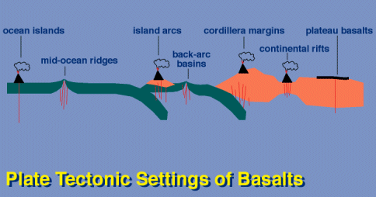
The following summary of the geology of basalts is modified from the material presented on a web page for an Igneous Petrology course at University College (London University). The original material was written by Ruth Siddall of UCL. The first half of this summary (to the end of the section entitled Ophiolites), is the most relevant.
Source: http://www.ucl.ac.uk/~ucfbrxs/B164/Plates.htm

BASALTS
Basalts occur in every tectonic environment, so we need to know a little more about them before we can successfully use them as indicators of tectonic and magmatic processes. Four main environments where basalts occur are defined;
- at mid-ocean ridges
- on ocean islands
- on oceanic or continental crust above subduction zones
- on continental crust away from subduction zones.
There are also four broad classifications of basalts to cover their compositional ranges;

· MORB (mid-ocean ridge basalt) - the most abundant volcanic rock type, it makes up much of the upper oceanic crust. The dominant minerals are olivine and Ca-plagioclase, clinopyroxene is rare. Characterized by low concentrations of incompatible elements. (a.k.a. Olivine tholeiites)

· OIB (ocean island basalts) - typical of the Hawaiian and Icelandic volcanoes, these are olivine-tholeiites, having Ca-plagioclase, pyroxenes and ± olivine. They are enriched relative to MORB in volatiles, alkali and incompatible elements.

· Island arc and continental tholeiites - are less mafic and more siliceous than MORB. Associated with flood basalts. They contain plagioclase and clinopyroxene, with less common olivine. Continental tholeiites are enriched in alkalis relative to island arc tholeiites.

· Alkali basalts - enriched in alkali elements, contain nepheline or analcite; alkali-olivine basalts, basanites.

EXTENSIONAL PLATE TECTONIC SETTINGS
Mid-Ocean Ridges (Oceanic Rifts - spreading centres)

Over the last 200 m.y. (ie. since the Jurassic) spreading at ocean ridges has created the entirety of the Earth’s oceanic crust, almost 70% of the total Earth’s surface. All older oceanic crust has been consumed by subduction. Ridges spread at rates of around 5-10 cm/yr. They are the main zones of heat loss for our planet, and ridge-push is the dominant force, over slab-pull, for continuing the motion of the plates.

Ridges have a definite geomorphology, forming a chain of undersea mountains 2-3 km higher than the surrounding abyssal plains (most of the abyssal plains are 4-5 km deep). Along the centre of the chain there is a rift valley, usually around 1 -1.5 km deep and 30 - 50 km wide. The depth and width of these rift valleys is mainly dependent on the rate of spreading of the ridge. Fast spreading ridges like the East Pacific Rise have narrow, shallow or even no median rifts and are characterized by a smooth topography, whereas slow spreading ridges like the Mid Atlantic Ridge have broad, deep median rifts and are characterized by very rugged topography. The water depth makes the features of mid-ocean ridges difficult to observe and therefore it is only recently that we have begun to learn about them.

The igneous rocks are characterized by basalts, specifically MORB, petrologically olivine-tholeiites. These have a strong mantle derived geochemical signature and they are actually sourced from the anomalously high-level mantle upwelling beneath the rift. These sea-floor basalts are erupted as sheet flows and pillows. Texturally they are characterized by glassy, rapidly cooled margins and a fine grain size (aphanitic - cryptocrystalline) also indicative of rapid cooling. Phenocrysts of plagioclase and olivine and occasionally, but rarely clinopyroxenes occur, but are not common. Geochemically, MORBs are fairly uniform.

Pyroclastic rocks are rare, but one type is relatively common. It is a breccia of angular, wedge-shaped fragments of pillow lavas called a hyaloclastic breccia. The pillows will break up along their radial cooling cracks to form this material.
The lavas are fed sporadically from a magma chamber lying only a kilometre or so beneath the crust. The lava is channeled to the surface by dykes and so technically fissure eruptions will occur, although these are very different from the fissure eruptions we see on land, i.e. in Iceland. Evidence for permanent axial magma chambers is sketchy. There is no way a single long and thin magma chamber can exist along an entire ridge system. In actual fact, a series of magma chambers with an elongate, sausage shape occur along the ridge, about 1-2 km wide and 4-5 km long. These expand and deflate with pulse of magma. As the ridge is spreads, magma chambers become successively intruded by new magma chambers, and the old ones get pushed away from the heat source and solidify as gabbros. As magma is constantly intruding pre-existing chambers, contact relationships are rarely seen. There is a gradation between one gabbro intrusion and the next.

Much of our knowledge about the magmatic processes active beneath MORs comes from geophysical surveys, especially gravity. Further information has been gleaned from ophiolite complexes (see below).

Alteration
The marine environment makes sea-floor basalts incredibly susceptible to alteration. Alteration occurs as a result of continual contact with seawater and also the circulation of hydrothermal fluids sourced from the shallow magma chambers. This later case is often called seafloor metamorphism.

Common alteration by seawater transforms olivine tholeiite basalts into spilites. These have undergone an ion-exchange reaction with the seawater, whereby the Ca from the plagioclases is replaced by Na (from sodium chloride, sea salt). The effect is that the basalts now have an albite-rich rather than anorthite-rich composition to the plagioclases. The lost calcium is frequently seen, infilling vesicles and fractures with calcite.

Seafloor metamorphism reduces basalts to greenschist mineral assemblages. This will be further explained when we look at metamorphism, but new minerals (green minerals) are developed, namely chlorite, epidote and actinolite (an amphibole). Ferro-magnesian minerals like olivine and pyroxenes will be altered to serpentine and associated clay minerals. Serpentinite the rock is not monomineralic, but an intimate mixture of serpentine-family clays, iron oxides, iron-rich clays and other minerals like talc and fibrous amphiboles. These phases are generally too fine grained to discern with an optical microscope.

Ophiolites
Evidence of oceanic crust prior to the Jurassic comes mostly in the form of ophiolites. These are slices of oceanic crust that have been emplaced on land during collision of plates. As a result we often see cross sections through the seafloor, the fossil magma chambers and the mantle below. Such sequences are called ophiolite complexes. Occasionally the phrase “Alpine ultramafic complexes” is used because these rock bodies were first described in areas affected by the Alpine Orogeny. The classic example is the Troodos Ophiolite in Cyprus. As these rock bodies are tectonically emplaced, deformation within them disrupts the structure so that no two ophiolites are the same, many missing key features. The process by which oceanic crust is emplaced on continental crust is called obduction. The Lizard Complex in Cornwall and the Ballantrae Complex in the Southern Uplands of Scotland are the two ophiolitic complexes in the UK. In both cases, the sequences are incomplete.
Ophiolite complexes are divided into six layers, all of which may or may not be observed. The top layer representing the fossil sea-floor is characterised by deep sea sediments like chert. Below that is a layer of pillow basalts, and below that the sheeted dyke layer. These latter represent the conduits which would have fed the basalts from the magma chamber to the sea floor. As the ridge spreads, dykes intrude dykes (at a rate of ~ 1 dyke every 50 years) so no country rock exists, just dykes. Below the sheeted dyke swarm lies the relicts of the magma chambers. These are gabbros. Towards the top of the chamber they are homogenous, but towards the bottom, they become rich in cumulates of ultramafic minerals like olivine and pyroxene. It is within these cumulate zones that the Seismic Moho is defined. At this point there is a marked increase in seismic wave velocity. Beneath the gabbros lies the true mantle, which in ophiolites is developed as ultramafic, ultrabasic rocks like dunites (ol peridotite), lherzolites (ol + opx + cpx peridotite) and harzburgites (ol + opx peridotite). These are almost always transformed to serpentinite, and fresh peridotite is rare. The transition from crustal plagioclase bearing rocks to plagioclase-free olivine and pyroxene rocks is called the Petrological Moho. Thereby the crust-mantle boundary is described slightly differently depending on whether you are a petrologist or geophysicist. As it is better to be good at both, both Mohos should be acknowledged and recognised.

Continental Extension
Continental rift zones are discrete regions of extension in the continental crust which may or may not become sufficiently thin to cause continents to split and form new ocean crust. The Atlantic Ocean formed as a direct result of continental rifting in the supercontinent Pangea in the early Triassic. Other rifts fail, they extend a little, thinning the continental crust and then the forces are removed and extension ceases. Such features are called aulacogens.
The mode of extension in continental rift zones also varies. As a result rifts have been divided into two categories, active and passive. Characteristically active rifts are associated with large amounts of magmatic activity and passive rifts with little or no magmatic activity.

The best-studied example of a present day active rift is the East African Rift (EAR), part of the Afro-Arabian Rift System (the Great African Rift). In fact this system shows the entire process of early continental rifting grading into the formation of new ocean crust and a mid-ocean ridge in the Red Sea and Gulf of Aden. Other examples of active rifts are the Rio Grande Rift of New Mexico, USA, and the Benue Trough, Cameroon. Passive rifts include The Rhone-Rhine Grabens and North Sea system (N. Europe) and the Baikal Rift, Siberia.
The magmatism associated with continental rift zones is varied but often expressed as explosive volcanism with pyroclastic products dominating, associated with trachytic, rhyolitic and phonolitic lavas. Chemically, the rocks range from alkali-basalts to SiO2-undersaturated basanites, nephelinites and leucitites (essentially they tend o be enriched in the alkali elements sodium, Na, potassium, K and even calcium, Ca) and is therefore bimodal in chemistry, basaltic-alkaline. As a rule of thumb, the rocks become more basaltic with increasing crustal extension.
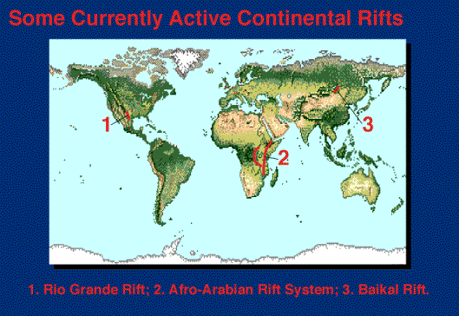
Because the East African Rift is the best present day example, we shall use it as a case study to illustrate the character of magmatism associated with continental extension.
The East African Rift - some facts
- extends along a N-S axis from Gulf of Aden coast in Ethiopia to Mozambique, 3,700 km long.
- the valley is on average 80 km wide, flaring to 480 km in the Ethiopian Triple Junction region.
- splits into two rift valleys, the West African Rift and the Gregory Rift in the Uganda, Kenya and Tanzania region.
- the largest known volumes of magmatism, 500,000 km3 in Kenya and Ethiopia alone.
- formed from phases of extension in the late Eocene (44-38 Ma), middle Miocene (16-11 Ma) and Plio-Pleistocene (5-0 Ma).
- spreading rate since the Miocene averages out at 1 mm yr-1, from crustal extension in Ethiopia (30 km), Kenya (10 km) and Tanzania (2-3 km). Contrast this rate with 10 cm yr-1 on the East Pacific Rise MOR.
- still active.
The volcanoes of the East and west African Rifts are typically stratovolcanoes like Oldoinyo Lengai and Mt Kenya, with a few large caldera structures (Ngorongoro Crater).

The volcanism associated with the western rift is highly potassic lavas, those rich in leucite. The Gregory Rift is characterized by nepheline rich magmas.
The southern parts of the Rift in Tanzania and Malawi (both Western and Gregory Rifts) are well known for their carbonatites. Although these are not voluminous magmas they are worth looking into because they are extremely unusual. Oldoinyo Lengai has recently erupted carbonatite and nephelinite lavas and pyroclastic rocks. Carbonatites are composed dominantly of the mineral calcite (CaCO3) and contain virtually no silica at all. Although recognized in the rock record, none were seen to erupt until 1960, thus proving that they were really carbonate melts and not metamorphically melted limestone as had hitherto been assumed - the presence of non-silicate melts being generally disbelieved by petrologists! Analyses of strontium isotopes from the lavas gave indisputable proof that they were derived from the mantle and not from limestones. Also, trace elements distributions in carbonatites and limestones are entirely different.
Carbonatite rocks - either intrusive or extrusive are always associated with a nephelinite lava (or the intrusive equivalent, ijolite). Another characteristic rock is fenite which is a contact metamorphism-metasomatic alteration of country rocks which is very widespread around carbonatite centres.

Geochemistry
The alkaline magmas must be derived from mantle-derived basaltic melts which have had residence in the crust, evolving through AFC (assimilation and fractional crystallisation) processes. As a result they are significantly, and characteristically enriched in volatiles (particularly halogens and CO2) LILEs (large ion lithophile elements - K, Ba, Rb and large Rare Earth Elements, LREEs). However, the areas of greater crustal extension and more basaltic magmas have a (weak) MORB signature (depleted mantle source). Consequently we see a transition from lithospheric to asthenospheric mantle source regions.

Low volcanicity rifts, like Baikal and the Rhine Graben, are characterized by small volumes of highly alkalic magmas (nephelinites, basanites, leucitites) associated with small amounts of crustal extension.

Compressional Plate Tectonic Settings
The processes that lead to Himalayan-style continent-continent collision are driven by a convergence stage which involves the subduction of oceanic crust beneath a continental margin, or beneath another oceanic plate to close an intervening ocean basin. The former process will bring about the formation of a cordillera mountain belt and the later will form an island arc. Both these features may be incorporated into and overprinted by continent-continent collision.
The majority of the igneous rocks associated with subduction in both cases are of the calc-alkaline suite. That is to say they are intermediate with respect to silica content; extrusive andesites and intrusive granites, granodiorites and tonalites often in the form of large batholiths. The characteristic andesites typically contain plagioclase, pyroxenes, hornblende, biotite ± olivine or quartz, and are commonly porphyritic containing one or more of these phases as phenocrysts.

Island Arcs
Oceanic island arcs represent the site where oceanic lithosphere is subducted under oceanic plates. They are characterized by linear or arcuate chains of islands, like the Aleutians of the North Pacific, and the Indonesian archipelagos.
Volcanoes on island arcs can be divided into two main subgroups. These are; i). basalt - basaltic andesite volcanoes and ii). andesite-dacite volcanoes. Obviously, each volcano has an architecture dependent on itís eruptive materials; shield volcanoes for the basaltic melts and stratovolcanoes from andesitic magmas, and these contrasting types of volcano can exist only a few tens of kilometres apart. Eruptions from both varieties tend to be explosive both from phreatic interaction and from the anomalously high volatile content of the magmas.

The magmas themselves are generated from the descending slab beneath the continental lithosphere. As the slab is heated, it dehydrates and the arising fluids pass up into the overriding lithosphere initiating partial melting. The island is built up of successive additions to the volcanic pile, obviously originating as seamounts on a basement of oceanic crust. As the crust thickens due to continued activity, the seamount becomes subaerial and forms and island. This thickening of the crust slows the ascent of magma allowing it to reside in magma chambers where it will undergo fractional crystallisation and form andesitic melts.

Active Continental Margins
Subduction of oceanic crust beneath a continental margin will produce a cordillera range of mountains such as that extending from Alaska to Tierra del Fuego in southern Argentina, the entire length the west coast of the Americas. This range comprises the Andes of South America and the Cascade Range of North America. Both ranges have a great number of active volcanoes and form the eastern perimeter of the Pacific Ring of Fire. Other examples of subduction beneath continental crust from the eastern Pacific are New Zealand, Japan and Kamchatka (Russia).
Volcanism at active continental margins is characterised by large, long lived stratovolcanoes. Eruptions are typically explosive, with pyroclastic rocks predominating over lavas. Consequently eruptions tend to be Vulcanian to Ultra-Plinian in style.

The 10, 000 km long Andes volcanic arc was developed on Precambrian and Palaeozoic crust during the Triassic and has been continually active ever since. It is the longest subaerial mountain chain on Earth and has some of the worlds highest peaks. As it is essentially a simple system involving only subduction (the North American Continental margin is far more complicated, involving terrane accretion and strike slip movement, as well as the subduction of the East Pacific Rise mid-ocean ridge) it has been extensively studied and has given us the name andesite to describe intermediate composition lavas.

The nature and distribution of the igneous activity in the overriding plate is governed by the geometry of descending subducting slab. Volcanoes occur approximately 200 - 300 km away from the trench but this distance varies depending on the steepness of dip of the Benioff Zone of the descending slab. Beneath the Andes, the slab dips at an average 30°C although it is slightly shallower beneath the central regions of the chain.

The composition of the igneous rocks is in fact wide ranging from basic through intermediate to acid (rhyolites - not found in island arc settings) and even alkaline rocks occur, although the intermediate rocks dominate. There is a zoning related to chemistry of the magmas. The andesitic (and basic) magmatism is generally on the seaward side of the belt, the acidic on thickened crust in the axis of the belt and the alkaline magmatism towards the landward side of the belt.

The petrogenesis of these calc-alkaline suites is complicated. Like island arcs, dehydration is initiated in the descending slab and fluids rise into the overriding lithosphere and crust lowering the melting temperature there. At depths the slab itself may melt, and also sediments that are carried down with it. The ascending melts will interact with the crust as they pass through it, residing temporarily in a series of magma chambers. Whilst residing in magma chambers, melts may be injected by new melts and magma mixing will ensue, altering the composition further. The thicker the crust, the more opportunity the magmas have to undergo AFC (assimilation and fractional crystallisation). Consequently those melts moving through thin crust will evolve not far from the basaltic end of the spectrum, and those under thick continental crust will evolve towards alkaline magmas. The majority, in the middle, will have a calc-alkaline affinity.

Continent-Continent Collision

Collision of two continental masses is a complex process involving the closure of an ocean basin as a result of subduction, or a series of subduction events, which may squash ocean islands, small continents and island arcs between the converging continents. Therefore the igneous signature may be the result of a wide combination of environments, often with cordilleras and island arcs dominating. The actual collision is often accompanied by the emplacement of ophiolite complexes, and so ironically these expressions of oceanic extensional regimes are often associated with collision belts. Compressional tectonics like thrust faulting and folding thicken the crust substantially, lowering its base into regions where temperatures may be sufficient to cause melting. In this case ëlateí orogenic granite batholiths may be intruded. The Cornubian Batholith of Cornwall was intruded in this way at the end of the Palaeozoic Variscan Orogeny. The Himalayas show a sequence of events revealing a history of northward dipping subduction beneath Tibet, initiating the intrusion of the trans- Himalayan Batholith along a cordilleran margin. Later, an island arc, the Kohistan-Ladakh terrane was accreted to the Tibetan margin and final collision of the Indian subcontinent provided immense crustal thickening of the Himalayas and the Tibetan Plateau. We have yet to erode the Himalayas down to a suitable level to observe any late orogenic granites!
The photograph shows Nanga Parbat at the western end of the Himalaya. Nanga Parbat is over 8 km high (one of the worlds highest mountains) and has one of the highest geotherms in the world (away from active volcanoes) in places a massive 150°C per kilometre! This means that temperatures sufficiently high to produce granitic melts at depths not too far below sea level.

Intraplate Magmatism - Hotspots
The appearance of volcanism within the centres of plates are something of a mystery, existing as it does away from the plate margins with which we normally associate igneous activity. Volcanism in the middle of plates has been attributed to hotspots, probably mantle plumes which are stationary with respect to the overriding plate. Consequently the trails left by volcanic islands as the plate moves them away from the heat source can reveal a great deal about plate motion. This is particularly so of the hotspot trails in the Pacific which show a dog-leg indicating a change in the direction of plate movement at 40 Ma and the trails in the Atlantic which clearly display its opening, complementing magnetic anomalies on the seafloor. Intraplate hotspots on oceanic crust characteristically feature ocean island basalt (OIB - olivine-tholeiites, with Ca-plagioclase, pyroxenes and ± olivine) and those on continental crust erupt floods of continental-tholeiites.

Plumes
Plumes are generally held to be responsible for the occurrence of hotspots. Morphologically they are upwelling diapiric pods which develop a mushroom shape formed by convection within the upwelling hot material, capable of generating large volumes of melt. They are originated at boundaries within the structure of the Earth, the largest (ësuperplumesí) probably originate at the core-mantle boundary, whereas smaller ones probably originate at the boundary between the depleted (asthenospheric MORB source mantle) and enriched (OIB source mantle) which lies at around 700 km depth. The OIB source mantle is a mixture of primordial mantle plus recycled crust from subducted slabs. The plume is of course fixed, and during its lifetime causes partial melting at its head which generates the melt to feed intraplate volcanoes. The initiation mechanism of plumes is poorly understood, however, the largest were apparently responsible for the break-up of the supercontinent Pangaea during the Mesozoic producing enormous outpourings of continental flood basalts.

Oceanic Hotspots
The classic examples of intraplate oceanic hotspots are the islands of Hawaii and Iceland. Both are believed to overly plumes. The Hawaiian islands, specifically the active Mauna Loa, is a small island in comparison to Iceland, and is probably fed by a small plume sitting happily in the middle of the Pacific Ocean. Iceland sits on the remains of the superplume which aided break-up of the North Atlantic 60 million years ago.

Hawaii, the currently volcanically active island lying at the end of the chain has three active volcanoes, Hualalai, Mauna Loa and Kilauea, and the extinct Mauna Kea. A new seamount, Loihi is emerging, continuing the chain to the SW of the island. Mauna Loa and Mauna Kea are the tallest mountains on Earth rising 9 km from the ocean floor, although by far the greatest volume is under water. The volcanoes erupt almost exclusively basalts; predominantly tholeiites (90%) and alkali olivine basalts, including localised picrites. Also, small volumes of andesitic lavas (hawaiite - phenocrysts of andesine plagioclase and olivine), trachytes and rare dacites occur.

The Hawaiian lavas are deeply sourced, probably from about 80 km depth, thus corresponding with the position of the inferred plume head. The sub-volcano plumbing has been imaged to depths of ~15 km. The main feeders appear to be vertical conduits with some magma chambers along their length and a final large magma chamber, the summit reservoir crown beneath the crater. Therefore there are opportunities for the magmas to undergo limited AFC during their ascent.
Iceland, in the North Atlantic in its position astride the Mid Atlantic Ridge is rather anomalous, because although it lies on plate boundaries, its evolution is distinct from that normally observed at mid-ocean ridges. The enormous quantities of basalt erupted have caused the oceanic crust to thicken, therefore becoming more buoyant and produce a subaerial setting with shield and fissure volcanoes. Although Iceland is currently active, itís legacy is evident in a broad ridge lying E-W across the North Atlantic between Greenland and the Faeroe Islands. It is becoming accepted that Iceland lies on top of a plume which now coincidently lies on top of a mid-ocean ridge. This plume was partially responsible for the opening of the North Atlantic in the Tertiary and the generation of flood basalts in Northern Ireland and Scotland (Antrim Plateau Basalts) and the offshore Thulean Flood Basalt Province west of Greenland.

The main active volcanoes are Hekla, Askja, Krafla and a number of fissure eruption sites, the most famous of which is Laki. The chemistry of the Icelandic basalts is more characteristic of ocean island basalt (e-MORB; sourced from the enriched mantle) rather than normal mid-ocean ridge basalt (n-MORB sourced from the depleted asthenosphere), so this provides furrther proof that the island is related to a plume.

Continental Hotspots
Continental Flood Basalt Provinces such as the Columbia River Plateau, USA, the Parana in Brazil and the Deccan Traps of India are characterized by huge volumes of tholeiitic basalt erupted over a short period of time. The Columbia River Plateau basalts occupy a volume of 174, 300 km3 and cover an area of 163, 700 km2 and most of the basalt was erupted in a 2 million year period.
These basalts are erupted onto continental crust through fissures rather than typical volcanic edifices. Flows spread out as sheet flows. The variation in chemistry is minimal. The flows all seem to be quartz tholeiites; i.e. oversaturated with respect to silica.

Such large amounts of basaltic melt in a continental area could only have been produced by mantle plumes. They must have passed through the crust fairly rapidly through feeder dykes only assimilating enough material to increase the silica content. It has been postulated that if the plume was large enough and long-lived enough it may have been responsible for the cause of continental break-up ... or did continental break-up cause the plume?


Top of Form
Bottom of Form
Top of Form
Bottom of Form
Geology.comNewsRocksMineralsGemstonesArticlesDictionaryState MapsWorld MapsStore
Top of Form
Bottom of Form
Advertising

Categories
- Astronomy
- Careers
- Diamonds
- Earth Science News
- Earthquakes
- Energy
- Fossils
- Gemstones
- General Geology
- Geologic Hazards
- Geologist Information
- Geology Tools
- Gold
- Igneous Rocks
- Landslides
- Metals
- Metamorphic Rocks
- Meteorites
- Minerals
- Oceanography
- Oil and Gas
- Plate Tectonics
- Rocks
- Rock Tumblers
- Satellite Images
- Sedimentary Rocks
- Teacher Resources
- U.S.A. Maps
- Volcanoes
- World Maps
- World Records
From Our Store
- All Products
- Field Books
- Fossil Fish
- Gem & Mineral Books
- Gfeller Leather Cases
- Gold Books & Maps
- Rock Hammers
- Rock & Mineral Kits
- Roadside Geology Guides
- Topographic Maps
- Tumbled Stones
- Wall Maps
- Waterproof Paper
Map Collections
- Alabama Map
- Alaska Map
- Arizona Map
- Arkansas Map
- California Map
- Colorado Map
- Connecticut Map
- Delaware Map
- Florida Map
- Georgia Map
- Hawaii Map
- Idaho Map
- Illinois Map
- Indiana Map
- Iowa Map
- Kansas Map
- Kentucky Map
- Louisiana Map
- Maine Map
- Maryland Map
- Massachusetts Map
- Michigan Map
- Minnesota Map
- Mississippi Map
- Missouri Map
- Montana Map
- Nebraska Map
- Nevada Map
- New Hampshire Map
- New Jersey Map
- New Mexico Map
- New York Map
- North Carolina Map
- North Dakota Map
- Ohio Map
- Oklahoma Map
- Oregon Map
- Pennsylvania Map
- Rhode Island Map
- South Carolina Map
- South Dakota Map
- Tennessee Map
- Texas Map
- Utah Map
- Vermont Map
- Virginia Map
- Washington Map
- West Virginia Map
- Wisconsin Map
- Wyoming Map

Advertising

Home » Rocks » Igneous Rocks » Basalt

Basalt

What Is Basalt, How Does It Form, and How Is It Used?

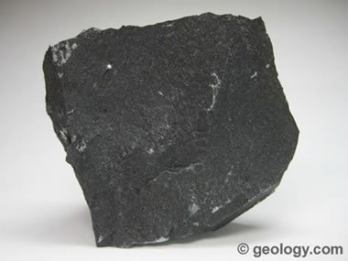
Basalt: A fine-grained igneous rock that is usually black in color. The specimen shown is about two inches (five centimeters) across.

What is Basalt?
Basalt is a dark-colored, fine-grained, igneous rock composed mainly of plagioclase and pyroxene minerals. It most commonly forms as an extrusive rock, such as a lava flow, but can also form in small intrusive bodies, such as an igneous dike or a thin sill. It has a composition similar to gabbro. The difference between basalt and gabbro is that basalt is a fine-grained rock while gabbro is a coarse-grained rock.
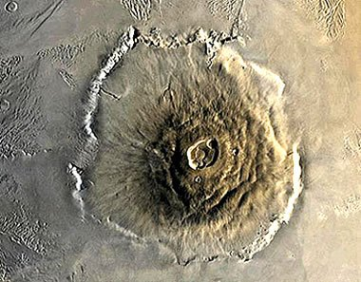
Olympus Mons Volcano: This shield volcano is composed of basalt and has enormous calderas at the summit. Olympus Mons is the highest topographic feature on Mars and is the largest known volcano in our solar system. It is about 375 miles (600 kilometers) in diameter and 15 miles (25 kilometers) high. NASA Mars Orbiter Camera image.

Earth's Most Abundant Bedrock
Basalt underlies more of Earth's surface than any other rock type. Most areas within Earth's ocean basins are underlain by basalt. Although basalt is much less common on continents, lava flows and flood basalts underlie several percent of Earth's land surface. Basalt is a very important rock.

Basalt on Moon and Mars
Basalt is also an abundant rock on the Moon. Much of the Moon's surface is underlain by basaltic lava flows and flood basalts. These areas of the Moon are known as "lunar maria." Large areas of the Moon have been resurfaced by extensive basalt flows which may have been triggered by major impact events. The ages of lunar maria can be estimated by observing the density of impact craters on their surface. Younger basalt flows will have fewer craters.
Olympus Mons is a shield volcano on Mars. It, like most other volcanic features on Mars, was formed from basaltic lava flows. It is the highest mountain on Mars and is the largest known volcano in our solar system.
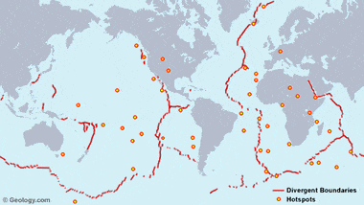
Basalt-Forming Environments: This map shows the location of oceanic divergent boundaries and hotspots. These are locations where large volumes of basalt have been formed. Map copyright by Geology.com and MapResources. Locations generalized after United States Geological Survey, Geologic Investigations Map I-2800: This Dynamic Planet.
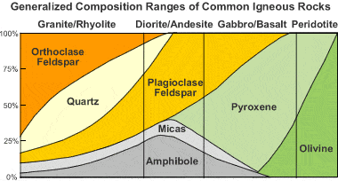
Igneous rock composition chart: This chart shows that basalt is typically composed of pyroxenes, plagioclase, micas, and amphiboles.

Basalt-Forming Environments
Most of the basalt found on Earth was produced in just three rock-forming environments: 1) oceanic divergent boundaries, 2) oceanic hotspots, and 3) mantle plumes and hotspots beneath continents. The images on this page feature some of these basalt-forming environments.
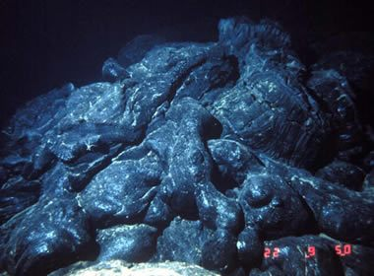
Sea floor pillow basalts on the Juan de Fuca Ridge, a divergent plate boundary located about 150 miles (240 kilometers) west of the Washington-Oregon coast. This lava flow, produced by a fissure eruption, was about five years old when the photograph was taken. NOAA Ocean Explorer image.
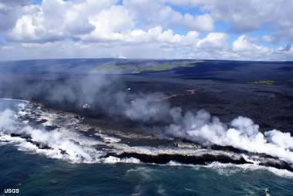
Hawaii Basalt Flows: Lava flows dump into the Pacific Ocean on the coast of Hawaii. Multiple locations where hot lava streams into the ocean can be seen in this image along with a red-hot lava flow traversing the lava field. This photo shows the enormous extent of the flows. They extend from the shoreline up to the horizon. A volcanic plume from the Pu`u `O`o vent can be seen over the horizon near the center of the image. The lava in these flows originated from the Pu`u `O`o vent. USGS image.

Basalts at Oceanic Divergent Boundaries
Most of Earth's basalt is produced at divergent plate boundaries on the mid-ocean ridge system (see map). Here convection currents deliver hot rock from deep in the mantle. This hot rock melts as the divergent boundary pulls apart, and the molten rock erupts onto the sea floor. These submarine fissure eruptions often produce pillow basalts as shown in the image on this page.
The active mid-ocean ridges host repeated fissure eruptions. Most of this activity is unnoticed because these boundaries are under great depths of water. At these deep locations, any steam, ash, or gas produced is absorbed by the water column and does not reach the surface. Earthquake activity is the only signal to humans that many of these deep ocean ridge eruptions provide. However, Iceland is a location where a mid-ocean ridge has been lifted above sea level. There, people can directly observe this volcanic activity.
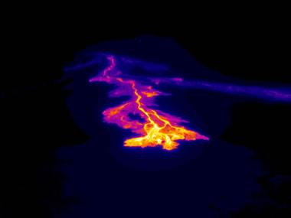
Thermal image of a hot basalt flow on the flank of Hawaii's Kilauea volcano. Hot lava at the front of the flow is revealed in yellow, orange and red colors. The channel that it flowed through on the previous day appears as a purple and blue track. United States Geological Survey image.

Oceanic Hotspots
Another location where significant amounts of basalt are produced is above oceanic hotspots. These are locations (see map above) where a small plume of hot rock rises up through the mantle from a hotspot on Earth's core. The Hawaiian Islands are an example of where basaltic volcanoes have been built above an oceanic hotspot.
Basalt production at these locations begins with an eruption on the ocean floor. If the hotspot is sustained, repeated eruptions can build the volcanic cone larger and larger until it becomes high enough to become an island. All of the islands in the Hawaiian Island chain were built up from basalt eruptions on the sea floor.
The island that we know today as "Hawaii" is thought to be between 300,000 and 600,000 years old. It began as an eruption on the floor of the Pacific Ocean. The volcanic cone grew as recurrent eruptions built up layer after layer of basalt flows. About 100,000 years ago it is thought to have grown tall enough to emerge from the ocean as an island.
Today it consists of five overlapping volcanoes. Kilauea is the most active of these volcanoes. It has been in amost continuous eruption since January, 1983. Basalt flows from Kilauea have extruded over one cubic mile of lava, which currently covers about 48 square miles of land. These flows have travelled over seven miles to reach the ocean, covering highways, homes and entire subdivisions that were in their path.
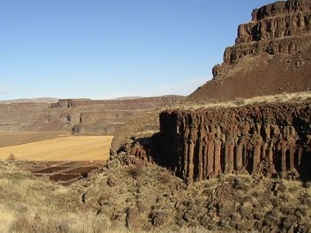
Columbia River Flood Basalts: The Columbia River Flood Basalts are an extensive sequence of stacked lava flows that reach a cumulative thickness of up to 6000 feet. The outcrops in the foreground and in the distance of this photo are all made up of layered basalt flows. Although basalt is typically a dark black rock, it often weathers to a yellow-brown color similar to the rocks shown here. Public domain image by Williamborg.
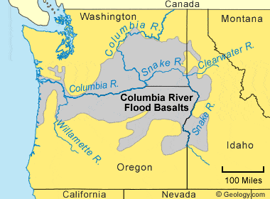
Columbia River Flood Basalts Map: A map of the area underlain by the Columbia River Flood Basalts in Washington, Oregon, and Idaho. The area shown is what has not yet been eroded away - the original extent of these basalt flows was much greater. Over 300 individual flows have been identified, and several hundred meters of basalt underlies much of the area shown in the map above. Map © by Geology.com and MapResources.com.

Plumes & Hotspots Below Continents
The third basalt-forming environment is a continental environment where a mantle plume or hotspot delivers enormous amounts of basaltic lava through the continental crust and up to Earth's surface. These eruptions can be from either vents or fissures. They have produced the largest basalt flows on the continents. The eruptions can occur repeatedly over millions of years, producing layer after layer of basalt stacked in a vertical sequence (see outcrop photo).
The Columbia River Flood Basalts in Washington, Oregon, and Idaho are an example of extensive flood basalts on land (see map below). Other examples include the Emeishan Traps of China, the Deccan Traps of India, the Keweenawan Lavas of the Lake Superior region, the Etendeka Basalts of Namibia, the Karroo Basalts of South Africa, and the Siberian Traps of Russia. (The word "traps" is derived from the Swedish word for "stairs," which describes the outcrop profile of these layered basalt deposits, as shown in the outcrop photo.)
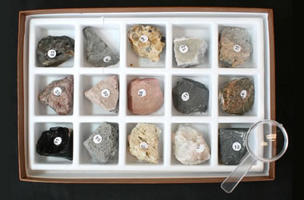
Rock & Mineral Kits: Get a rock, mineral, or fossil kit to learn more about Earth materials. The best way to learn about rocks is to have specimens available for testing and examination.
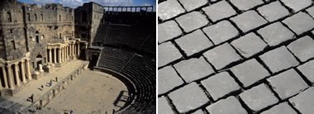
The Roman theatre: (left) in Bosra, Syria. The dark building stone is basalt. Image © iStockphoto / Steve Estvanik.
Basalt paving stones: (right) on a city street in Rome, Italy. Basalt pavers were often used in areas close to volcanoes. Image © iStockphoto / Giovanni Rinaldi.

Uses of Basalt
Basalt is used for a wide variety of purposes. It is most commonly crushed for use as an aggregate in construction projects. Crushed basalt is used for road base, concrete aggregate, asphalt pavement aggregate, railroad ballast, filter stone in drain fields, and may other purposes. Basalt is also cut into dimension stone. Thin slabs of basalt are cut and sometimes polished for use as floor tiles, building veneer, monuments, and other stone objects.
Contributor: Hobart King
More Rocks

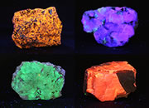 | Fluorescent Minerals
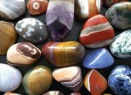 | Tumbled Stones
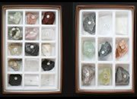 | Rock, Mineral and Fossil Collections.
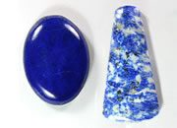 | Lapis Lazuli
 | The Rock Used to Make Beer
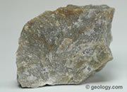 | Quartzite
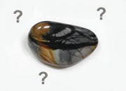 | Difficult Rocks
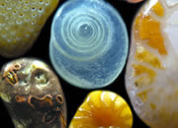 | A Grain of Sand



More From Geology.com:
Top of Form
Bottom of Form
Top of Form
Bottom of Form

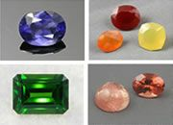 | 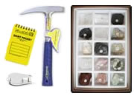
  100+ Gems - Photos of over 100 beautiful gems ranging from the popular to the obscure.
  Geologist Tools: Visit our store for a large selection of field and laboratory tools.
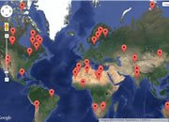 | 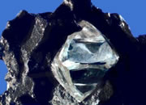
  Asteroid Impact Map: Explore fifty of the most obvious asteroid impact craters on Earth.
  Biggest Misconception: Lots of people think that diamonds form from coal. Not True!
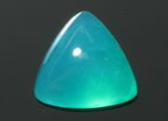 | 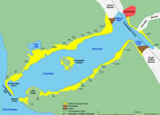
  Gem Silica is a blue chalcedony colored by copper. It is the rarest and most valuable chalcedony.
  The Largest Tsunami! The tsunami with the highest run-up was in Lituya Bay, Alaska.
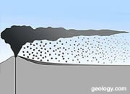 | 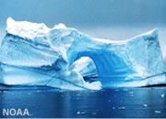
  Volcanic Ash: Learn about volcanic ash, volcanic dust and their impacts.
  Are Water and Ice Minerals? Comparing their properties with the definition of a mineral.

© 2005-2017 Geology.com. All Rights Reserved.
Images, code, and content on this website are property of Geology.com and are protected by copyright law.
Geology.com does not grant permission for any use, republication, or redistribution.
Images, code and content owned by others are marked on the pages where they appear.

Sandatlas
- Rock Types
- Minerals
- Sand Types
- Photos
- Contact
- About
Basalt  Basalt is a very common dark-colored volcanic rock composed of calcic plagioclase (usually labradorite), clinopyroxene (augite) and iron ore (titaniferous magnetite). Basalt may also contain olivine, quartz, hornblende, nepheline, orthopyroxene, etc. Basalt is a volcanic equivalent of gabbro.  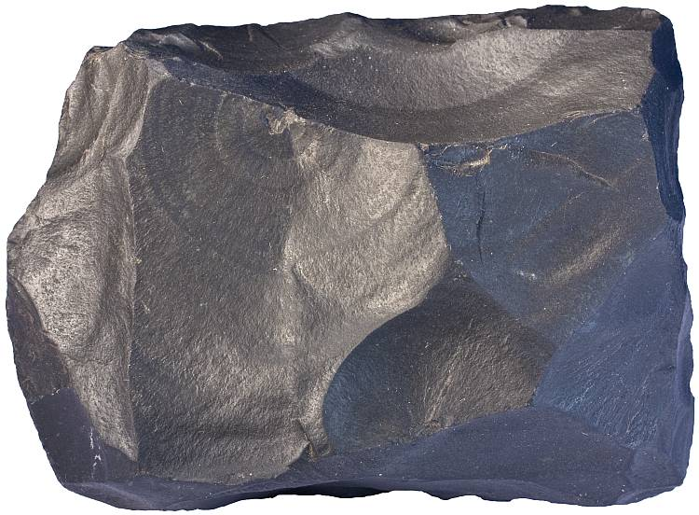  Basalt is a fine-grained and dark-colored rock. Black color is given to basalt by pyroxene group mineral augite. Width of the sample is 12 cm.  Basalt is usually black or dark gray and relatively featureless. It is composed of mineral grains which are mostly indistinguishable to the naked eye. Basalt may also contain volcanic glass. Basalt may contain phenocrysts (larger crystals within fine-grained groundmass) and vesicules (holes that were filled by volcanic gases).  Black color is given to basalt by pyroxene and magnetite. Both of them contain iron and this is the reason why they are black. So this is iron again which is responsible for the coloration of basalt. Plagioclase, volumetrically usually the most important constituent, is mostly pale gray in color.  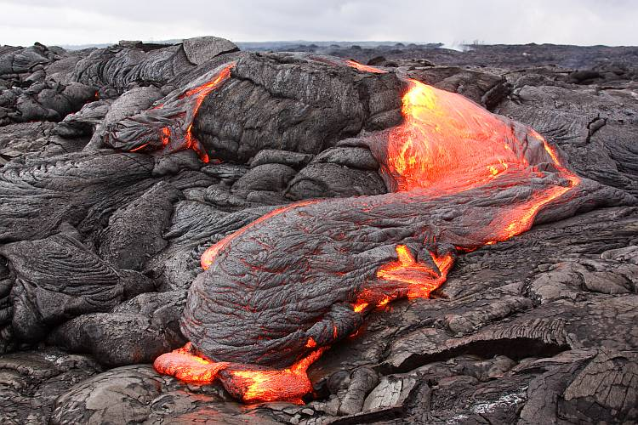  Basalt lava flowing in Hawai’i (Kilauea volcano, Pu’u O’o vent).  Basalt is a major rock type that occurs in virtually every tectonic setting. Basalt is clearly the most common volcanic rock on Earth and basaltic rocks (including gabbro, diabase and their metamorphosed equivalents) are the most common rocks in the crust². Basalt is also common on the Moon and other rocky planets of the Solar System.  What makes basalt so common? Basalt is the original constituent of the crust from which almost all other rock types have evolved. Basalt forms when mantle rocks (peridotite) start to melt. Rocks melt incongruently. It basically means that melt that forms has a different composition from the source rocks. Of course, it can only happen if rocks melt only partially, but this is exactly what happens in the upper mantle. It melts partially to yield basaltic magma which is less dense and rises upward to form new oceanic crust in mid-ocean ridges or volcanoes and intrusives (dikes, sills) in many other tectonic regimes. Basalt is the source rock of other more evolved volcanic rocks like dacite, rhyolite, etc.  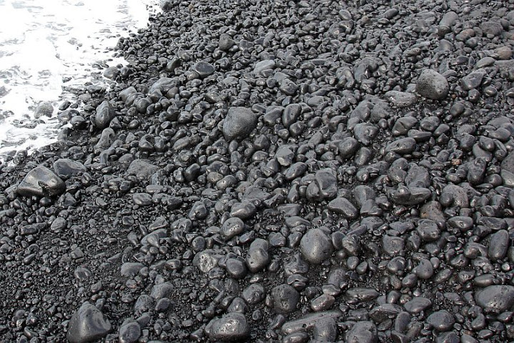  Basalt pebbles near the southern tip of La Palma slowly transforming into black sand typical to volcanic oceanic islands.  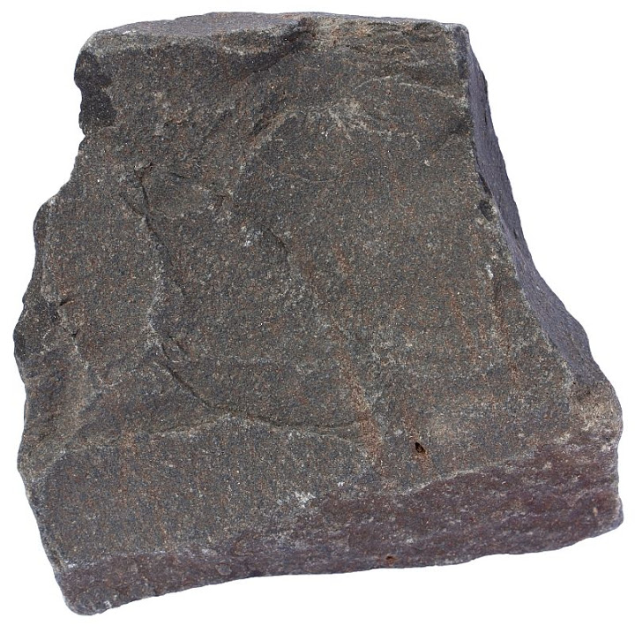  Basalt sample collected near the Giant’s Causeway, Northern Ireland. Width of sample 8 cm.  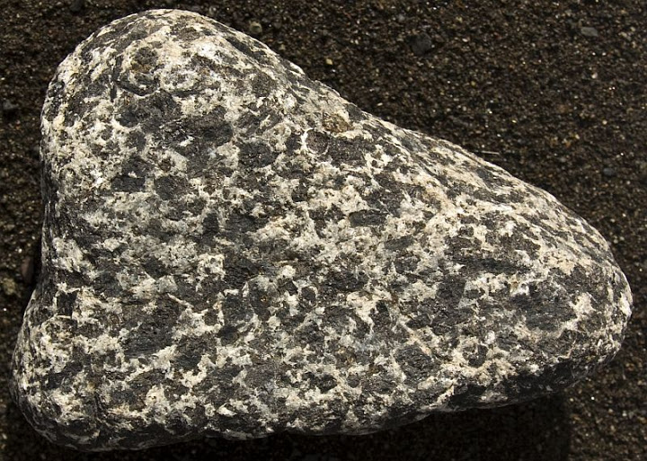  Gabbro is a coarse-grained (intrusive) equivalent of basalt. This sample of gabbro comes from La Plama. La Palma is an oceanic island, but some parts of it are uplifted and there are deep ravines like Caldera de Taburiente that cuts deep into the interior of the island and allows intrusive rocks like gabbro to be exposed. Width of sample 10 cm.  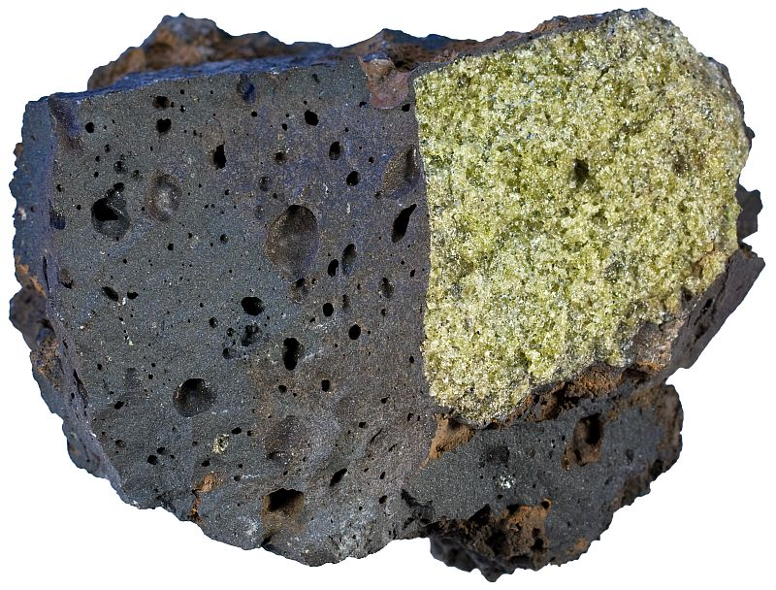  Basaltic rocks may carry xenoliths from the mantle. Here is a bright green dunite xenolith inside basalt from Hawai’i. Width of sample 8 cm.  Classification  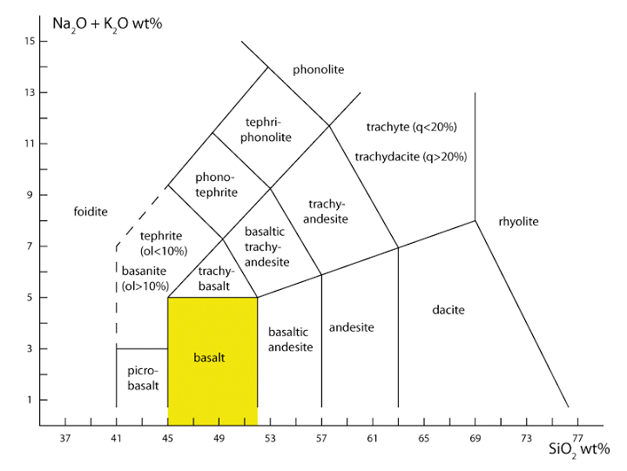  Basalt has a strict chemical definition. It is defined in the TAS diagram shown above. Basalt is an igneous rock that contains more than 45 and less than 52% of SiO₂ and less than five percent of total alkalies (K₂O + Na₂O)³.  Neighboring rock types like basaltic andesite, basanite, picrite (picrobasalt), trachybasalt and even more distant rocks like phonotephrite or andesite may have very similar look and can be easily mistaken for basalt in many cases.  Basalt is widespread in many tectonic regimes, but there are slight variations in chemical composition which allow more precise classification. MORB is an acronym for “mid-ocean ridge basalt” and OIB for “oceanic island basalt”. MORB is a result of partial melting of the upper mantle which is already recycled many times while OIB is at least partly from more deeper part of the mantle (deep-sourced mantle plumes that feed hot spots like Hawai’i or the Canary Islands) and is therefore less depleted in incompatible chemical elements.  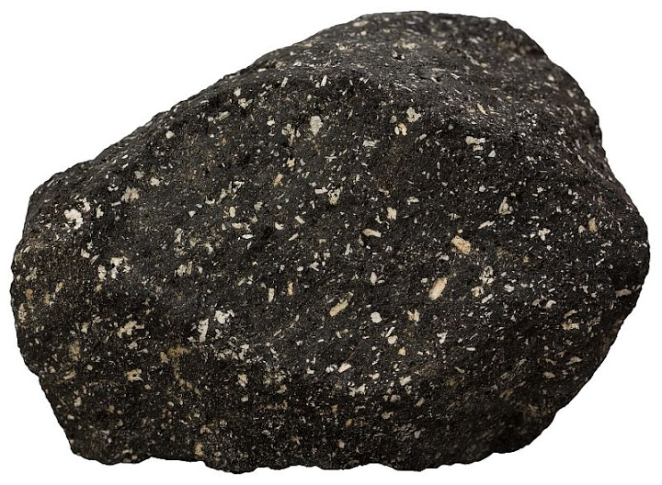  Andesite is similar to basalt, but it contains more silica and is generally lighter in color. White crystals are plagioclase phenocrysts, but they contain less Ca and more Na than plagioclase in basalt does. Andesite is very common product of subduction zone volcanism. Santorini, Greece. Width of sample 7 cm.  Composition  Average chemical composition of basalt determined by 3594 chemical analyses of basaltic rocks² (numbers are mass percents, recalculated volatile-free to total 100%):  SiO₂ — 49.97  TiO₂ — 1.87  Al₂O₃ — 15.99  Fe₂O₃ — 3.85  FeO — 7.24  MnO — 0.20  MgO — 6.84  CaO — 9.62  Na₂O — 2.96  K₂O — 1.12  P₂O₅ — 0.35  Minerals that host these chemical elements (chemical composition of igneous rocks is traditionally expressed in oxides) are augite, plagioclase and titaniferous magnetite. These minerals are difficult to demonstrate because they are too small to be seen in typical basalt, but some basaltic rocks are porphyritic (lots of porphyritic rocks can be seen here: porphyry) and show some of these minerals nicely (unfortunately not magnetite, though).  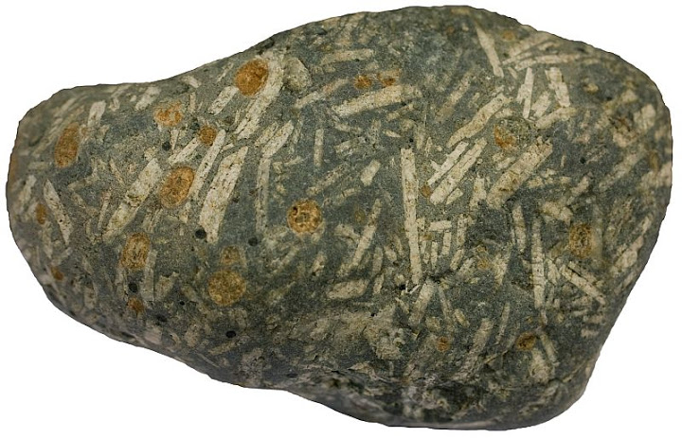  Basalt porphyrite from the Isle of Mull, Scotland with many plagioclase phenocrysts. The rock is 8 cm in length.  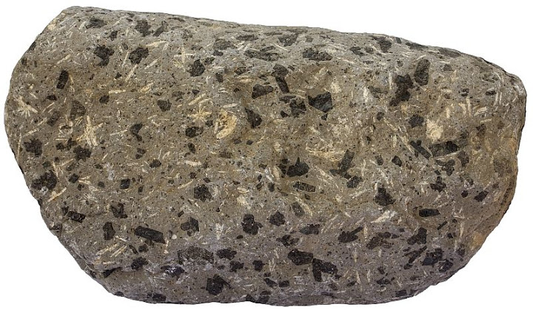  Porphyritic basaltic rock from Tenerife. Phenocrysts are plagioclase (white) and augite (black). Width of sample 14 cm.  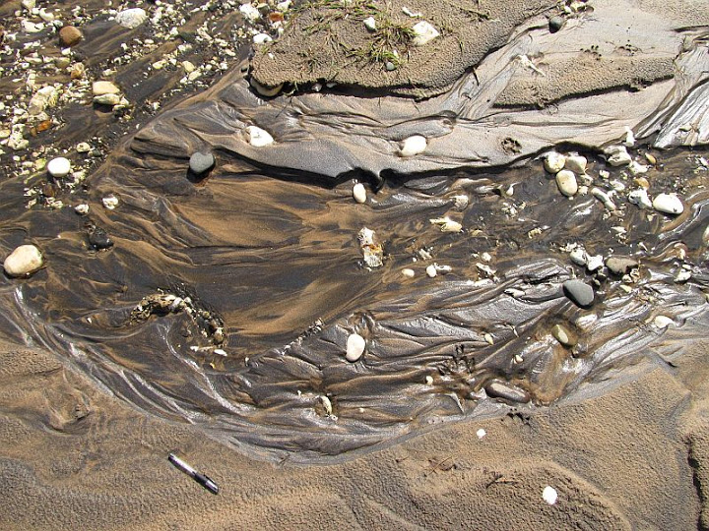  Magnetite crystals are always microscopic in basalt, but sometimes they form black stripes in light-colored sand. Here are heavy minerals (mostly magnetite) as a residue of weathering of basaltic rocks. White Park Bay, Northern Ireland.  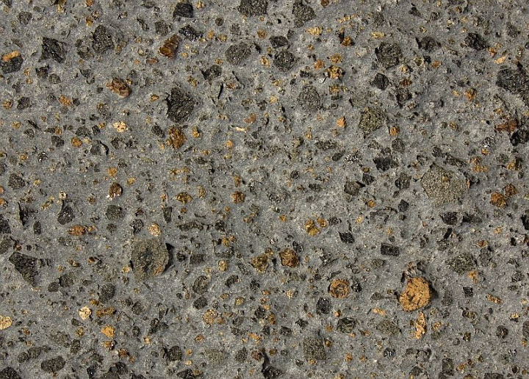  Basaltic rock (most likely basanite) from Caldera de Taburiente, La Palma. Black is pyroxene augite, orange is olivine or more precisely what is left of it. Orange patches are former olivine crystals that are now composed of a mixture of silicates and iron oxides which is known as iddingsite. Olivine is a common mineral in many basaltic rocks. Width of view 10 cm.  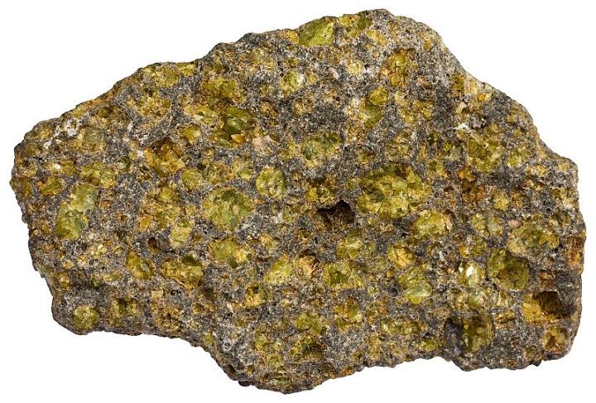  Another basalt (chemically probably picrobasalt) with lots of olivine (fresh olivine is bright green, but it gets more and more yellow as it weathers). Oahu, Hawai’i. Width of sample 6 cm.  Basalt in the field  Subaerial basalt forms lava flows or pyroclastic fields and cones. Two main types of basaltic lava flows are aa lava and pahoehoe lava.  Aa lava has rough rubbly irregular crust while pahoehoe is smooth. Lava crust of aa type is broken into pieces while pahoehoe retains its continuity. Both lava flow types are massive beneath the crust and this massive interior may be columnar. Columns are separated from each other by narrow cracks which form because cooling basaltic magma contracts. Cracks start to form at the surface and propagate deeper as lava cools. Submarine basalt usually forms pillows. Pillow basalt forms as a result of very rapid cooling. Outer part of forming pillow cools very quickly in contact with cold seawater while the interior still fills with molten lava.  Basalt mostly forms lava flows because it is among the least viscous magma types and therefore does not generate explosive volcanic eruptions, but sometimes pyroclastic material is formed when magma contains more volcanic gases. Basaltic rocks can be thrown out of volcanic vents as lapilli (singular: lapillus) and volcanic bombs. Basaltic volcanoes are fed by dikes (planar intrusive rock bodies when solidified that cut through other rocks) and sills (similar to dike but generally parallel to preexisting bedding planes).  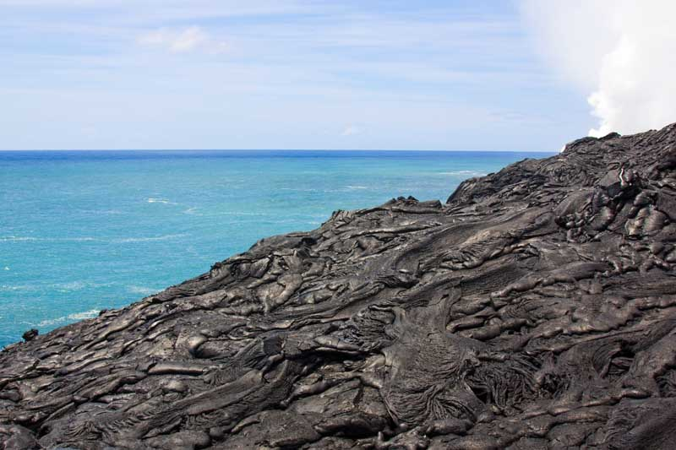  Basaltic lava flows of Kilauea volcano in Hawai’i.  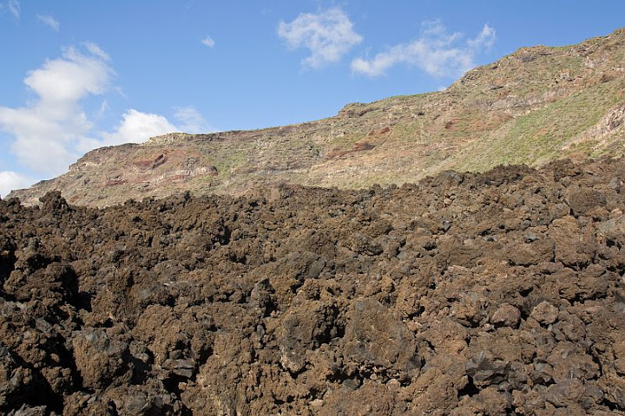  Aa lava in the foreground. La Palma, Canary Islands.  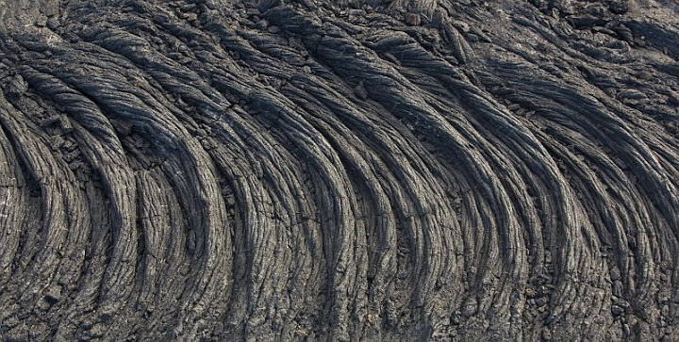  Pahoehoe lava (ropy lava). La Palma, Canary Islands.  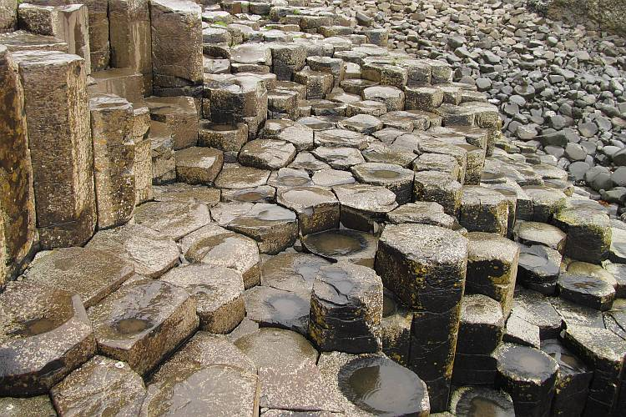  Basalt columns. Giant’s Causeway, Northern Ireland.  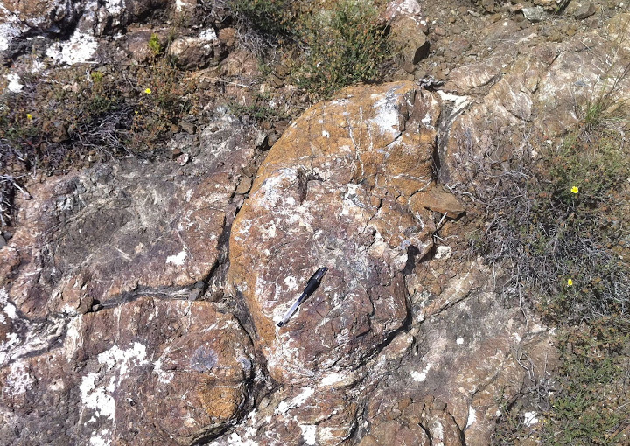  Pillow lava near Fasoula, Troodos ophiolite, Cyprus. Pillow lava is very common on Earth, but difficult to find because almost all of it is on the ocean floor. Examples can be found on land usually where former ocean floor is tectonically squeezed between two blocks of continental crust.  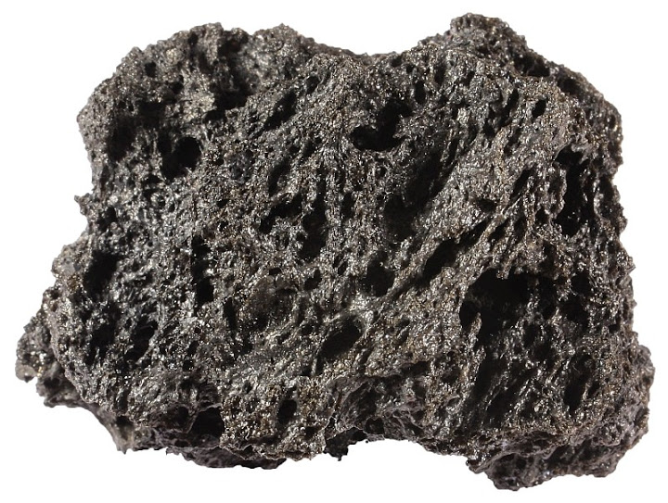  Scoriaceous lapillus from Etna, Italy. Despite being 5 cm in width it weighs only 15 grams because it is filled with gas bubbles (vesicules). Similar rock type with a felsic composition is pumice.  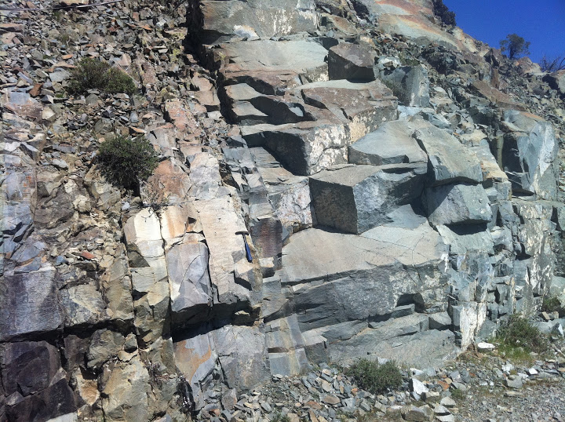  Sometimes dikes are so close to each other that the whole outcrop is composed of them. These sheeted dikes in Cyprus once fed volcanoes on the ocean floor.  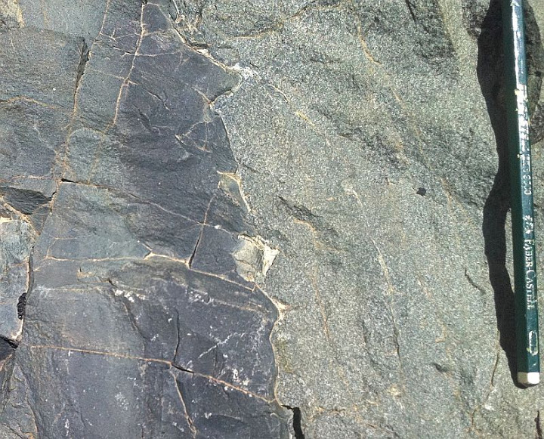  Dikes are composed of basalt and diabase. Diabase is nothing more than coarse-grained basalt. Here is a contact between basalt (on the left) and diabase in Cyprus. The basaltic dike is fine-grained because it is younger and was chilled (it lost heat rapidly to the diabase dike on the right).  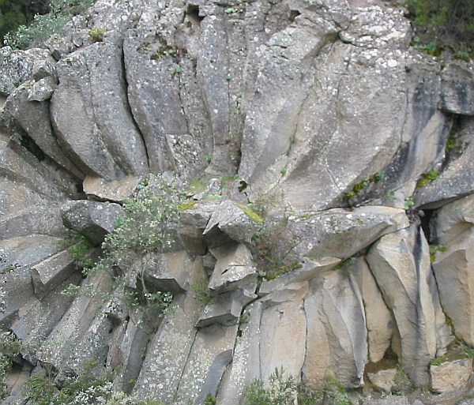  Columns in basalt are perpendicular to the cooling front. In this case it is evident that basalt formed a tube (filled lava tunnel). Such conduits are common phenomena in volcanic islands and provide a way for the volcano to enlarge itself because magma can flow great distances inside such thermally insulated tubes before solidifying. Tenerife, Canary Islands.  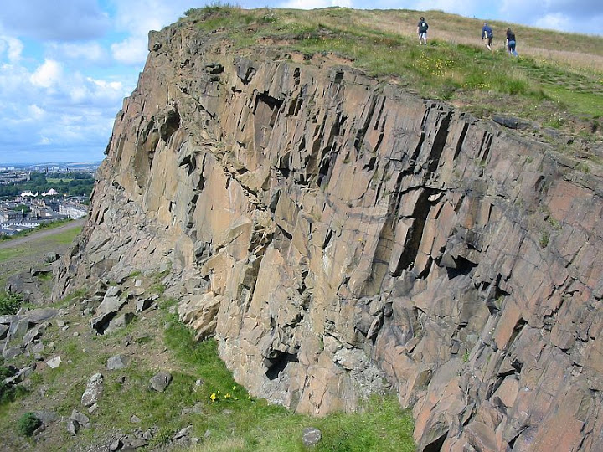  Dikes and sills are often visible on the ground and may become notable landforms. Salisbury Crags in Edinburgh is basaltic sill.  Metamorphism and weathering  Basalt is largely composed of minerals with little resistance to weathering. Hence, basalt as a whole also tends to disintegrate faster than granite and other felsic rock types. Magnetite is one of the most resistant common minerals in basalt and forms the bulk of heavy mineral sands. Other minerals disintegrate and release their components to water as ions or form clay minerals. Iron and aluminum are among the least mobile ions and therefore tend to form laterite deposits enriched in these elements.  Basalt metamorphoses to a number of different rock types, depending on pressure, temperature, and the nature of volatile compounds that react with minerals in basalt. Most common metamorphic rocks with basaltic protolith are chlorite schist, amphibolite, blueschist, and eclogite.  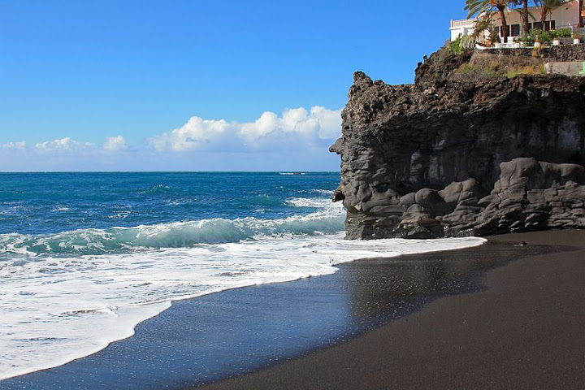  Black sand forms in volcanic islands when quartz and biogenic grains are not available. Here is a basaltic cliff and black sand on La Palma, Canary Islands.  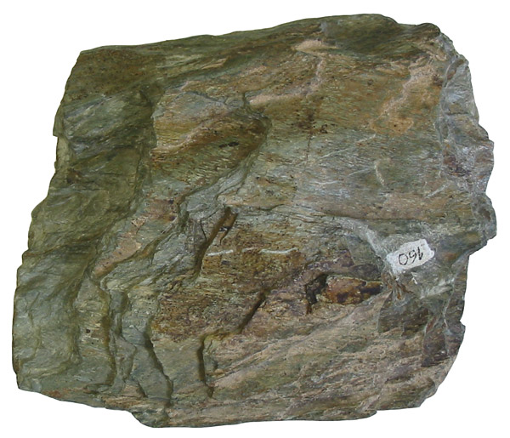  Chlorite schist is a low-grade metamorphosed mafic igneous rock, often with a basaltic protolith. Iron-bearing green sheet silicate mineral chlorite gives slaty cleavage to the rock. Width of sample 13 cm.  Etymology  The term “basanite” was already used in antiquity and “basalt” is probably a faulty transcription of basanite. It was German scholar Agricola (Georg Bauer) who first mentioned “basalt” in 1546. He referred to black columnar rocks from Stolpen (near Dresden in Germany) which is indeed basalt even according to modern classification principles¹.  References  1. Tomkeieff, S. I. (1983). Dictionary of Petrology. John Wiley & Sons.  2. Best, Myron G. (2002). Igneous and Metamorphic Petrology, 2nd Edition. Wiley-Blackwell.  3. Le Maitre, R. W. (2005). Igneous Rocks: A Classification and Glossary of Terms: Recommendations of the International Union of Geological Sciences Subcommission on the Systematics of Igneous Rocks, 2nd Edition. Cambridge University Press.  5 comments to Basalt  - Daraje Garba  June 10, 2013 at 11:56  It is good note taking I delighatedful.  - Daraje Garba  June 10, 2013 at 12:02  You said that Basalt is a volcanic equivalent gabbro.does gabbro volcanic igneous rock?  - Erhan GURCAM  February 1, 2015 at 22:59  How many tests are required for stonewool production?  Should we go thru all 3594 chemical analyses of basaltic rocks?  - Siim  February 1, 2015 at 23:09  These 3594 are taken from scientific literature. Stonewool production shouldn’t have anything to do with these numbers.  - abdullah  December 23, 2015 at 11:33  pleas share 5 main types of basalt rock 1 flood 2 alkali 3 thoeiiltic 4 columnar 5 pillow  « Aa lava  Colors in sand » | Top of Form  Bottom of Form  Articles  Basalt  Composition of the Earth's Crust  Limestone  Minerals  Gabbro  Rock types  Arkose  Sandstone  Types of lava flows  Chert  What is sand made of  Gneiss  What is black sand  Porphyry  Sand types  Conglomerate  Oolite  Olivine  Igneous rocks  Quartzite  Diabase  Amphibolite  U- and V-shaped valleys  Sand minerals  Dolomite rock  Silica and sand  Peridotite  Serpentinite  Coquina  Pegmatite  Laterite  Scoria  Garnet  Obsidian  Eclogite  Tuff  Syenite  Conchoidal fracture  Quartz sand  Pumice  Dunite  Bauxite  Principle of inclusions  Feldspar  Sand  Volcanic bomb  Heavy minerals  Pyrite  Magnetite  Granite  Ooid sand  Charnockite  Ignimbrite  Biotite  Calcite  Brain games with sand grains  Banded iron formation  Heavy mineral sand  Carbonatite  Hematite  Potassium  Volcanic gases  Quartz  Mylonite  Diamictite  Xenolith  Schist  Kyanite  Diopside  Shale  Marble  Recent Posts  - Schist  - Marble  - Rocks of Norway  - Shale  - Diamictite  - Pyroxenite  - Carbonatite  - Hedgehog rock  - Foyaite  - Diorite
Siim Sepp (www.sandatlas.org) Contact · About · Privacy Policy
Powered by WordPress & Atahualpa

12.109 Petrology
Basalts, basalt series, and basalt classification
Basalt in the generic sense = plagioclase + clinopyroxene
+/- (olivine, nepheline, hypersthene, quartz, melilite, magnetite).
The basalt tetrahedron is a useful tool for classifying basalts. The tetrahedron is constructed using the normative components olivine, quartz, clinopyroxene, and nepheline.
There are six volumes in the tetrahedron that define the different groups: Name |  |  | Normative components
I | Quartz tholeiite |  | Oversaturated |  | Quartz and hypersthene
II | Tholeiite |  | Saturated |  | Hyp
III | Olivine tholeiite |  | Undersaturated |  | Olivine and hyp
IV |  | Transitional basalt or olivine basalt |  | No normative hyp, only oliv
V | Alkaline oliv basalt |  | Critically undersaturated |  | Oliv and nepheline
VI | High Al basalt |  | High Al from plag |  | Plagioclase

4/23/2014
1
FLOOD BASALTS or LARGE IGNEOUS PROVINCES (LIP)
(Armageddon Volcanoes?)
“Civilization lives by geological consent, subject to change without notice.”
Will Durant, 1946
There are both continental (yellow) and oceanic (orange) flood basalt provinces
They are characterized by:‐
❑ Huge volumes
❑ Thick piles of flows
❑ Relatively short duration (< 3 Ma)
❑ All are old (> 16 Ma)
❑ Closest historical eruption is the Laki eruption, Iceland (1783)
4/23/2014
2
Siberian Flood Basalts
Faroe Islands – North
Atlantic Flood Basalts
Greenland ‐ North Atlantic
Flood Basalts
4/23/2014
3
Eastern Greenland – North Atlantic Flood Basalts
How are they Formed?
❑ Meteorite or Comet impact.
❑ Melting the head of mantle plumes.
❑ De-lamination of the lithosphere.
4/23/2014
4
The Plume Model
Many Flood Basalts are associated with continental breakup
and the formation of volcanic continental margins
4/23/2014
5
The Deccan Flood‐basalts and Reunion hotspot tail
Where are the flood basalts associated with the Hawaiian tail?
4/23/2014
6
The Columbia River Basalts
Ginko over Grande Ronde
Basalts in Palouse Canyon
Vast piles of thick (20 – 100 m) lava flows,
some of which are up to 600 km in length.
4/23/2014
7
Stratigraphy, Age and Volume of the Columbia River Basalts
Total Volume = 174,400 Km3
Over 90% erupted
within <2 million years
Typical section
through a flow.
Individual components
can vary in thickness
and may not always be
present.
4/23/2014
8
Typical columnar jointing in a flow
Pillow basalts and palagonite at the base of a flow
4/23/2014
9
Comparison of Roza with other “normal” flows
1. Kupainaha Flows, Kilauea ‐ 0.5 km3 in 5.6 yrs = 2‐5 m3/sec
2. Mauna Loa, 1859 – 0.27 km3 in 10 months = 4 m3/sec
3. Laki 1783, Iceland – 14.7 km3 in 9 months = 709 m3/sec
4. Roza Flow (CRB) ‐ 1300 km3 in 6 – 14 yrs – 2600 – 8100 m3/sec
Estimates of the time taken to erupt
Columbia River Basalt flows
❑ Swanson suggests the 1300 km3 Roza flow was
emplaced in 7 days!
❑ Ho and Cashman estimate the 500 km long Ginko flow
was also emplaced in 7 days.
❑ Reidel estimates months for the Pomona flow.
❑ Self et al. (based on work of Martin) estimate 6 – 14
years for the Roza flow.
4/23/2014
10
Growth of the Roza flow (1300 km3 ) in 6 to 14 years
Comparison of the structure of the Roza flow unit
with examples from Iceland and Kilauea
VF = Vesicle features
JH = Jointing features
4/23/2014
11
Inflation model for the growth of
flood basalt flows (Self et al., 1997)
Are Flood Basalts Responsible for Mass Extinctions?
Is the Mantle a Serial Killer?
What is the Kill Mechanism?
4/23/2014
12
The Geological Time Scale
(Breaks between Periods and Epochs based on major
changes in fauna and flora (extinctions))
Amazing correlation between the time of
major extinctions and the ages of flood basalts.
Only one known impact event (Chicxulub) at
end of Cretaceous.
4/23/2014
13
Correlations, although suggestive, are not proof
Timing is Critical
Problems
❑ Need to know precise age and duration of extinctions.
❑ Need to know precisely when and for how long flood
basalts were erupted.
Dating
❑ Early K/Ar dating indicated eruptions over 40‐50 Myr.
❑ Modern 40Ar/39Ar dating narrows this down to under 2
Myr for 80 – 90 % of the eruptive event.
❑ New Pb dating of zircon narrows this down further to
less than 1 Myr.
Example of refining ages of Karroo Flood Basalts, S. Africa
4/23/2014
14
EXAMPLE – SIBERIAN TRAPS
❑ The end of Permian extinction (90% of all marine species and
largest loss of floral and faunal diversity in earth’s history) occurred
about 250 Myr ago.
❑ Early K/Ar dating of the Siberian Traps gave ages from 235 – 220
Myr.
Conclusion – no connection.
❑ Subsequent 40Ar/39Ar dating increased and refined the ages for
the Traps to 250 +/‐ 1.6 Myr.
Smoking Gun!
❑ New (2013) very precise zircon dating shows the following:‐
1) Age of end of Permian extinction (Meishan, China) between
251.94 and 251.88 Myr (in other words the extinction occurred in
less than 100 thousand years!).
2) The beginning of the eruption occurred at 252.28 Myr (that is,
before the extinction event).
Cause and Effect!
The Laki Eruption, Iceland (1783 ‐1784)
❑ Duration – 9 months (June – February)
❑ Volume ‐ 14.7 km3
❑ No direct fatalities but several farms
destroyed
❑ 50 percent of cattle died
❑ 75 percent sheep
❑ 24 percent of entire Iceland population
died of starvation and illness
4/23/2014
15
Effects on
Europe and
North America
❑ Drop in winter temperature of 1 – 3 oC
❑ Volcanic haze (VOG) blanketed much of
Europe and northern N. America.
❑ 40% higher mortality rate than expected in
England in both summer and winter.
Total SO2 from eruption = 122 Mt
Total SO2 in plume = 99 Mt (81%)
Total SO2 from flows = 23 Mt (19%)
Estimated sulfur release from the Laki eruption
A megatonne (Mt) = 1 million metric tons (1000 x 106 kg)
4/23/2014
16
Release of Sulfur and other gases during the
eruption of the entire Rosa flows (1300 km3 )
SO2 HCl HF
Original amount in Magma (Mt) 13795 1065 4840
Amount released locally by lava (Mt) 2808 307 333
Amount released from vents (Mt) 9617 397 1442
Total amount released (Mt) 12425 704 1774
Compare with 122 Mt of SO2 released from the Laki eruption
Possible Kill Mechanisms
❑ Volcanic winter due to SO2 gas in volcanic plumes.
❑ Global warming due to release of volcanic CO2 .
❑ Acid rain (from SO2, HCl, HF) in volcanic plumes.
❑ Acidification and anoxic conditions of the oceans (from SO2,
HCl, HF) in volcanic plumes.
❑ Ozone destruction due to release of HCl and HF gases
❑ Release of methane (greenhouse gas) due to eruption of
submarine flood basalts
❑ Massive release of CO2 (global warming) due to contact
metamorphism of underlying carbonate and coal sediments.
❑ Anoxic conditions in the oceans due to contact
metamorphism and assimilation of salt beds.
4/23/2014
17
Two‐stage de‐gassing of flood basalts: Example from Deccan Basalts
(Self et al. 199XXXXX)
4/23/2014
18

