CONTINENTAL IGNEOUS ROCKS
Introduction
A wide variety of igneous rocks occur in the continental lithosphere, a reflection of its heterogeneous nature compared to oceanic lithosphere. In addition, because the continents are not subducted and are subject to uplift and erosion, older plutonic rocks are both preserved and accessible to study. Here we take a different approach than your textbook. While your textbook only considers rocks that are produced in tectonic settings unrelated to plate boundaries, we consider all rocks of the continental lithosphere, some of which were likely produced as a result of plate interactions. We start with granitic rocks and their associated pegmatites, next consider large volume continental rhyolites and basalts, and finish with continental rift valleys. Discussion of kimberlites, carbonatites, anorthosites, and layered gabbroic intrusions is left for your textbook reading pleasure.
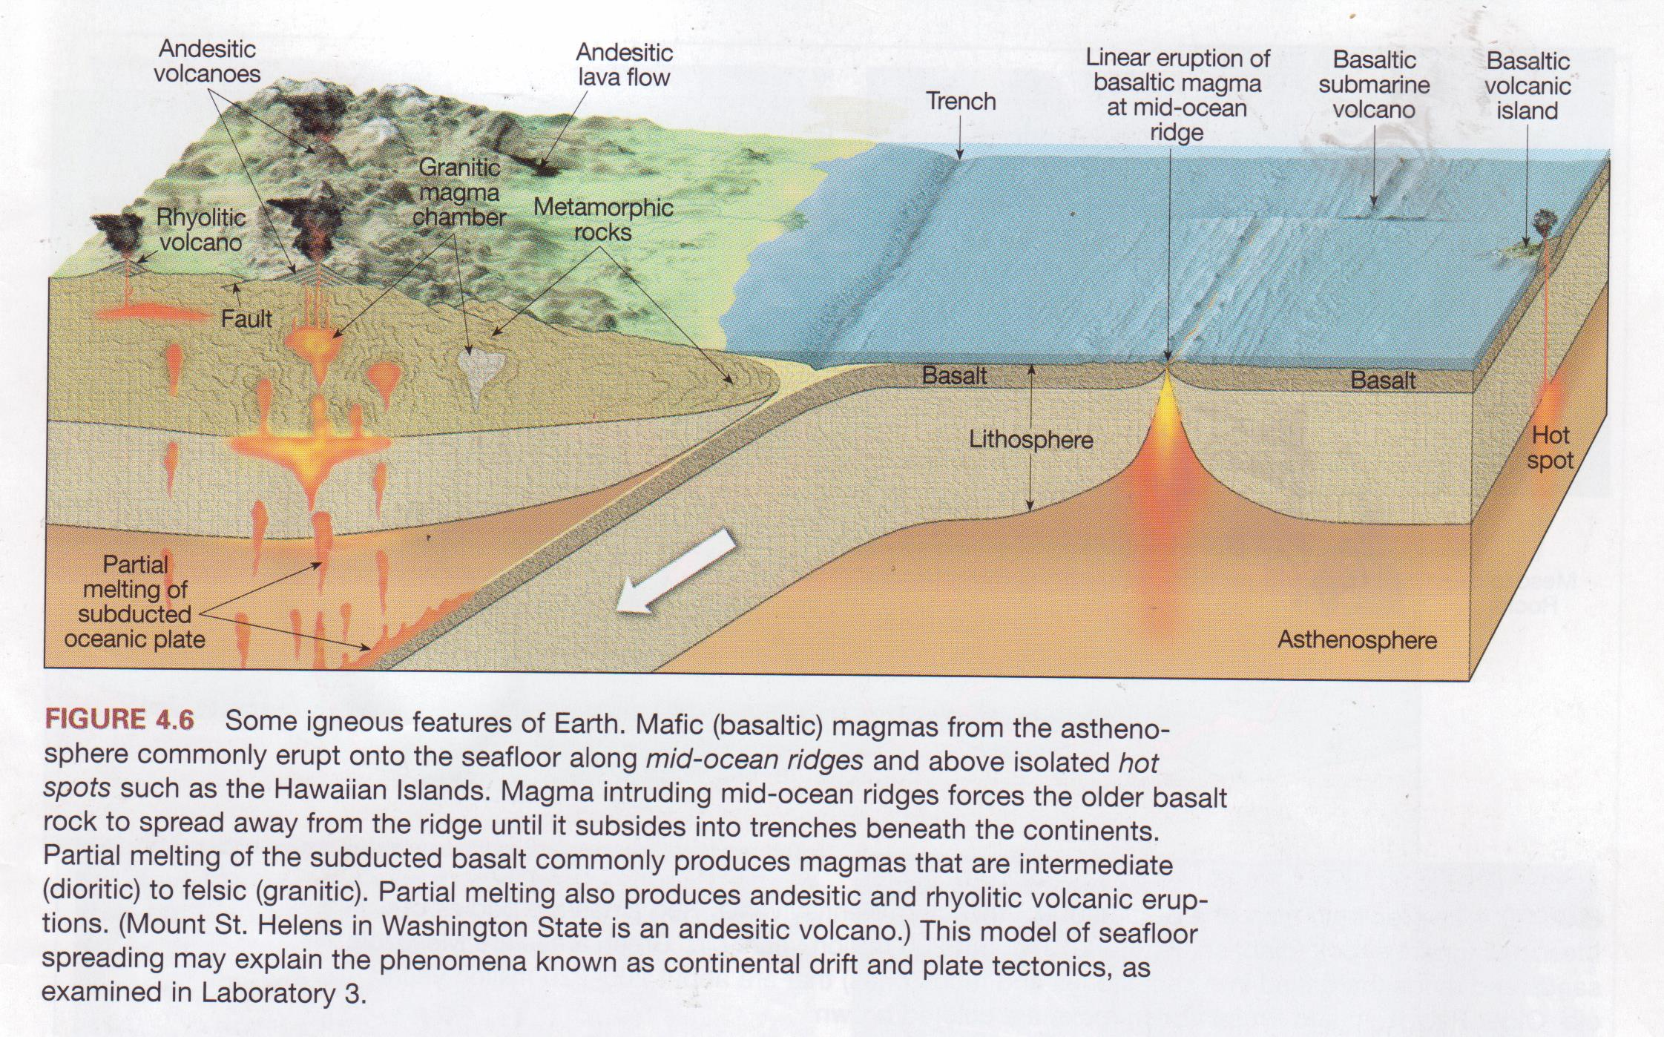

Granitic Rocks
Here we discuss a group of plutonic igneous rocks usually referred to as "granitic rocks", "granitoids", or loosely as granites. Included are true granites, but our discussion will include all medium to coarse-grained rocks that are mostly felsic with a few mafic minerals.
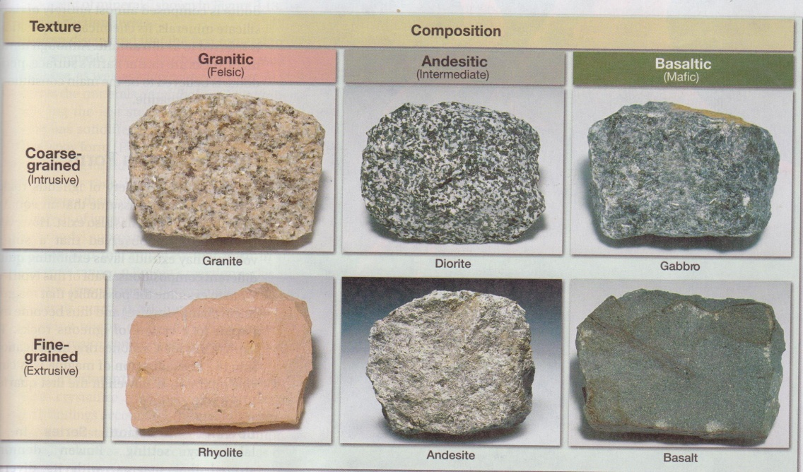
COMMON IGNEOUS ROCKS
Classification
A variety of classification schemes have been proposed for granitic rocks. The easiest to employ uses the modal mineralogy of the rocks, while others attempt classification on the basis of the pressure at which crystallization occurred, the tectonic setting, or type of source rock which melted to produce the granitic magma.
- Mineralogical Classification. The IUGS mineralogical classification scheme shown here is based modal mineralogy.
Note that true granites have between 10% and 65% of their feldspars as plagioclase, and between 20% and 60% quartz. All rocks will likely contain mafic minerals such as biotite, hornblende, and perhaps pyroxenes, along with opaque oxide minerals. The base of the composition triangle is a thermal divide, that separates quartz-bearing rocks from feldspathoid-bearing rocks.
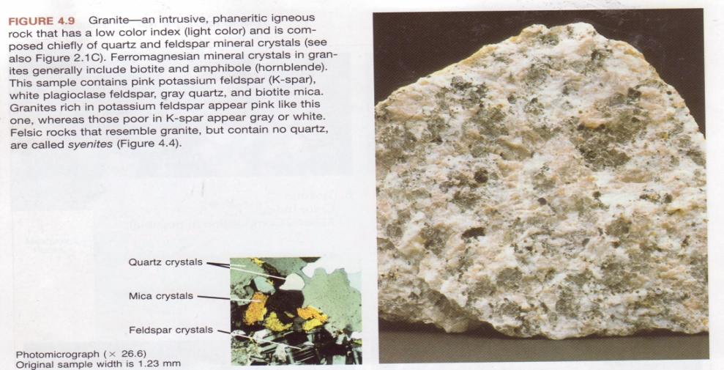

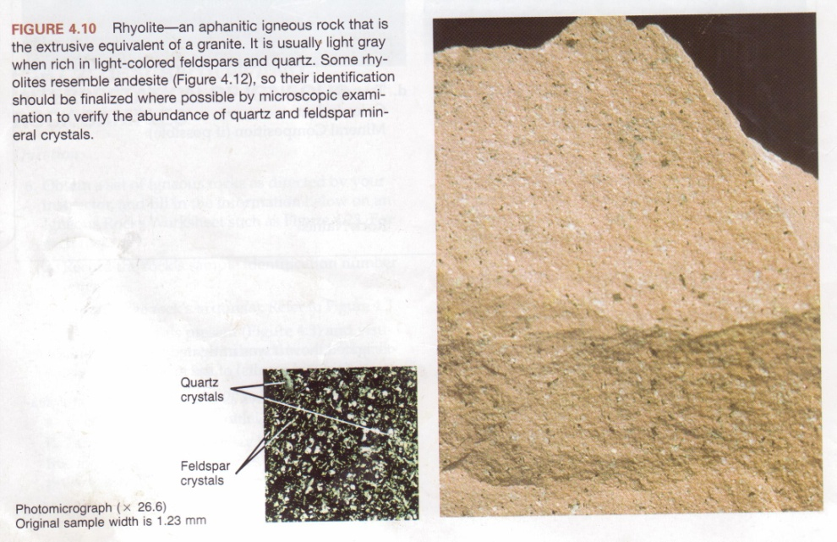

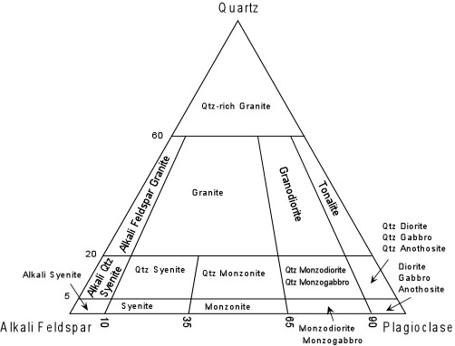

The feldspathoid bearing rocks include the feldspathoidalsyenites, which will not be considered to any large extent here
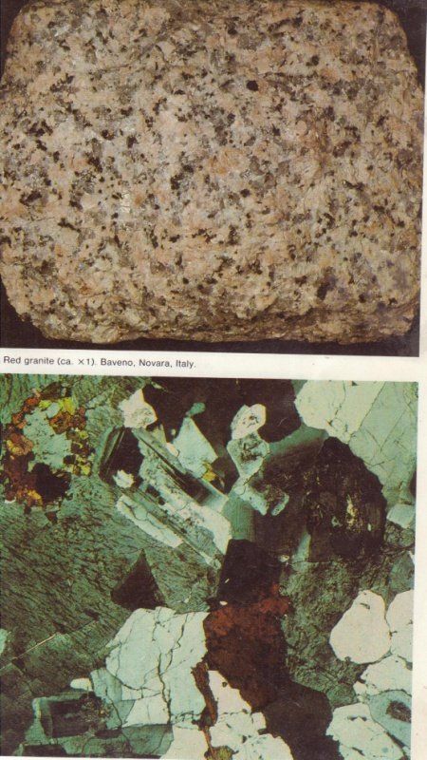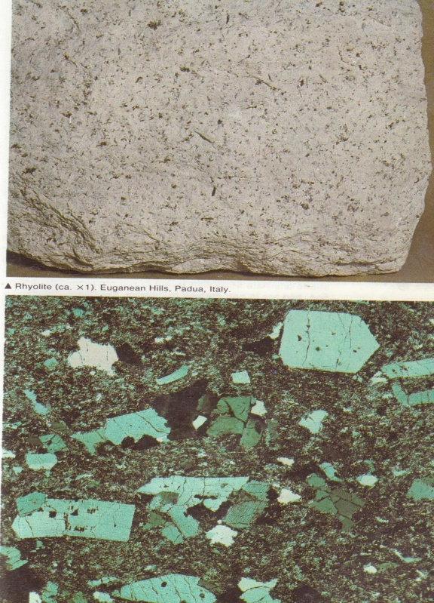
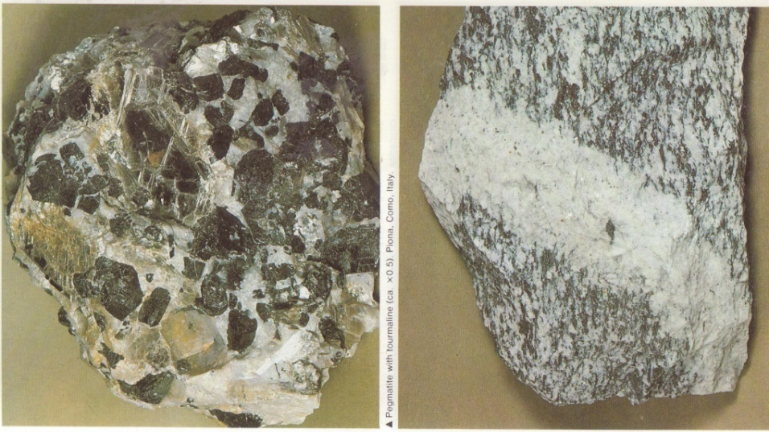
.Texture:
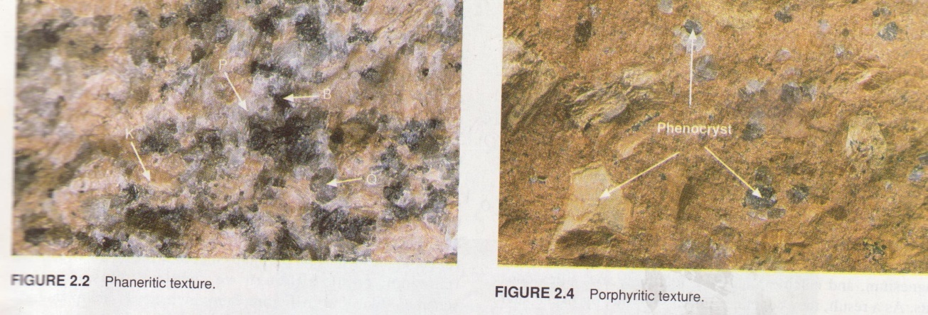
- Hypersolvus and Subsolvus Granites. Another way of looking at the classification of granitic rocks is based on the feldspars, and whether or not they crystallized under relatively dry low pressure conditions or "wet", higher pressure conditions. This can be seen by comparing the experimentally determined phase diagrams at various conditions. At low pressure under dry conditions, the alkali feldspars form a complete solid solution at high temperature, but, upon slow cooling, they eventually reach the solvus and exsolve into two feldspars, one rich in albite and the other rich in orthoclase. But, because of the low temperature at which this occurs, only single feldspars will occur and these will show a perthitic texture.

Granites that crystallize under low pressure and exhibit a singleperthitic alkali feldspar are considered hypersolvus granites.  At higher pressure, under water-saturated conditions, the liquidus surface is suppressed and the solvus moves up to intersect the solidus. | 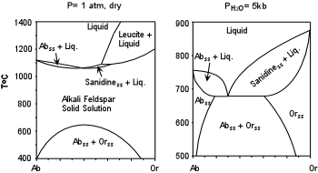

This results in the crystallization of two alkali feldspar solid solutions, one rich in Ab, and the rich in Or. Each of these will further exsolve on cooling to form perthites. Granites that crystallize under these conditions are referred to as subsolvus granites.
While this classification scheme may be useful in distinguishing between granites that crystallized at high pressure and those that crystallized at low pressure, the addition of the anorthite component complicates things. Thus, the utility likely only applies to those granites that are poor in plagioclase, or to those that would be classified as alkali feldspar granites under the IUGS classification scheme.

- Tectonic/Chemical Classification. Tectonic classification is more appropriately called a chemical classification, because, as we will see, the various chemical types are not necessarily restricted to certain tectonic environments.
  - S-type Granites. S-type granites are thought to originate by melting (or perhaps by ultrametamorphism) of a pre-exiting metasedimentary or sedimentary source rock. These are peraluminous granites [i.e. they have molecular Al₂O₃> (Na₂O + K₂O)]. Mineralogically this chemical condition is expressed by the presence of a peraluminous mineral, commonly muscovite, although other minerals such as the Al₂SiO₅ minerals and corundum may also occur. Since many sedimentary rocks are enriched in Al₂O₃ as a result of their constituents having been exposed to chemical weathering near the Earth's surface (particularly rocks such as shales that contain clay minerals), melting of these rocks is a simple way of achieving the peraluminous condition.
Many S-type granitoids are found in the deeply eroded cores of fold-thrust mountain belts formed as a result of continent-continent collisions, such as the Himalayas and the Appalachians, and would thus be considered orogenic granites.

  - I-type Granites. I-type granites are granites considered to have formed by melting of an original igneous type source. These are generally metaluminous granites, expressed mineralogically by the absence of peraluminous minerals and the absence of peralkaline minerals, as discussed below. Instead these rocks contain biotite and hornblende as the major mafic minerals.
Mesozoic or youngerexamples of I-type granites are found along continental margins such as the Sierra Nevada batholith of California and Nevada, and the Idaho batholith of Montana. In these regions the plutonism may have been related to active subduction beneath the western U.S. during the Meszoic. I-type granites are also found in the Himalayas, which are related to continent-continent collisions.
Plutonic suites that were emplaced in convergent continental margin settings,show many of the same characteristics as the calc-alkaline volcanic suite that likely erupted on the surface above. The suites include gabbros, diorites, quartz monzonites, granodiorites, and granites. They show mild to no Fe-enrichment, similar to calc-alkaline volcanic rocks, and a range of isotopic compositions similar to the associated volcanic rocks. Nearly all are I-type granitoids.
An example of the a convergent margin plutonic suite is found in the Sierra Nevada Batholith and associated plutons in eastern California and western Nevada that were emplaced during the Mesozoic Era.

