Types of Metamorphism and Where They Occur
The outcome of metamorphism depends on pressure, temperature, and the abundance of fluid involved, and there are a great many settings with unique combinations of these factors. Some types of metamorphism are characteristic of specific plate tectonic settings, but others are not.

1-Burial Metamorphism
Burial metamorphism occurs when sediments are buried deeply enough that the heat and pressure cause minerals to begin to recrystallize and new minerals to grow, but does not leave the rock with a foliated appearance. As far as metamorphic processes go, burial metamorphism takes place at relatively low temperatures (above 300 °C) and pressures (100s of metres depth). One rock that can form in this setting is metaconglomerate (Figure 10.17). It looks like a regular conglomerate, except the clasts have become elongated.
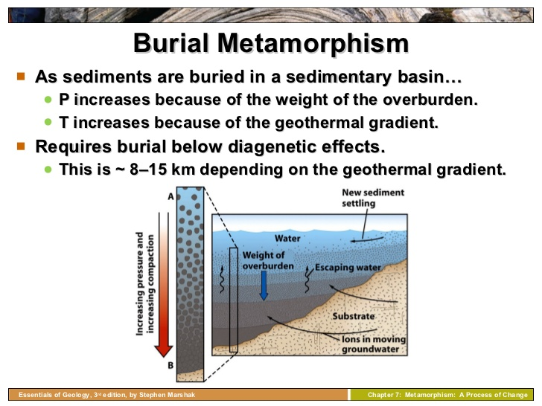
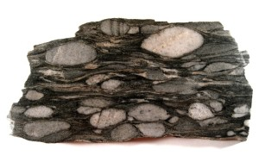
A metaconglomerate, displaying clasts that have become elongated.

2-Regional Metamorphism
Regional metamorphism refers to the large-scale metamorphism that happens to continental crust along convergent tectonic margins (where plates collide). The collisions result in the formation of long mountain ranges, like those along the western coast of North America. The force of the collision causes rocks to be folded, and broken and stacked on each other, so not only is there the squeezing force from the collision, but the lithostatic pressure from the weight of rocks being stacked on top of each other. The deeper rocks are within the stack, the higher the pressures and temperatures, and the higher the grade of metamorphism that occurs. Rocks that form from regional metamorphism are likely to be foliated because of the strong directional pressure of converging plates.
The Himalaya range is an example of where regional metamorphism is happening because two continents are colliding (Figure 10.18). Sedimentary rocks have been both thrust up to great heights (nearly 9,000 m above sea level) and also buried to great depths. Considering that the normal geothermal gradient (the rate of increase in temperature with depth) is around 30°C per kilometre in the crust, rock buried to 9 km below sea level in this situation could be close to 18 km below the surface of the ground, and it is reasonable to expect temperatures up to 500°C. In Figure 10.17 the dashed lines are isotherms– lines of equal temperature^{[1]}– resulting from the geothermal gradient. Notice the sequence of rocks that from, beginning with slate higher up where pressures and temperatures are lower, and ending in migmatite at the bottom where temperatures are so high that some of the minerals start to melt. These rocks are all foliated, and that is to be expected because of the strong compressing force of the converging plates.
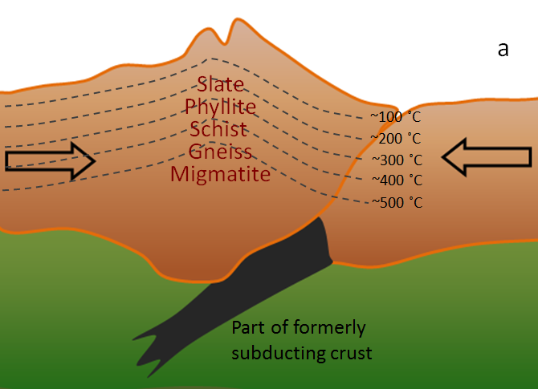
Regional metamorphism beneath a mountain range (such as the Himalaya) resulting from continent-continent collision. Arrows represent the forces due to the collision. Dashed lines represent temperatures that would exist assuming a typical geothermal gradient. A sequence of foliated metamorphic rocks of increasing metamorphic grade forms as you go deeper within the mountians.
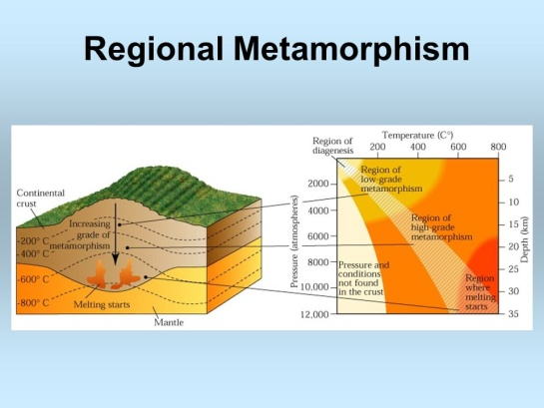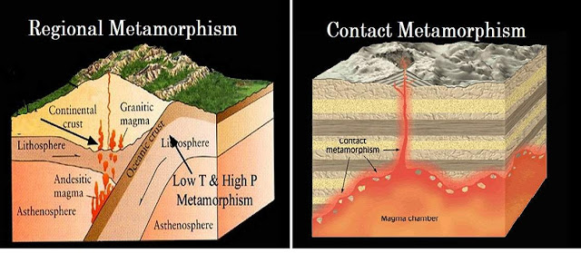
The generalized mineralogical changes during regional metamorphism may be outlined as follows:-

1. Very low-grade:- temps are within 200-300ºC, pressures are very low (it represents
burial metamorphism passes towards diagenesis) zeolites, prehnite, pumpellyte and lithites.

2. Low-grade:- temps are in the range of 300-500ºC and pressures up to 5-6 kb. Shearing stress prevails and recrystallization is rather weak. Minerals are sericite, chlorites, serpentines, talc epidot. Typical rocks are phyllites, chlorite and sericite schist.

3. Medium-grade:- temps reach 500-600ºC and pressures up to 7 kb. Stress is still strong and effects of hydrostatic pressures are also visible. Recrystallization is advanced and chemical reactions are intense. Mineral assemblage include muscovite, biotite, amphibole, epidot, cordierite, staurolite, garnet, kyanite, albite-plagioclase, microcline. Rock examples include mica schists, gneisses, marbles and amphibolites.

4. High-grade:- temps are between 600-800ºC and pressures greater than 4 kb. Its upper limit is bounded by the beginning of melting. Directed pressure vanishes, and hydrostatic pressure prevails. Biotite is the only stable mineral with …groups, other characteristic minerals are hyperthene, augite, sillimanite, cordierite, garnets, orthoclase, kyanite. Typical rocks are represented by eclogite, granulites and charnokite.
Two methods are usually used to consider the changes during regional metamorphism.

- The first method characterizes changes of mineralogy in a given protolith throughout the various P/T conditions;
- The second method describes the resulting rocks within each of a given ranges of P/T conditions, independently on the nature of a protolith [the idea of metamorphic facies.
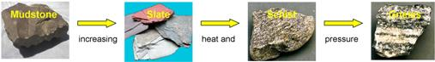

3-Seafloor (Hydrothermal) Metamorphism

(Oceanic – ridge)
At an oceanic spreading ridge, recently formed oceanic crust of gabbro and basalt is slowly moving away from the plate boundary (Figure 10.19). Water within the crust is forced to rise in the area close to the source of volcanic heat, and this draws more water in from farther out, which eventually creates a convective system where cold seawater is drawn into the crust, heated to 200° to 300°C as it passes through the ocean crust, and released again onto the sea floor near the ridge.
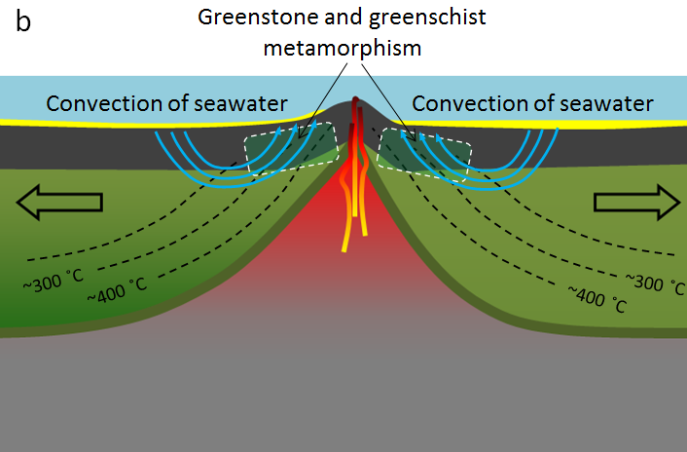
Hydrothermal metamorphism of oceanic crustal rock on either side of a spreading ridge. (Example: Juan de Fuca spreading ridge)
The passage of this water through the oceanic crust at 200° to 300°C promotes metamorphic reactions that change the original pyroxene in the rock to chlorite ((Mg₅Al)(AlSi₃)O₁₀(OH)₈) and serpentine ((Mg, Fe)₃Si₂O₅(OH)₄). The low-grade metamorphism occuring at these relatively low pressures and temperatures can turn mafic igneous rocks in ocean crust into greenstone , a non-foliated metamorphic rock.
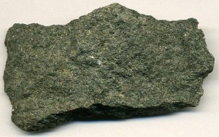
Greenstone from the metamorphism of seafloor basalt that took place 2.7 billion years ago. The sample is from the Upper Peninsula of Michigan,

Chlorite and serpentine are both hydrated minerals, containing water in the form of OH in their crystal structures. When metamorphosed ocean crust is later subducted, the chlorite and serpentine are converted into new non-hydrous minerals (e.g., garnet and pyroxene) and the water that is released migrates into the overlying mantle, where it contributes to flux melting

4-Subduction Zone Metamorphism
At subuction zones, where oceanic crust is forced down into the hot mantle, there is a unique combination of relatively low temperatures and very high pressures. The high pressures are to be expected, given the force of collision between tectonic plates, and the increasing lithostatic pressure as the subducting slab is forced further and further into the mantle. The lower temperatures exist because even though the mantle is very hot, the ocean crust is relatively cool, and doesn’t take in heat from the mantle rapidly. That means it can be several hundreds of degrees cooler than the surrounding mantle. In Figure 10.21, notice that the isotherms (dotted lines) plunge deep into the mantle along with the subducting slab. This means that regions of relatively low temperature exist deeper in the mantle.
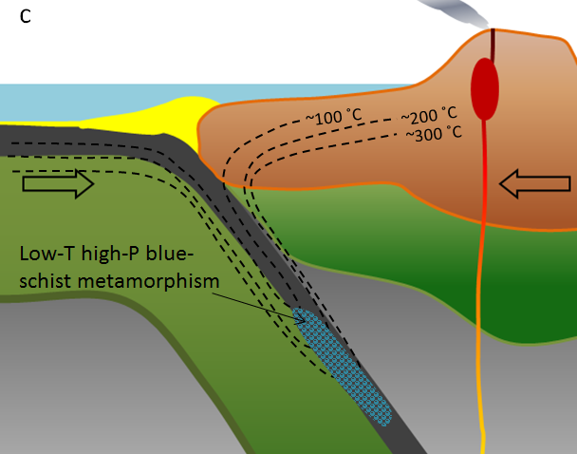
Regional metamorphism of oceanic crust at a subduction zone. (Example: Cascadia subduction zone. Rock of this type is exposed in the San Francisco area.)
A special type of metamorphism takes place under these very high-pressure but relatively low-temperature conditions, producing an amphibole mineral known as glaucophane (Na₂(Mg₃Al₂)Si₈O₂₂(OH)₂). Glaucophane is blue in colour, and the major component of a rock known as blueschist (Figure 10.22).
If you’ve never seen or even heard of blueschist, that not surprising. What is surprising is that anyone has seen it! Most of the blueschist that forms in subduction zones continues to be subducted. It turns into eclogite at about 35 km depth, and then eventually sinks deep into the mantle, never to be seen again. In only a few places in the world, the subduction process was interrupted, and partially subducted blueschist rock returned to the surface. One such place is the area around San Francisco. The blueschist is part of a set of rocks known as the Franciscan Complex
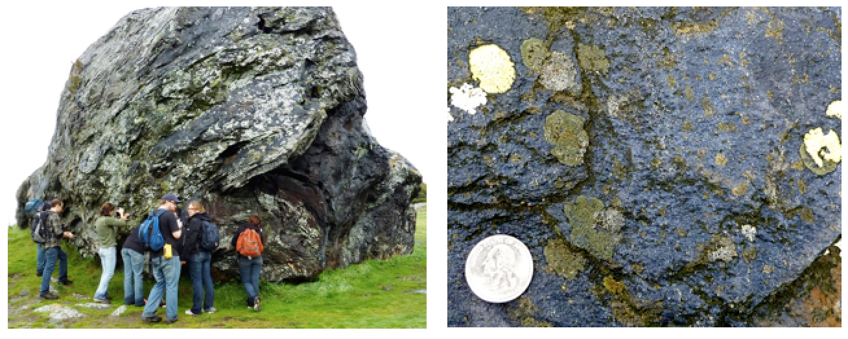
Franciscan Complex blueschist rock exposed north of San Francisco. The blue colour of rock is due to the presence of the amphibole mineral glaucophane.

5-Contact Metamorphism
Contact metamorphism happens when a body of magma intrudes into the upper part of the crust. Heat is important in contact metamorphism, but pressure is not a key factor, so contact metamorphism produces non-foliated metamorphic rocks such as hornfels, marble, and quartzite.
Any type of magma body can lead to contact metamorphism, from a thin dyke to a large stock. The type and intensity of the metamorphism, and width of the metamorphic aureole will depend on a number of factors, including the type of country rock, the temperature of the intruding body and the size of the body (Figure 10.23). A large intrusion will contain more thermal energy and will cool much more slowly than a small one, and therefore will provide a longer time and more heat for metamorphism. That will allow the heat to extend farther into the country rock, creating a larger aureole.
The width of nature of the thermal aureole depends on:-

(i) the temp gradient between the intrusion and the country rock
(ii) the temp of magma at depth at which intrusion took place, as well as the temp of
magma when it reaches the country rock
(iii) the size of the igneous body; this affects its rate of cooling
(iv) the composition of the country rock
(v) the distance from the igneous body to any particular site in the country rock
(vi) the volatile content of the magma
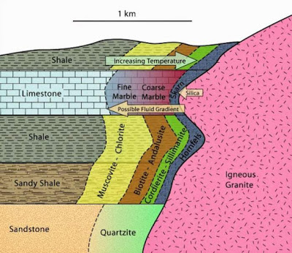

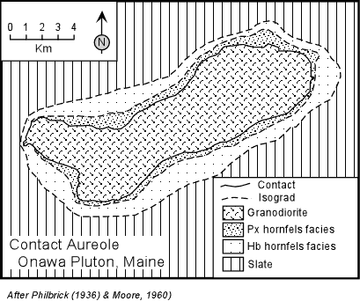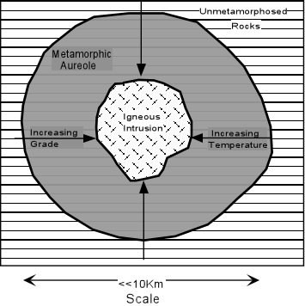
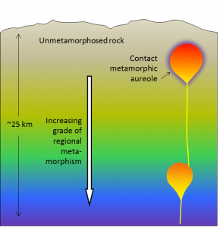
Schematic cross-section of the middle and upper crust showing two magma bodies. The upper body, which has intruded into cool unmetamorphosed rock, has created a zone of contact metamorphism. The lower body is surrounded by rock that is already hot (and probably already metamorphosed), and so it does not have a significant metamorphic aureole.

Contact metamorphic aureoles are typically quite small, from just a few centimetres around small dykes and sills, to as much as 100 m around a large stock. Contact metamorphism can take place over a wide range of temperatures — from around 300° to over 800°C. Different minerals will form depending on the exact temperature and the nature of the country rock.
Although bodies of magma can form in a variety of settings, one place magma is produced in abundance, and where contact metamorphism can take place, is along convergent boundaries with subduction zones, where volcanic arcs form (Figure 10.24). Regional metamorphism also takes place in this setting, and because of the extra heat associated with the volcanism, the geothermal gradient is typically a little steeper in these settings (somewhere between 40° and 50°C/km). That means higher grades of metamorphism can take place closer to surface than is the case in other areas (note the foliated metamorphic rocks listed on the right-hand side of the diagram).
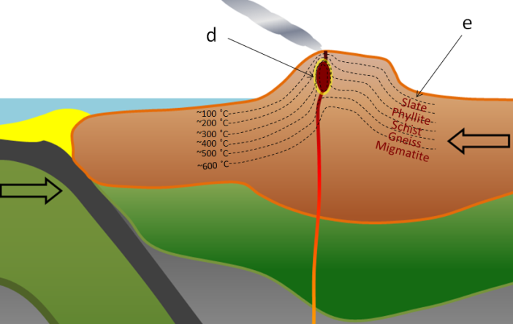
Contact metamorphism around a high-level crustal magma chamber, and regional metamorphism in a volcanic-arc related mountain range (volcanic-region temperature gradient)
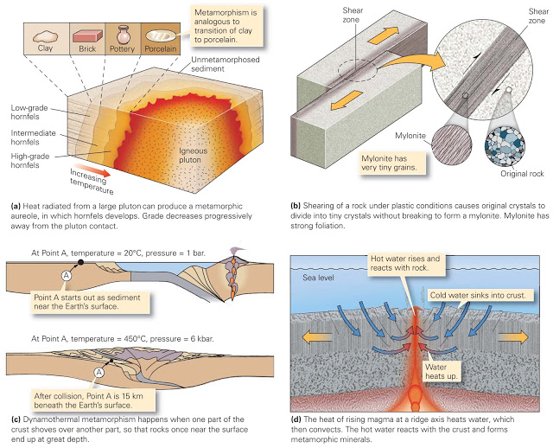

6-Shock Metamorphism
When extraterrestrial objects such as meteorites and asteroids hit the Earth, the result is a shock wave. Where the object hits, pressures and temperatures become very high in a fraction of a second. A “gentle” impact can hit with 40 GPa and raise temperatures to up to 500 °C.^{[2]} Pressures in the lower mantle start at 24 GPa (giga Pascals), or and climb to 136 GPa at the core-mantle boundary, so the impact is like plunging the rock deep into the mantle and releasing it again within seconds. The sudden change associated with shock metamorphism makes it very different from other types of metamorphism which can develop over hundreds of millions of years, starting and stopping as tectonic conditions change.
Two features of shock metamorphism are shocked quartz, and shatter cones. Shocked quartz (Figure 10.25 left) refers to quartz crystals which display damage that shows up as parallel lines throughout the crystal. The quartz crystal in Figure 10.25 has two sets of these lines. The lines are small amounts of glassy material within the quartz. Shatter cones are cone-shaped fractures within the rocks (Figure 10.25 right). The fractures are nested together like a stack of ice-cream cones, and point in the direction of the impact
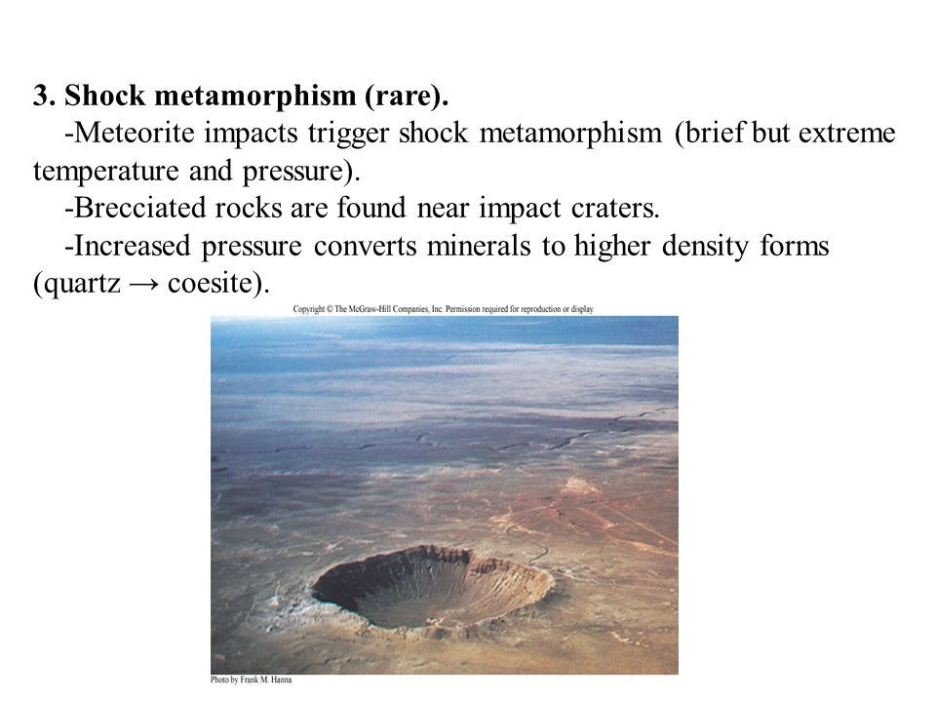
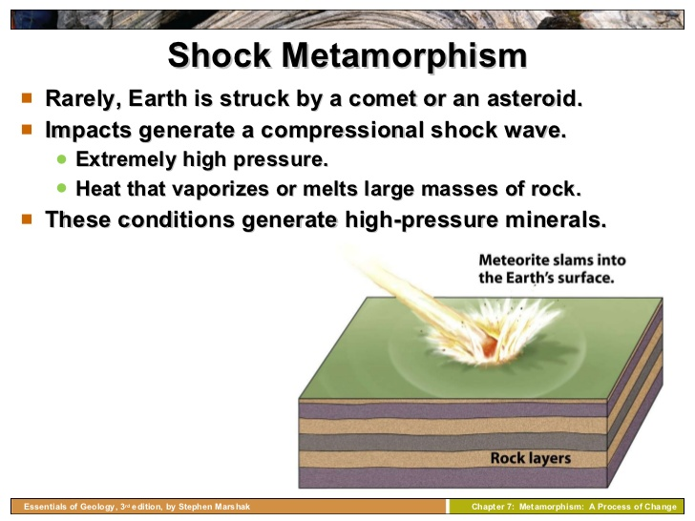
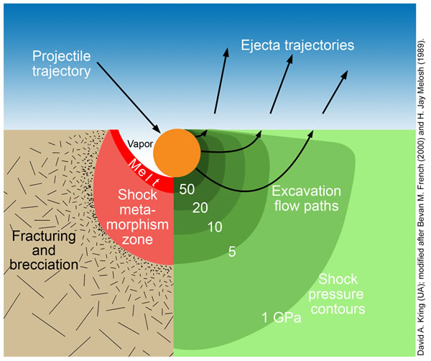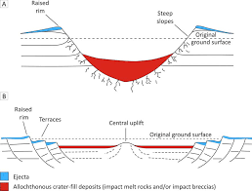
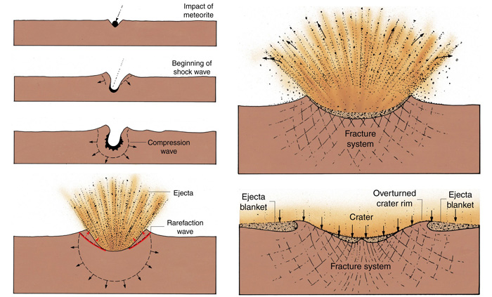
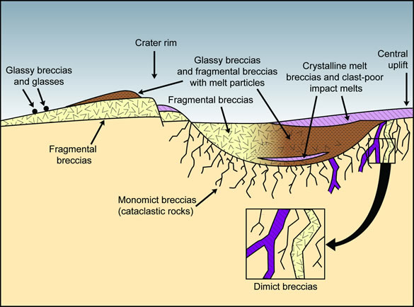
Schematic cross-section of a complex crater on the Moon illustrating the locations of different types of impact melts and impact breccias. The cross-section extends radially from the ejecta blanket (left) to the uplifted central peak in the crater center (right). Examples of the different types of impact products can be seen in the Lunar Sample Atlas. Glassy breccias (sample 68815), glasses (sample 60095), ejected fragmental breccias (sample 67455), fragmental breccias with melt particles (67015 and 67016), fragmental breccias in the crater fill (samples 14063 and 67495), crystalline melt breccias (65015 and 77135), clast-poor impact melts (samples 14310 and 68415), and dimict breccias (samples 61015 and 62255). This illustration is modified from those by Stöffler (1981) and Heiken et al. (1991).

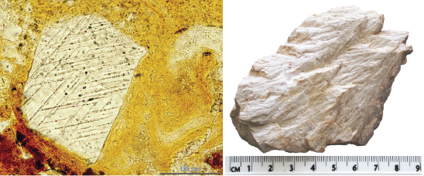
Shock metamorphism features. Left: Shocked quartz displaying lines of glassy material, from the Suvasvesi South impact structure in Finland. [Martin Schmieder CC-BY http://bit.ly/24vRcmM] Right: Shatter cones from the Wells Creek impact crater in the USA

7-High Strain Metamorphism
High-strain metamorphism deforms rocks with only minor thermal effects and occurs when the strain rate exceeds the ability of the rock to deform plastically. It is sometimes also called cataclastic metamorphism.
Deviatoric stress, strain rate and temperature are the most important variables in this type of metamorphism. Different minerals respond to deviatoric stress in different ways and variously exhibit the effect of the stress. The temperature has a first-order effect on the rheologic properties of materials.
High-strain metamorphism is typically produced along fault and shear zones in the upper and middle crust. It is usually restricted to orogenic zones and is therefore mostly located near plate margins.

The extensive folding and crustal thickening that often accompanies regional metamorphism implies that it is usually associated with compressive tectonic regimes. For this reason, most attempts to link regional metamorphism to plate tectonics setting have concentrated on regions where plates converge
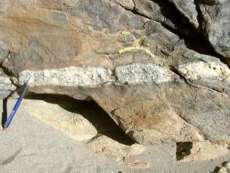

Boudinaged felsic (i.e., rich in quartz and feldspar) dike crosses metasediments
Image Credit: MBG
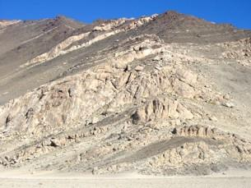

Wide ductil shear zone with banded gneiss and mylonitic metagranite in amphibolite facies. Lower Paleozoic, Sierra El Peñón, Argentin
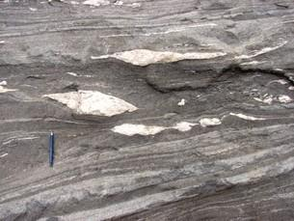

Subhorizontal shear zones devolped in high-grade amphibolite facies. Sierra de Quilmes, Argentina
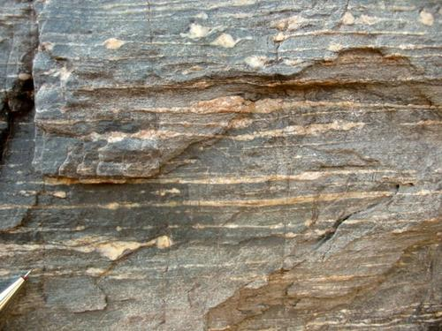

Shear sense indicators
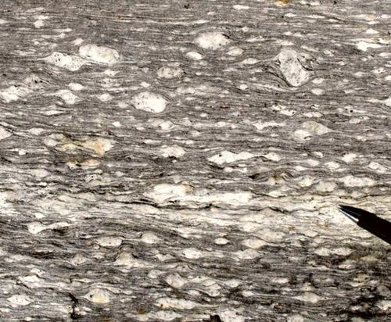

Augen gneiss from the Alps
Image Credit: Steffen Biersack

