TEXTURES OF METAMORPHIC ROCKS

1. INTRODUCTION

The term texture refers to the shape, size, orientation and arrangement of mineral grains in a rock. A single rock may contain several textures or textural elements. The term structure is more commonly used for larger features.

Textures in metamorphic rocks can be of three different types:

a) Relictic - when pre-metamorphic features are preserved such as
cross-bedding, ophitic texture, amydules, etc.
x
Foliation and bedding in quartzite, The opaque minerals represent the original bedding

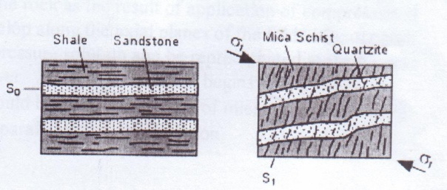

b) Superimposed - modification or alteration of a pre-existing texture, such as
pseudomorphosis of porphyries. The texture is partly relictic,
partly new.
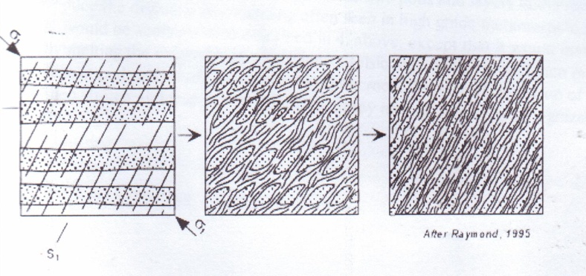

c) Typomorphic - new textures produced by metamorphism.

We will concentrate on the third type. For a better understanding of the metamorphic textures it is necessary to have knowledge of some basic principles of metamorphic reactions.

Metamorphic reactions have the aim to produce stable mineral parageneses that have a minimal energy under the physical conditions of metamorphism. As soon as the lowest energy state is reached the rock system is in equilibrium at that particular P and T. In other words: metamorphism is a thermally activated response of a solid rock to minimize its total energy.

Crystal growth in the solid state during metamorphism involves:

(1) Crystallization of new minerals that were not already present by mineralogical
reaction, nucleation and growth.

(2) Modification of boundaries of existing grains that may be strained or otherwise
less stable.

The two processes take place simultaneously. A simple illustration is given in Figure 1.

A metamorphic reaction involves three independent processes: liberation of ions from the crystal lattices of the original minerals; diffusion of these chemical constituents towards the location of the newly growing grain; and nucleation of new stable phases on those locations. Reaction rates of metamorphic reactions are extremely slow as high activation energies are necessary to break crystal lattices and because diffusion rates are very low in the solid state.

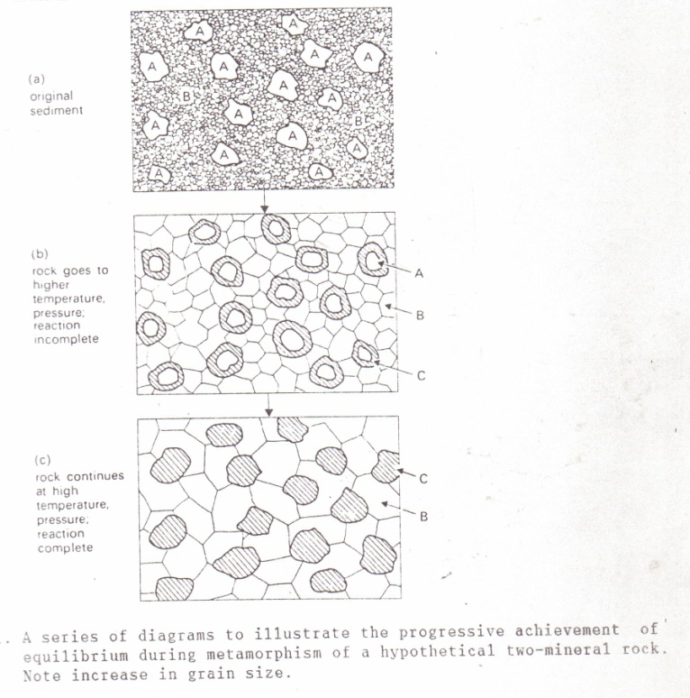
Figure 1
The presence of water increases reaction rates. Water (H₂O) may be present within the crystal lattices of the minerals, as well as filling pore spaces, or adsorbed on grain boundaries. In the latter case we speak of an intergranular fluid or film. The intergranular fluid is important for the transport of chemical constituents by diffusion, especially under low to medium grade metamorphic conditions. At high temperatures diffusion through crystal lattices becomes more important.

2. SURFACE FREE ENERGY

Increasing metamorphic grade is commonly reflected by an increase in grainsize of the minerals: High grade metamorphic rocks are usually coarser than low grade ones. The coarsening represents the attempt by the crystals to reduce their surface free energy, which is corresponding to the proportion of surface area to volume.

Near and at the surface of a crystal the ions are unable to bond completely with other ions. As the formation of bonds results in a decrease in energy the ions at the surface of a crystal are in a higher energy state than ions within the crystal.

Surface free energy is associated with grain boundaries and crystallization tends to reduce it to a minimum. As the surface free energy increases with an increase in the proportion surface area to volume one coarse grain is more stable than for instance four small grains with the same total volume, and straight boundaries will tend to develop. Thus the surface free energy has a strong effect on the textures that develop during metamorphism.

Many minerals have significantly different surface free energy in different crystallographic directions. Micas, for example, grow as platy crystals because the {001} form has a lower overall surface energy than any other form. This variation in surface energy for different crystallographic directions is called surface energy anisotropy. In polymineralic rocks grains with a strong surface energy anisotropy tend to form euhedral crystals at the expense of neighbouring grains that are less anisotropic. Quartz, feldspars and cordierite have a low surface energy anisotropy (i.e. the energy varies little with respect to the crystallographic orientation of the surface), so that they tend to adjust themselves to the more anisotropic crystals in the rock, such as garnet and mica. Commonly they occur as anhedral grains in metamorphic rocks. Hence there is a hierarchy, known as the crystalloblastic series, among minerals indicating their relative tendency to form euhedral crystals during solid state growth.

Crystalloblastic series

MOST EUHEDRAL

Sphene, rutile, pyrite
Garnet, sillimanite, staurolite, tourmaline
Epidote, magnetite, ilmenite
Andalusite, pyroxene, amphibole
Micas, chlorite, dolomite, kyanite
Calcite, idocrase, scapolite
Plagioclase, quartz, cordierite

LEAST EUHEDRAL

In monomineralic rocks, or monomineralic bands/lenses within a rock, the equilibrium texture can be seen as a crystalloblastic or granoblastic aggregate of polygonal grains, their boundaries meeting at triple junctions with equal angles of about 120º. This results of growth of crystals of one type of mineral, i.e. with equal surface free energy anisotropy. It is the typical equilibrium texture of quartzites and marbles which recrystallised during contact metamorphism (see Figures 2 and 3), but it is also developed in high grade politic rocks (see Figure 4).
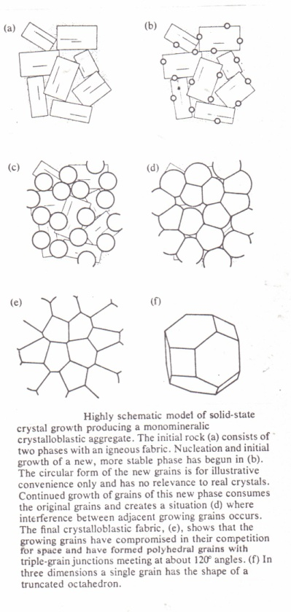

Figure 2
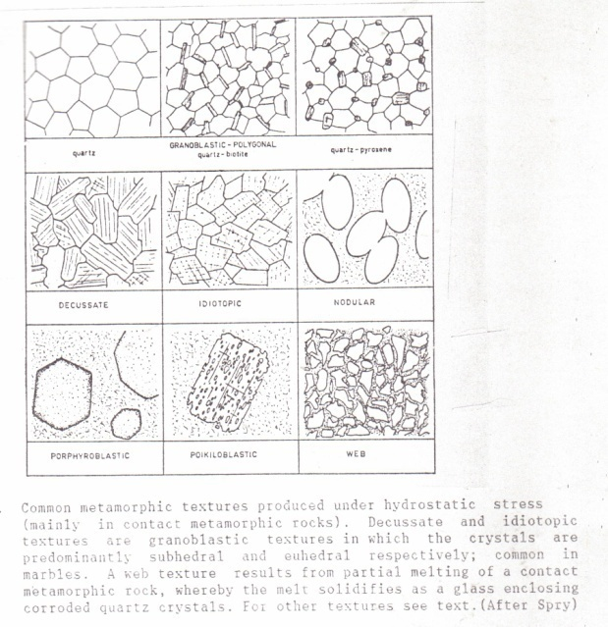
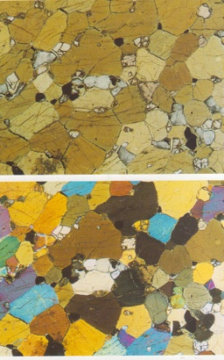Granoblastic polygonal texture in hornblende

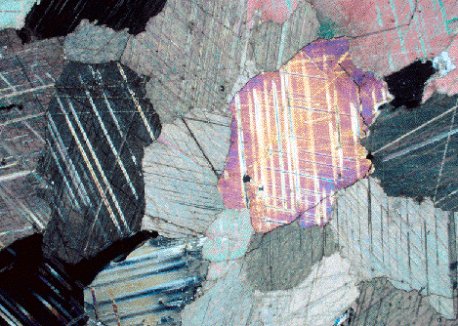

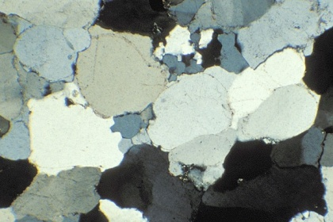

Figure 3

3. FOLIATED ROCKS

Foliations are structures that are typically formed at deeper levels in the crust in regions where tectonic stresses are active. These structures are different from those produced at higher levels due to the effect of increased T and P:

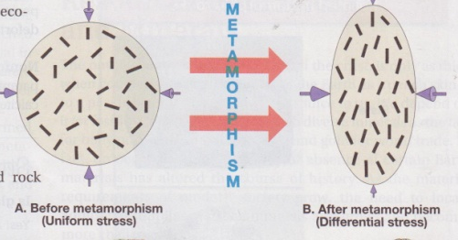
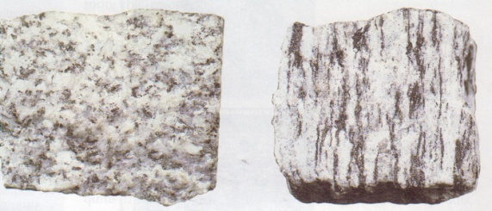
Under the pressure of metamorphism, some mineral grains become oriented and aligned to the stress

the rocks behave in a ductile manner. Folding then is the typical way of deformation rather than faulting. This folding, in combination with metamorphic recrystallization under high temperature and pressure, leads to the development of new sets of planar surfaces, i.e. foliations, which are nearly exclusively present in regional metamorphic rocks. The term foliation covers any type of planar or linear fabric, including cleavage, schistosity, gneissosity and gneissic banding (see Figure 5,6, and 7).

For a more extensive treatment of the development of foliations see Chapter 5 of course GGY 3020.

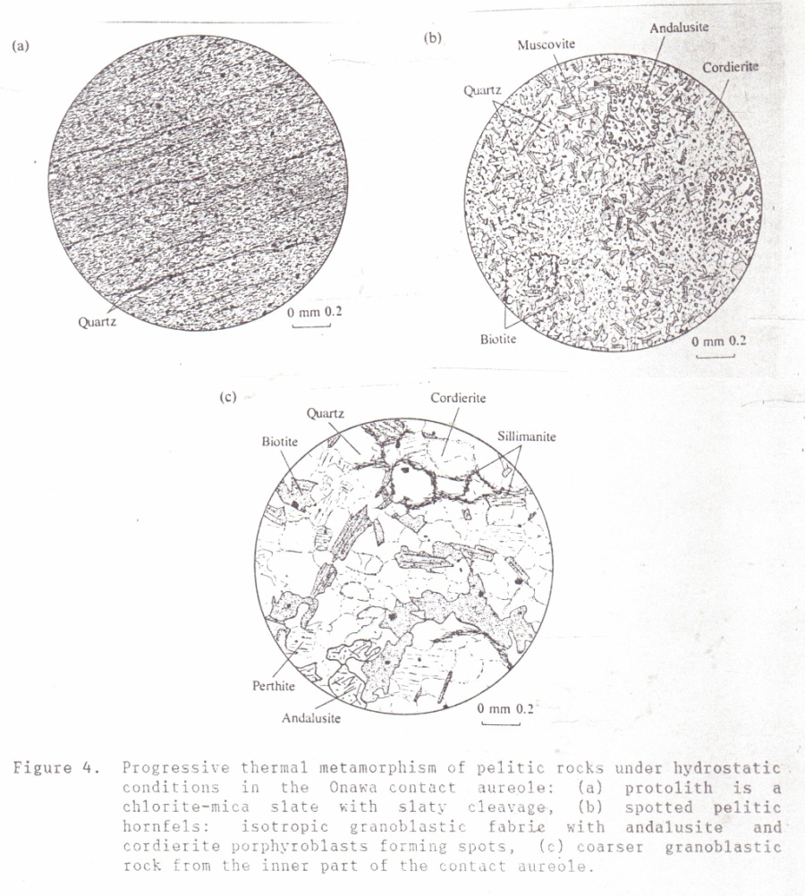

Figure 4
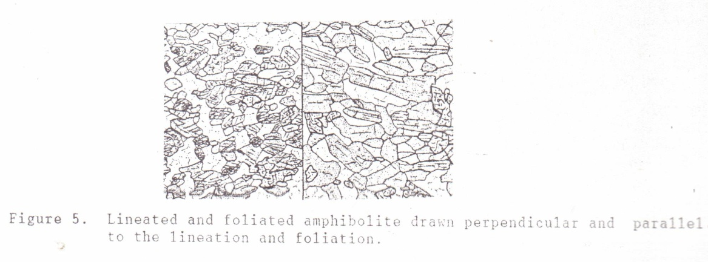

Figure 5

Several different microstructures may give rise to foliations in metamorphic rocks:

(1) Preferred orientation of platy minerals or lenticular mineral aggregates: the
platy minerals such as chlorite, muscovite, biotite and clay minerals, or elongate aggregates of quartz and feldspar, are aligned in a direction perpendicular to the strongest compression. Thus they define the schistosity or the gneissosity of the rock.
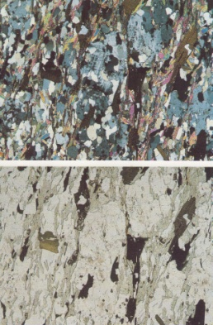Microcline mica schist

(2) Compositional layersing: alternation of thin layers of different composition,
usually an alternation of light quartz-feldspar layers and darker mica-rich layers. It is also called gneissic banding or gneissic layering and is the result of the migration of chemical constituents into preferred zones parallel to the schistosity, a process which is called metamorphic differentiation.
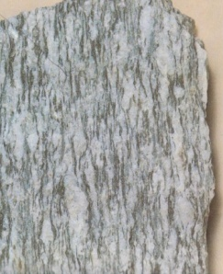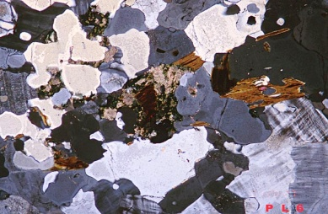

(3) Textural layering: the alternation of layers with a different texture, for instance
grainsize.

Commonly a metamorphic rock displays a combination of the above microstructures.
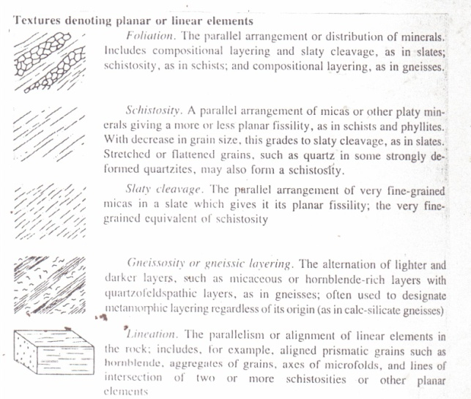

Figure 6
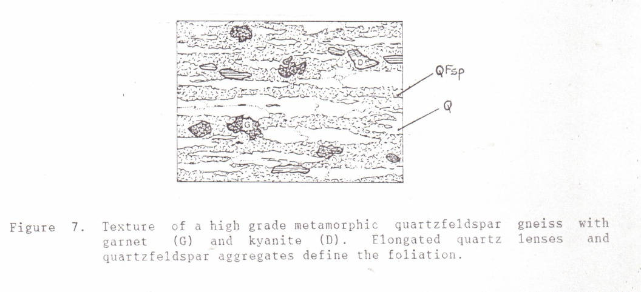

Figure 7

4. CATACLASTIC TEXTURES

Cataclasis is the term used for the mechanical deformation of rocks. This process typically takes place near the surface of the Earth where temperatures and pressures are low so that the rocks show brittle behavior.

Fault gouge and fault breccias are loosely textured rocks that are typically formed along faults and fault zones near the surface of the Earth. In fault zones at greater depths rocks are produced which retain their coherence through a process of continuous recrystallization and ductile flow accompanying mechanical fracturing and granulation (see also GG 332 Chapter 3). These fault zones are termed shear zones and the resulting sheared rocks are called mylonites.

A mylonite is a very hard, dark rock consisting of roundedporphyroclasts embedded in a fine-grained matrix with a strong foliation called fluxion structure. If the rock consists of an extremely finegrained, streaky matrix with only few, tiny porphyroclasts the name ultramylonite is used. A protomylonite contains more and usually larger pophyroclasts than a mylonite .
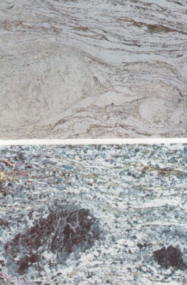
Granite mylonite

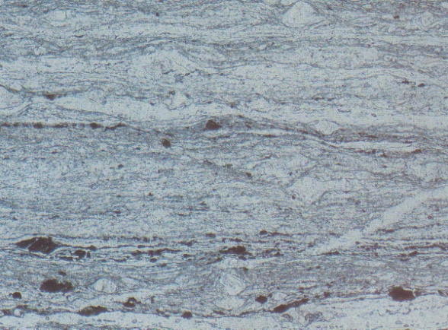
Ultramylonite

A recrystallized mylonite is called a blastomylonite. An augengneiss is a protomylonite with coarse alkali feldspar porphyroclasts (which are the augen=eyes); most commonly it is produced by cataclastic deformation of a granite.
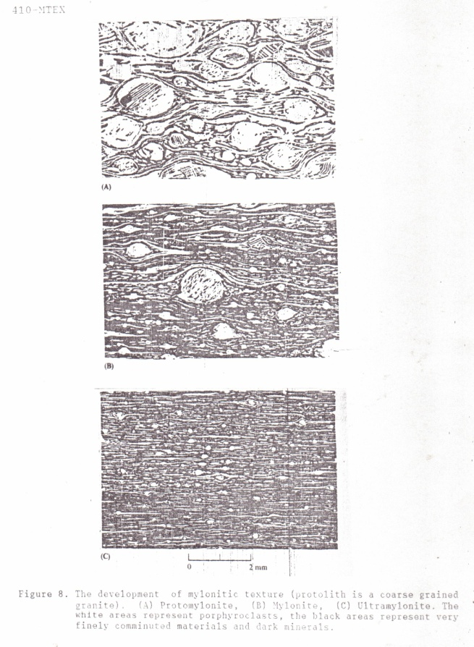

Figure 8

5. PORPHYROBLASTIC FABRIC

Porphyroblasts or metacrysts are relatively large grains that grow during metamorphism and that are embedded in a finer grained matrix of other minerals. Their origin seems to be related to both nucleation and diffusion rates of chemical constituents. If the number of sites for nucleation is low and if diffusion rates are fast large porphyroblasts will tend to form. Alternatively, if sites for nucleation are abundant and the diffusion rates of the constituents are slow a large number of smaller grains are formed. Garnet, staurolite and the Al₂SiO₅ polymorphs andalusite, kyanite and sillimanite are especially common as porphyroblasts. According to the shape of the porphyroblasts they can be subdivided into idioblasts, subidioblasts and xenoblasts
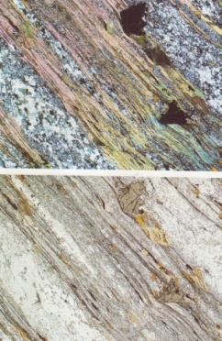Porphyroblastic schist

Figure 9).

The growth of a porphyroblast may lead to impoverishment of certain constituents in its vicinity, for example a light coloured halo may surround the porphyroblast of an Fe-Mg mineral (see Figure 10).
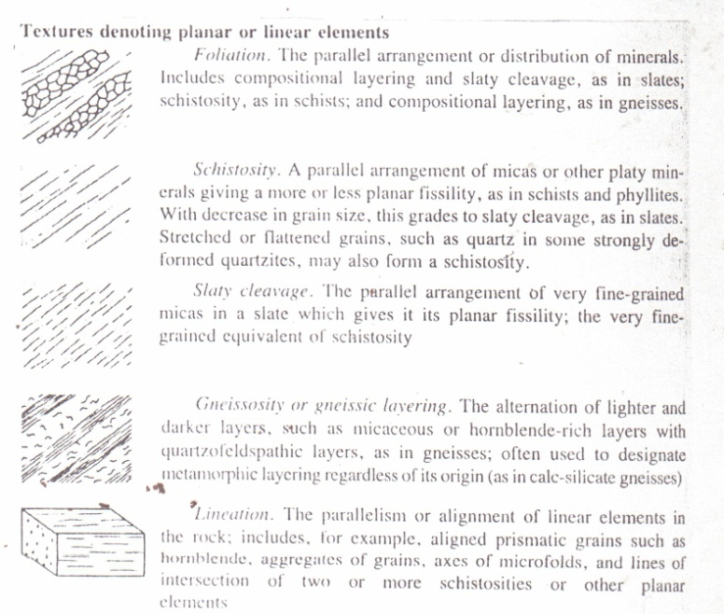

Figure 9

Porphyroblasts often grow by replacement of the groundmass. The growth-replacement process may be complete or incomplete. If complete, no trace of the former matrix material remains within the porphyroblast; if incomplete, inclusions may be found within the porphyroblast. If the number of inclusions is very large the porphyroblast is called poikiloblast.
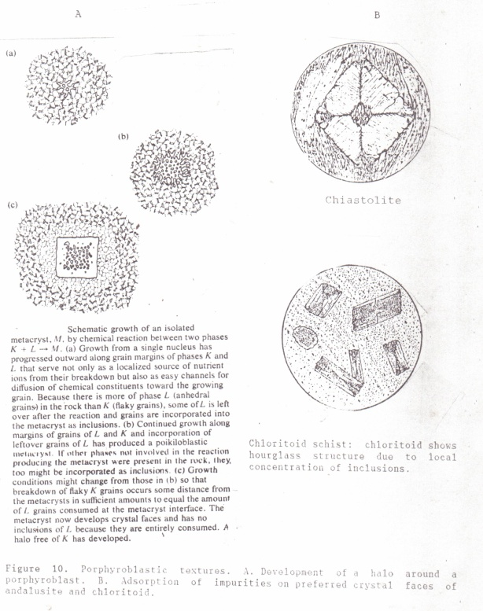

Figure 10

In some cases the inclusions appear to represent relics of an earlier metamorphic stage of lower grade: outside the porphyroblast these minerals have been destroyed by metamorphic reactions but the inclusions inside the porphyroblast were apparently effectively separated from the intergranular fluid and thus they were unable to react.

Inclusions may be randomly or regularly distributed. When there are parallel rows or “trails” of inclusions (straight or curved) they define an internal schistosity(S₁), reflecting preferred crystal orientations that already existed in the matrix before the porphyroblast was developed. For example opaque grains may reflect the schistosity that existed before the growth of the porphyroblast. If the inclusions define an internal schistosity the term helicitic texture is sometimes used. Some porphyroblasts (such as amphibole and cordierite) may be riddled with rounded quartz inclusions and then the term sieve texture may be used (see Figure 10 C).

In rare cases, such as the chiastolite variety of andalusite, the distribution of inclusions is related to specific crystallographic directions within the porphyroblast: it results from adsorption of impurities during growth of the porphyroblast on certain crystal faces and not on others. Hour glass structure in chloritoid has a similar origin (see Figure 10 B).

6. THE RELATIONSHIP OF PORPHYROBLASTS TO DEFORMATION

A typical metamorphic event is not a simple situation in which T and P have smoothly increased to a maximum, and then smoothly decreased. Commonly the temperature rise is irregular through time (see Figure 11), and maximum temperatures are not necessarily related to maximum intensity of deformation. In addition, many regions have been subjected to more than one metamorphic event (polymetamorphism). The evidence of the relative sequence is often revealed by the mineralogy and textures of the rock.

Figure 11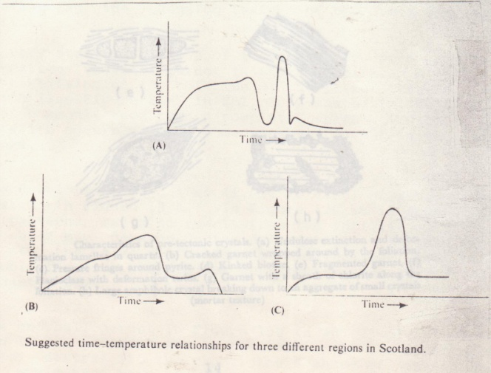

Study of the relation between the internal schistosity S₁ with regard to the external schistosity S_{o} of the rock, makes it often possible to determine whether a porphyroblast has grown before, during or after a period of deformation (that is, the S_{o} producing deformation) in a rock. We distinguish:

- Pretectonic crystal growth, occurring prior to deformation

- Syntectonic crystal growth, occurring during deformation, and

- Post tectonic crystal growth, occurring after the deformation of the rock.

Synonyms are: Prekinematic, synkinematic and postkinematic.

Figure 12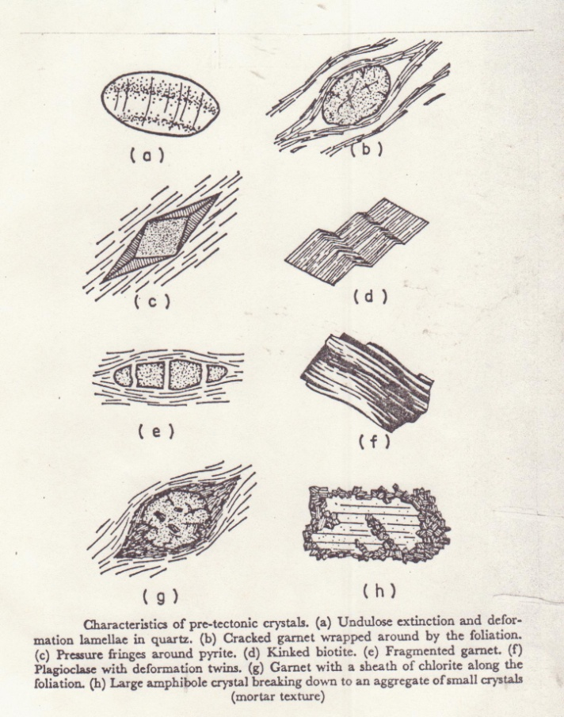

Pretectonic porphyroblasts

A porphyroblast grown before a period of deformation may contain inclusions distributed in a way that indicates an earlier feature such as bedding. This may show up as parallel lines of inclusions, for instance of opaque grains. During later deformation the porphyroblast acts as a relatively rigid part of the rock in comparison to the matrix: it may be rotated, the matrix may be flattened around the blast, etc. In all these cases S₁ no longer corresponds to S_{o} (see Figure 15).

The porphyroblast commonly shows the effects of deformation by fractures, undulose extinction due to bending of the crystals, or kinking (see Figure 12). As the porphyroblast acts as a development of pressure shadows, i.e. areas of apparently lower P on opposite sides of the grain, parallel to the S_{o} directi). 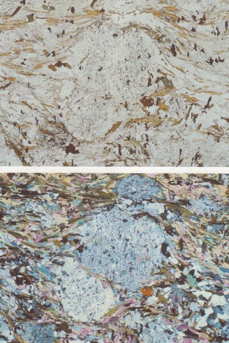

Syntectonic porphyroblasts

Porphyroblasts most commonly grow during a period of deformation. If the porphyroblast acquires inclusions during growth the inclusions will define different orientations in different portions of the porphyroblast (see Figures 13A and 15), reflecting the changing texture of the rock during the deformation.

A very striking example of a syntectonic porphyroblast is the so-called snowball garnet in which a spiral of inclusions occurs testifying of the rotation of the garnet crystal during its growth (see Figure 21-7 in EB). An S-shaped inclusion pattern is more commonly seen than a complete spiral, indicating that less rotation occurred. The name snowball garnet is applied for both types.

The development of a true (i.e. rotated) snowball garnet is illustrated in Figure 13B. In Figure 13C it is shown that S-shaped patterns may also result from the infilling of tension cracks which may develop during deformation. Another process leading to the same texture can be posttectonic growth of a porphyroblast over a microfolded schistosity (see also Ehlers and Blatt Chapter 21).

The snowball garnet in Figure 13B is an example of sinistral rotation (i.e. movement was to the left). If the rotation would have been dextral (to the right) the S-shape of the inclusion pattern would have been mirrored.
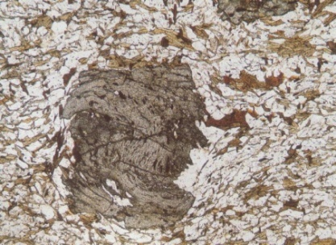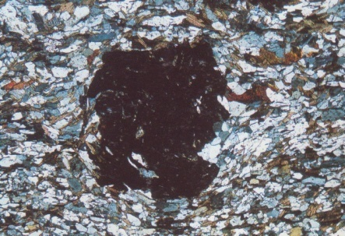
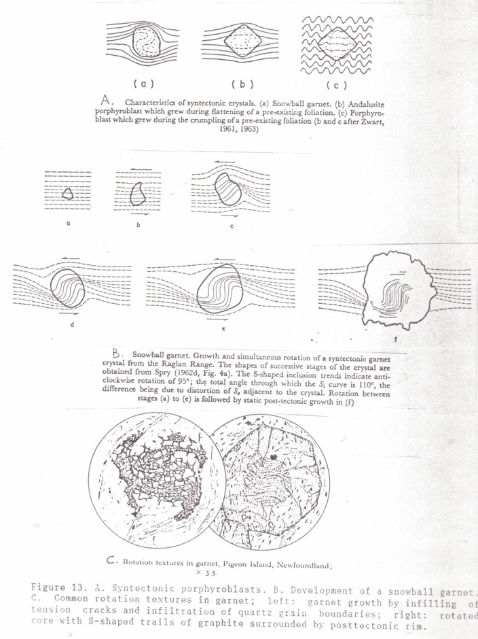

Figure 13

Sometimes syntectonic porphyroblasts grow as extremely elongated xenoblasts parallel to the foliation of the rock, sometimes the exnoblasts are “folded” copying the crenulation of the main foliation. In these situations it is often difficult to decide whether +the porphyroblast is syntectonic or posttectonic with respect to the deformation.

Posttectonic porphyroblasts

Posttectonic growth is often the easiest to recognize, as the porphyroblast can grow with complete disregard of the foliation within the matrix. Elongated porphyroblasts such as mica, chloritoid, andalusite, etc. usually have an elongation direction that is random with respect to S_{o}. However, S₁ corresponds perfectly to S_{o}, as the inclusion pattern mimics the existing foliation (see Figure 14a). Post tectonic porphyroblasts do not show pressure shadows or evidence of deformation.
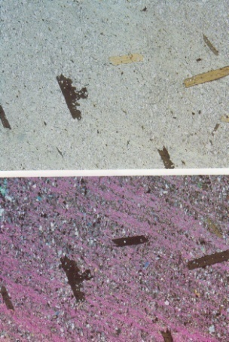

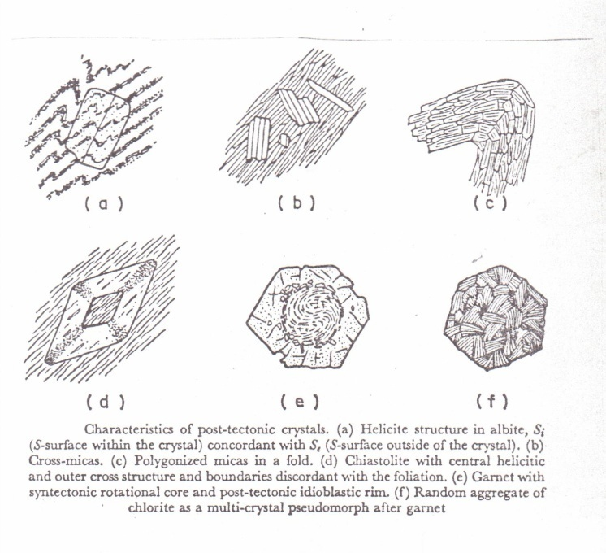

Figure 14
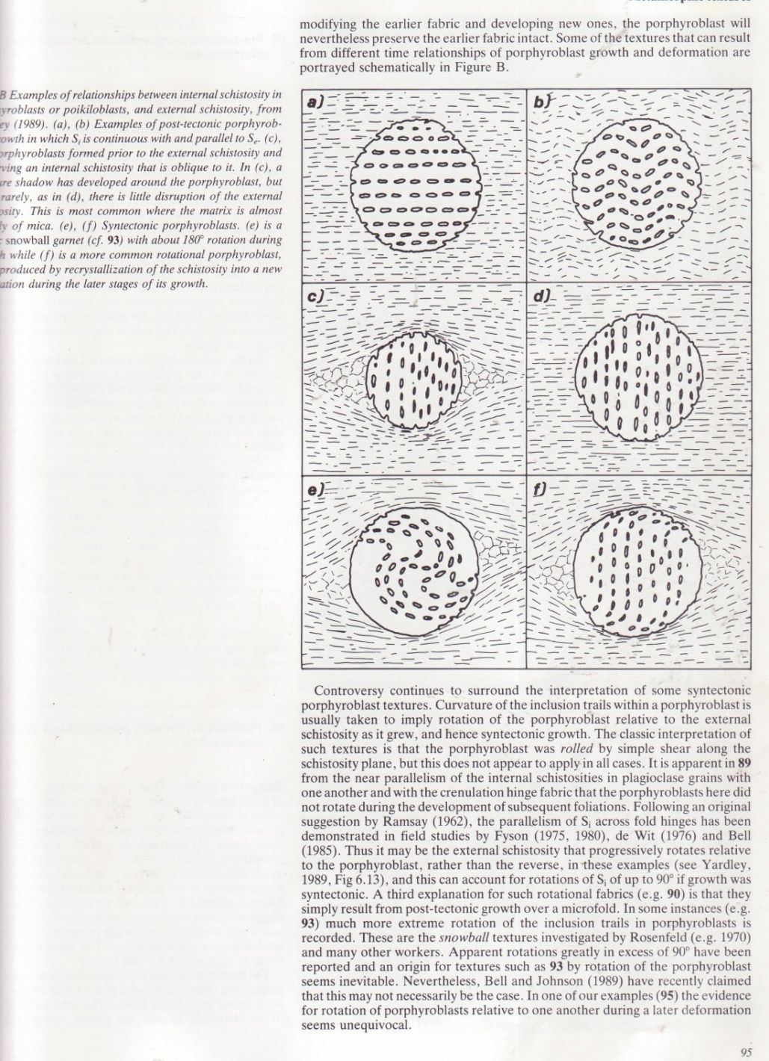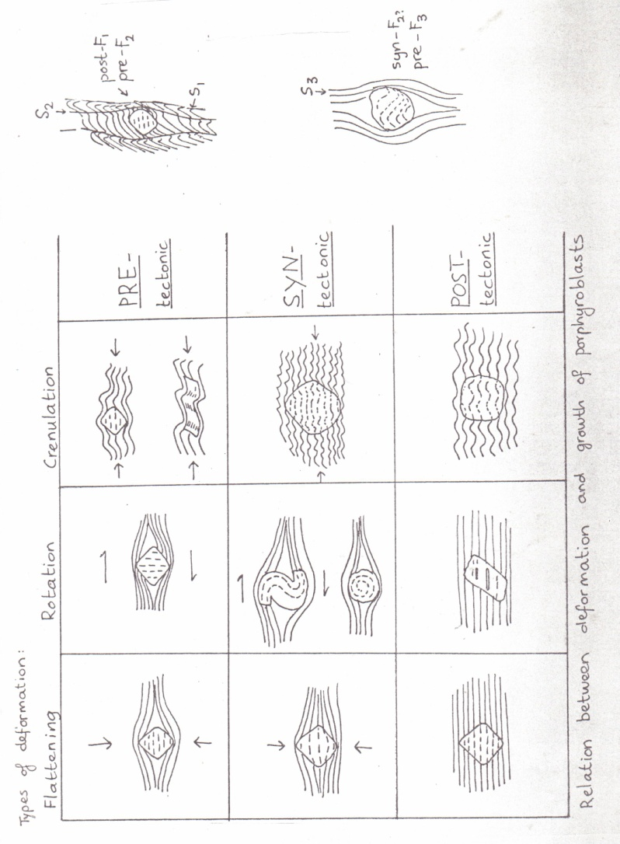Figure 15

During and after deformation recovery processes are continuously operative. This involves the elimination of strained crystals by the formation of a number of smaller unstrained crystals forming a granoblastic polygonal aggregate. This process is called polygonization and it is a process which affects especially matrix minerals.

A special type of polygonization is the recrystallization of strained micas or amphiboles within the hinges of microfolds to unstrained crystals. The recrystallized platy minerals mimic the microfolds which are then called polygonal arcs (see Figure 14c).

Polymetamorphism

Textural and mineralogical evidence often indicates that metamorphic terranes have been subjected to a sequence of tectonothermal events, involving several periods of deformation and metamorphic recrystallization. The repetition of metamorphic events is called polymetamorphism, but it should be kept in mind that these events are usually connected with successive deformation phases. Thus polymetamorphic rocks often show multiple foliations (i.e. more than one) in the groundmass (see Figure 16 and refer to course GG 332, 432). Porphyroblasts develop textures as shown in Figures 17 and 18.
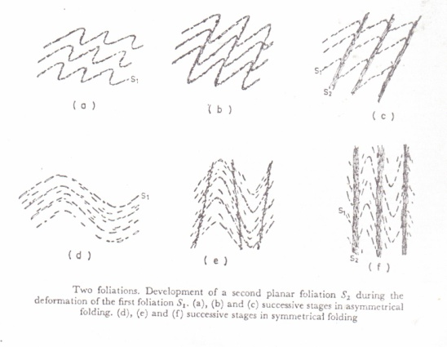

Figures 16,
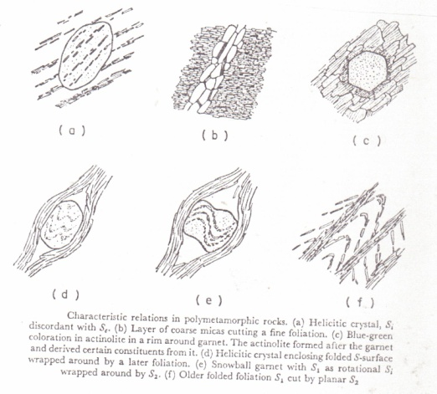

17
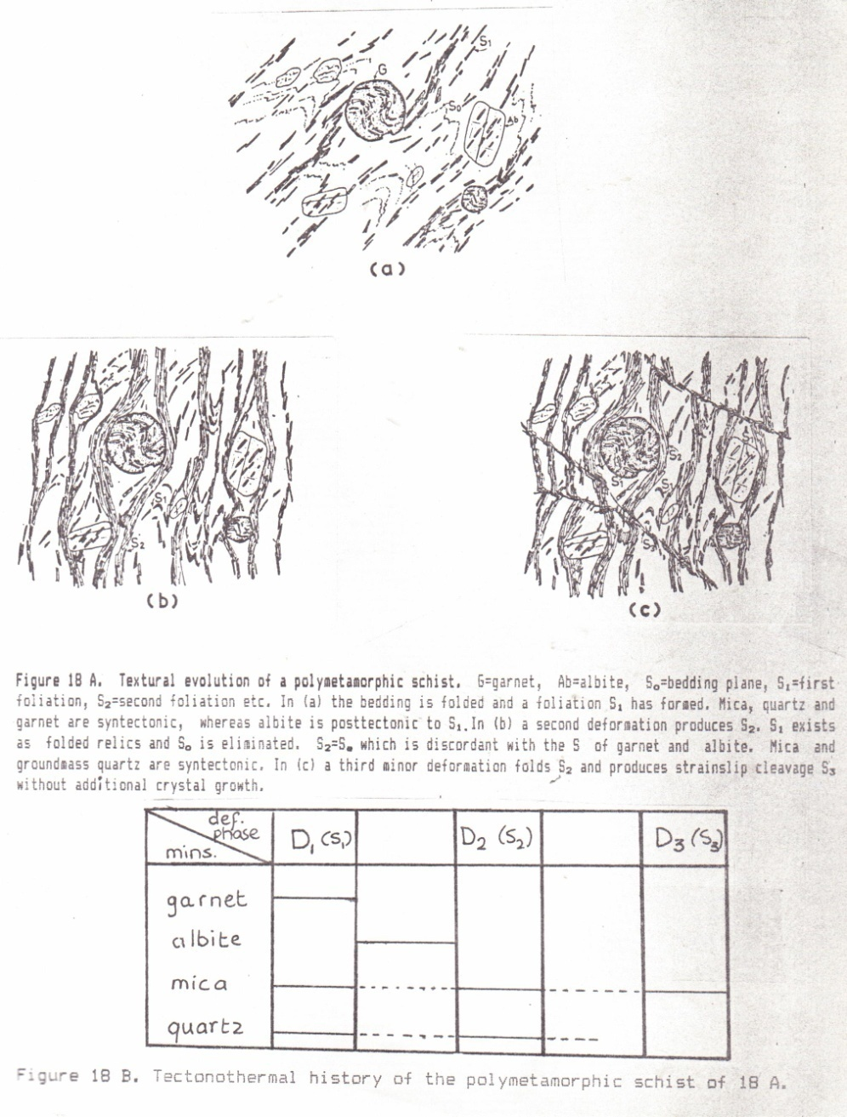
and 18

