GGY 4070 IGNEOUS AND METAMORPHIC PETROLOGY
METAMORPHIC LAB
HAND SAMPLES
Schist
Schist is a metamorphic rock that contains flakes of mica. Schist can originate as a sedimentary rock or igneous rock. It can contain different minerals. Most schist contains the mineral mica and is called mica schist
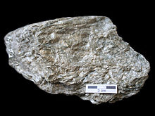
Schist specimen showing the characteristic "scaly" schistose texture, caused by platy micas
MICA-SCHIST, in petrology, a rock composed essentially of mica and quartz, and having a thin parallel-banded or foliated structure, with lamellae rich in mica alternating with others which are principally quartz. They split readily along the micaceous films, and have smooth or slightly uneven surfaces covered with lustrous plates of muscovite or biotite; the quartzose lamellae are often visible only when the specimens are looked at edgewise. Mica-schists are very common in regions of Archean rocks accompanying gneisses, crystalline limestones and other schists. Some have a flat banding yielding smooth slabs; others are crumpled or contorted with undulating foliation. Occasionally the quartz forms elliptical lenticles or "eyes." In some cases mica composes nearly the whole of the rock, in others quartz preponderates so that they approach quartz-schists and quartzites.
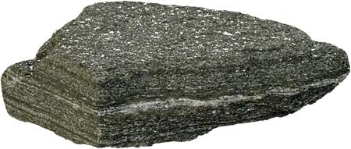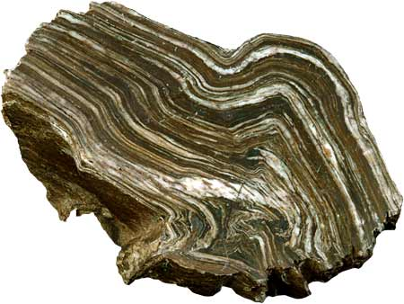
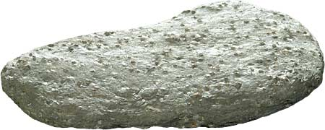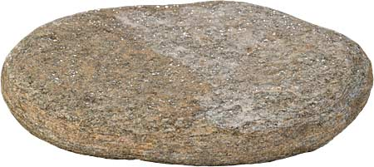
PHYLITE
Phyllite has fine-grained mica flakes in a preferred orientation, whereas slate has extremely fine clay flakes that achieve a preferred orientation, and schist has large flakes in a preferred orientation.^{[1]} Among foliated metamorphic rocks, it represents a gradation in the degree of metamorphism between slate and schist

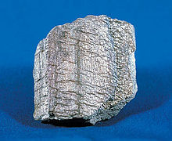
GNEISS
is a common distributed type of rock formed by high-grade regional metamorphic processes from pre-existing formations that were originally either igneous or sedimentary rocks. It is often foliated (composed of layers of sheet-like planar structures). The foliations are characterized by alternating darker and lighter colored bands, called "gneissic banding
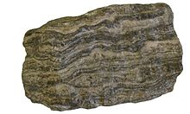
GNEISS
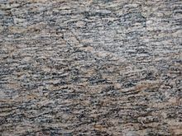
AUGEN gneiss
QUARTZITE
Quartzite is a hard metamorphic rock.^{[1]} It is formed when sandstone is squeezed and heated under a chain of mountains.
Although pure quartzite is white, it usually occurs in shades of pink and red. This happens when it contains some iron oxide (Fe₂O₃). Other colours, such as yellow and orange, are due to other mineral impurities.
When sandstone is changed to quartzite, the individual quartz grains and cement material recrystallizes. Most of the original texture of the sandstone is destroyed by the metamorphism. Minor amounts of cementing materials, iron oxide, silica, carbonate and clay, often move when this is happening. It causes streaks and lens shapes to form in the quartzite.

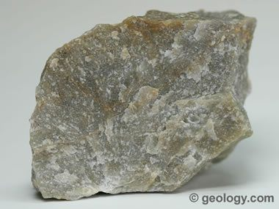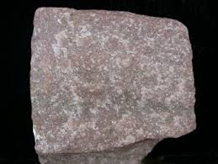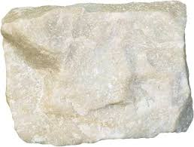
MARBLE
Marble is a metamorphic rock that forms when limestone is subjected to the heat and pressure of metamorphism. It is composed primarily of the mineral calcite (CaCO₃) and usually contains other minerals, such as clay minerals, micas, quartz, pyrite, iron oxides, and graphite. Under the conditions of metamorphism, the calcite in the limestone recrystallizes to form a rock that is a mass of interlocking calcite crystals. A related rock, dolomitic marble, is produced when dolostone is subjected to heat and pressure.
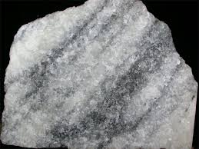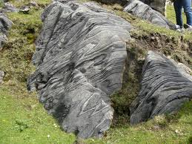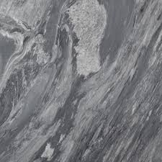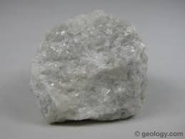
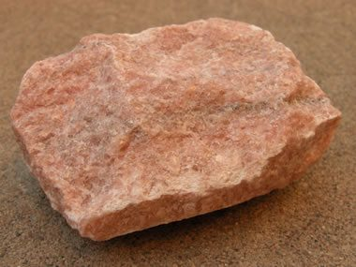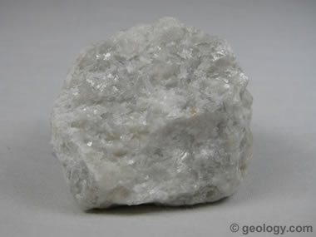

GNEISS
Gneiss is a foliated metamorphic rock identified by its bands and lenses of varying composition, while other bands contain granular minerals with an interlocking texture. Other bands contain platy or elongate minerals with evidence of preferred orientation. It is this banded appearance and texture - rather than composition - that define a gneiss
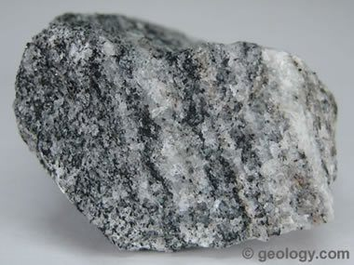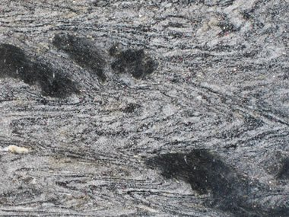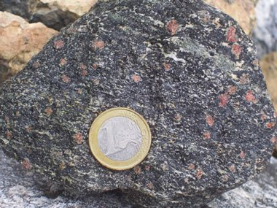
ECLOGITE
a mafic metamorphic rock. Eclogite forms at pressures greater than those typical of the crust of the Earth. An unusually dense rock, eclogite can play an important role in driving convection within the solid Earth.
The fresh rock can be striking in appearance, with red to pink garnet (almandine-pyrope) in a green matrix of sodium-rich pyroxene (omphacite). Accessory minerals include kyanite, rutile, quartz, lawsonite, coesite, amphibole, phengite, paragonite, zoisite, dolomite, corundum, and, rarely, diamond. Plagioclase is not stable in eclogite.

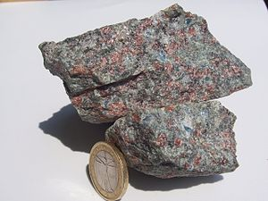
Eclogite piece with a garnet (red) and omphacite (greyish-green) groundmass. The sky-blue crystals are kyanite. Minor white quartz is present, presumably from the recrystallization of coesite. A few gold-white phengite patches can be seen at the top. A 23 mm coin added for scale
AMPHIBOLITE
Amphibolite ( /æmˈfɪbəlaɪt/) is a metamorphic rock that contains amphibole, especially the species hornblende and actinolite, as well as plagioclase. A holocrystalline plutonic igneous rock composed primarily of hornblende amphibole is called a hornblendite, which is usually a crystal cumulate rock. Rocks with >90% amphiboles which have a feldspar groundmass may be a lamprophyre.
Amphibolite is a grouping of rocks composed mainly of amphibole and plagioclase feldspars, with little or no quartz. It is typically dark-colored and heavy, with a weakly foliated or schistose (flaky) structure. The small flakes of black and white in the rock often give it a salt-and-pepper appearance.
Amphibolites need not be derived from metamorphosed mafic rocks. Because metamorphism creates minerals based entirely upon the chemistry of the protolith, certain 'dirty marls' and volcanic sediments may actually metamorphose to an amphibolite assemblage. Deposits containing dolomite and siderite also readily yield amphibolites (tremolite-schists, grunerite-schists, and others) especially where there has been a certain amount of contact metamorphism by adjacent granitic masses. Metamorphosed basalts create ortho-amphibolites and other chemically appropriate lithologies create para-amphibolites.
Tremolite, while it is a metamorphic amphibole, is derived most usually from highly metamorphosed ultramafic rocks, and thus tremolite-talc schists are not generally considered as 'amphibolites'

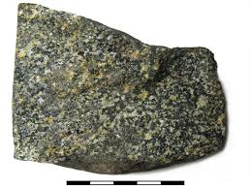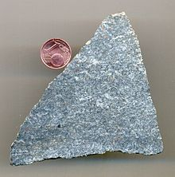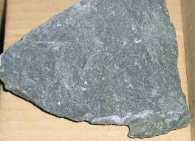

SLATE
Slate is a fine-grained, foliated, homogeneous metamorphic rock derived from an original shale-type sedimentary rock composed of clay or volcanic ash through low-grade regional metamorphism. It is the finest grained foliated metamorphic rock.^{[1]} Foliation may not correspond to the original sedimentary layering, but instead is in planes perpendicular to the direction of metamorphic compression.^{[1]}
The foliation in slate is called "slaty cleavage".^{[1]} It is caused by strong compression causing fine grained clay flakes to regrow in planes perpendicular to the compression.^{[1]} When expertly "cut" by striking parallel to the foliation, with a specialized tool in the quarry, many slates will display a property called fissility, forming smooth flat sheets of stone which have long been used for roofing, floor tiles, and other purposes.^{[1]} Slate is frequently grey in color, especially when seen, en masse, covering roofs. However, slate occurs in a variety of colors even from a single locality; for example, slate from North Wales can be found in many shades of grey, from pale to dark, and may also be purple, green or cyan. Slate is not to be confused with shale, from which it may be formed, or schist.
The word "slate" is also used for certain types of object made from slate rock. It may mean a single roofing tile made of slate, or a writing slate. This was traditionally a small smooth piece of the rock, often framed in wood, used with chalk as a notepad or noticeboard, and especially for recording charges in pubs and inns. The phrases
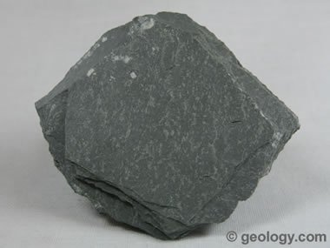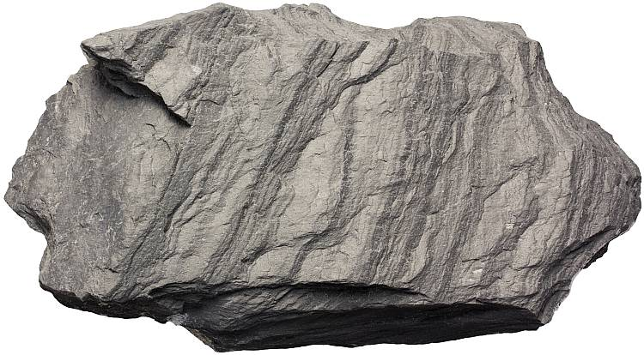

GRANULITE
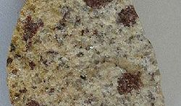
Granulites are a class of high-grade metamorphic rocks of the granulite facies that have experienced high-temperature and moderate-pressure metamorphism. They are medium to coarse–grained and mainly composed of feldspars sometimes associated with quartz and anhydrous ferromagnesian minerals, with granoblastic texture and gneissose to massive structure.^{[1]} They are of particular interest to geologists because many granulites represent samples of the deep continental crust. Some granulites experienced decompression from deep in the Earth to shallower crustal levels at high temperature; others cooled while remaining at depth in the Earth.
The minerals present in a granulite will vary depending on the parent rock of the granulite and the temperature and pressure conditions experienced during metamorphism. A common type of granulite found in high-grade metamorphic rocks of the continents contains pyroxene, plagioclase feldspar and accessory garnet, oxides and possibly amphiboles. Both clinopyroxene and orthopyroxene may be present, and in fact, the coexistence of clino- and orthopyroxene in a metabasite (metamorphosed basalt) defines the granulite facies.
A granulite may be visually quite distinct with abundant small pink or red pyralspite garnets in a 'granular' holocrystalline matrix. Concentrations of garnets, micas, or amphiboles may form along a linear pattern resembling gneiss or migmatite banding

