ANORTHOSITES
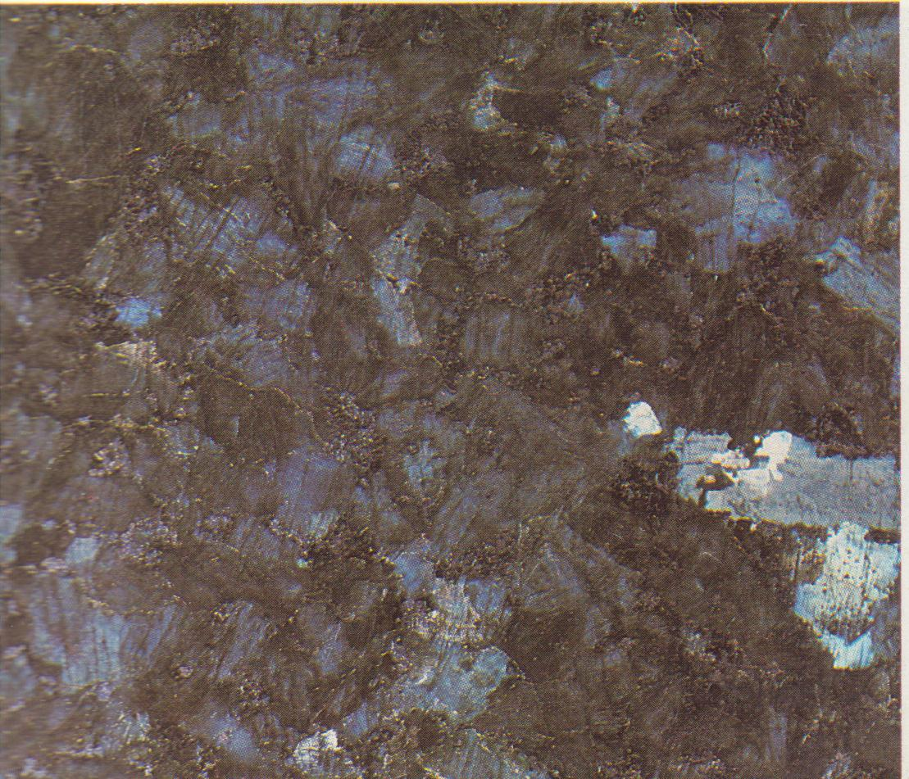
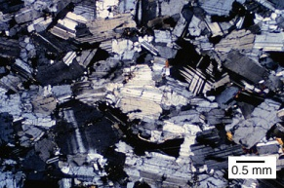
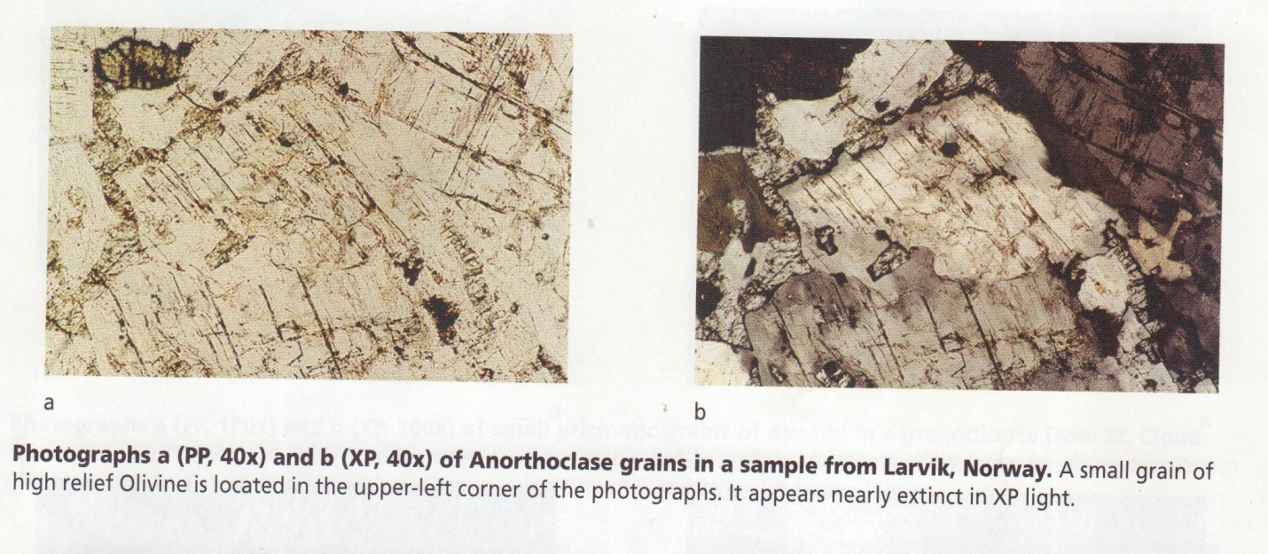
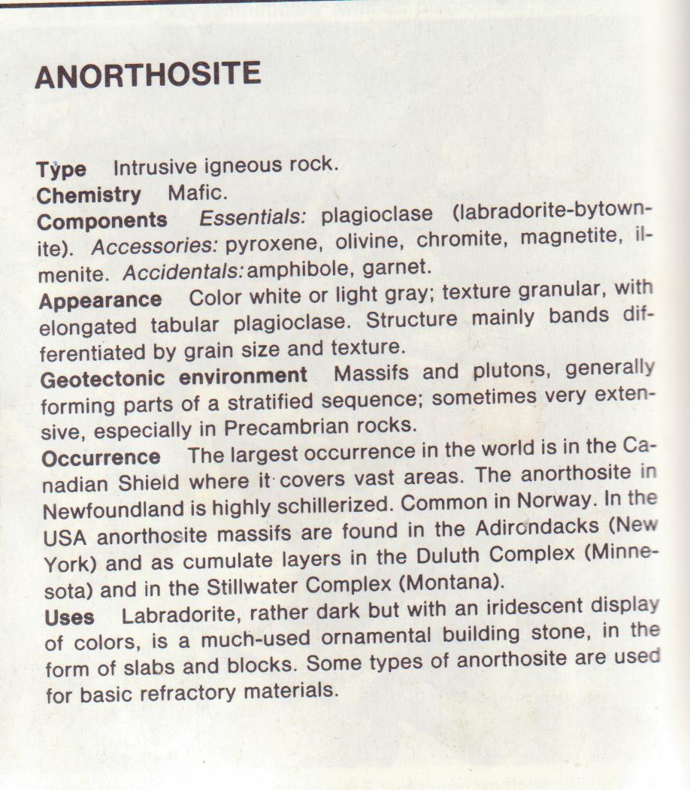
Anorthosites masifs are unique in as much as most were probably emplaced during the Precambrian – most between 1100 and 1700 m.y.b.p with some Archaen types (pre 2500 m.y.b.p). this perhaps implies a unique event or events that cannot be related to more recent geologic situations.
Most anorthosites are found within Precambrian shield areas. Within the Grenville tectonic province of eastern Canada anorthosites comprise about one-
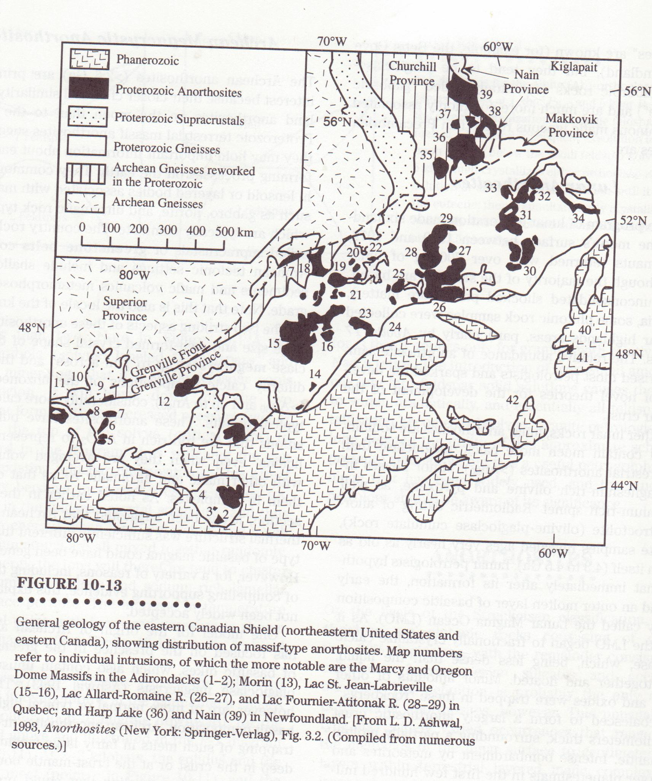

fifth of the exposed bed rock. The adjacent related Adirondack Mountains in New York State contain an anorthosite body covering 200 km² . these rocks studies in detail by Buddington (1939) have been considered the model for typical anorthosite boidies but recent work has indicated considerable gradation from this generally unlayered massif to the stratified mafic intrusive discussed above. The Adirondack and similar Norwegian massifs are lenslike or sheetlike with an uplifted roof. The central portion is coarse plagioclase (andesine) with minor mafic minerals. Border areas are often gabbroic with up to 30% pyroxene. Associated intrusive are pyroxene-bearing varieties of granite, granodiorite and quartz syenite. Both the anorthosite and associated igneous and metamorphic rocks are compatible with the granulite metamorphic facies.
Both magmatic and metamorphic origins have been postulated for anorthosite bodies. In light of recent data – mainly the common existence of crude cumulate layering and igneous trace-element patterns – the idea of metamorphic origin is now largely abandoned. At present, the source magma for anorthosites is viewed as one containing a high percentage of the plagioclase component, originating either through partial melting in the mantle or perhaps in the deep crust. Although either models have been postulated, thus far none is sufficiently compelling to discount all other contenders. The development of a largely anorthositic body from differentiation of basalt has been described for an intrusion at Mineral Lake, Wisconsin. This intrusion is of Middle Keweenawan age, has a thickness of 4,500 m and covers an area of about 120 km². Injection of magma occurred along a contact between pre-Keweenawan metasediments and Middle Keweenawan rocks.
The origin of this body has been deduced (by Olmsted, 1968) from internal features such as texture composition and mineralogy. Let us consider the evidence.
The intrusion is a tilted differentiated sheet. The internal rock sequence graded upward from a chilled basal zone through minor ultramafic segregations, anorthosite , olivine gabbro, anorthosite, ferrodiorite to granite. Rhythmic layering is absent. Aside from a distinct change in the basal zone, mineral compositions are relatively consistent in the lower half of the intrusion. In the upper portion composition changes show increasing ratios of Fe/Mg in pyroxene and Na/Ca in plagioclase. Chemical analysis of the chilled zone indicates an unusually high iron content (FeO = 15.08% by weight and Fe₂O₃ = 2.19% by weight) as compared to typical Keweenawan basalts and the chilled order zones of intrusions such as the Skaergaard.
The relatively minor ultramafic rocks near the base are coarse-grained and rich in pyroxene and olivine. Mafic grains occur in clusters whereas plagioclase is intersetial, suggesting that the mafic crystals were derived as cumulates from the overlying magma.
The anorthositic olivine gabbro above is ophitic to subophitic indicating that the pyroxenes probably crystallized from the melt around preexisting plagioclase crystals. The zone above is mainly anorthosite and leuco-gabbro (containing 80-90% plagioclase); pyroxene continues to be interstitial and the plagioclase shows a preferred orientation, most of which is parallel to the edges of the intrusion.
Putting all the above information together, let us consider the possible origin. The unusually high iron content in the chilled border zone indicates that the magma was probably partially crystallized when intruded. Assuming an average Keweenawan basalt as the source magma, Olmsted (1968) has calculated that the magma was composed of about half solids (of anorthositic gabbro composition) when intruded. Wholesale contamination by iron-rich, silica-poor wall rock is rejected because of the relatively low silica content of the border zone. A partially solid character of the magma is also indicated by the well-developed preferred orientation and fractured character of much of the plagioclase. The presence of some ultramafic materials near the base indicates crystal settling.
As rhythmic banding and compositional layering are absent throughout much of the intrusion, differentiation was apparently not accomplished as a result of crystal settling after emplacement. The densities of olivine and pyroxene are known to be greater than that of a gabbroic melt, whereas plagioclase has been thought to be similar to it. It was suggested that during intrusion of the partially crystalline magma, the heavier mafic minerals settled to the base of the inclined magma chamber (and are now mainly not exposed), and the lighter plagioclase was intruded with the melt. This mechanism results in separation of much of the early cumulate mafic phases that would be expected normally as a result of basaltic differentiation. The probability of plagioclase being carried by the intruding magma has been enhanced by recent data on the Skaergaard intrusion.

