LAYERED BASIC INTRUSIONS
A layered intrusion is a large sill-like body of igneous rock which exhibits vertical layering or differences in composition and texture. These intrusions typically are many kilometres in area covering from around 100 km² to over 50,000 km² and several hundred metres to over a kilometre in thickness.^{[1]} While most are Archean to Proterozoic in age (for example, the Paleoproterozoic Bushveld complex) they may be any age such as the Cenozoic Skaergaard intrusion of east Greenland or the Rum layered intrusion in Scotland.^{[1][2]} Although most are ultramafic to mafic in composition, the Ilimaussaq complex of Greenland is an alkalic intrusion.
Layered intrusions are found in typically ancient cratons and are rare but worldwide in distribution. The intrusive complexes exhibit evidence of fractional crystallization and crystal segregation by settling or floating of minerals from a melt.
Ideally the stratigraphic sequence of an ultramafic-mafic intrusive complex consists of ultramafic peridotites and pyroxenites with associated chromitite layers toward the base with more mafic norites, gabbros and anorthosites in the upper layers. Some include diorite and granophyre near the top of the bodies. Orebodies of platinum group elements, chromite, magnetite and ilmenite are often associated with these rare intrusions.

The world’s largest basic pluton with a total volume of the order of 100,000km³ is the principle component of the Precambrian Bushveld complex of South Africa. The comparable but much smaller Eocene Skaergaard intrusion of Greenland (500 km³⁾ must surely be –through the effort of L.R. Wager – the world’s most completely investigated major igneous body. Many plutons of the same kind are now known, in overall composition, basic intrusions of this kind invariably are tholeiitic and for the most part somewhat undersaturated in silica. Internally, they exhibit lithological layering on a variety of scales.
Classic examples from which grew early notions regarding layered intrusions are rather small ultramafic central complexes of Skye (Cuillin) and Rhum in the Eocene Hebridean Province, the Bushveld “norite” intrusion of South Africa (A. L. Hall, 1932) and the late Precambrian Duluth anorthosite sheet of Minnesota – established by Grout (1918) as the prototype of the lopolith. Current knowledge and ideas stem largely from two sources: studies on the Precambrain (2750 m.y). Stillwater complex, Montana (H. H. Hess, 1960; E.D. Jackson, 1961), and especially a lifelong investigation by Wager and associates concentrating on the Skaergaard intrusion but also including the ultramafic Hebridean complexes and other layered plutons the world over. Also noteworthy are relatively recent accounts of complex layering in the “critical zone” near the base of the Bushveld intrusion (for example, Cameron, 1963 and papers cited therein) in the ultramafic base of the Great “Dike” of Rhodesia (Worst, 1958) and in the Muskox intrusion of Canada (C.H. Smith and Kapp, 1963). The whole subject has been treated exhaustively and illustrated beautifully by Wager and Brown (1967) and special facets have been developed in a symposium of the Mineralogical Society of America (Heinrich et al. 1963).
Layered intrusions vary greatly in size and have individual characteristics related partly to their dimensions. They cover much of the span of geologic time: Stillwater, ~ 2750 m.y, : Bushveld, ~2000 m.y; Muskox, 1160 m.y; Skaergaard, ~ 60 m.y. however, they have sufficient in common to permit generalization as to their nature, structure and petrogenesis.

GEOMETRIC FORM
Even the skaergaard intrusion, although elaborately dissected in a region of glacial topography (relief 1000 to 1300m) and relatively small for plutons of this class, is still too large for its form and internal structure to be more partially revealed. Nevertheless, much is known about parts of many plutons: the upper third half of the Skaegaard, the lower half of the tilted Stillwater complex, detailed sections in the lower part of the Bushveld, segments of the deformed early Paleozoic sheet of north east Scotland,the basal ultramafic zones of Tertiary Hebridean complexes (G.M. Brown. 1956; Wadsworth, 1961), the strangely elongate H=Great “Dike” of Rhodesia and Muskox intrusion of the Canadian Arctic (C.H. Smith and Kapp, 1963). Information from these and other sources – all summarized by Wager and Brown – yields a composite, generalized picture.
In layered basic intrusions, we see the most extensive known deployment of basaltic magmas in the plutonic crustal environment. The Bushveld complex in places is 7000m thick. The exposed remnant of the tilted and partially eroded Stillwater complex is about 400km² in area; within it, the measured thickness normal to the layering is 6000m. a similar apparent thickness has been recorded for the Cuilin central complex of Skye which is less than 10km in diameter. In fact, thicknesses of the order of 3 to 5 km seem to be general and may be exceeded. Extensive though such plutons are, the largest are only half the size of the Sierra Nevada and southern Califonia granodioritic batholiths.
Following Grout’s thinking it was long believed that most layered basic intrusions have the form of a lopolith – “a large centrally sunken, generally concordant intrusive mass with its thickness approximately one-tenth to one twentiet of its width or diameter.” Certainly the lateral extent of many bodies (for example, the northeast Scotland sheet) greatly exceeds their proved depth. But the Skaergaard intrusion has the form of a funnel tapering downward, and a triangular cross section with the apex downward proves to be typical even of elongate bodies such as the Muskox intrusion and the Great “Dike” – the latter is certainly no dike and is probably the infaulted basal remnant of a larger composite intrusion (worst, 1958). 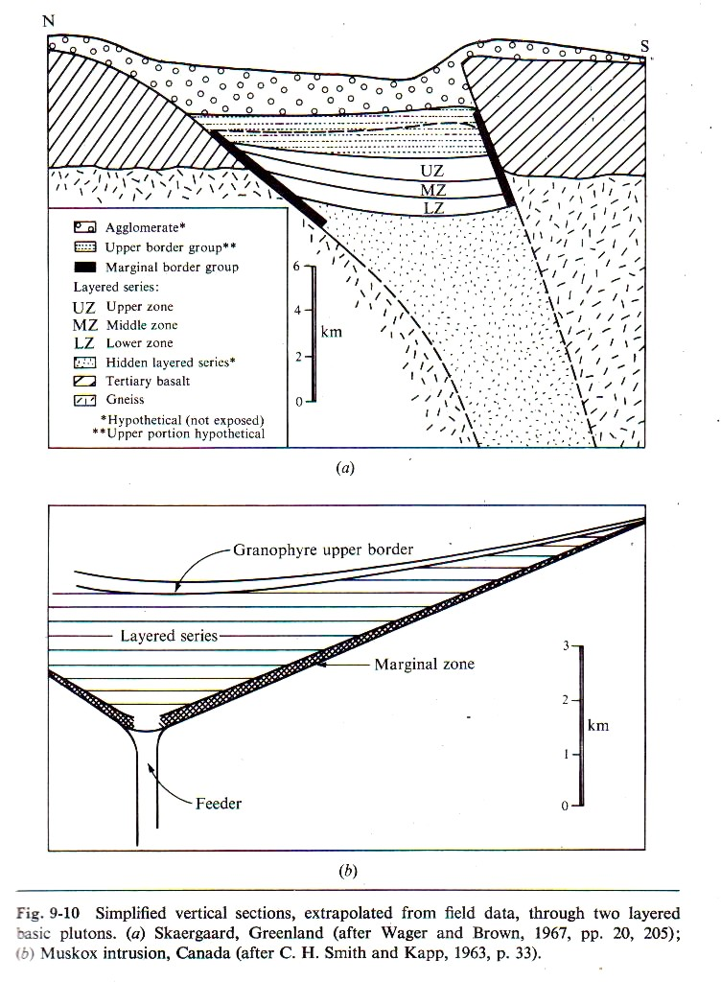 The lopolith profile as a general characteristic of basic plutons had been inferred partly from observed subhorizontal (or gently convex downward) attitudes of layering. But these now prove to be discordant to more steeply dipping external contacts.
MAJOR VERTICAL ZONING
On the scale of a thousand meters or more, most layered basic plutons conform to a general pattern of gross compositional variation: ultramafic rocks at the base, gabbros (norites) in the middle, feldspathic gabbros or ferrodiorites at the top. This pattern permits rather arbitrarily defined vertical zonation for mapping purposes. The following are illustrative examples, the units being numbered 1,2, …. In upward sequence.
Skaergaard intrusion, eastern Greenland – Exposed rocks constitute the upper part (3500m) of a vertical section of unknown thickness; zones 0 to 3 constitute what is termed collectively the layered series.
(4) Upper border group: contaminated gabbros and ferrodiorites with granophric streaks and many xenoliths of acid gneiss: 1000 m.
(3) Upper zone: ferrogabbros with ferrous olivine 920 m.
(2) Middle zone: gabbros lacking olivine: 780 m
(1) Lower zone: gabbros with magnesian olivine: 800 m
(0) Hidden zone: unexposed, presumably mafic and ultramafic rocks whose total bulk has been estimated as at leas 70 percent of the whole pluton.
Stillwater complex, Montana – The following vertical section pieced together by Hess from several measured sections, exceeds 5000 m in thickness but still is incomplete because the pluton was tilted and the top is still partially hidden beneath a blanket of younger sediments.
(6) Upper gabbro: 600 m.
(5) Gabbros and anorthosite (alternating in 200- to 500-m units): 1900 m
(4) Lower gabbro: 650m
(3) Norite (two-pyroxene gabbro): 850 m
(2) Ultramafic rocks (pyroxenites grading down to peridotites): 1050 m
(1) Border zone, retaining something of the composition of the initial magma: 100 m

Bushveld pluton –
The Bushveld Igneous Complex (BIC) is a large layered igneous intrusion within the Earth's crust which has been tilted and eroded and now outcrops around what appears to be the edge of a great geological basin, the Transvaal Basin. Located in South Africa, the BIC contains some of the richest ore deposits on Earth.
The complex contains the world's largest reserves of platinum-group metals (PGMs)—platinum, palladium, osmium, iridium, rhodium, and ruthenium—along with vast quantities of iron, tin, chromium, titanium and vanadium.
Gabbro or norite is also quarried from parts of the Complex and rendered into dimension stone. The site was discovered around 1897 by Gustaaf Molengraaff.^{[1]}

Origin
The Bushveld Igneous Complex covers a pear-shaped area in the central Transvaal. It is divided into an eastern and western lobe, with a further northern extension.
All three sections of the system were formed around the same time—about 2 billion years ago—and are remarkably similar. Vast quantities of molten rock from Earth's mantle were brought to the surface through long vertical cracks in Earth's crust—huge arcuate differentiated lopolithic intrusions—creating the geological intrusion known as the Bushveld Igneous Complex.
These intrusions are thought to predate the nearby Vredefort impact to the south, by some 30 million years.^{[2]} The effects of these injections of molten rock over time, combined with the crystallisation of different minerals at different temperatures, resulted in the formation of a structure rather like a layered cake consisting of distinct rock strata, including three PGM-bearing layers, referred to as reefs. Large portions of the central area are covered by younger rocks.
The extrusions were emplaced over an early diabasic sill, outcrops of which are visible on the southeastern side of the Complex. These are typically greenish in colour and composed of clinopyroxene, altered to hornblende and plagioclase, and are regarded as the earliest phase of the Complex.
The Complex includes layered mafic intrusions (the Rustenburg Layered Suite) and a felsic phase. The complex has its geographic centre located north of Pretoria in South Africa at about 25° S and 29° E. It covers over 66,000 km² (25,000 sq mi), an area the size of Ireland.
The complex varies in thickness, in places reaching 9 kilometres (5.6 mi) thick. Lithologies vary from largely ultramafic peridotite, chromitite, harzburgite, and bronzitite in the lower sections to mafic norite, anorthosite, and gabbro toward the top, and the mafic Rustenburg Layered Suite is followed by a felsic phase (the Lebowa Granite Suite).
The orebodies within the complex include the UG2 (Upper Group 2) reef containing up to 43.5% chromite, and the platinum-bearing horizons Merensky Reef and Plat Reef. The Merensky Reef varies from 30 to 90 cm in thickness. It is a norite with extensive chromitite and sulfide layers or zones containing the ore.
The Reef contains an average of 10 ppm platinum group metals in pyrrhotite, pentlandite, and pyrite as well as in rare platinum group minerals and alloys. The Merensky and UG-2 reefs contain approximately 90% of the world's known PGM reserves. About 80% of the platinum and 20% of the palladium mined each year are produced from these horizons.

Hall generalized section through the eastern part of the intrusion exceeds 8000 m. it has been summarized with some mineralogical and petrographical amplication by Wager and Brown (1967, pp. 349-382).
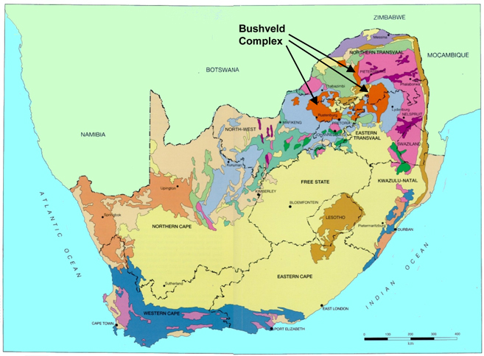
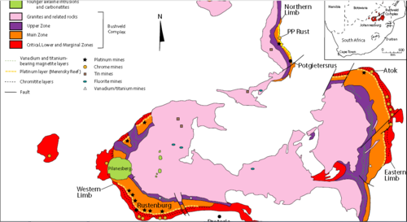
(4) Upper zone: ferrodiorites with local minor granophyric differentiates: 1500 m
(3) Main norite zone: two-pyroxene gabbros: 4000 to 5000 m
(2) Critical zone: profusely layered plagioclase-bronzite-chromite rocks: 1000 m
(1) Basal zone: layered bronzite-pyroxenites, harzburgites, dunites: 1300 m
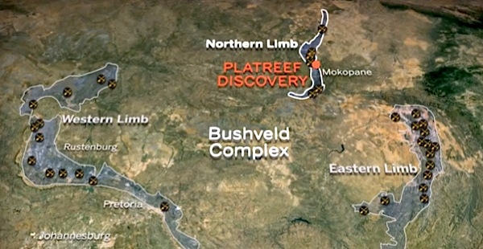
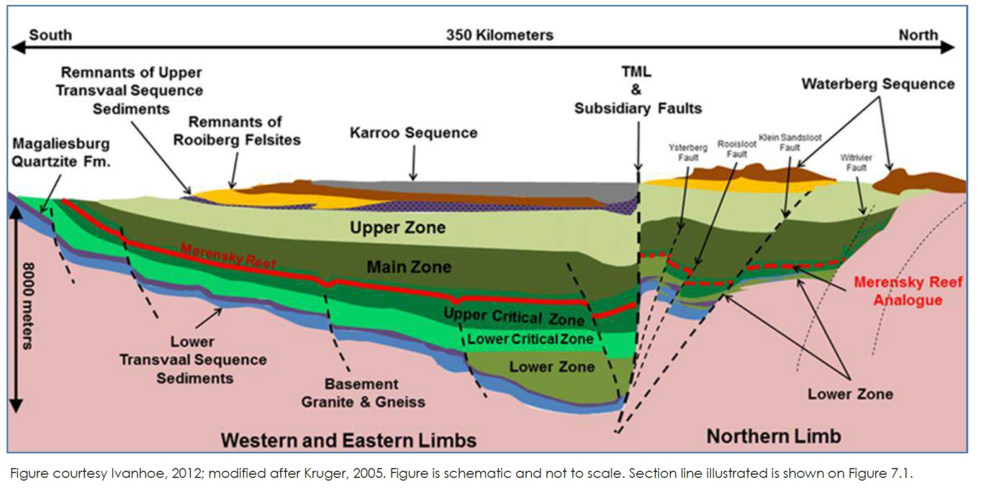
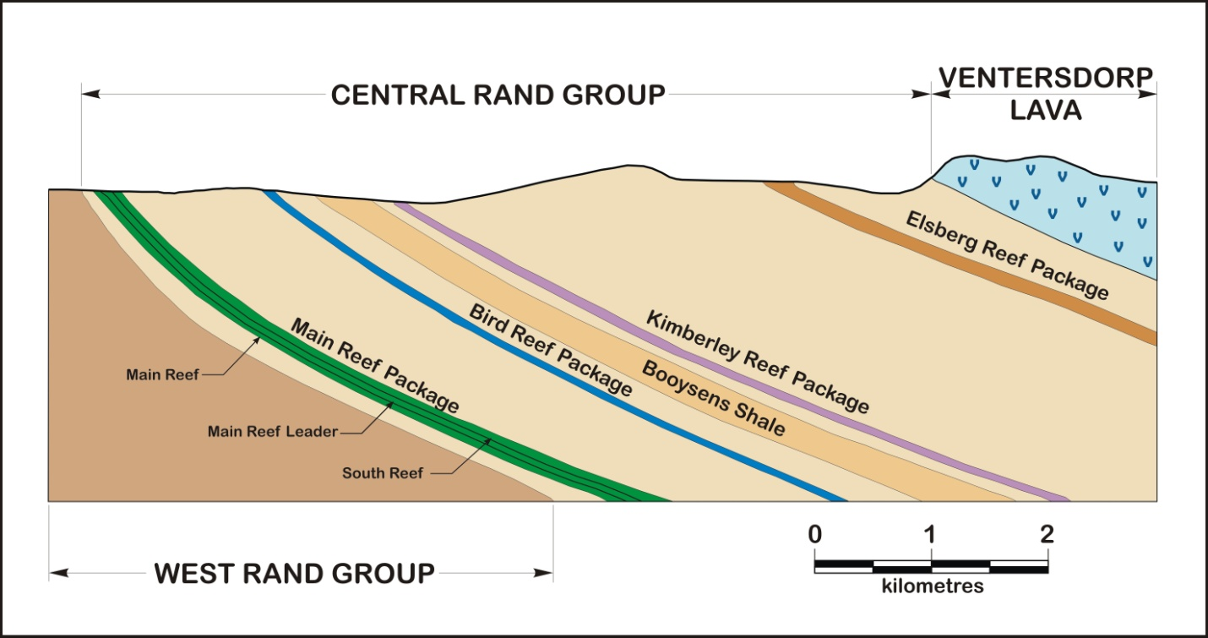
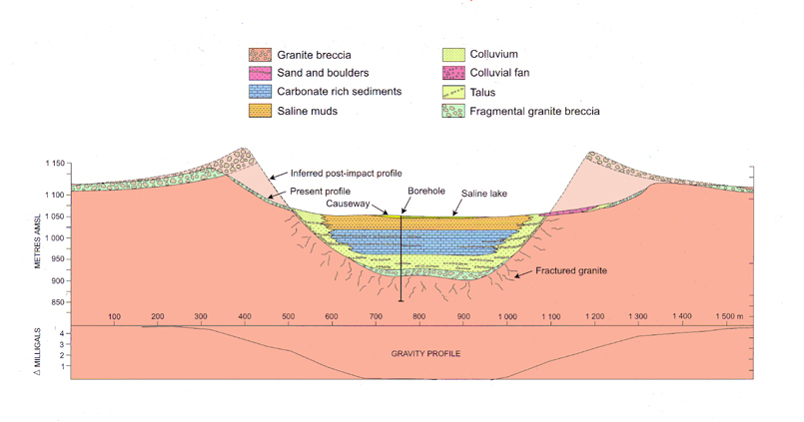
Location and Geology
The project is located in northern South Africa, west of the city of Polokwane on the northern limb of the Bushveld Complex. This igneous intrusion has long been famed as the dominant world source for PGE and chrome mineralization since exploitation began in the 1920’s. The intrusion itself is massive irregularly shaped body, 350 by 230 kilometres across and over 2 billion years old. It has been weathered down to a concentric pattern of hills of more resistant rocks with a large flat area in the middle covered by younger rocks. These hills define what are called the “lobes” and “limbs” of the intrusion. There is an eastern and western lobe, and the northern limb. Despite it’s great age the intrusion is relatively undeformed except for minor faulting.
The intrusion itself is classed by mineralogy and layering into various zones, for instance the zone where the mineralization occurs is known as the “critical zone” . The stratigraphic thickness of the igneous rocks is over 8000 metres from top to bottom, with the lighter rocks being at the top and the heavier ones at the bottom. From surface the PGE rich layers dip steeply inwards towards the base of the intrusion. The classic or “Merensky” style is one of these PGE rich layers which tends to be very thin and dips steeply towards the centre of the intrusion. The Bushveld is a classic example of an-orogenic magmatism (or magmatism not related to mountain building). It formed when there was a rift between two continental blocks, much as the great rift is doing to modern Africa today.
In the Northern Limb, where the Platreef project is located mineralization is less layer bound is described as a
“contact” type where it is located at the boundary between the intrusion and the wallrock. At surface the PGE rich layer is steeply dipping and fairly thin. The mineralization crosses a fault and then it dramatically thickens and is essentially flat before it crosses a second fault and starts dipping again. It is this flat part that so unusual and gives the deposit it’s significance, it’s large and it’s high grade and it’s still shallow enough (700 m below surface) to be easy to access and mine at large scale.

Cuillin complex, Skye – The generalized section summarized by Wager and Brown (1967, p. 423) exceeds 5500 m
(4) Gabbro series: 600 m
(3) Eucrite series: 2000 m
(2) Allivalite series: 1700 m
(1) Peridotite series: 1250 m
Distinction between the three basic units – all varieties of olivine gabbro – is based largely on plagioclase composition: An₈₀ to An₇₀ in gabbro.
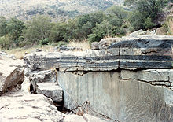

Scottish J. Geol., vol 6, pt. 1, 1970

