QUARTZ:
FELDSPARS:
- Plagioclase – An%
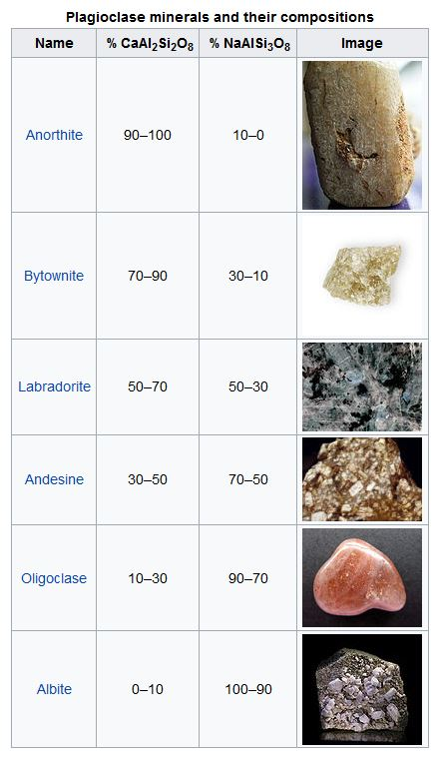
- K – Feldspar
- Microcline
- Orthoclase
- Perthite
- Anorthoclase
- Sanidine
MAFIC MINERALS
- Olivine - Forsterite /fayalite
- Pyroxene -
- Clinopyroxene
- Augite
- Diopside
- Aegirine
- Pigeonite

- Orthopyroxene
- Hyperthene
- Enstatite
- Bronzite
- Amphibole
- Ca-Amphiboles:
- Tremolite
- Hornblende
- Na – Amphiboles
- Glaucophane
- Riebeckite
- Katophorite
- Arfvedsonite

- Mica
- Biotite
- Muscovite
- Iepidolite
- Zinnwaldite

FELDSPATHOIDS
- Nepheline
- Leucite
- Sodalite analcime
- Carncuvinite
ACCESSORY
- Apatite
- Sulphides
- Tourmaline
- Sphene
- Zircon
- Rutile
- Garnets
SECONDARY - Chlorite
- Epidot
- Serricite
- Kaoline
- Calcedony
- Calcite
- Fe – hydroxides
- Topaz
- Flourite
- Fe-oxides
- Corundum

