3-Igneous Rocks of the Convergent Margins
The convergent plate margins are the most intense areas of active magmatism above sea level at the present time. Most of world's violent volcanic activity occurs along these zones. In addition, much magmatism also has resulted (and probably is resulting at present) in significant additions to the crust in the form of plutonic igneous rocks. Here, we look at this magmatism in terms of the volcanic rocks that appear to be related to subduction.
Occurrence
The "Pacific Ring of Fire" is often discussed in relation to both earthquakes and volcanoes. It surrounds the Pacific Ocean basin and extends into the Indian Ocean and Caribbean Sea. Active subduction is taking place, along these convergent plate boundaries, as evidenced by the zone of earthquakes, called a Benioff Zone, that begins near the oceanic trenches and extends to deeper levels in the direction of plate motion. Earthquake focal depths reach a maximum of about 700 km in some areas. Volcanism occurs on the upper plate about 100 to 200 km above the Benioff Zone. For this reason, volcanism in these areas is often referred to as subduction-related volcanism.
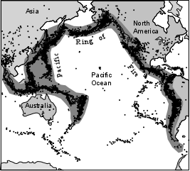
Two situations occur.
- In areas where oceanic lithosphere is subducted beneath oceanic lithosphere the volcanism is expressed on the surface as chains of islands referred to as island arcs. These include the Caribbean Arc, the Aleutian Arc, the Kurile Kamachatka Arc, Japan, the Philippines, the South Sandwich Arc, The Indonesian Arc, the Marianas, Fiji, and Solomon Islands
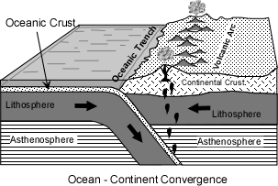
2-In areas where oceanic lithosphere is subducted beneath continental lithosphere volcanism occurs as chains of volcanoes near the continental margin, referred to as a continental margin arc. These include the Andes Mountains, Central American Volcanic Belt, Mexican Volcanic Belt, the Cascades, the part of the Aleutian arc on Continental crust, and the North Island of New Zealand.

Within these volcanic arcs the most imposing, and therefore most recognized by early workers, features of the landscape are large stratovolcanoes. These usually consist of predominantly andesitic lava flows and interbedded pyroclastic material. But, in the late stages of volcanism more silicic lavas and pyroclastics like dacites and rhyolites are common.
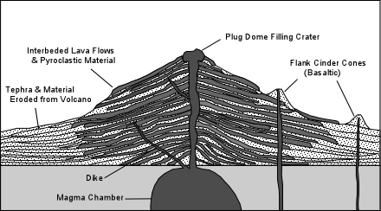
Many of these stratovolcanoes pass through a stage where their upper portions collapse downward to form a caldera. These caldera forming events are usually associated with explosive eruptions that emit silicic pyroclastic material in large-volume eruptions. It is the sudden evacuation of underlying magma chambers that appears to result in the collapse of the volcanoes to form the calderas.
The imposing presence of these large mostly andesitic stratovolcanoes led to an early widespread perception among petrologists that basalts were rare or absent in these environments. In recent years, however, it has become more evident that basalts are widespread, but do not commonly erupt from the stratovolcanoes. Instead, they are found in areas surrounding the stratovolcanoes where they erupt to form cinder cones and associated lava flows. One explanation for this distribution is that the magma chambers underlying the stratovolcanoes intercept the basaltic magmas before they reach the surface and allow the basalts to differentiate to more siliceous compositions before they are erupted. Basaltic magmas that are not intercepted by the magma chambers can make it to the surface to erupt in the surrounding areas.

Petrography
Probably the most distinguishing feature of subduction-related volcanic rocks is their usually porphyritic nature, usually showing glomeroporphyritic clusters of phenocrysts. Basalts commonly contain phenocrysts of olivine, augite, and plagioclase. Andesites and dacites commonly have phenocrysts of plagioclase, augite, and hypersthene, and some contain hornblende. The most characteristic feature of the andesites and dacites is the predominance of fairly calcic plagioclase phenocrysts that show complex oscillatory zoning. Such zoning has been ascribed to various factors, including:
- Kinetic factors during crystal growth. As one zone of the crystal is precipitated the liquid immediately surrounding the crystal becomes depleted in the components necessary for further growth of the same composition. So, a new composition is precipitated until diffusion has had time to renourish the surrounding liquid in the components necessary for the equilibrium composition to form.

- Cycling through a chemically zoned magma chamber during convection. As crystals grow, they are carried in convection cells to warmer and cooler parts of the magma chamber. Some zones are partially dissolved and new compositions are precipitated that are more in equilibrium with the chemical compositions, pressures, and temperatures present in the part of the magma chamber into which the crystal is transported.
- Magma mixing. As magmas mix the chemical compositions of liquids and temperatures change during the mixing process. This could result in dissolution of some zones, and precipitation of zones with varying chemical composition.
Rhyolites occur as both obsidians and as porphyritic lavas and pyroclastics. Phenocrysts present in rhyolites include plagioclase, sanidine, quartz, orthopyroxene, hornblende, and biotite.
In addition to these features, petrographic evidence for magma mixing is sometimes present in the rocks, including disequilibrium mineral assemblages, reversed zoning etc. Xenoliths of crustal rocks are also sometimes found, particularly in continental margin arcs, suggesting that assimilation or partial assimilation of the crust could be an important process in this environment.
Major Elements
Before discussing the major element chemistry of subduction related volcanic rocks we first need to clarify some terminology concerning rock suites. In the early 1900s a petrologist by the name of Peacock examined suites of rocks throughout the world. On a plot of CaO and total alkalies versus SiO₂, Peacock noted that the two curves intersected at different values of SiO₂ for different suites. He used the value of SiO₂ where the two curves intersect (now known as the Peacock Index or Alkali-Lime Index) to divide rock suites into the following:

Peacock Index | Name of Suite
<51 | Alkalic
51-56 | Alkali-Calcic
56-61 | Calc-Alkalic
>61 | Calcic

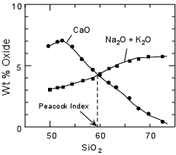

Although Peacock's classification of rock suites is rarely used today, some of the terminology has survived in slightly different forms. For example the general term "alkaline suite" is used to describe rock suites in which the basic rocks have relatively high values of total alkalies, like the alkali basalt -hawaiite - mugearite - trachyte suite or the basanite - nephelinite suites discussed previously. Most subduction related volcanic and plutonic rocks fall into the calc-alkalic suite of Peacock, and thus the term calc-alkaline is often given to the suite of rocks found associated with subduction. But, it is notable that all four suites of rocks defined by Peacock are found in subduction-related areas.

The modern definition of the calc-alkaline suite is based on the AFM diagram. On this diagram subduction-related volcanic rocks show a trend along which the ratio of MgO to total iron (MgO/FeO*) remains nearly constant. This trend is often referred to as the Calc-Alkaline trend. Note that the calc-alkaline trend is distinct from the Fe-enrichment trends shown by the alkaline and tholeiitic suites discussed previously. Also, calc-alkaline basalts, like tholeiitic basalts are subalkaline, but they differ from tholeiitic basalts in their higher concentrations of Al₂O₃, with values of 17 to 20 wt %. Thus, these calc-alkaline basalts are often referred to as high alumina basalts
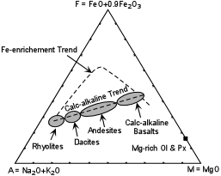

Recall that the Fe-enrichment trend exhibited by the tholeiitic and alkaline rock series can be explained by crystal fractionation involving removal of early crystallizing Mg-rich olivines and pyroxenes from the parental basaltic magmas. The calc-alkaline trend, however, would require early removal of mineral assemblages with a higher Fe/Mg ratio, or some other process. Over the years several explanations for the calc-alkaline trend have been discussed. Among these are:
- Crystal fractionation by early removal of an Fe-rich mineral assemblage. Because the basaltic compositions are similar to tholeiitic basalts, they would crystallize the same Mg-rich olivines and pyroxenes as tholeiitic basalts. So, this process would require early crystallization of additional Fe-rich phases to raise the Fe/Mg ratio of the early crystallizing assemblage. Likely candidates for the Fe-rich phase or phases would be magnetite or an Fe-rich amphibole. Experiments conducted in the 60s through 80s failed to show that magnetite or Fe-rich amphibole would be early crystallizing phases in basalts or andesites under geologically reasonable conditions. So, at least initially, this mechanism appeared to be unacceptable (but see below).
- Assimilation of crustal material by basaltic magmas. Since rhyolites and granites are chemically similar, and since the continental crust contains a higher proportion of granitic rocks, it could be possible that the calc-alkaline trend is due to assimilation of crustal granites by basaltic magmas. We have previously discussed the difficulty of such a process operating on a large scale because of the energy requirements involved. A larger hindrance to this mechanism, however, is that the calc-alkaline suite occurs both in island arcs, where there is little or no continental crust, as well as in continental margin arcs where there is such crust.
- Magma Mixing. The calc-alkaline trend could be explained by mixing of basaltic magmas with rhyolitic magmas to produce the intermediate andesites and dacites. This involves the problem of first, how are the rhyolites generated, and second that such rhyolitic and basaltic magmas would have to be present beneath all arcs. While mixing does seem to play a role, it is unlikely that it always occurs and is always able to generate the large volumes of magma required to build a mostly andesitic stratovolcano.
- Andesites as primary magmas. In the early years, when it was not recognized that basalts do occur in the arcs or at least that andesites were the predominant type of magma erupted, it was suggested that andesites were primary magmas. Since it was known that the mantle would not likely be able to produce silica oversaturated andesitic magma by partial melting, except at very low pressure, it was suggested that the subducted oceanic crust partially melted to produce andesitic magmas. This seemed like a good hypothesis in light of the new theory of Plate Tectonics that was coming out at the time. But, as we will see later, there are serious obstacles to this theory in the trace element composition of the magmas. Nevertheless, this early theory became popular and was put into introductory physical geology textbooks, many of which still advocate that andesitic magmas are generated by partial melting of the subducted oceanic crust.
In recent years more light has been shed on the possible origin of the calc-alkaline suite. Perhaps the best evidence comes from experimental petrology and recent advances in experimental techniques. Experimental petrology has long suffered from the possibility that the experimental charge could possibly react with the container in which it was placed. Thus, the choice of the container or capsule, as it is called, is very important. Perhaps the best in this regard is gold. Gold remains relative inert at high temperatures, and thus does not appear to react with silicate liquids in any major way. But, the melting temperature of Gold is about 1060ºC which means that experiments must be conducted at temperatures that are relatively low compared with those of basaltic liquids. Platinum (Pt) has a much higher temperature and is inert and does not react with liquids that have no Fe. But Pt absorbs Fe from liquids if it is present. Thus, if one is attempting to determine whether or not an Fe-rich phase crystallizes from a liquid at high temperature, Fe-loss to the Pt capsule could become important (i.e. it might suppress the crystallization of an Fe-rich phase because there is less Fe in the liquid than would be present under natural conditions). Although this limitation was recognized and attempts were made in early experiments to minimize Fe loss to the Pt, the experiments still remained suspect. In the 1980's, however, techniques were developed to saturate the Pt capsules with Fe prior to experimentation. This led to important new experiments addressing the problem of the calc-alkaline suite.
First, however, consider experiments conducted at low pressure on tholeiitic basalt magmas. These experiments show that at low pressure Plagioclase and Olivine crystallize first, with proportion of plagioclase crystallizing being higher than that of olivine. On the projected phase diagram, removal of Olivine and Plagioclase drives the liquid composition away from the Olivine corner until it intersects the Ol + Plag + Cpx + Liq. cotectic. Further crystallization of these phases will then drive the liquid composition along the cotectic to eventually crystallize pigeonite (low Ca-pyroxene) as shown by the light colored path on the diagram.
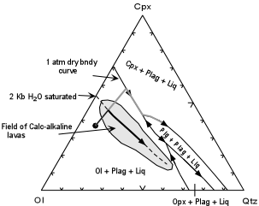
Next, experiments were conducted at a pressure of 2 kb with enough H₂O in the capsules to assure that the liquid would be H₂O saturated at this pressure (i.e. a free vapor phase would coexist with the liquid). These experiments were conducted because it was known that H₂O would lower the temperature of appearance of the silicate minerals, but would lower the temperature of appearance of oxide minerals, like magnetite to a lesser extent, and could stabilize a hydrous phases like hornblende at a higher temperature.

The experiments show that
- The position of the Ol + Plag + Cpx + Liq. cotectic shifts toward the Olivine corner of the projected phase diagram.
- The proportion of Olivine relative to plagioclase becomes much higher than in the dry low pressure experiments.
- Magnetite becomes an early crystallizing phase and hornblende also crystallizes early if the liquids have a high enough concentration of Na₂O.
- Most importantly, analyses of the liquids produced in the experiments plot along the calc-alkaline trend in the AFM diagram.
Furthermore, if subduction related arc rocks are plotted on the projection there are seen to lie in a field surrounding the 2 kb H₂O saturated cotectic. This indicates that the calc-alkaline suite could be produced by fractional crystallization under moderate pressure water saturated conditions. This would suggest that the main difference between tholeiitic rocks and calc-alkaline rocks might be the presence (in calc-alkaline basalts) or absence (in tholeiitic basalts) of H₂O in the parental magmas and/or the source rocks that melt. From our previous discussion, we know that it is possible to introduce water into the subduction related environment by dehydration of the subducting lithosphere, whereas it is more difficult to envision a mechanism to add water to the source where tholeiitic magmas are generated.

Trace Elements
As mentioned before, the trace element concentrations found in subduction related volcanic rocks are not consistent with derivation of the magmas from partial melting of subducted oceanic crust. First we will look at what the trace element concentrations show, then discuss why they are not consistent with an origin involving direct melting of the oceanic lithosphere, and then discuss how the trace element patterns of subduction related magmas might develop. As we will see the subducted oceanic lithosphere likely does make a contribution to calc-alkaline magmas, but not necessarily as the primary source of these magmas.
When plotted on an incompatible trace element diagram (often referred to as a spider diagram), calc-alkaline rocks show an irregular pattern with many peaks and valleys, unlike the relatively smooth patterns exhibited by OIBs and MORBs. Two things of note are shown on this diagram. First, in calc-alkaline basalts (as well as andesites, not shown) the heavy REE, represented by Yb are not depleted relative to MORBs. | 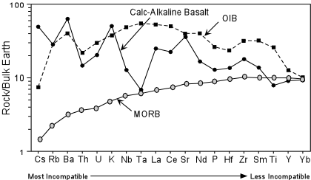

Second, the elements Nb, Ta, and Ti show negative anomalies (depletion) relative to elements like Ba, K, La, and Ce. We'll discuss the implications of each of these points below

- Lack of HREE depletion. When oceanic crust is subducted it traverses a path of increasing pressure and temperature. In doing so it is metamorphosed. The mineral assemblage of olivine, pyroxene and plagioclase is not stable at higher pressures and temperatures and is metamorphosed into an assemblage of mostly pyroxene and garnet. Such a rock is called an eclogite. At the temperatures and pressures expected to be present at the depth of the subduction zone below the volcanic arc the basalt would in fact be an eclogite, yet its chemical composition will not have changed, i.e. it will still show a MORB-like trace element pattern.
Heavy REEs are compatible in garnet. Thus if garnet is present in the source, HREEs will be held back by the garnet during partial melting, and thus any liquids produced should show lower HREE concentrations than the original source. Thus, if the source of calc-alkaline magmas is postulated to be oceanic crust (now an eclogite) we would expect to see HREE concentrations lower than oceanic crust. Since this is not observed, it is unlikely that the calc-alkaline magmas represent partial melts of the subducted oceanic crust.
- Depletion in Nb, Ta, and Ti relative to K, La, and Ce. The elements Nb, Ta, and Ti are elements called High Field Strength Elements (HFSE). These are elements that have a small ionic radius and a high charge (usually +4). Because of their high charge and small size they are not readily soluble in aqueous fluids. During chemical weathering or dehydration for example these elements remain in the solids. Elements like Ba and K are often called Large Ion Lithophile Elements (LILE). The LILE and REE (like La and Ce) are highly soluble in aqueous fluids. Thus, dehydration of the subducted oceanic crust would be expected to release fluids that have high concentrations of LILE and REE and low concentrations of HFSE. If these fluids then interacted with the mantle overlying the subducted plate they would change the composition of that mantle (metasomatize it) so that it would have a trace element pattern more similar to the pattern observed in calc-alkaline volcanic rocks. Subsequent melting of this metasomatized mantle would explain the trace element pattern observed in the erupted magmas

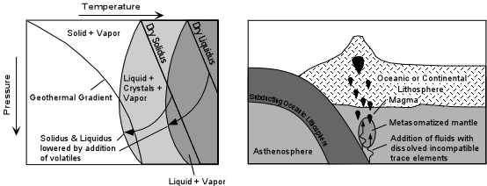

The addition of fluids has an additional effect, discussed earlier, in lowering the solidus temperature of the mantle and inducing partial melting. Furthermore, addition of fluids at the source of calc-alkaline magmas would explain why these magmas would become saturated with water at lower pressures to fractionate to produce the calc-alkaline trend on an AFM diagram.

Isotopes
Sr and Nd isotopic ratios for subduction-related volcanic rocks are similar to OIBs, but show higher ratios of ⁸⁷Sr/⁸⁶Sr, and extend to lower ratios of ¹⁴³Nd/¹⁴⁴Nd. Three points are notable about this data.  - The subduction related rocks do not generally show Sr and Nd isotopic ratios similar to MORBs. This suggests that they were not derived from partial melting of subducted oceanic crust or from partial melting of an unmodified MORB source. | 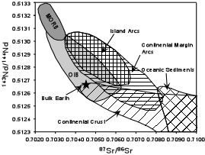

- The offset from OIBs to higher values of ⁸⁷Sr/⁸⁶Sr at constant ¹⁴³Nd/¹⁴⁴Nd could be explained by addition of seawater to the source of the subduction-related rocks. Seawater has relatively high concentrations of Sr and extremely low concentrations of Nd. Thus, if seawater expelled from the subducted lithosphere were incorporated into the mantle source, it would raise the ⁸⁷Sr/⁸⁶Sr ratio and have little effect on the ¹⁴³Nd/¹⁴⁴Nd ratio.
- The extension of the array toward higher ⁸⁷Sr/⁸⁶Sr and lower ¹⁴³Nd/¹⁴⁴Nd suggests that a continental crustal component is incorporated into subduction related magmas. This could come from either subducted oceanic sediments or crustal contamination. If sediments are subducted, they would metamorphose along with the rest of the oceanic crust and upon dehydration the fluids could carry an isotopic signature contributed by the sediments. In general, rocks erupted in continental settings show higher ⁸⁷Sr/⁸⁶Sr and lower ¹⁴³Nd/¹⁴⁴Nd ratios than those erupted in island arcs. This argues for some contamination of the magmas by the crustal rocks through which the magmas pass
The extent of subducted sediment involvement can, in some cases be evaluated by looking at an isotope of Beryllium, ¹⁰Be, and a highly incompatible trace element Boron (B).
¹⁰Be is an isotope of Be that is produced in the upper atmosphere by bombardment of cosmic rays. Once produced it has a half-life of 1.5 million years. Be and its radioactive isotope are absorbed by the oceans and are adsorbed onto the surface of clay minerals. Because of its short half life, only small quantities ¹⁰Be remain after the passage of more than about 10 million years. If oceanic sediment is subducted and contributes material to the source of calc-alkaline magmas before it has completely decayed, then we should see small amounts of ¹⁰Be in the magmas and rocks. But note that this will only be true for very young sediment and in young volcanic rocks. So, we do not necessarily expect to see ¹⁰Be in all subduction related rocks.
B is an element that is abundant in sediments but has very low concentrations in the mantle. B/Be ratios for mantle rocks are also low. Furthermore, B is much more readily soluble in fluids, so fluids derived from dehydration of the sediments have much higher B/Be ratios than the mantle and sediments. Thus, if we look at the concentration of ¹⁰Be and the B/Be ratio in subduction-related volcanic rocks we may be able to determine whether or not sediments and fluids are involved in the production of subduction-related magmas.

What is found is that for some arcs the concentration of ¹⁰Be increases linearly with B/Be ratio. Some arcs like the Central American Arc, the Kurile arc, and the New Britain Arc range to high values of ¹⁰Be indicating the incorporation of some component of relatively young oceanic sediment. Other arcs like the Aleutians, Chile, and Kamchatka have low ¹⁰Be, but extend to higher values of B/Be. Note that fluids could have rather variable ¹⁰Be and B/Be, but the data clearly indicates that some fluid is contributing to the source of subduction-related magmas, consistent with other information we have examined. | 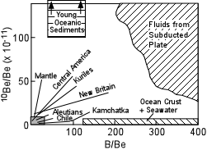

Origin
Over the last fifteen years or so we have come to a much clearer picture of the origin of the calc-alkaline suite of rocks that is commonly associated with subduction. We here summarize the current theory based on the information discussed above:
- Subduction carries oceanic crust and sediment to depth. As the pressure and temperature rise, the MORB crust and sediments undergo metamorphism that releases hydrous fluids.
- These hydrous fluids carry with them high concentrations of LILE and REE, but leave behind the relatively insoluble HFSE. They also carry the isotopic signature of the basaltic crust sediment mixture that released the fluids, and thus have higher ⁸⁷Sr/⁸⁶Sr ratios and lower ¹⁴³Nd/¹⁴⁴Nd ratios, reflecting the isotopic composition of the subducted material. If the sediments are young, they may contribute ¹⁰Be to these fluids.
- The fluids act to metasomatize the overlying mantle wedge, enriching it in LILE, REE, B, ⁸⁷Sr/⁸⁶Sr, and possibly ¹⁰Be and lowering the ¹⁴³Nd/¹⁴⁴Nd ratio of this mantle.
- Adding H₂O to the mantle wedge lowers the solidus temperature allowing for partial melting of this metasomatized mantle and generating hydrous basaltic magmas.
- This hydrous basaltic magmas become saturated with water at crustal depths and differentiate by crystal fractionation, possibly accompanied by contamination of crustal material, to generate the andesites, dacites, and rhyolites of the calc-alkaline suite.
Note that despite what your Physical Geology Textbook said about the origin of these rocks, they do not appear to be generated by melting of the subducted oceanic crust, although subducted crust and sediment do appear to contribute to the source.

