MINERAL DEPOSITS
FORMATION OF MINERAL DEPOSITS
There are various classes of mineral deposits that are formed in various processes and environments (table 1).
Table 1: The different classes of mineral deposits and the processes
through which they are formed.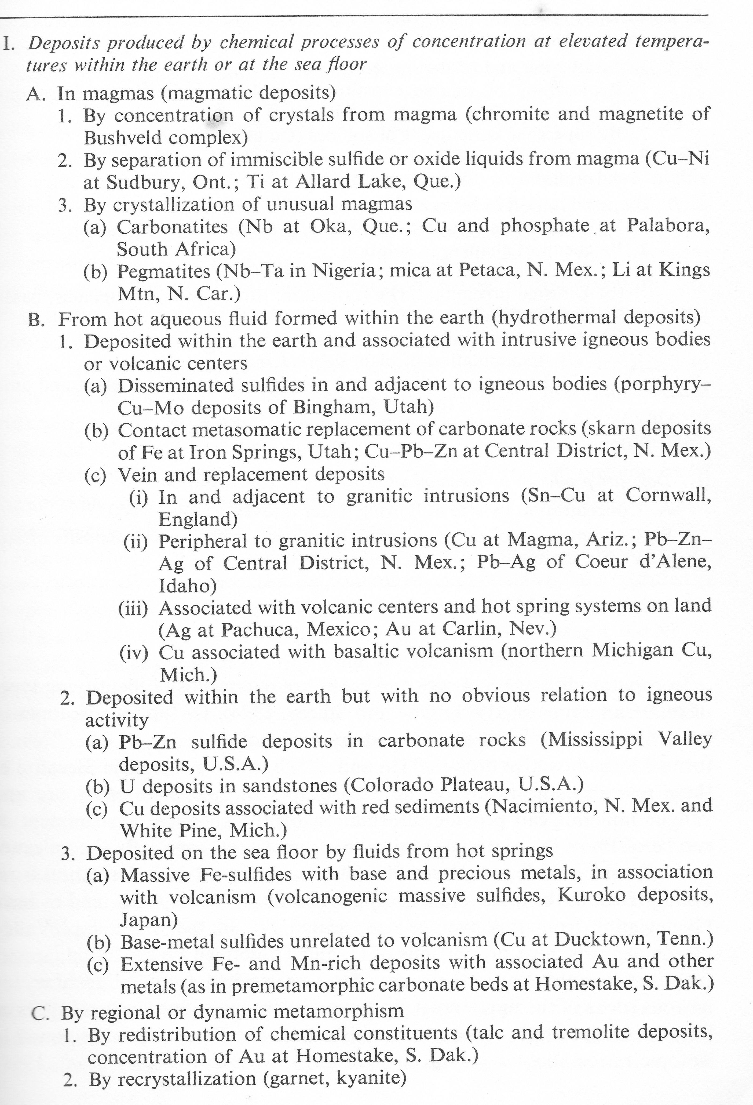
Table 1: Continued
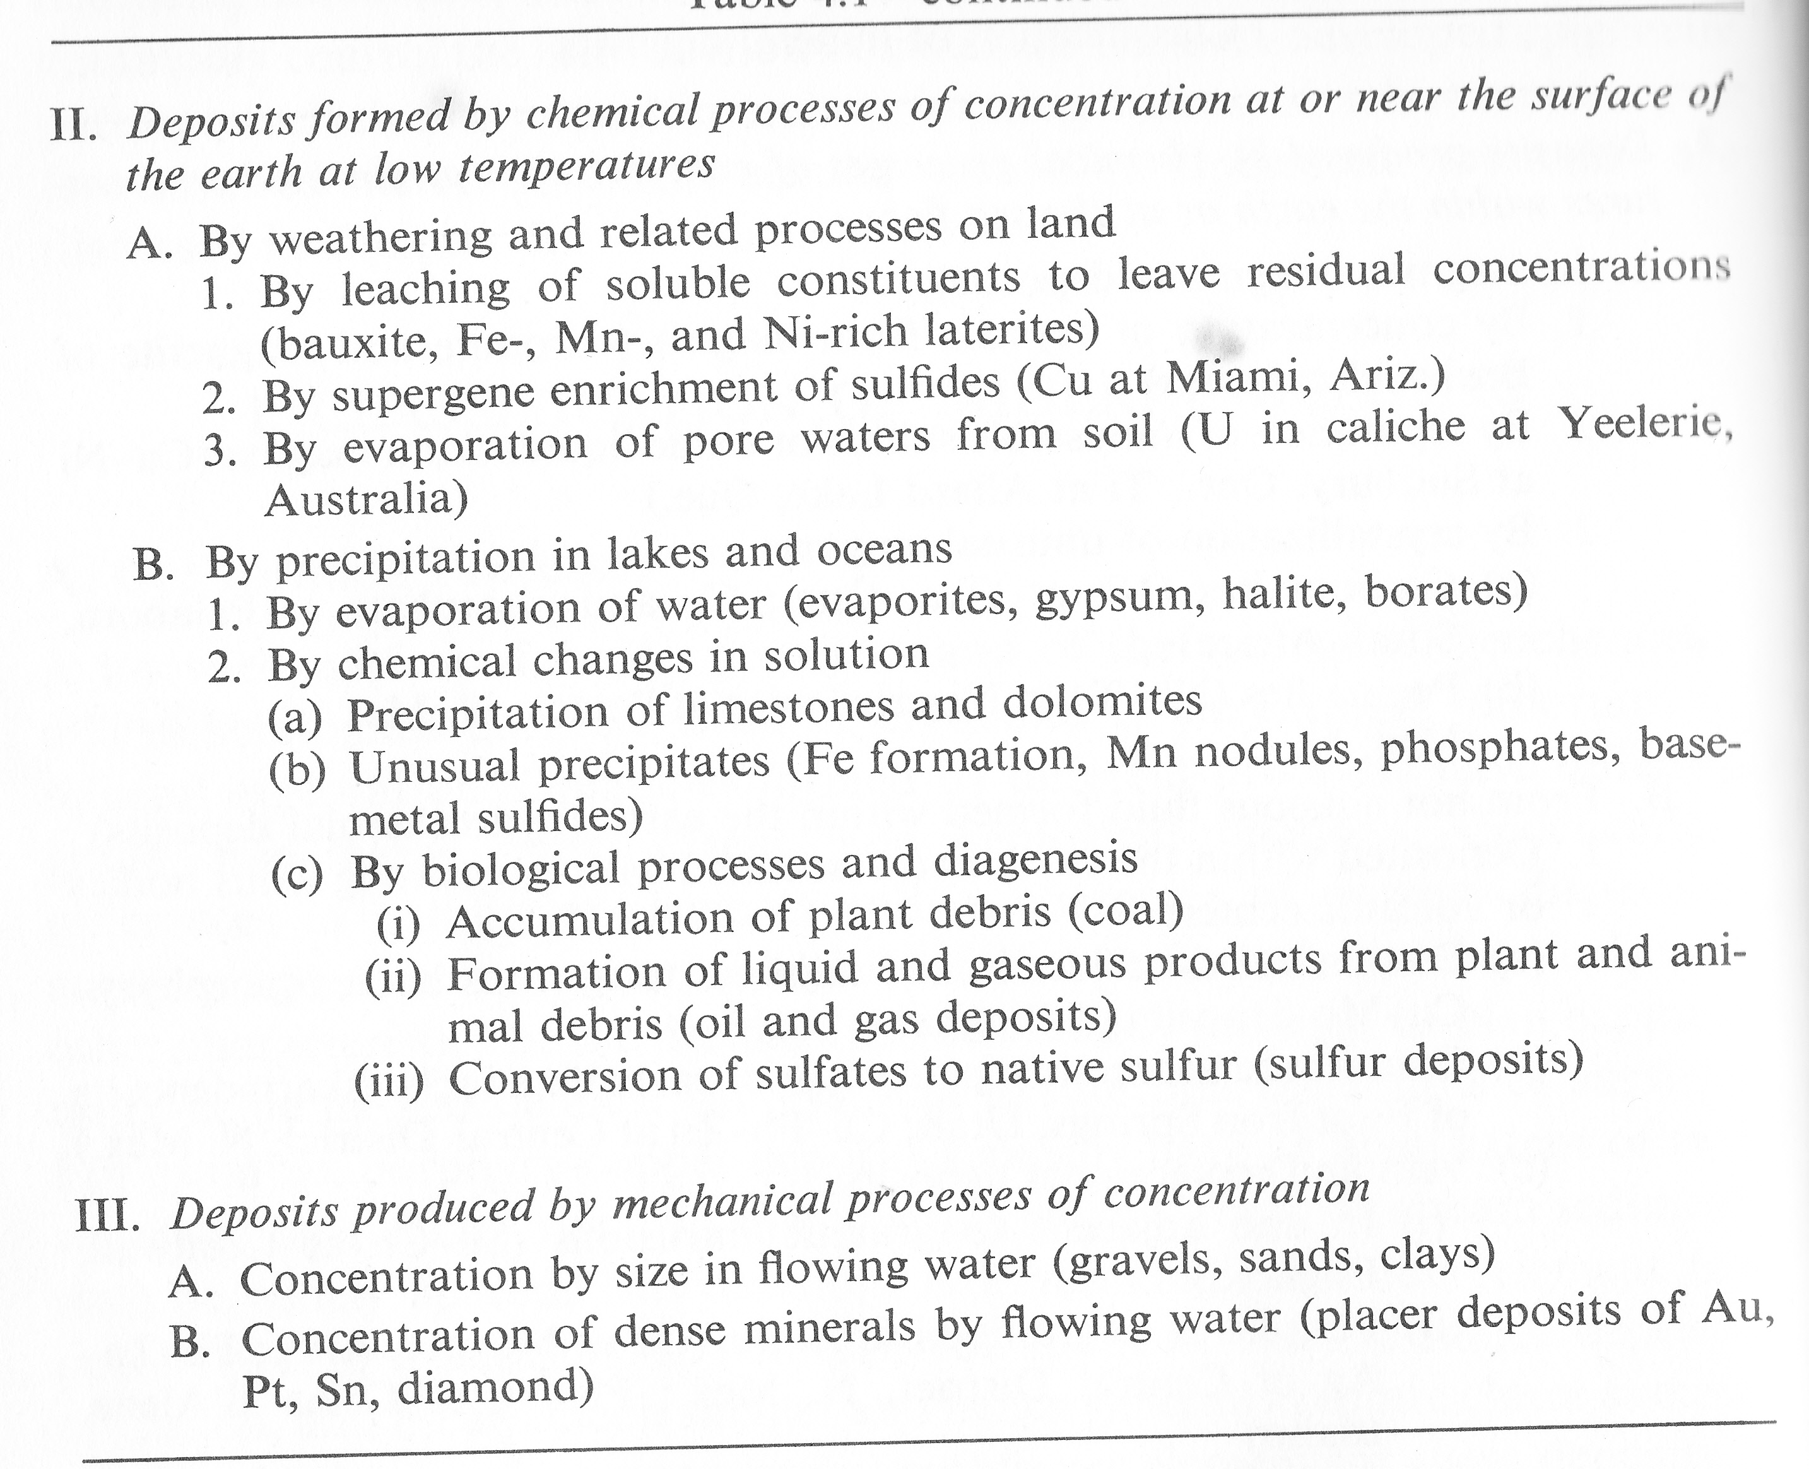

THE MINERAL DEPOSITS OF Zambia
INTRODUCTION
The complex geological history of Zambia has resulted in the formation of a large variety of mineral deposits. The major types of deposits found in Zambia include magmatic, sedimentary, metamorphic and hydrothermal. The exploitation of mineral resources has resulted in the development of a vibrant mining sector whose contribution to the economy of Zambia is second to none. The largest mining operations are in the copper-belt region.
The mineral resources and the areas in which these resources occur are given below.
Copper Deposits
The most important copper deposits occur in most of the districts of the copperbelt province and some of the districts in north western province. There are some small copper deposits that occur in central province. The districts where copper ores have been developed include Mumbwa, Mkushi, Kasempa, Solwezi, Mwinilunga, Chililabombwe, Chingola, Kalulushi, Mufulira, Kitwe, Luanshya and Ndola.
The major copper deposits of the Zambian copperbelt are hosted by the meta-sediments of the the Lower roan group. The copper deposits are believed to have formed through sedimentary and hydrothermal processes. The major copper minerals are chalcopyrite, bornite, chalcocite, malachite and cuprite.
The copper ores are mined and processed in the Zambian copperbelt to produce copper which is exported to Europe, America, Japan and Asia.The export of copper generates the much needed foreign currency for importation of other essential commodities such as medicine, machinery, equipment and petroleum.
The exploitation of copper deposits has resulted in the development of large mining districts in the copperbelt and north western provinces of Zambia.

Lead and Zinc Deposits
The major lead and zinc deposits occur in Kabwe district. The Pb-Zn deposits are hosted by the Kabwe dolomite. The PB-Zn deposit is of hydrothermal origin. The major minerals in this deposit include sphalerite and galena. The Kabwe Pb-Zn deposit was exploited from 1903 to 1994.
Other zinc occurences are found in Lusaka where they are hosted by dolomite.
Cobalt-rich deposits

Cobalt is recovered from cobalt-rich copper ores at Nkana, Chibuluma, Baluba and Nchanga mine. The major cobalt minerals in these ores are linnaeite and carrollite.
Nickel-rich deposits
Nickel –rich deposits occur at Kalumbila copper mine and Munali nickel-copper mine in Mazabuka. In Mazabuka the nickel minerlisation is hosted by the Munali gabbro.
Manganese Deposits
The major manganese deposits occur in Mansa, Chipili, Serenje and Mkushi districts. The major manganese minerals in these districts include psilomelane, manganite and pyrolusite. The manganese deposits in Mansa provided the major ingredient which was needed for the establishment of a battery manufacturing plant in Zambia. Most of the manganese ore is exported to China. A smelter for processing of manganese ores has been constructed in Serenje district.
Gold Deposits
The occurances of gold are spread over a wide area of Zambia.In some of the occurances the gold is associated with copper mineralization. The major gold-bearing areas of Zambia include the following: Mumbwa, Chongwe, Rufunsa, Luangwa, Lusaka, Lundazi, Solwezi, Mwinilunga, Serenje and Petauke.
Mines where significant quantity of gold has been mined include Dunrobin and Matala (Mumbwa district), Chambwe mine (Lusaka), Jessie mine (Rufunsa), Sasare mine ((Petauke), Velocity mine (Kabwe).
The major gold mining and processing operations in Zambia are at Kansanshi mine where the gold is associated with the copper mineralization.
Most of the gold occurances occur in the form of quartz veins that cut metamorphic rocks such as quarzites, schists, phyllites and gneisses. The prominent minerals in the veins include quartz, pyrite and copper sulfides in some cases. More than half a million ounces of gold has been produced in Zambia in the past 100 years. Alluvial gold occurences are associated with streams that drain hills with epigenetic gold mineralization.
Most of the copper minera;lisation in Zambia contain traces of gold which can be recovered from copper ores at the refinery stage of copper processing.
Iron Deposits
Iron deposits have been exploited for a long time by the indigenous people. The important iron deposits occur about 20 to 30 km west of Lusaka and include Sanje deposit, Venters Ridge., King Edward mine, Cheta hill deposit, Pambu deposit, Ngaibwa and Mutombe deposit.
Replacement type deposits occur west of Lusaka in Chinda, Nabutali and Nambala-Sonkwe areas. Replacement and surface enrichment deposits of iron have been mined at Kampumba and Mwomboshi in Kabwe district.
Tin and Tantalum
Tin has been produced in Choma district at mines such as Chisuki, Simwami, Marel and Nkeni. These deposits are hosted by pegmatites whose major minerals include quartz, muscovite and k-feldspar.

Pyrochlore Deposits
Deposits of this mineral are associated with carbonatites. Pyrochlore contains Nb, Ta, Zr and REE. Carbonatites that are rich in pyrochlore are found at Nkombwa hill (Isoka) and in Rufunsa valley at Kaluwe, Chasweta, Nanchomba and Mwambuto.

Gypsum Deposits
Gypsum occurences of some economic significance occur in the Kafue flats within the Lochnivar National Park.

Graphite Deposits
These deposits include Luano deposit south of Mkushi district, Njoka graphite deposit in Lundazi, Mkonda deposit and Mvuvye deposit in Petauke district.

Talc Deposit
Talc deposits occur in Lilayi area (Lusaka) and Bwana Mkubwa (ndola) area. The grade of the talc is not suitable for its use in the manufacture of cosmetic products such as baby powder and lotion.

Clay Deposits
The clay deposits are found in all the major towns of Zambia. The main classes of industrial clays are:
- Ceramic Clays
- Brick Clays
- Fire Clays
- Fulling Clays
- Bentonitic Clays
- Modelling Clays
Ceramic clays occur in Shiwangandu and Kapirimposhi. Brick clays occur in several districts which include Mazabuka, Lusaka, Kabwe, Kapirimposhi, Serenje, Kalulushi and Mansa.
Apatite Deposits
The apatite deposits occur in carbonatites that are found in Nkombwa hill and lower Rufunsa valley (Kaluwe and Nanchomba). Apatite is a major ingredient in the manufacture of phosphate fertilisers.

Limestone Deposits
High quality limestone that can be used in the manufacture of cement occurs in Magoye, Shimabala, Lusaka south, Lusaka west, Bwana Mkubwa area, Masaiti and Mpongwe area. Dolomite rich limestones are widely scattered in Zambia.
Sand Deposits
Sands for use in building construction occur in stream channels all over Zambia. Sands that are suitable for use in the manufacture of glass occur 13 km north of Kapiriimposhi district. These sands are a product of weathering of the Muva quartzite.

White Mica deposits
Ruby mica books have been exploited at Phoenix mine (Choma), Sachenga mine (Chikankata) and Aries mine in Lundazi. The white mica books occur in pegmatites that cut the schists and gneisses. The largest quantity of ruby mica was produced at sachenga mine in Chikankata district of southern province.
Energy Mineral Deposits
CoaL
The coal deposits of Zambia are confined to the low valleys of the Zambezi, Luangwa, Mulungushi, Lunsemfwa and Lukusashi rivers. These valleys are sites where the coal bearing sedimentary rocks of the Lower Karoo group are found. The Kandabwe coal deposit lies south east of Choma at the foot of the escarpment.
The most important coal deposit is located in the Maamba area. This deposit is being exploited by Maamba collieries limited. The coal mined at mamba coal mine is used in the generation of electrical energy at the Maamba thermal power plant.
The coal deposits of Luano valley have low economic importance due to a high ash content.
Radioactive Minerals
Deposits of uranium bearing minerals occur in Siavonga, Mindola ( Kitwe) and Lumwana areas.

Gemstone Deposits
Deposits of emerald and aquamarine occur in the strongly evolved pegmatites that are hosted by schists. Aquamarine is mined in Lundazi district while emerald deposits are being exploited in Lufwanyama district.
Amethyst is mined in Choma and kariba areas. Rose quartz is mined in Lundazi district.

Rock Units for Production of Aggregates and Dimension Stones
These include marble, limestone, gneisses and granite. These rock units are being exploited for production of aggregates and dimension stones. Most of these operations are based in Lusaka and copperbelt.

