Sedimentary Structures
One of the most obvious sedimentary structure is stratification ( layering of sediments). Most layers of sediments, or strata (plural of stratum, a single layer), accumulate in nearly horizontal sheets. Strata less than 1 cm thick is called lamination; strata 1 cm thick or more are called beds.
Surfaces between strata are called bedding planes. These represent surfaces of exposure that occurred between sedimentary depositional events.
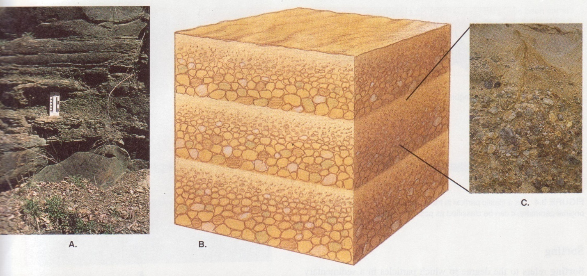
Figure 34. Horizontal strata
Most strata are deposited in nearly horizontal sheets. However, some stratification inclined is inclined and referred to as cross-stratification or cross bedding. E.g. sediments transported in a single direction by water or air currents commonly forms current ripple marks
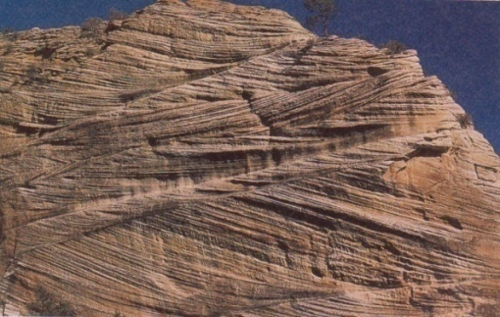
Figure 35. Cross bedding
Graded bedding

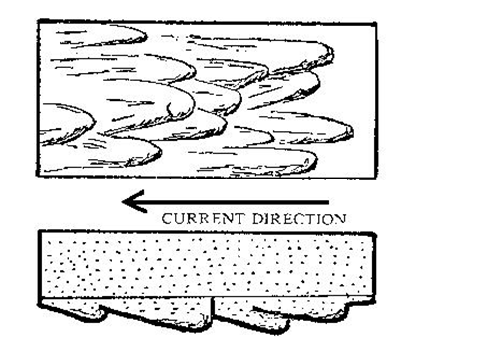
Figure 36. Ripple marks
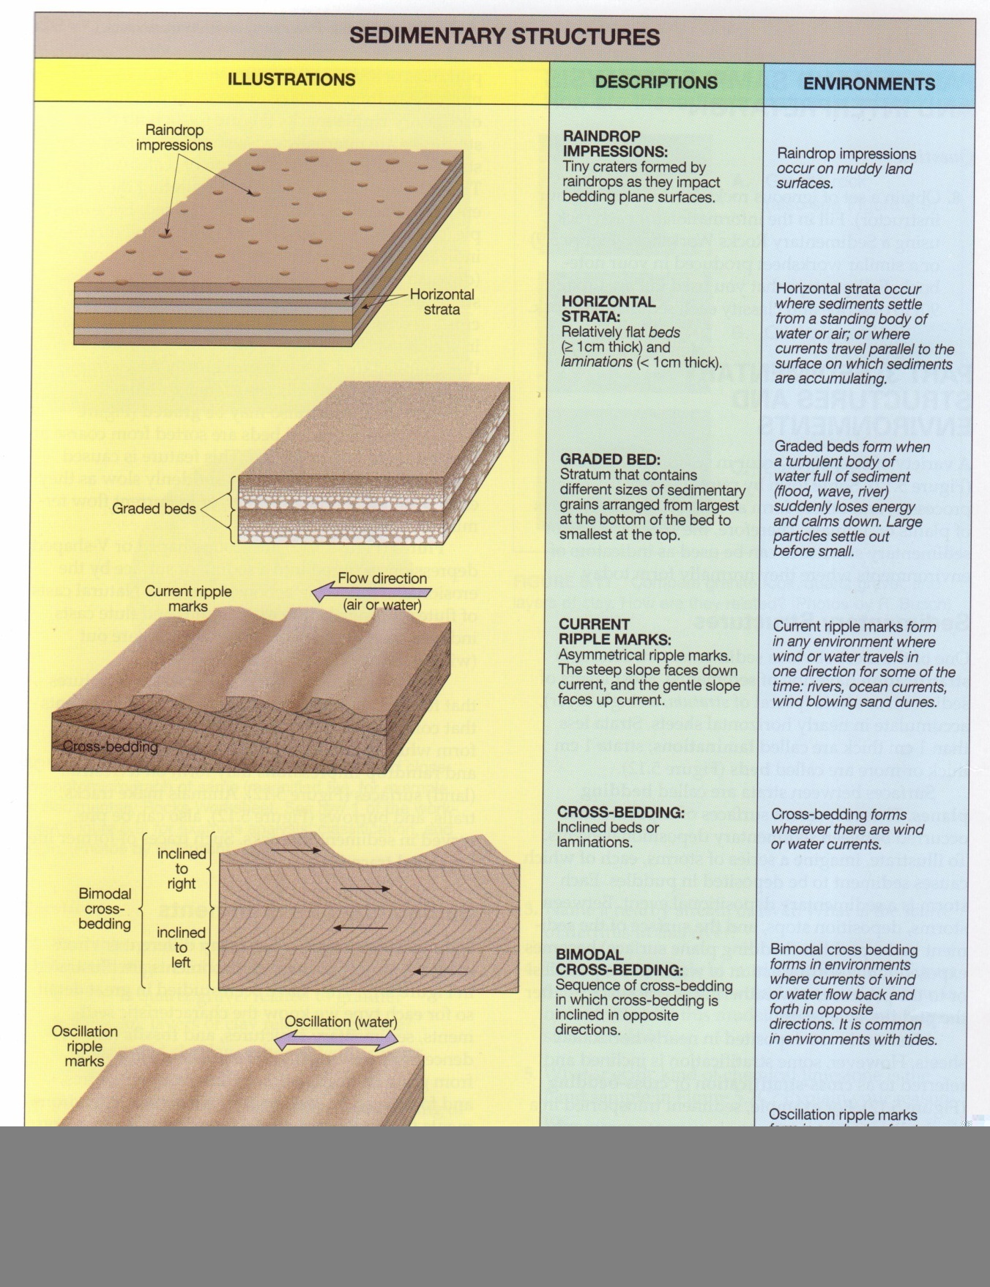
Figure 37. Sedimentary structures
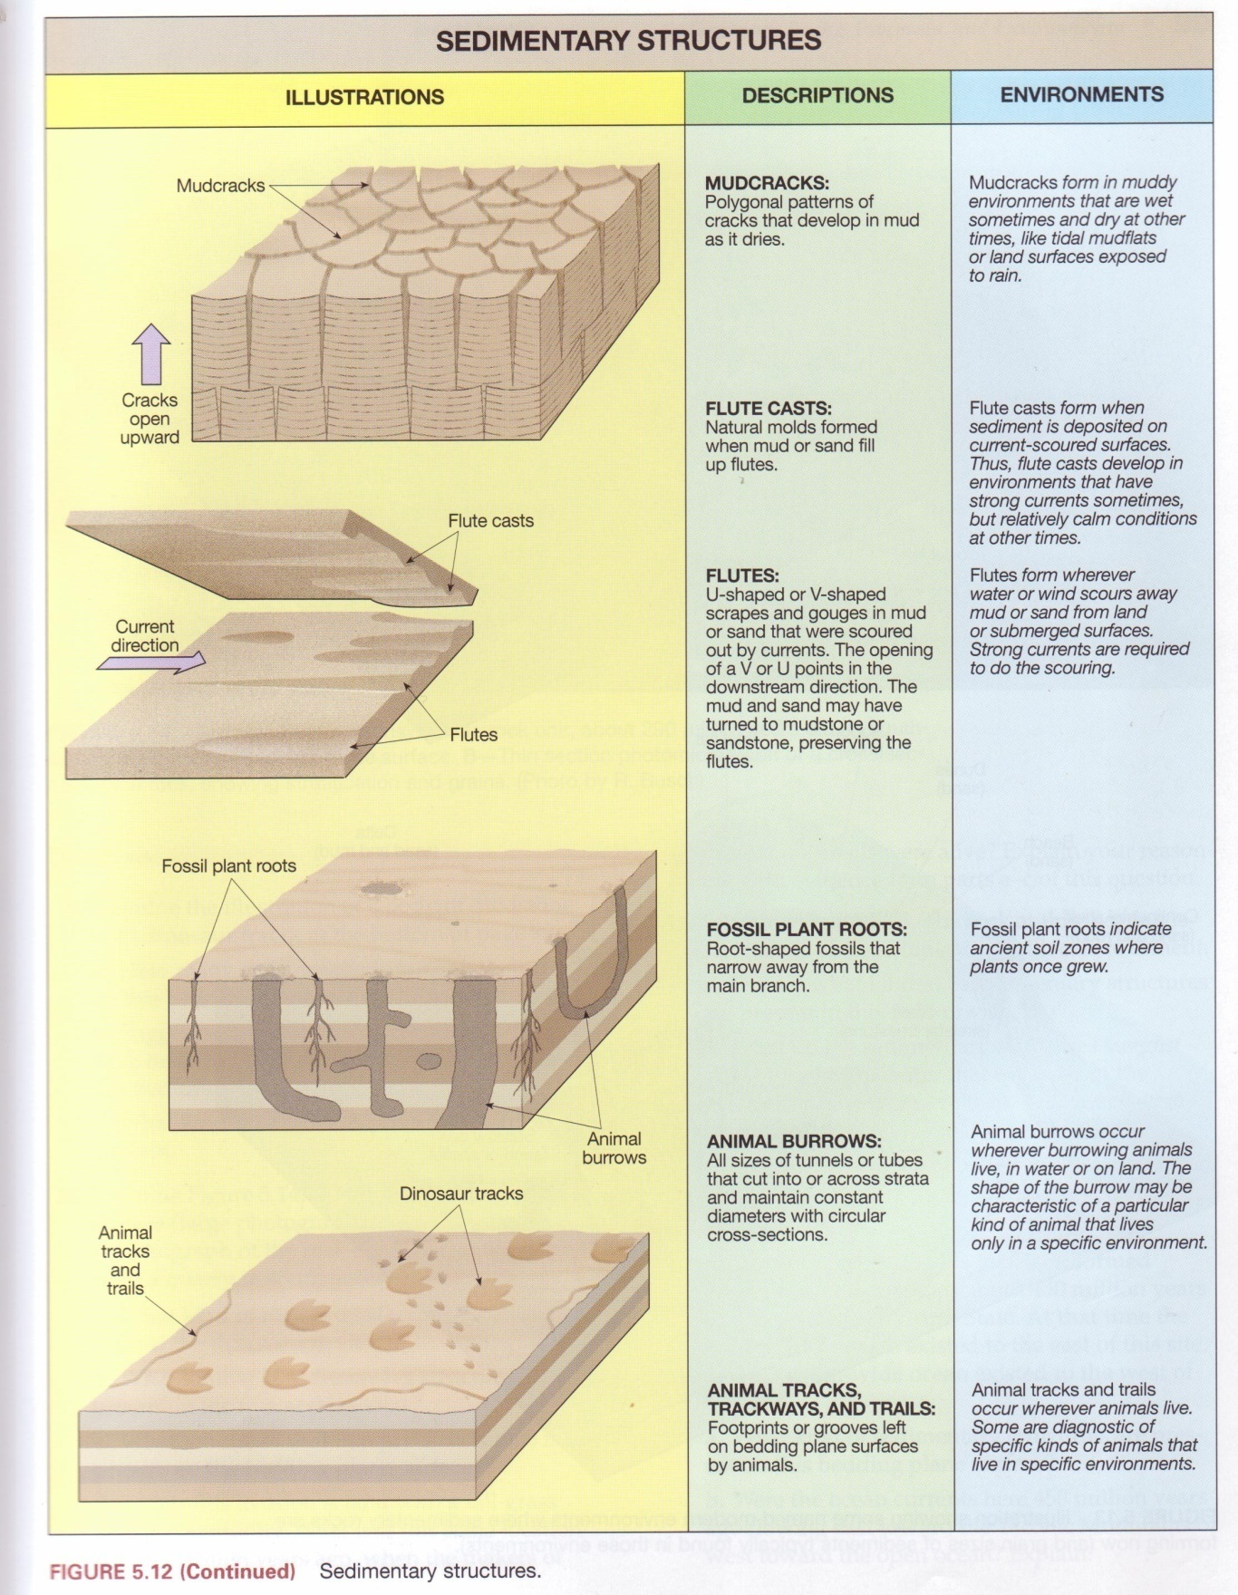
Figure 38. Sedimentary structures (continued)

Sedimentary Environments
Sediments are deposited in many different environments. A variety of these environments are illustrated in figure above. They have been studied in great detail, so for each type we know the characteristic sediments, sedimentary structures, and fossils (any evidence of prehistoric life). The information gained from grain characteristics, sedimentary structures, and fossils can be used to infer what ancient environments (pale environments) were like in comparison to modern ones
