SEDIMENTARY PROCESSES

The rock-forming processes leading to the formation of sedimentary rocks include:

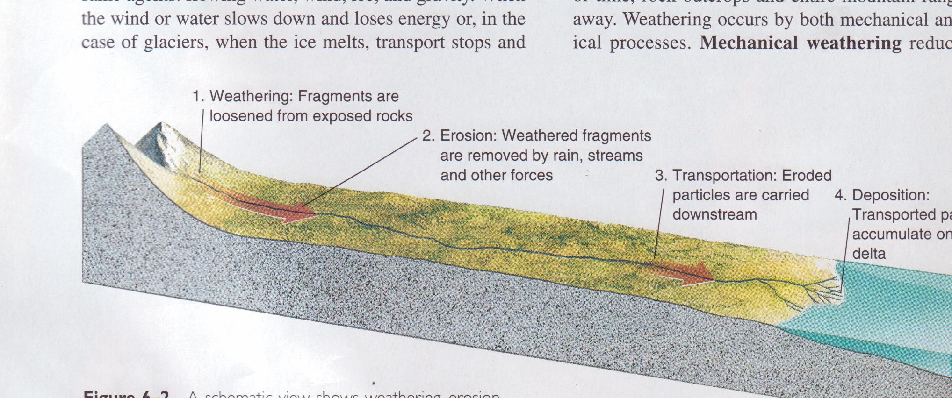
Showing weathering, erosion, transportation, and deposition of sediments

- WEATHERING,

a) Water

b) ice

c) chemical

- TRANSPORTATION

- DEPOSITION (sedimentation),

- DIAGENSIS (lithifications),

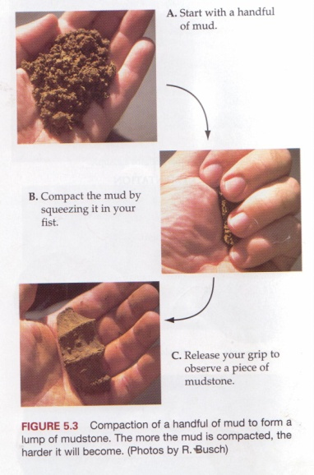

and each of the resulting rocks passed through at least one or two of these processes.

Weathering. All rocks exposed to the action of atmosphere, ground waters and organic life undergo more or less advanced physical and chemical alteration.

The physical weathering is caused by:

1) Changes in temperatures (daily and seasonal), leading to repeated
expansion and contraction of minerals and sometimes to freezing
and thawing of interstitial waters. These processes disintegrate rocks, producing residuum of mineral grains (mineral disintegration) and rock fragments (block disintegration);

2) action of organisms, especially roots of plants, loosening of rocks;
3) mechanical abrasion of particles during their transportation by
waters, glaciers and wind.
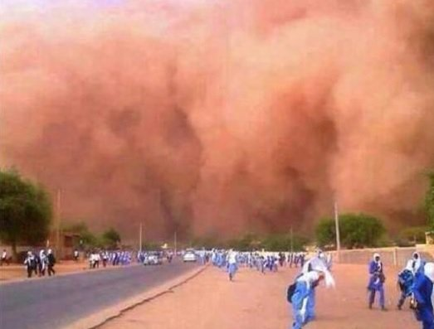

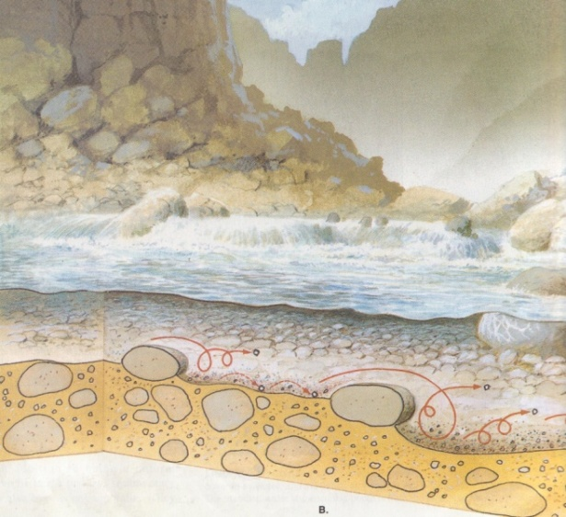
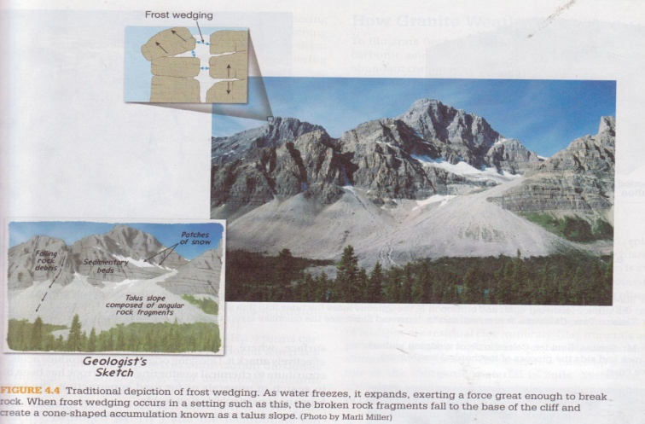

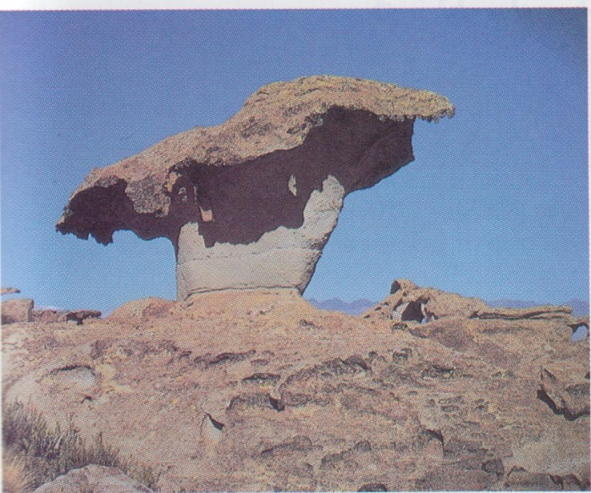
Wind abrasion

The chemical weathering leads to more profound changes, especially in the case of crystalline rocks, whose minerals are not stable under atmospheric and ground-water conditions. Waters with dissolved oxygen and carbon dioxide react eventually with minerals, liberating at first alkalia (mainly by decomposition of feldspars). Alkaline waters dissolve consequently other silicates and eventually even quartz. The organic life produces the humic acids which further accelerate processes of decomposition. Major chemical changes may be identified as:
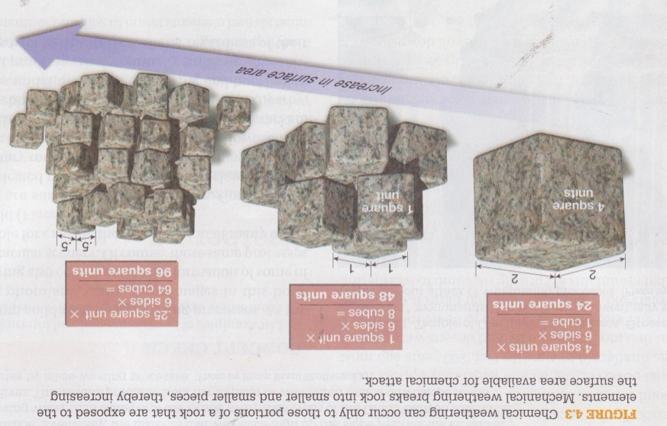

1) hydrolysis
2) hydration
3) oxidation
4) carbonation
5) dissolving

During chemical and physical weathering of crystalline rocks, the end products are found to be of four kinds:
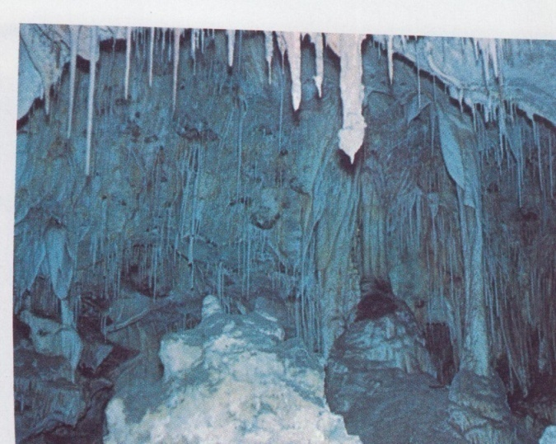
1) soluble salts (of Na, Ca, K, Mg)
2) colloidal substances (hydroxides of Fe, Al, Mn, colloidal silica)
3) insoluble decomposition products (clay minerals)
4) chemically resistant constituents (mainly quartz but in some extent
rock fragments, feldspars, micas, heavy minerals).

Transportation. Running waters are the major transporting agent but also the action of sea currents, waves, sediment plus water flows, glaciers and wind must be considered. The solid grains may be transported by saltation and rolling and these of the smallest size – in suspension. The velocity of current and degree of its turbulence have the strongest influence on the type of transportation. A part of the weathered material is carried away in the form of colloidal solutions and soluble salts are removed as true solutions.

Deposition (sedimentation). Sediments are laid down in one of the following environments:

1) continental

- fluviatile
- lacustrine (fresh-water lake, salt lake)
- glacial
- eolian
- swampy

2) intermediate

- deltaic
- castuarine

3) marine

a. literal (shoreline areas – tidal flats, sabkhas, beaches, barriers,
lagoons)
b. neritic (shallow waters – continental shelves, epeiric seas)
c. bathyal (the continental slope to a depth approx. 2000 m)
d. abyssal (deep waters)

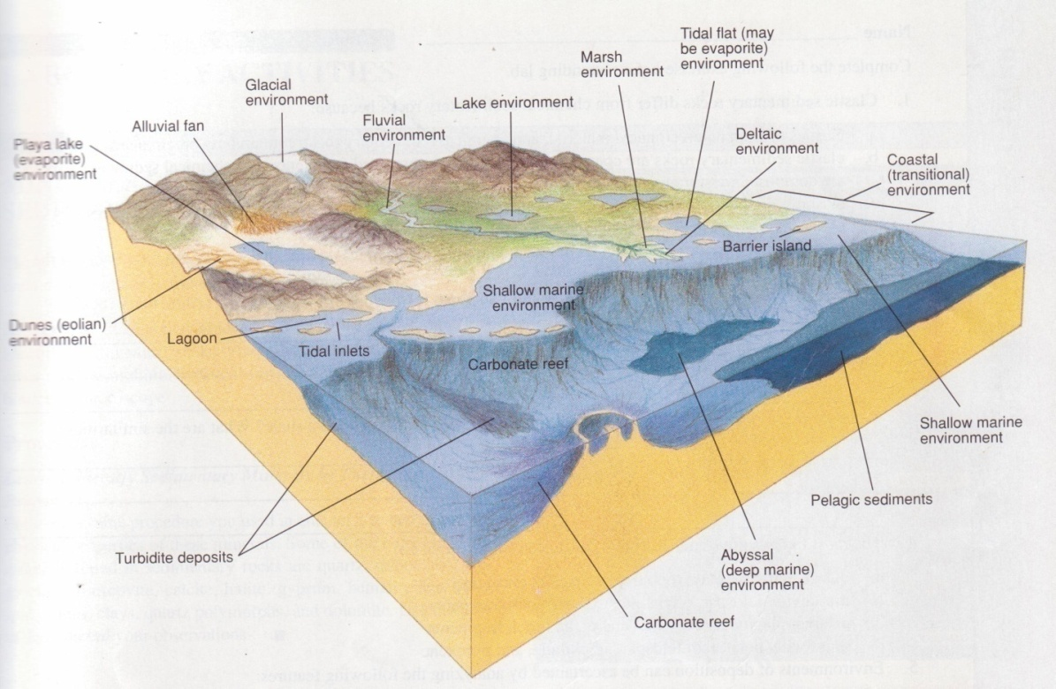
Common terrestrial and marine sedimentary enviroments

Many environmental factors influence the structure, texture and composition of sediments. On the dry land they include mainly climate and topography, as well as the cover of vegetation. In aqueous environments the bottom topography, depth of water, its temperature, salinity, alkalinity – acidity (pH), redox potential (Eh), freedom of circulation, turbulence, presence of organic life must be considered. Many of these factors result again from the climatic conditions. The tectonic factor controls the depositional setting (a stable craton, intracratonic basin or rift, continental margin, trench, any of arc-basins, etc).

A facies is a body or packet of sedimentary rocks with features that distinguish it form other facies. Lithofacies are based on sedimentary characteristics: mineral composition, grain size, texture, structure, colour. Biofacies rely on paleontological differences (fossil content). Facies can be described in terms of:

1) the sediment itself
2) the depositional process
3) the depositional environment
In the course of deposition one can observe so-called sedimentary differentiation: the subsequent deposition at first coarser then finer material or precipitation at first less and then – more soluble components. Dynamically evolving processes may, however, change this basic succession.

Diagenesis (lithification). Burial and compaction of soft sediments harden them into a massive rock. The major physical changes are caused by compaction, the squeezing of mineral grains closer to each other by the weight of overburden; it results in the decrease of porosity. The chemical changes are expressed by dissolution of certain minerals and after it – by reaction between water in pore spaces and minerals. It forms cement, binding the grains together. Other chemical changes include recrystallization, replacement and authigenesis.

Diagenesis may occur immediately after the deposition of a sedimentary rock (when it is still in the loose state) or long after that (it affects a rock already hardened).

