TEXTURES OF SEDIMENTARY ROCKS
Textures in sedimentary rocks are significant in that they provide important clues concerning distance of transportation and environments of deposition. Two basically different types of textures are recognized: (1) clastic textures (fragments of rock debris) and (2) crystalline textures (crystals which have grown from solutions).
Clastic Textures. The basic criterion for classifying clastic textures is grain size, with subordinate subdivisions made on the basis of rounding, sorting and cementation. The size of clastic particles ranges from large blocks, many feet in diameter, to fine dust.

Particle Size
Usually grain size of sedimentary rocks is expressed in Wentworth classes after C.K. Wentworth (1922). Wentworth grain size classes commonly used by sedimentologists in describing sediments:
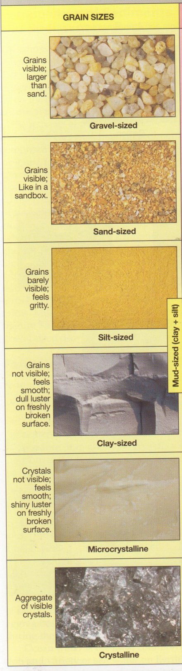
Gravel includes grains larger than 2mm in diameter (granules, pebbles, cobbles, and boulders).
Sand includes grains from 1/16 mm to 2mm in diameter. This is the size range of grains in a sandbox. He grains are visible and feel very gritty when rubbed between the fingers.
Silt includes grains from 1/256 mm to 1/16 mm in diameter. Grains of silt are usually too small to see but can be felt as very tiny gritty grains when they are rubbed between the fingers and the teeth.
Clay includes grains less than 1/256 mm in diameter. Clay- sized grains are too small to see and they feel smooth ( like chalk dust ) when rubbed between the fingers or teeth. Note that the word clay is used not only to denote a grain size but also a clay mineral.
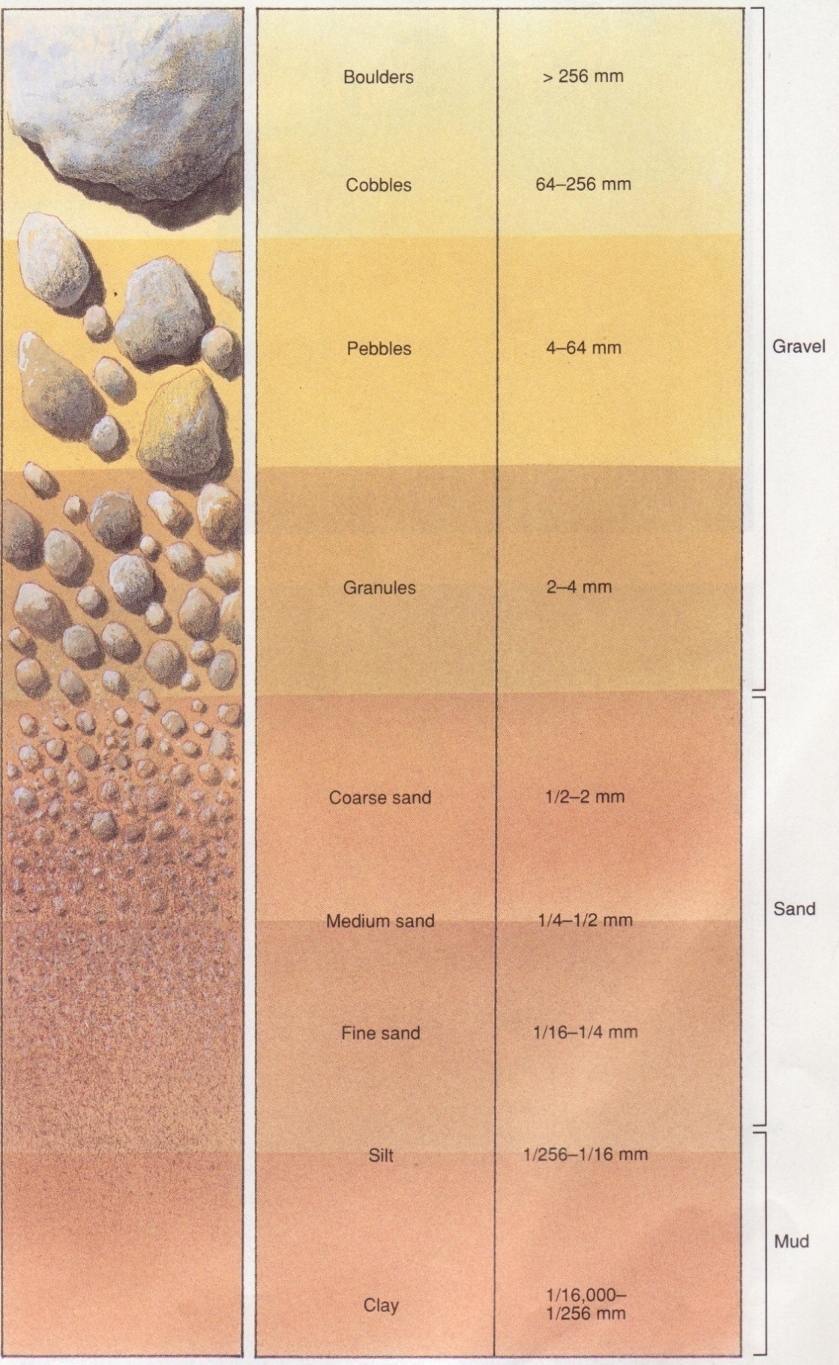
Figure 30. Grain size

Particle shape
Once formed, clastic sediment is removed and transported by running water, wind,, ice, or gravity. During transportation, particles that are initially angular tend to become more rounded by abrasion of sharp edges and corners. The further a particle is transported, the more its shape is changed. Grain carried a long distance by water or wind may become very smooth and rounded. The degree of rounding can be used as indication of how far a grain has travelled e-g a conglomerate composed of rounded gravel probably formed far from the sediment source area. On the other hand, breccia which has angular particles probably formed near source of the gravel.
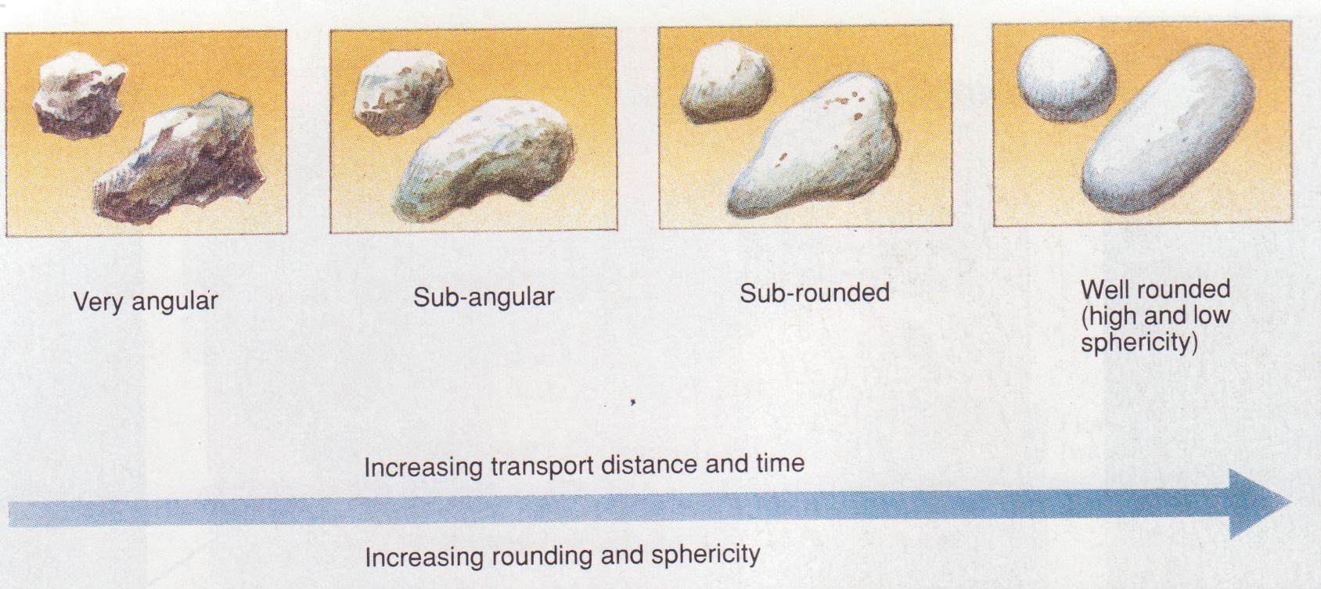
Figure 30. Grain shape
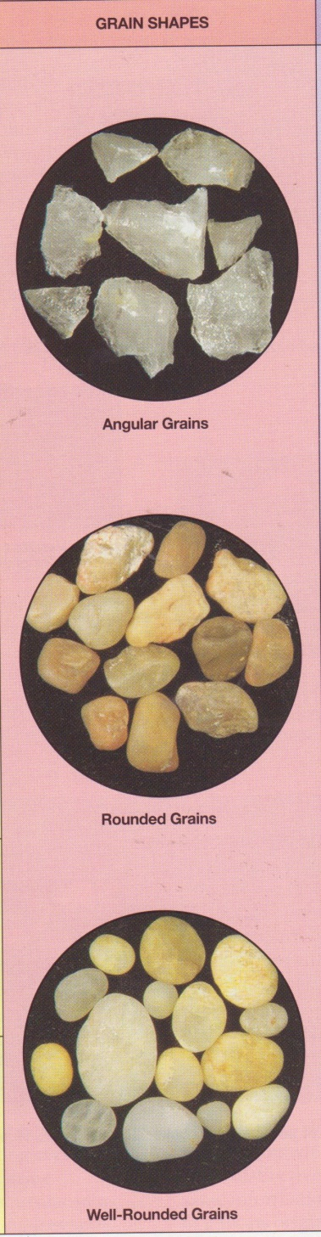

Sorting
Sorting refers to the range of various sizes of particles. It is a very important textural characteristic since it may provide clues concerning the history of transportation and the environment in which the sediment accumulated. Well-sorted material (Figure 30) is composed of one dominant size and usually one type of material. It results only after considerable transportation, during which particles similar in size and density are concentrated by prolonged washing and winnowing by current action. Poorly sorted material (Figure 30) contains several different sizes. Glaciers do not sort materials but deposit coarse and fine particles together. Mudflows do the same. Wind and water are the best sorting agents; they usually concentrate materials of one dominant grain size in dunes, beaches, bars and mud flats.
After a sediment is deposited, it may become tightly cemented together to form a solid rock. The dominant cementing materials are calcite, quartz, iron and chert which may be carried by ground water from a foreign source or derived within or very near the site of sedimentation by solution activity. The degree to which a sediment is cemented is thus an important textural characteristic in clastic rocks.
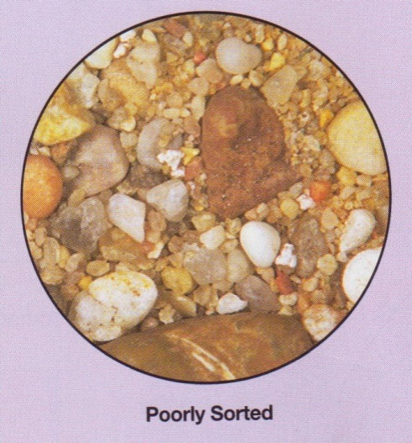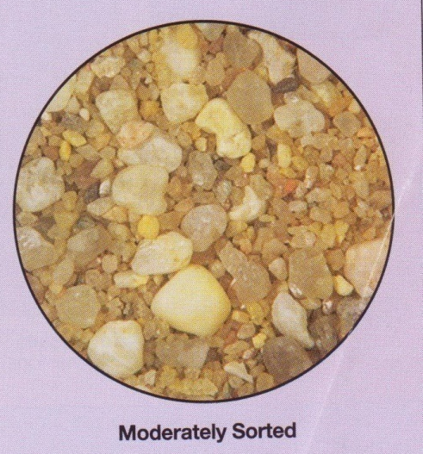
Figure 31. Sorting
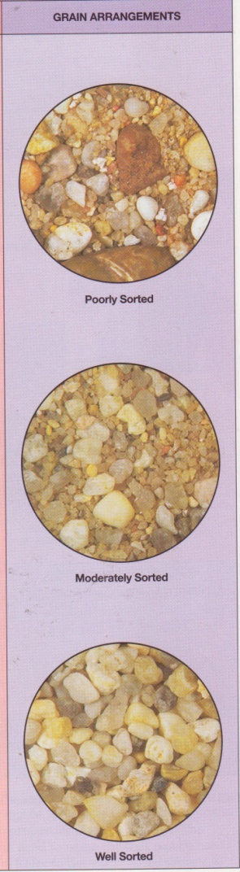

Crystalline Textures. (Figures 31) In contrast to the clastic texture described above, minerals precipitated from sea water or lakes develop a texture consisting of a network of interlocking crystals. Such textures are similar to those found in igneous rocks but generally consist of one dominant mineral.
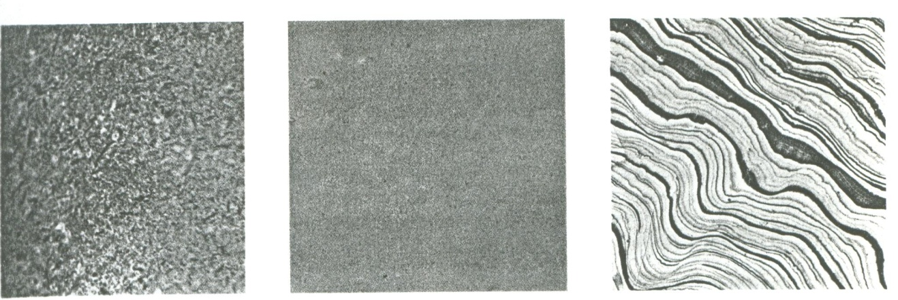
Figure 32 . Limestone textures

The individual crystals are usually about the same size and interlock to form a dense rock. Crystalline textures are described as coarse (greater than 2mm), medium (1/16mm to 2mm, Figure 32) and fine or microcrystalline (less than 1/16mm, Figure 32) deposits from springs and caves are commonly microcrystalline but have a banded structure (Figure 32) resulting from chemical variations and impurities during deposition.
Oolitic Texture. Calcium carbonate precipitated on a sea floor and agitated by wave or current action commonly accumulates around a tiny shell fragment or grain or silt. As the particle moves to and fro, small spheres called oolites are built up by accretion and form a limestone texture which superficially resembles a well-rounded sandstone. Close examination of an oolitic texture reveals a concentric structure around a nucleus and generally minor amounts of associated shell debris (Figure 88C).
Skeletal Textures. Calcium carbonate may also be removed from sea water by organisms to make their shells and other hard parts. When the organisms die, the shell material will settle to the sea floor and may be concentrated as shell fragments on a beach or near a reef. The texture of the resulting rock is similar to a clastic texture, but the material is unique in that it consists of the skeletal fragments of organisms. Such a texture is referred to as skeletal (Figure 32) and is of fundamental importance in many limestones.
The samples shown above illustrate a variety of coarse clastic textures. All are composed of fragments greater than 2mm in diameter. In specimen A, large rounded pebbles composed mostly of quartzite are surrounded by a matrix of red sand and silt. The material is poorly sorted but a crude stratification is present. In Specimen B, two grain sizes are preserved – a fine sand-size matrix and coarse-grained pebbles. The angularity of the pebbles is an important textural characteristic of this rock and serves to distinguish it from the other coarse-grained sediments. In Specimen C, the grains are moderately well sorted and subangular and represent the border line between a medium and coarse grained texture.
Specimen A is typical of a medium-grained clastic texture. The grains are less than 2mm and are well rounded and well sorted. A fine-grained clastic texture is shown in Specimen B. individual grains are too small to be distinguished with the unaided eye but are well sorted. A microscopic view of this texture is shown in Figure 31. redistribution of these silt-sized particles by burrowing organisms is common and is evident in the lower left corner of the photo.
The finest-grained clastic texture is illustrated in C. Individual particles are less than 1/256mm and cannot be seen without high magnification. Lamination like that shown in C is common in fine-grained clastic rocks. (See photomicrograph of this texture in Figure 31).
Calcium carbonate precipitated from the sea or lakes may form a texture of interlocking crystal. The crystal size ranges from large crystals greater than one inch long to small submicroscopic grains. In Specimen A, the texture is coarse, crystalline and equigranula. Micro crystalline material, such as shown in B, forms a very dense, structureless rock. Even under the microscope the crystal material is difficult to distinguish. With extremely high magnification, discrete crystals can be identified. Some microcrystalline material is characteristically banded due to variations in conditions during deposition, such as illustrated by Specimen C.
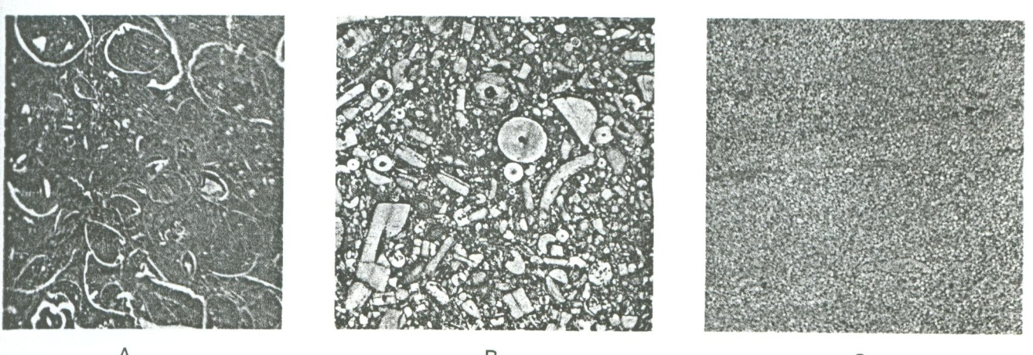
Figure 33. Examples of Limestone textures (actual size)

Organisms play an important role in many limestone textures. Shells and shell fragments accumulate after the organisms die and may dominate the textural aspect of the rock. In Specimen A, cross sections of shells of clamlike organisms are shown in white. Crinoid stem fragments are shown in Specimen B. Oolitic textures, such as are shown in Specimen C, develop when a silt particle or shell fragment is shifted to and fro by waves and picks up newly precipitated calcium carbonate. A microscopic view of oolites is shown in Figure 33.

