TYPES OF SEDIMENTARY ROCKS
Materials accumulating as sediments have two principles sources. First sediments may be accumulations of materials that originate and transported as solid particles derived from both mechanical and chemical weathering. Deposits of this type are termed detrital and the sedimentary rocks that they form are called detrital sedimentary rocks. The second major source of sediment is soluble material produced largely by chemical weathering. When these dissolved substances are precipitated by either inorganic or organic processes, the material is known as chemical sediments and the rock formed from it are called chemical sedimentary rocks

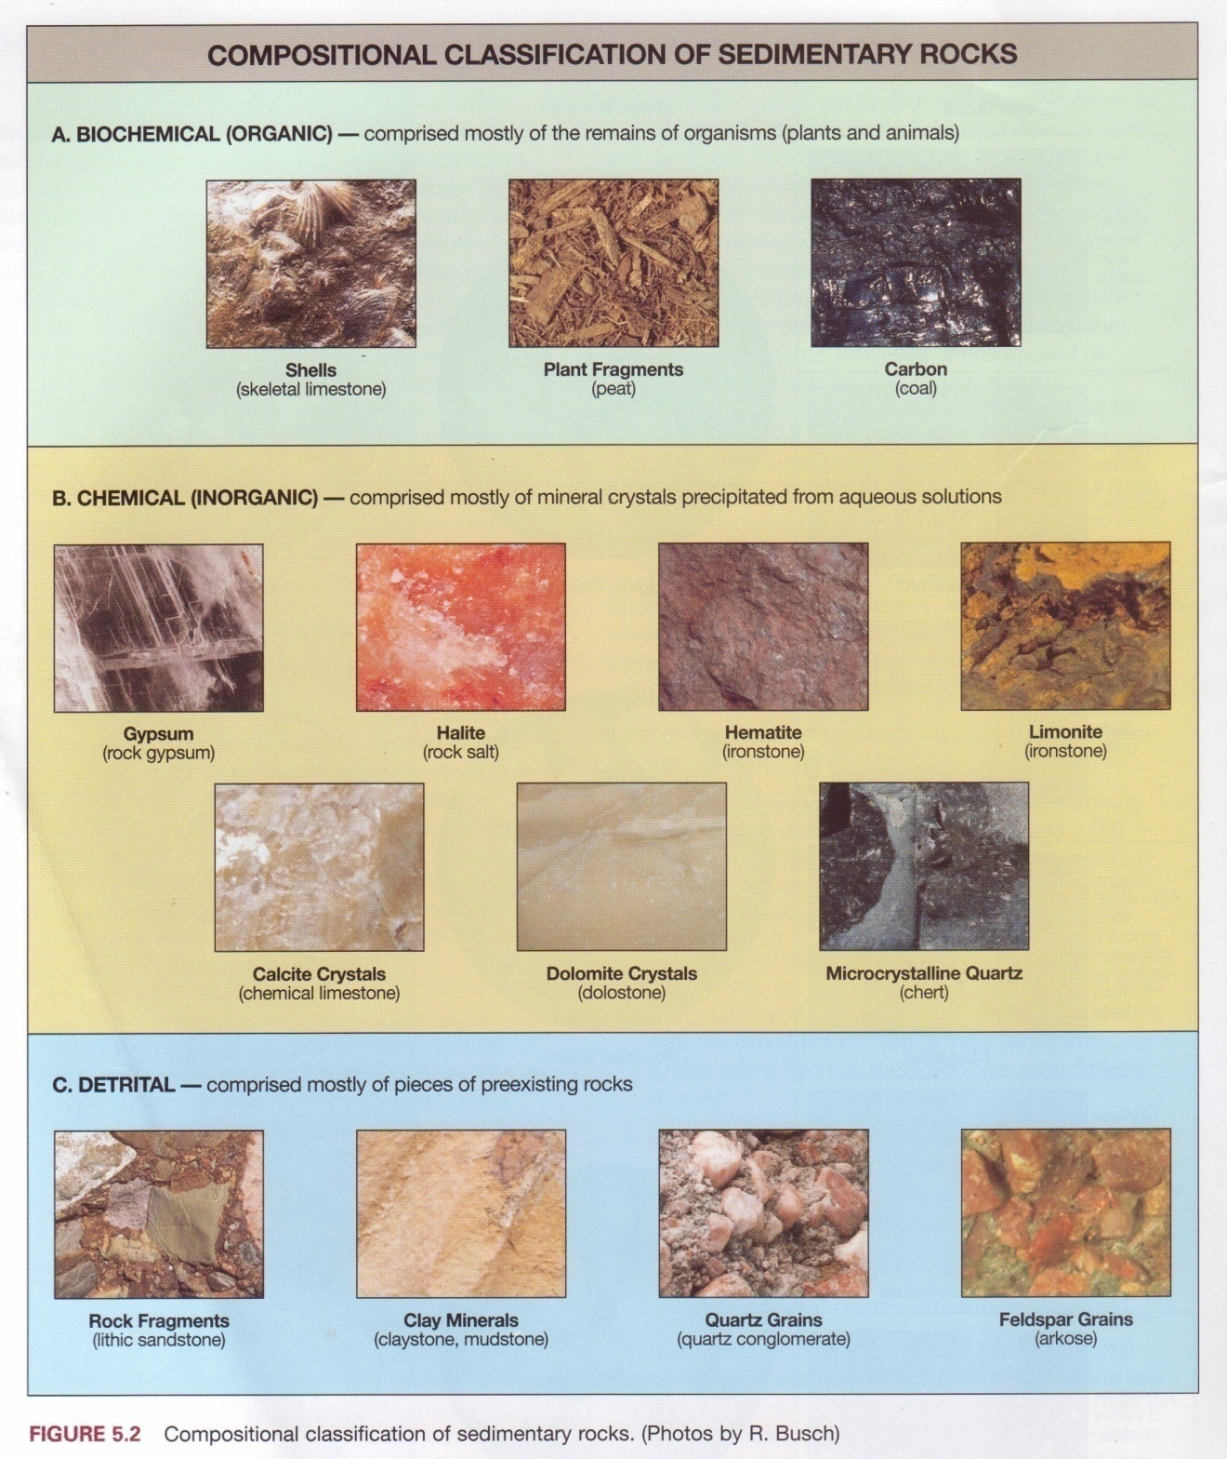
Figure 39. Composition classification of sedimentary rocks

CLASTIC ROCKS
Clastic rocks consist predominatly of fragments and debris of other rock material. These deposits are familiar as gravel, sand and mud when unconsolidated and are referred to as conglomerate, sandstone, and shale when indurated. Most of the material in the sedimentary record is sorted and stratified, and shows the effects of abrasion. Classification of classic rocks is made on the basis of texture and composition.
Table: Clastic sedimentary rocks
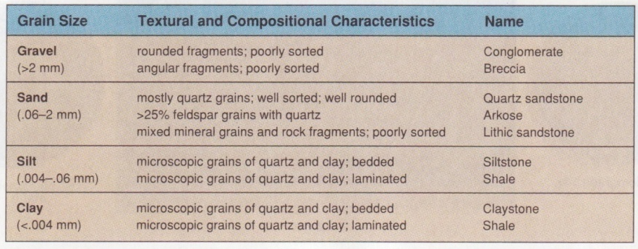

CONGLOMERATE
Conglomerates consists of coarse rock fragements(greater than 2 mm in diameter], held together by a matrix of sand, clay, and cement. The individual pebbles are usually well rounded and moderately well sorted{Figure 40].
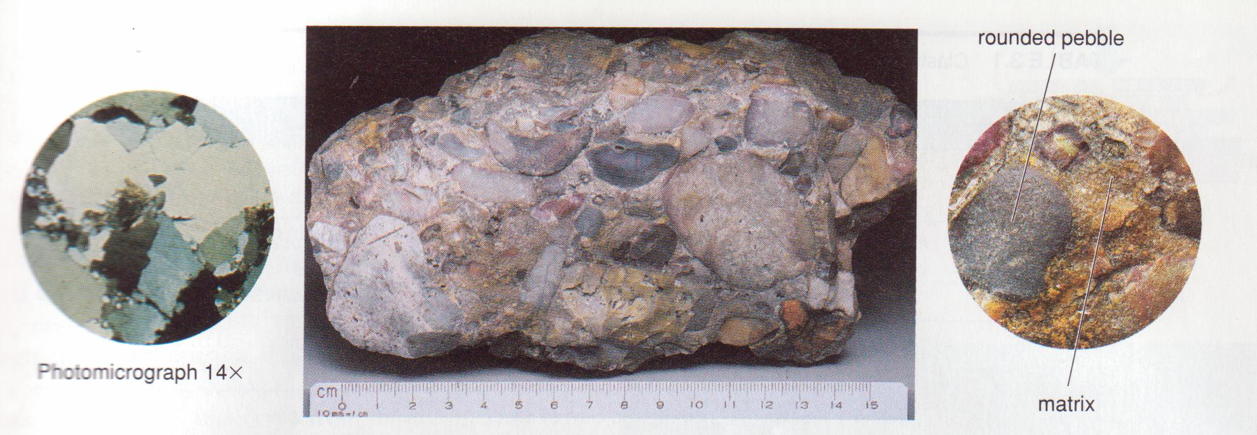
Figure 40. Conglomerate thin section and hand specimens
Pebbles in conglomerates may consist of any mineral or rock, but resistant materials such as quartz, quartzite, and chert are especially common. Fragments of limestone, granite, or other rock types may predominate in some deposits.
The only agents capable of transporting gravels and large fragments are swift-moving water, ice and gravity. The most important environments for conglomerate deposition are alluvial fans, river channels, and beaches.

BRECCIA
A breccia is a course-grained clastic rock in which the fragments are angular and show little evidence of abrasion (Figure 41). The material is commonly poorly sorted, with a fine-grained matrix.
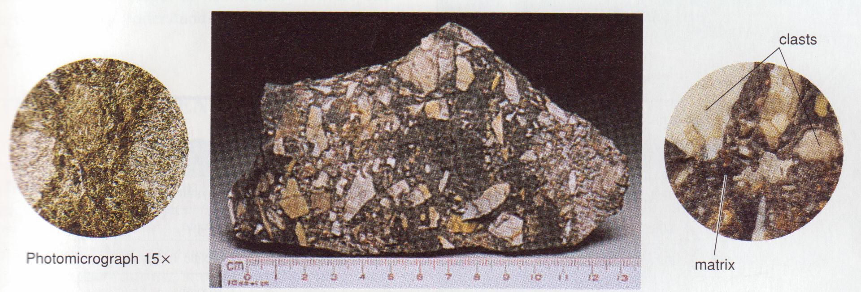
Figure 41. Breccia in thin section and hand specimen
The most significant breccia deposits result from glaciation, landslide, and other types of mass movement. Movement along fault planes will also produce a breccia zone, as will collapse in caves.

AKROSES
An arkrose (Figure 42) is a clastic rock which is composed of at least 25 percent feldspar. Quartz is the other major constituents. Arkose is generally coarse grained angular, and moderately well sorted. In most arkoses the grain size is commonly in the sand range, but some arkoses are coarse enough to be termed conglomerates.
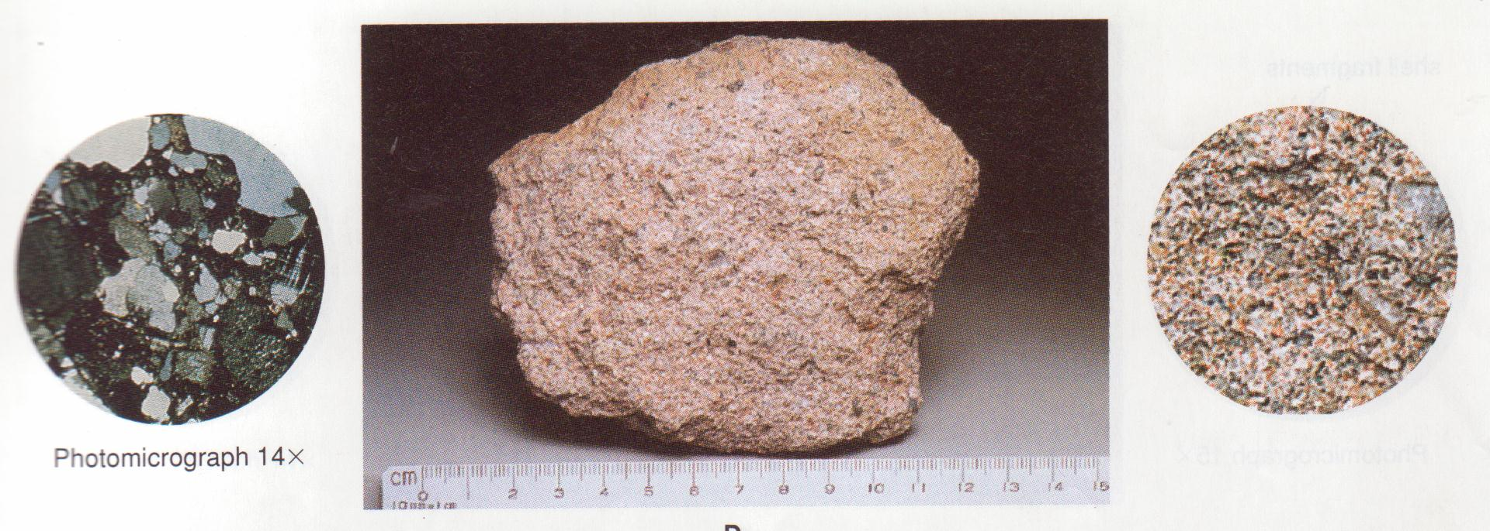
Figure 42. Arkose in thin section and hand specimen

In fugure 35, the feldspar is pink, and close inspection will reveal that it is very abundant. In thin section the feldspar grains, which have a plaid pattern, are nearly as abundant as quartz (gray). Calcite cement appears brown in the thin section.
Arkoses form by rapid erosion of a granitic terrain and rapid deposition. They are common in alluvial fans.

SANDSTONES
Sandstone are clastic sedimentary rocks consisting mostly of grains ranging from 1/16 to 2 mm in diameter. The grains are generally rounded and show other effects of abrasion. Quartz is usually the dominant mineral, although feldspar, garnet, mica, and other minerals may be present in varying amounts. Poorly sorted, dirty sandstones containing over 20 percent clay are called greywacke. Calcite, quartz, and iron oxide are the dominant cementing materials. Sandstones are generally stratified and are colored buff, red, brown, yellow, or green, depending on impurities’ and cementing agents.
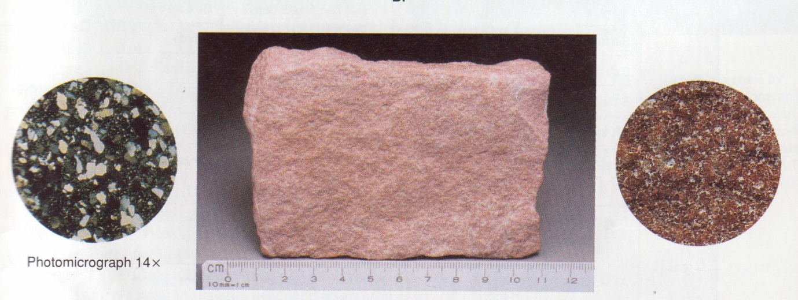
Grit or Lithic sandstone consists of a mixture of angular, sand- sized grains including quartz, feldspar, mica, and rock fragments in a poorly sorted matrix.

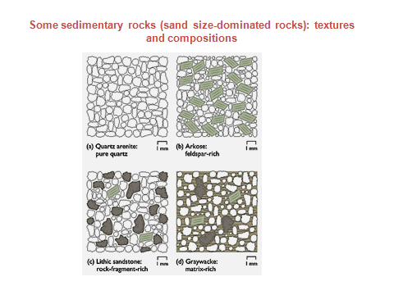

Sandstones may accumulate in a wide variety of environments, such as beaches, deserts, flood plains and deltas.

SILTSTONES
Siltstones are fine-grained clastic rocks in which at least 50 percent of material is 1/16 to 1/256 mm in diameter. They are commonly laminated (Figure 44), but burrowing organism may destroy or obscure evidences of stratification. Silt particles, when viewed under the microscope, appear to be angular rather than rounded like sand. They are composed of quartz grains, with an abundance of mica and clay minerals.
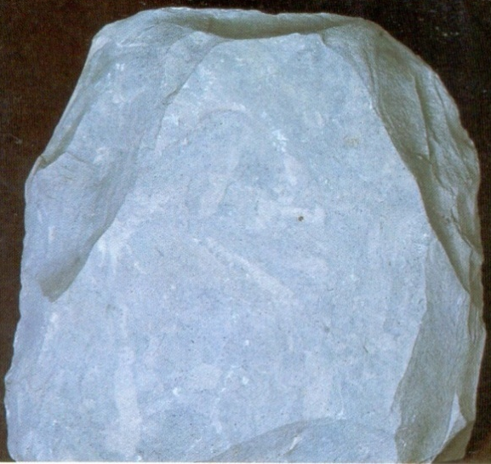
Figure 44. Siltstone
Silt is common material deposited by most streams in deltas and flood plains. It rarely forms thick beds and is characteristically interstratified with shales and sandstones.

SHALES
Shales are fine grained clastic rocks consisting of particles less than 1/256 mm in diameter. They are characteristically laminated or thin bedded, as is well expressed in both hand specimen and thin section. Quartz, mica, and the clay minerals are the dominant constituents, but, as is shown in Figure 85, particles are too small to be seen without a high magnification. Calcite may be present – usually as cement – in amounts ranging up to 50 percent. Eighty percent of exposed sedimentary rocks are shales. They accumulate in an environment of low mechanical energy such as lagoons, quite offshore waters, flood plains, and lakes.
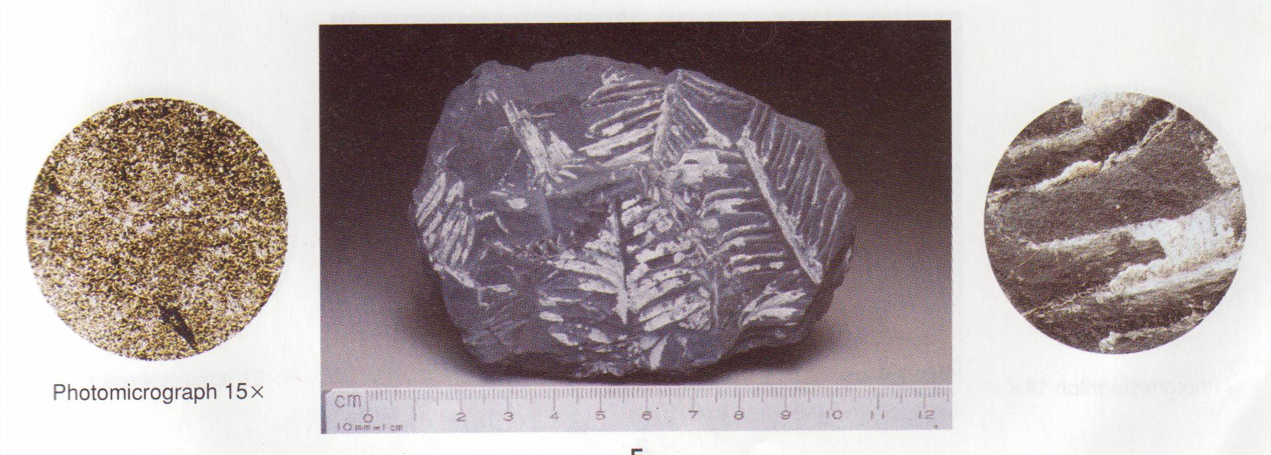
Figure 45. Shale in thin section and hand specimen

Chemical Sedimentary Rocks
Table: Chemical Sedimentary Rocks
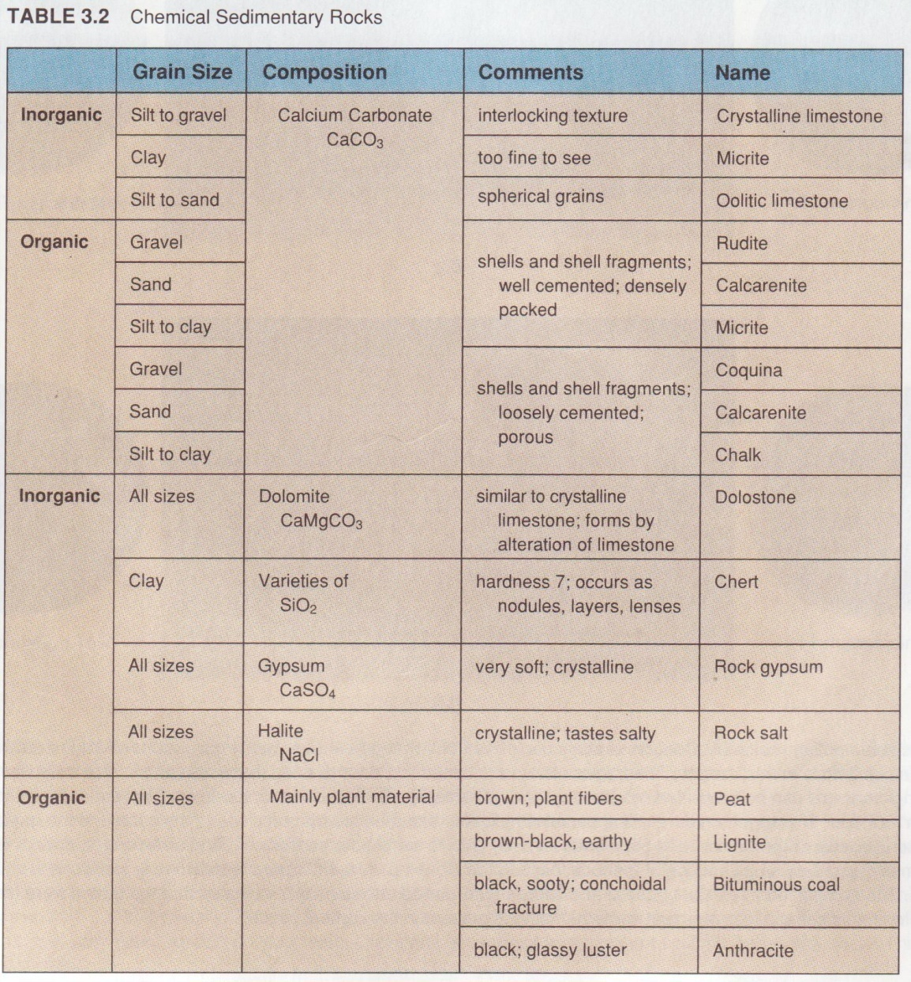

LIMESTONE
Limestones are sedimentary rocks that contain more than 50 percent calcium carbonate. Impurities, which may range in amount to 50 percent, include clay, quartz, iron oxide, rock fragements, and othe material. The calcite may be precipitated chemically or organically or may be of detrital origin. The many varieties of limestones are classified on the basis of texture or some other significant property.
All limestones are similar in that they are composed mostly of calcite and effervesce in hydrochloric acid.

CRYSTALLINE LIMESTONE (Sparite)
Crystalline limestone (Figure 46) is composed of interlocking crystals of calcite which can be seen with the unaided eye or with low power magnification.
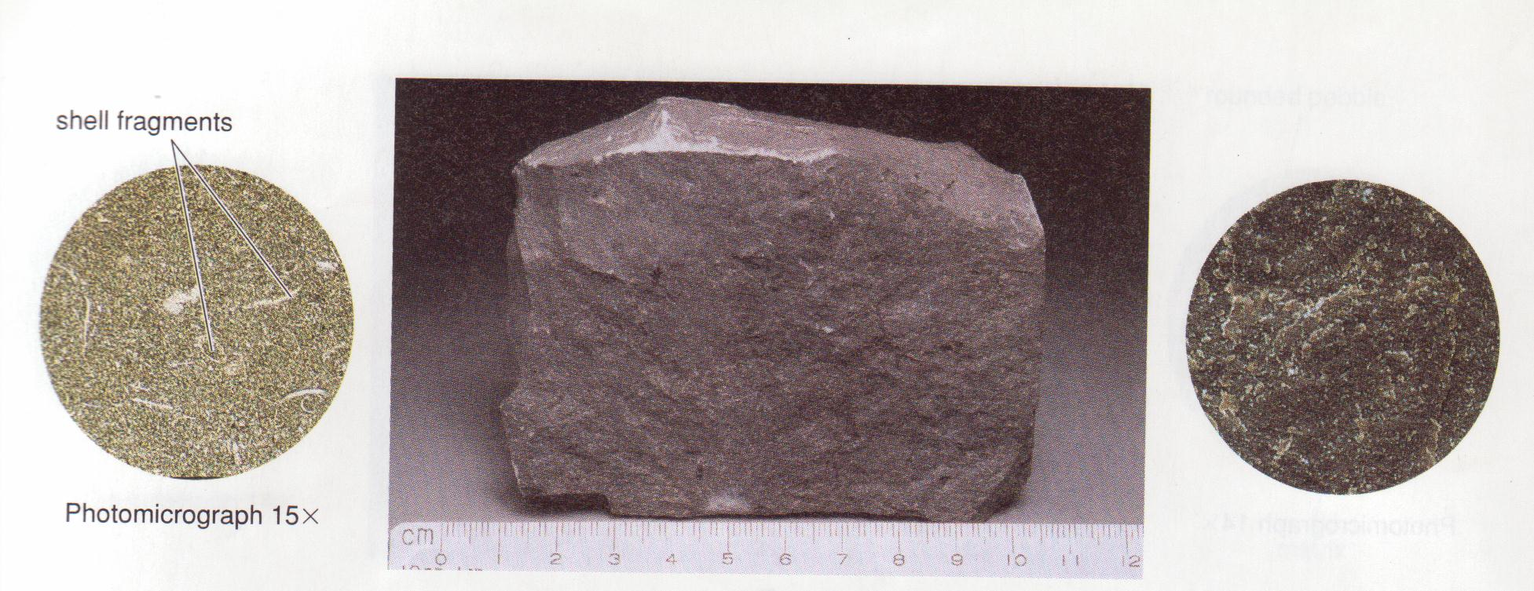
Figure 46. Crystalline limestone in thin section and hand specimen

In many respects it is similar to a marble, but it shows no evidence of pressure or flowage. Well-preserved fossils are common, and bedding planes are generally distinct. Good rhombohedral cleavage is commonly well expressed in thin sections of crystalline limestone.
Large crystals in limestone may grow after deposition if ground-water solutions migrate through the rock and precipitate calcite.
Dolomite or dolostone closely resembles crystalline limestone but is composed of the mineral dolomite. It can be distinguished by its reaction to dilute hydrochloric acid it must be powdered to exhibit effervescent (dolomite will react weakly if the hydrochloric acid is too concentrated. It is typical colour is buff to brown.
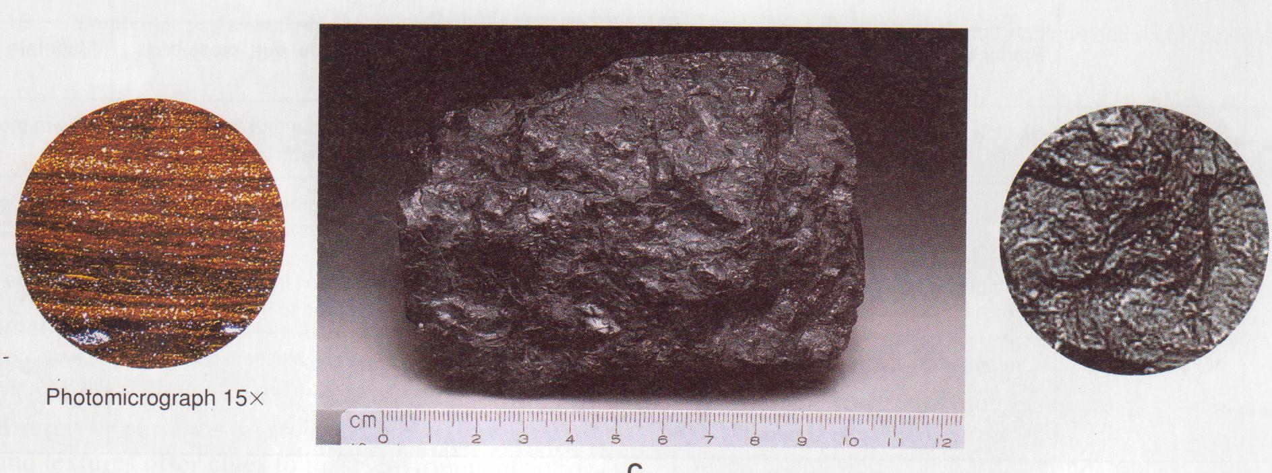
Figure 47. Dolomite in thin section and hand specimen

MICROCRYSTALLINE LIMESTONE (Micrite)
Micricrystalline limestone is composed almost entirely of microscopic crystals of calcite so small that they are difficult to discriminate even under the microscope. The rock has uniform texture, is very dense, and characteristically breaks with a conchoidal fracture. It is commonly buff or light yellow but may range in colour to dark gray or black if organic material is abundant.
Microcrystalline limestone forms in warm, quite, shallow seas.

OOLITIC LIMESTONE
Oolitic limestone is composed of small spheres of calcite concretions called oolites. The grains range up to 2 mm in diameter and consists of a sequence of concentric layers built around a nucleaus of fine silt, clay, or shell fragments. Calcite commonly cement the oolites together into a rock which closely resemble a well-rounded quartz sandstone. Stratification, sorting, cross-bedding, and other features characteristic of a sand stone are also common in oolitic limestone.

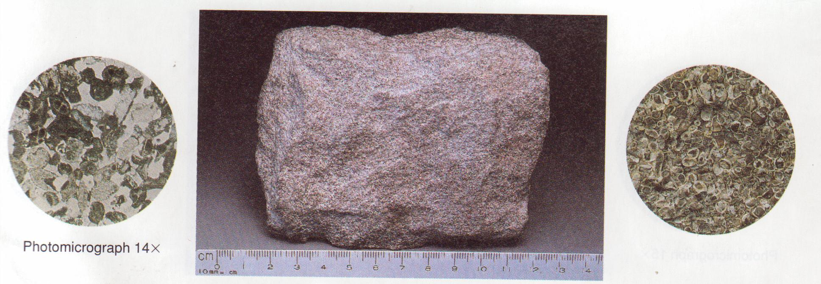
Figure 48. Oolitic limestone in thin section and hand specimen

Oolites originate in shallow water where the nucleus, agitated by current and waves, rolls along the bottom and picks up calcite that adheres to its surface.

COQUINA
Coquina [Figure 49] is the name given to a weak, porous, poorly cemented limestone composed almost exclusively of shells and shell fragments. The shell material in a coquina is commonly broken into platy fragments which are rounded, abraded, and well sorted, as is shown in the thin section.
Coquina is thus a particular type of clastic rock in which the fragmental material originated within the sedimentary environment rather than being transported to it from an eroded landmass. Coquinas are forming today along the southern Atlantic coast and in the Bahamas Islands where shell material is wished up on the shore and accumulates as calcareous sand on a beach or in shallow marine water.
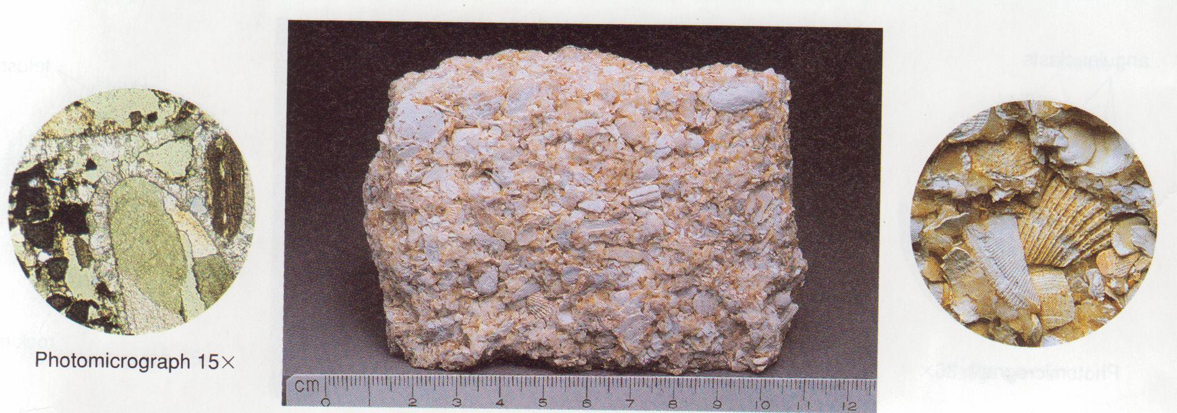
Figure 49. Coquina in thin section and hand specimen

SKELETAL OR FOSSILIFEROUS LIMESTONE
Skeletal limestone (Figure 50) is composed primarily of hard parts of invertebrate organisms such as molluscs, corals, crinoids, and other invertebrates. This material is commonly cemented with calcite and forms a dense rock. Fossils may weather out in relief, however, and reveal minute details of rock textures. In thin section, details of fossil shell structure are clearly expressed.
Fossiliferous limestone forms in warm, shallow seas where marine life is abundant.
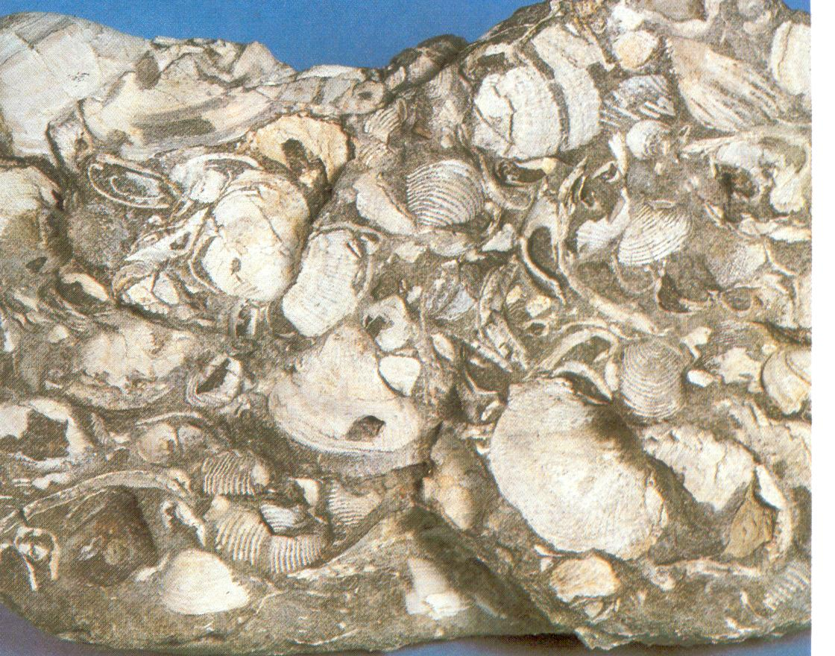
Figure 50. Fossiliferous limestone

CHALK
Chalk is a soft, porous, fine-textured limestone composed of shells of microscopic organisms, mostly foraminifera. It is normally white or buff and may contain varying amounts of mud (Figure 51).
The best-known chalks are of Cretaceous age, such as the famous white chalk cliffs on both sides of the English Channel, the Selma Chalk of the Gulf coast, and the Niobrara Chalk of Kansas. Chalk is considered to be a shallow water deposit formed by the accumulation of shells of floating organisms.

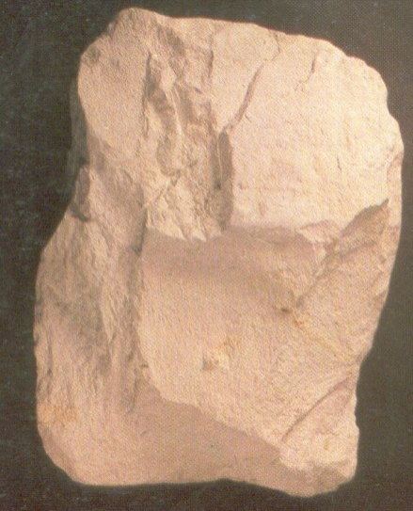

Figure 51. Chalk

TRAVERTINE
Travertine (Figure 52) is a calcium carbonate deposit formed in caves and springs. It is characteristically banded with alternating light and dark layers resulting from minor amounts of iron oxide which accumulate during successive periods of deposition.
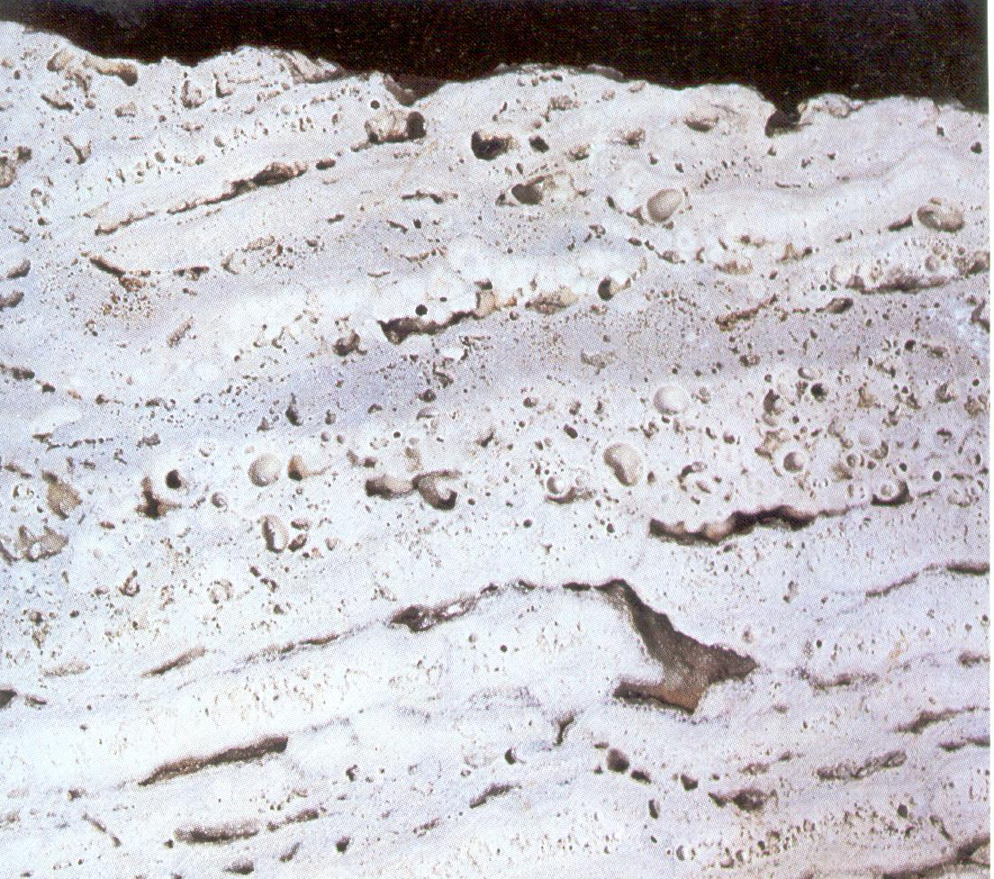
Figure 52. Travertine

The well-known flowstone, dripstone, stalagmites, and stalactites of caves are all varieties of travertine. In as much as traverstine forms relatively small deposits, mostly recent in age, it is of no great geologic importance, but it is of interest because of its beauty and the variety of forms in which it may occur.

ROCK GYPSUM
Rock gypsum is a chemical precipitate composed almost exclusively of aggregates of the mineral gypsum (Figure 53). It is normally white or is delicately coloured in various shades of yellow or light red. One of its most distinctive characteristics is that it can be scratched with the fingernail. Gypsum is commonly massive, but thin, delicate laminae formed by seasonal influxes of clay are found in some deposits.
Gypsum originates from evaporation of saline lakes or sea water in restricted bays and thus indicates an arid or semi arid climate at the time of formation.

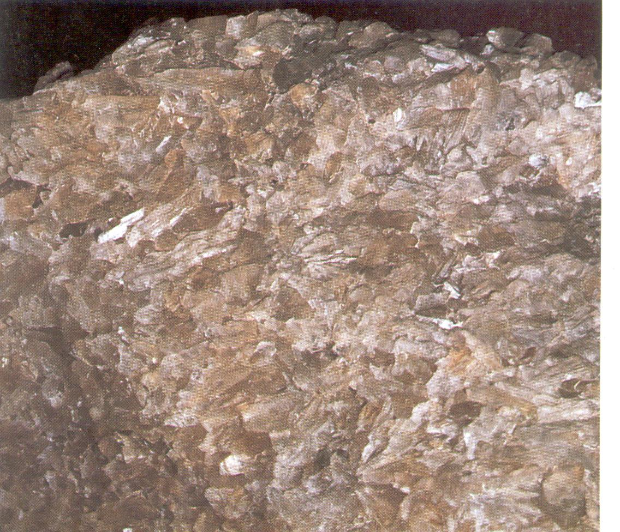
Figure 53. Gypsum

ROCK SALT
Rock salt is a rock composed of the mineral halite. Crystals may be fine, medium, or coarse and are generally colourless, unless modified with impurities of iron oxide or clay to various shades of red (Figure 54).

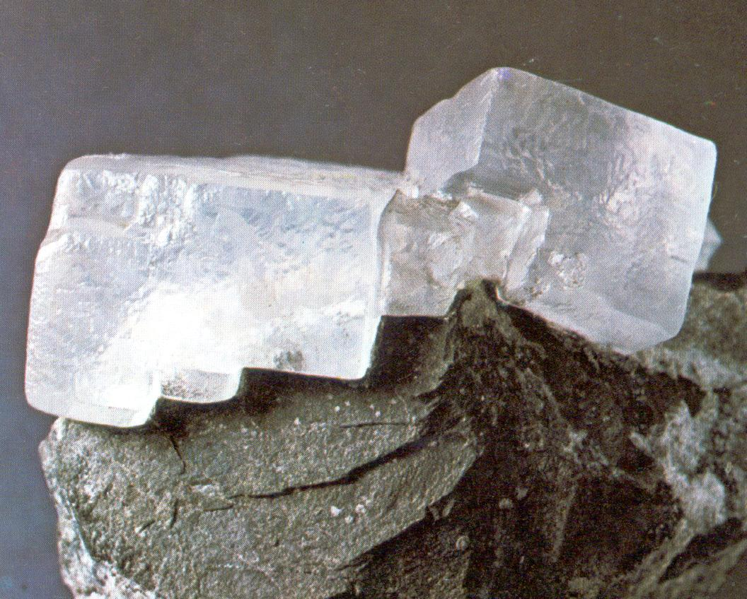
Figure 54. Rock salt
The origin of rock salt is similar to that of gypsum. Thick salt deposits are found in Michigan, New York, and Kansas and in relatively recent deposits of the western states. One of the interesting and important characteristics of salt is that it flows at relatively low temperatures and pressures. Salt from deeply buried strata may rise as piercement plugs or salt domes.

CHERT AND FLINT
Chert and flint (Figure 55) are common chemical siliceous sediments. The colour may be white or various shades of gray, green, blue, red, yellow, or black. Under high magnification, they have a fibrous or granular texture. Chert and flint commonly occur as nodules in limestone and may be coated white. Like other varieties of quartz, chert and flint are characterised by a hardness of 7 and a conchoidal fracture.
A large amount of chert is deposited in limestones by ground water but some appears to be deposited in shallow seas with limestone.
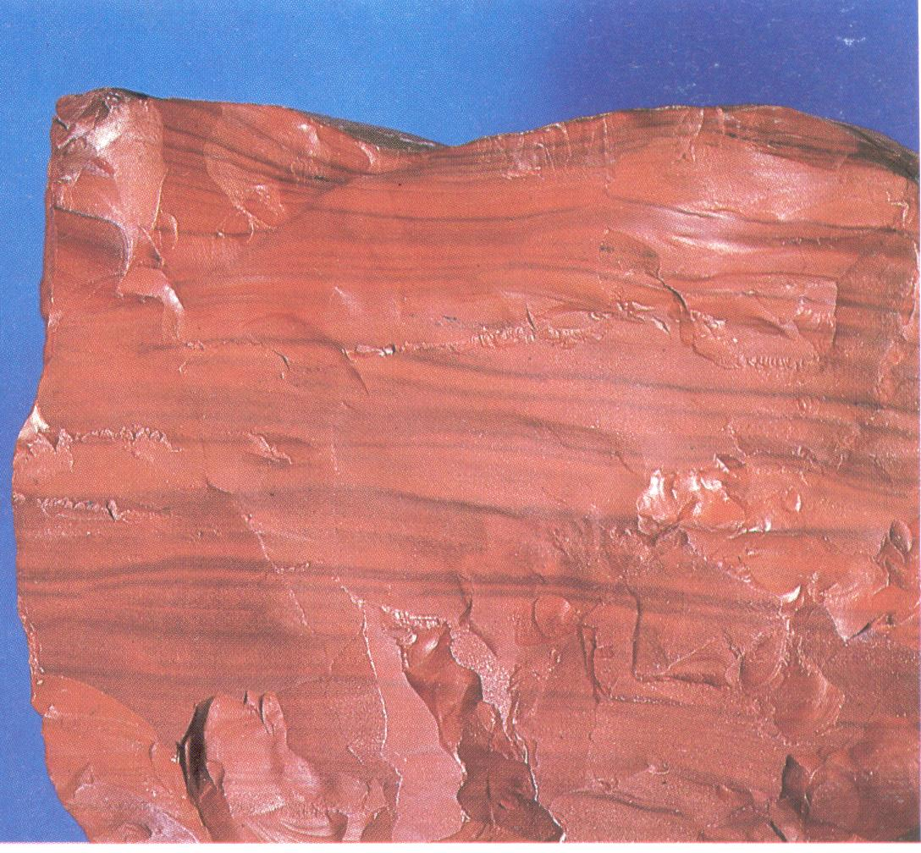
Figure 55. Flint

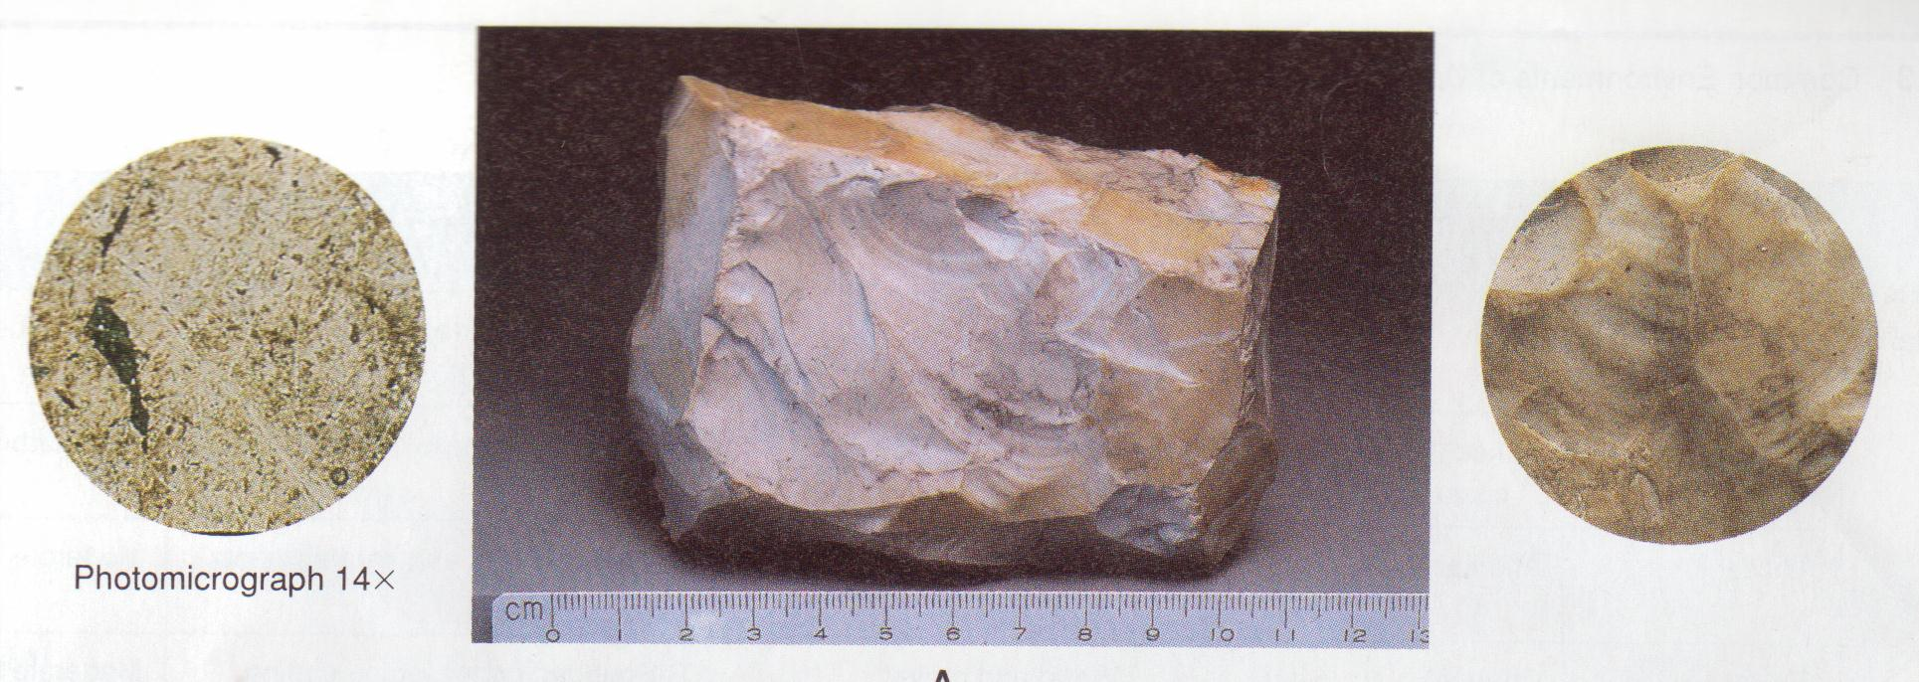
Figure 56. Jesper/Chert in thin section and hand specimen

PEAT
Peat is a dark brown or black residuum produced by partial decomposition and disintegration of plants (Figure 47). It represents the initial step in the formation of coal and forms in bogs and swamps. The organic residues constitute from 70 to 90 percent of the total accumulation. Mineral compounds are insignificant. The development of peat requires rapid growth and reproduction of plants and a minimum of life activity of micro-organisms. Peat deposits may be tens of feet thick and cover many square miles.
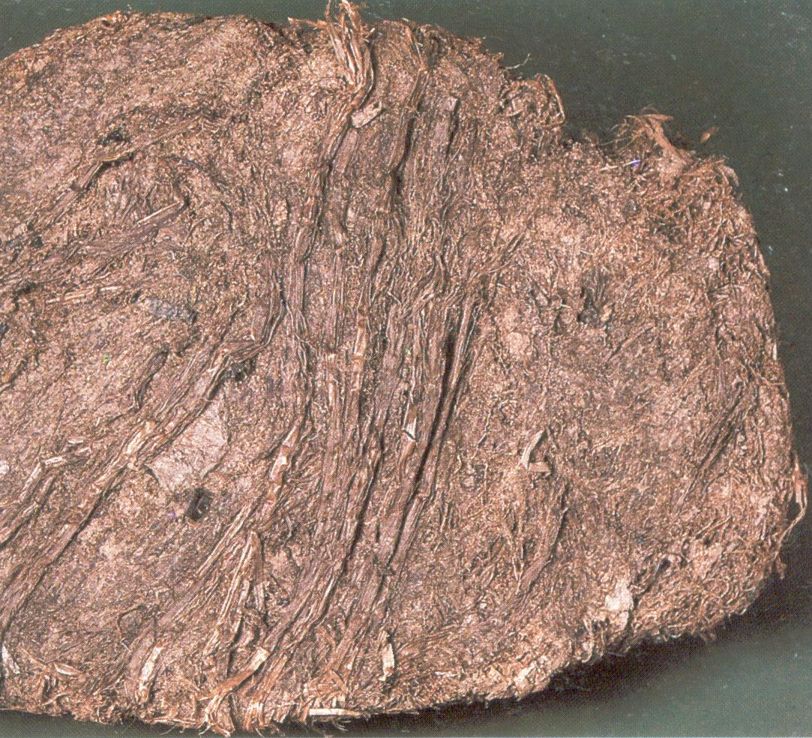
Figure 57. Peat

COAL
Coal (Figure 58) is composed of highly altered plant remains and various amounts of clay. It is opaque and noncrystalline, with colours ranging from light brown to black. Coalification results from the burial of peat and is classified according to the degree of change. Prolonged heat and pressure produce lignite (brown coal), bituminous (soft) coal, and anthracite (hard) coal.

Figure 58. Coal (Anthracite) in thin section and hand specimen

