MINERALOGICAL COMPOSITION
The most important from the genetical point of view is the division of rock-forming minerals of sedimentary rocks into authigenic and allogenic ones.

Authigenic
Authigenic constituents are these which were formed by chemical processes and subsequently deposited at the same basin. The most important among them are:

Clay Minerals
Kaolinite Al₄(Si₄O₁₀) (OH)₈
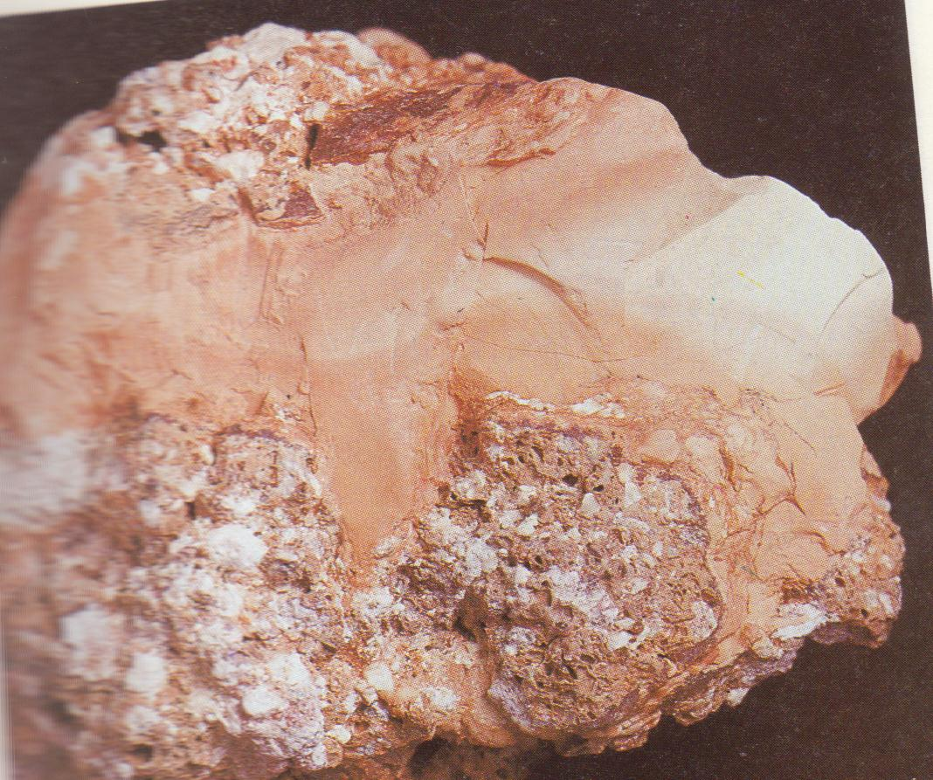
Figure 5. Kaolinite specimen

Montmorillonite Al₂(AlSi₃O₁₀) (OH)₂ . x H₂O; Mgmay partly replace Al; interlayer cations (Na, Ca, K, etc.) always present
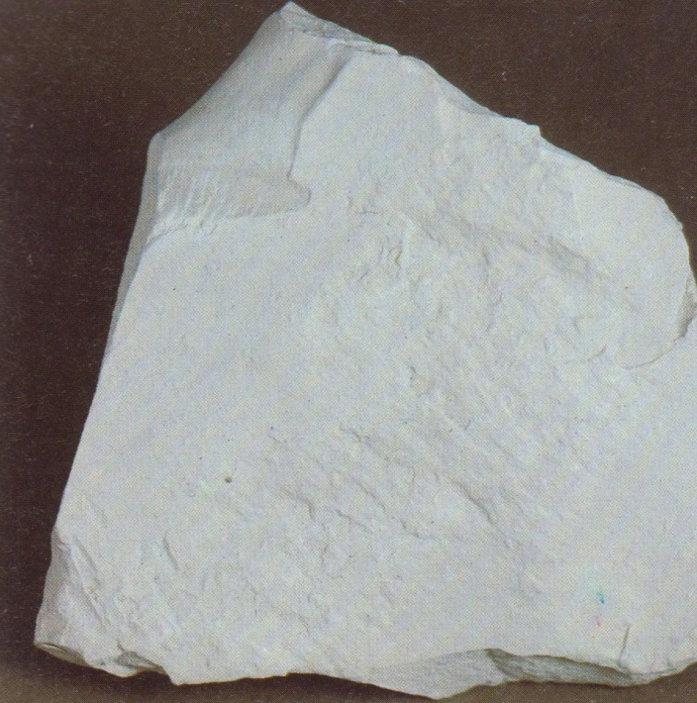
Figure 6. Montmorillonite specimen

Illite-sericite KAl₂ (AlSi₃O₁₀) (OH)₂
Chlorite Mg₅ (Al,Fe) ((Al,Si)₄O₁₀) (OH)₈
Chamosite Fe₃ (Al₂Si₂O₁₀) . 3H₂O
Clauconite (K, Na) (Fe, Al, Mg)₂ ((Al, Si)₄O₁₀) (OH)₂

2. Carbonates
Calcite CaCO₃ Siderite FeCO₈

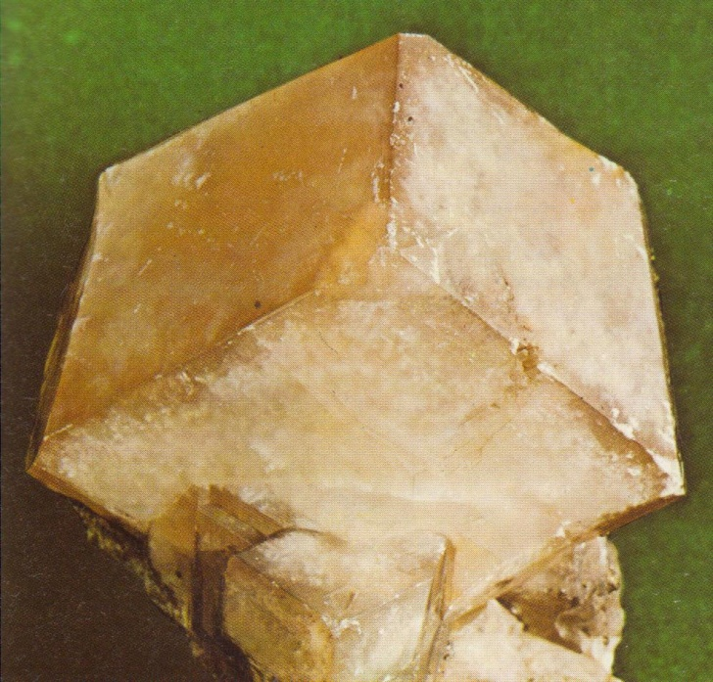
Figure 7. Calcite specimen

Dolomite CaCo₃ . MgCO₃
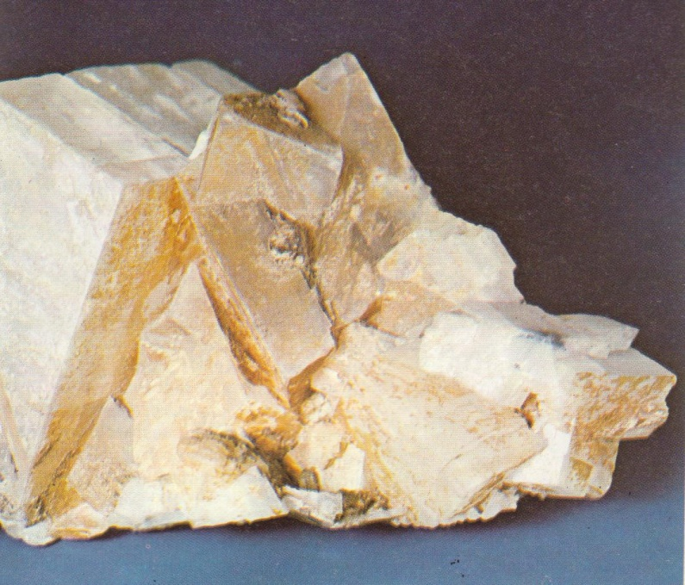
Figure 8. Dolomite specimen

Rhodochrosite MnCO₂
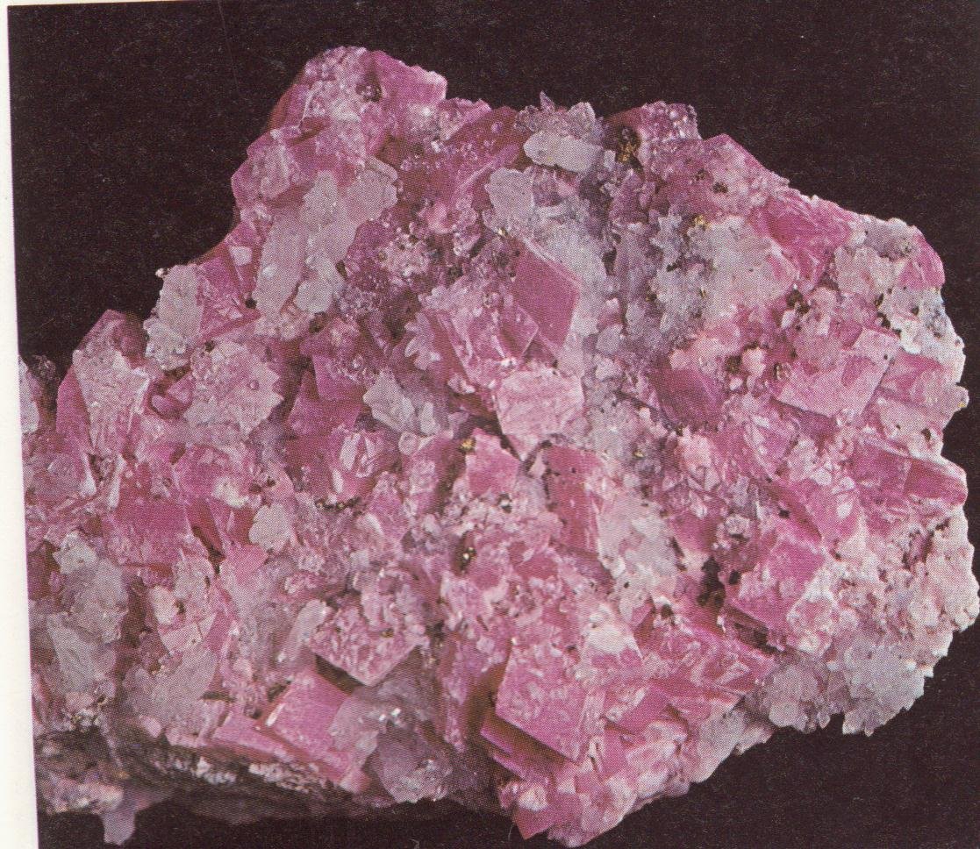
Figure 9. Rhodochrosite specimen

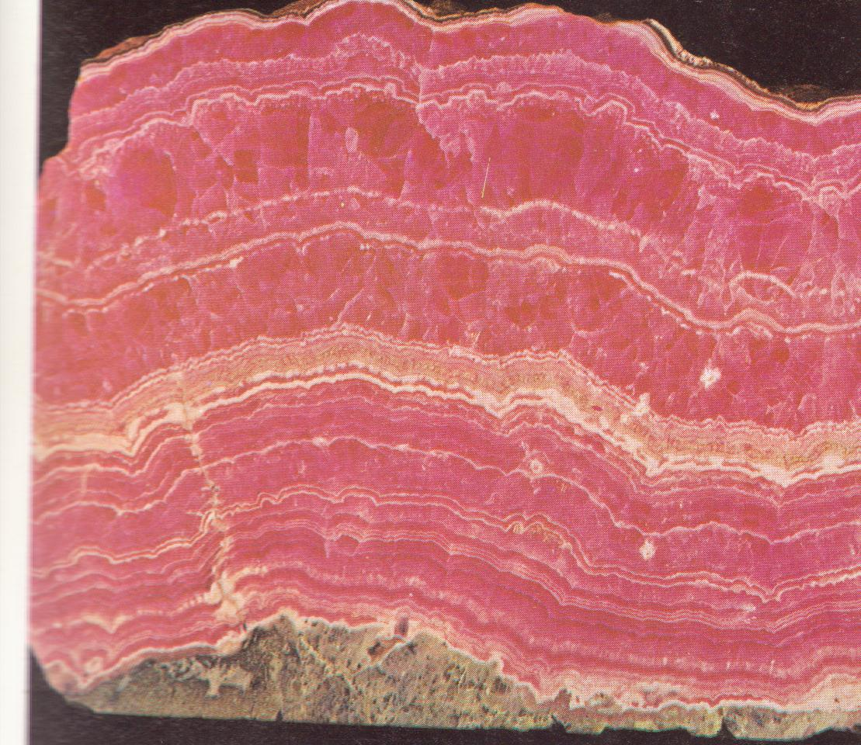
Figure 10. Bedded Rhodochrosite specimen

Ankerite CaCO₃ . (Mg,Fe)CO₃

3. Silica group
Quartz
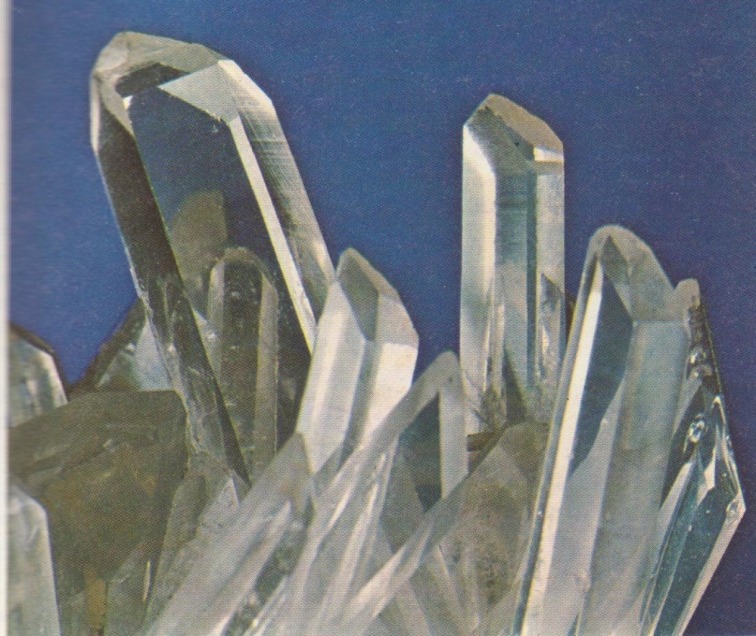
Figure 11. Bedded Rhodochrosite specimen

Chalcedony SiO₂
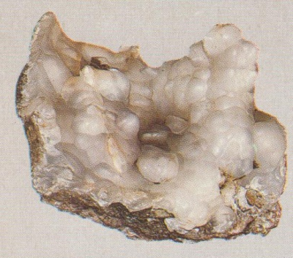
Figure 12. Chalcedony specimen

Opal SiO₂ . nH₂O
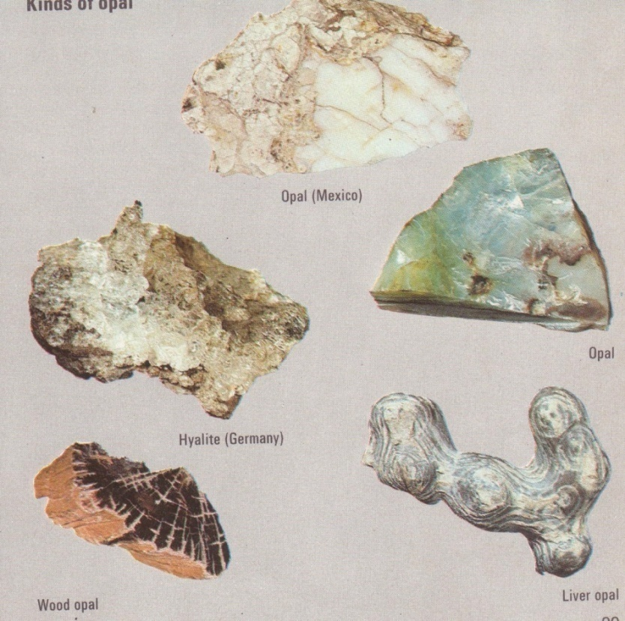
Figure 13. Opal minerals specimen

4. Minerals of Evaporites
Halite NaCl
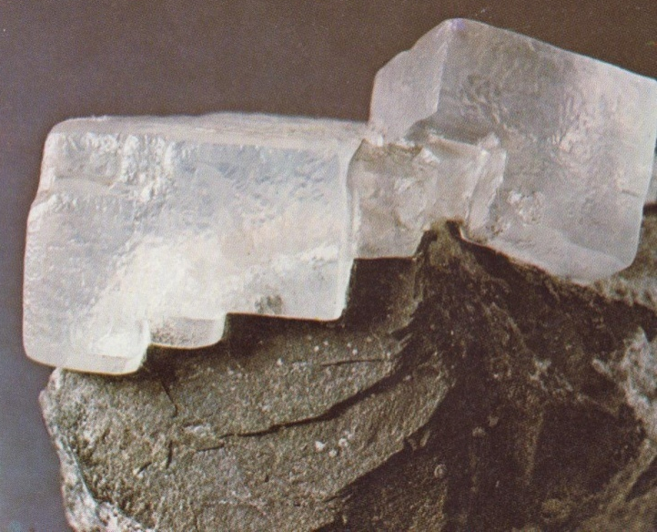
Figure 14. Halite specimen

Gypsum CaSO₄ . 2H₂O
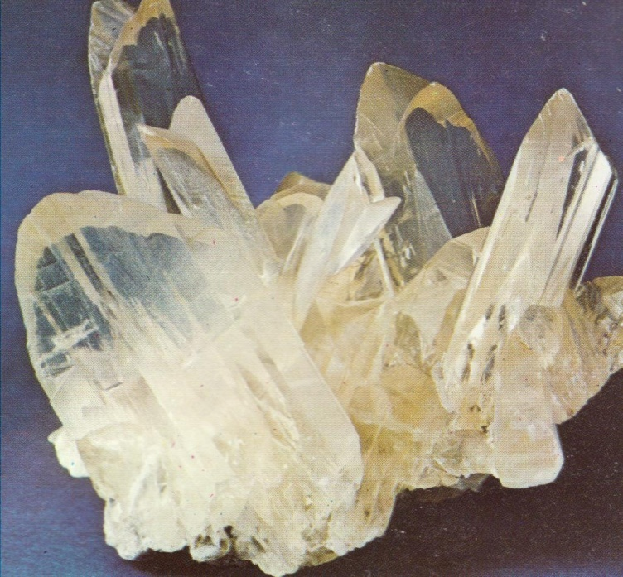
Figure 15. Gypsum specimen

Sylvite KCl
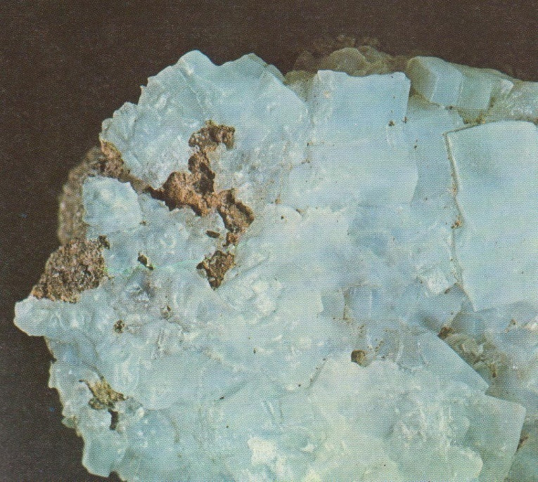
Figure 16. Sylvite specimen

Anhydrite CaSO₄, etc.
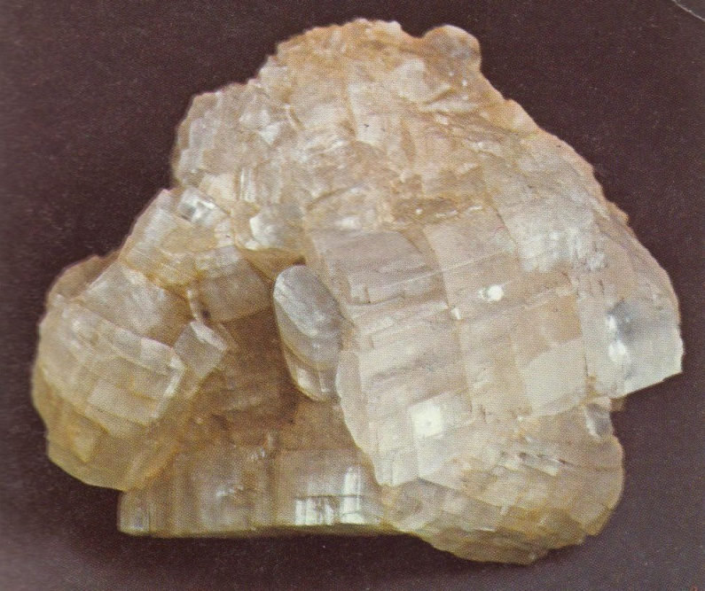
Figure 17. Anhydrite specimen

Carnallite KCl . MgCl₂ . 6H₂O
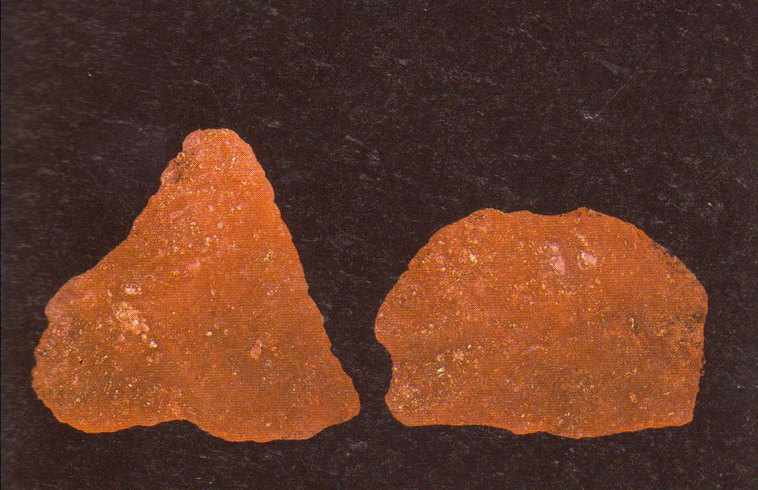
Figure 18. Carnallite specimen

Polyhalite K₂SO₄ . 2SO₄ . MgSO₄ . 2H₂O

5. Phosphates
Cellophane Ca₅ (PO₄)₃ (F, OH, Cl)

6. Hydroxides
Goethite/lepidocrokite α/γ . FeO.OH
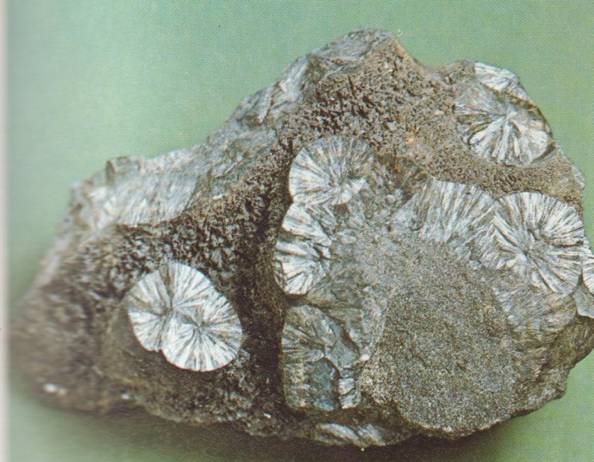
Figure 19. Goethite specimen

Hydrargillite Al(OH)₃
Boehmite/diaspar α/γ . AlO.OH
Manganite MnO . OH
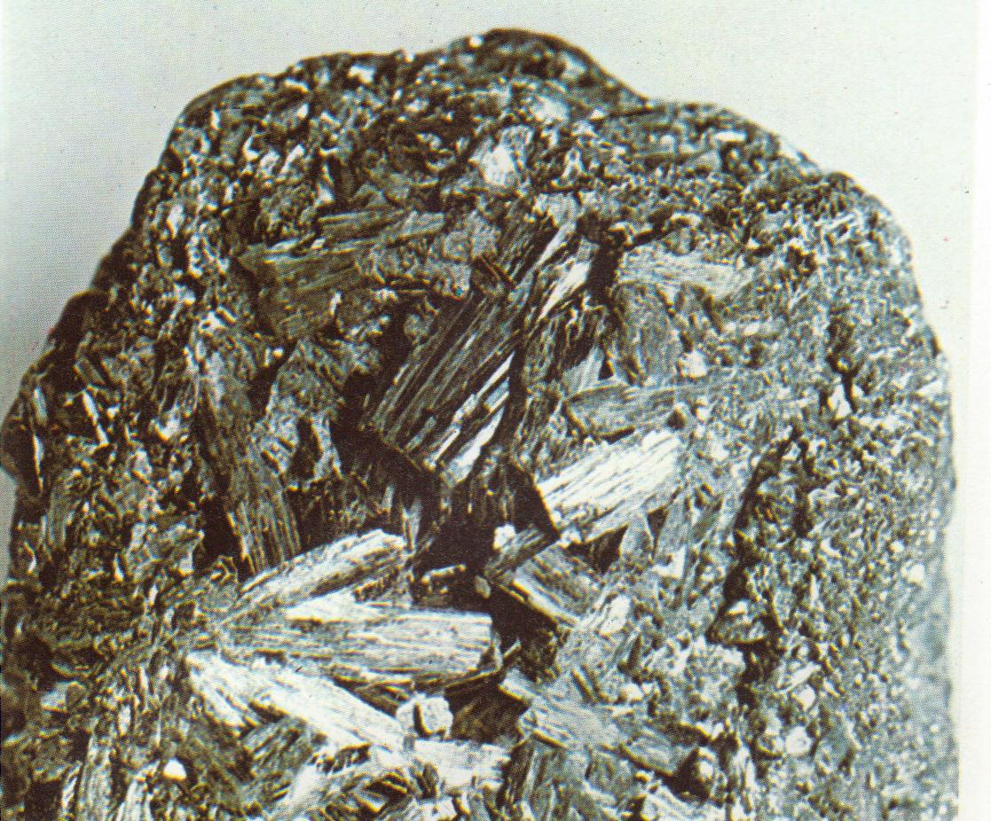
Figure 20. Manganite specimen

7. Others
Pyrite FeS₂
Hematite Fe₂O₃
Sulphur S
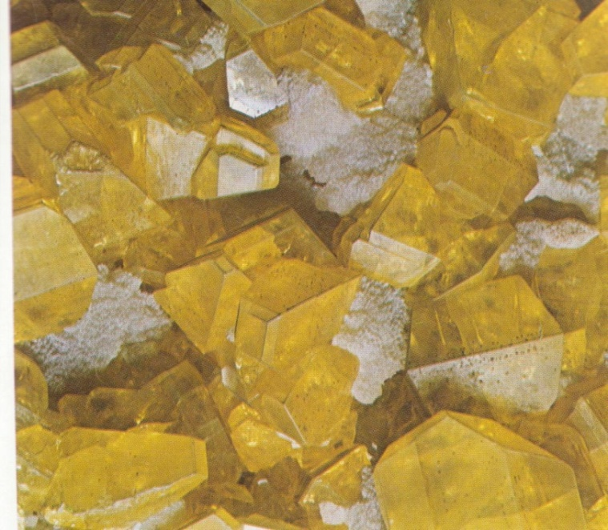
Figure 21. Sulphur specimen
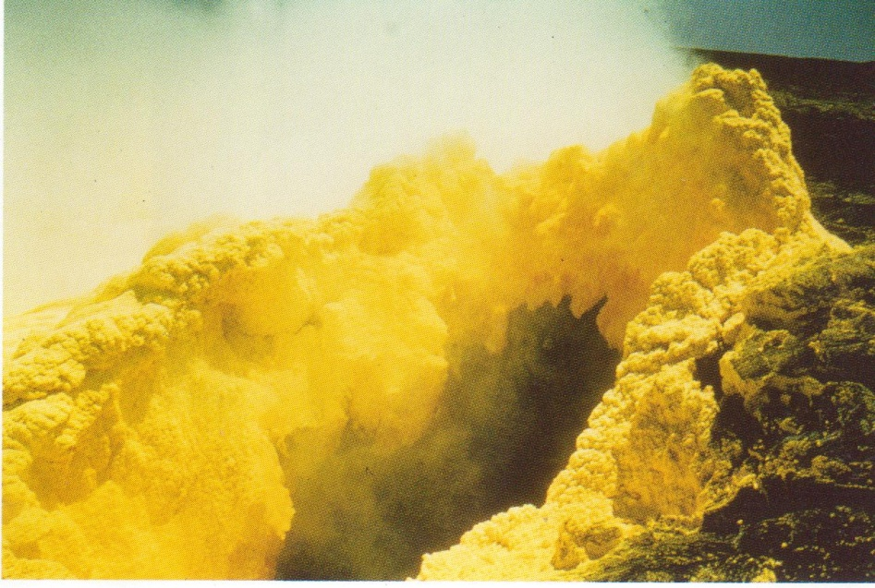
Figure 22. Volcanic gas vent ( a fimarole) deposits sulphur as gases cool and mix with air

Organic matter (carbonaceous and bituminuous)

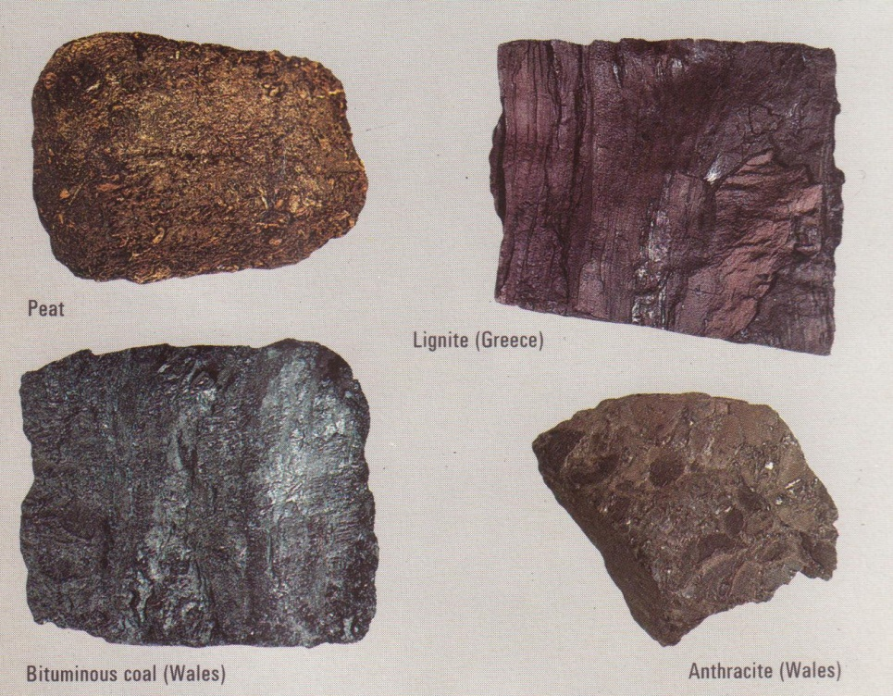
Figure 23. Organic specimen

Allogenic
Allogenic constituents are these which had been formed beyond the place of their deposition, into which they were subsequently transported (mechanical processes). The following must be mentioned:

1) Quartz SiO₂
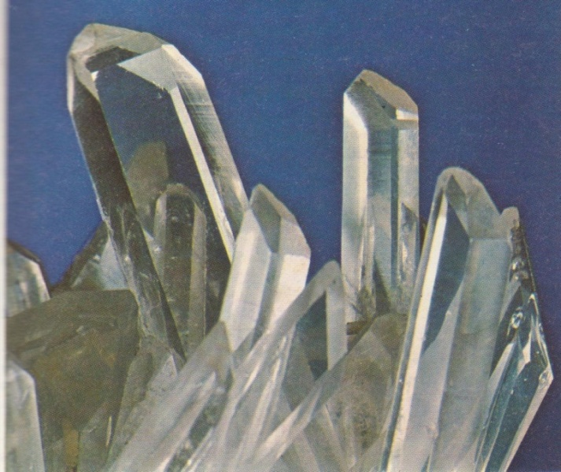
Figure 24. Quartz specimen

2) Feldspars
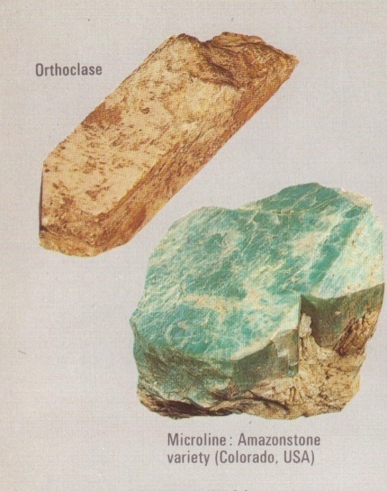
Figure 25. Feldspar specimen
Orthoclase – microcline K(AlSi₃O₈)
Sodium-rich plagioclase Na(AlSi₃O₈)
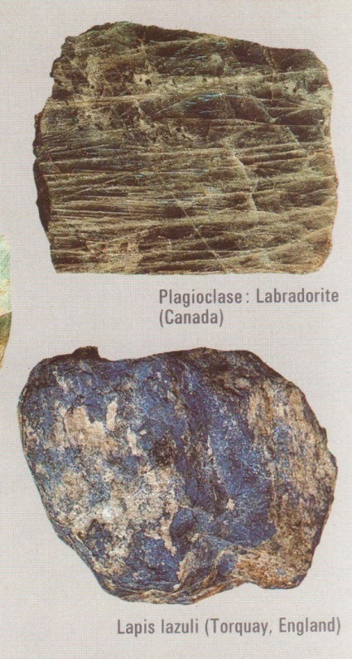
Figure 26. Plagioclase Feldspar specimen

3) Micas
Muscovite KAl₂ (AlSi₃O₁₀) (OH)₂
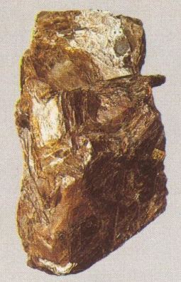
Figure 27. Muscovite specimen

4) Heavy minerals
Garnet, zircon, staurolite, kyanite, etc
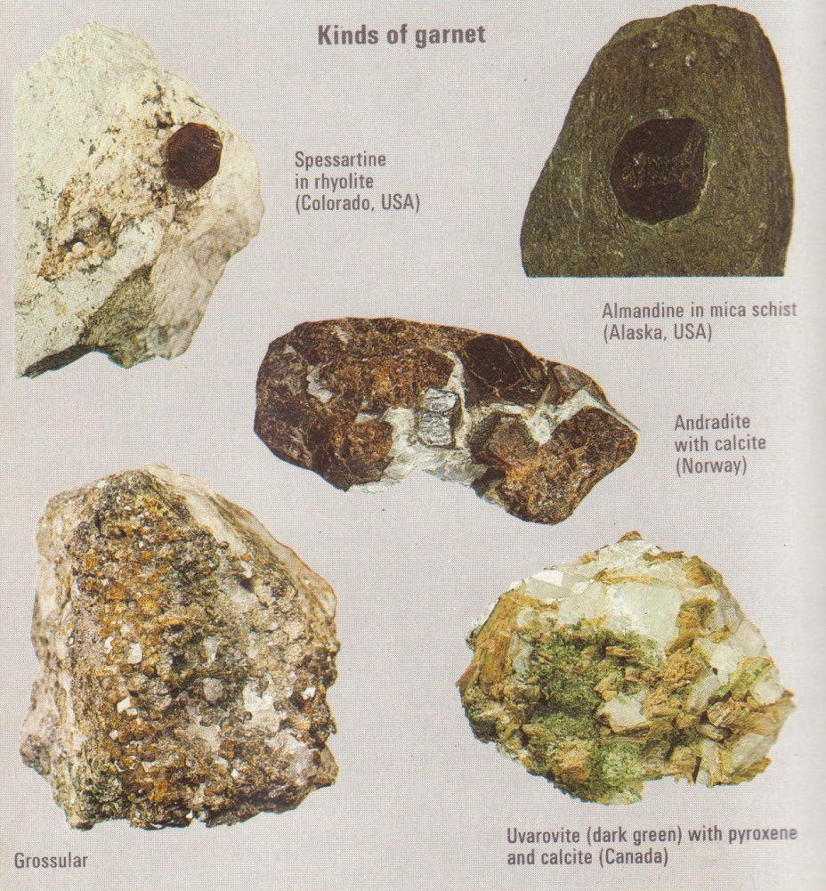
Figure 28. Muscovite specimen

5) Rock fragments
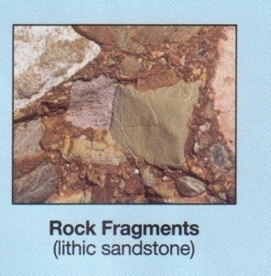
Figure 29. Rock Fragments specimen

